DOCUMENTATION

ASSIGNMENT 1

STUDENT NAME: CÂNDEA ANA-SOFIA
GROUP:30425

CONTENTS

1. Assignment Objective 3
2. Problem Analysis, Modeling, Scenarios, Use Cases 3
3. Design 3
4. Implementation 3
5. Results 3
6. Conclusions 3
7. Bibliography 3

Assignment Objective
Main Objective:
Design and implement a polynomial calculator with a dedicated graphical interface through which the user can insert polynomials, select the mathematical operation to be performed and view the result. The operations that the user can perform are: addition, subtraction, multiplication, differentiate and integrate.

Sub-Objectives:
- Analyze the problem and define functional requirements.
- Model the problem using use case diagrams and use case descriptions.
- Design the software, emphasizing encapsulation and object-oriented principles.
- Implement the designed solution.
- Test the application with various scenarios.
- Draw conclusions and outline future developments.

Problem Analysis, Modeling, Scenarios, Use Cases
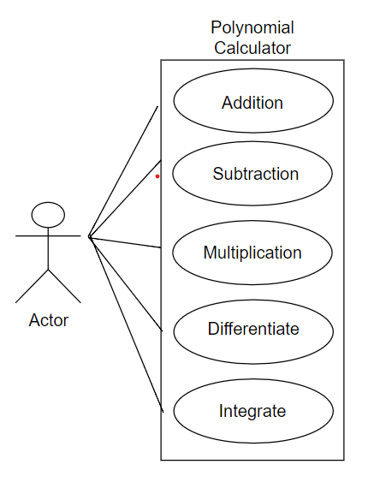
Functional Requirements:
- User can input polynomials.
- User can select mathematical operations: addition, subtraction, multiplication, differentiation and integration.
- User can view the result of the operation.
Use Cases:
- Input Polynomial:
  - Actor: User
  - Description: User inputs polynomial expressions.
  - Steps:
    - User enters polynomial expression(s).
    - User confirms input.
- Perform Addition:
  - Actor: User
  - Description: User selects addition operation.
  - Steps:
    - User inputs two polynomials.
    - User selects addition operation.
    - System computes the result.
    - System displays the result.
- Perform Subtraction:
  - Actor: User
  - Description: User selects subtraction operation.
  - Steps:
    - User inputs two polynomials.
    - User selects subtraction operation.
    - System computes the result.
    - System displays the result.
- Perform Multiplication:
  - Actor: User
  - Description: User selects multiplication operation.
  - Steps:
    - User inputs two polynomials.
    - User selects multiplication operation.
    - System computes the result.
    - System displays the result.
- Perform Differentiation:
  - Actor: User
  - Description: User selects differentiation operation.
  - Steps:
    - User inputs a polynomial.
    - User selects differentiation operation.
    - System computes the result.
    - System displays the result.

- Perform Integration:
  - Actor: User
  - Description: User selects integration operation.
  - Steps:
    - User inputs a polynomial.
    - User selects integration operation.
    - System computes the result.
    - System displays the result.

Design
Class diagram:
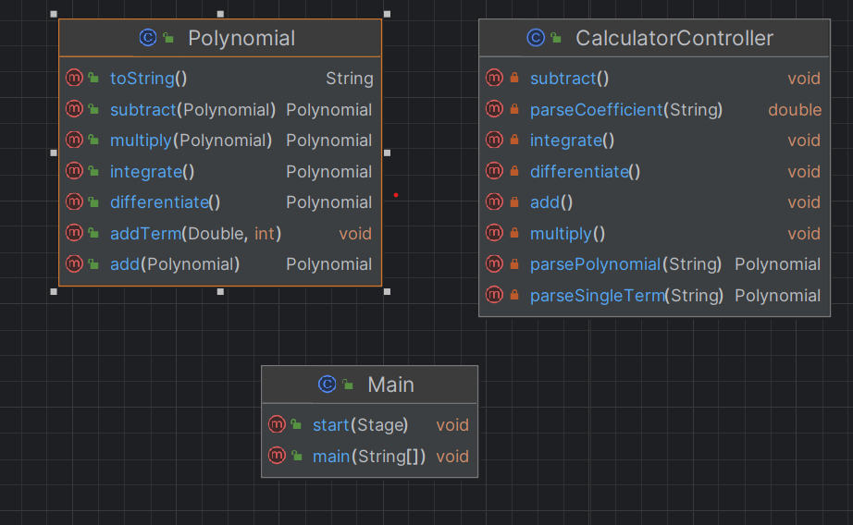
The design will emphasize encapsulation and object-oriented principles, ensuring clear separation of concerns and modularity. Key aspects include:
- Polynomial Class: Represents a polynomial and provides methods for addition, subtraction, multiplication, differentiation, integration, and parsing.
- CalculatorController: Manages user interactions and integrates with the Polynomial class to perform operations.

Implementation
Polynomial Class
- Fields: terms (a map representing terms of the polynomial with exponents as keys and coefficients as values).
- Methods:
  - addTerm(Double coefficient, int exponent): Adds a term to the polynomial.
  - add(Polynomial other): Performs polynomial addition.
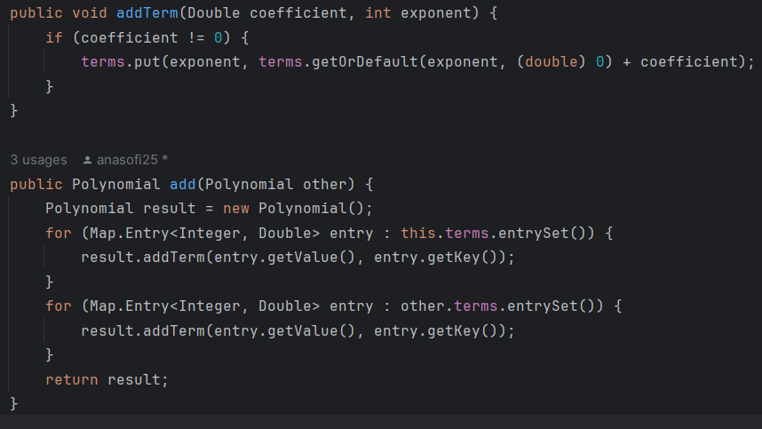

The rest of the methods are written in the same logic as the addition presented above. The class also contains the methods:
  - subtract(Polynomial other): Performs polynomial subtraction.
  - multiply(Polynomial other): Performs polynomial multiplication.
  - integrate(): Computes the integral of the polynomial.
  - differentiate(): Computes the derivative of the polynomial.
  - toString(): Converts the polynomial to a human-readable string.
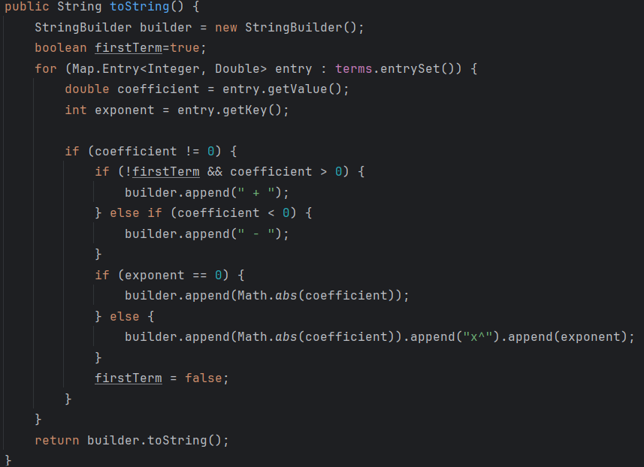
CalculatorController Class
- Fields:
  - polynomial1TextField: A TextField for inputting the first polynomial expression.
  - polynomial2TextField: A TextField for inputting the second polynomial expression.
  - resultTextArea: A TextArea for displaying the result of polynomial operations.
- Methods:
  - add(): Retrieves polynomial expressions from polynomial1TextField and polynomial2TextField, performs polynomial addition using the add method of the Polynomial class, and displays the result in resultTextArea.
  - subtract(): Retrieves polynomial expressions from polynomial1TextField and polynomial2TextField, performs polynomial subtraction using the subtract method of the Polynomial class, and displays the result in resultTextArea.
  - multiply(): Retrieves polynomial expressions from polynomial1TextField and polynomial2TextField, performs polynomial multiplication using the multiply method of the Polynomial class, and displays the result in resultTextArea.
  - integrate(): Retrieves a polynomial expression from polynomial1TextField, computes its integral using the integrate method of the Polynomial class, and displays the result in resultTextArea.
  - differentiate(): Retrieves a polynomial expression from polynomial1TextField, computes its derivative using the differentiate method of the Polynomial class, and displays the result in resultTextArea.
  - parsePolynomial(String polynomial): Parses a polynomial expression given as a string and converts it into a Polynomial object.
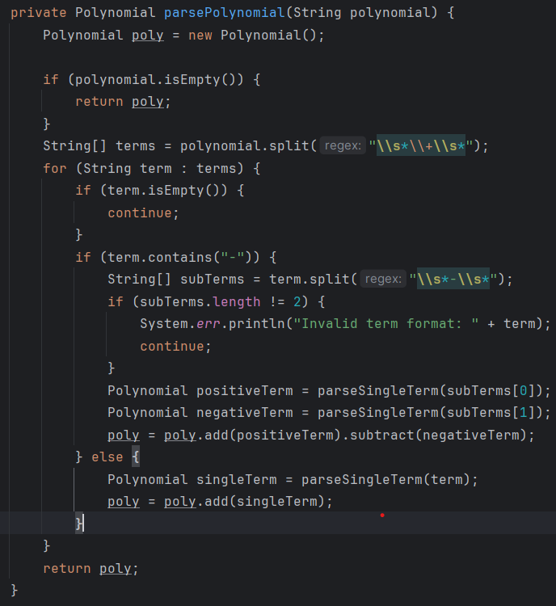
  - parseSingleTerm(String term): Parses a single term of a polynomial expression and converts it into a Polynomial object. It handles different cases based on the structure of the term:
  - If the term starts with a -, it signifies a negative coefficient, so it removes the - sign and adds the term with a coefficient of -1.0.
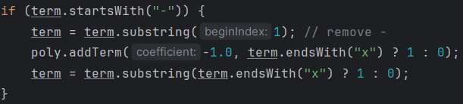
  - If the term contains x^, it means it has both a coefficient and an exponent. It splits the term based on x^ to extract the coefficient and exponent, then adds the term to the polynomial using the extracted values.
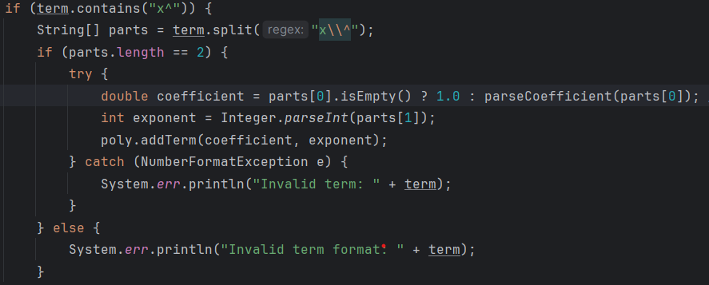
  - If the term equals "x", it represents a term with a coefficient of 1 and an exponent of 1.
  - If the term ends with "x", it represents a term with a coefficient and an exponent of 1, so it extracts the coefficient and adds the term accordingly.
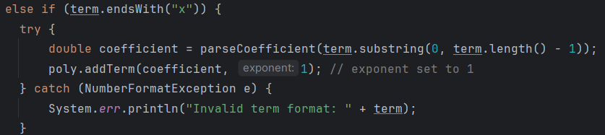
  - If none of the above conditions match, it considers the term as a constant and extracts the coefficient accordingly.
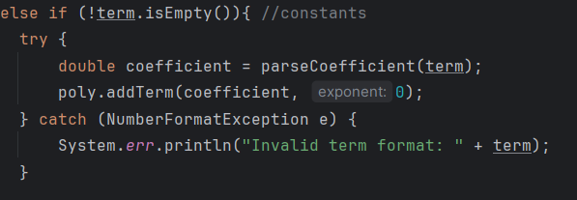
  - parseCoefficient(String coefficientPart): Parses the coefficient part of a term in a polynomial expression.
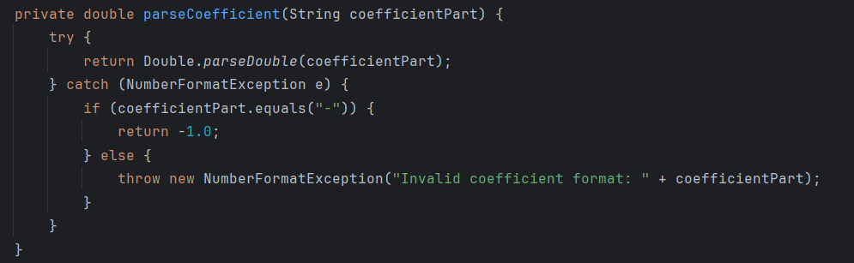

Graphical User Interface
Two FXML file Calculator.fxml defines the graphical user interface of my application. It includes GUI elements such as buttons, labels, and text fields for user interaction.

Results
The physical result of the whole implementation consists in the interface where the user can insert polynomials and perform operations with them. The GUI looks like in the picture below:

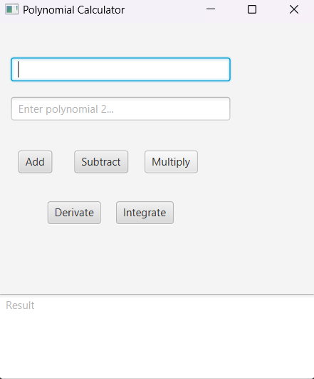

The testing scenarios are implemented in the PolynomialTest class. There are teo tests made for each operation, checking if the operation methods are functioning correctly for different scenarios. Testing scenarios:

Addition:
The tests are made for polynomials with different degrees and coefficients.
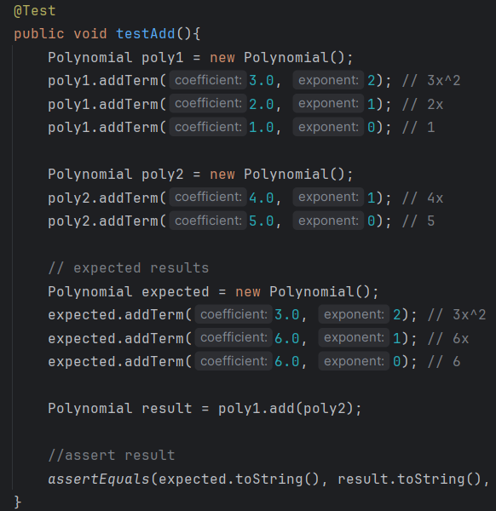
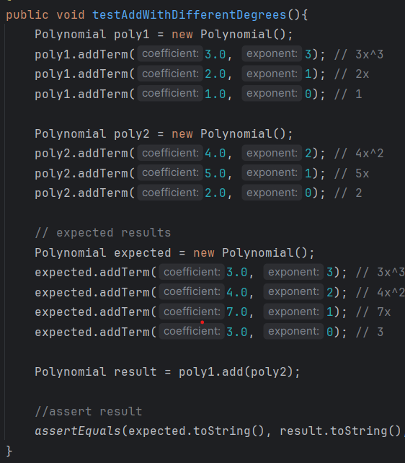

Subtraction:
The tests are made for polynomials with different degrees and coefficients, following the idea presented above for addition.

Multiplication:
The tests are made for polynomials with different degrees and coefficients, following the idea presented above for addition.

Differentiation:
The tests are made for polynomials with different degrees and coefficients to ensure that the polynomial is differentiated correctly.

Integration
The tests are made for polynomials with different degrees and coefficients to ensure that the polynomial is integrated correctly.

Conclusions
In conclusion, the assignment objective was successfully achieved by designing and implementing a polynomial calculator with a graphical user interface. The development process involved problem analysis, design, implementation, and testing, leading to a functional and user-friendly application. Future developments may include the division operation, optimization, and refinement of the user interface.

Bibliography
https://www.baeldung.com/junit-5

