DOCUMENTATION

ASSIGNMENT 2

STUDENT NAME: Candea Ana-Sofia
GROUP: 30425

CONTENTS

1. Assignment Objective 3
2. Problem Analysis, Modeling, Scenarios, Use Cases 3
3. Design 3
4. Implementation 3
5. Results 3
6. Conclusions 3
7. Bibliography 3

Assignment Objective
Main objective:
Design and implement a queues management application which assigns clients to queues such that the waiting time is minimized.
Sub-objectives:
- Utilize object-oriented programming principles with appropriate class and method sizes;
- Implement a random client generator and a multithreading style;
- Adapt two strategies, one for the shortest time and one for the shortest queue;
- Display the simulation into a txt file and on the GUI interface;
- Implement additional results, such as Average Waiting Time, Average Service Time and Peak Hour;

Problem Analysis, Modeling, Scenarios, Use Cases
Functional Requirements
- The application should allow users to enter the number of clients, number of queues, simulation interval, min and max service time and min and max arrival time;
- The application should check if the data is valid and display a message;
- The application should allow the user to start the simulation and to see the real-time progress;
- The application should allow the user to also see the results of the simulation;

Use cases:
Input Data Validation:
Actor: User
Description: User inputs values for the number of clients, number of queues, simulation interval, min and max service time, and min and max arrival time.
Flow:
- User enters data.
- System validates the input data.
- System displays a success message if data is valid, or an error message if data is invalid.
Start Simulation:
Actor: User
Description: User starts the simulation after inputting valid data.
Flow:
- User clicks "Start Simulation".
- System initializes the simulation parameters.
- System starts simulation and updates the real-time progress in the GUI.
- System logs simulation events to a text file.
Display Results:
Actor: User
Description: User views the simulation results.
Flow:
- System calculates Average Waiting Time, Average Service Time, and Peak Hour.
- System displays the results in the GUI and writes them to the log file.
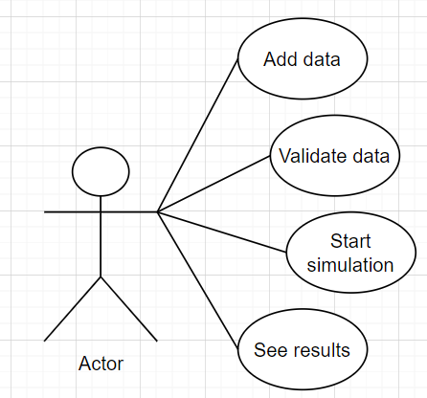

Design
Object Oriented Design
The application uses object oriented approach to design it’s components. Key classes include:

- Client: Represents a client with attributes like client ID, it’s arrival and service time;
- Queue: Represents a queue and it implements Runnable;
- Simulation: Handles the simulation of the queues;
- Controller: Handles the controlling part;

Class diagram:
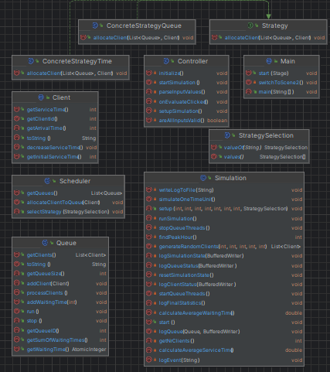

Implementation
Classes description:
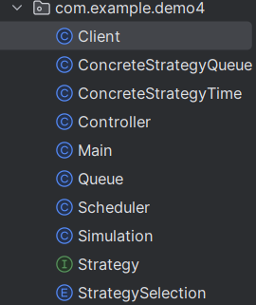
1.Controller
It handles the controll logic between the application and the GUI. It coordinates the simulation and the handles the logic of the buttons and text area.
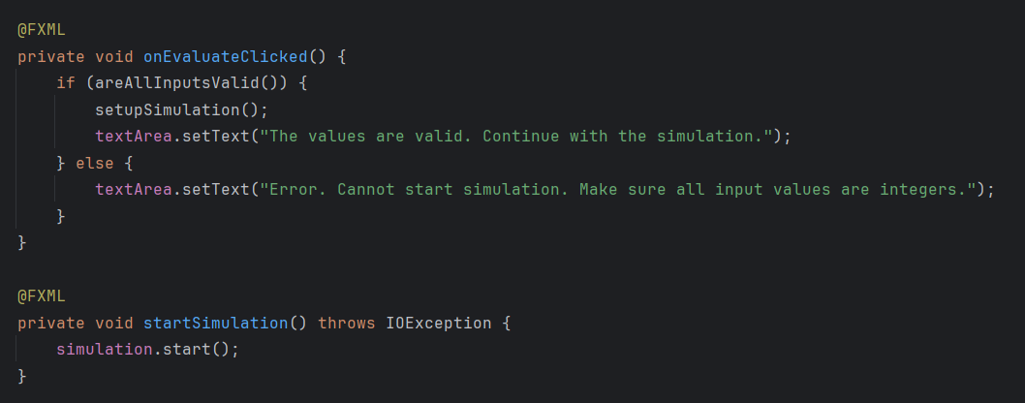
2. Simulation
Handles the core simulation logic, manages state, progression, and logging.
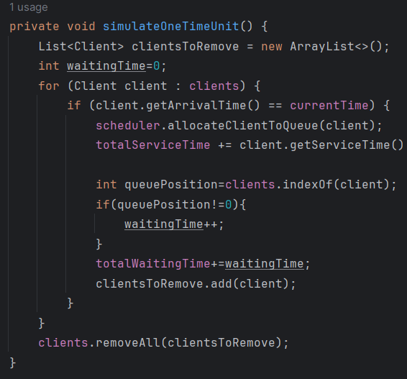

In order to have a better functuniolaity, the program handles each time unit at a time based on the function above. The logging part also consits of multiple methods, handling each segment, client, status, queue, at a time.
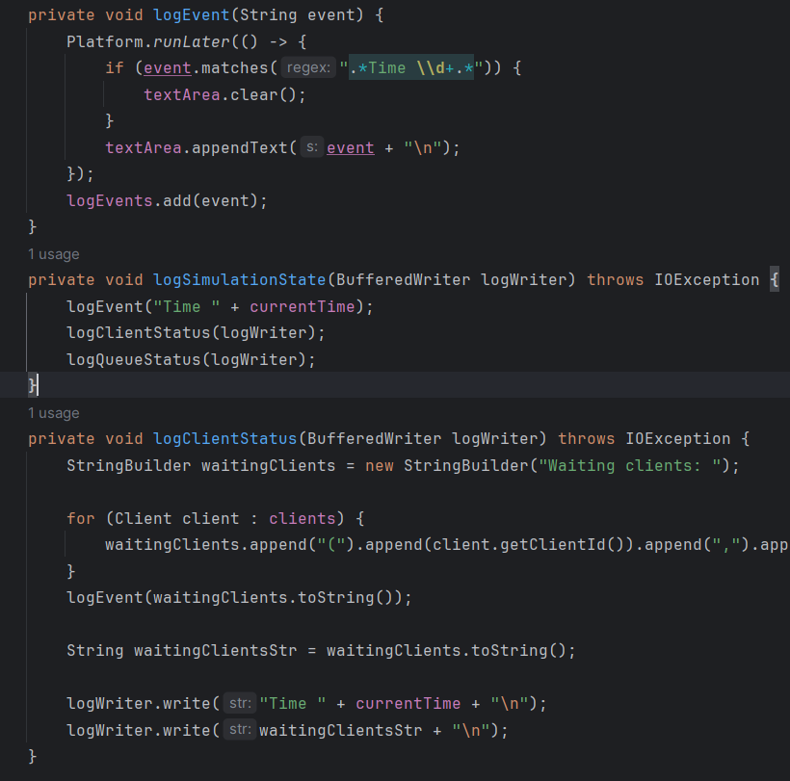
Here we also have the functions which handle the averages and the peak hour.

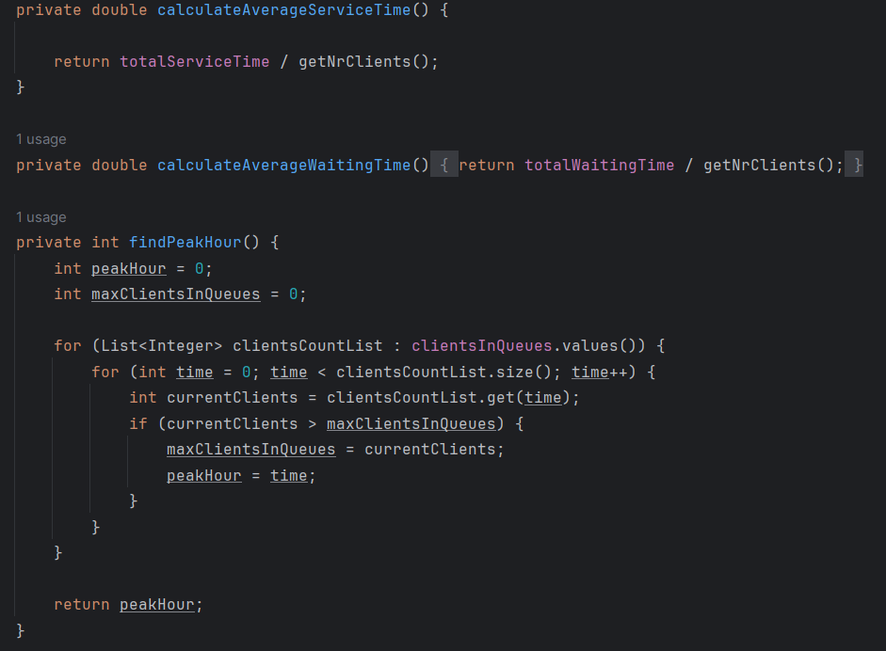

3. Client
It represents a client and the operations related to it. The program also generates random arrival and waiting times based on a Random variable.
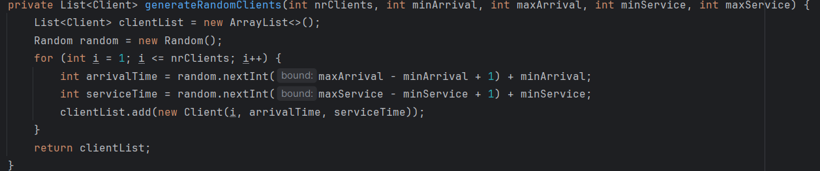
4.Queue
It represents a queue and the operations related to it. Since it is a runnable class, it also ovverides the method run in order to ensure multithreading. 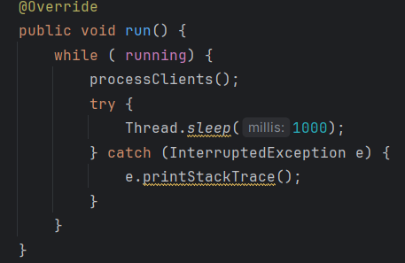

5.Strategy
In order to ensure a proper creation of two different strategies, a enum class is creates. It contains the two available strategies, based on shortest time, respectively shortest queue.
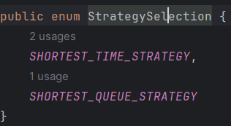

6.Shortest Time Strategy
It provides the client allocation logic based on the shortest waiting time. The other strategy class behaves similarily to this one, but it allocates clients based of the number of people in the queue.
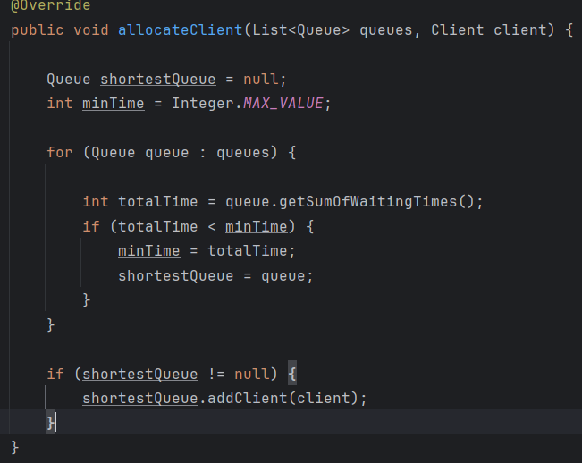
7.Scheduler
The Scheduler class is responsible for managing the queues and assigning clients to them based on a selected strategy. This class ensures that clients are allocated to the appropriate queues in a way that optimizes the overall performance of the system.
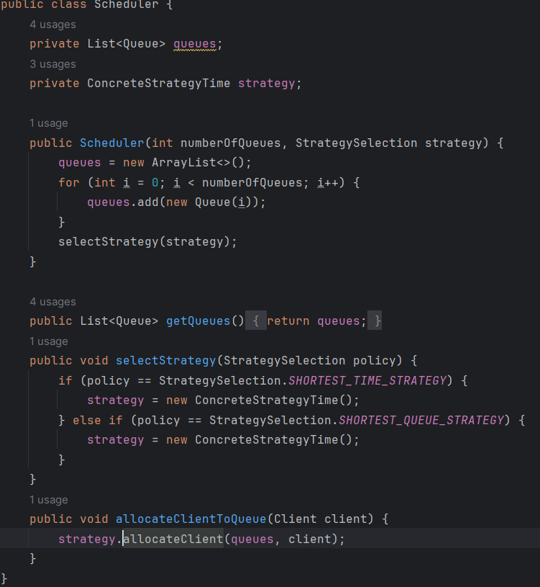

GUI Interface
The interface allows the user to enter the desired data and select a strategy. It can further start the simulation which is displayed in real time in the text area
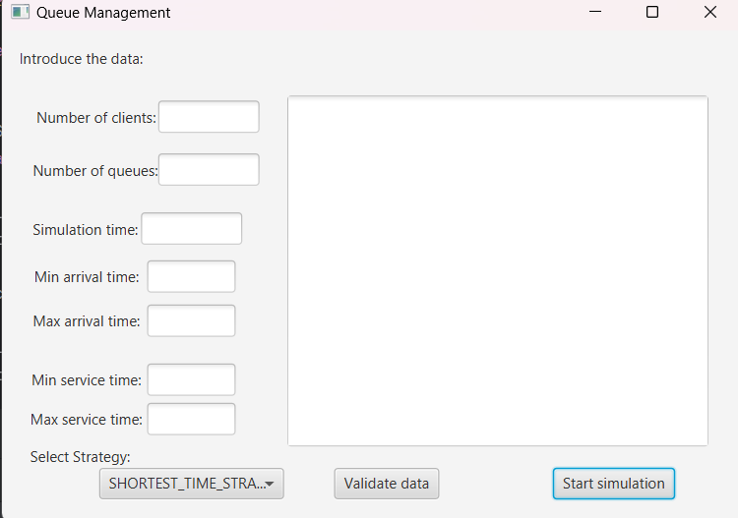

Results

The application was tested for 3 example usages and their contents were provided in the txt files test1, test2, respectively test3.

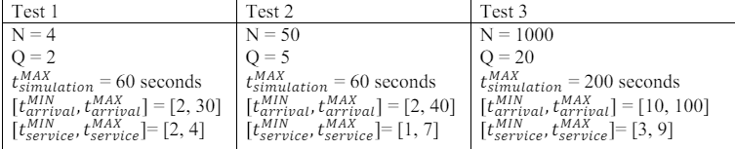

Conclusions
Learning:
- Implementing multithreading and managing synchronization.
- Designing a GUI with JavaFX.
- Applying object-oriented principles to a real-world problem.
Future Developments:
- Enhance GUI with more detailed visualization.
- Implement more advanced queue allocation strategies.
- Optimize performance for larger simulations.

Bibliography
- http://docs.oracle.com/javase/tutorial/essential/concurrency/index.html
- http://www.tutorialspoint.com/java/util/timer_schedule_period.htm
- http://www.javacodegeeks.com/2013/01/java-thread-pool-example-using-executorsandthreadpoolexecutor.html

