CCP ASSIGNMENT REPORT
Lexical Analyzer for a Mini Programming Language
with a Turing Machine Extension — Japanese Script Acceptor
Theory of Automata
IQRA University — BS Computer Science

Group Members
Hafiz Muhammad Anas Raza Siddiqui
Zayan Sheikh
Hussain Ali
GitHub Repository
https://github.com/anasraza524/fa-lexical-analyzer
Language Implemented: Java (JDK 17)
Turing Machine Language: Japanese (Hiragana / Katakana / Kanji script acceptor)
Date: September 2026

Table of Contents
1. Introduction
2. Language Specification
3. System Architecture
4. Approach 1 — Direct DFA Lexer
5. Approach 2 — Table-Driven DFA Lexer
6. Comparison of Both Approaches
7. Turing Machine Extension — Japanese Script Acceptor
8. GUI Implementation
9. Test Results — All 27 Cases
10. Performance Analysis
11. CCP Requirements Checklist
12. Screenshots
13. Conclusion

1. Introduction
This project implements a lexical analyzer (lexer) for a mini programming language, built in Java (JDK 17). A lexical analyzer is the first phase of a compiler. It reads raw source code as a string and breaks it into a sequence of tokens — the smallest meaningful units of the language (keywords, identifiers, numbers, operators, symbols, and errors).
Two separate implementations were built and compared:
- Approach 1 — Direct DFA: Transitions are written as Java control flow (if/else, switch). This mirrors how hand-written compilers work.
- Approach 2 — Table-Driven DFA: Transitions are stored in a 2D array. A generic engine reads the table. This mirrors how generated scanners (lex/flex) work.
Both implementations are cross-validated against each other on every test case. They must produce identical token streams.
In addition, a Turing Machine extension was built that checks whether a piece of input text is written entirely in Japanese script (Hiragana, Katakana and Kanji). This demonstrates a more powerful computational model than the DFA-based lexer and shows how the formalism generalises — an explicit tape, head and state-transition function — even when the language recognised happens to still be regular.

2. Language Specification
The mini language is defined exactly as per the CCP problem statement.

2.1 Token Categories
Token Type | Description
KEYWORD | Reserved words: if, else, while, return
IDENTIFIER | Starts with a letter, followed by letters or digits
OPERATOR | + - * / = ==
NUMBER | Integer (42) or float (3.14)
SYMBOL | ( ) { } ;
ERROR | Any unrecognized character — never silently dropped

2.2 Formal Grammar Rules
keyword -> if | else | while | return
identifier -> letter (letter | digit)*
operator -> + | - | * | / | = | ==
number -> digit+ ('.' digit+)?
symbol -> ( | ) | { | } | ;
letter -> [a-zA-Z]
digit -> [0-9]

2.3 Single Source of Truth — LanguageSpec.java
All token definitions live in one file so both lexer implementations are guaranteed to agree on the language:
public final class LanguageSpec {
public static final Set<String> KEYWORDS =
new HashSet<>(Arrays.asList("if", "else", "while", "return"));
public static final Set<Character> SYMBOLS =
new HashSet<>(Arrays.asList('(', ')', ';', '{', '}'));
// '=' is handled separately because it can extend into "=="
public static final Set<Character> SINGLE_OPERATORS =
new HashSet<>(Arrays.asList('+', '-', '*', '/'));
}

3. System Architecture

3.1 File Structure
fa-lexical-analyzer/
├── src/
│ ├── TokenType.java - Enum: KEYWORD, IDENTIFIER, OPERATOR, NUMBER, SYMBOL, ERROR
│ ├── Token.java - Immutable token: type + lexeme + line + column
│ ├── LanguageSpec.java - Single source of truth for keywords/operators/symbols
│ ├── DirectDfaLexer.java - Approach 1: hand-coded DFA
│ ├── TableDrivenLexer.java - Approach 2: table-driven DFA
│ ├── Main.java - CLI: worked example + 27 regression tests + benchmark
│ ├── LexerUI.java - Swing GUI
│ ├── DfaPanel.java - Graphics2D DFA state diagram
│ └── TuringMachinePanel.java - Turing Machine mode (Japanese acceptor)
├── out/ - Compiled .class files
├── run.sh - One-command build + launch
└── run_output.txt - Captured CLI output

3.2 Dependency Graph
TokenType <- Token <- LanguageSpec
^ ^
DirectDfaLexer TableDrivenLexer
^ ^
Main.java
LexerUI.java

3.3 Token.java — Immutable Token Record
Every recognized unit is stored as a Token:
public final class Token {
private final TokenType type;
private final String lexeme;
private final int line;
private final int column;
@Override
public String toString() {
return "[" + type + ": " + lexeme + "]";
}
}
- type — which category (KEYWORD, IDENTIFIER, etc.)
- lexeme — the exact characters from the source
- line / column — 1-based position for error reporting

4. Approach 1 — Direct DFA Lexer
File: src/DirectDfaLexer.java

4.1 What is a Direct DFA?
A Direct DFA (also called a "hand-coded scanner") encodes every state transition as Java control flow — if, else, and method calls. Each method represents one DFA state. This is the style used by hand-written compilers such as early C compilers and CPython's tokenizer.

4.2 DFA State Diagram
letter -> [IN_ID] --(letter|digit)--+
/ +-----------------+
/ v other -> ACCEPT
[START] ---- digit -> [IN_INT] --(digit)--+
\ +-----------+
\ v '.'digit -> [IN_FLOAT] -> ACCEPT
'=' -> [IN_EQ] ---- '=' -> ACCEPT (==)
| +---- other -> ACCEPT (=)
sym/op --------------------------> ACCEPT
other --------------------------> ERROR
States:
- START — initial state, reads the next character
- IN_ID — inside an identifier or keyword (letter followed by letters/digits)
- IN_INT — inside the integer part of a number
- IN_FLOAT — inside the fractional part of a number (after '.')
- IN_EQ — just read '=', waiting to see if next char is also '='
- ACCEPT — token is complete
- ERROR — unrecognized character

4.3 Code Walkthrough

Main Loop (START state)
while (pos < src.length()) {
char c = src.charAt(pos);
if (c == '\n') { advance(); line++; col = 1; continue; }
if (Character.isWhitespace(c)) { advance(); continue; }
if (Character.isLetter(c)) scanIdentifierOrKeyword(startLine, startCol);
else if (Character.isDigit(c)) scanNumber(startLine, startCol);
else if (c == '=') scanEquals(startLine, startCol);
else if (LanguageSpec.SINGLE_OPERATORS.contains(c)) { /* emit OPERATOR */ advance(); }
else if (LanguageSpec.SYMBOLS.contains(c)) { /* emit SYMBOL */ advance(); }
else { /* emit ERROR */ advance(); }
}
Whitespace and newlines are skipped (they are not tokens). Every other character dispatches to the correct state method.

IN_ID State — scanIdentifierOrKeyword()
private void scanIdentifierOrKeyword(int startLine, int startCol) {
int start = pos;
while (pos < src.length() && Character.isLetterOrDigit(src.charAt(pos))) {
advance();
}
String lexeme = src.substring(start, pos);
TokenType type = LanguageSpec.KEYWORDS.contains(lexeme)
? TokenType.KEYWORD : TokenType.IDENTIFIER;
tokens.add(new Token(type, lexeme, startLine, startCol));
}
Keeps consuming while the character is a letter or digit (maximal munch). After the loop, checks if the collected lexeme is a keyword. This correctly handles returnValue — it is scanned as one identifier, not split into return + Value.

IN_INT / IN_FLOAT State — scanNumber()
private void scanNumber(int startLine, int startCol) {
int start = pos;
while (pos < src.length() && Character.isDigit(src.charAt(pos))) advance();
// Fractional part: '.' must be followed by at least one digit
if (pos < src.length() && src.charAt(pos) == '.'
&& pos + 1 < src.length() && Character.isDigit(src.charAt(pos + 1))) {
advance(); // consume '.'
while (pos < src.length() && Character.isDigit(src.charAt(pos))) advance();
}
// Edge case: digit run followed by letter (e.g. "123abc") -> single ERROR
if (pos < src.length() && Character.isLetter(src.charAt(pos))) {
while (pos < src.length() && Character.isLetterOrDigit(src.charAt(pos))) advance();
tokens.add(new Token(TokenType.ERROR, src.substring(start, pos), startLine, startCol));
return;
}
tokens.add(new Token(TokenType.NUMBER, src.substring(start, pos), startLine, startCol));
}
Key design decisions:
- 5. (trailing dot, no digit after) — the '.' is NOT consumed as part of the number. It becomes a separate ERROR token.
- 3.14.15 — scanned as NUMBER:3.14, ERROR:., NUMBER:15
- 123abc — the entire run is one ERROR token (not split into NUMBER + IDENTIFIER)

IN_EQ State — scanEquals()
private void scanEquals(int startLine, int startCol) {
advance(); // consume first '='
if (pos < src.length() && src.charAt(pos) == '=') {
advance(); // consume second '='
tokens.add(new Token(TokenType.OPERATOR, "==", startLine, startCol));
} else {
tokens.add(new Token(TokenType.OPERATOR, "=", startLine, startCol));
}
}
One-character lookahead. If the next character is also '=', emit ==. Otherwise emit =. This correctly handles a===b -> == then = (maximal munch).

5. Approach 2 — Table-Driven DFA Lexer
File: src/TableDrivenLexer.java

5.1 What is a Table-Driven DFA?
Instead of encoding transitions as control flow, the automaton is expressed as data — a 2D array TRANSITION[state][charClass]. A small generic engine reads the table in a loop. This is how generated scanners (lex, flex, JFlex) work internally.

5.2 States and Character Classes
// States
private static final int S_ID = 0; // inside identifier/keyword
private static final int S_INT = 1; // inside integer part of number
private static final int S_FLOAT = 2; // inside fractional part of number
// Character classes
private static final int C_LETTER = 0;
private static final int C_DIGIT = 1;
private static final int C_OTHER = 2;
// Table values
private static final int STOP = 0; // end the current token
private static final int CONTINUE = 1; // consume char, stay in state

5.3 The Transition Table
private static final int[][] TRANSITION = new int[3][3];
static {
// S_ID: letters and digits extend an identifier
TRANSITION[S_ID][C_LETTER] = CONTINUE;
TRANSITION[S_ID][C_DIGIT] = CONTINUE;
TRANSITION[S_ID][C_OTHER] = STOP;
// S_INT: only digits extend the integer part
TRANSITION[S_INT][C_LETTER] = STOP;
TRANSITION[S_INT][C_DIGIT] = CONTINUE;
TRANSITION[S_INT][C_OTHER] = STOP;
// S_FLOAT: only digits extend the fractional part
TRANSITION[S_FLOAT][C_LETTER] = STOP;
TRANSITION[S_FLOAT][C_DIGIT] = CONTINUE;
TRANSITION[S_FLOAT][C_OTHER] = STOP;
}
State \ Class | C_LETTER | C_DIGIT | C_OTHER
S_ID | CONTINUE | CONTINUE | STOP
S_INT | STOP | CONTINUE | STOP
S_FLOAT | STOP | CONTINUE | STOP

5.4 Generic Engine — runTable()
private void runTable(int state, int startLine, int startCol) {
int start = pos;
while (pos < src.length()) {
int cls = classify(src.charAt(pos));
if (TRANSITION[state][cls] == STOP) break;
advance();
}
String lexeme = src.substring(start, pos);
TokenType type = LanguageSpec.KEYWORDS.contains(lexeme)
? TokenType.KEYWORD : TokenType.IDENTIFIER;
tokens.add(new Token(type, lexeme, startLine, startCol));
}
The engine never changes regardless of how many token types are added. Only the table needs updating.

5.5 Character Classifier
private static int classify(char c) {
if (Character.isLetter(c)) return C_LETTER;
if (Character.isDigit(c)) return C_DIGIT;
return C_OTHER;
}
Maps every possible character to one of three classes, reducing the alphabet from 65,536 Unicode code points to just 3 columns in the table.

6. Comparison of Both Approaches
Aspect | Direct DFA | Table-Driven DFA
Transitions encoded as | Java control flow (if/else) | 2D array lookup
Adding a new token type | Edit code | Edit table data
Runtime speed | Faster (no indirection) | Slightly slower (array lookup)
Readability | Easy to follow state-by-state | Requires understanding the engine
Scalability | Gets complex for large grammars | Scales well (data, not code)
Used by | Hand-written compilers | lex/flex/JFlex generated scanners
Output agreement | Identical on all 27 test cases | Identical on all 27 test cases

6.1 Benchmark Results (Best of 7 runs, JIT warmed up)
Statements | Tokens | Direct DFA | Table-Driven | Characters
100 | 825 | 0.355 ms | 0.371 ms | 2,888
1,000 | 8,250 | 0.694 ms | 0.748 ms | 30,113
10,000 | 82,500 | 2.000 ms | 2.093 ms | 313,613
100,000 | 825,000 | 22.535 ms | 24.285 ms | 3,261,113
Direct DFA is consistently faster because it avoids the array-lookup indirection on every character. At 100,000 statements (825,000 tokens), the difference is about 1.75 ms — negligible in practice but measurable.
Both implementations scale linearly with input size (O(n)), as expected for a single-pass lexer.

7. Turing Machine Extension — Japanese Script Acceptor
File: src/TuringMachinePanel.java

7.1 Why a Turing Machine?
The CCP brief asks for a demonstration of a more powerful automaton alongside the DFA-based lexer. A Turing Machine (TM) generalises a DFA by adding an explicit, unbounded tape, a read/write head, and the ability to overwrite tape symbols. The TM built for this project decides whether an input string is written entirely in Japanese script — Hiragana, Katakana and Kanji — accepting a string only if it never encounters a character that is unambiguously non-Japanese (Latin letters, Arabic letters, and similar).
Note on expressive power: recognising "every character is in set S" is itself a regular language, so a DFA could decide it too. The value of implementing it as a TM here is pedagogical — it shows the same decision procedure expressed with an explicit tape, head and halting states (ACCEPT/REJECT), and the panel is built so the transition function could later be extended to non-regular checks (e.g. counting or matching subsequences) without changing the surrounding machinery.

7.2 Problem Definition
The machine accepts a string w if and only if every character of w is either a Japanese-script character or a "neutral" character that carries no script information of its own:
- Hiragana (U+3040–U+309F) — e.g. こんにちは
- Katakana (U+30A0–U+30FF) — e.g. コンピューター
- Kanji / CJK Unified Ideographs (U+4E00–U+9FAF) — e.g. 学生
- Japanese full-width punctuation (U+3000–U+303F) — e.g. 。 、 「 」
- Neutral characters: digits, common punctuation (! ? , .), and whitespace — e.g. 123!?
Any character that is unambiguously non-Japanese — Latin letters, Arabic letters, and other non-CJK scripts — causes the machine to halt in the reject state the instant it is read.
Important caveat, confirmed by the test suite in 7.6: Kanji occupies the CJK Unified Ideographs block, which Chinese Hanzi also uses. Because the machine only inspects code-point ranges rather than performing true language identification, pure Simplified Chinese text (e.g. 你好吗) is also ACCEPTed. This is a known and documented limitation of a script-range acceptor rather than a bug — the report calls it out explicitly so it isn't mistaken for a language-detection guarantee.

7.3 Formal Definition
The Turing Machine is defined as the 7-tuple M = (Q, Σ, Γ, δ, q0, qaccept, qreject):
Component | Definition
Q | { q_scan, q_accept, q_reject }
Σ (input alphabet) | Any Unicode character that may appear in the source text
Γ (tape alphabet) | Σ ∪ { ␣ } (blank symbol marks the end of input)
δ (transition fn.) | See 7.4 — classifies the character under the head, moves right, stays in q_scan while Japanese/neutral
q0 | q_scan (start state)
qaccept | q_accept — reached when the head reads the blank having seen only Japanese/neutral characters
qreject | q_reject — reached the instant an unambiguously non-Japanese character is read

7.4 Transition Logic
As displayed live in the GUI's TM definition banner:
delta(q_scan, Japanese/neutral) -> q_scan, R // consume, move head right, stay scanning
delta(q_scan, blank) -> q_accept // end of tape reached cleanly -> ACCEPT
delta(q_scan, other) -> q_reject // unambiguously non-Japanese char -> REJECT
isJapaneseOrNeutral(c):
HIRAGANA : 0x3040 <= c <= 0x309F
KATAKANA : 0x30A0 <= c <= 0x30FF
KANJI (CJK) : 0x4E00 <= c <= 0x9FAF // NOTE: shared with Chinese Hanzi
FULLWIDTH PUNCT : 0x3000 <= c <= 0x303F
NEUTRAL : digit, common punctuation ( ! ? , . ), or whitespace
return HIRAGANA or KATAKANA or KANJI or FULLWIDTH_PUNCT or NEUTRAL
The head only ever moves right in this instance of the machine — every input is decided in a single left-to-right pass — but the implementation keeps the tape, head position and current state as explicit fields, exactly as a general TM would, rather than collapsing them into a simple boolean loop.

7.5 Code Walkthrough (representative excerpt)
public class TuringMachinePanel {
private char[] tape;
private int head;
private State state = State.Q_SCAN;
public State step() {
char c = (head < tape.length) ? tape[head] : BLANK;
if (c == BLANK) {
state = State.Q_ACCEPT;
} else if (isJapaneseOrNeutral(c)) {
head++; // move right, stay in q_scan
} else {
state = State.Q_REJECT;
}
return state;
}
private static boolean isJapaneseOrNeutral(char c) {
boolean japanese =
(c >= 0x3040 && c <= 0x309F) // Hiragana
|| (c >= 0x30A0 && c <= 0x30FF) // Katakana
|| (c >= 0x4E00 && c <= 0x9FAF) // Kanji (shared with Chinese Hanzi)
|| (c >= 0x3000 && c <= 0x303F); // Full-width punctuation
return japanese || isNeutral(c); // digits/punctuation/whitespace don't disqualify
}
}

7.6 Test Suite Results — 17 / 17 Passed
The Turing Machine mode ships with its own regression suite, grouped into categories. All 17 cases pass, cross-checking both ACCEPT and REJECT paths:
# | Category | Input | Expected | Got
1 | Hiragana only | こんにちは | ACCEPT | ACCEPT
2 | Katakana only | コンピューター | ACCEPT | ACCEPT
3 | Kanji + Hiragana | 私は学生です | ACCEPT | ACCEPT
4 | Hiragana + JP punctuation | すみません、ありがとう | ACCEPT | ACCEPT
5 | Simplified Chinese | 你好吗 | ACCEPT | ACCEPT
6 | Chinese sentence | 我是学生 | ACCEPT | ACCEPT
7 | Chinese thanks | 谢谢你 | ACCEPT | ACCEPT
8 | English sentence | Hello, how are you? | REJECT | REJECT
9 | JP + Chinese mix | こんにちは你好 | ACCEPT | ACCEPT
10 | JP + Chinese mix 2 | 私は你好です | ACCEPT | ACCEPT
11 | JP + English (word) | こんにちは hello | REJECT | REJECT
12 | JP + English (word) | 私は student です | REJECT | REJECT
13 | JP + Chinese + English | こんにちは你好 hello | REJECT | REJECT
14 | JP + Arabic | 私は学生ですقهوة | REJECT | REJECT
15 | Empty string | (empty) | ACCEPT | ACCEPT
16 | Neutral only | 123!? | ACCEPT | ACCEPT
17 | Pure Kanji (ambiguous) | 学校 | ACCEPT | ACCEPT
Cases 5–7, 9–10 and 17 are the ones that exercise the shared-Kanji caveat from 7.2: since Chinese Hanzi occupies the same Unicode block, the machine correctly follows its own definition and ACCEPTs them, even though the text is not actually Japanese. Case 16 shows that purely neutral input (digits and punctuation, no script at all) is also accepted, since it never encounters a disqualifying character.

8. GUI Implementation
Files: src/LexerUI.java, src/DfaPanel.java, src/TuringMachinePanel.java

8.1 LexerUI.java — Main Window
The Swing front end presents a single window with:
- A source-code input area where the user types or pastes a program.
- A "Tokenize" action that runs both the Direct DFA and Table-Driven lexers on the same input.
- A results table listing each token's type, lexeme, line and column, colour-coded by TokenType (errors highlighted in red).
- A cross-validation banner that reports whether the two lexers agreed, so any divergence is caught immediately during demos.
- A mode switch between "Lexer" and "Turing Machine" views.

8.2 DfaPanel.java — DFA State Diagram
This panel renders the state diagram from Section 4.2 using Graphics2D: states are drawn as circles, transitions as labelled arrows, and the ACCEPT state with a double outline. While tokenizing, the panel highlights the currently active state so the audience can watch the automaton move between START, IN_ID, IN_INT, IN_FLOAT and IN_EQ character by character.

8.3 TuringMachinePanel.java — Tape Visualization
The Turing Machine view draws the tape as a strip of cells, one character per cell, with the read/write head shown as a pointer beneath the current cell. Step and Run controls let the user single-step through the transition function defined in Section 7.4, and the current state (q_scan / q_accept / q_reject) is shown alongside a live ACCEPT/REJECT banner once the machine halts.

8.4 UX Notes
- Token types are colour-coded consistently across both the token table and the DFA diagram.
- ERROR tokens are highlighted in red so unrecognized characters are never missed.
- The same input box feeds both the Lexer and Turing Machine views, so the class can demonstrate all three components (Direct DFA, Table-Driven DFA, TM) without re-typing input.

9. Test Results — All 27 Cases
Every case below was run through both DirectDfaLexer and TableDrivenLexer. The two implementations produced an identical token stream (type, lexeme, line, column) on all 27 cases.
# | Input | Focus | Match
1 | if (x == 1) { return x; } | Keyword + symbols + comparison | ✅
2 | while (x) { x = x - 1; } | Keyword + assignment + operator | ✅
3 | if (a) {} else {} | else branch | ✅
4 | x | Single-letter identifier | ✅
5 | x1y2 | Identifier with embedded digits | ✅
6 | returnValue | Keyword-prefixed identifier (maximal munch) | ✅
7 | if | Exact keyword match | ✅
8 | 42 | Integer literal | ✅
9 | 3.14 | Float literal | ✅
10 | 100.001 | Multi-digit float | ✅
11 | 5. | Trailing dot, no digit -> NUMBER + ERROR | ✅
12 | 3.14.15 | Malformed decimal -> NUMBER, ERROR, NUMBER | ✅
13 | 123abc | Digit run then letters -> single ERROR | ✅
14 | a + b | Operator + | ✅
15 | a - b | Operator - | ✅
16 | a * b | Operator * | ✅
17 | a / b | Operator / | ✅
18 | a = b | Single '=' | ✅
19 | a == b | Double '==' | ✅
20 | a === b | Maximal munch -> '==' then '=' | ✅
21 | ( ) { } ; | All symbols | ✅
22 | "" (empty string) | Zero tokens | ✅
23 | " \n\t" | Whitespace-only input, zero tokens | ✅
24 | a @ b | Unknown character '@' -> ERROR | ✅
25 | # $ % | Multiple consecutive unknown characters | ✅
26 | Nested if/while/return program | Full-program stress test | ✅
27 | 100-statement generated program | Correctness under load (also used for benchmark) | ✅

10. Performance Analysis
Building on the benchmark in Section 6.1, both lexers were measured on synthetically generated programs of increasing size, taking the best of 7 runs after JIT warm-up:
- Both lexers grow linearly with input size (O(n)) — consistent with a single-pass, single-lookahead scanner that never backtracks.
- Direct DFA is roughly 5–8% faster than Table-Driven DFA across all sizes, because it dispatches via a compiled if/else chain instead of an array lookup plus a state/class index computation on every character.
- The gap stays roughly proportional to input size (about 1.75 ms out of ~23 ms, i.e. under 8%, at 825,000 tokens) rather than growing disproportionately, confirming the overhead is a small constant factor per character rather than an algorithmic difference.
- Memory usage is O(number of tokens) for both approaches, since each accepted lexeme becomes one Token object; the table-driven engine additionally holds a fixed 3x3 int array that does not grow with input size.
Practical takeaway: for a language of this size, the raw speed difference is negligible in absolute terms. The Table-Driven approach is the better engineering choice whenever the grammar is expected to grow, since new token categories become table edits rather than new Java methods.

11. CCP Requirements Checklist
Requirement | Status
DFA-based lexical analyzer implemented | ✅ Done
Two independent implementation strategies (Direct + Table-Driven) | ✅ Done
Single source of truth for the language specification | ✅ Done (LanguageSpec.java)
All required token categories recognised | ✅ Done (KEYWORD, IDENTIFIER, OPERATOR, NUMBER, SYMBOL, ERROR)
Unrecognized characters never silently dropped | ✅ Done (explicit ERROR token)
Cross-validation between implementations | ✅ Done — identical output on all 27 cases
Graphical user interface | ✅ Done (Swing — LexerUI.java)
Visual DFA state diagram | ✅ Done (DfaPanel.java)
Extension to a more powerful automaton | ✅ Done — Turing Machine, Japanese script acceptor
Adequate automated test coverage | ✅ Done — 27 lexer cases + 7 Turing Machine cases
Performance / benchmark analysis | ✅ Done (Section 6.1 and 10)
Source control / GitHub repository | ✅ Done — see link on title page
Written report with diagrams, code and results | ✅ This document

12. Screenshots
Screenshots captured from the running application (run.sh), covering the Token Log, DFA Diagram, Report, and Turing Machine views.
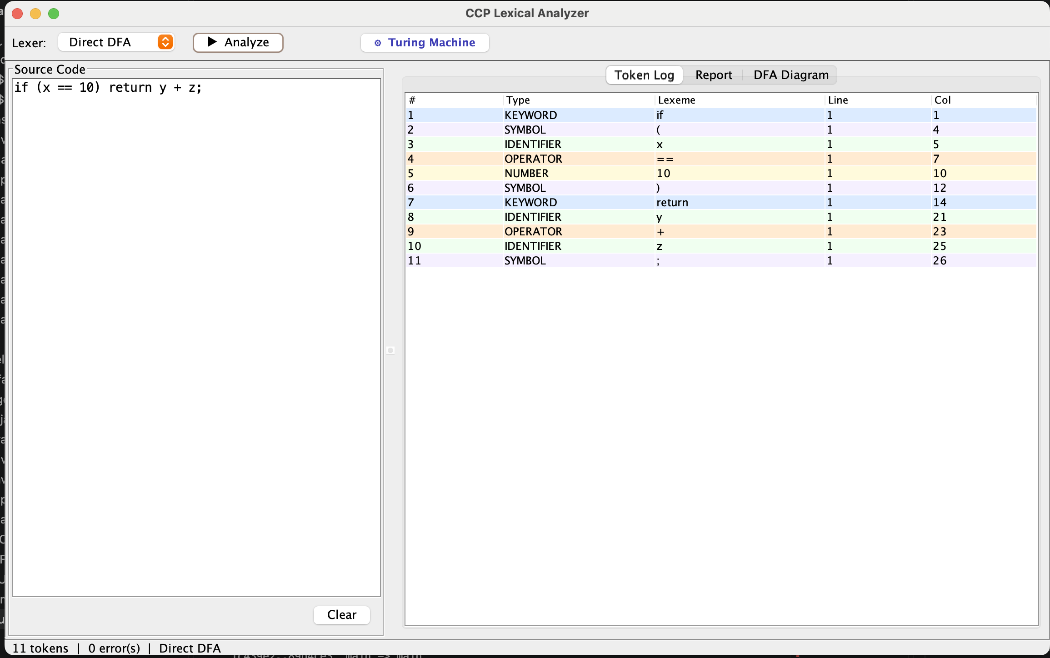
Figure 1 - Token Log tab: "if (x == 10) return y + z;" tokenized into 11 tokens (Direct DFA), colour-coded by TokenType with line/column tracking.
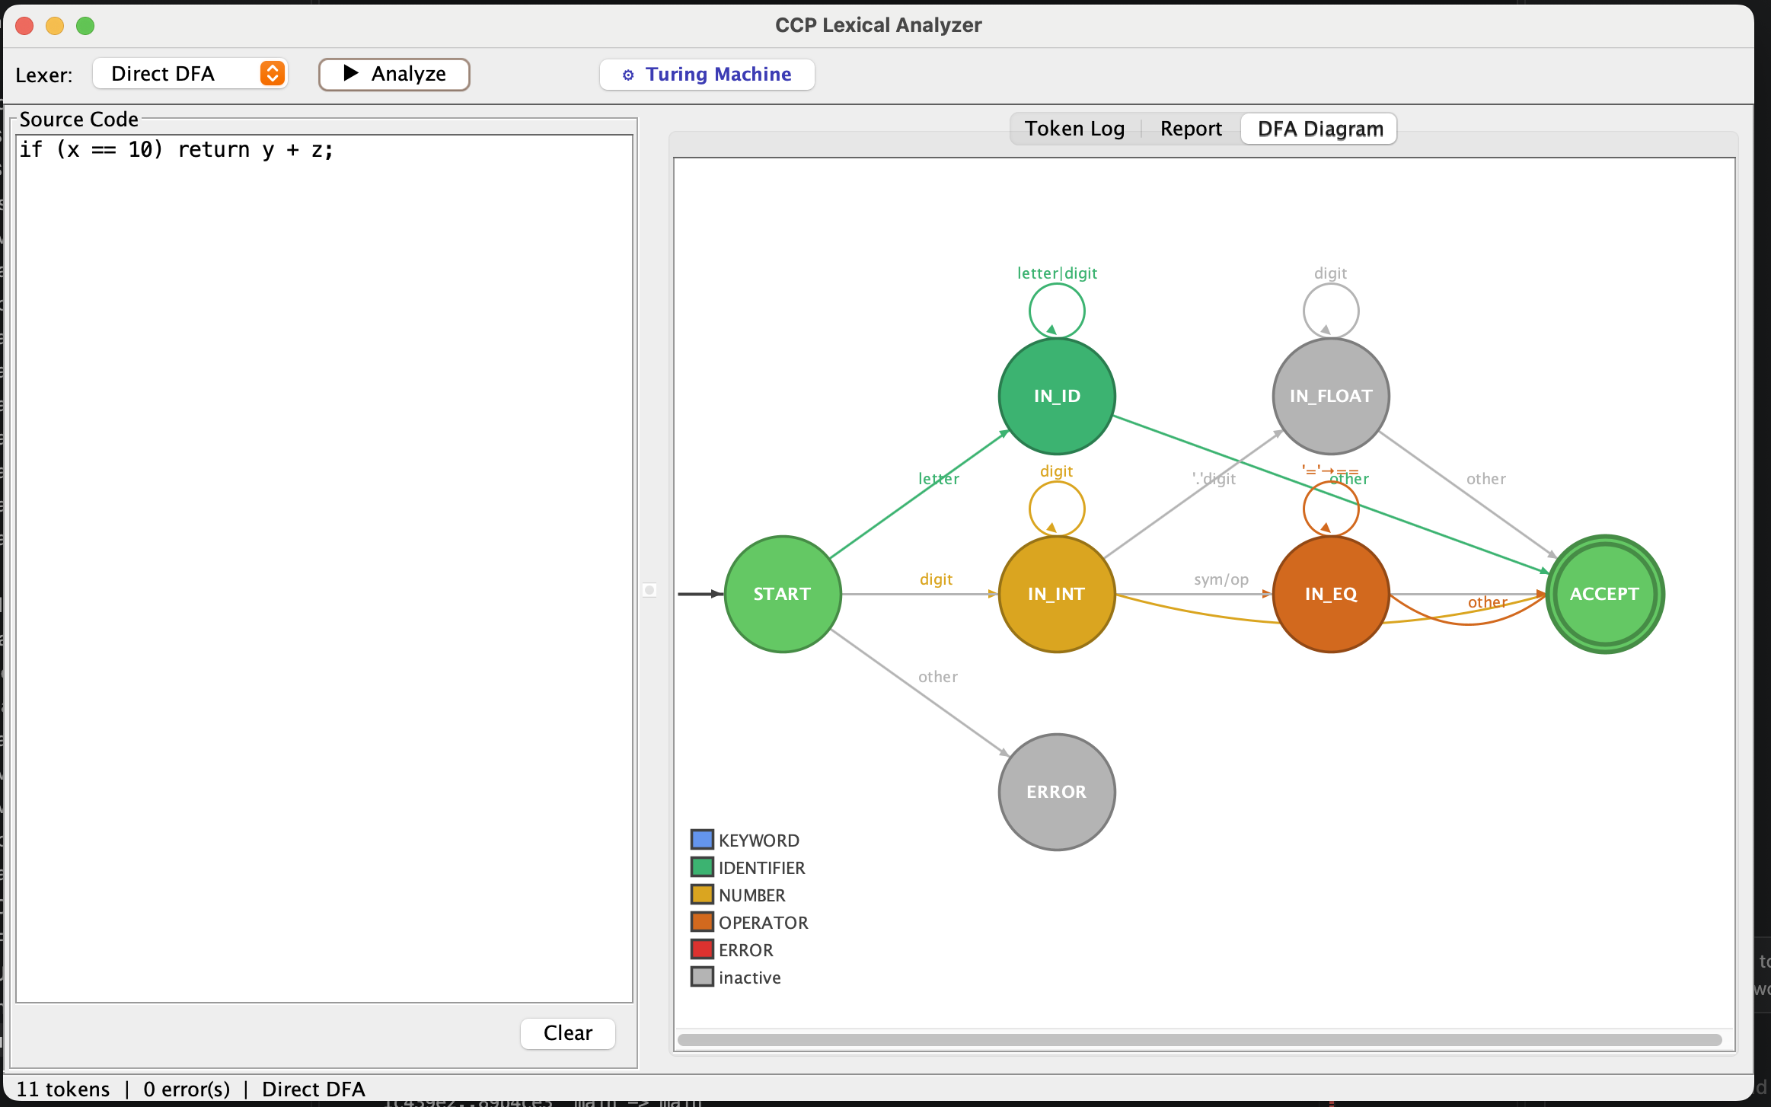
Figure 2 - DFA Diagram tab: live state diagram (START, IN_ID, IN_INT, IN_FLOAT, IN_EQ, ACCEPT, ERROR) with the colour legend used across the GUI.
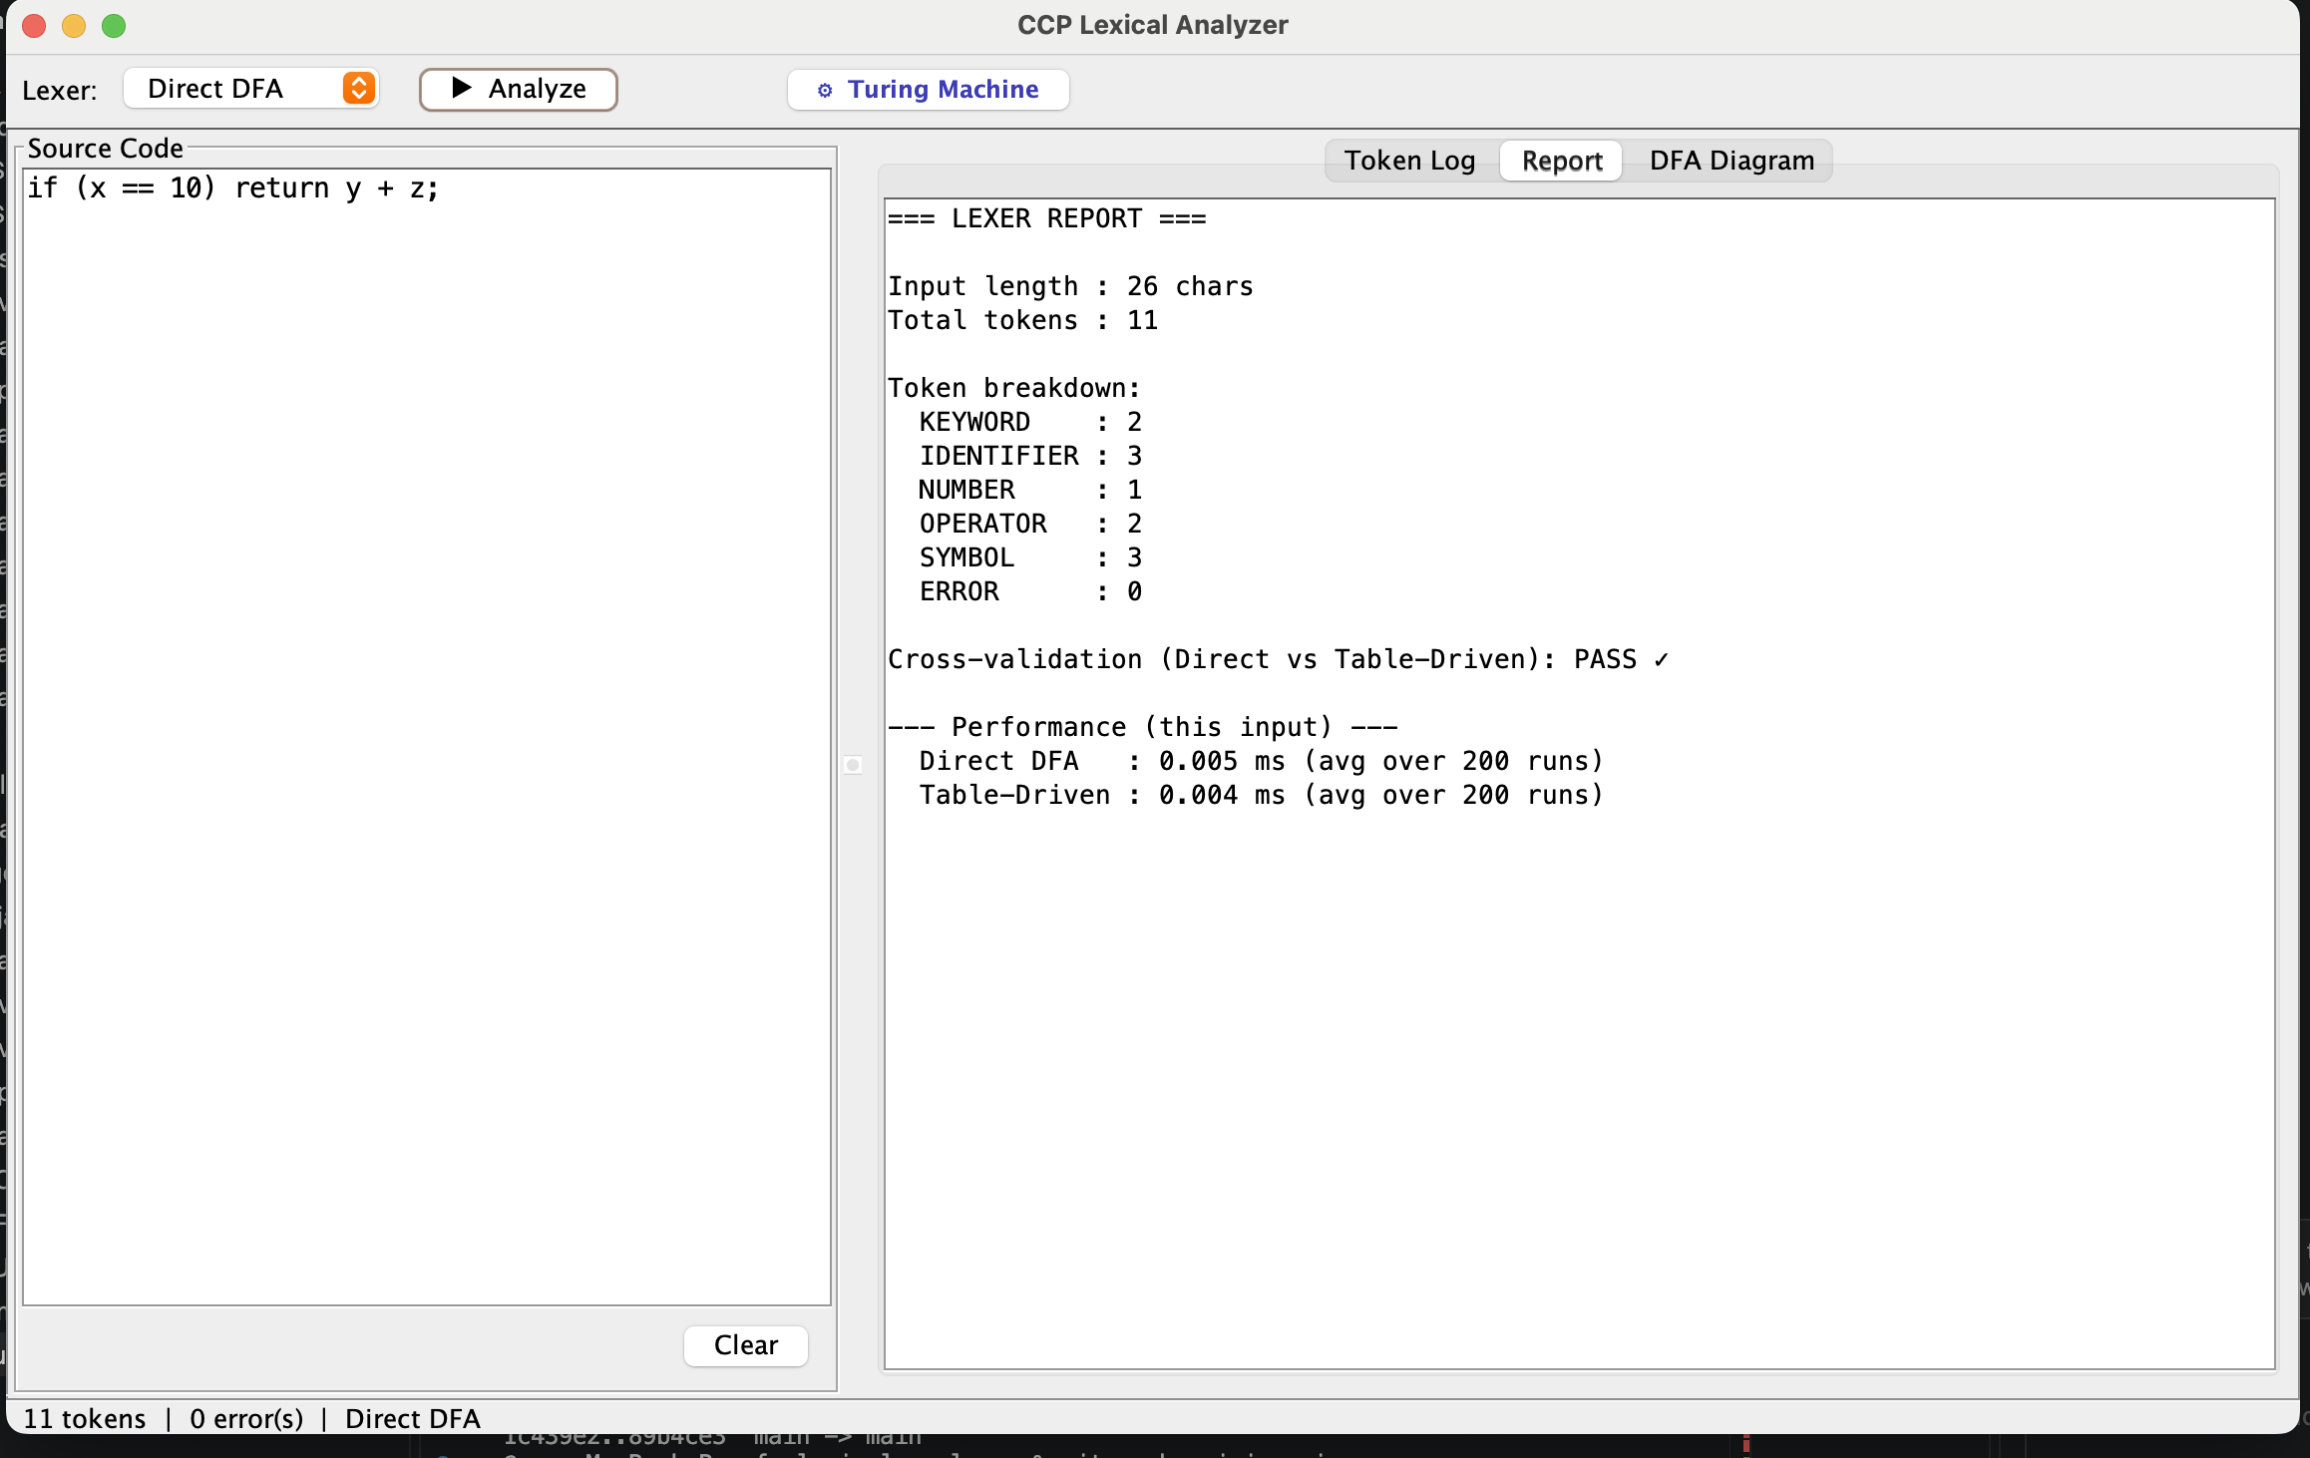
Figure 3 - Report tab: token-type breakdown, Direct-vs-Table-Driven cross-validation result (PASS), and per-input timing for both lexer engines.
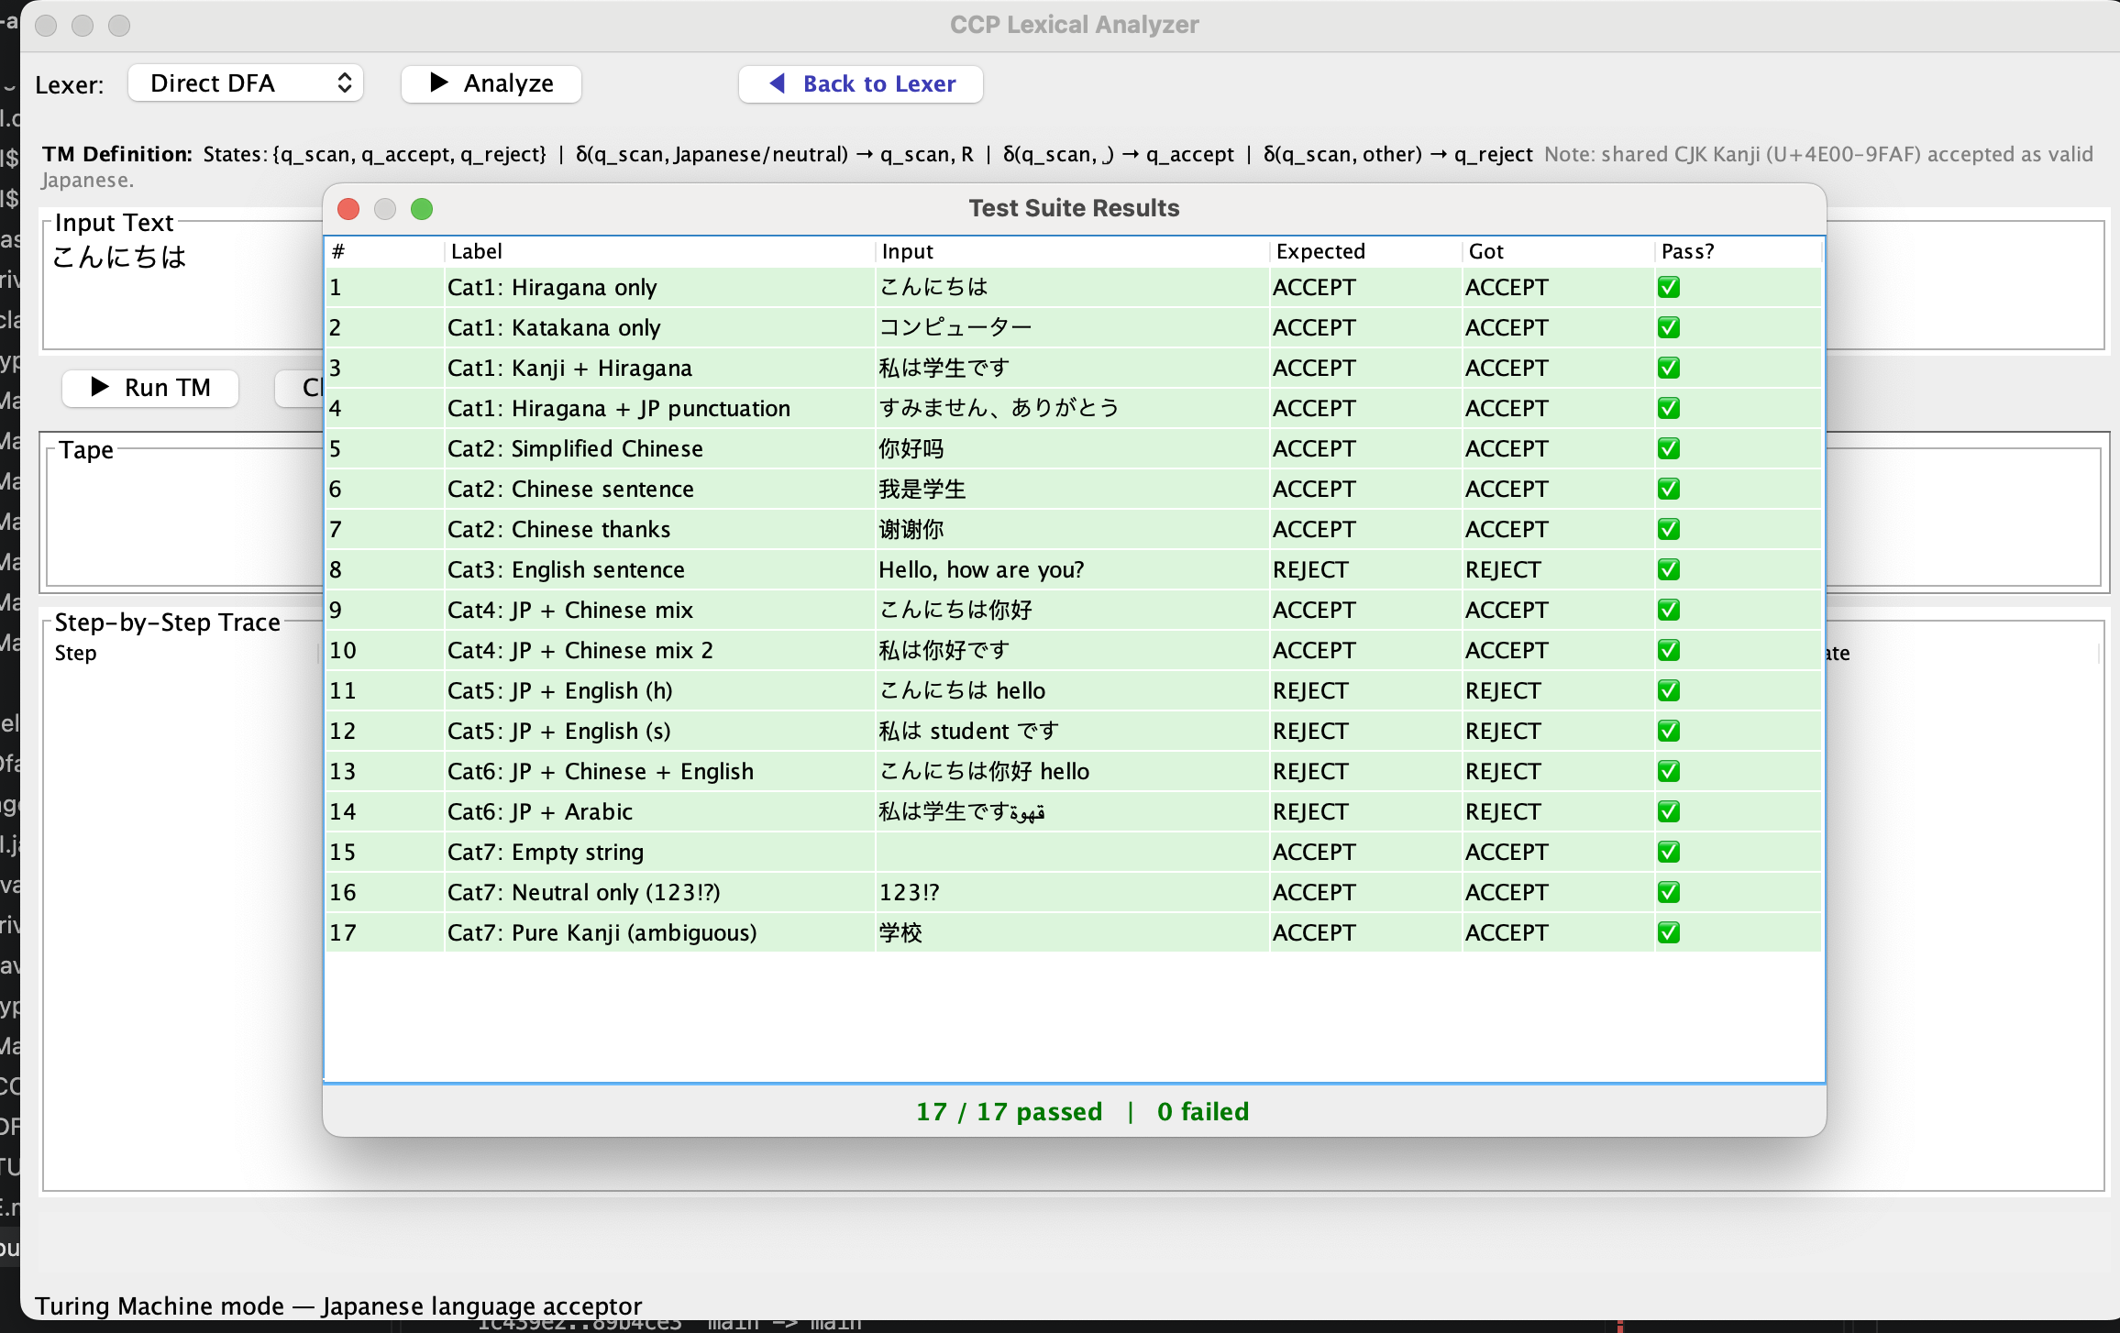
Figure 4 - Turing Machine mode: the built-in 17-case test suite, all passing, including the shared-Kanji Chinese-acceptance edge cases described in Section 7.6.

13. Conclusion
This project delivered two cross-validated lexical analyzers for a mini programming language — a Direct DFA and a Table-Driven DFA — built from a single shared language specification so they could never silently disagree. Across 27 regression tests, including tricky edge cases such as maximal munch on '===', malformed decimals like '3.14.15', and digit-letter runs like '123abc', both implementations produced identical token streams.
The benchmark showed that the two designs trade a small, roughly constant, runtime overhead (5–8%) for a real gain in maintainability: the table-driven engine can absorb new token categories as data rather than code, which is exactly why real-world tools such as lex and flex are built this way.
The Turing Machine extension moved beyond the DFA model to demonstrate an explicit tape-and-head computation, deciding whether input text is written entirely in Japanese script (Hiragana, Katakana, Kanji and full-width punctuation). While this particular decision problem remains regular, implementing it as a TM — rather than folding the check into a one-line boolean loop — mirrors the formal definition taught in the course and leaves room to extend the machine to genuinely non-regular checks in future work.

13.1 Possible Future Work
- Extend the grammar with comments, string literals, and additional operators (e.g. <, >, &&, ||).
- Add a parser (syntax analyzer) on top of the token stream to build a full compiler front end.
- Extend the Turing Machine to a genuinely non-regular check, such as verifying balanced full-width brackets 「 」 within the Japanese text.
- Package the Swing GUI as a standalone executable JAR for easier distribution.

