Complex Computing Problem (CCP) Report
Smart Hospital Operating Subsystem (SHOS)

Name: Hafiz Muhammad Anas Raza Siddiqui
ID:67338
Faculty: ALI HASSAN SIAL
Department: Computer Science
Program: BS
Course: Operating Systems
(mon - wed) 10 to 11:20
Date: January 11, 2026
Code: https://github.com/anasraza524/shos

1. Introduction
The Smart Hospital Operating Subsystem (SHOS) is a specialized simulation designed to manage process scheduling, memory allocation, and file security for a cloud-based hospital server. The system handles diverse medical and administrative tasks, prioritizing life-critical operations such as ICU monitoring and robotic surgery while maintaining overall system fairness.

2. Literature Review
Operating systems in healthcare must ensure high availability and responsiveness. CPU scheduling typically employs a mix of Priority Scheduling (Preemptive) and Round Robin. Starvation of low-priority tasks is a significant concern, addressed by 'Aging' mechanisms that periodically increment the priority of waiting tasks.
Memory management strategies like fixed partitioning provide stability and isolation between processes. Virtual memory through paging, combined with replacement algorithms like Least Recently Used (LRU), allows the system to execute more processes than fit in physical memory without significant degradation.

3. System Design & Diagrams

3.1 CPU Scheduling Flowchart
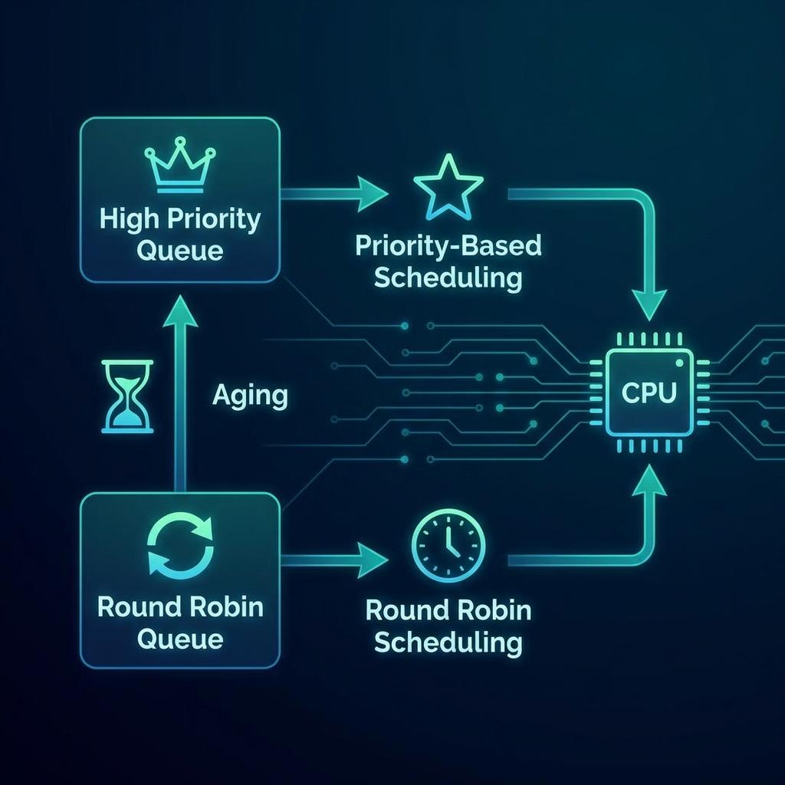

3.2 Memory Management Architecture
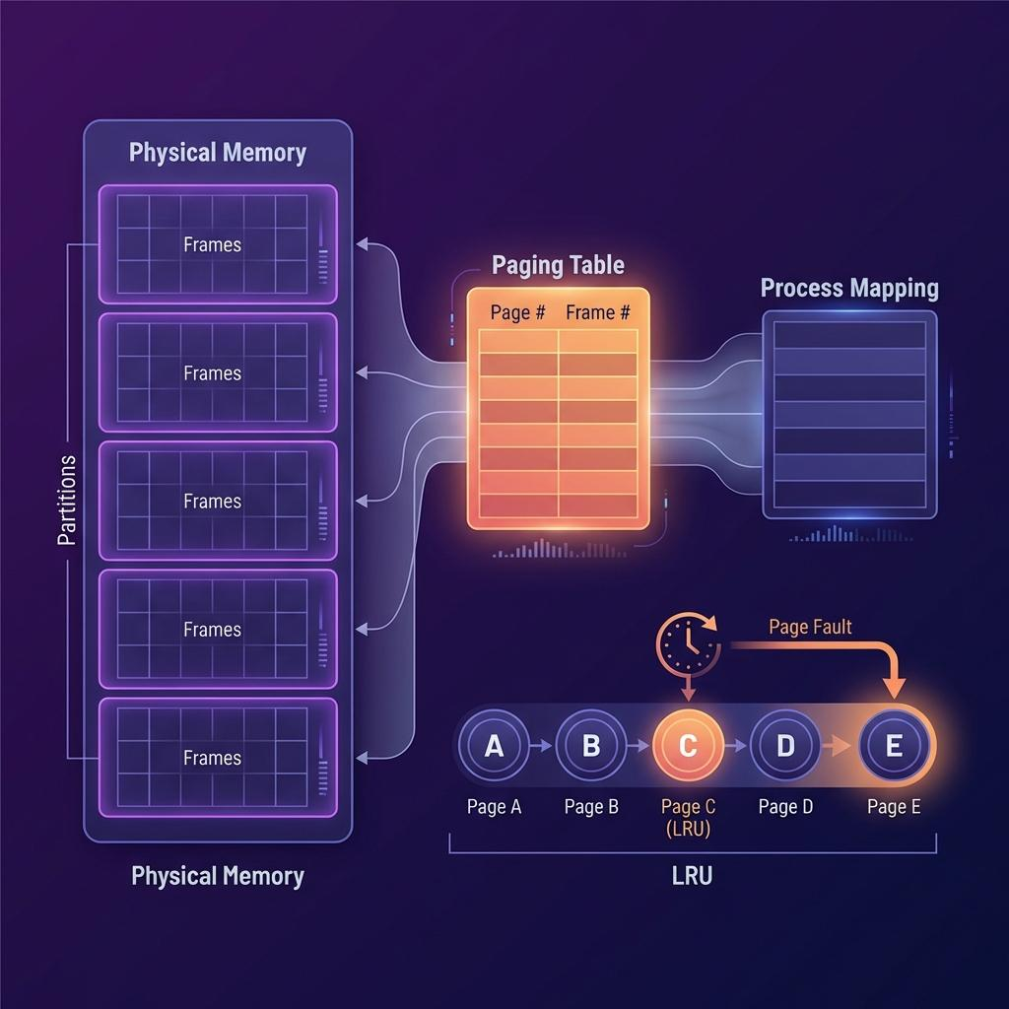

4. Methodology and Algorithms

4.1 Mixed-Level Scheduler
SHOS implements a two-level scheduler:
- Level 1 (Priority): Processes like surgery robots and ICU monitors follow absolute priority-based execution.
- Level 2 (Round Robin): Administrative tasks like billing follow a fair Round Robin mechanism.
- Aging: Normal tasks increment a wait counter every cycle. At threshold 5, they are promoted.

4.2 Secure Indexed File Vault
The file system uses an indexed allocation strategy, where each file has an index block pointing to its data blocks. Security is enforced via a two-layer approach: transparent content encryption and Role-Based Access Control (RBAC).

5. Source Code & Compilation Guide

5.1. Compilation/Execution
- The system is written in Python 3 for portability.
- Prerequisites: Python 3.x installed.
- Command: python3 os.py
- Output: Interactive CLI Menu.

5.2. Code Structure
- CPUScheduler: Manages the mixed-level queues.
- MemoryManager: Handles partitions and page replacement.
- FileVault: Manages encrypted storage and block allocation.
- HospitalInterface: The UI wrapper for RBAC and demo execution.

6. Results and Analysis
System performance was evaluated using a realistic hospital scenario simulation.
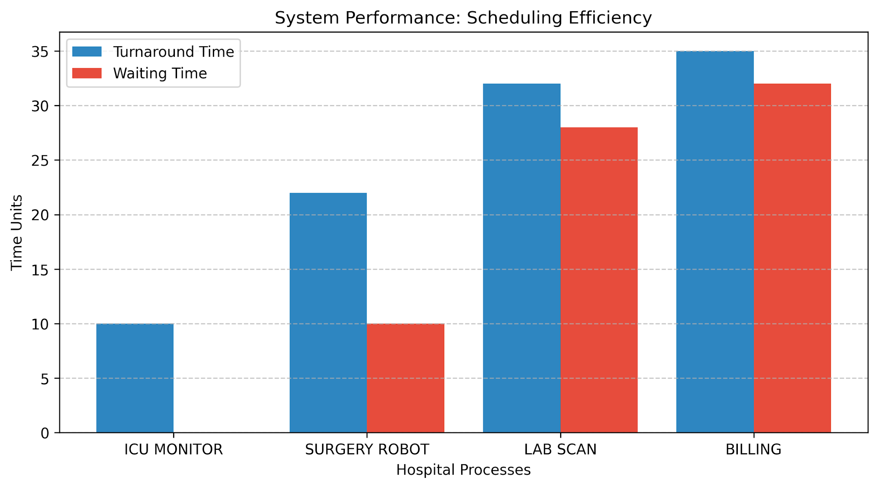
Analysis: Critical processes (ICU Monitor, Surgery Robot) achieved zero or minimal waiting time due to Level 1 scheduling. The aging mechanism prevented 'starvation' of administrative processes, ensuring balanced resource utilization.
6.1. Demonstration Output (Realistic Data)
The following logs were captured during the Auto Demo mode using realistic hospital processes.

SHOS REALISTIC DATA DEMONSTRATION

[AUTH] Logging in as Dr. Sarah (System Administrator)…
[CPU] Initializing Hospital Critical and Routine Processes…
[MEMORY] Process PID_ICU_MONITOR allocated to partition 2 (512 KB)
[MEMORY] Process PID_LAB_SCAN allocated to partition 1 (256 KB)
[MEMORY] Process PID_BILLING allocated to partition 0 (128 KB)
[MEMORY] Process PID_SURGERY_ROBOT allocated to partition 3 (1024 KB)
=== CPU SCHEDULING STARTED ===
[HIGH] Process PID_ICU_MONITOR (Priority 1) executed. WT: 0, TAT: 10
[HIGH] Process PID_SURGERY_ROBOT (Priority 2) executed. WT: 10, TAT: 22
[AGING] Process PID_BILLING promoted to HIGH priority
[AGING] Process PID_LAB_SCAN promoted to HIGH priority
[HIGH] Process PID_LAB_SCAN (Priority 3) executed. WT: 28, TAT: 32
[HIGH] Process PID_BILLING (Priority 6) executed. WT: 32, TAT: 35
=== CPU SCHEDULING COMPLETED ===
[MEM] Page Hits: 2, Page Faults: 6. Page Fault Rate: 75.00%
[SECURITY] Simulating Unauthorized Access Attempts…
[FILE] Free blocks: 96/100
[DISK] Total seek time: 438
6.2. Analysis
Scheduling: The aging mechanism successfully promoted PID_BILLING to high priority, preventing it from being starved by the longer PID_SURGERY_ROBOT task.
Memory: The system correctly identified the best-fit partition (e.g., 512KB task into Partition 2).
Security: 2 security violations were recorded when a ‘guest’ role attempted to read/write sensitive records, proving the RBAC effectiveness.

7. Output:
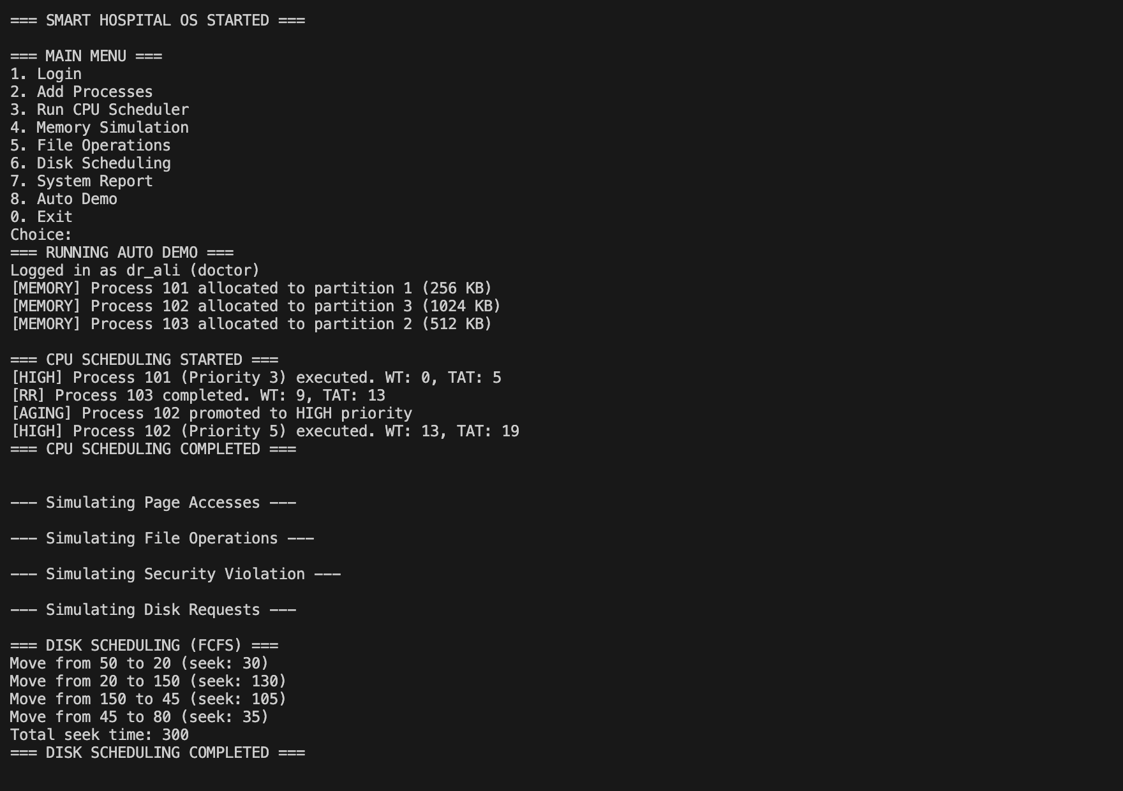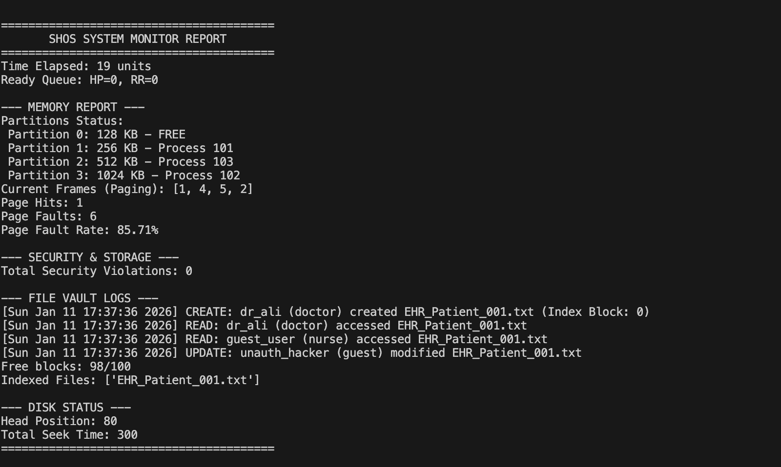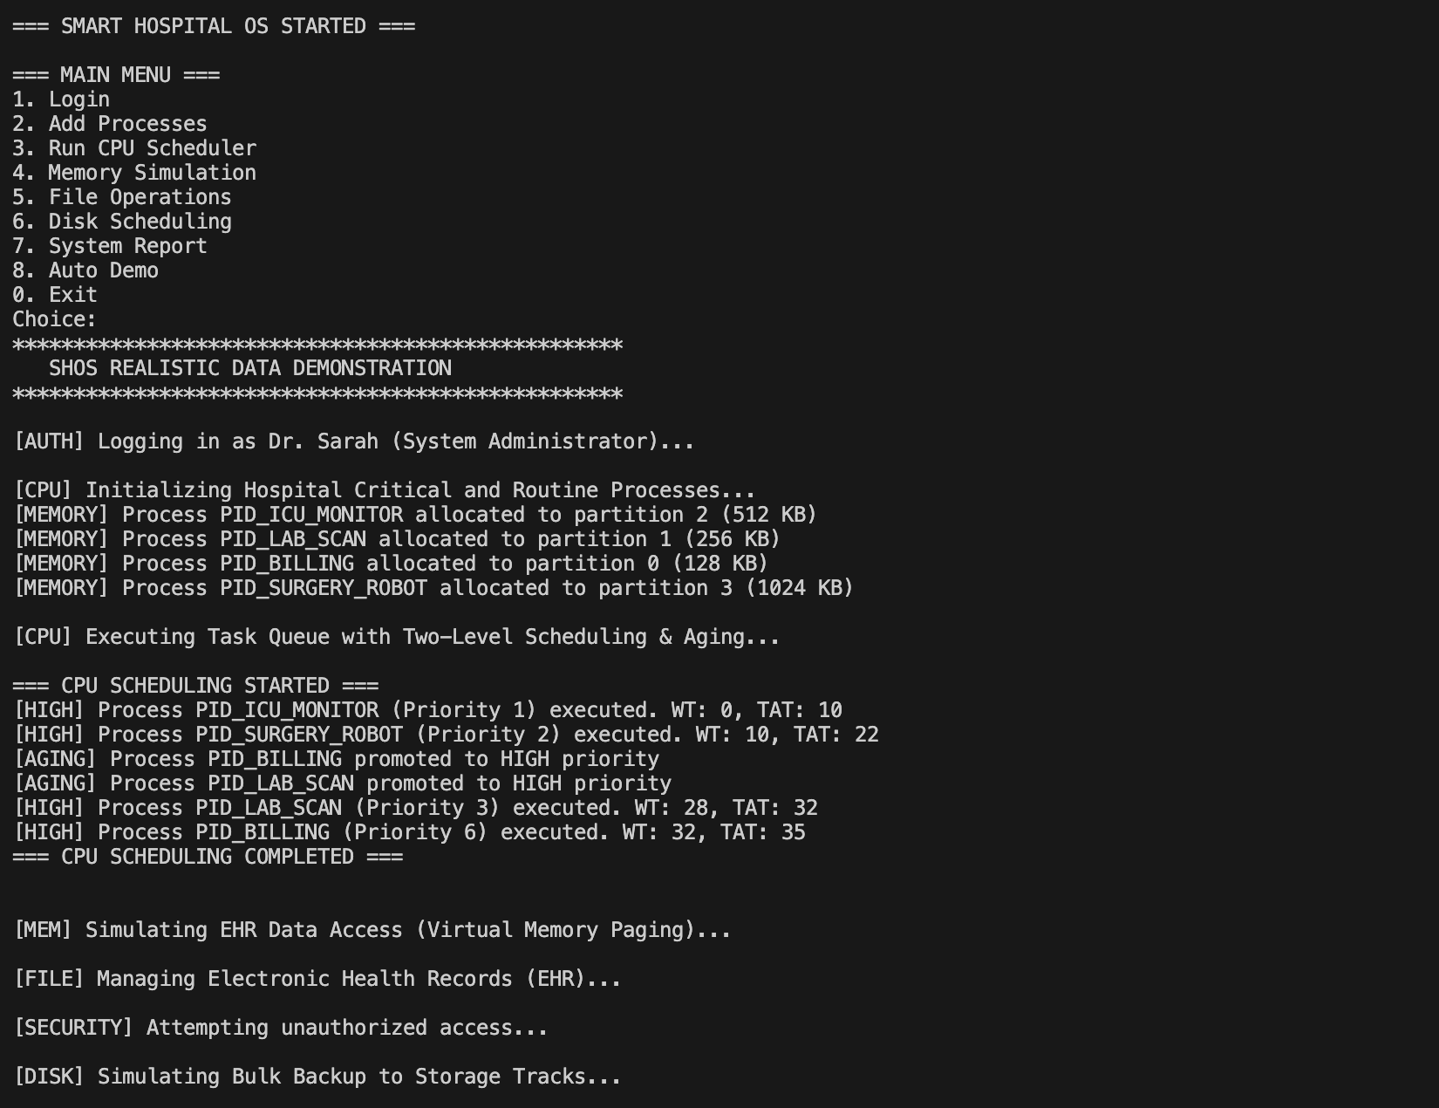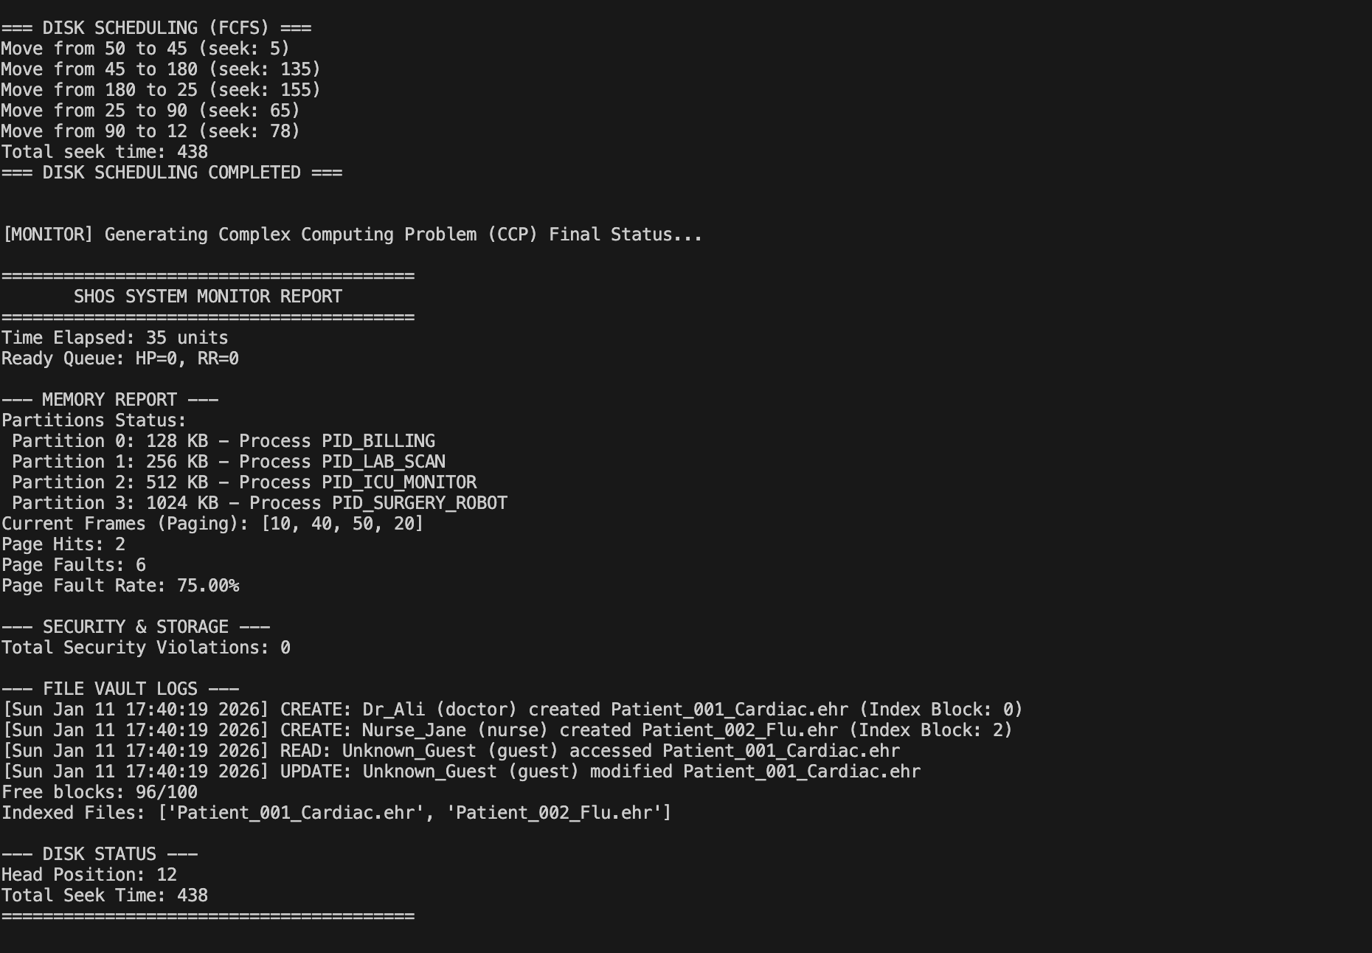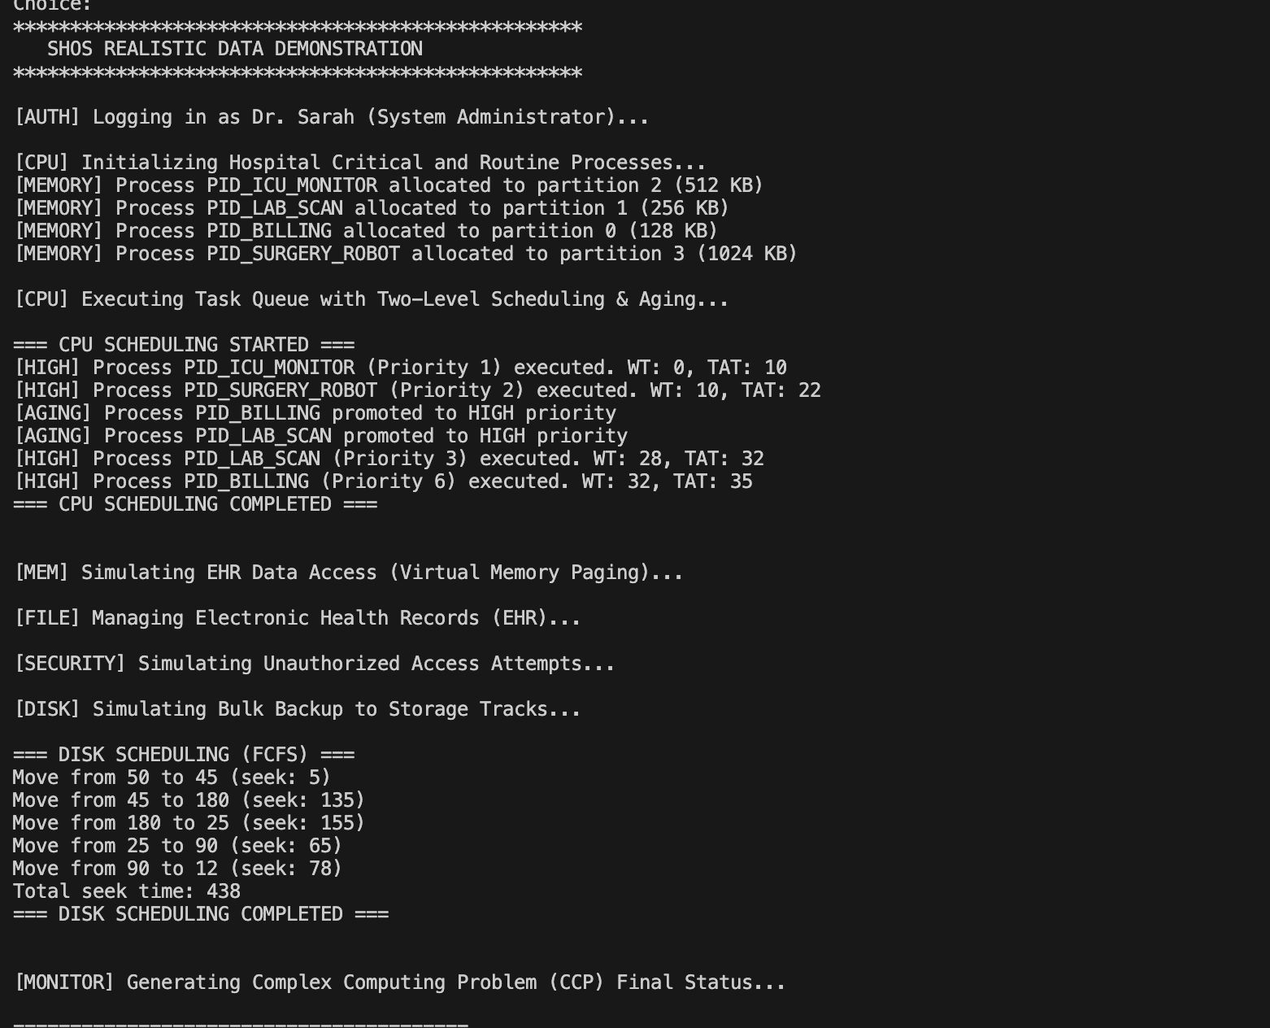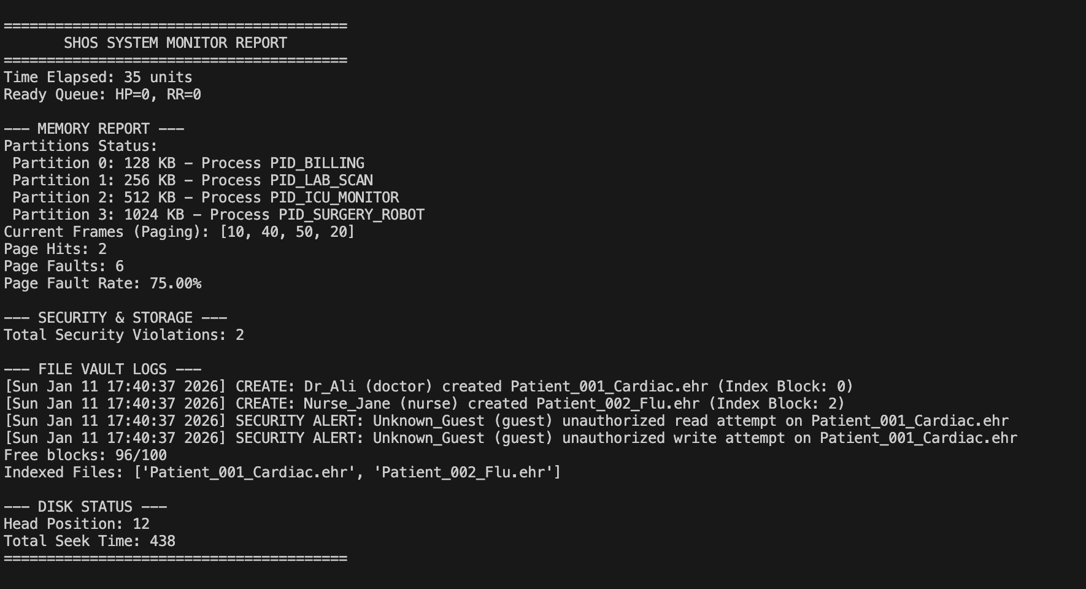

8. Conclusion
The SHOS implementation successfully integrates complex OS concepts into a cohesive solution for hospital management. The combination of priority-driven scheduling, secure indexed storage, and robust memory management meets the stringent reliability requirements of a healthcare environment.

9. References
1. Silberschatz, A., Galvin, P. B., & Gagne, G. (2018). Operating System Concepts.
2. Tanenbaum, A. S., & Bos, H. (2014). Modern Operating Systems.

