

**Deliverable 2:** The new ER diagram.

**Project Id :** 4

**Client :** OCP's Purchasing & Contract Management Unit

**Supervised by :** PR Karima ECHIHABI

**By :** ABERCHA Zineb

BOUDHAINE Ilyas

KEMMOUNE Anass

MOUIMI Oumaima

The new ER diagram :

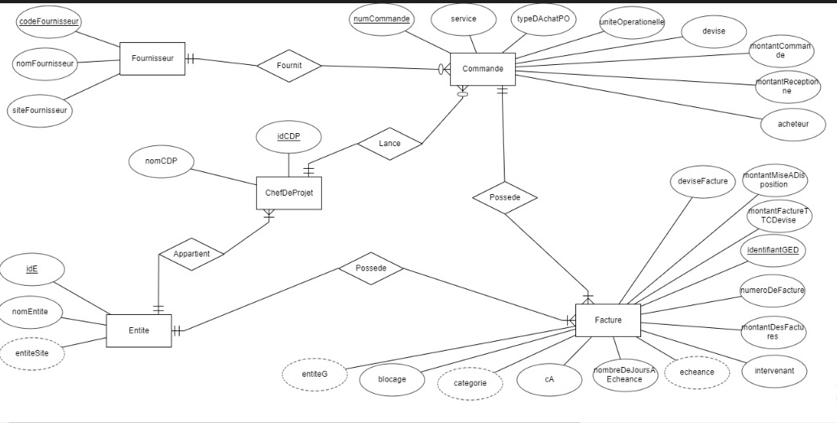

Updated version of the ER Diagram :

* We deleted the relationship “Gere” between the entities ChefDeProjet and Facture.
* We added a relationship “Possede” between the entities Entite and Facture for the following reason: We were told that the ChefDeProjet responsible on invoices(Facture) is the same one responsible on the order(Commande), but there’s a special case where when treating the invoices some of them may go under the supervision of a different , yet ChefDeProjet is still the same.
* We changed the notation of the attributes using upper camel case notation in order to match it with the names in the base table.
* We added the attributes “montantFactureTTCDevise” and “deviseFacture” to the entity Facture because it turned out that we need them for further calculations after our client provided us with more details.
* We changed “typeDeBlockage” to “blocage” in order to match the notation in the base table.
* Noting that cA stands for contract admin.