**Application** **log :**

**1. Signup :**

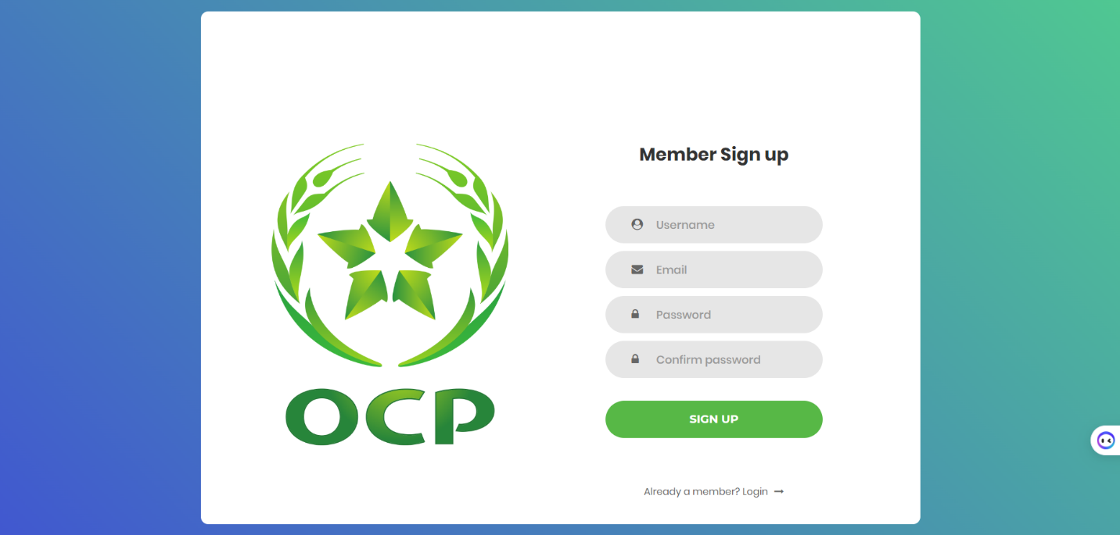

**2. Login :**

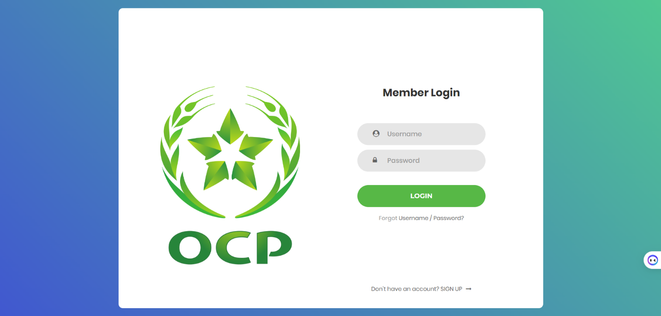

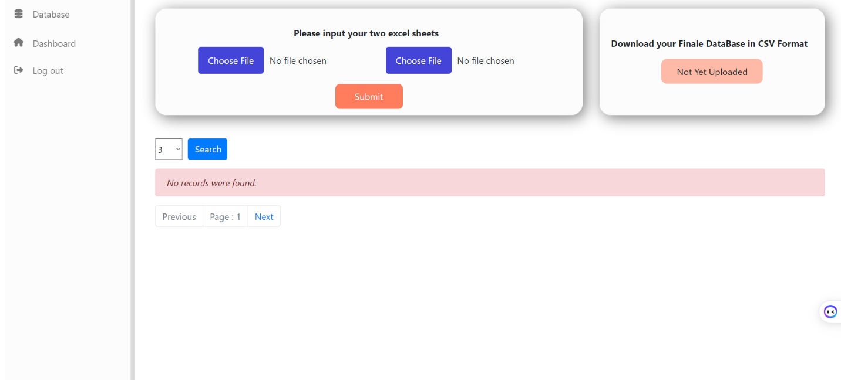**3. Home page :**

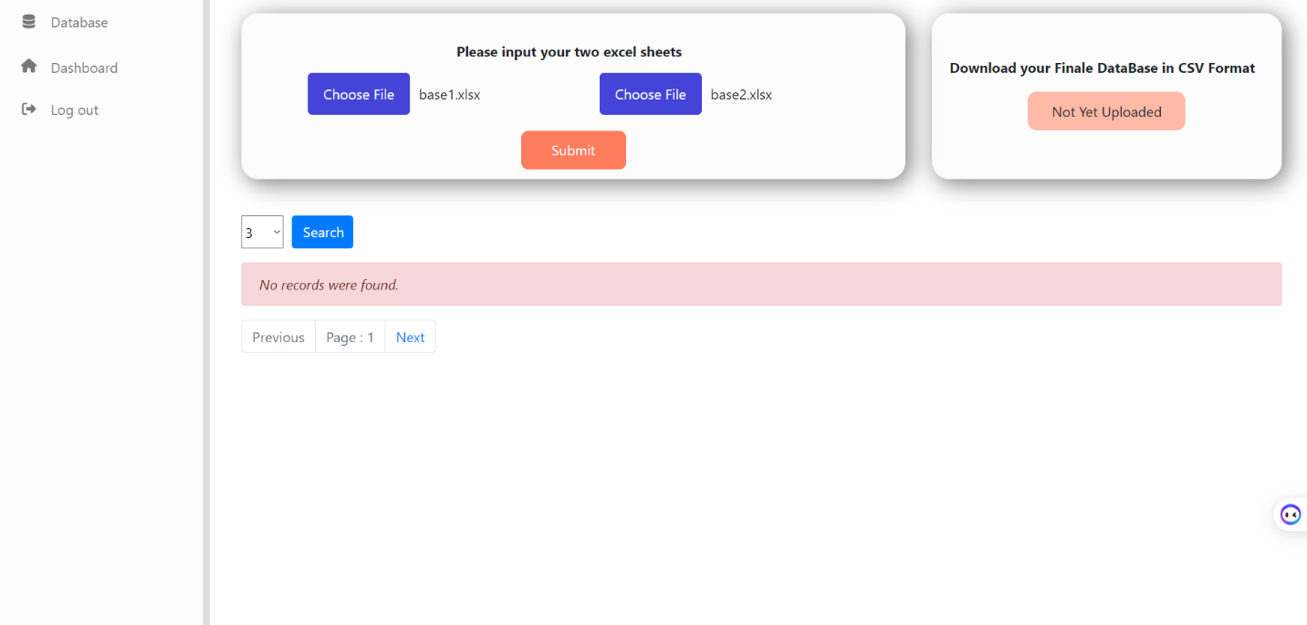**4.Upload the invoices datasheets :**

**4.Upload the invoices datasheets :**

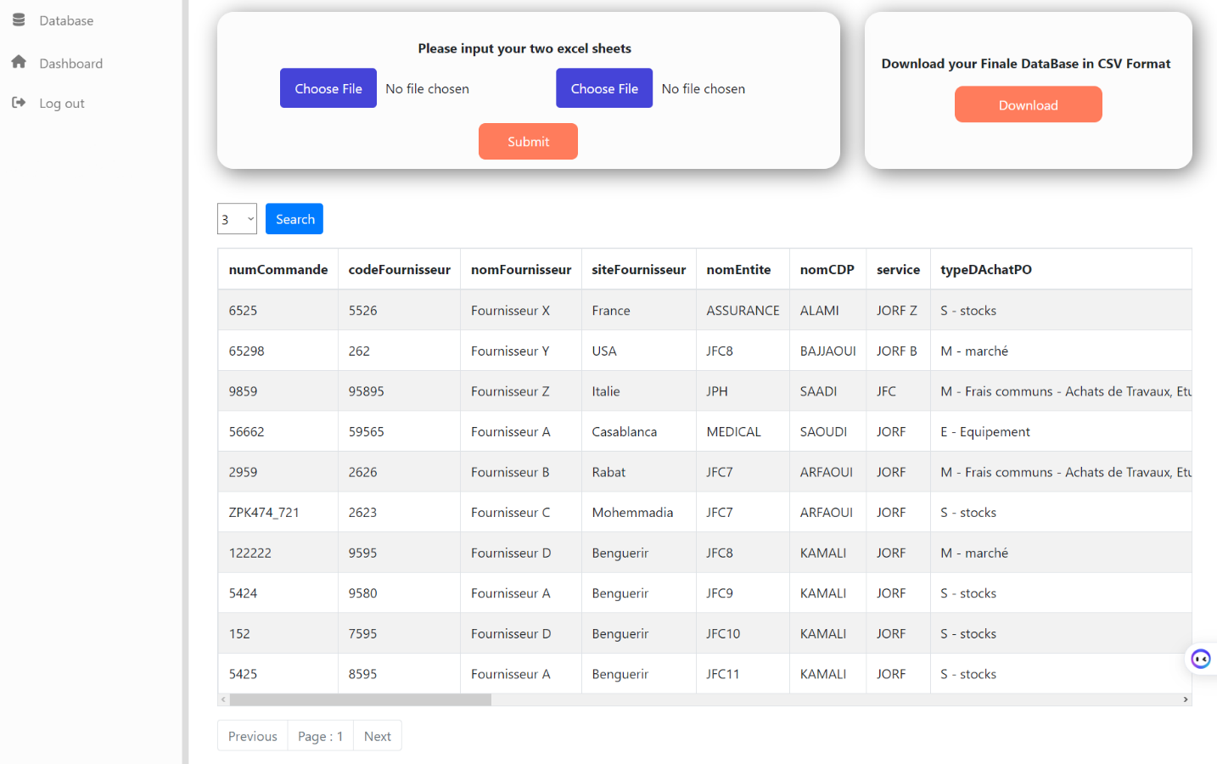

**5. Download the resulting datasheet:**

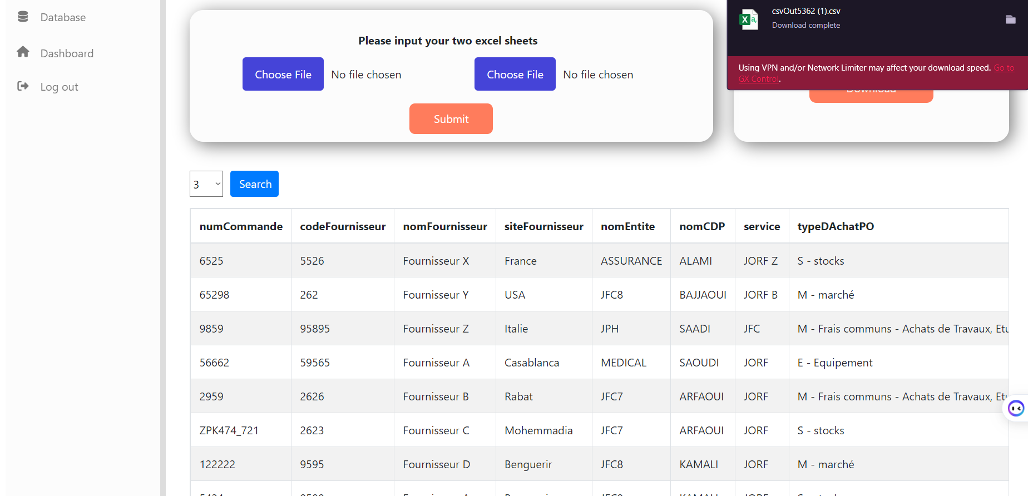

**6. Dashboard page :**

Which includes insights corresponding to the invoices.

