**Performance log file :**

1. **Insertion of 1 000 000 row in the database:**

mysql> LOAD DATA INFILE 'C:/ProgramData/MySQL/MySQL Server 8.0/Uploads/fournisseur100.csv'

-> INTO TABLE `fournisseur`

-> FIELDS TERMINATED BY ','

-> ENCLOSED BY '"'

-> LINES TERMINATED BY '\r\n'

-> IGNORE 1 ROWS;

Query OK, 19 rows affected (0.01 sec)

Records: 19 Deleted: 0 Skipped: 0 Warnings: 0

mysql>

mysql> LOAD DATA INFILE 'C:/ProgramData/MySQL/MySQL Server 8.0/Uploads/entite100.csv'

-> INTO TABLE `entite`

-> FIELDS TERMINATED BY ','

-> ENCLOSED BY '"'

-> LINES TERMINATED BY '\r\n'

-> IGNORE 1 ROWS;

Query OK, 10 rows affected (0.00 sec)

Records: 10 Deleted: 0 Skipped: 0 Warnings: 0

mysql>

mysql> LOAD DATA INFILE 'C:/ProgramData/MySQL/MySQL Server 8.0/Uploads/cdp100.csv'

-> INTO TABLE `chefdeprojet`

-> FIELDS TERMINATED BY ','

-> ENCLOSED BY '"'

-> LINES TERMINATED BY '\r\n'

-> IGNORE 1 ROWS;

Query OK, 100 rows affected (0.00 sec)

Records: 100 Deleted: 0 Skipped: 0 Warnings: 0

mysql>

mysql> LOAD DATA INFILE 'C:/ProgramData/MySQL/MySQL Server 8.0/Uploads/commande100.csv'

-> INTO TABLE `commande`

-> FIELDS TERMINATED BY ','

-> ENCLOSED BY '"'

-> LINES TERMINATED BY '\r\n'

-> IGNORE 1 ROWS;

Query OK, 499999 rows affected (11.02 sec)

Records: 499999 Deleted: 0 Skipped: 0 Warnings: 0

mysql>

mysql> LOAD DATA INFILE 'C:/ProgramData/MySQL/MySQL Server 8.0/Uploads/facture100ca.csv'

-> INTO TABLE `facture`

-> FIELDS TERMINATED BY ','

-> ENCLOSED BY '"'

-> LINES TERMINATED BY '\r\n'

-> IGNORE 1 ROWS;

Query OK, 1000000 rows affected (33.89 sec)

Records: 1000000 Deleted: 0 Skipped: 0 Warnings: 0

1. **Performance before using an unclustered index on cA column:**

It took 1.953sec.

1. **Performance after using an unclustered index on cA column:**

It took 0.000sec.

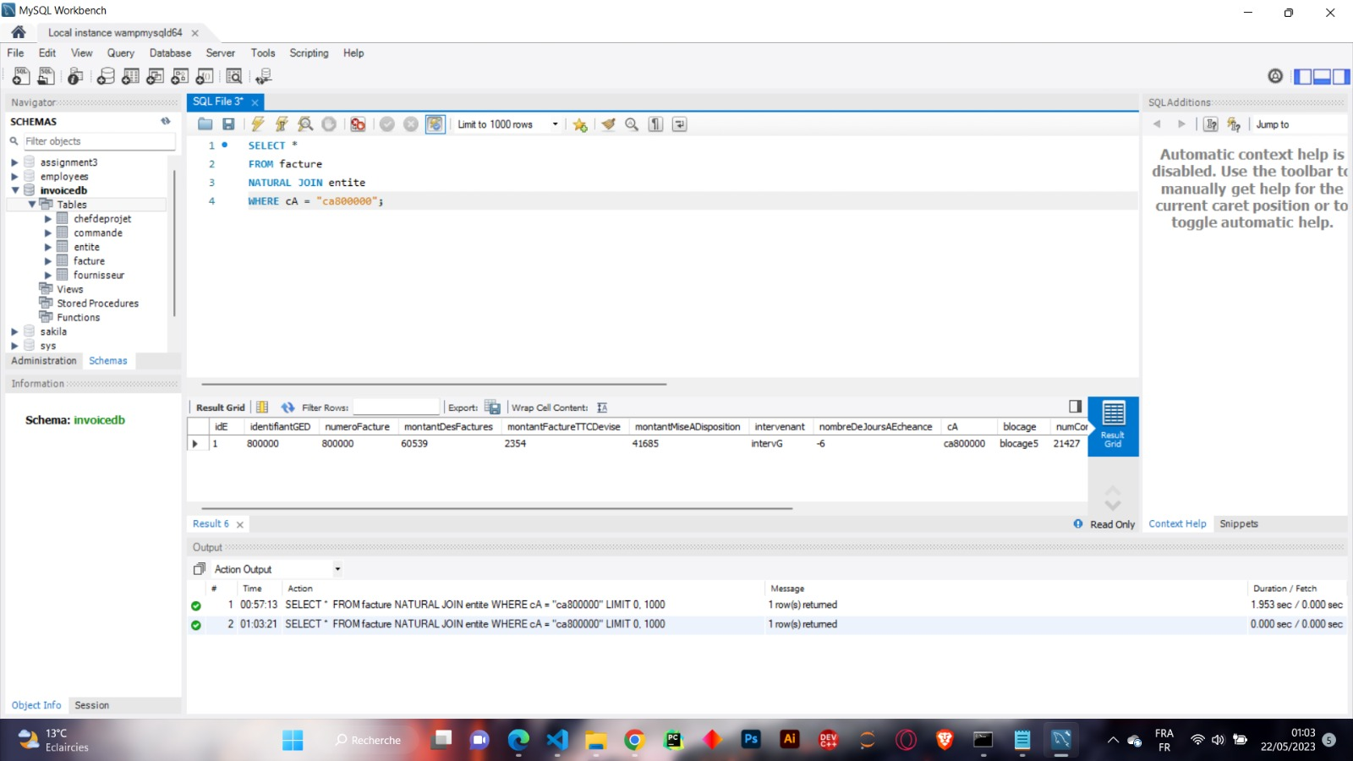

Before using index index

After using index

Query executed