Web Application Security Assessment Report

1. Vulnerability: Privilege Escalation via Role Manipulation (Broken Access Control)

Severity
Critical – This vulnerability may allow a regular authenticated user to gain administrative privileges.

Description
The application suffers from a Broken Access Control vulnerability. A regular authenticated user is able to escalate their privileges to administrator by modifying the 'role' field in the profile update request. The backend API does not properly validate or enforce authorization rules for sensitive attributes such as user roles.

Affected Component
Profile update endpoint (example: PUT api/v1/users/:id).

Steps to Reproduce
1. Authenticate as a normal user.
2. Intercept the profile update request using Burp Suite.
3. Modify the request body to change the role value.
Example request:
PUT /api/profile
Content-Type: application/json
{
"role": "admin"
}

Impact
An attacker could escalate privileges from a standard user account to an administrator account. This would allow the attacker to access administrative functionalities, modify sensitive data, manage other users, or perform other high‑privilege operations. In severe cases, this may lead to full system compromise.

Recommendation
Security-sensitive fields such as roles must not be modifiable by regular users. The backend should enforce strict authorization checks and ignore or reject any role modifications unless the request is performed by an authorized administrator. Additionally, role validation should be implemented server-side.
Example : burp suite
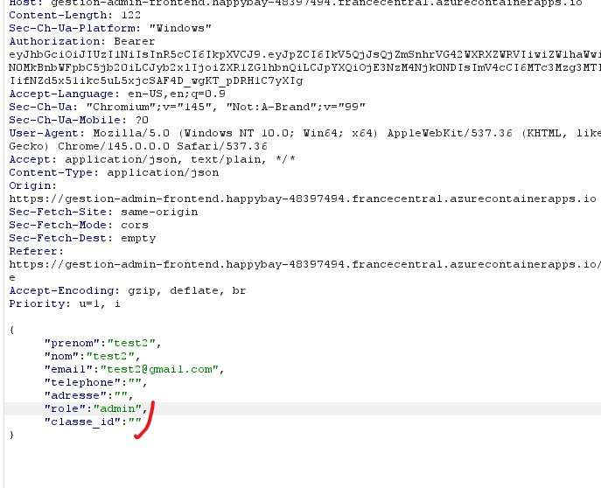
Other broken access control In registration

{
"nom": "attacker",
"prenom": "attacker",
"email": "attacker@admin.com",
"password": "admin123",
"role": "admin",
"isActive": true
}
Send the request. If you receive a 200 OK and can then log in with administrative privileges, the vulnerability is confirmed.
Impact
- Immediate privilege escalation – attacker gains full admin rights without needing to compromise an existing account.
- If isActive can be set to true, even unapproved accounts become active.
- Combined with other misconfigurations (e.g., missing email verification), the attacker can instantly take over the system.
Remediation
- Never trust client-supplied values for security-critical fields.
- The backend should ignore role, isActive, and any similar fields during registration.
- Roles should be assigned server-side based on business logic (e.g., first user gets admin, or only via an admin-only endpoint).
- Use a whitelist of allowed fields and explicitly define which ones are writable by the client.
This finding aligns with the Privilege Escalation vulnerability already documented in your report, but it affects the registration flow. You can add it as an additional attack vector in the same section or as a separate finding.

2. Vulnerability: Missing Rate Limiting on Authentication Endpoint

Severity
High – Allows attackers to perform unlimited login attempts.

Description
The login endpoint does not implement rate limiting or account lockout mechanisms. As a result, an attacker can repeatedly send authentication requests in order to guess valid credentials through brute force attacks.

Affected Component
Authentication endpoint (example: POST /api/login).

Steps to Reproduce
1. Navigate to the login page.
2. Intercept the authentication request using Burp Suite.
3. Send multiple login attempts with different passwords.
Example request:
POST /api/login
Content-Type: application/json
{
"email": "user@test.com",
"password": "wrongpassword"
}
4. Repeat the request many times (50–100+ attempts).
5. Observe that the application does not enforce rate limiting, does not trigger CAPTCHA, and does not temporarily lock the account.

Impact
Attackers may systematically attempt a large number of password guesses until they discover valid credentials. If weak passwords are used, this could lead to unauthorized access to user accounts or administrative accounts.

Recommendation
The application should implement rate limiting on authentication endpoints. Additional protections such as temporary account lockout, CAPTCHA challenges, and monitoring of suspicious login activity should also be implemented.

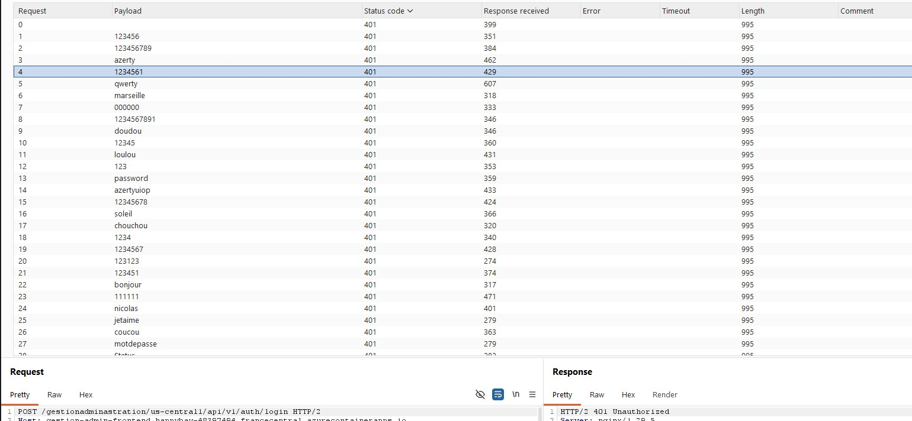
3.Vulnerability: Missing Input Size Validation
Payload Example:
json
{
"email": "test@test.com",
"password": "[VERY LONG STRING - 1000+ characters]"
}
Severity: Low to Medium (depending on impact)
Description:
The application accepts extremely long password strings without validation. While the server returns a 400 error, processing such large payloads could potentially lead to:
- Increased memory consumption
- CPU processing overhead
- Potential DoS vector if combined with multiple requests
Steps to Reproduce:
- Send a login request with a password field containing 1000+ characters
- Observe the server response time and resource usage
- Attempt multiple concurrent requests to test for resource exhaustion
Recommendation:
- Implement maximum length validation on password fields (e.g., 128 characters)
- Add rate limiting to prevent abuse
- Consider rejecting oversized payloads at the web server/load balancer level
- Continue using generic error messages (which appears to be already implemented correctly)

Impact:
- Attackers can attempt to exhaust server resources by sending oversized payloads
- Potential memory-based DoS if the server attempts to process extremely large passwords
- The application lacks proper input validation limits
Recommendation:
- Implement strict input size limits (e.g., maximum password length of 128 characters)
- Add rate limiting to prevent brute force and resource exhaustion attacks
- Validate and reject oversized payloads before processing
- Continue using generic error messages (which is already being done correctly)
- Consider implementing request size limits at the web server/application level
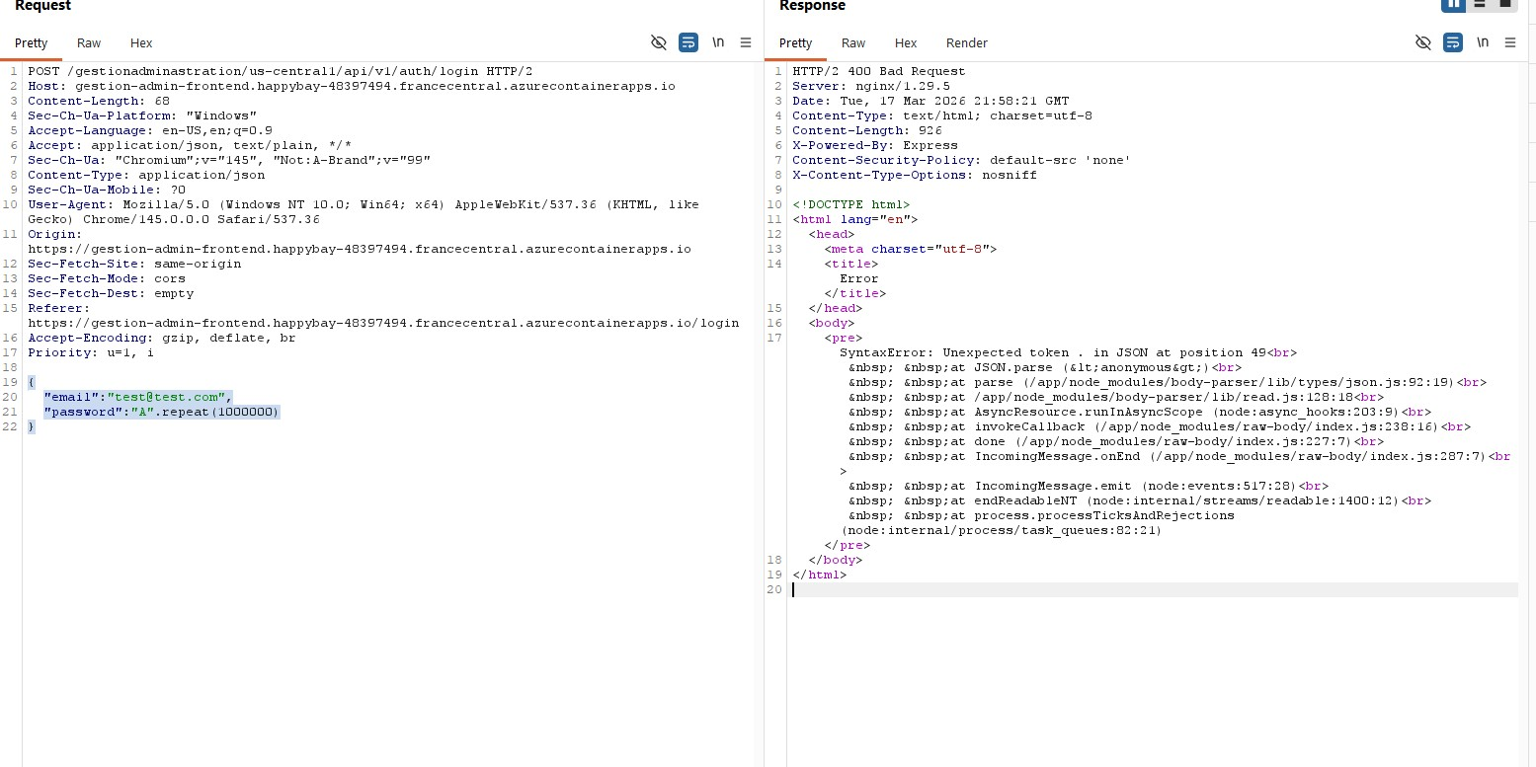

4. Vulnerability: Insecure Application Architecture
Severity
High – Weak architectural decisions can create multiple security vulnerabilities.
Description
The application architecture allows the frontend to handle critical security logic, such as role validation, without proper enforcement on the backend. The backend trusts client input for sensitive operations, including role assignments and account status changes.
Affected Component
Frontend application, backend API endpoints responsible for authorization and role management.
Steps to Reproduce
1. Analyze frontend code to identify security logic handled client-side.
2. Intercept API requests and modify sensitive fields (e.g., role, isActive).
3. Observe if the backend accepts the manipulated requests without server-side validation.
Impact
An attacker can bypass frontend restrictions and perform unauthorized actions, such as privilege escalation, access to restricted endpoints, or manipulation of sensitive data. Poor architectural decisions amplify the impact of other vulnerabilities.
Recommendation
Move all critical security logic to the backend. Implement server-side authorization checks, input validation, and role enforcement. Trust the client only for UI purposes, never for enforcing security controls.

5. Vulnerability: Firebase Injection Vectors & Misconfiguration
Severity
Medium – Potential for unauthenticated data exposure or backend abuse.
Description
During the assessment, various NoSQL injection payloads were tested against the login endpoint (e.g., {"email":"test@test.com","password":{"$ne":null}}). The server consistently returned 500 Internal Server Error for all injected payloads, indicating that the backend does not accept NoSQL operators in these fields. However, the persistent 500 errors reveal that the server does not gracefully handle unexpected input—a vulnerability in itself that could lead to information leakage or denial-of-service if exploited further.
Furthermore, the application is built on Firebase (as evidenced by the path /us-central1/api/v1/auth/login). The following potential misconfigurations were identified:
- The Firebase configuration may be exposed in the frontend (search for firebaseConfig).
- Direct database endpoints (Realtime Database, Firestore, Storage) might be publicly accessible.
- Other Cloud Functions may be vulnerable to injection or misconfigured.
- An API key found in the frontend could allow direct interaction with Firebase Auth REST API, bypassing application logic.
Steps to Reproduce (Next Steps)
- Locate Firebase Configuration
  - Open browser DevTools on the login page.
  - Search for firebaseConfig, apiKey, projectId, databaseURL, storageBucket.
  - Example:
javascript
firebase.initializeApp({
apiKey: "AIza...",
projectId: "happybay-48397494",
databaseURL: "https://happybay-48397494.firebaseio.com",
storageBucket: "happybay-48397494.appspot.com"
});

Impact
- If Firebase configuration is exposed, attackers can directly access databases or storage buckets, potentially reading or writing sensitive data.
- Publicly accessible Cloud Functions could lead to unauthorized actions.
- An exposed API key allows attackers to create new user accounts and escalate privileges without going through the application’s business logic.
Recommendation
- Secure Firebase configuration: never expose API keys or project IDs in client-side code. Use environment variables and backend-only initialization.
- Implement proper Firebase Security Rules to restrict read/write access based on authentication and authorization.
- Ensure all Cloud Functions are protected with authentication checks and input validation.
- Monitor and rate-limit Firebase Auth endpoints to prevent abuse.
- Review all Cloud Functions for injection vulnerabilities (NoSQL, command injection, etc.) and implement strict input validation.

