1. I have used the scikit implementation of SVM to train a classifier on the MNIST data for only the 3’s and 8’s. I did this by checking the label and only adding the training example if the label was a 3 or an 8. I wanted to add a snapshot of my code here but I am limited to a page for this analysis.

2. For this part I have used many variations of the kernel, C, the degree, gamma and the coefficient. A bigger C would make the margin smaller if that will do a better job at classifying the data. The C values did not affect my accuracy result at all. This could be due to the data being highly separable (big margin) and the high accuracy of the trails with a low C values support that idea. The kernel type parameter was the most influencing. Gamma also did affect my accuracy for the polynomial kernel by increasing the accuracy for higher values of gamma, which makes sense because a higher gamma would lessen the influence of each individual point.

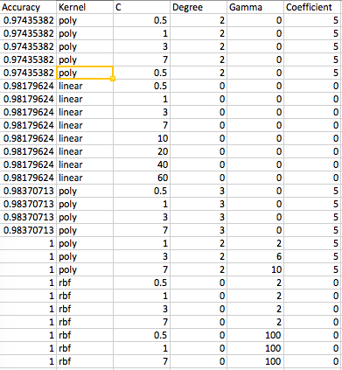

3.

