Final Project Report — Programming Fundamentals
University Name: FAST NUCES
Department: Computer Science
Course: Programming Fundamentals
Project Title: Connect 4 Console Game
Submitted By: Anas Sheikh(25K-0576) & Sheikh Muhammad Hammad(25K-0820)
Submitted To: Miss Izzah Salman
Semester: Fall 2025
Date: 24/11/25

Abstract
This project presents an enhanced version of the Connect 4 console game implemented in C. In addition to the traditional two-player mode, a new AI opponent has been introduced. At the start of the program, the user chooses whether to play against another human player or the computer. The AI uses a basic heuristic approach to determine its moves. The system continues to showcase essential programming fundamentals such as arrays, loops, conditional logic, and modular design. The introduction of AI adds complexity to decision-making logic and demonstrates how intelligent agents can be incorporated into classical board games using foundational programming concepts.

1. Introduction
Connect 4 is a popular strategy game in which players attempt to align four consecutive pieces horizontally, vertically, or diagonally on a 6×7 board. This project was developed to reinforce knowledge of C programming, with a new addition: an AI opponent mode. Players now begin by selecting whether they wish to compete against another human or the computer. The AI logic provides automated piece placement, making the gameplay more dynamic. The project emphasizes the use of arrays, nested loops, conditionals, input handling, and modular functions.

2. Objectives
• Implement the classic Connect 4 game using C programming fundamentals.
• Use 2D arrays to manage a 6×7 board.
• Add a menu to choose between Human vs Human and Human vs AI gameplay.
• Create a basic AI that selects valid columns automatically.
• Validate input and ensure error-free gameplay.
• Detect horizontal, vertical, and diagonal win conditions.
• Apply modular programming practices for readability and reusability.
• Create an engaging console-based game experience.

3. System Design
System Overview and Flow:
Start → Choose Game Mode (AI or Human Player) → Initialize Board → Display Board → Player/AI Move → Drop Piece → Check Win/Draw → Switch Turns → Continue/End
Algorithm: Flowchart:
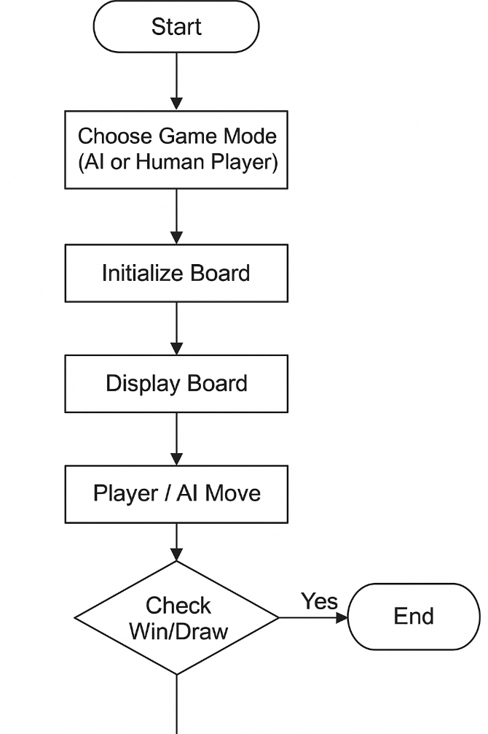
• Start program
Ask the user to choose game mode:
• Player vs Player
• Player vs AI
• Initialize a 6×7 board with empty spaces
• Display the board
• Ask current player for a column
• Validate input
• Drop piece in the selected column
• Check for win or draw
• Switch turns
• Repeat until game ends

4. Implementation
Language: C
Compiler/IDE: Code::Blocks / Dev-C++ / GCC
Key Features:
• 6×7 Connect 4 grid
• Player vs Player or Player vs AI mode
• Gravity-based piece placement
• AI decision-making for valid column selection
• Input validation
• Win detection in all directions
• Replay option
CODE SNIPPET:
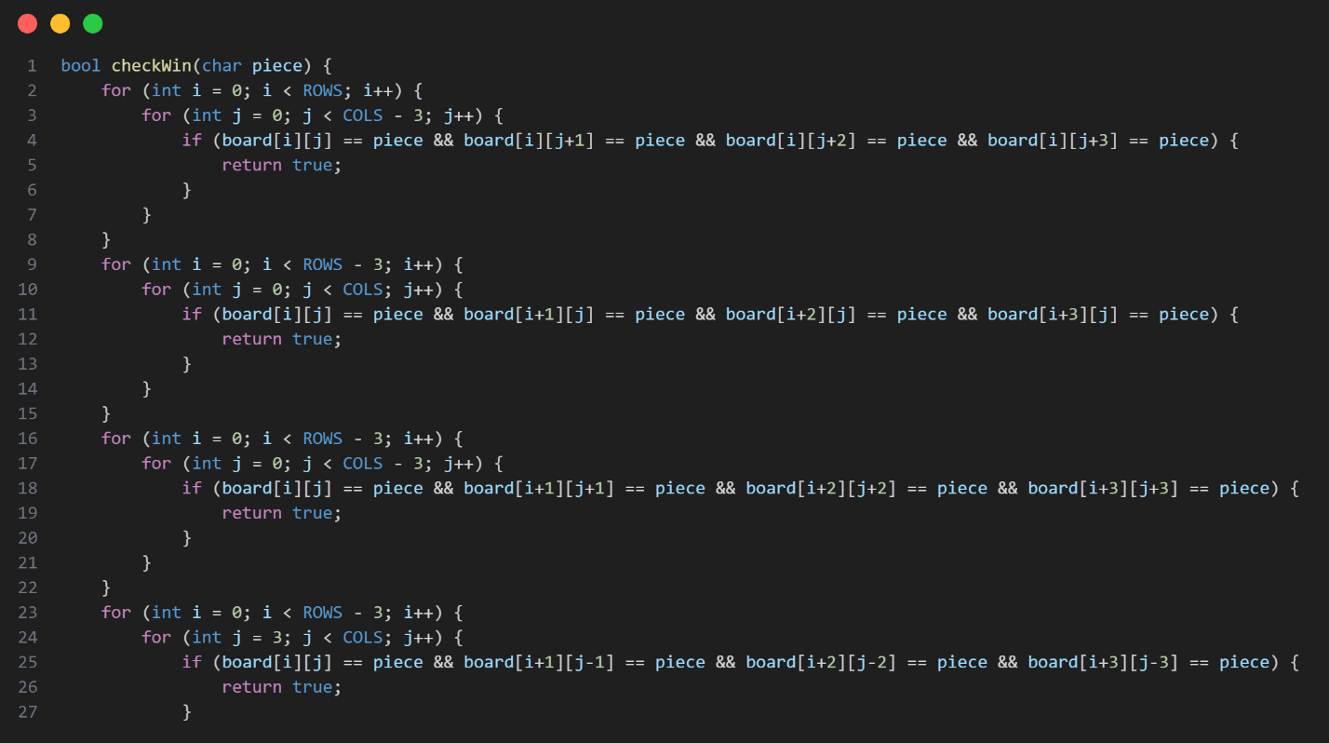

5. Testing & Results

Test No. | Input | Expected Output | Actual Output | Status
1 | Player X drops in full column | "Invalid move" | "Invalid move" | ✅
2 | X aligns 4 horizontally | X wins | X wins | ✅
3 | O aligns 4 vertically | O wins | O wins | ✅
4 | Diagonal alignment | Correct winner | Correct winner | ✅
5 | Board full with no winner | Draw | Draw | ✅
6 | Invalid input (letters) | Error + retry | Error + retry | ✅

The game was tested for both gameplay modes. The AI correctly selected columns, and win conditions were detected accurately across scenarios.

6. Conclusion, Limitations & References
Conclusion:
The enhanced Connect 4 Console Game demonstrates how classical board games can incorporate AI logic using fundamental C programming tools.
Limitations:
• AI is basic and not predictive.
• No file handling for saving game history.
• Console-only interface.
Future Enhancements:
• Improve AI difficulty.
• Add GUI support.
• Implement save/load features.
References:
• Code with Harry
• https://www.programiz.com/c-programming
• https://www.geeksforgeeks.org/c-programming-language/

