Architecture Design Document
Multimodal COPD Exacerbation Risk Tool — Future Engineering Blueprint
Author: Anas Shawah'en | Status: Pre-implementation design — no production code exists yet

1. Purpose
This document records the major architectural decisions for a future deployable version of the COPD multimodal risk tool, so that if/when a real engineering team (internal hire, contractor, or academic collaborator) picks this up, they start from settled decisions instead of re-litigating them under time pressure. Nothing in this document authorizes building a clinical tool now — see the Regulatory Classification Memo and IRB protocol for why real deployment must wait for approvals.

2. Five Foundational Decisions
Decision | Choice | Rationale
Inference location | On-device (local) | ED/pre-hospital connectivity is unreliable; a 9-feature SVM is small enough to run locally with no latency or offline-availability risk
Data storage | Local-only, encrypted; sync optional/deferred | Minimizes breach surface and simplifies early-stage privacy compliance; avoids designing a cloud PHI pipeline before it's needed
Model updates | Manual, reviewed, versioned releases only | A silent auto-update to a model behind a clinical risk score is not acceptable; every version must be traceable to a specific validated release
Audio capture | In-app recording only, fixed protocol | External file uploads would introduce uncontrolled recording conditions (sample rate, duration, background noise) that silently degrade the audiomics features
EHR integration | None (standalone) at this stage | EHR integration adds substantial legal/technical complexity that is premature before IRB approval and real-data validation even exist

3. System Architecture Diagram
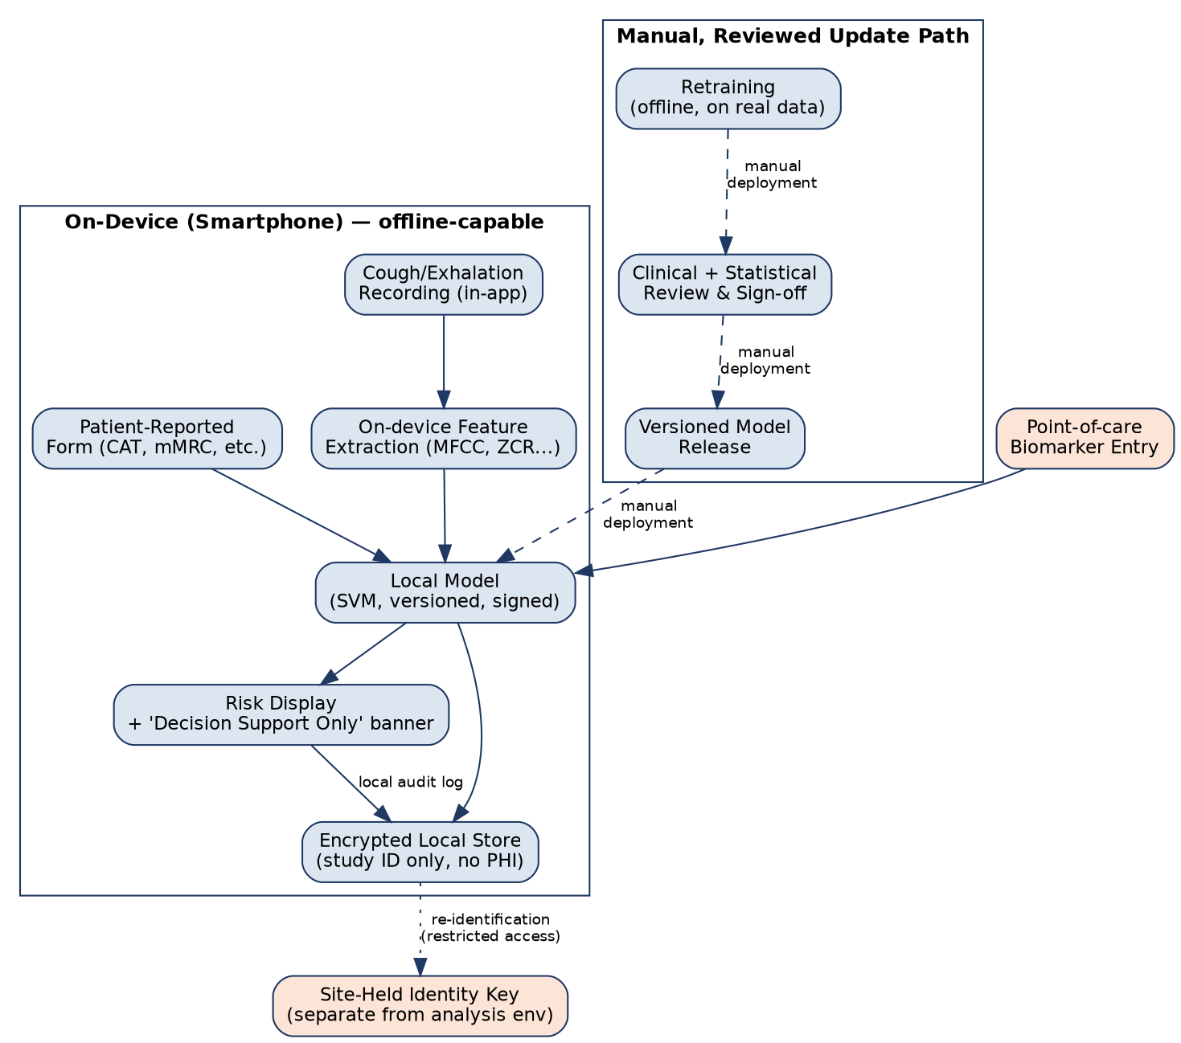
The dashed path (top right) is deliberately disconnected from automatic execution: a new model version only reaches the device through a manual, reviewed release step — never a silent background update.

4. Fail-Safe UX Principle (Non-Negotiable)
The single most important design constraint in this document: every screen that shows a risk score must make it structurally impossible to mistake the output for a diagnosis. This is not a disclaimer footnote — it is a layout requirement.
- The risk percentage is never the largest or most visually dominant element on the screen.
- A persistent, non-dismissible banner (“Decision support only — not a diagnosis”) appears on every screen showing model output, not just a first-launch splash screen.
- The interface never issues an instruction (“admit patient,” “escalate care”) — only descriptive information (“estimated risk: X%, based on N inputs”).
- Missing or low-confidence inputs (e.g., a poor-quality cough recording) must visibly downgrade the displayed confidence, never silently fall back to a default value that looks like a real reading.

5. Data & Privacy Design
- Every record keyed by study ID only; the identity-linking key is held solely at the clinical site, never in the analysis environment (matches the IRB protocol's data management section).
- Audio is processed to features on-device where possible; raw audio retention (if any, for re-analysis/QA) requires separate, explicit consent language and its own retention limit.
- All local storage encrypted at rest; the device lock screen is not treated as sufficient protection on its own.
- A local, append-only audit log records every risk-score displayed (timestamp, model version, inputs used) — required for any future regulatory submission's traceability evidence.

6. MLOps: Monitoring for Model Drift
A model trained once and never re-checked is a known failure mode in clinical ML. Before any real-data deployment, the following monitoring plan should be implemented, not left implicit:
- Track the distribution of input features over time (e.g., is incoming CAT score distribution shifting from the training population?) — a simple population stability index is sufficient at this scale.
- Log predicted-risk distributions over time; a sudden shift with no corresponding change in patient population is a signal to investigate before trusting new predictions.
- Any retraining must re-run the full leak-free evaluation pipeline (src/model_comparison.py) and require the same sign-off step shown in the architecture diagram — no exceptions for “small” updates.

7. What Is Explicitly Out of Scope Right Now
- Any EHR/hospital information system integration.
- Any cloud inference or centralized data lake.
- Any automatic/OTA model update mechanism.
- Any multi-tenant or multi-hospital deployment design — premature before a single-site pilot exists.

8. Next Engineering Steps (When Authorized)
- Select the on-device ML runtime (e.g., ONNX Runtime Mobile or Core ML/TFLite export) once the model family is finalized on real data.
- Build the audio-capture module with enforced recording-quality checks (duration, clipping detection, background noise level) before any feature extraction runs.
- Implement the local encrypted store and the audit log described in §5 before any real patient data touches a device.
- Commission a security review (even informal/academic) before the first real-data pilot, given audio + biomarker data sensitivity.

