**ЗВІТ**

**до лабораторної роботи № < 10.3 >**

**« Опрацювання текстового файлу »**

**з дисципліни**

**«Алгоритмізація та програмування»**

**студента групи ІН-105Б**

**Горанова Анастаса**

**Умова завдання:**

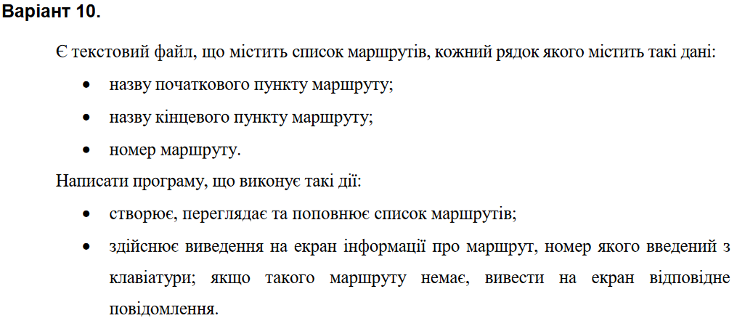

**Структурна схема:**

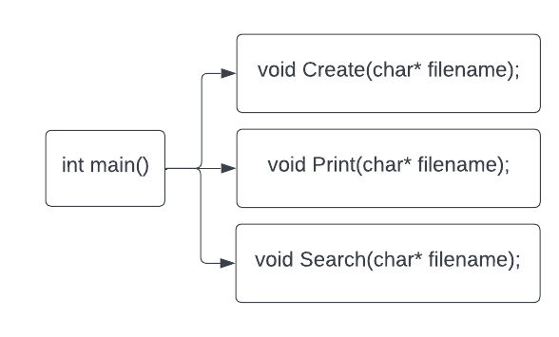

**Текст програми:**

#define _CRT_SECURE_NO_WARNINGS

// 10.3.cpp

// < Горанов Анастас >

// Лабораторна робота № 10.3

// Опрацювання текстового файлу

// Варіант 10

#include <iostream>

#include <iomanip>

#include <string>

#include <fstream>

using namespace std;

struct route

{

int nomer;

char start[30];

char end[30];

};

void Print(char* filename);

void Create(char* filename);

void Search(char* filename);

int main() {

int choice;

char filename[101];

do {

cout << "--------------------------\n";

cout << "Menu\n";

cout << "[1] - Enter and save information\n";

cout << "[2] - Load and display information\n";

cout << "[3] - Search by route number\n";

cout << "[0] - Exit\n";

cout << "--------------------------\n";

cout << "Select: ";

cin >> choice;

switch (choice) {

case 1:

cout << "Entering and saving:\n";

cin.get();

cin.sync();

cout << "Enter a file name: "; cin.getline(filename, sizeof(filename));

Create(filename);

break;

case 2:

cout << "Information output:\n";

cin.get();

cin.sync();

cout << "Enter a file name: "; cin.getline(filename, sizeof(filename));

Print(filename);

break;

case 3:

cout << "Search by route number:\n";

cin.get();

cin.sync();

cout << "Enter a file name: "; cin.getline(filename, sizeof(filename));

Search(filename);

break;

case 0:

break;

default:

cout << "--------------------------\n";

cout << "Меню\n";

cout << "[1] - Enter and save information\n";

cout << "[2] - Load and display information\n";

cout << "[3] - Search by route number\n";

cout << "[0] - Exit\n";

cout << "--------------------------\n";

cout << "Select:";

cin >> choice;

}

} while (choice != 0);

}

void Create(char* filename)

{

FILE* f;

if ((f = fopen(filename, "w")) == 0)

{

cerr << "Error opening file '" << filename << "'" << endl;

return;

}

route r;

char ch;

do

{

cout << endl;

cout << "Start: "; cin >> r.start;

cout << "End: "; cin >> r.end;

cout << "Number: "; cin >> r.nomer;

cin.sync();

if (fwrite(&r, sizeof(route), 1, f) != 1)

{

cerr << "Error writing file." << endl;

return;

}

cout << "Continue? [Y/n]: "; cin >> ch;

} while (ch == 'y' || ch == 'Y');

fclose(f);

}

void Print(char* filename)

{

FILE* f;

if ((f = fopen(filename, "r")) == NULL)

{

cerr << "Error opening file '" << filename << "'" << endl;

return;

}

route r;

cout << "=============================="

<< endl;

cout << "| Start | End | Number " << setw(3) << "|"

<< endl;

cout << "------------------------------"

<< endl;

while (!feof(f))

{

if (fread(&r, sizeof(route), 1, f) != 1)

if (feof(f))

{

cout << "------------------------------" << endl << endl;

return;

}

cout << "| " << setw(7) << left << r.start << " "

<< "| " << setw(6) << right << r.end << " "

<< "| " << setw(7) << left << r.nomer << " |" << endl;

}

fclose(f);

}

void Search(char* filename)

{

int found = 0;

int nomer;

cout << "Enter route number: ";

cin.sync(); cin >> nomer;

FILE* f;

if ((f = fopen(filename, "r")) == NULL)

{

cerr << "Error opening file '" << filename << "'" << endl;

return;

}

route r;

while (!feof(f))

{

if (fread(&r, sizeof(route), 1, f) != 1)

if (feof(f))

{

break;

}

if (r.nomer == nomer)

{

found++;

cout << endl;

cout << " Route with a number " << nomer << " found: " << endl;

cout << " Start: " << r.start << endl;

cout << " End: " << r.end << endl;

}

}

if (found == 0)

{

cout << "Route not found." << endl;

}

fclose(f);

}

**Посилання на git-репозиторій з проектом:**

*https://github.com/StassNG/10.3*

**Результати програми та unit-тесту:**

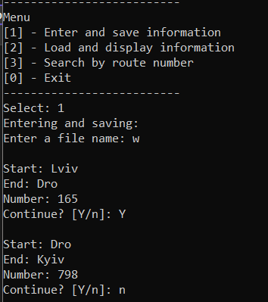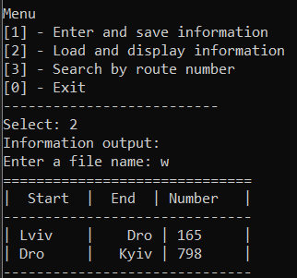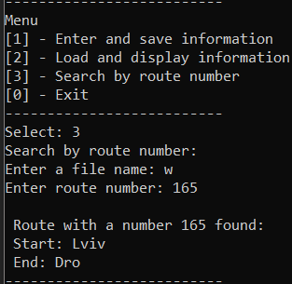

**Висновок:** я навчився опрацьовувати текстові файли.