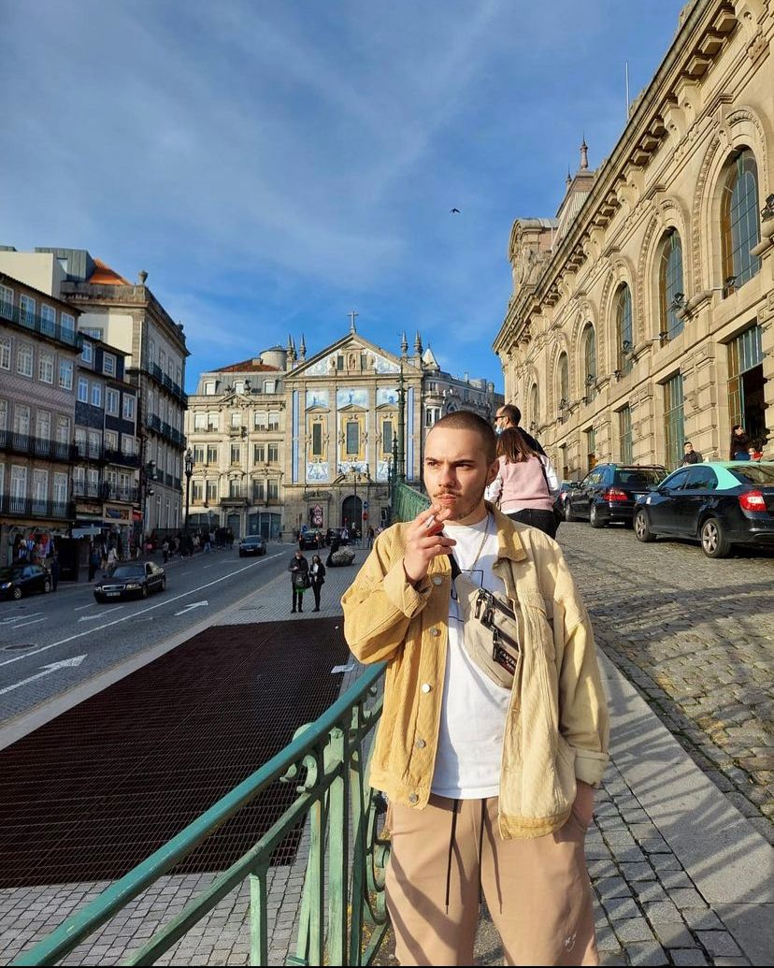

**Name: Dizzy**

Our user is a student , He likes being trendy and to always have a fresh cut.

He takes his inspiration from Instagram and tiktok

He usually uses his phone and laptop for browsing the web

Dizzy would like to see the profile of all the emplyees before choosing a barber. He would also like to see reviews from previous users.

Dizzy

He would like to avoid unnecessary human interaction and use a platform to make a reservation and do research about the barber before going

**21**

**Male**

**Student**