**LAB 6**

**VARIANT 7,PI**

**TASK 1**

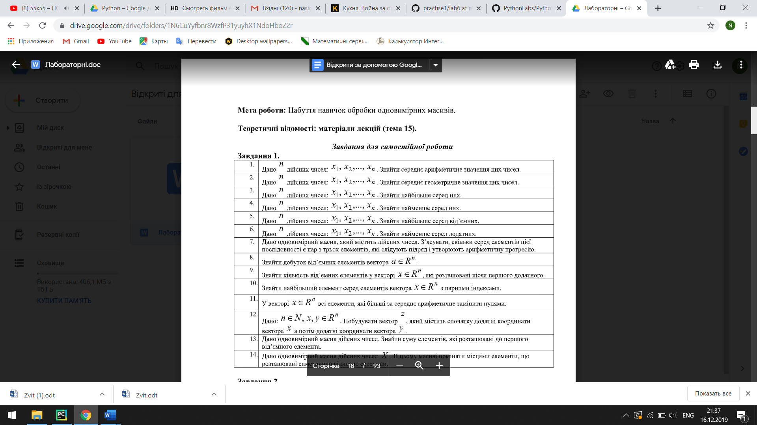

n = int(input("n=")  
a = [  
 int(input("a="))  
 for i in range(n)  
]  
count = 0  
for i in range(n - 2):  
 a_1 = a[i]  
a_2 = a[i + 1]  
a_3 = a[i + 2]  
if (a_1 + a_3) / 2 == a_2:  
 count += 1  
print(count)

**TASK 2**

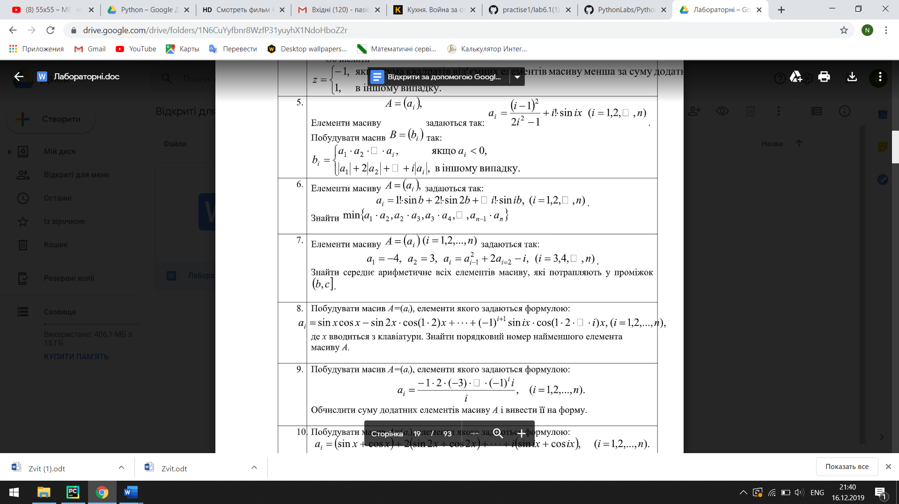

def get_ai(i):  
 if i == 1:  
 return -4  
 if i == 2:  
 return 3  
 return get_ai(i - 1) ** 2 + 2 * get_ai(i - 2) - i  
  
  
n = int(input("n="))  
b = int(input("b="))  
c = int(input("c="))  
A = [get_ai(i + 1) for i in range(n)]  
Af = [x for x in A if b < x <= c]  
s = 0  
for el in Af:  
 s += el  
f = s / len(Af)  
print(f)

**TASK 3**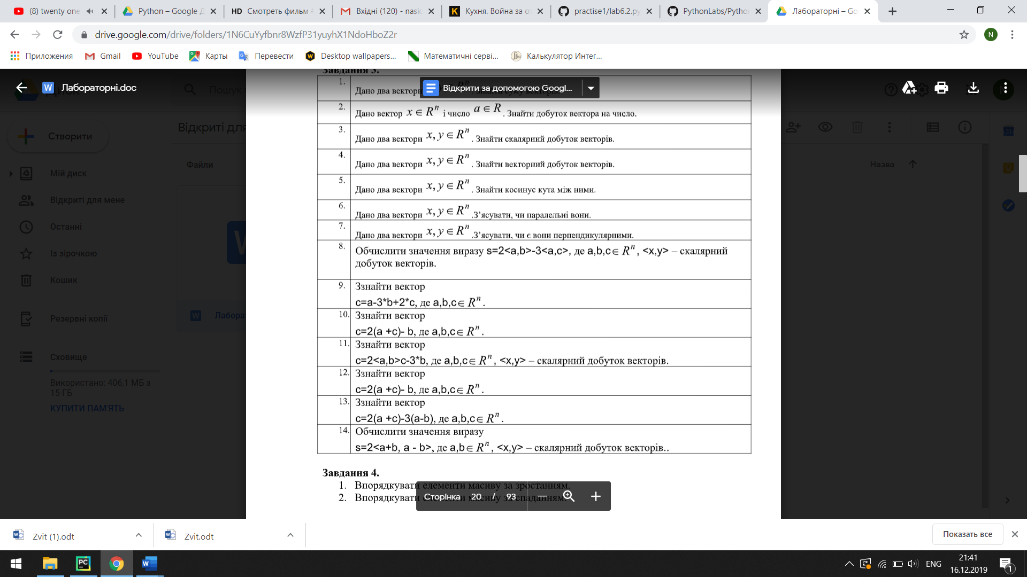

n = int(input("enter the number of vectors"))  
x_list = [float(input("vector coordinates x")) for x in range(n)]  
y_list = [float(input("vector coordinates y")) for y in range(n)]  
perpendicular = list(map(lambda x, y: x * y, x_list, y_list))  
# print("perpendicularnist vectoriv x and y ")  
s = 0  
  
for el in perpendicular:  
 s += el  
  
if s == 0:  
 print("perpendicularnist vectoriv x and y")  
else:  
 print("not")

**TASK 4**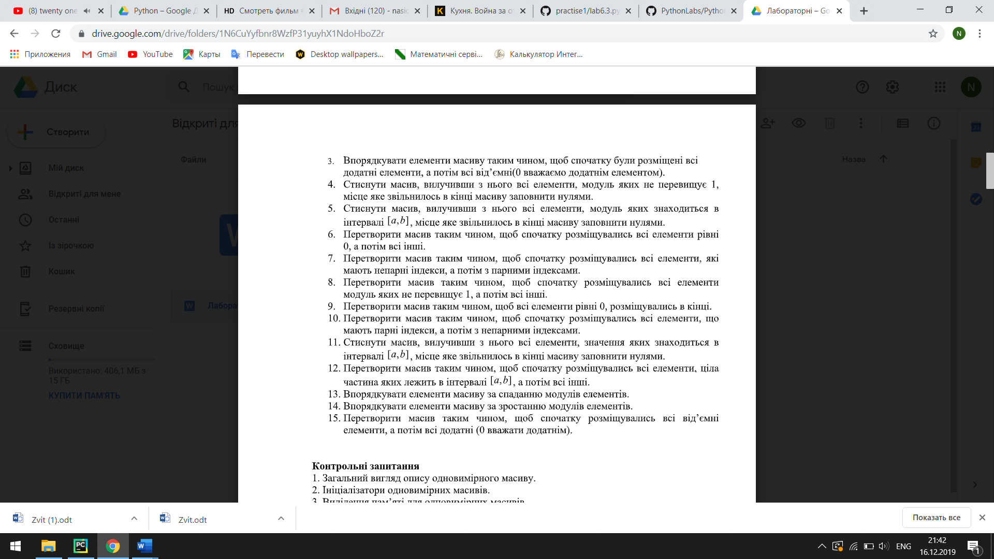

n = int(input("n="))  
a = [  
 int(input("a="))  
 for i in range(n)  
]  
  
r = [a[i] for i in range(0, n, 2)] + [a[i] for i in range(1, n, 2)]  
  
print(r)