ISkillo XPATHs

Icon

//img[@id='homeIcon']

Home

//a[@id='nav-link-home']

Login

//a[@id="nav-link-login"]



//app-post-detail//img[@src='https://i.imgur.com/u62Rlx8.jpg']



//a[text()='daniel.takov3']

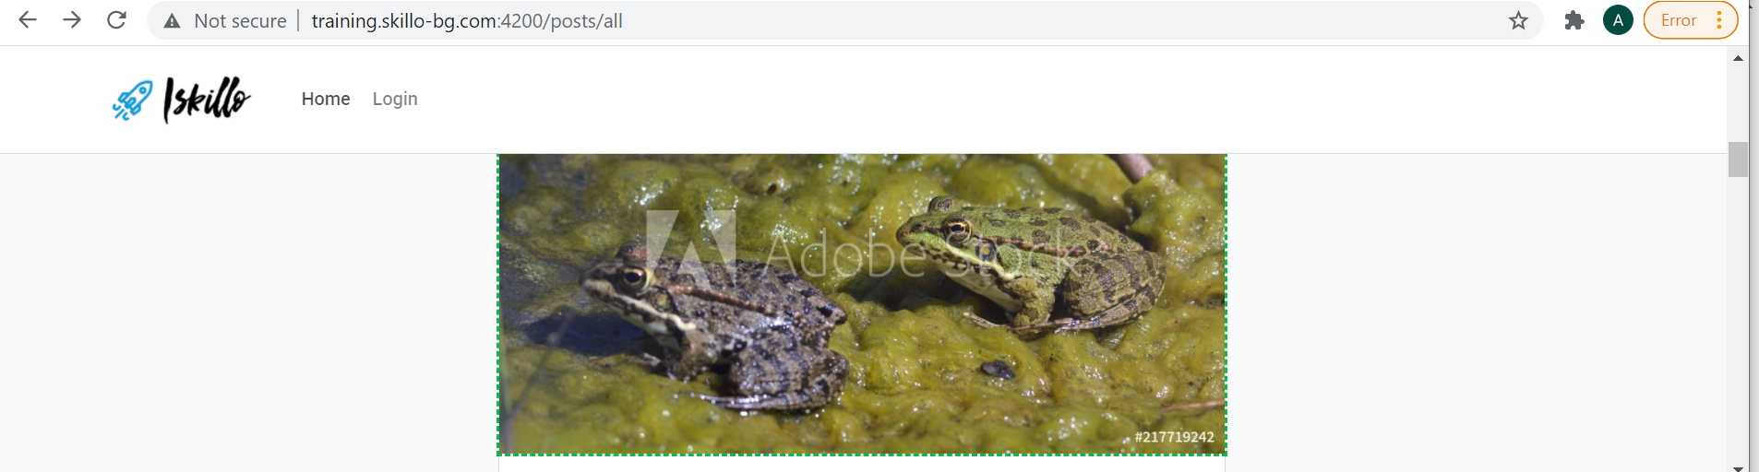

//img[@src='https://i.imgur.com/BsmHVTb.jpg']

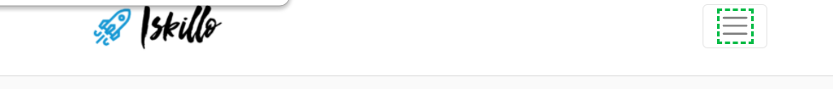

//span[@class='navbar-toggler-icon']

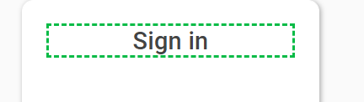

//p[text()='Sign in']

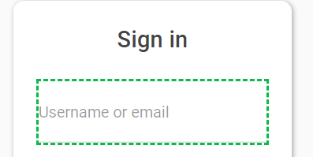

//input[@name='usernameOrEmail']

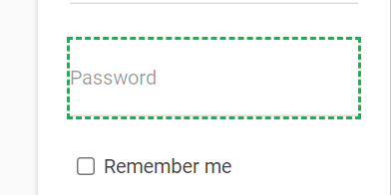

//input[@name='password']



//div[@class='remember-me']/input

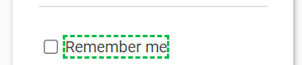

//div[@class='remember-me']/input/../span



//button[@id='sign-in-button']



//a[text()='Register']

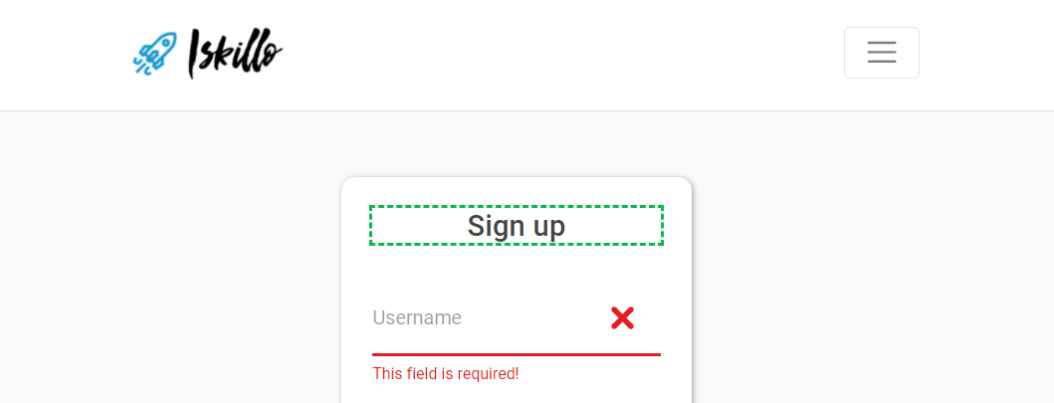

//h4[text()='Sign up']

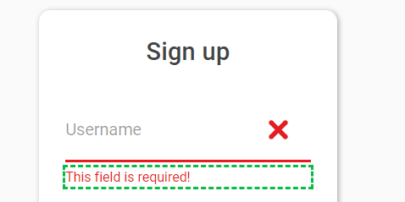

//div[@class='input-filed has-danger']/span

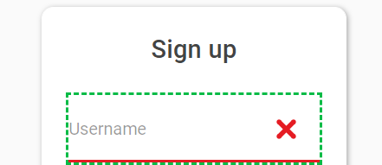

//input[@name='username']

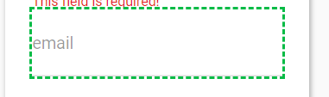

//input[@type='email']

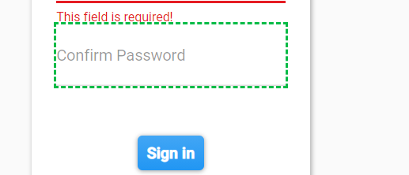

//input[@name='verify-password']



//button[@id='sign-in-button']



//a[@id='nav-link-profile']



//a[@id='nav-link-new-post']

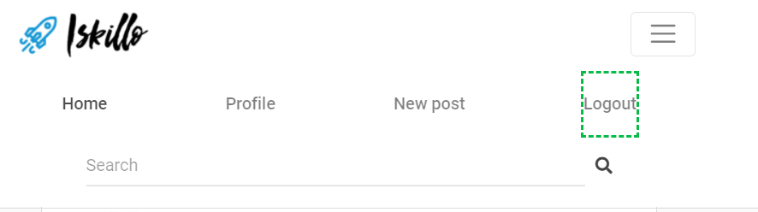

//a[text()='Logout']

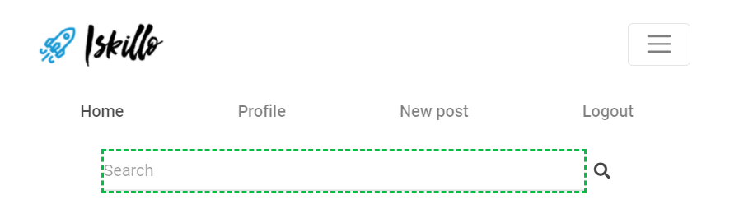

//input[@id='search-bar']