Student: Gheorghița Anastasia, FAF-192

Databases Laboratory Work Nr 1

Title: Installation and configuration of SQL Server 2017

Prerequisites: SQL 2017, SQL Server Management Studio

Objectives: - learn how to install SQL Server
- learn how to configure SQL Server

Tasks:
- To install SQL Server 2017, following the instructions described.
- Register the server on the available computer, choosing SQL authentication.
- Create three user logins that have SQL Authentication.
- Assign the first user access to the HumanResources scheme from the AdventureWorks2017 database. The given user must be able to read and edit the data in the tables.
- User #2 should only have access to read data from the Sales scheme in the AdventureWorks2017 database. At the same time, he should be able to manage any object and the content of this object in the AdventureWorksDW2017 database.
- User #3 must be able to create new databases and define access to them

Implementation

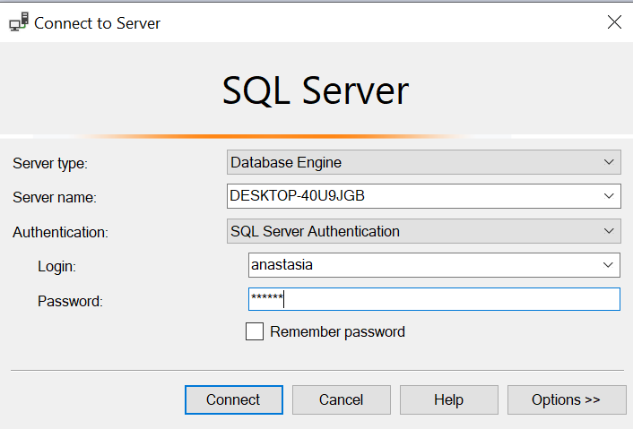
2.

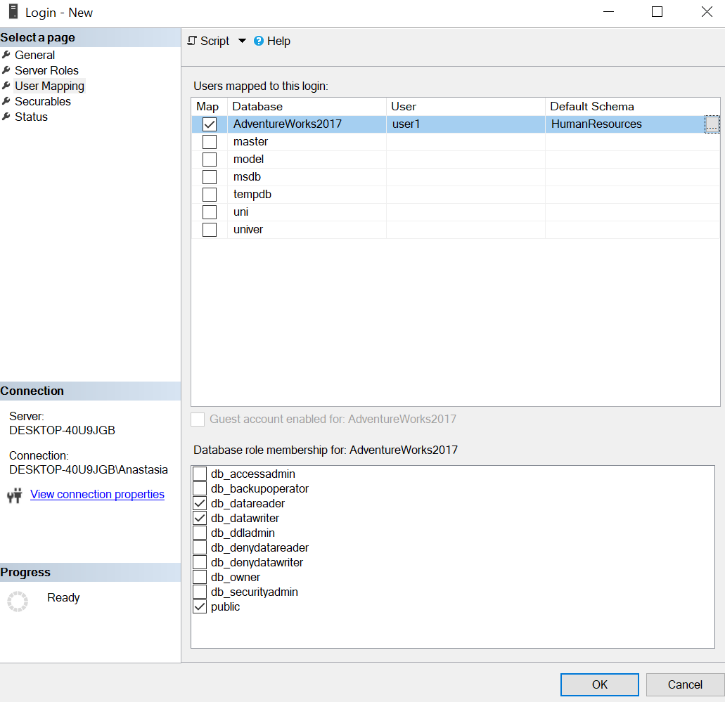
3 a)

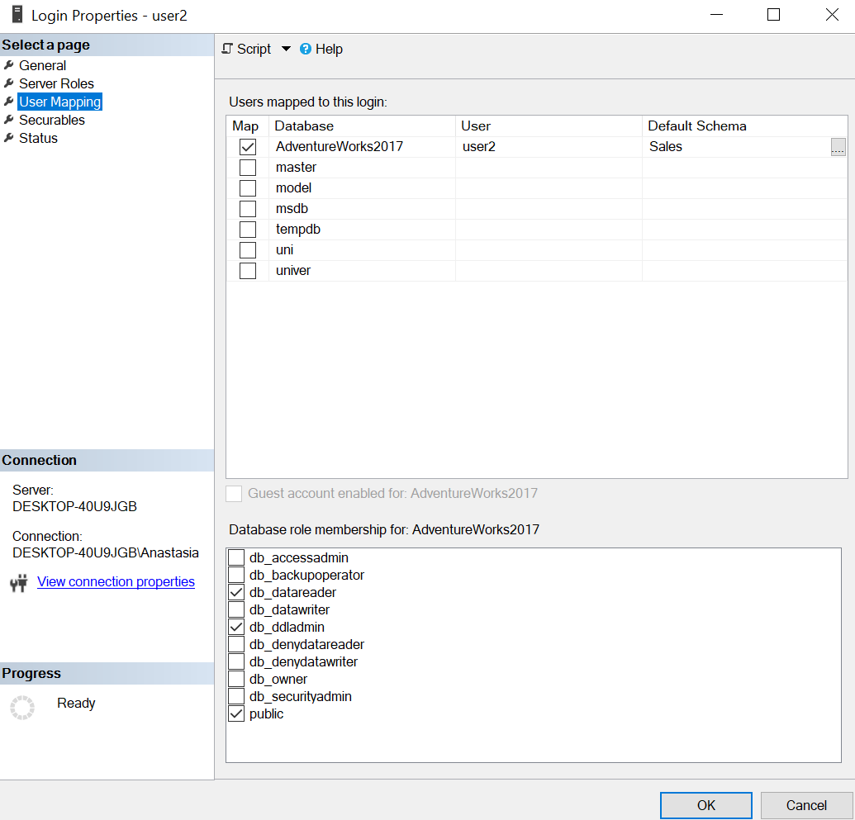
b)

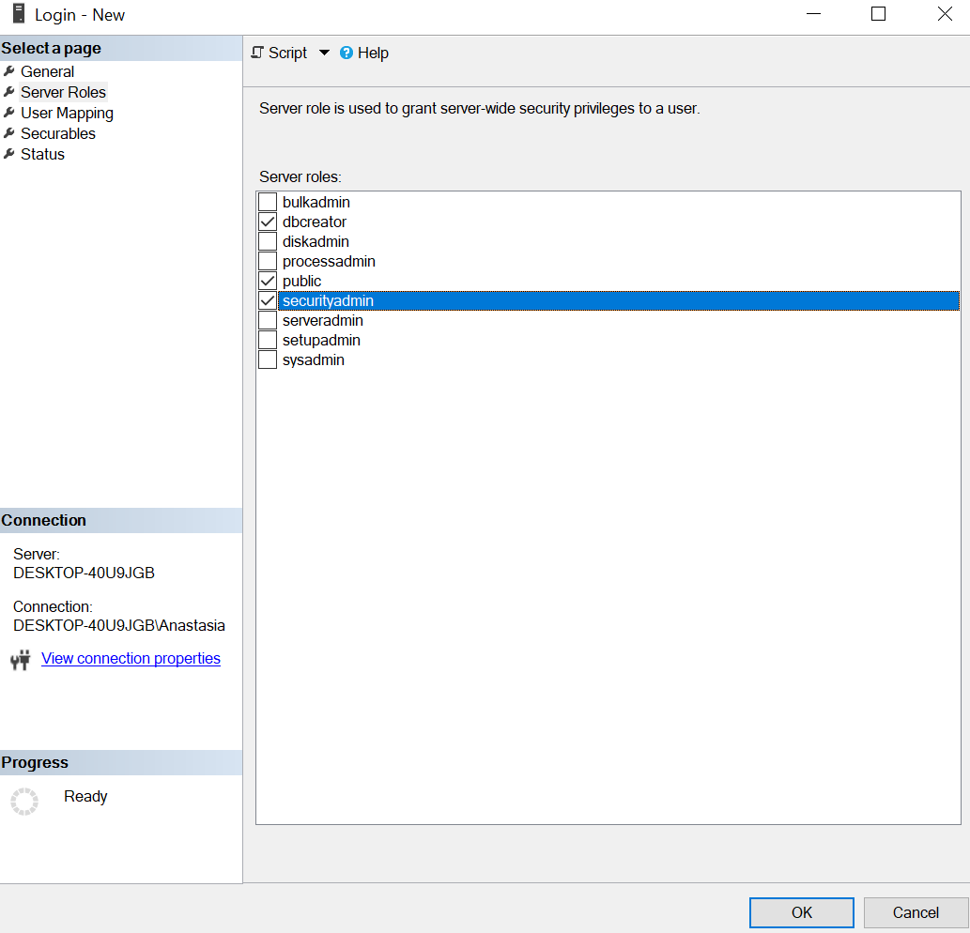
c)

Conclusion

I have learnt how to install and configure a SQL Server. Also, I have learnt how to register logins and how to give them certain roles.

