Student: Gheorghița Anastasia, FAF-192

Databases Laboratory Work Nr 2

Title: Database creation and maintenance

Prerequisites: SQL 2017, SQL Server Management Studio

Objectives: - learn how to create a database
- learn how to maintain a database using maintenance plan

Tasks:
- Create a database physically placed in the MyDocuments\Data folder, setting an increase of the base file of 16MB with the growth limit of 128 MB and the log of 64 MB with the growth limit of 1024 MB. For secondary files, define a new default Filegroup, setting the growth of secondary files to 64 MB with a limit of 1024 MB.
- Create a database, where the log file is physically placed in the MyDocuments\Log folder, the name of the log file in the operating system environment must differ from the logical one defined in the physical scheme. It is important that the database created is compatible with the MS SQL Server 2017 system and that it is accessible to only one user at a time.
- Create the database maintenance plan, built in task 1. Unused space in the database files must be removed when it reaches 2000Mb. The freed space must be returned to the operating system. This operation must run every Friday at 00:00. The maintenance plan execution report must be saved in the MyDocuments\SQL_event_logs folder. Initialize the execution of the plan. After execution, check the results in the log file.
- Create the database maintenance plan, built in exercise 2. The name of the plan will be: "Index rebuild". In this plan, the system must perform the rebuild of indexes only on the base tables (excluding views) of all existing schemes in the database. The free space on the page must be 10%. The sorting of the indexes must be done in tempdb. After the reconstruction, the collection of the complete statistics about the reconstructed indexes must follow. The third step of the plan must be the deletion task of the history of Backup-Restore operations that took place on SQL Server. The history that is older than 6 weeks must be deleted. This plan must be executed every first Sunday of the month. Create the MyDocuments\SQL_reports folder. Report must be added to this file. Maintenance process - to be logged in extended way. Initialize plan execution. After execution, check the results in the generated log file.

Implementation

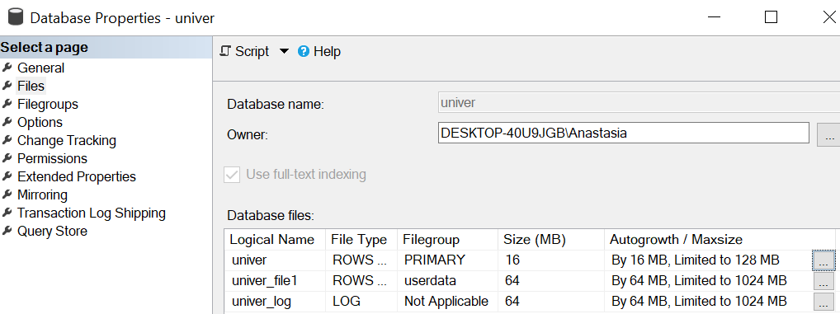

- 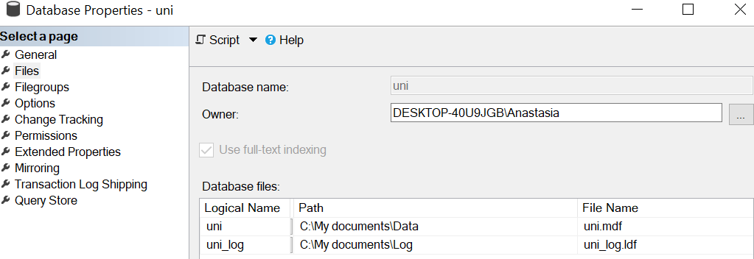

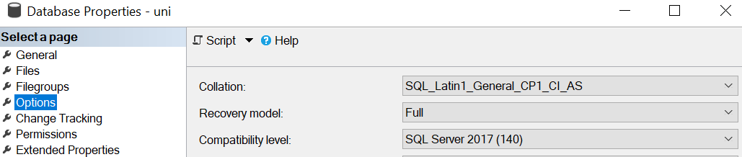

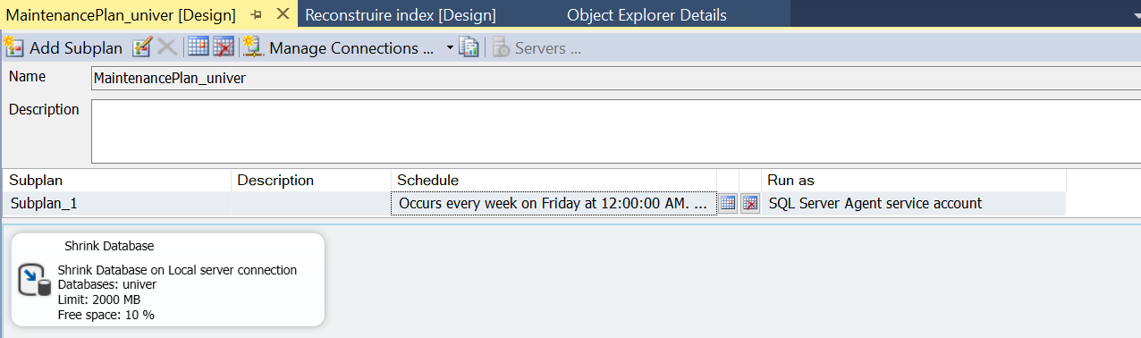

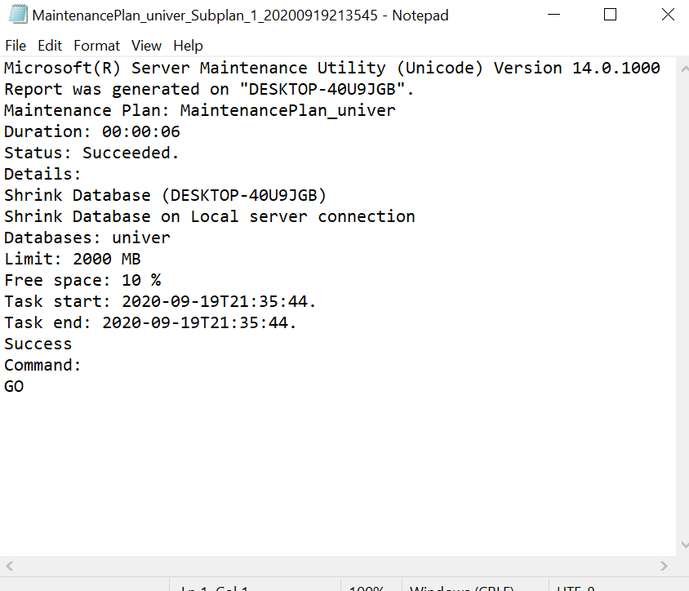
- 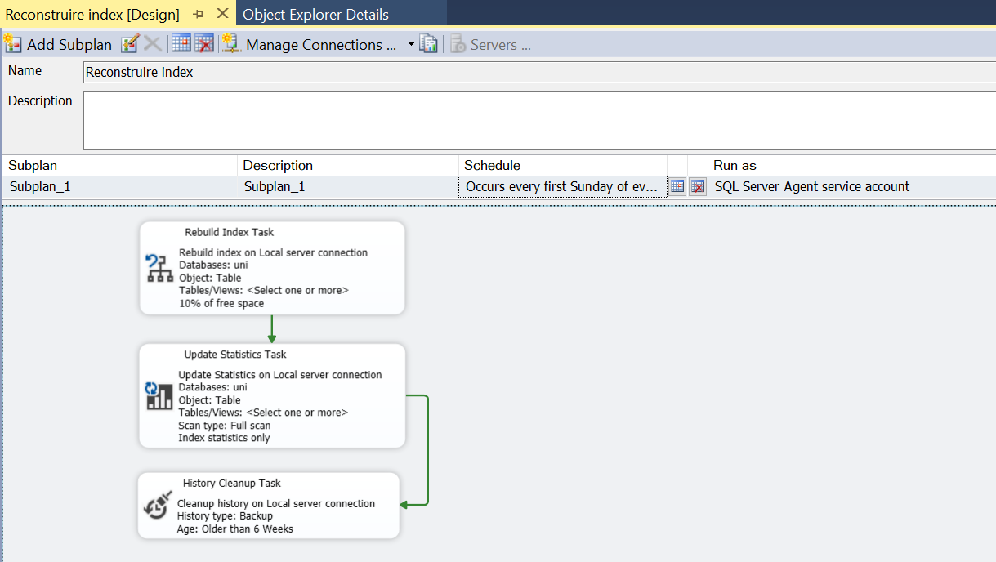

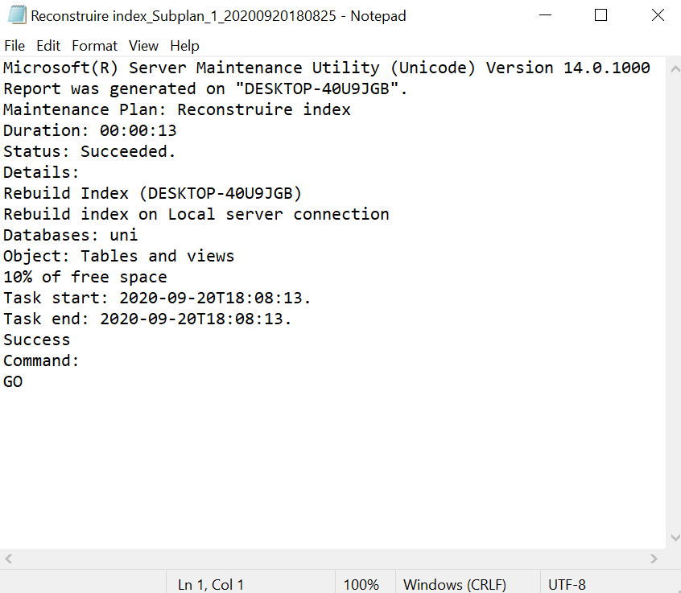

Conclusion

I have learnt how to create a database in SQL Management Studio, and how to maintain it using both manual Maintenance Plan and Maintenance Plan Wizard.

