Homework #9
Graphs II

Anastasiia Konoplina

1. Study the line graph. Use graph from lecture - below. Form a line graph. Formulate the Euler and Hamilton path tasks on original graph and line graph. How do these relate to the Euler and Hamilton paths in the original graph?

I didn’t know if I can add labels to nodes or I can use edges’ labels, so just in case I have done both options:
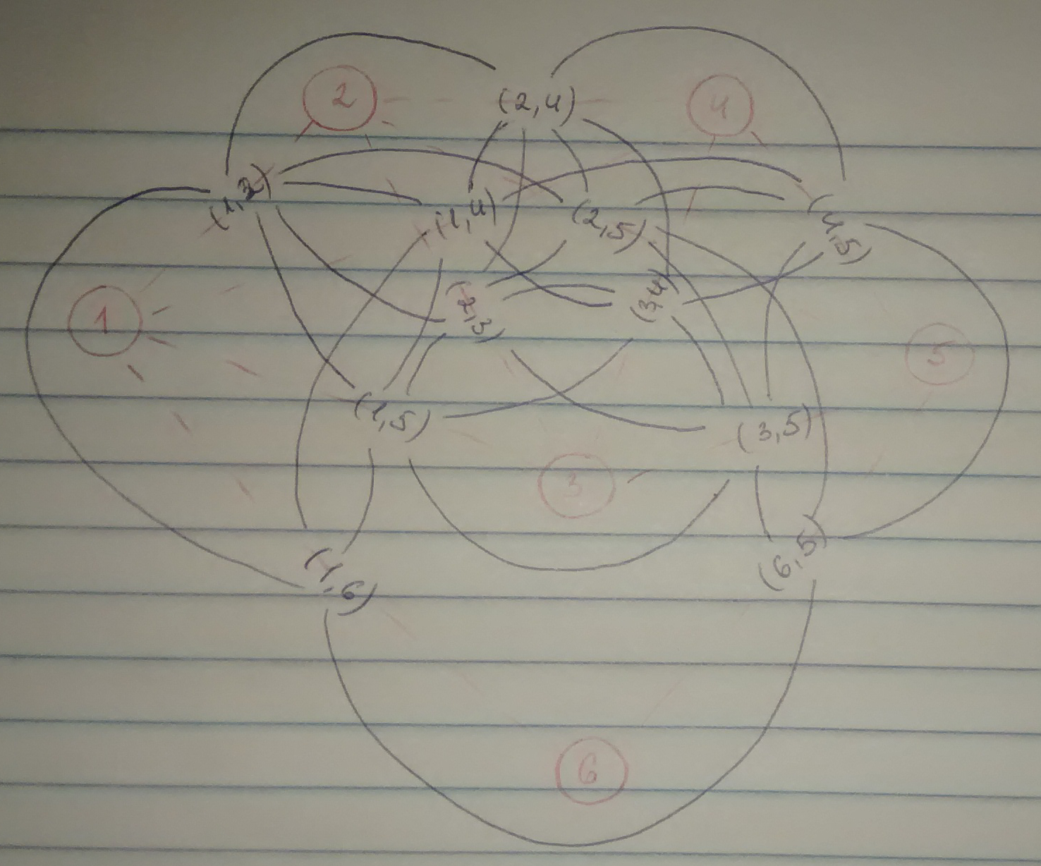
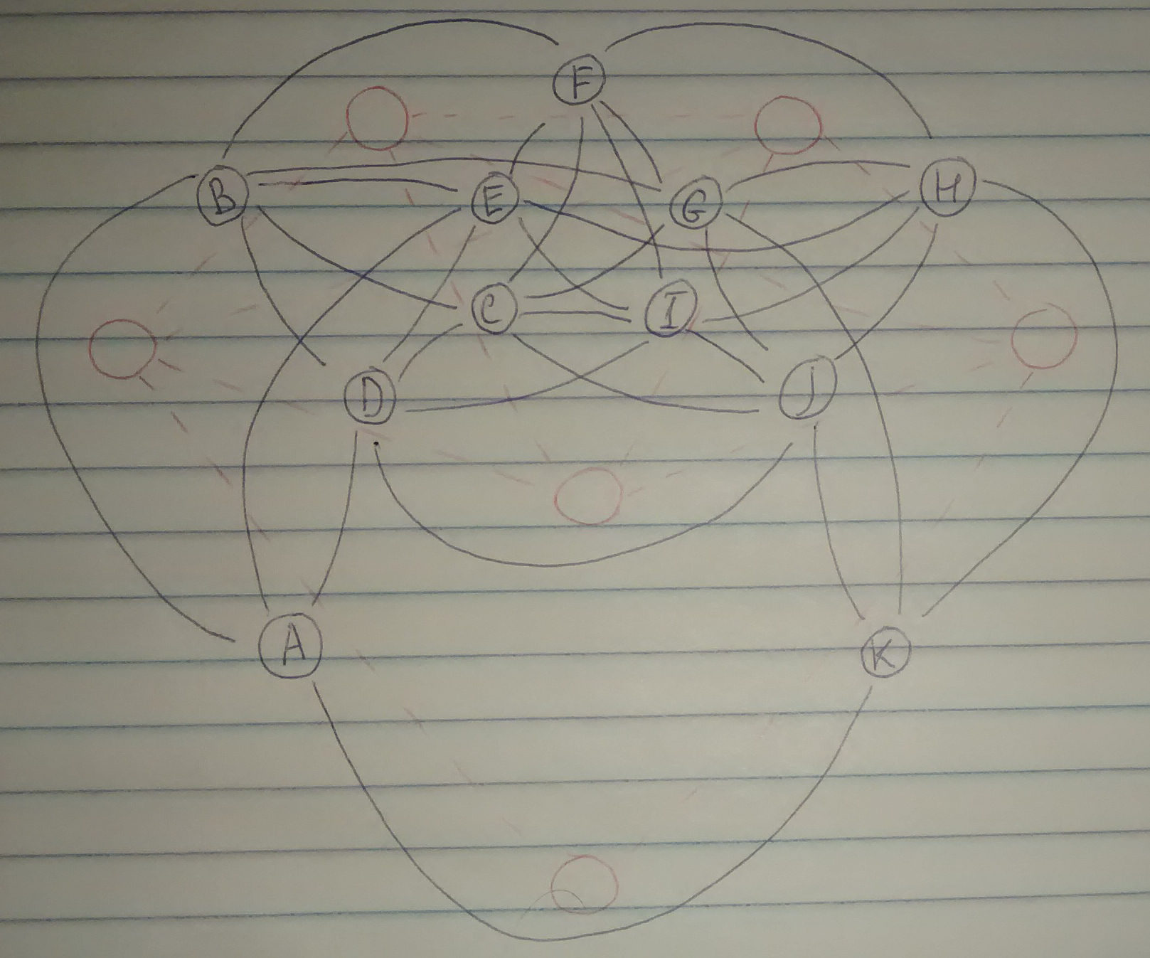

For original graph:
- Euler path – path to visit each edge exactly once
- Hamilton path – path to visit every node exactly once
For line graph:
- Euler path – path to visit every node exactly once
- Hamilton path – usually node in line graph contains edges between to nodes of original graph. So Hamilton path in L(G) will be path of nodes which includes only “unique” values of original graph nodes. For example path (3,1), (2,3) but not (1,2), (2,3), (3,1) – one node is redundant.

2. Compare the five series T1..T5 between each other using Dynamic Time Warping (DTW) algorithm (but you can experiment with the minimization function ). Calculate all pairwise similarities. Which series are most similar?

The results are below:
 | T1 | T2 | T3 | T4 | T5
T1 |  | 8.29 | 10.56 | 6.22 | 8.53
T2 |  |  | 10.32 | 18.33 | 7.96
T3 |  |  |  | 19.24 | 13.92
T4 |  |  |  |  | 13.65
T5

The most similar are T1 and T4.

3. Visualize the time series as line graphs (as in above Excel screenshot) and respective DTW table of most similar pairs (use Excel to highlight the DTW table as was done for edit distance).

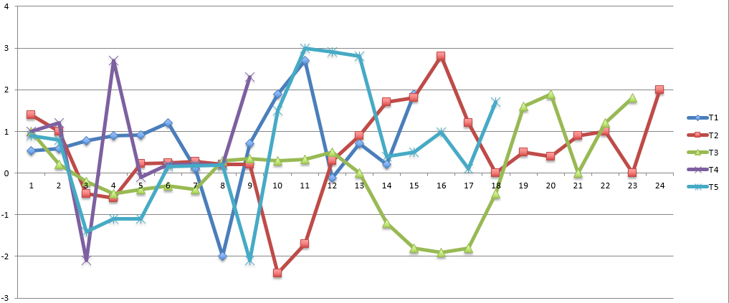
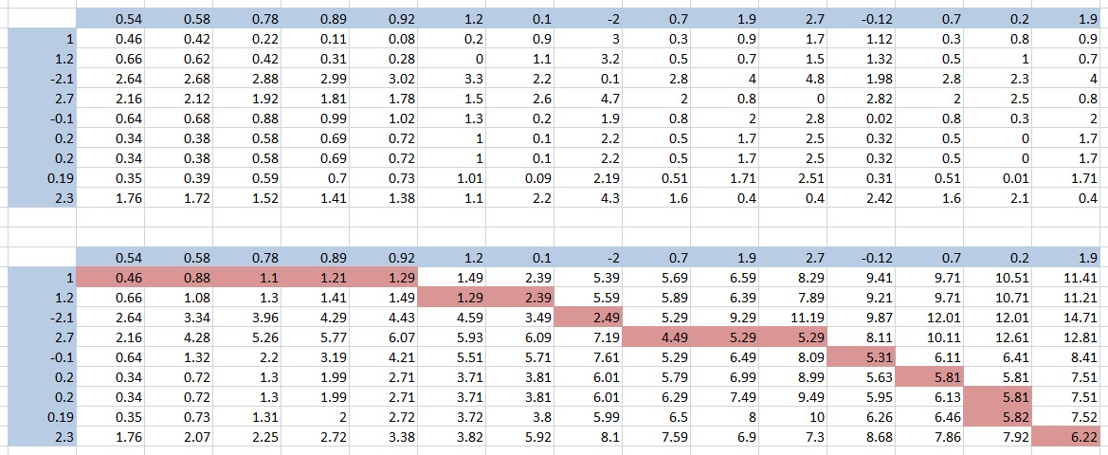

The excel file with calculations are available here on the second tab.

4. Study what are these data about. See readme files and original sources. Note that they are in slightly different formats. Better reformat first. And you can first ignore the weights or types of edges.

In “students” there is directed graph which shows social media interaction between 180 students while working on assignments.
In “karate” the data represents ties between karate club members.
In “Email-Enron” directed graph representing e-mail exchange among users.
In “usairport” directed graph showing flight between airports in USA, where weight – number of passengers.

5. Install and use Cytoscape - http://www.cytoscape.org/ - try to visualise some graphs (from Cytoscape or even better, if from task 4) yourself. Show some screenshot from your computer. Identify key features and capabilities of Cytoscape.
I have tried to visualize “karate” graph (screenshot is below).
Key features:
- Import table/network from file/URL
- Analyze graph (shortest path, distributions of degrees, number of shared neighbors, neighborhood connectivities, average clustering coefficients etc)
- Merge graphs/tables
- Apply different layouts
