Homework #1
Introduction, measuring code ...

Anastasiia Konoplina

1. Generate random data consisting of unsigned 64bit integers. Implement some sorting algorithm (any) on your own. Repeat measurements many times (100+) to study how much the times will vary. Increase the array size (n) and plot the measured times so that you can visually explore the timings. Discuss which data sizes are meaningful to analyze in practice.

For this homework I used python. As I understood from this article unsigned 64bit integers are “positive” integers in range [0; (2^64)-1], so that I generated an 10000 elements array using following code:
import random
lim = 2**64 - 1
array = [random.randint(1, lim) for _ in range(10000)]

The implementation of sorting algorithm:
def sort_func(array):
k = 1
while k < len(array):
for i in range(len(array)-k):
if array[i] > array[i+1]:
array[i],array[i+1] = array[i+1],array[i]
k += 1
return array

I measured time of sorting using this algorithm 150 times using following code:
for i in range(1,150):
start_time = time.time()
res2 = sort_func(array)
res_time1 = time.time() - start_time
manual.append(res_time1)

So as result I got an array of times of execution. Min is 3.25329113007s, max is 6.55651092529s, mean is 3.32587398459.
To plot the results I used mean values. Result is in the end of second task.

2. Now measure the language-specific built-in sort algorithm. Plot the execution times as in the first. Try to also overlay some function f(x) that would approximate the built-in sort timings well.

Time of execution for 150 times:
Min - 0.000248908996582
Max - 0.00417804718018
Mean - 0.000294926982598
Following graph show run time of both sorting algorithms: custom(red) and built-in(blue).
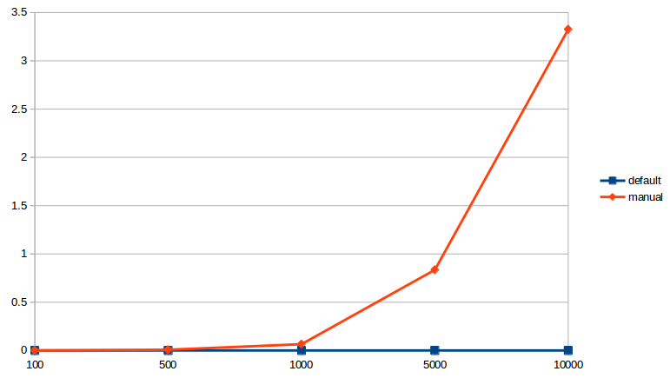
We can see that increasing array size leads to exponential increasing of run time of manual algorithm (red).

