Homework #2
Sorting data and functions

Anastasiia Konoplina

1. Measure the actual speed of binary search. How many searches can you perform in one minute for various sizes of the arrays?

I have not found built-in binary search in python, so I created it manually. The code is below:
def binarySearch(array, value):
if len(array) == 0:
return False
else:
midpoint = len(array)//2
if array[midpoint] == value:
return True
else:
if value < array[midpoint]:
return binarySearch(array[:midpoint],value)
else:
return binarySearch(array[midpoint + 1:],value)

I have created arrays starting from array of 1000 elements and iteratively increased size of array by 10 000 up to 1000000. For each size of array I made 10 measures and calculated mean. The code is below:
for i in range(1000, 1000000, 10000):
test_array = [random.randint(1,500) for _ in range(i)]
test_array = sorted(test_array)
for k in range(1,10):
start_time = time.time()
res = binarySearch(test_array, 20)
res_time = time.time() - start_time
time_array.append(res_time)
res_time = sum(time_array) / float(len(time_array))
search_time.append(res_time)
The chart of binary search time based on this information is below:
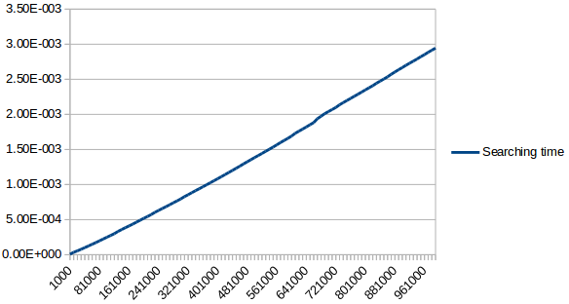
The chart of array size – number of searches in 1 minute dependency is below:
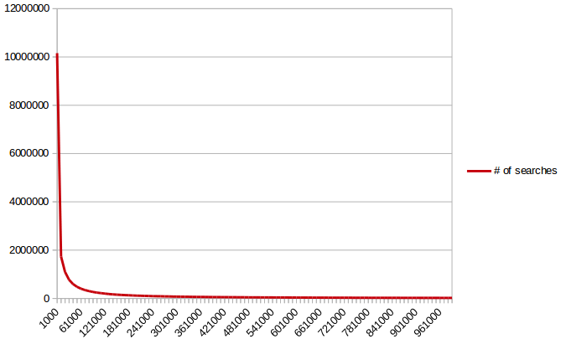

2. Implement the Quicksort with two pivots. Describe how you might try to avoid bad splits to make your code "unbreakable".

My implementation of dual Quicksort is below:
def dualQuickSort(array):
if len(array) > 2:
a = random.sample(array,2)
p1 = min(a)
p2 = max(a)
part1 = [i for i in array if i <= p1]
part2 = [i for i in array if ((i > p1) & (i < p2))]
part3 = [i for i in array if i >= p2]
part1 = dualQuickSort(part1)
part2 = dualQuickSort(part2)
part3 = dualQuickSort(part3)
else:
return array
res = part1 + part2 + part3
return res

For test I used array: [1, 2, 3, 4, 5, 6, 7, 8, 9, 8, 7, 6, 5, 4, 3, 2, 1], where most of elements are not unique. So that when I randomly choose 2 pivots – they might be the same. To fix this problem I used random.sample() function, which takes only unique elements from population.

3. Implement the linear-time order statistics calculations on the unsorted data, measure the speed. Run many searches - does the speed improve over time? (does the data become sorted slowly?)

I have chosen Quickselect algorithm, its implementation is below:
def quickSelect(array, k):
p = array[(len(array) // 2)]
part1 = [i for i in array if i < p]
part2 = [i for i in array if i > p]
p1 = len(part1)
r = len(array) - len(part1) - len(part2)
if k >= p1 and k < p1 + r:
return ppart1 = [i for i in array if i < p]
elif m > k:
return quickSelect(part1, k)
else:
return quickSelect(part2, k - p1 - r)

To prove that in average this is linear function, I ran it for arrays [1000; 1000000] elements with 10 000 step, and took mean of 10 runs of every array. The chart of array size – time dependency is below:
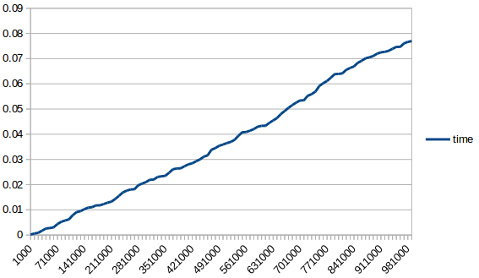

4-5. Solve task 3-3 from CLRS - order functions by their growth rate. Group together those that belong to the same Theta() group.

Honestly, I have no idea how to order them, I mean I could not do it by myself, that is why I tried to understand solutions I could find on stackoverflow and so on:
To order these functions 2 statements (do not remember where I took it from) should be used:
- Exponential functions grow faster than polynomial functions, which grow faster than polylogarithmic functions.
- The base of a logarithm doesn't matter asymptotically, but the base of an exponential and the degree of a polynomial do matter.
They used several math formulas (identities):
- (lgn)^lgn = n^lglgn
- 4^lgn = n^2
- 2^lgn = n
- 2 = n^(1/lgn)
- 2^sqr(2lgn) = n^sqr(2/lgn)
- sqr(2)^2lgn = sqr(n)
- lg*(lgn) = (lg*n) – 1
The ordered list of functions is below:
- 1
- lg(lg* n)
- lg* n and lg*(lg n)
- 2^lg* n
- ln ln l
- sqr(lg n)
- ln n
- lg^2 n
- 2^sqr(2lg n)
- sqr(2)^lg n
- n
- n lgn
- n^2
- n^3
- n^lglgn
- (3/2)^n
- 2^n
- n2^n
- e^n
- n!
- (n+1)!
- 2^2^n
- 2^2^(n+1)
