Homework #4
Trees

Anastasiia Konoplina

2. Describe the deletion procedure from red-black tree. What are the possible different cases and how can we ensure re-balancing. How many operations (recolorings, rotations) is needed?

In general deletion procedure of some node in black-red tree can be divided into 2 steps:
1) Deletion:
- If a node does not have children, no additional actions (# of operations = 1)
- If a node has 1 child – move this child up on a place of deleted node (# of operations = 2)
- If a node has 2 children. New node which replaces deleted one is a node with “next value element”. It means we go to right child and then to left until left child exists (the “most left” child in right subtree) (# of operations = 2)
2) Ensure re-balancing. Deletion of red node does not affect tree's “parameters”. But in case of black node deletion there are several cases:
- If sibling is red → rotation between parent and sibling (so that sibling becomes parent). Then perform recoloring. (# of operations = 2)

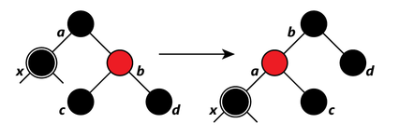

- If sibling is black there are 3 cases:
- If both sibling's children are black. Recolor sibling to red, its parent – to black. (# of operations = 1)

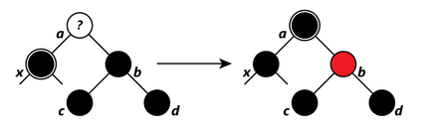

- If sibling's right child is black and left is red. In this case we need to recolor sibling and left child and perform rotation. (# of operations = 2)

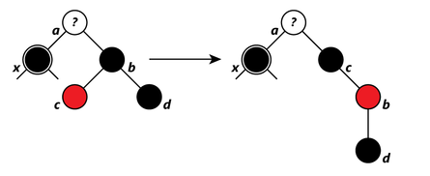

- If sibling's right child is red. Recolor sibling to parent's color, child and parent – to black. Perform rotation (# of operations = 2)

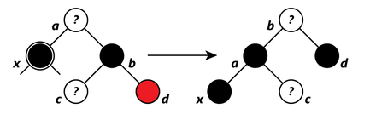

3. In the lecture we said rotations can not be used for k-d trees. Explain why. How might one try to achieve rebalancing of dynamic k-d trees?

Rotations cannot be used for k-d trees since in for example binary trees we insert elements one by one, but for building k-d trees usually whole dataset is used, so that in k-d trees different “axes” compare different “aspects” of node, and if we rotate the tree for balancing purpose we would break its structure.
I think that re-building of some part of kd-tree. For example divide the tree into several sub-trees and rebuild some of these subtrees id needed.

4. Define the random projections based search tree for 2-D data. First, define the orthogonal plane between any two randomly chosen points. Next, define formula for deciding whether a particular point should be in the left or right subtree from the hyperplane. Illustrate this with some 12-15 data points graphically. Draw the points and the full search tree. Provide the formulas needed for traversing the tree for identification of a particular point in the tree. (take note of task 5 when designing the illustration).

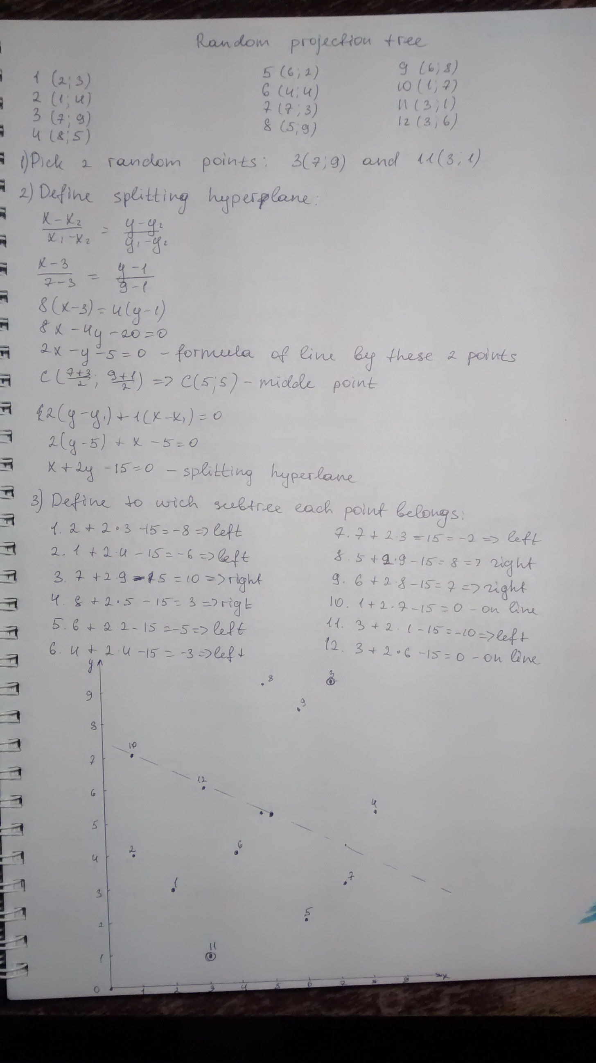

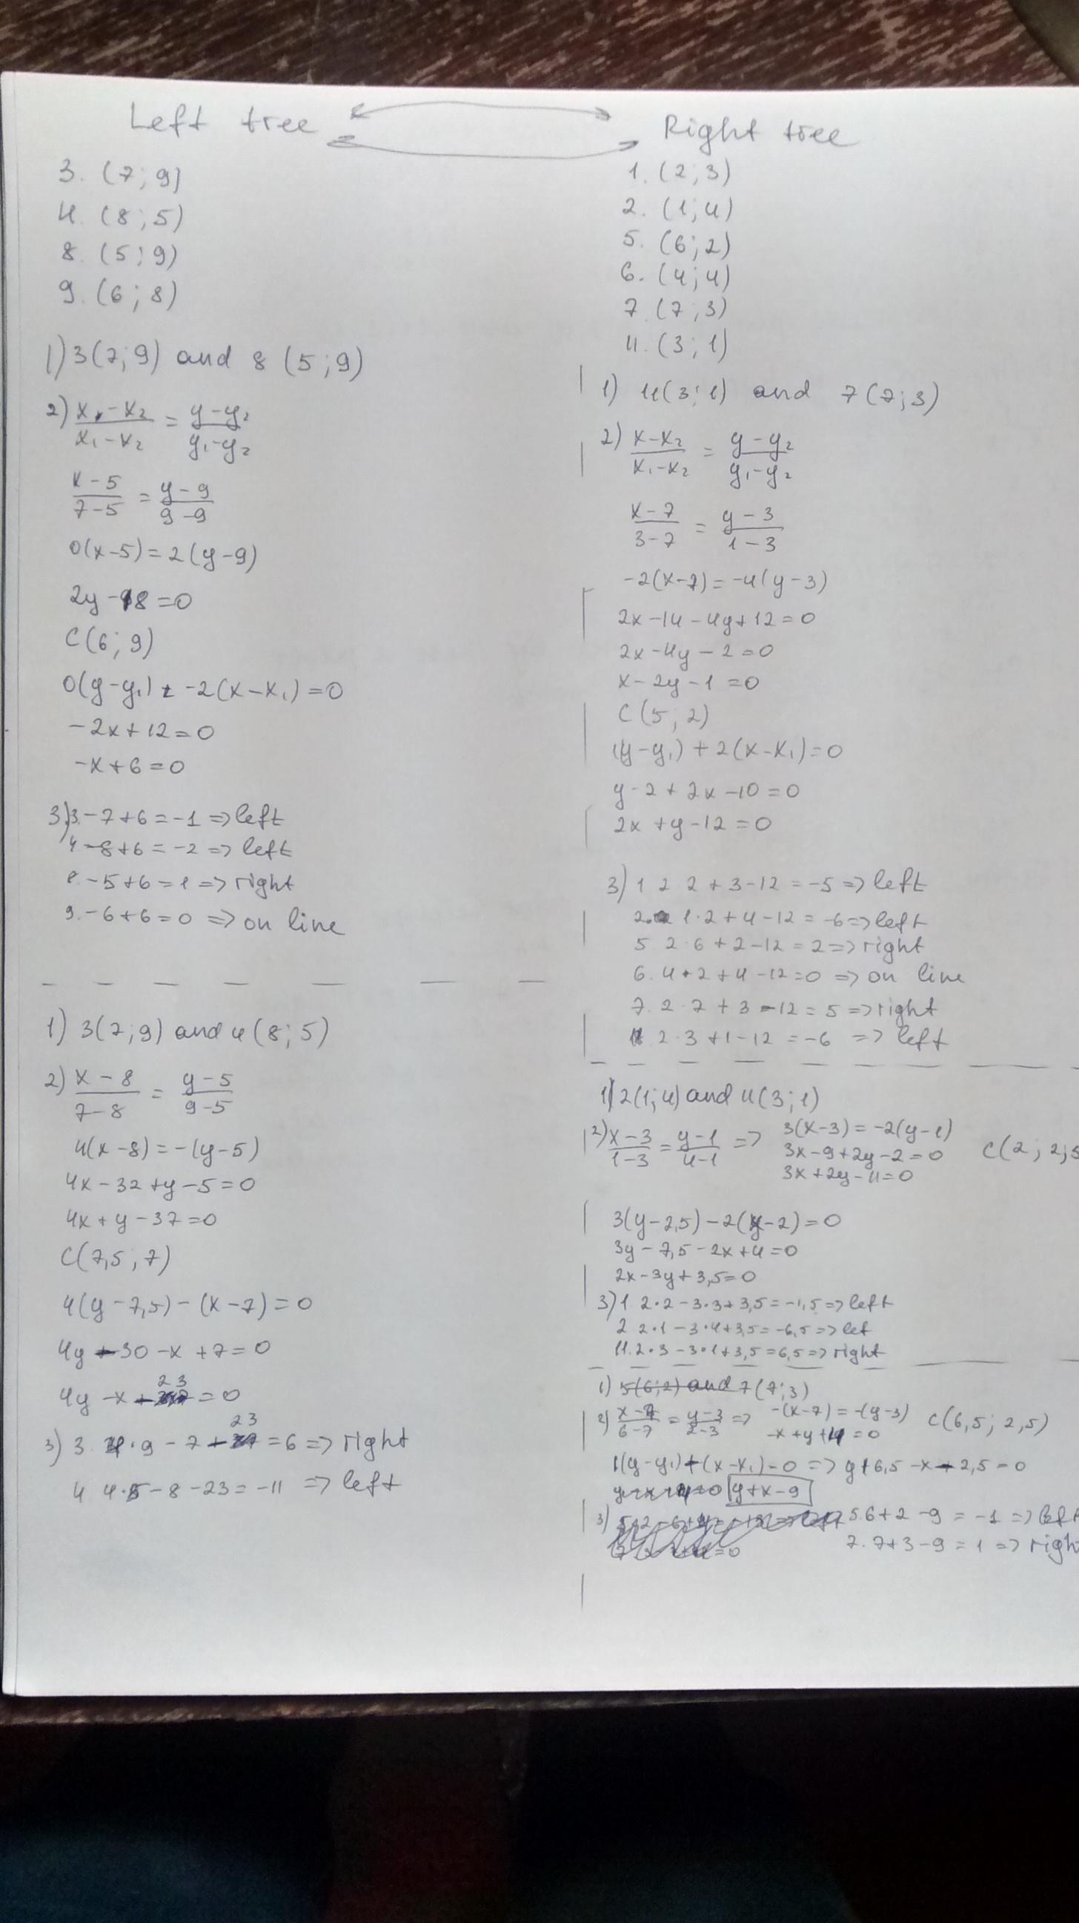

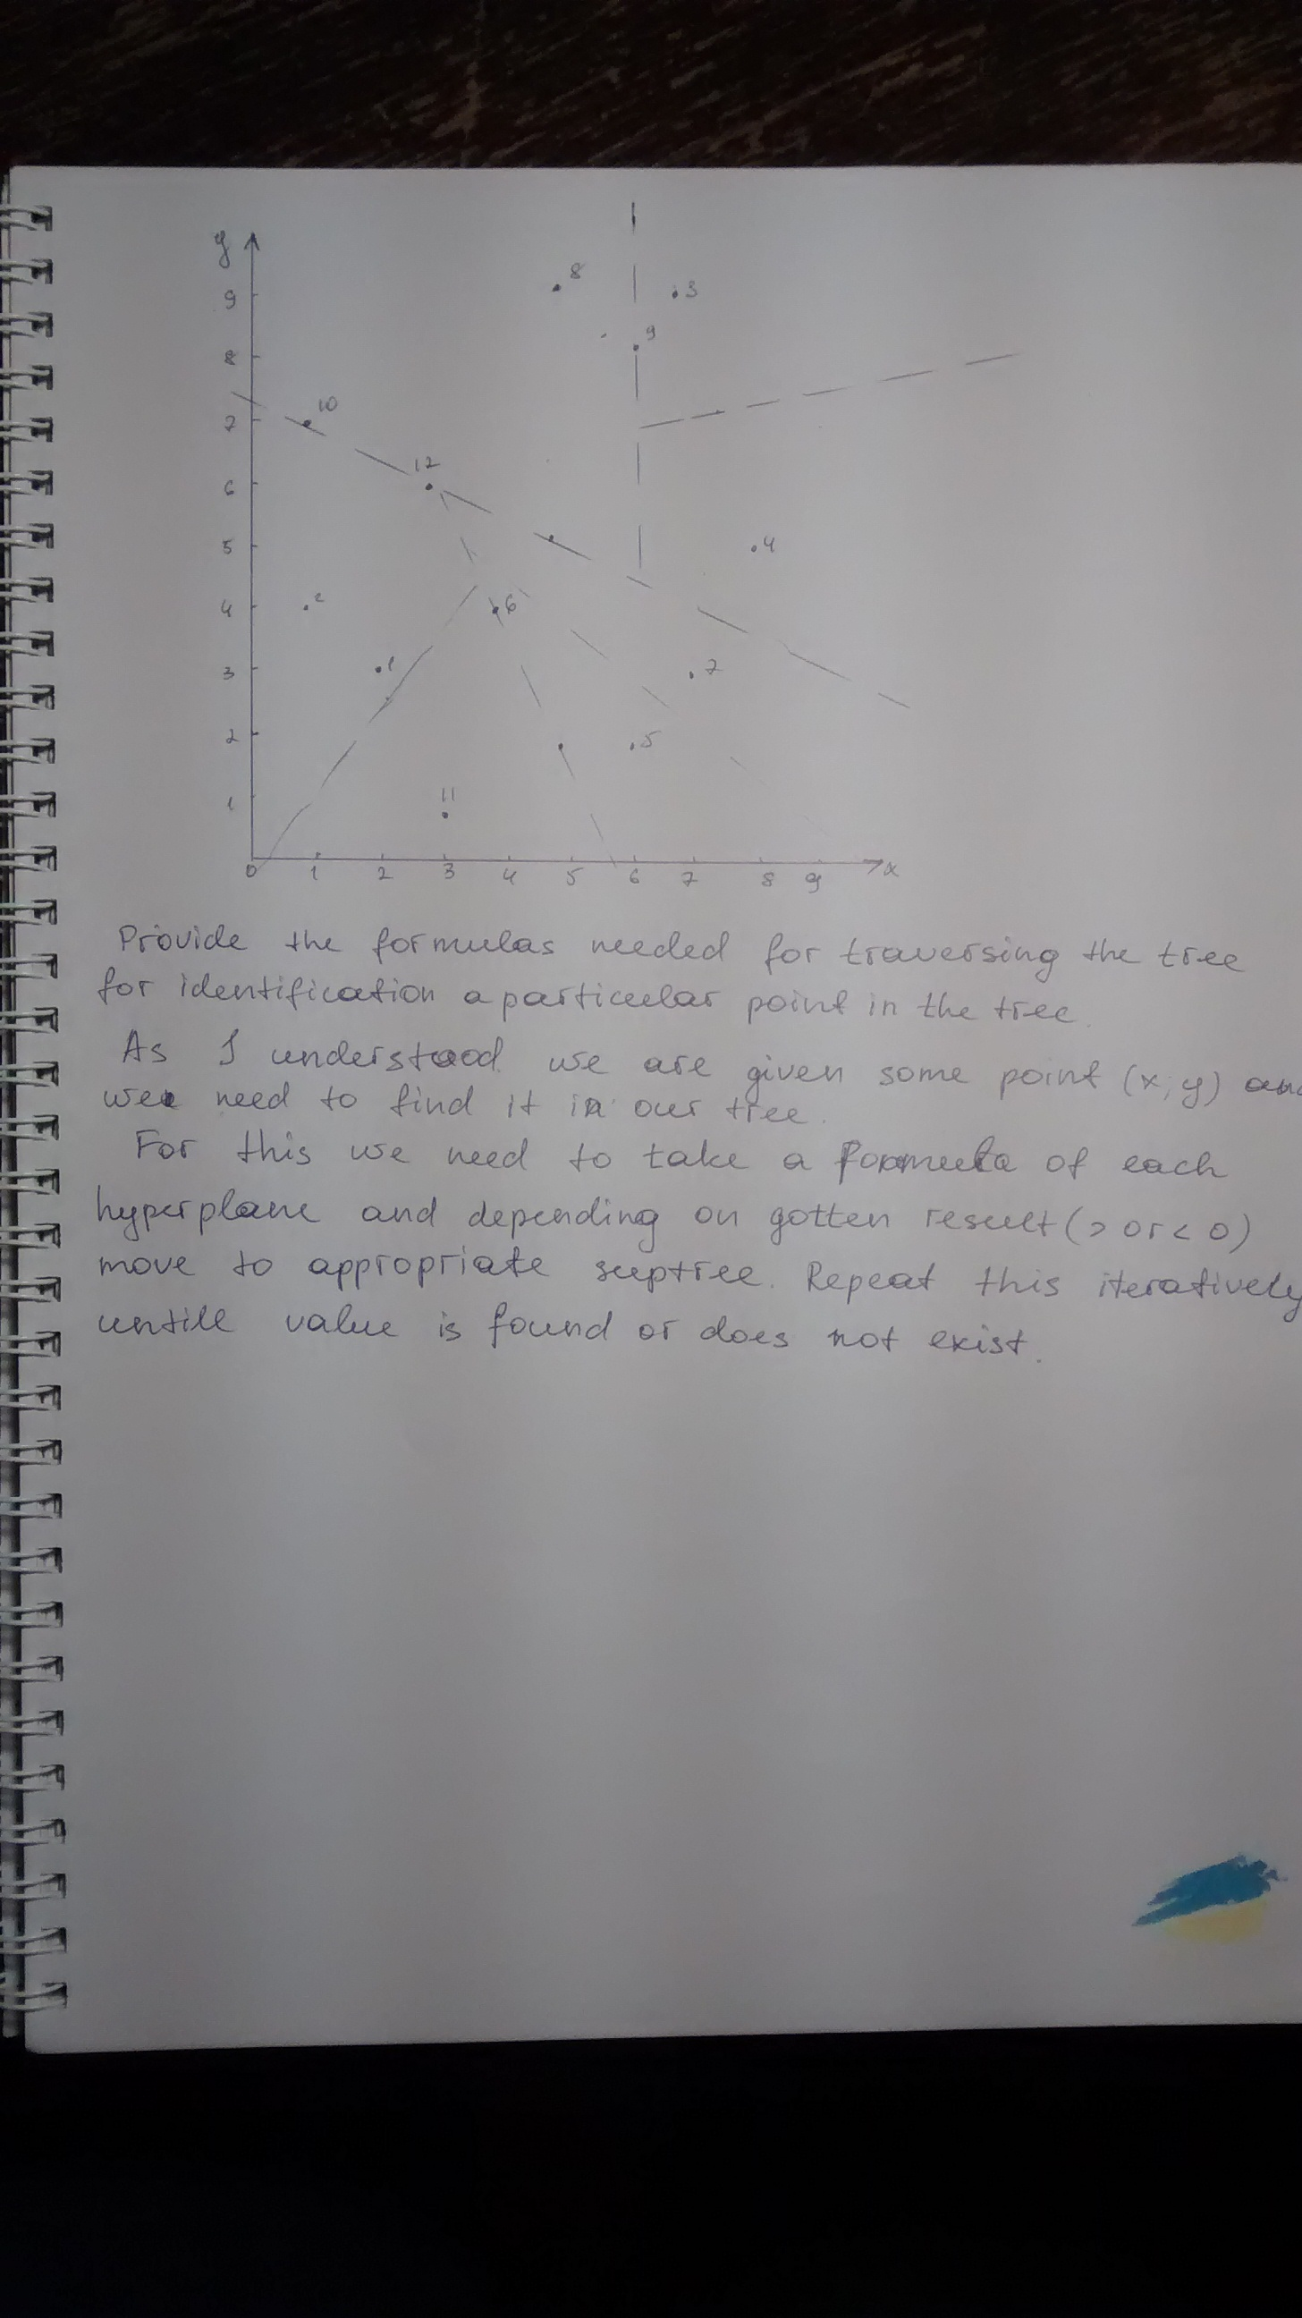

5. Describe the process of searching the proximity of a particular point from a random projection tree. E.g. - list all points that are within radius <= sqrt(3) from the search point. Illustrate this on the same example from task 4. Make an example query that does not exist exactly in data but that would fetch exactly 4 points within that radius.

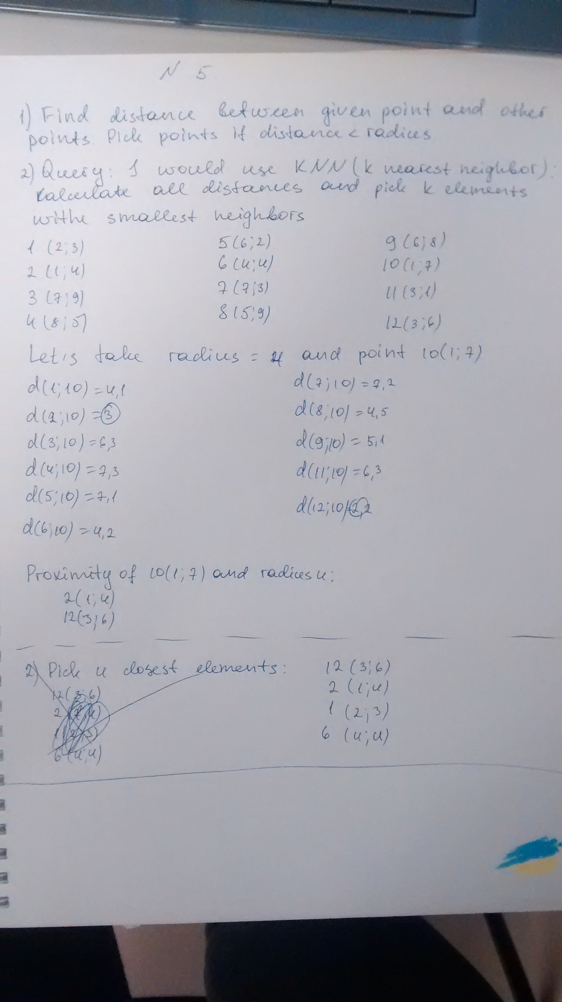

6. Define the random projections tree for 3-D and k-D data. Next, define formula for deciding whether a point should be in the left or right subtree from the hyperplane. Try to create an educational example of this situation for 5-dimensional data.

