Homework #6
Union-find, Binomial Heap, Succinct trees

Anastasiia Konoplina

2. Insert values 6, 9, 2, 8, 19, 25, 10, 13, 7, 5, 11 into a max-priority Binomial heap. Draw the final initial steps and final state. Then delete the max value 4 times in a row. Draw the final state.
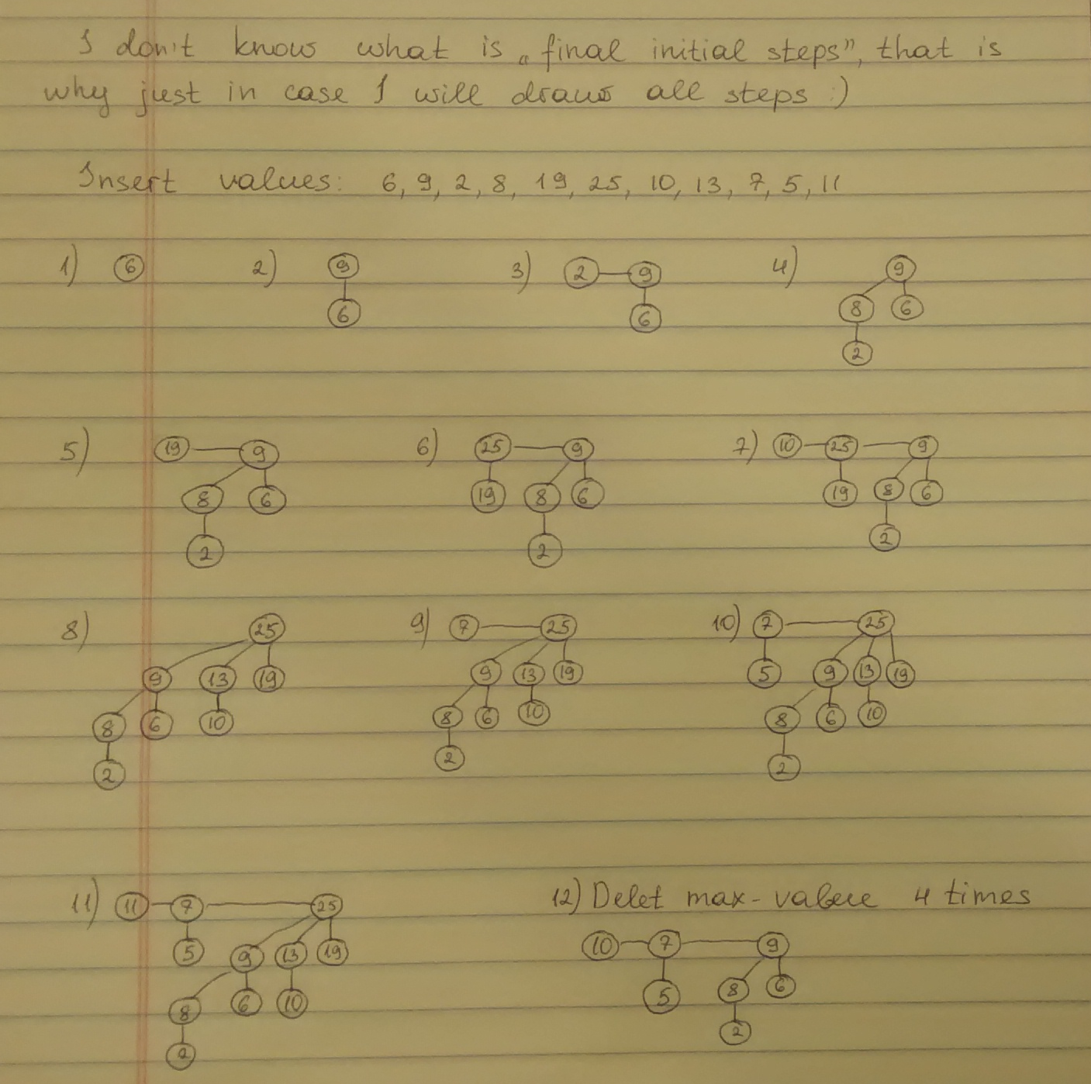

2. Insert values 6, 9, 2, 8, 19, 25, 10, 13, 7, 5, 11 into a max-priority Binomial heap. Draw the final initial steps and final state. Then delete the max value 4 times in a row. Draw the final state.

