Homework #7

Anastasiia Konoplina

*1. read in the files.*

For this homework I used R instead of python.

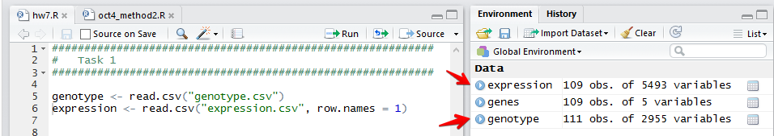

The code of implementation of all the tasks can be found on [Github](https://github.com/anastasiiakonoplina/bioinformatics/blob/master/hw7/hw7.R). The code for first task can be find under appropriate comment (“Task 1”).

*2. choose 2 - 5 genes (columns in expression.csv file) and plot their expression distribution.*

Code of implementation can be found [here](https://github.com/anastasiiakonoplina/bioinformatics/blob/master/hw7/hw7.R) under Task 2

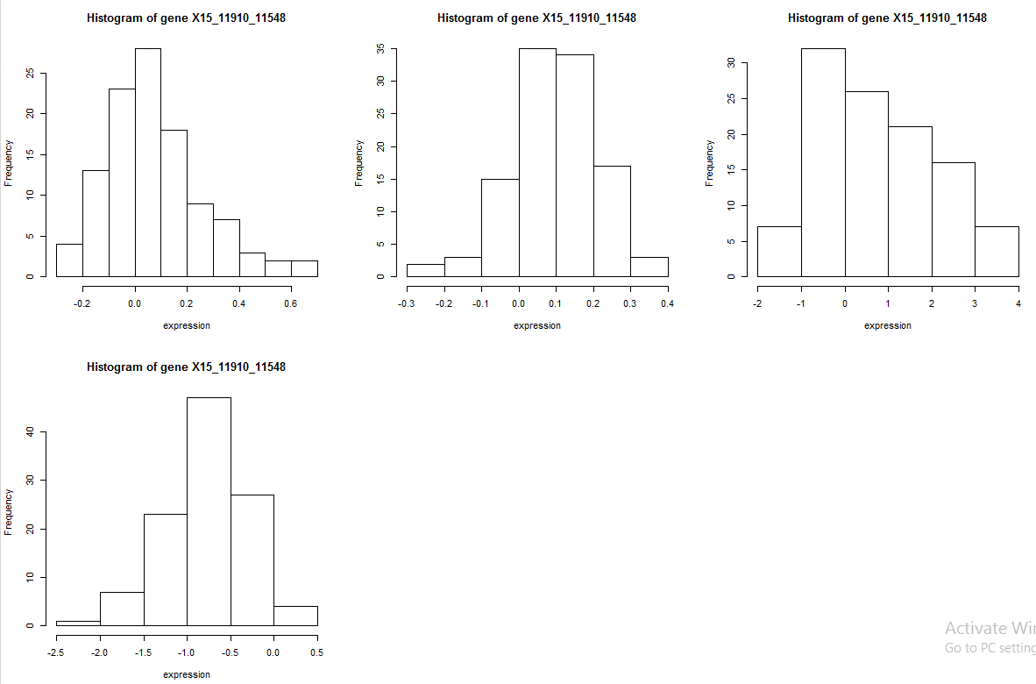

*3. choose 2 - 5 individual yeast IDs (rows in genotype.csv file) and plot SNP values.*

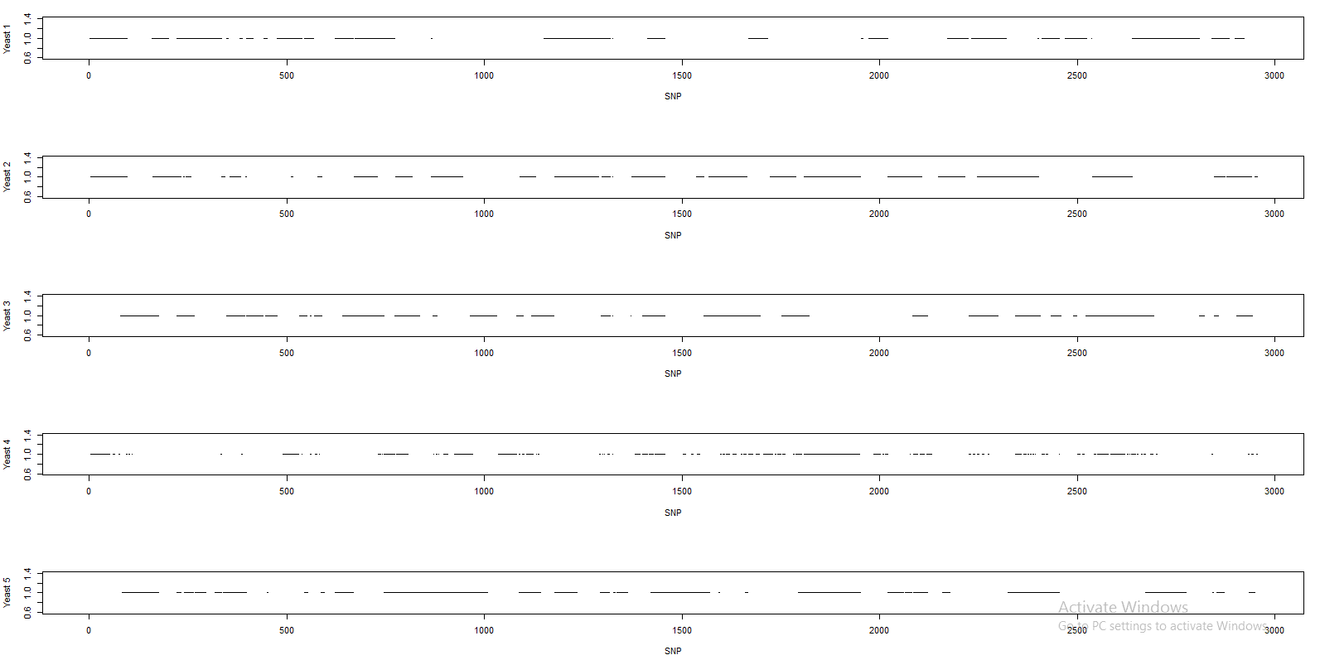

The code can be found [here](https://github.com/anastasiiakonoplina/bioinformatics/blob/master/hw7/hw7.R).