Anastasija Sidorkina

sidorkinastacy@gmail.com

Assignment 1 data visualisation

Excel and Tableu

Contents

Scenario 2

Policies and Procedures 2

First Task 3

Second Task 6

Tableau 7

# Scenario

The “Wealth of Nations” dataset includes GDP, life expectancy at birth, and the number of smartphone users per country. This dataset was assigned in order to create a visual report in the form of charts and tables using Microsoft Excel and Tableau, to transform information into useful insights for business outcomes. In the age of “Big Data”, such strategies are crucial in maximising business efficiency, but must be done in accordance with data protection laws to ensure compliance and data integrity.

# Policies and Procedures

As aforementioned, data protection policies and procedures account for a vital step in data analysis and data visualisation, and relevant procedures must be carried out to prevent data leakage, bias, and multiple other risks. The General Data Protection Regulation (GDPR) enforced in the EU in 2018, and a subsequent separate UK version in 2021 post Brexit, has emphasised the importance of data protection policies, a few of which that are relevant when working with the “Wealth of Nations” dataset, and are outlined below.

1. Data handling

A successful data analyst must ensure that the data with which they are working is encrypted, stored safely, and is handled with confidentiality. This entails using password protection, pseudonymisation of data, keeping detailed documentation of the data cleaning process, and storing the dataset in a secure location.

1. Ethical considerations

The cleaning process of the dataset is a crucial step in a data analyst’s role and can help avoid bias and ensure transparency. During the process, one must identify and deal with any potential bias that could skew data and exacerbate the bias further along the analysis process to ensure fairness. As well as this, the explanation of methodology, having clear records of the handling of outliers or missing data, and having transparency in the results report will increase the accuracy and reliability of the data analysis. The ethical considerations of only using the data for its authorised purpose, and accounting for potential negative impacts of one’s findings are also important to keep in mind when dealing with data.

# First Task

1. **Set a password to protect the workbook**

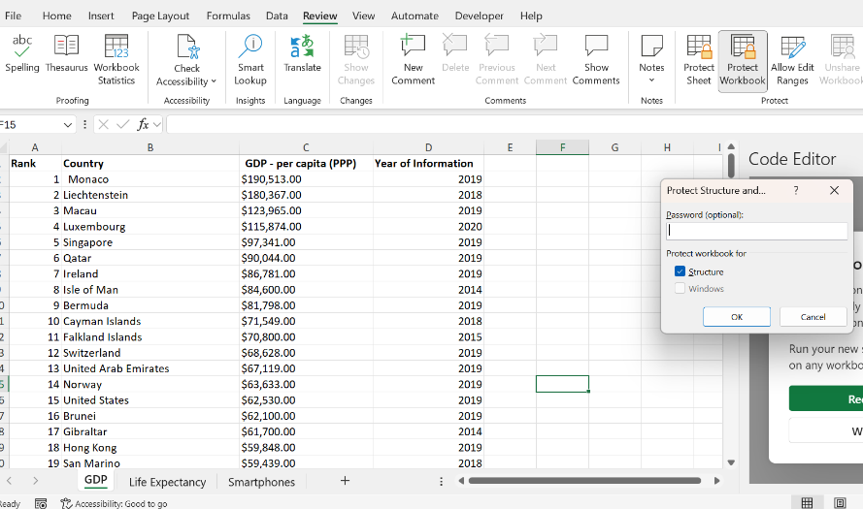

There are two options within Excel that can secure sensitive and important information. By clicking on the “Review” section in the Ribbon, you can choose to protect the sheet or workbook with a password.

1. **Highlight column C and change data to GBP**

1. **Turn the GDP sheet into a table**

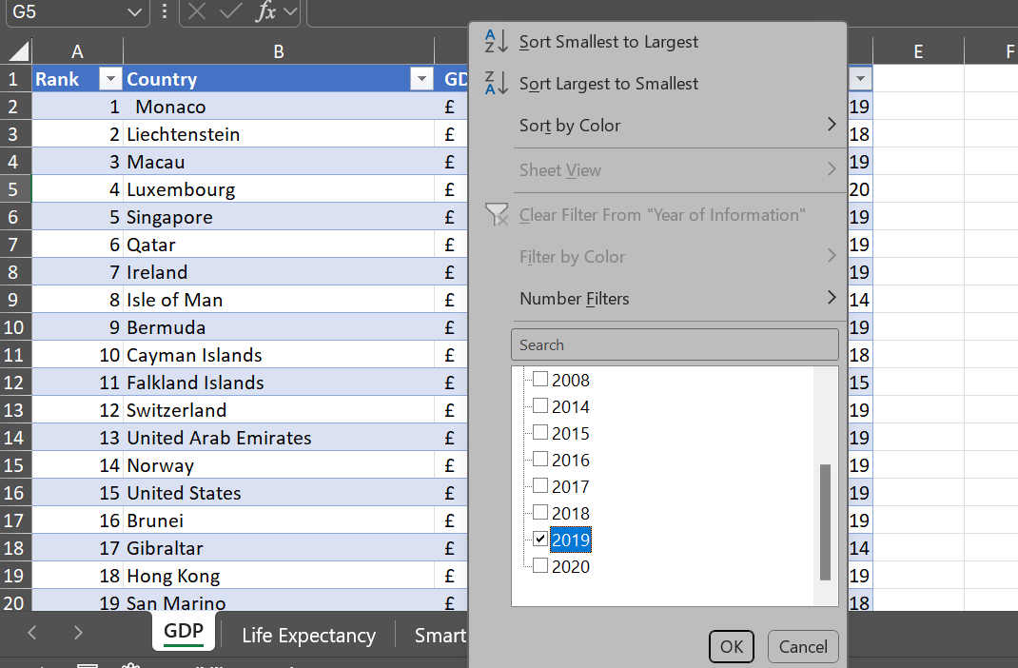**4. Filter the table to display only information for 2019**

1. **Create a chart that will only display Rank, Country, and GDP per capita, and**
2. **add axis titles**

1. **Move the chart to a new sheet tab and add a suitable name**

1. **Create a sort for the top 20 highest ranking countries**

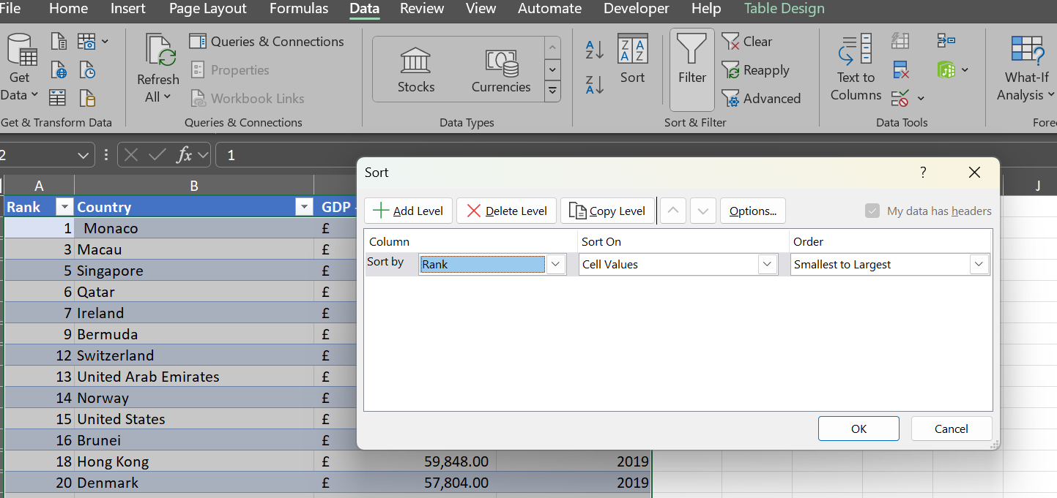

1. 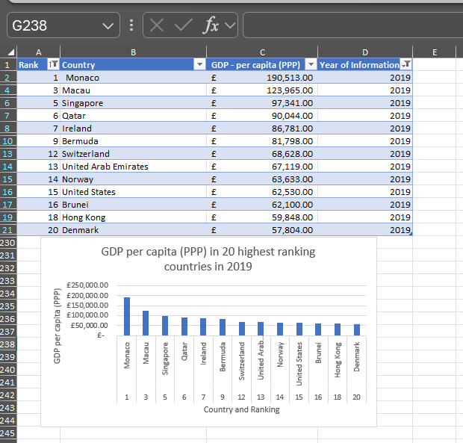**Create a new bar chart to display the 20 highest ranking countries from your sort and then move the chart to be underneath the table**
2. **Fill in the background colour**

# Second Task

1. **Create three macros and their buttons to “Copy sheet”, “Print sheet” and “Save File”**

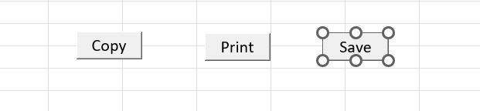

1. **Using the copy macro, copy the sheet and paste it into a new Word document, giving the title: “GDP – Gross Domestic Product”**

1. **Save document in word**

# Tableau

I first import the data by clicking “Data” in the toolbar and selecting the Excel document I have just saved in the previous step. I then input the three columns Life Expectancy, GDP, and Smartphones as shown below, with the relationship between them set as “country”.

I then made sure that all data types are correct, such as shown in the screenshot below, where date of information has been changed to “string”.

Here are four visualisations:

Visualisations revised to contain only the top 20 ranked countries in each:

