PROJECT 2025–2026

Pattern Recognition

Anastasis Sepetis TH20697

Introduction:
Heart diseases are among the leading causes of death worldwide, making early diagnosis particularly critical. In this project, our goal was to analyze the UCI Heart Disease dataset, preprocess it for machine learning tasks, apply various supervised and unsupervised learning methods, and draw conclusions from the results.

STEP 1 – Data Selection:
The dataset selected for this project is the Heart Disease dataset. Heart diseases are among the main causes of mortality worldwide, which makes early detection and classification vital. Within this project, we analyzed the UCI Heart Disease dataset, preprocessed it for machine learning applications, applied various supervised and unsupervised methods, and derived meaningful conclusions from the results.

STEP 2 – Data Inspection:
The first step was to replace the numeric column names with descriptive names such as:
age, sex, cp, trestbps, chol, fbs, restecg, thalach, exang, oldpeak, slope, ca, thal, num. We observed that the variable “num” exhibits class imbalance. Next, we checked for missing values and found NULL values in the variables ca and thal.

These values were replaced with the mean of the corresponding column. After the replacement, it was confirmed that there were no missing values remaining.

Then, a separate table was created to store the class value for each sample in the dataset, i.e., the “num” column.

STEP 3 – Data Preprocessing
Initially, we visualized the data using boxplots and descriptive statistics.
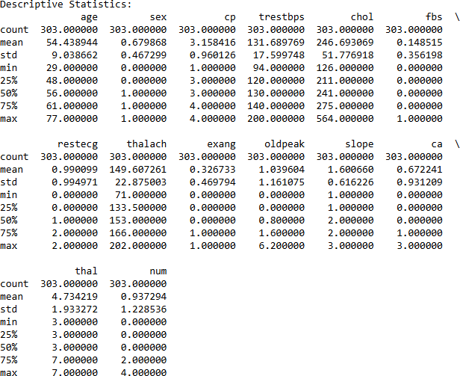

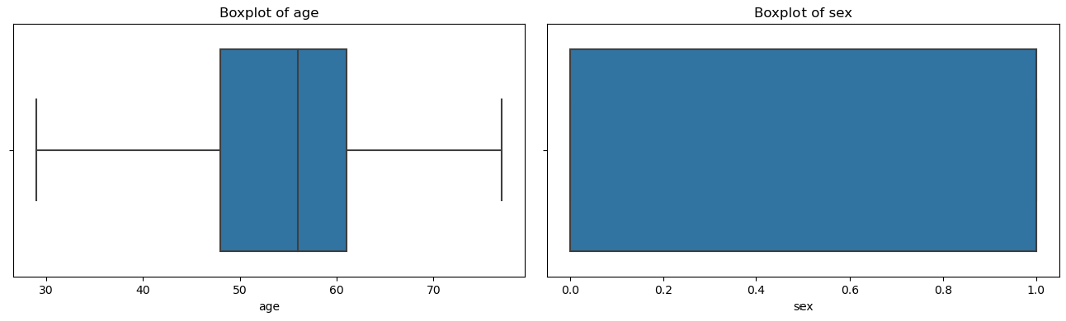
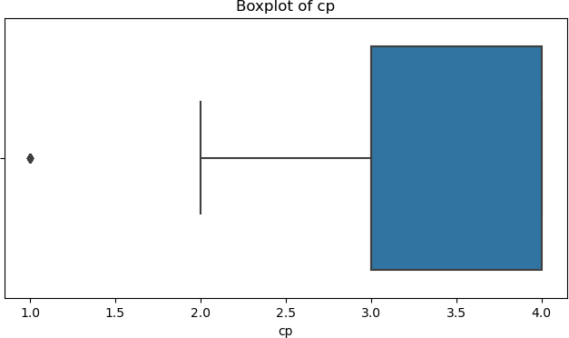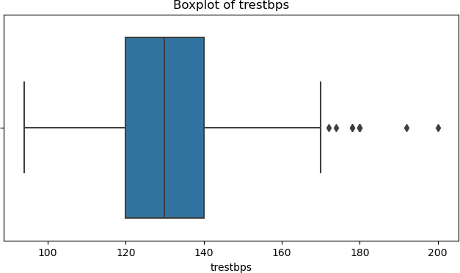

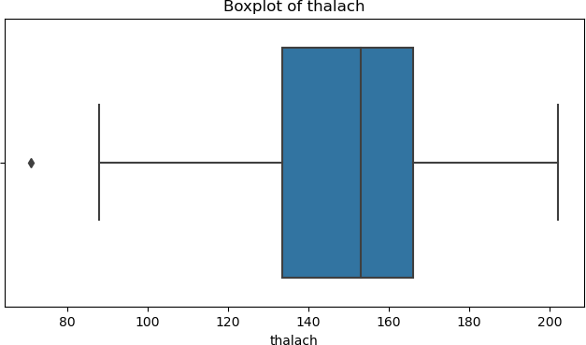
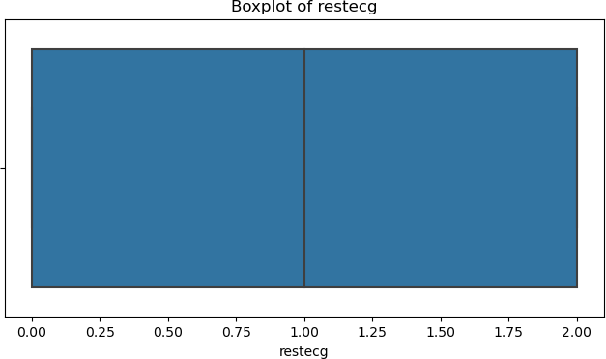
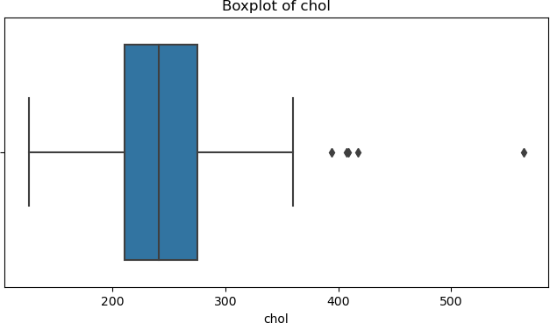
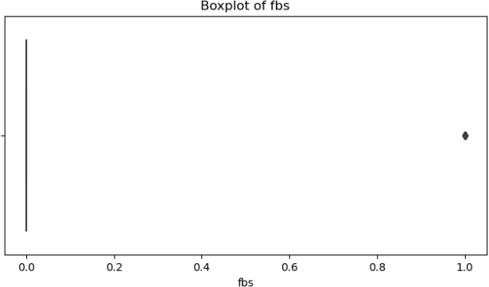
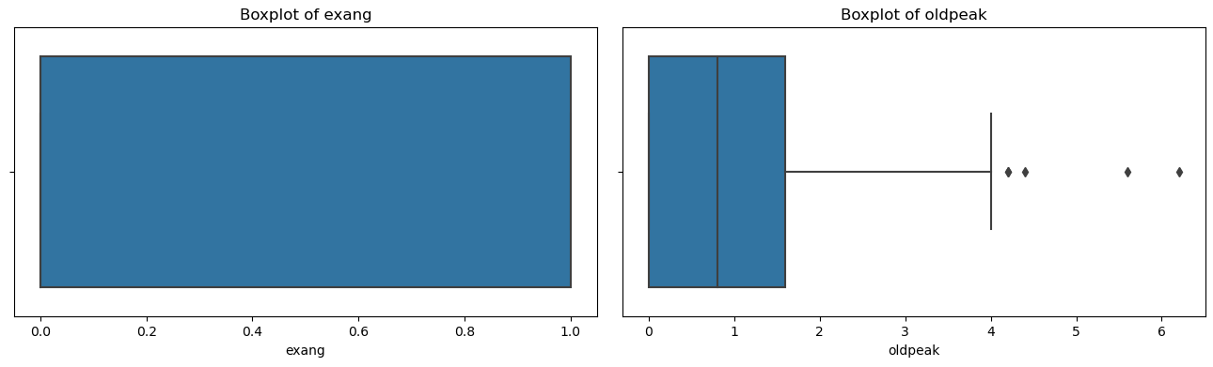
From the boxplots, the presence of outliers is evident, mainly due to the spread of the “chol” feature. Therefore, the next step was to remove the outliers.
After removal, a small decrease in the total number of samples is observed.

Next, we normalized and standardized the data (e.g., to the [0,1] range) and visualized them again using scatterplots. Standardization was performed so that all features are on the same scale, either within [0,1] or with mean 0 and standard deviation 1.
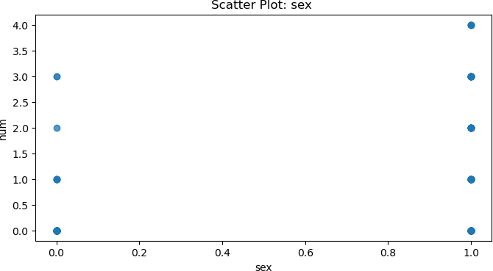
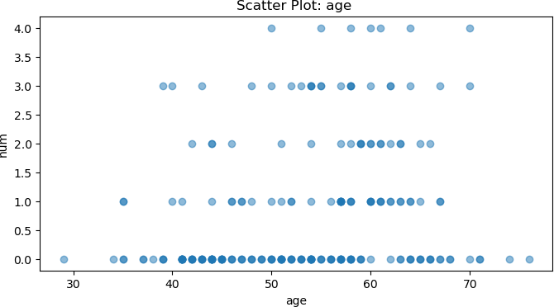
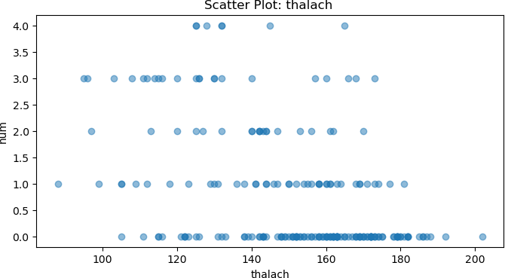
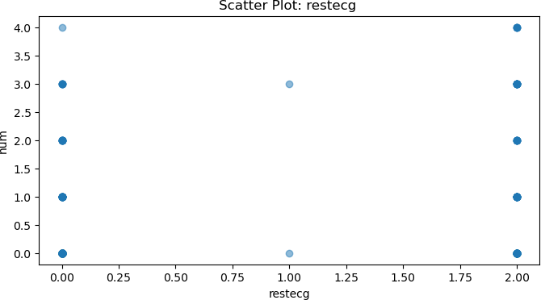
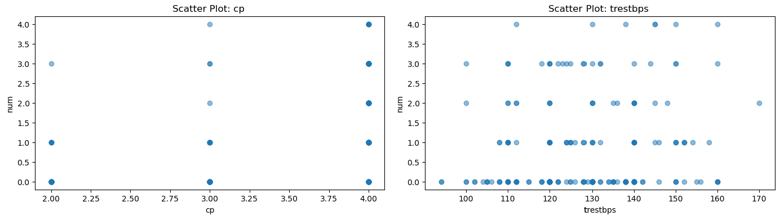
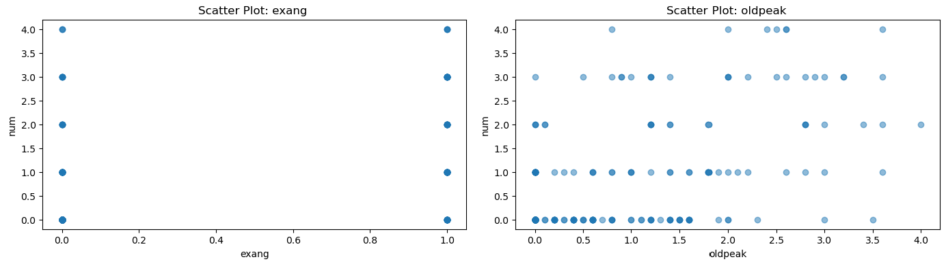
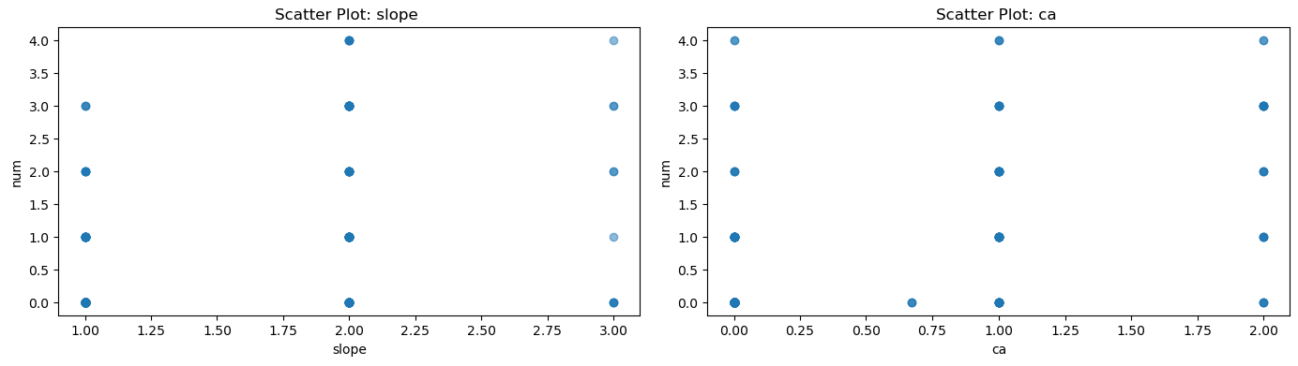

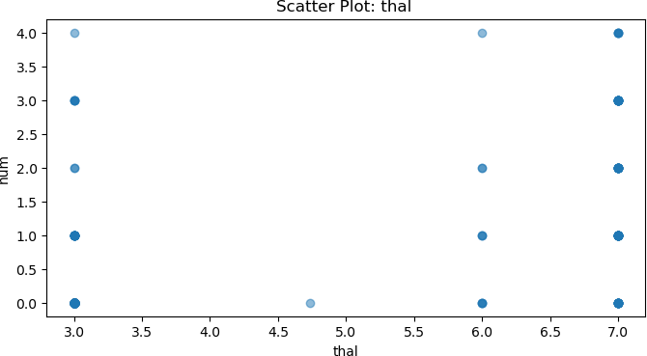

The scatterplots created indicate possible relationships between the features and the target variable. The next step was to select the best features using the ANOVA F-statistic method.

As shown, the features are ranked in descending order based on their score. Finally, we split the data into a 70% training set and a 30% test set.

STEP 4 – Supervised Learning (Classification):
In this step, three classifiers were evaluated:
- Linear Discriminant Analysis (LDA)
- Quadratic Discriminant Analysis (QDA)
- Naïve Bayes
Initially, we trained the models using 80%–20% and 90%–10% splits and obtained the corresponding results.
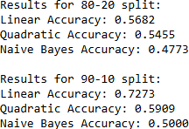
Next, 10-fold cross-validation was applied.

Conclusions:
- Smaller test sets (e.g., 90%–10%) often lead to slightly higher accuracy, but they may not be representative.
- Larger test sets (80%–20%) provide a more reliable evaluation, albeit with slightly lower accuracy.

LDA: Performs well when the relationship between features and the target is linear.
QDA: Can capture more complex relationships, but there is a risk of overfitting on small datasets.
Naïve Bayes: Fast and efficient, but it relies on the assumption of feature independence, which often does not hold.

10-fold cross-validation provides a reliable estimate of performance and reduces the risk of misleading results from a single data split.

STEP 5 – Unsupervised Learning (k-means):
First, the K-Means algorithm was applied and the optimal value of k was sought using the Elbow method.

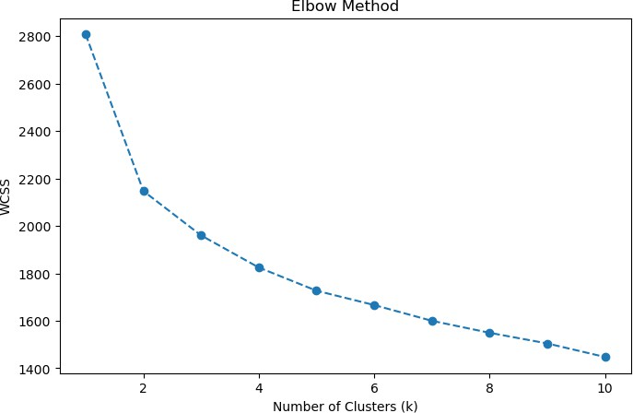

From the plot, the point where the decrease in WCSS slows down significantly is at k = 3.
From the Silhouette Analysis, the highest silhouette value corresponds to k = 2.
Then, the k-means algorithm was applied for both cases.

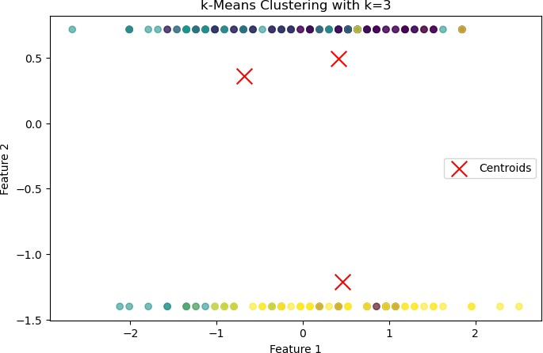

STEP 6 – Unsupervised Learning (Hierarchical Clustering):
In the final step, hierarchical clustering was applied and a dendrogram was constructed.

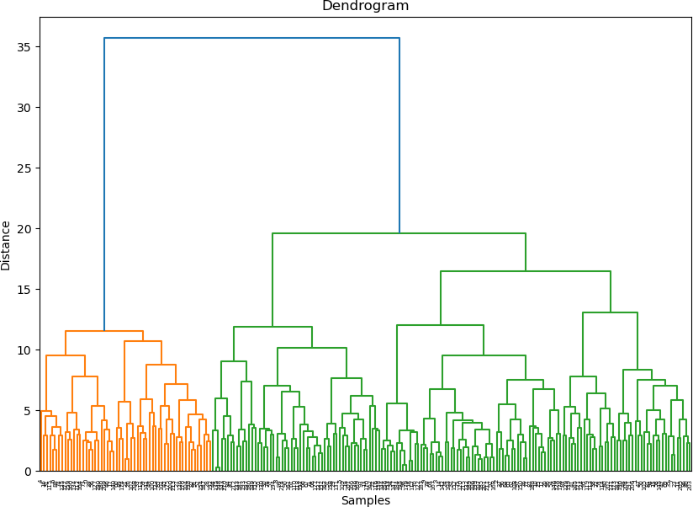
From the dendrogram, the largest vertical merge distance indicates that the optimal number of clusters is 2. The blue line at the top separates two main clusters. Ward’s method was used to minimize within-cluster variance. K-Means clustered the data effectively when an appropriate k was selected, while hierarchical clustering provided insight into the nested structure of the data, although it is more computationally demanding.
STEP 7 – Conclusions:

Comparison of Supervised and Unsupervised Learning
Method | Pros | Cons
Supervised | High predictive accuracy with labeled data | Requires labeled data
Unsupervised | Independent of labels, exploratory value | Limited accuracy, subjective evaluation

Supervised learning achieved higher accuracy and reliability in predicting heart disease, while unsupervised learning excelled at exploring the data and identifying hidden patterns. The two approaches are not directly comparable, since supervised learning targets prediction whereas unsupervised learning focuses on exploring the structure of the data. Combining both provides a more comprehensive analysis. For real-world applications, the use of supervised models with cross-validation is recommended.

