# Department of Computing

**CS213: Advanced Programming**

**Class: BSCS – 4A**

# Lab 2: Analysis of Matrix Multiplication Algorithms

**Date: October 6, 2016**

# Documentation

# Instructor: Fahad Ahmed Satti

# Name: Anas Tehseen

# CMS: 112398

**Introduction:** In this lab, we were asked to analyze the algorithms of the matrix multiplication (Iterative Method and Strassen Algorithm). Then we were asked to run some unit tests on the methods to actually check the validity of these methods and also do the profiling of the algorithms. We were also asked to implement the generic form of Strassen’s algorithm which works for any sized matrix.

**Screenshot:** This is the screenshot for the profiling of iterative method.

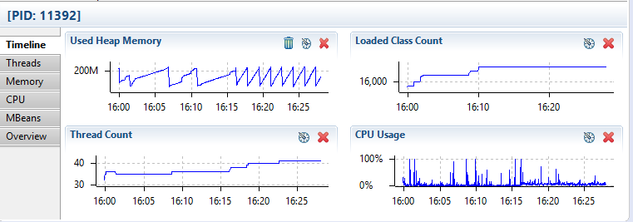

**GitHub Link:** https://github.com/anastehseen/AP-Lab-02