E-Commerce Data Engineering & Analysis Report

Introduction
The goal of this project was to design and implement a complete data pipeline using an e-commerce dataset. The project combines data analysis, data engineering, and business intelligence techniques to transform raw data into meaningful insights.

Dataset link :
https://www.kaggle.com/datasets/carrie1/ecommerce-data?resource=download
This is a transnational data set which contains all the transactions occurring between 01/12/2010 and 09/12/2011 for a UK-based and registered non-store online retail.The company mainly sells unique all-occasion gifts. Many customers of the company are wholesalers.

Data Cleaning and Preprocessing
The dataset was processed using Python (Pandas). The following steps were applied during the data cleaning:
- Removed cancelled transactions (InvoiceNo containing 'C')
- Removed duplicate records
- Removed non-product codes (POST, BANK CHARGES,etc)
- Converted date columns to datetime format
- Extracted Date and Time features
- Ensured correct data types
- Filtered out:
  - Negative or zero quantities
  - Missing CustomerID values
  - Invalid Country names
  - Zero or negative prices

ETL Process
The ETL pipeline includes:
Extract: Raw csv data from kaggle
Transform: Clean and filter data, create new features, build dimension tables
Load: Insert into MySQL database, export to csv

Data Modeling
A star schema was designed to support analytical queries.
Fact Table:
fact_sales: InvoiceNo, DateID, CustomerID, StockCode, Quantity, UnitPrice, TotalPrice

Dimension Tables:
- dim_customer: CustomerID, Country
- dim_product: StockCode, Description
- dim_date: DateID, InvoiceDATE, Year, Month, Day, Weekday
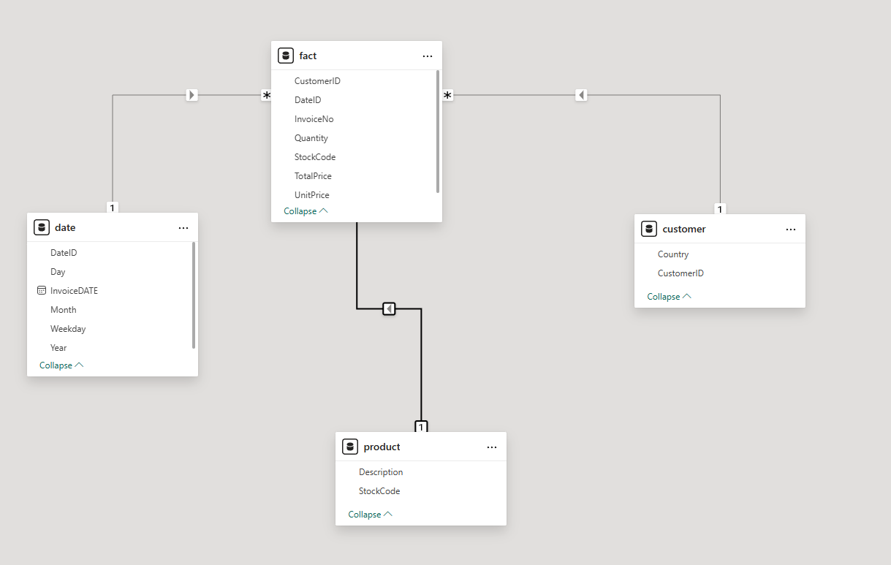

Exploratory Data Analysis (python pandas)
EDA was performed to understand the structure and patterns of the dataset.
1)Sales over the time
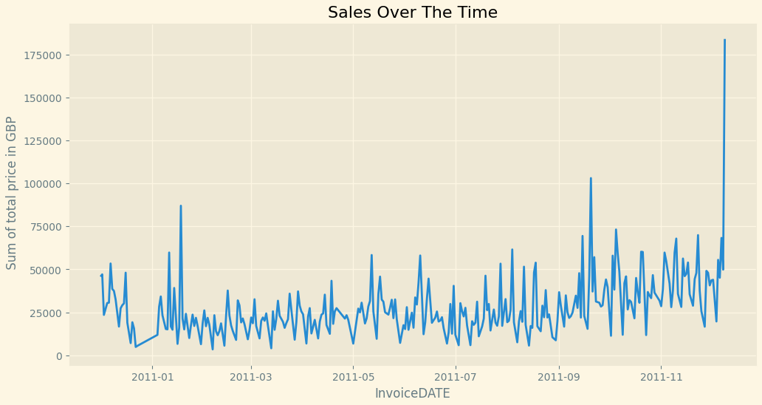
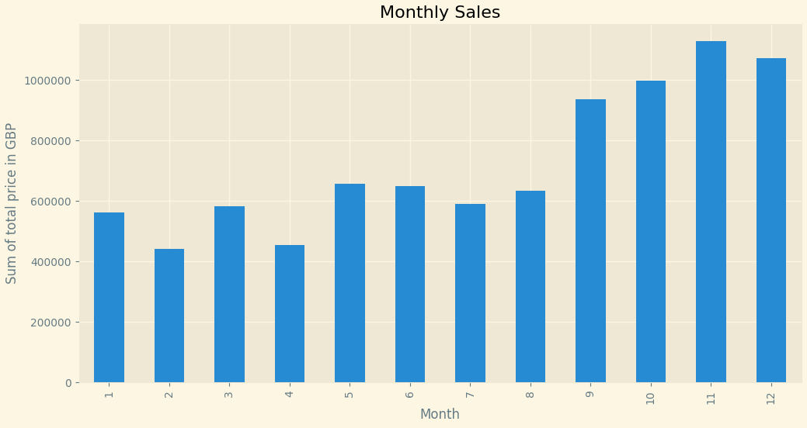
- sales are very unstable
- there is a clear increase toward the end of the year
Insight : Sales increase significantly in the last months of the year most likely due to Holiday season.
2)Sales by Country
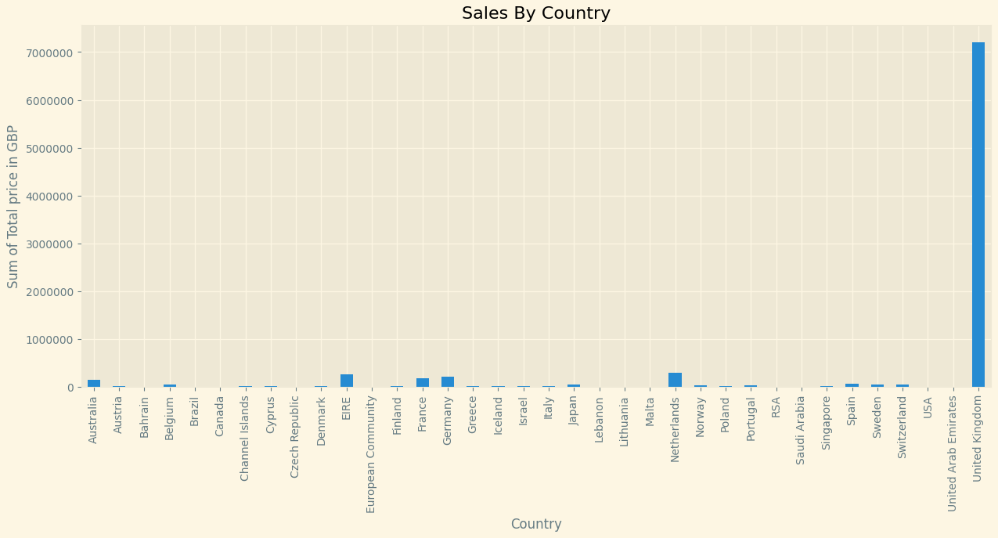
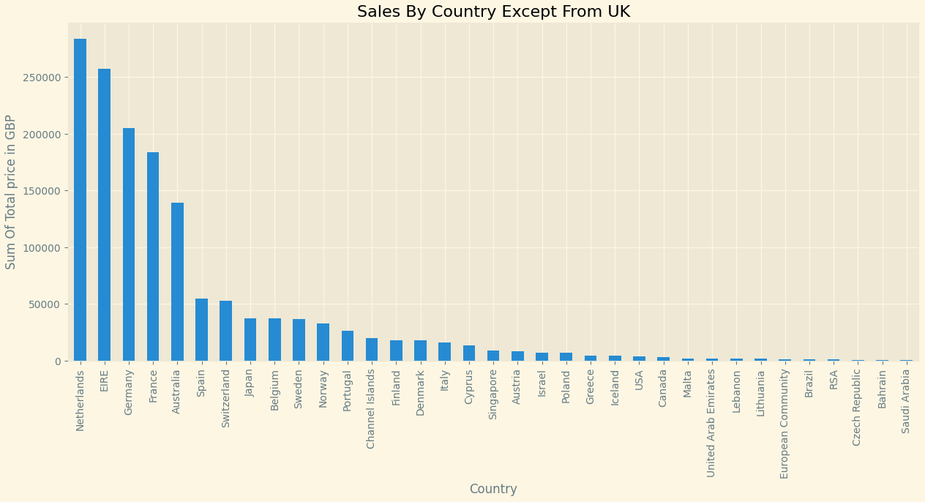
Countries like Netherlands, EIRE, Germany, France contribute but very small compared to UK
Insights:
- The business is heavily dependent on UK. The United Kingdom dominates massively.
- Other countries contribute very little revenue.
3)Top 10 Products by total sales value
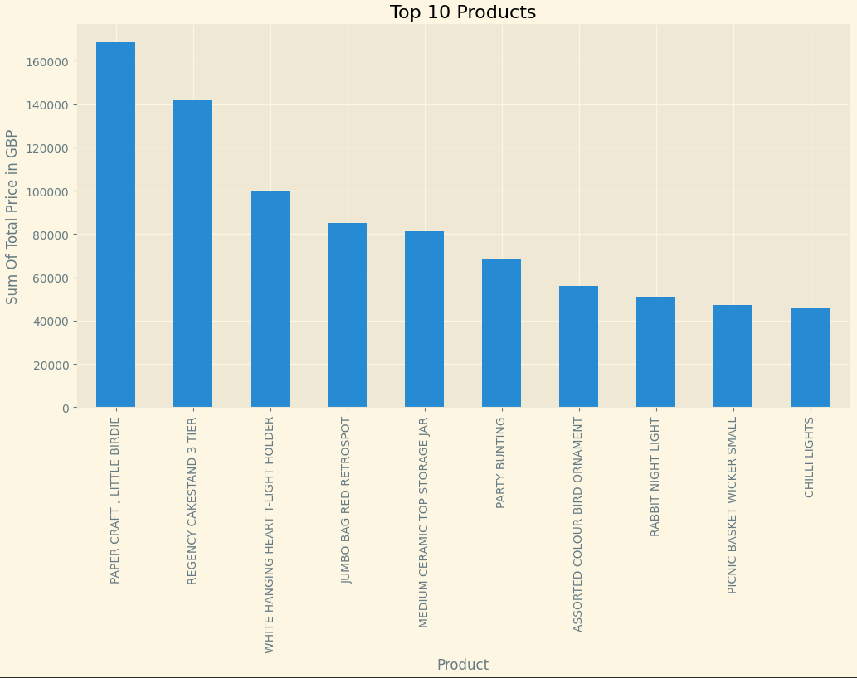
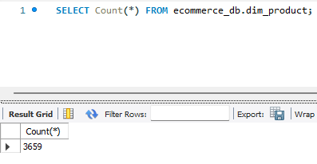
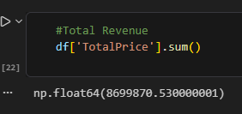
The total amount of different products is 3659
The total revenue of the top 2 products is ~ 310.000 GBP
The total revenue is 8.699.870 GBP
Insight: There is a steep drop after the top 2 products, suggesting that these 2 products drive a large portion of the total revenue ( almost 3.57% and there are 3659 different products)
4) Top 10 customers
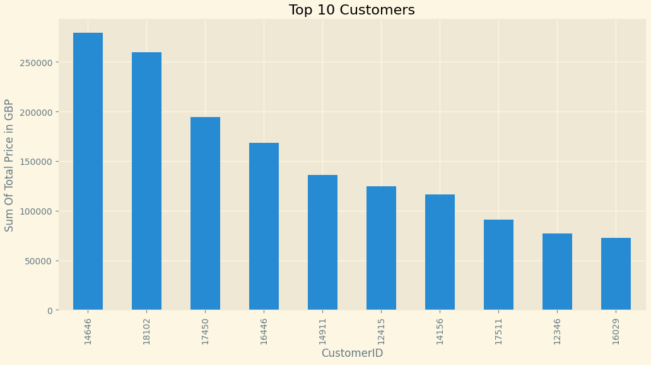
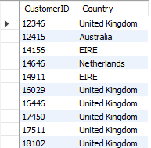
United Kingdom dominates
EIRE appears twice
Netherlands appears once
Australia appears once

Insight: The business is UK-centric ,but a few international high-value customers contribute meaningfully.

5) Customers spending Distribution
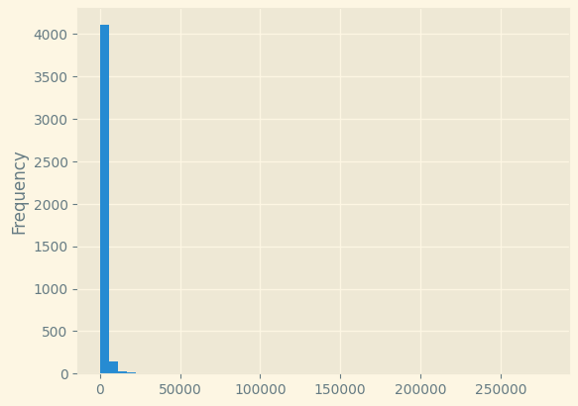
Insight: Just a few customers spend lots of money. Most of them spend less than 50.000 GBP on purchases throughout the year.

6)Average Order Value && Average items per order
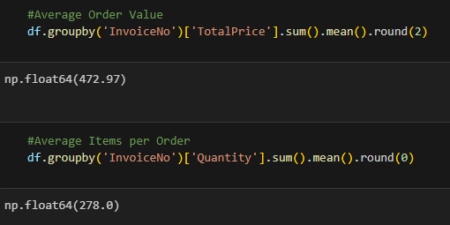
API Development
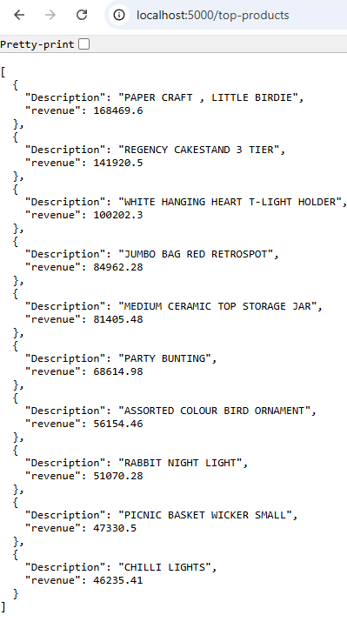
A REST API was developed using Flask to provide access to the data.
Example endpoints:
- /revenue
- /top-products
- /top-customers
- /country-sales
- /monthly-sales
The API provides data in JSON format accessible through a web browser. The API handles HTTP requests and returns data, making it easy to retrieve and use in other applications or front-end interfaces.

Users can send a GET request to a specific endpoint. For example http://localhost:5000/top-products
The API responds with data in JSON format.

In order to access the API and retrieve data via GET requests, the Flask server must be running in the background. This means that the app.py file needs to be executed so that the server listens for incoming HTTP requests. Once the server is active, users can send requests through a browser and receive JSON responses from the API.

Data Visualization
Data visualization was implemented using Power BI and it consists of 4 pages. All pages have interactive slicers that are used for dynamic analysis.
