FraudLens
An Anomaly Detection Framework for Identifying Fraudulent Credit Card Transactions
Final Project Report: the complete data science lifecycle on an open-source data platform
PRT661 · Theme 3: Anomaly Detection and Intelligent Monitoring · Assessment 4
Charles Darwin University
Repository: github.com/anasua2905/fraudlens-or-credit-card-fraud-detection (branch final-a4)
20 October 2026

Table of Contents
In Word: right-click the table below and choose “Update Field” → “Update entire table”.

Executive Summary
FraudLens is an end-to-end anomaly detection framework for card fraud, built through all eight stages of the data science lifecycle (problem understanding, acquisition, preparation, exploratory analysis, modelling, evaluation and interpretation, deployment and visualisation, monitoring and improvement) and implemented on an open-source data platform that mirrors a modern cloud data pipeline: MinIO object storage, Apache NiFi ingestion, an Apache Hive Metastore catalog, governance through Trino access rules, MinIO policies and OpenMetadata, analytics with Trino and ClickHouse, and visualisation with Superset, Grafana and a Streamlit dashboard.
The data are the Sparkov simulated transactions: 1,852,394 transactions from 2019 to 2020, of which 0.52% are fraudulent. Exploratory analysis showed that fraud is concentrated in large amounts relative to a card's history, at night (84.8% of training fraud between 22:00 and 03:59), in bursts on compromised cards, and in online and grocery point-of-sale categories.
Six models were tuned with time-series cross-validation and compared on a later validation period. A pre-registered rule selected the simplest model that is statistically non-inferior to the best: HistGradientBoosting (scikit-learn). On the untouched test period (21 June to 31 December 2020) it detects 96.2% of fraud with 72.4% precision at 14.7 alerts per day, a PR-AUC of 0.970 (251× the random baseline), and catches 98.7% of the fraud value, for an estimated net benefit of $964,182 after review costs. All four success criteria set before modelling are met, and all 56 automated end-to-end verification checks pass.
The system is deployed as a FastAPI scoring service with an online feature store and SHAP explanations, and a Streamlit dashboard for analysts and managers; both run from a self-contained 40 MB bundle, are packaged as a container image, and were deployed with public links. Monthly monitoring with Evidently AI flagged seasonal feature drift in August and December 2020 without a loss of recall, and a champion/challenger retraining test shows how the improvement loop works. The project is managed with a GitHub Project board and CI/CD workflows. The data are simulated, so the absolute results validate the method rather than forecast production accuracy.

1. Problem Understanding

1.1 Context and objectives
Card issuers must decide within milliseconds whether a transaction proceeds quietly or is queued for an analyst. Missing fraud loses money; every false alert costs analyst time and inconveniences a genuine customer. The project brief set five objectives:
- Build a machine-learning system that identifies fraudulent transactions.
- Improve detection while minimising false-positive alerts.
- Provide an interactive dashboard for transaction monitoring and reporting.
- Show the full flow from data collection to visualisation.
- Support quicker decision-making for financial institutions.

1.2 Stakeholders
Table 1. Users of the system and what each needs.
Stakeholder | Question | What FraudLens provides
Fraud analyst | Which alerts first, and why? | Ranked alert queue with SHAP reasons; feedback form
Operations manager | How many alerts, what do they cost and save? | Alerts/day, precision, recall, review cost, net benefit; threshold what-if
Model risk / governance | Is it valid, fair, reproducible, monitored? | Verification report, model card, fairness by group, drift monitoring, MLflow registry, data catalog
Data platform team | Does it run on our open-source stack? | Docker platform: MinIO, NiFi, Hive Metastore, Trino, ClickHouse, Superset, Grafana

1.3 Formal problem and success criteria
For each transaction, using only the transaction and the card's earlier history, produce a score that ranks fraud first, and alert when the score exceeds a threshold chosen to maximise net benefit = 0.9 × fraud value in alerts − $15 × alerts on the validation period. Accuracy is unsuitable: on the test period a model that never alerts is 99.61% accurate and catches nothing.
Table 2. Success criteria (config/pipeline.yaml), set before modelling and checked on the test period.
Criterion | Target | Achieved | Met
min test recall | 0.9 | 0.9622 | Yes
min test precision | 0.5 | 0.724 | Yes
max alerts per day | 20 | 14.7 | Yes
min pr auc lift | 50 | 251.3 | Yes

1.4 Hypotheses
Table 3. Hypotheses formulated in stage 1 and tested in stage 4.
# | Hypothesis | Features that capture it
H1 | Fraudulent transactions are larger than the card's usual spend | amount, amt_to_card_mean, amt_zscore_card
H2 | Fraud happens disproportionately at night | hour, is_night
H3 | Fraud arrives in bursts on a compromised card | txn_count / amt_sum over 1 h, 24 h, 7 d; secs_since_last_txn
H4 | Some merchant categories are riskier | category, category_share_card
H5 | Demographics carry little signal and must not drive decisions | age, gender (fairness check)

2. Solution Architecture and Open-Source Platform
The project follows the modern cloud data-pipeline pattern (storage, crawler, catalog, governance, analytics, visualisation) with an open-source component in each role. One Python package (src/fraudlens, one module per lifecycle step) and one configuration file drive both a laptop run and the Docker platform.
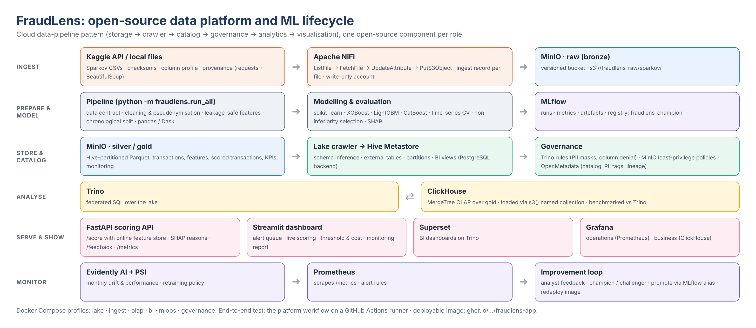
Figure 1. FraudLens architecture: the open-source data platform and the ML lifecycle.
Table 4. Cloud data-pipeline roles and the open-source components used.
Role | Cloud pattern | FraudLens implementation
Storage | Amazon S3 | MinIO: raw (versioned) / silver / gold buckets, Hive-partitioned Parquet
Crawler / ingest | AWS Glue crawler | Apache NiFi flow (landing folder → raw layer, ingest record per file) and a Python lake crawler that infers schemas
Catalog | Glue Data Catalog | Apache Hive Metastore on PostgreSQL
Governance | Lake Formation | Trino file-based access control (PII masks, column denial), least-privilege MinIO policies, OpenMetadata (catalog, PII classification, lineage)
Analytics | Athena / Redshift | Trino over the lake; ClickHouse MergeTree tables for fast OLAP
Visualisation | QuickSight | Apache Superset (BI on Trino), Grafana (operations on Prometheus, business on ClickHouse), Streamlit (analysts)
ML operations | SageMaker | MLflow tracking and registry, FastAPI scoring service, Evidently drift reports, Prometheus metrics

Table 5. Lifecycle stages, notebooks, modules and tools.
Stage | Notebook | Modules | Tools
1 Problem understanding | 01 | config/pipeline.yaml | Jupyter, Markdown
2 Data acquisition | 02 | acquire.py, platform/nifi | Kaggle API, requests, BeautifulSoup, NiFi, MinIO
3 Data preparation | 03 | validate, clean, features, split, quality | pandas, Dask, PyArrow
4 EDA | 04 | eda.py, interactive.py | pandas, Seaborn, Matplotlib, Plotly
5 Modelling | 05 | preprocess, models, tuning, train, selection | scikit-learn, XGBoost, LightGBM, CatBoost, MLflow
6 Evaluation & interpretation | 06 | evaluate.py, explain.py | sklearn metrics, SHAP, ELI5, Yellowbrick
7 Deployment & visualisation | 07 | api, runtime, online, dashboard/app.py, publish, crawler, olap | FastAPI, Streamlit, Plotly, Docker, Trino, ClickHouse, Superset
8 Monitoring & improvement | 08 | monitor.py, tracking.py | Evidently AI, Prometheus, Grafana, MLflow

Design principles, each enforced by a test or a verification check: no feature uses the label; no feature uses information unavailable at authorisation time; splits are chronological; every reported number is reproducible from saved artefacts; the deployed object scores exactly as in training.

3. Data Acquisition
The dataset is Kaggle kartik2112/fraud-detection (licence CC0-1.0), acquired through the official Kaggle API or from a local copy of the same files. Acquisition records a manifest with SHA-256 checksums, sizes and row counts, a column profile, and the provenance of the source; the generator's public repository page is scraped with requests and BeautifulSoup for its description and licence (notebook 02). Verification recomputes the checksums on every run.
Table 6. Acquired files (bronze layer).
Split | File | Rows | Size (MB) | SHA-256 (first 16)
train | fraudTrain.csv | 1,296,675 | 351.2 | fd7139200dbfcbed
test | fraudTest.csv | 555,719 | 150.4 | 12d553ab19440c75

On the platform, the acquisition stage drops the files in a landing folder and Apache NiFi lands them in the raw bucket: ListFile → FetchFile → UpdateAttribute (lake key, ingest time) → PutS3Object → AttributesToJSON → PutS3Object (ingest record). NiFi writes with a write-only service account limited to raw/sparkov/, the raw bucket is versioned so a source file can never be silently replaced, and the stage waits until every file has arrived with the expected size before continuing.

4. Data Preparation

4.1 Data contract
Each raw file is validated against twelve expectations before any transformation. All pass except a warning that the unix_time column is offset by 2556 days in the public copies; time features are therefore derived from the readable timestamp.

4.2 Cleaning and privacy
No duplicates or invalid rows were found, so the silver layer keeps all 1,852,394 transactions. Names and street addresses are dropped, card numbers are replaced by a salted SHA-256 identifier, and the generator's "fraud_" prefix on every merchant name is removed so it cannot be mistaken for a signal. Amount outliers are kept: the top 5% of amounts contain 76% of all training fraud.

4.3 Leakage-safe features
Table 7. Engineered features.
Group | Features | Purpose
Transaction | amount, log_amount, hour, day_of_week, is_weekend, is_night, category | describe the event
Customer | age, gender, log_city_pop | context (checked for fairness)
Card history | amt_to_card_mean, amt_zscore_card, secs_since_last_txn, category_share_card | compare with the card's own past
Velocity | txn_count and amt_sum over 1 h, 24 h and 7 d | detect bursts on a compromised card

Every history and velocity feature uses only transactions strictly before the one being scored (a brute-force recomputation in notebook 03 matches the vectorised values exactly). Running totals (card_prior_txn_count, card_prior_category_count, distance_km, is_new_merchant_for_card) were excluded after measuring that they drift by construction or carry no signal. Dask recomputes the monthly aggregates directly from the raw CSV partitions and matches the pandas silver layer, showing that the preparation scales beyond memory.

4.4 Chronological split
Table 8. Train, validation and test periods.
Split | Start | End | Transactions | Frauds | Fraud rate
Train | 2019-01-01 | 2020-05-10 | 1,185,094 | 6,837 | 0.577%
Validation | 2020-05-10 | 2020-06-21 | 111,581 | 669 | 0.600%
Test | 2020-06-21 | 2020-12-31 | 555,719 | 2,145 | 0.386%

5. Exploratory Data Analysis
All analysis uses the training period only. The results test the stage-1 hypotheses and shape the modelling choices.
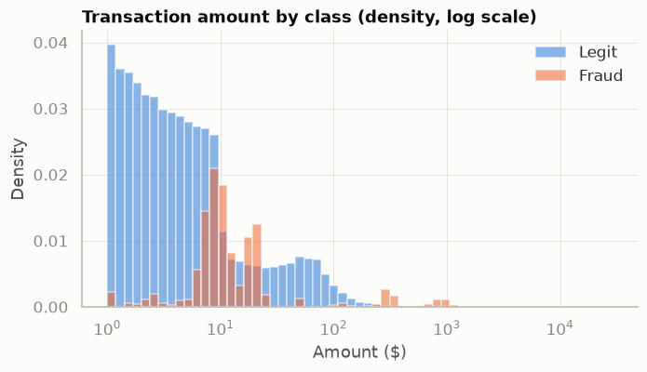
Figure 2. Transaction amount by class (training period).
H1, amount (strongly supported). The median fraudulent transaction is $387 against $47 for legitimate ones. Transactions above ten times the card's usual amount are fraudulent 27.6% of the time and account for 32.7% of fraud.
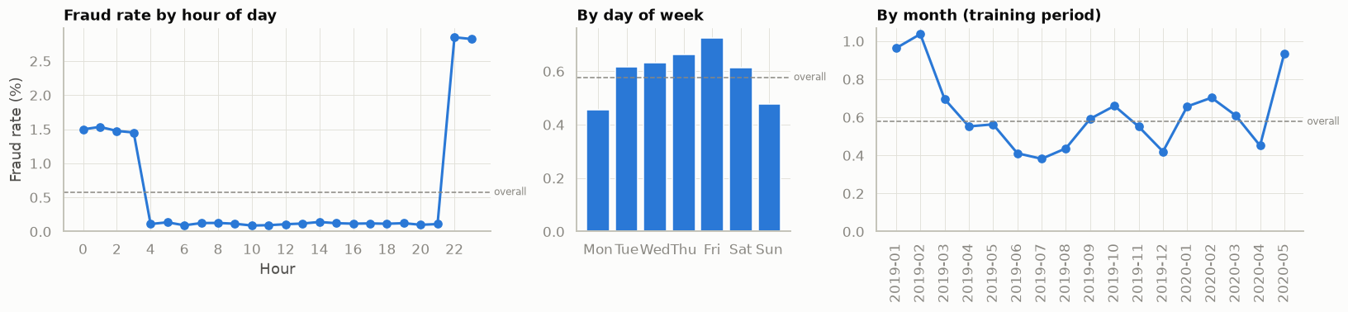
Figure 3. Fraud rate by hour, weekday and month.
H2, night (strongly supported). 84.8% of training fraud occurs between 22:00 and 03:59, where the fraud rate is 2.08% against 0.11% during the day.
H3, bursts (supported). Of 978 cards, 694 were compromised in the training period; a compromised card typically sees 10 fraudulent transactions within about 45 hours. Spend over the previous 24 hours is the single strongest feature (single-feature AUC 0.860).
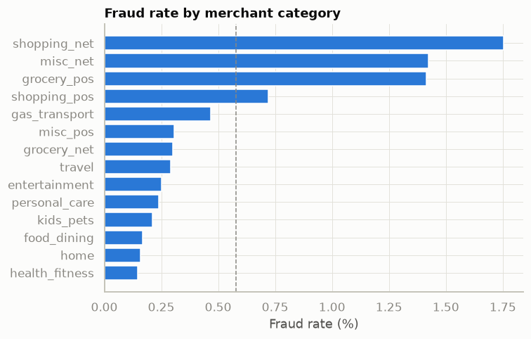
Figure 4. Fraud rate by merchant category.
H4, category (supported). shopping_net (1.75%), misc_net (1.42%), grocery_pos (1.41%) have two to three times the base rate of 0.58%.
H5, demographics (weak). Fraud rates differ modestly by age band and barely by gender (F 0.52%, M 0.64%); they are kept as inputs but monitored for fairness.
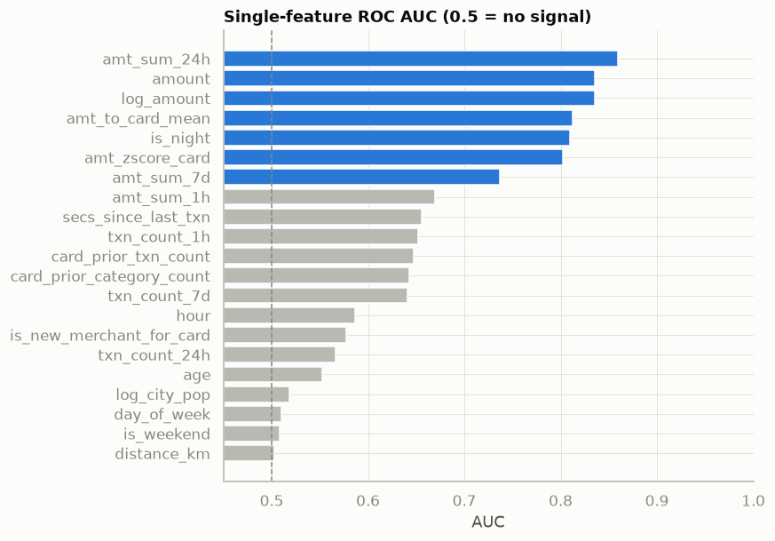
Figure 5. Single-feature ROC AUC on a stratified sample.
Interactive versions of these views (Plotly) are in reports/interactive/eda_explorer.html and notebook 04.

6. Modelling

6.1 Feature views and class imbalance
Two preprocessing views are fitted on the training period only: a tree view (20 features with native categorical codes) and a linear view (39 features: log transforms, train-fitted clipping, standardisation, cyclical time encoding, one-hot categories). Imbalance (172.3 legitimate transactions per fraud) is handled with class weights; no SMOTE or other resampling is used, so the training distribution stays real.

6.2 Candidates, tuning and comparison
Six candidates were evaluated: logistic regression, HistGradientBoosting, XGBoost and LightGBM, an Isolation Forest trained on legitimate transactions only, and a hybrid that feeds the Isolation Forest anomaly score into HistGradientBoosting. Boosted models were tuned by random search with three-fold expanding-window (time-series) cross-validation inside the training period; every run, candidate and model is tracked in MLflow.
Table 9. Model comparison (validation chooses; test shown for completeness).
Model | CV PR-AUC | Val PR-AUC | Test PR-AUC | Test precision | Test recall | Alerts/day
LightGBM | 0.9745 | 0.9878 | 0.9775 | 89.3% | 95.3% | 11.8
XGBoost | 0.9703 | 0.9868 | 0.9768 | 88.7% | 95.1% | 11.9
Hybrid (HistGB + Isolation Forest score) | n/a | 0.9841 | 0.9753 | 89.9% | 94.9% | 11.7
HistGradientBoosting | 0.9724 | 0.9820 | 0.9698 | 72.4% | 96.2% | 14.7
Logistic regression | n/a | 0.6839 | 0.5900 | 20.3% | 83.1% | 45.4
Isolation Forest | n/a | 0.3556 | 0.2662 | 7.1% | 57.2% | 89.1

A compact re-run in notebook 05 repeats the comparison with time-series CV on a one-in-four sample and adds CatBoost as a further contender; the ranking is the same: boosted trees far ahead of the linear baseline, which in turn is far ahead of the purely unsupervised detector.

6.3 Champion selection
Selection follows a rule written before the results were seen: order the models by operational complexity and choose the simplest whose validation PR-AUC is not worse than the best by more than 0.01, judged by the upper bound of a 95% paired-bootstrap interval of the gap. lightgbm has the highest validation PR-AUC (0.9878), but hist_gb (0.9820) is non-inferior: the 95% bootstrap interval of the gap is [+0.0032, +0.0084], entirely below the 0.01 margin. hist_gb is simpler, so it is selected.
Table 10. Paired-bootstrap gap to the best model on validation PR-AUC.
Model | Mean gap | 95% CI | Non-inferior
Logistic regression | 0.3037 | [0.2734, 0.3357] | No
HistGradientBoosting | 0.0059 | [0.0032, 0.0084] | Yes
LightGBM | 0.0000 | [0.0000, 0.0000] | Yes
XGBoost | 0.0011 | [-0.0013, 0.0042] | Yes
Hybrid (HistGB + Isolation Forest score) | 0.0038 | [0.0020, 0.0058] | Yes

The champion is HistGradientBoosting (learning rate 0.1, 15 leaves, min 50 samples per leaf), saved together with its preprocessor and threshold as one FraudModel object and registered in MLflow as fraudlens-champion (alias champion). A train/serve parity test proves the deployed object reproduces the training scores exactly; it caught, and led to the fix of, a float32/float64 representation mismatch during the final run.

7. Evaluation and Interpretation

7.1 Operating point and test performance
The threshold 0.7397 was chosen on validation by maximising net benefit (min_cost) and applied once to the test period.
Table 11. Champion on the test period, with 95% bootstrap intervals (300 resamples).
Metric | Value | 95% CI
PR-AUC (baseline 0.0039) | 0.9698 | 0.9632 - 0.9751
ROC-AUC | 0.9995 | -
Recall | 96.2% | 95.3% - 96.9%
Precision | 72.4% | 70.8% - 73.9%
False-positive rate | 0.142% | 0.13% - 0.15%
Alerts per day | 14.7 | -
Alerts / true positives / false positives / missed | 2,851 / 2,064 / 787 / 81 | -
Net benefit | $964,182 | $909,182 - $1,021,586

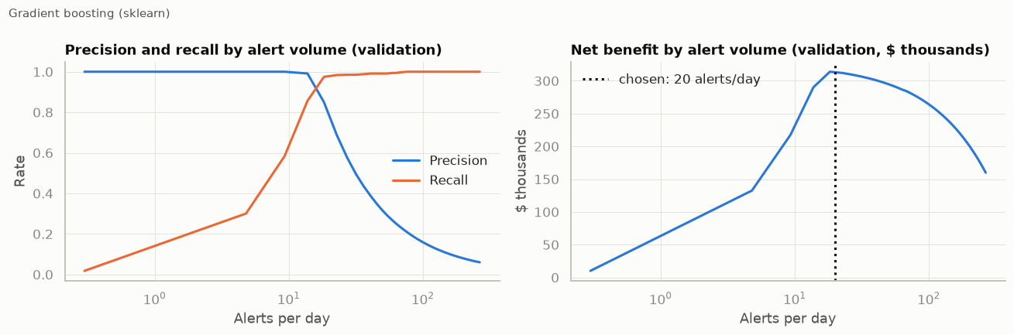
Figure 6. Validation sweep: recall, precision and net benefit across alert volumes.

7.2 Business impact
At 14.7 alerts a day the champion catches 98.7% of the fraud value in the test period ($1,118,830 of $1,133,325); recovering 90% of it and paying $15 per review leaves a net benefit of $964,182. Roughly 1.4 alerts are reviewed per fraud caught. Lowering the threshold to the alert-budget point would only pay if a review cost less than $2.02. Missed fraud is concentrated in small transactions, where an alert costs more than it recovers.

7.3 Stability, calibration and fairness
Monthly recall on the test period ranges from 94.4% to 98.0% and precision from 67.1% to 75.6%. Scores rank well but are not calibrated probabilities (class weighting inflates them); the threshold is therefore defined in score units on validation.
Table 12. Performance by group on the test period.
Group | Value | Transactions | Frauds | Recall | False alarms per 10k | Precision
gender | F | 304,886 | 1,164 | 0.947 | 15.67 | 0.698
gender | M | 250,833 | 981 | 0.981 | 12.45 | 0.756
age band | <25 | 46,931 | 153 | 0.993 | 15.82 | 0.673
age band | 25-34 | 113,806 | 427 | 0.960 | 17.82 | 0.670
age band | 35-44 | 120,059 | 386 | 0.959 | 16.38 | 0.654
age band | 45-54 | 115,736 | 427 | 0.944 | 13.36 | 0.724
age band | 55-64 | 68,556 | 342 | 0.968 | 12.31 | 0.798
age band | 65+ | 90,631 | 410 | 0.971 | 8.53 | 0.838

Recall is high for every group but not identical: 0.947 for women against 0.981 for men, with 15.67 against 12.45 false alarms per 10,000 transactions; across age bands recall ranges from 0.944 to 0.993. The gap is reported rather than hidden: before use on real data the model would be retrained without gender and compared, and group metrics are part of monthly monitoring.

7.4 Explainability
SHAP explains every score in log-odds contributions. For this champion's native categorical splits TreeSHAP's values did not reproduce the model output, so the pipeline automatically switched to SHAP's permutation explainer on the same output, which is exactly additive. The largest average contributions are amount (2.83), category (1.22), amt_sum_24h (1.16), is_night (0.66), txn_count_7d (0.55), consistent with the EDA. Every alert carries its top three reasons into the dashboard and the API. ELI5 weights of the logistic baseline and a Yellowbrick precision-recall curve of the champion (notebook 06) give independent views of the same picture.
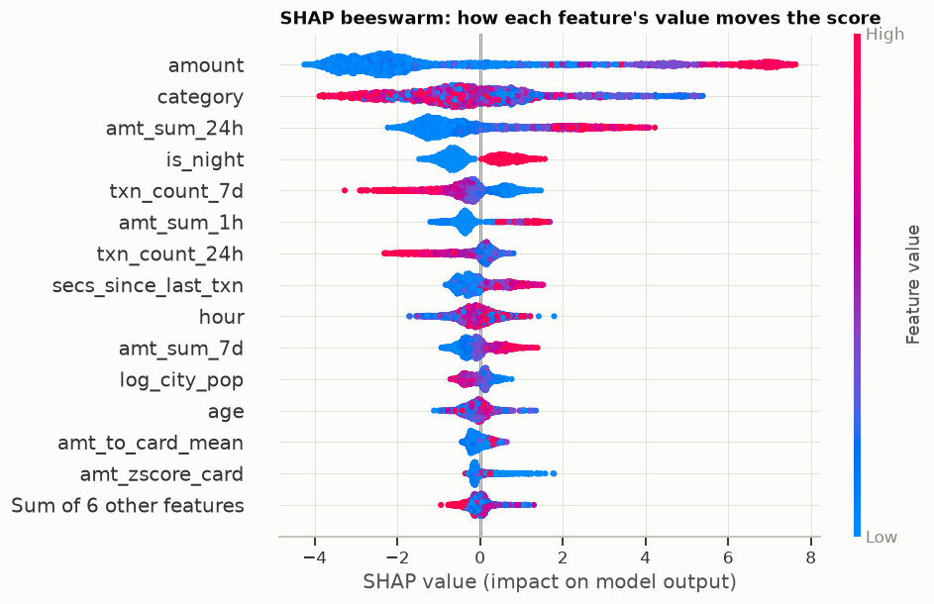
Figure 7. SHAP beeswarm: how each feature's value moves the score (test period).
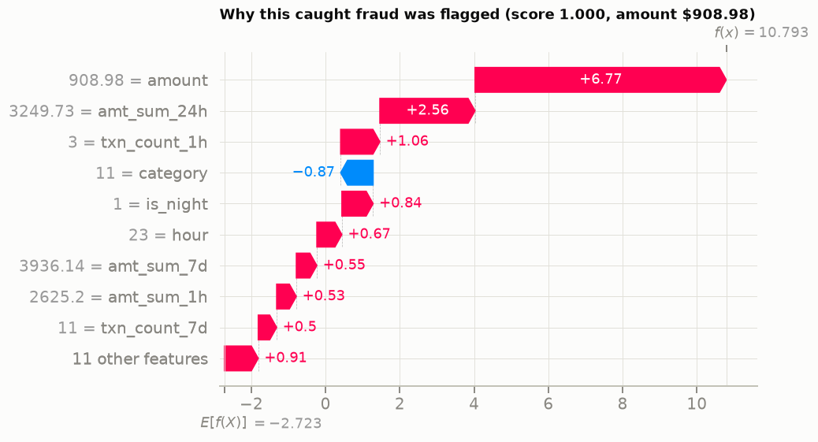
Figure 8. Local explanation of a caught fraud.

8. Deployment and Visualisation

8.1 Serving
The FastAPI service scores raw transactions in real time: an online feature store keeps each card's running statistics and recent window and computes the same features as the batch pipeline (a verification check compares 2,000 test transactions), the champion scores them, and alerts come with SHAP and plain-language reasons. Endpoints: /score, /score/batch, /feedback (analyst verdicts), /metrics (Prometheus), /health and /model; invalid inputs are rejected by schema validation.

8.2 Dashboard
The Streamlit dashboard has nine tabs: Overview (KPIs, daily outcomes, money caught and missed), Alert queue (ranked cards, reasons, feedback), Live scoring (the API's runtime in the browser, including a simulated card-testing burst), Threshold & cost (what-if trade-off), Patterns, Monitoring, Model, Data pipeline and Report. All views recompute from the sidebar filters, threshold and cost assumptions.
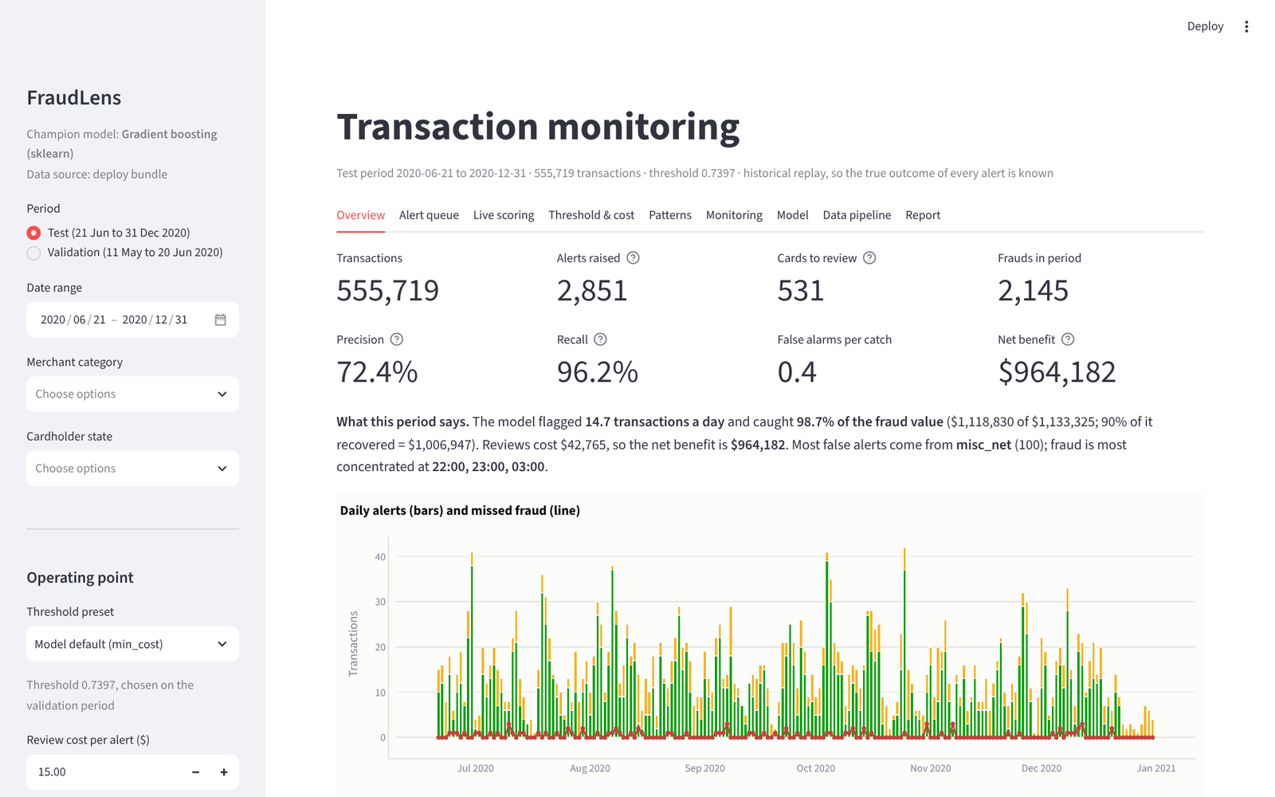
Figure 9. Dashboard, Overview tab (test period, deployed threshold).
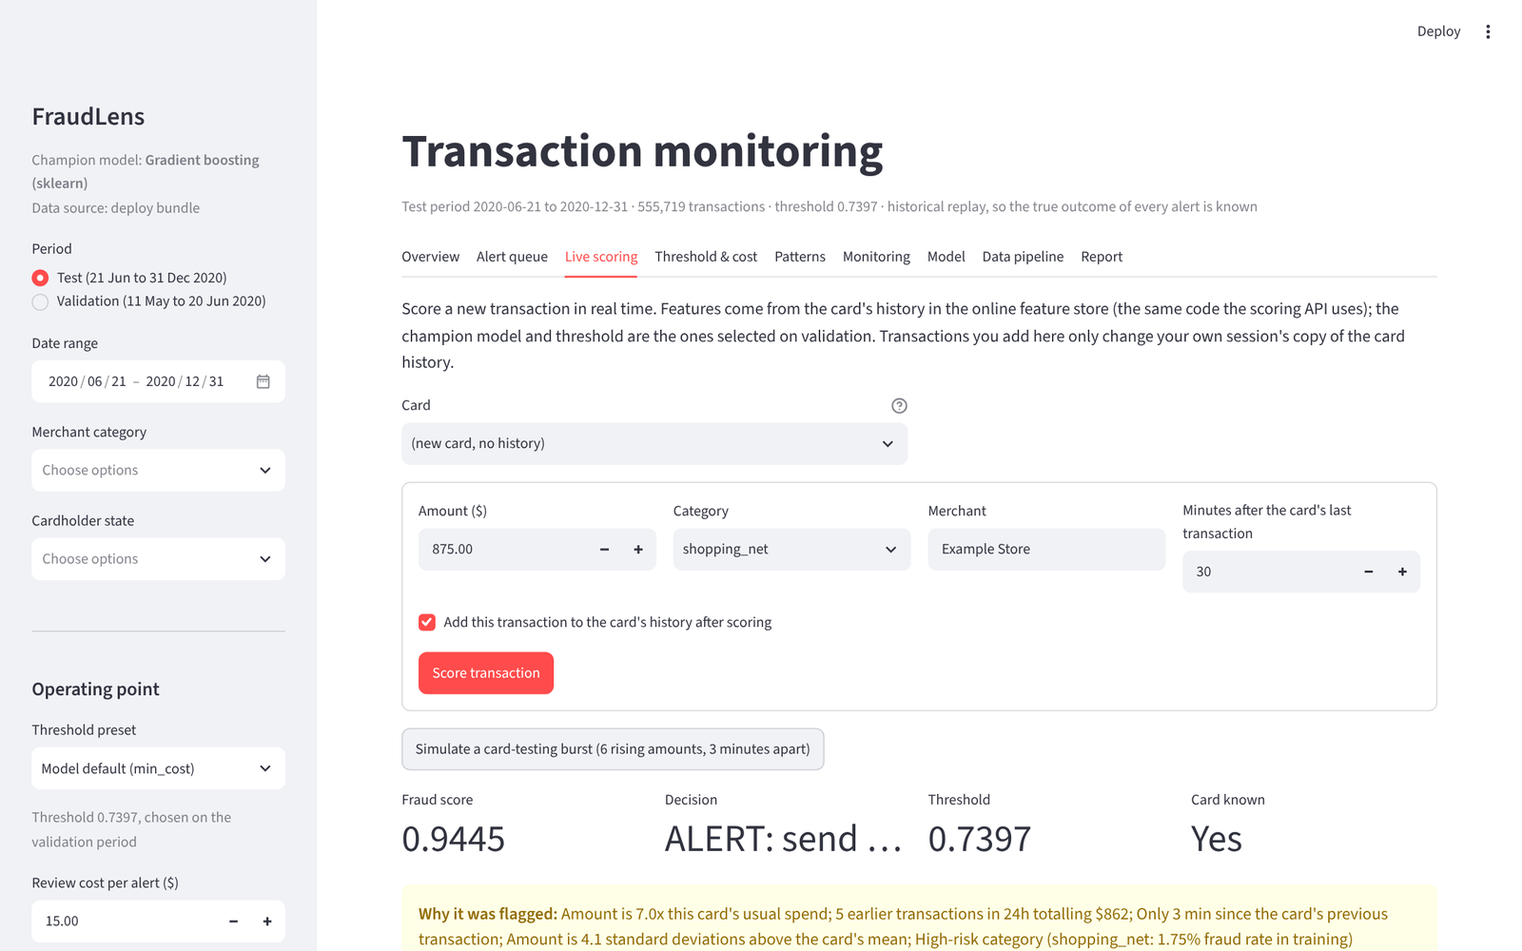
Figure 10. Dashboard, Live scoring tab: a simulated card-testing burst is flagged, with its reasons.
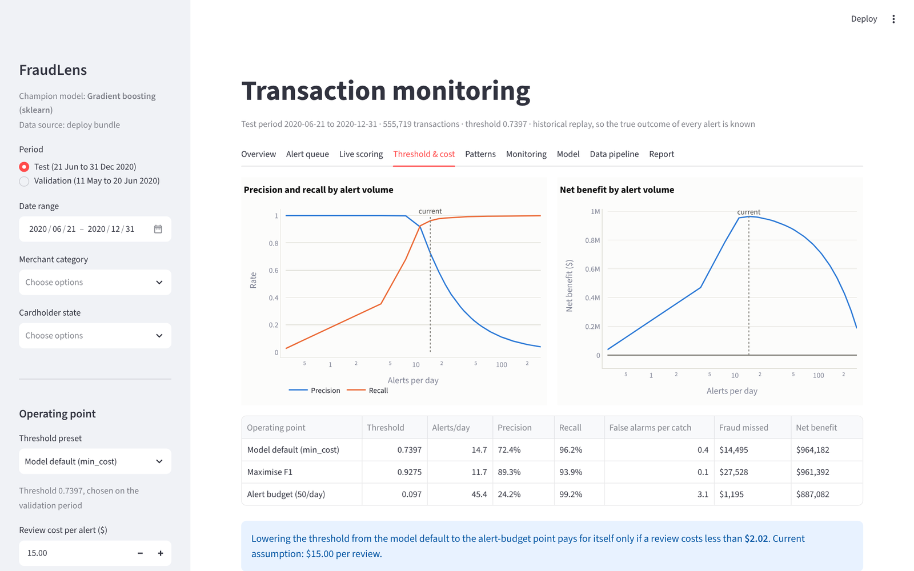
Figure 11. Dashboard, Threshold & cost tab: the operating-point trade-off.

8.3 Lake, catalog and BI
The publish stage writes silver and gold as Hive-partitioned Parquet to MinIO; the crawler infers schemas from Parquet footers and CSV headers and registers external tables and BI views in the Hive Metastore through Trino; Superset builds the fraud-operations dashboard on Trino; the OLAP stage loads the gold tables into ClickHouse through a named collection that uses the read-only analyst account, then answers four business questions on both engines and checks the answers agree.
Table 13. Same questions, two engines (median of five runs; platform workflow run 39430878611, sample data on a GitHub runner).
Question | Trino (ms) | ClickHouse (ms) | Answers agree
Daily caught, false and missed alerts | 292.6 | 14.8 | Yes
Fraud and alerts by category and hour | 225.6 | 16.3 | Yes
Merchants with the most missed fraud | 212 | 10.6 | Yes
Alert precision by state | 232.3 | 9.9 | Yes

8.4 The platform, verified end to end
The platform workflow starts every service on a GitHub runner, runs the whole lifecycle on synthetic sample data through NiFi, the lake, the crawler, Trino and ClickHouse, then checks each component. Run 39430878611 (commit a5c7b0d) passed 14 of 14 smoke checks; its governance job catalogued 13 tables and views in OpenMetadata 1.13.4, tagged 29 PII columns and recorded 9 lineage edges from raw to gold.
Table 14. Platform smoke checks (platform workflow).
Component | Check | Result
lake | three layer buckets exist | Pass
lake | raw CSVs, silver and gold tables are in the lake | Pass
lake | analyst account cannot read the raw layer (least privilege) | Pass
ingest | NiFi flow is running and wrote an ingest record per file | Pass
catalog | crawler registered the lake tables in the Hive Metastore | Pass
trino | gold row count matches what the pipeline published | Pass
governance | Trino masks PII and hides `job` from the analyst role | Pass
governance | BI role cannot read the raw layer | Pass
olap | ClickHouse loaded gold and agrees with Trino | Pass
mlflow | MLflow server has the run and the registered champion | Pass
api | scoring API is healthy and scores a transaction | Pass
monitoring | Prometheus scrapes the API | Pass
monitoring | Grafana datasources (Prometheus, ClickHouse) are healthy | Pass
bi | Superset is up with the FraudLens dashboard | Pass

8.5 Deployment
Table 15. Deployment targets.
Target | How | Where
Local (Windows, no Docker) | scripts/deploy/run_local.ps1 starts the API and the dashboard; -Public adds Cloudflare quick-tunnel links | Deployed during the project
Container image | platform/docker/Dockerfile.app; built, smoke-tested and published to GHCR by the deploy workflow | ghcr.io/anasua2905/fraudlens-app
Hosted dashboard | Streamlit Community Cloud from the repository (dashboard/app.py, runs from the bundle) | Documented in docs/deployment.md
Full platform | docker compose profiles lake, ingest, olap, bi, mlops (+ OpenMetadata) | platform/; verified end to end by the platform workflow

9. Monitoring and Improvement
Monitoring replays the validation and test periods month by month as if the model were live. Evidently AI's DataDriftPreset compares each month with a training reference (with the project's PSI as a cross-check) and performance is measured at the fixed threshold. A retraining recommendation is raised when more than 30% of monitored features drift, recall falls below 85% or precision below 40%.
Table 16. Monthly monitoring.
Month | Transactions | Frauds | Drift share | Recall | Precision | Alerts/day | Retrain
2020-05 | 53,834 | 335 | 0.143 | 0.988 | 0.768 | 20.1 | No
2020-06 | 87,805 | 467 | 0.286 | 0.970 | 0.777 | 19.4 | No
2020-07 | 85,848 | 321 | 0.286 | 0.944 | 0.715 | 13.7 | No
2020-08 | 88,759 | 415 | 0.357 | 0.969 | 0.756 | 17.2 | Yes
2020-09 | 69,533 | 340 | 0.143 | 0.959 | 0.738 | 14.7 | No
2020-10 | 69,348 | 384 | 0.286 | 0.966 | 0.726 | 16.5 | No
2020-11 | 72,635 | 294 | 0.214 | 0.980 | 0.713 | 13.5 | No
2020-12 | 139,538 | 258 | 0.500 | 0.950 | 0.671 | 11.8 | Yes

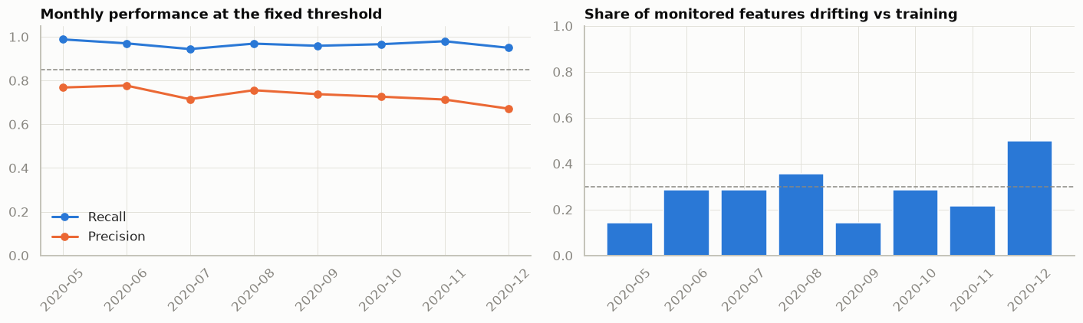
Figure 12. Monthly performance and drift share.
The policy fired in 2020-08 and 2020-12 because of drift (seasonal spending patterns), while recall stayed above the floor. The recommendation goes to a person, who decides whether to retrain.
Champion/challenger. Retraining the same algorithm on the training plus validation periods and comparing at the same alert budget on the test period gives PR-AUC 0.9741 for the challenger against 0.9698 for the champion (gap 0.0043, 95% CI [0.0028, 0.0057]); under the promotion rule (non-inferior PR-AUC (95% bootstrap lower bound of the gap > -0.01)) the challenger would be promoted. The test period is used here only to illustrate the loop; in production the comparison runs on the next labelled period, so the champion's reported test results stay untouched.
Operationally, the API exports Prometheus metrics (transactions, alerts, latency, score distribution, cold-start cards, feedback, monitoring verdict); Prometheus evaluates alert rules (API down, alert-rate spike, slow scoring, retraining recommended) and Grafana shows an operations dashboard and a ClickHouse business dashboard. Analyst verdicts recorded through /feedback close the loop into the next retraining; the runbook (docs/monitoring_runbook.md) describes promotion and rollback.

10. Project Management, Quality and Reproducibility

10.1 GitHub Project
Work is tracked on a GitHub Project board generated from scripts/github/project_plan.yaml by scripts/github/setup_project.py: four milestones (data foundation, analysis and modelling, deployment and monitoring, final submission), one issue per task with an acceptance checklist, labels for lifecycle stage and type, and a Lifecycle stage field on the board so progress can be followed stage by stage. Issue and pull-request templates and built-in workflows (auto-add, closed → Done) keep it in sync with the repository; docs/github_project.md is the team's guide.

10.2 CI/CD
Three GitHub Actions workflows: ci (unit and end-to-end tests of the whole lifecycle on synthetic sample data, plus a headless render of the dashboard from the committed bundle), platform (the complete Docker platform on a runner: NiFi ingest, MinIO, Hive Metastore, Trino governance, ClickHouse, MLflow, API, Prometheus, Grafana, Superset, and a second job for OpenMetadata, checked by a smoke test of every component), and deploy (build, smoke-test and publish the application image). In platform run 39430878611 14 of 14 smoke checks passed and the governance job succeeded.

10.3 End-to-end verification
Table 17. Verification checks by lifecycle stage (final run).
Stage | Checks | Passed
1-problem | 1 | 1
2-acquisition | 3 | 3
3-preparation | 8 | 8
4-eda | 4 | 4
5-modelling | 23 | 23
6-evaluation | 9 | 9
7-deployment | 5 | 5
8-monitoring | 3 | 3

A single command reproduces the project (python -m fraudlens.run_all), every stage can be resumed or run alone, library versions are pinned (requirements.lock.txt), and eight executed notebooks document each stage with live code.

11. Discussion and Limitations
- Non-linearity decides the model family. Boosted trees reach validation PR-AUC around 0.98 against 0.68 for logistic regression; interactions between amount, time, category and recent spend matter more than any single feature.
- Simplicity as a selection principle. Four boosted variants were within statistical noise; choosing the simplest reduced dependencies, artefact size and serving latency at no measurable cost.
- Unsupervised detection alone is insufficient. The Isolation Forest finds unusual transactions, not fraudulent ones (validation PR-AUC 0.36); its score added nothing measurable on top of the supervised model, but it remains a candidate detector for new, unlabelled patterns.
- Operating point over metric. The cost-based threshold, not the ranking metric, determines what the bank experiences; the dashboard makes that trade-off explicit.
- Simulated data. Sparkov's fraud patterns are cleaner than real ones, so absolute results are optimistic. The method, evaluation protocol and platform are what transfer.
- Selective labels. In production, analyst feedback only labels alerted transactions; chargeback labels for non-alerted transactions are needed to avoid biasing retraining.
- Platform scale. The Docker platform runs on one machine; the same components scale out (MinIO and ClickHouse clusters, Trino workers, NiFi cluster) without changing the pipeline code.

12. Conclusion
FraudLens demonstrates end-to-end thinking from problem framing to a monitored deployment: requirements and success criteria defined first; data acquired with provenance and integrity checks; prepared without leakage and with privacy controls; explored to form and test hypotheses; modelled and selected by a pre-registered rule; evaluated on an untouched period with uncertainty, business impact, fairness and explanations; deployed as an API and dashboard on an open-source platform; and monitored with a clear path to retraining. All five project objectives are met: the champion catches 96.2% of fraud with 72.4% precision at 14.7 alerts a day, the dashboard supports analysts and managers, and the flow from data collection to visualisation is reproducible with one command and verified by 56 checks.
Next steps: validate on real (or more realistic) transaction data, add probability calibration for expected-loss reporting, schedule the monitoring and retraining loop, and explore sequence models of card histories if deep learning is brought into scope.

References
Shenoy, K. (2020). Credit Card Transactions Fraud Detection Dataset (Sparkov). Kaggle. https://www.kaggle.com/datasets/kartik2112/fraud-detection
Harris, B. Sparkov Data Generation. GitHub. https://github.com/namebrandon/Sparkov_Data_Generation
Pedregosa, F. et al. (2011). Scikit-learn: Machine learning in Python. Journal of Machine Learning Research, 12, 2825-2830.
Chen, T. & Guestrin, C. (2016). XGBoost: A scalable tree boosting system. Proceedings of KDD 2016, 785-794.
Ke, G. et al. (2017). LightGBM: A highly efficient gradient boosting decision tree. Advances in NeurIPS 30.
Prokhorenkova, L. et al. (2018). CatBoost: unbiased boosting with categorical features. Advances in NeurIPS 31.
Liu, F. T., Ting, K. M. & Zhou, Z.-H. (2008). Isolation Forest. Proceedings of IEEE ICDM 2008, 413-422.
Lundberg, S. M. & Lee, S.-I. (2017). A unified approach to interpreting model predictions. Advances in NeurIPS 30.
Saito, T. & Rehmsmeier, M. (2015). The precision-recall plot is more informative than the ROC plot when evaluating binary classifiers on imbalanced datasets. PLoS ONE, 10(3), e0118432.
Dal Pozzolo, A. et al. (2015). Calibrating probability with undersampling for unbalanced classification. IEEE SSCI 2015.
Evidently AI. Evidently documentation: data drift. https://docs.evidentlyai.com
Apache Software Foundation. Apache NiFi, Apache Hive, Apache Superset documentation. https://nifi.apache.org, https://hive.apache.org, https://superset.apache.org
Trino Software Foundation. Trino documentation: Hive connector and file-based access control. https://trino.io/docs
ClickHouse Inc. ClickHouse documentation: s3 table function and named collections. https://clickhouse.com/docs
OpenMetadata. OpenMetadata documentation. https://docs.open-metadata.org
MLflow Project. MLflow documentation: tracking and model registry. https://mlflow.org/docs

Appendix A: Reproduction
python -m venv .venv && .venv\Scripts\activate
pip install -c requirements.lock.txt -e ".[ml,serve,platform,data,dev]"
python -m fraudlens.run_all --local-dir <folder with fraudTrain.csv and fraudTest.csv>
python scripts/build_notebooks.py --execute
streamlit run dashboard/app.py | uvicorn fraudlens.api:app --port 8000
cd platform && docker compose --profile lake --profile ingest --profile olap --profile bi --profile mlops up -d
pytest
Repository and documentation:
https://github.com/anasua2905/fraudlens-or-credit-card-fraud-detection (branch final-a4)

Appendix B: Verification Checks
Table 18. All 56 end-to-end verification checks from the final run.
Stage | Check | Status
1-problem | success criteria defined in config | PASS
2-acquisition | fraudTrain.csv checksum matches manifest | PASS
2-acquisition | fraudTest.csv checksum matches manifest | PASS
2-acquisition | dataset licence and source recorded | PASS
3-preparation | raw files passed the data contract | PASS
3-preparation | silver rows = manifest rows - removed rows | PASS
3-preparation | no direct identifiers in silver | PASS
3-preparation | split rows sum to silver rows | PASS
3-preparation | no transaction appears in two splits | PASS
3-preparation | splits are chronological (train < val < test) | PASS
3-preparation | no feature is derived from the label | PASS
3-preparation | online store holds every card and every transaction | PASS
4-eda | eda_summary.json written | PASS
4-eda | cleaning_audit.json written | PASS
4-eda | EDA figures written | PASS
4-eda | interactive EDA explorer written | PASS
5-modelling | linear: train matrix rows = feature rows | PASS
5-modelling | linear: excluded features absent | PASS
5-modelling | tree: train matrix rows = feature rows | PASS
5-modelling | tree: excluded features absent | PASS
5-modelling | lightgbm: saved model exists | PASS
5-modelling | lightgbm: input features = preprocessed columns | PASS
5-modelling | lightgbm: imbalance handled by weighting (no resampling) | PASS
5-modelling | xgboost: saved model exists | PASS
5-modelling | xgboost: input features = preprocessed columns | PASS
5-modelling | xgboost: imbalance handled by weighting (no resampling) | PASS
5-modelling | hybrid_gb: saved model exists | PASS
5-modelling | hybrid_gb: input features = preprocessed columns | PASS
5-modelling | hybrid_gb: imbalance handled by weighting (no resampling) | PASS
5-modelling | hist_gb: saved model exists | PASS
5-modelling | hist_gb: input features = preprocessed columns | PASS
5-modelling | hist_gb: imbalance handled by weighting (no resampling) | PASS
5-modelling | logistic: saved model exists | PASS
5-modelling | logistic: input features = preprocessed columns | PASS
5-modelling | logistic: imbalance handled by weighting (no resampling) | PASS
5-modelling | isolation_forest: saved model exists | PASS
5-modelling | hyper-parameters tuned with time-series CV | PASS
5-modelling | reported champion = champion chosen by the rule | PASS
5-modelling | champion is the simplest model equivalent to the best | PASS
6-evaluation | packaged model = reported champion | PASS
6-evaluation | packaged threshold = threshold chosen on validation | PASS
6-evaluation | threshold re-derived on validation = reported | PASS
6-evaluation | re-scored test PR-AUC = reported | PASS
6-evaluation | re-scored test confusion matrix = reported | PASS
6-evaluation | re-scored net benefit = reported | PASS
6-evaluation | test PR-AUC inside its bootstrap 95% CI | PASS
6-evaluation | SHAP explanations written | PASS
6-evaluation | every test alert has SHAP reasons | PASS
7-deployment | batch scores generated | PASS
7-deployment | scores use the selected champion and threshold | PASS
7-deployment | scored rows = validation + test rows | PASS
7-deployment | scored test alerts = reported alerts | PASS
7-deployment | online feature store reproduces batch features (streamed replay) | PASS
8-monitoring | monitoring summary written | PASS
8-monitoring | every scored month monitored | PASS
8-monitoring | retraining decision recorded | PASS

