**Hyper Parameters:**

Network: Single LSTM/Bi-directional LSTM (30 units) layer with 2 hidden PRelu layers of 30 hidden units each. [Units change to 96 if its LFBE features].

Activation function in output layer: Sigmoid

Loss Function: Cross-Entropy

Learning Rate: 0.001

|  |  |  |  |
| --- | --- | --- | --- |
| **Algo. Name** | **Number of Training dialogs** | **Prosody Dimensions** | **Loss** |
| LSTM | 7 batches, each of 1000 | 6 | 0.0138 |
| 64 | 0.0132 |
| 126 | 0.0142 |
| Bi-directional LSTM | 6 | 0.0134 |
| 64 | 0.0135 |

Epochs: 10

**PS: Some of the graphs are shown below.**

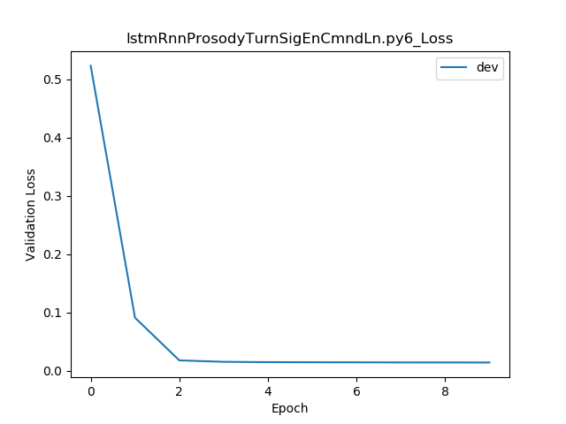

LSTM with 6dimension features

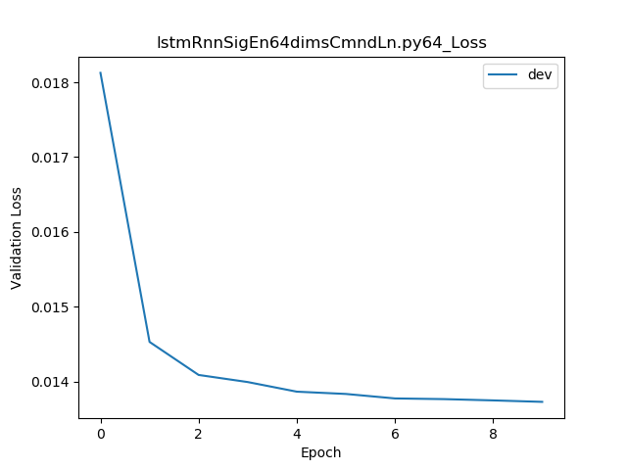

LSTM with 64 dimension features

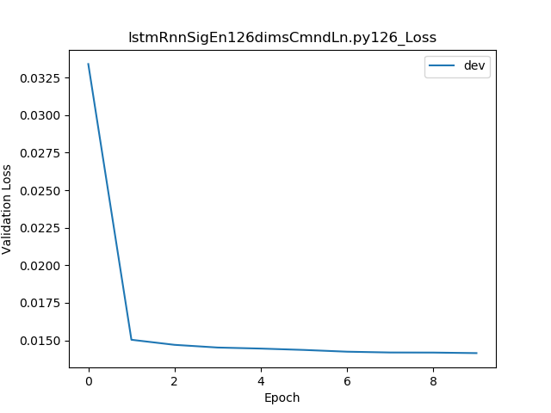

LSTM with 126 dimension features

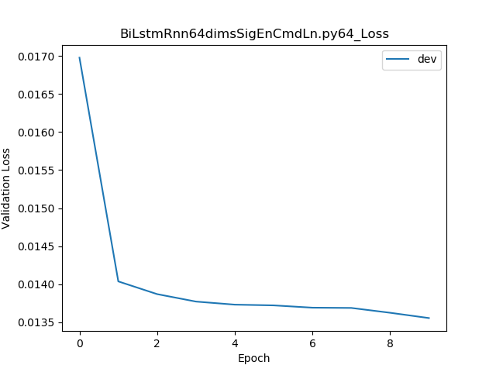

Bi-directional LSTM for 126 dimension features