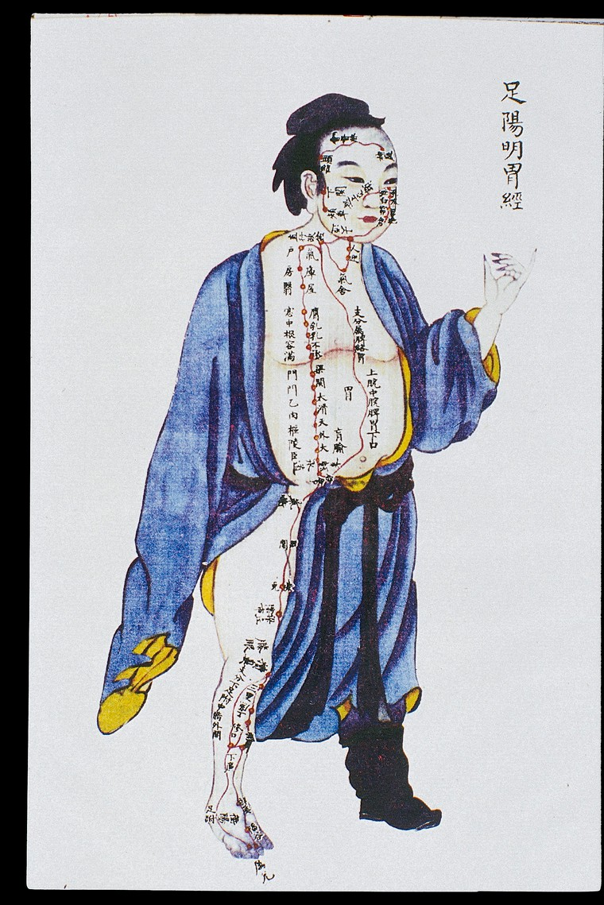

Stomach channel of leg yangming, C17/18 Chinese book art.
Illustration showing the stomach channel of leg yangming from Renti jingmai tu (Illustrations of the Channels of the Human Body), a manuscript text executed during the Kangxi reign period of the Qing dynasty (1662-1722), illustrated with 24 paintings in colour.
Catalog URL: https://anatomiesofintelligence.github.io/posts/2019-09-24-Stomach-Channel
Source URL: https://wellcomecollection.org/works/m86avyq2
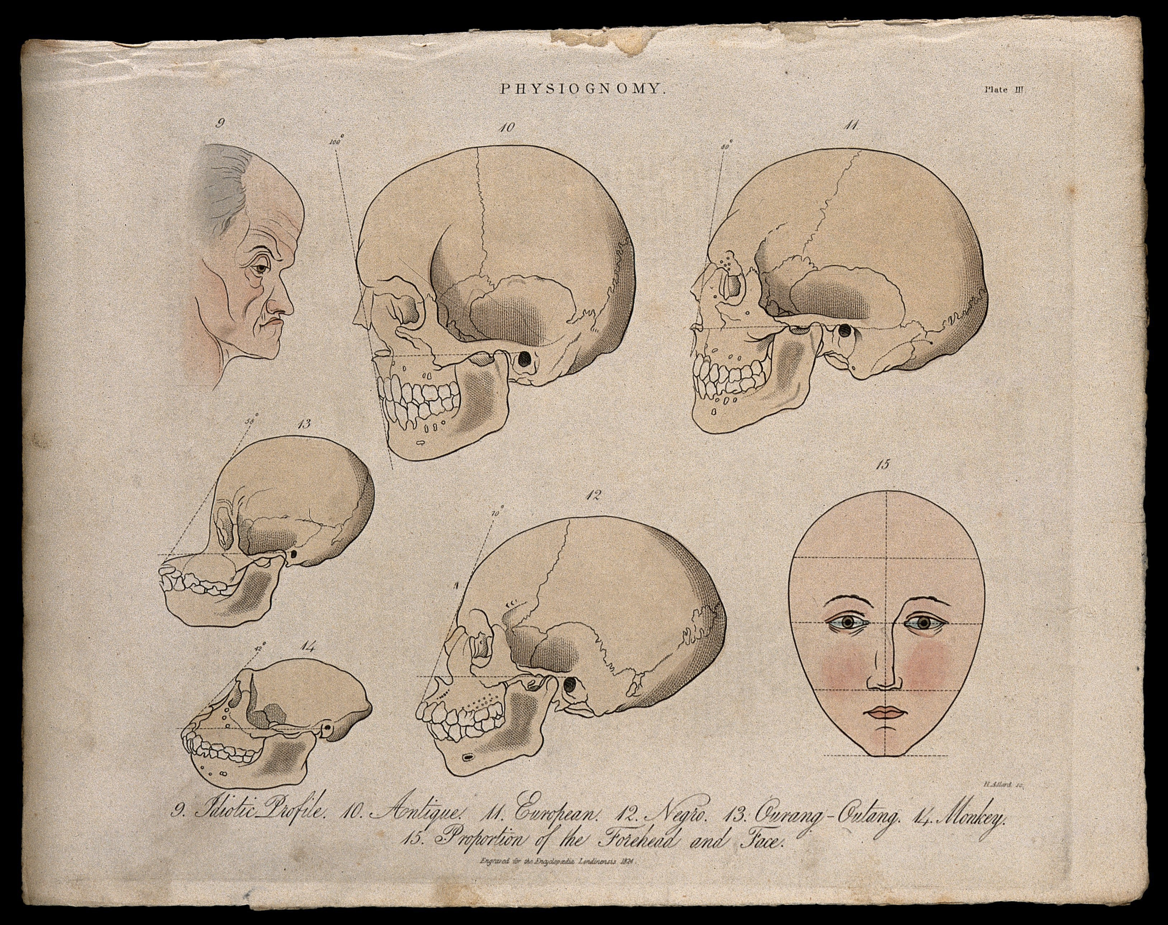

Skulls, 1824.
A profile of an old mentally handicapped man, skulls of various races, skulls of a monkey and an orangutan, and a perfect, diagrammed human face; demonstrating the methods of physiognomy. Coloured engraving by H. Adlard, 1824.
Catalog URL: https://anatomiesofintelligence.github.io/posts/2019-09-24-Skulls-Profiles
Source URL: https://wellcomecollection.org/works/pbp4j9ka

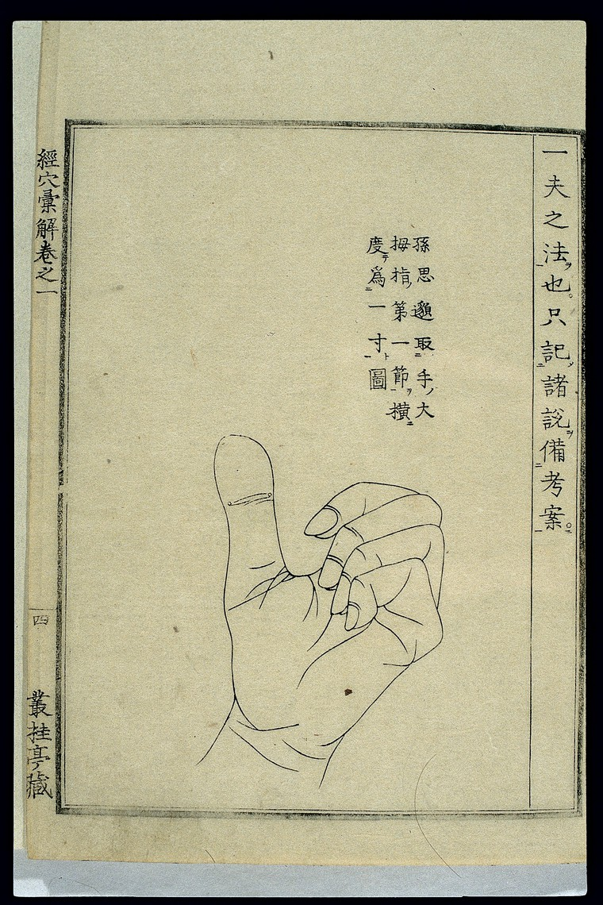

Palm measurement method, Japanese woodcut, 1807.
Woodblock illustration from a work on 'Chinese' medicine by the 18th century Japanese physician Hara Masakatsu, published in 1807 (4th year of the Bunkwa era). The palm measurement method (yi fu fa) is recorded by the prominent Tang physician Sun Simiao in Qianjin yaofang (Prescriptions Worth a Thousand Gold Pieces) (652 CE). Also known as shoufu, it is one of several digit-based measurement techniques used to establish the location of acu-moxa points. In this method, the patient holds all four fingers close together, and the measurement from the middle joint of the little finger to the index finger is taken as 3 cun (Chinese inches) or 1 palm. Using another digit-based measurement technique, the width of the top joint of the thumb is defined as 1 cun.
Catalog URL: https://anatomiesofintelligence.github.io/posts/2019-09-24-Palm-Measurement
Source URL: https://wellcomecollection.org/works/j5fumjyw
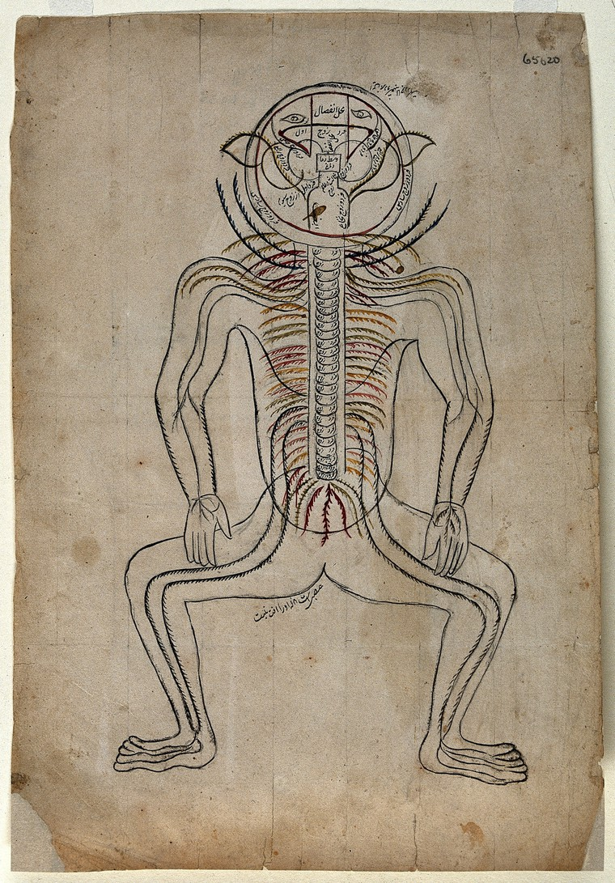

Nerves of the human body. Watercolour drawing by a Persian artist.
Diagram comparable to the 'six picture series' or 'Alexandrian series' pasted or bound in Persian manuscripts of the 'Zakhīrah-i Khvārazm’Shāhī' ('Treasure of Khvārazm'Shāhī') written by al-Jurjani (Ismā'īl ibn Muḥammad al-Ḥusayn Jurjānī) ca. 1110 AD, and the 'Tashrīḥ-i Mansur-i' ('Anatomy of Mansur' written by Manṣūr ibn Muḥammad ibn Aḥmad ibn Yūsuf Ibn Ilyā, ca. 1390 AD)
Catalog URL: https://anatomiesofintelligence.github.io/posts/2019-09-24-Nerves-Human-Persian
Source URL: https://wellcomecollection.org/works/sc7ptw4y
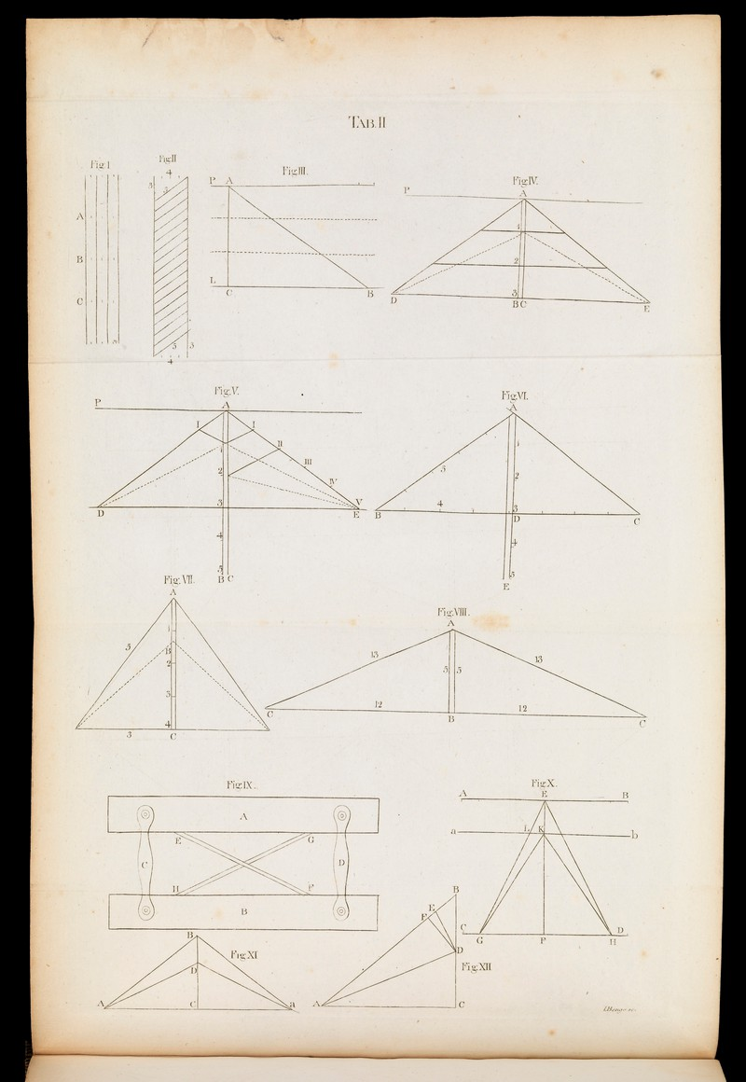

Observations on the muscles, Blane, Gilbert, Sir, 1749-1834.
Observations on the muscles, and particularly on the effects of their oblique fibres: with an appendix, in which the pretension of Dr. Gilbert Blane, that he first demonstrated the same effect to be produced by oblique muscles as by straight ones, with a less proportional decurtation of fibres, is proved to be unfounded ...
Catalog URL: https://anatomiesofintelligence.github.io/posts/2019-09-24-Muscles-Fibres
Source URL: https://wellcomecollection.org/works/hnnx6f5r
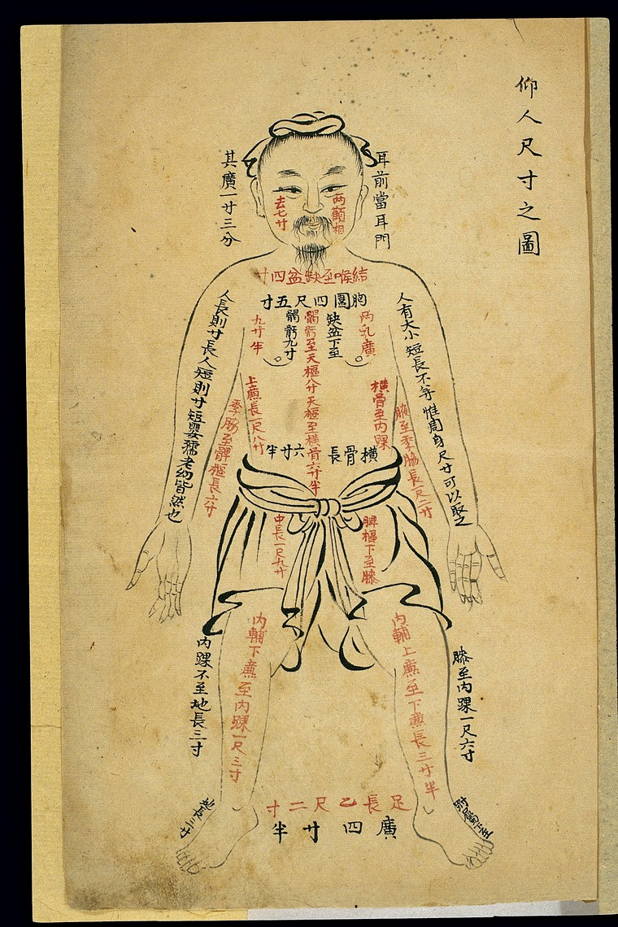

Acu-moxa aid, landmark measurements, Chinese MS, late Qing.
Line drawing in ink and brush style from an anonymous manuscript probably dating from the end of the Qing period (1644-1911). The image shows the outline of a human body viewed from the front. Captions in corresponding places on the body indicate the distances between various landmarks on the bodily surface, as an aid in establishing the location of acupoints and the paths of the channels and collaterals at the front of the body. For instance, on either side of the head, there is a caption reading 'From in front of the ear to ermen (Ear Portal) is 1 cun, 5 fen', a caption on the face reads 'The distance between the cheekbones (quan) is 7 cun', etc. The units of measurement are the chi 8 Chinese foot 9 and cun (Chinese inch), the length of the cun being based on the proportions of the individual's body, i.e. 1 cun = the distance from the base of the middle finger to the end of the crease of the middle joint. 10 cun = 1 chi.
Catalog URL: https://anatomiesofintelligence.github.io/posts/2019-09-24-Landmark-Body-Chinese
Source URL: https://wellcomecollection.org/works/jptyzjyp
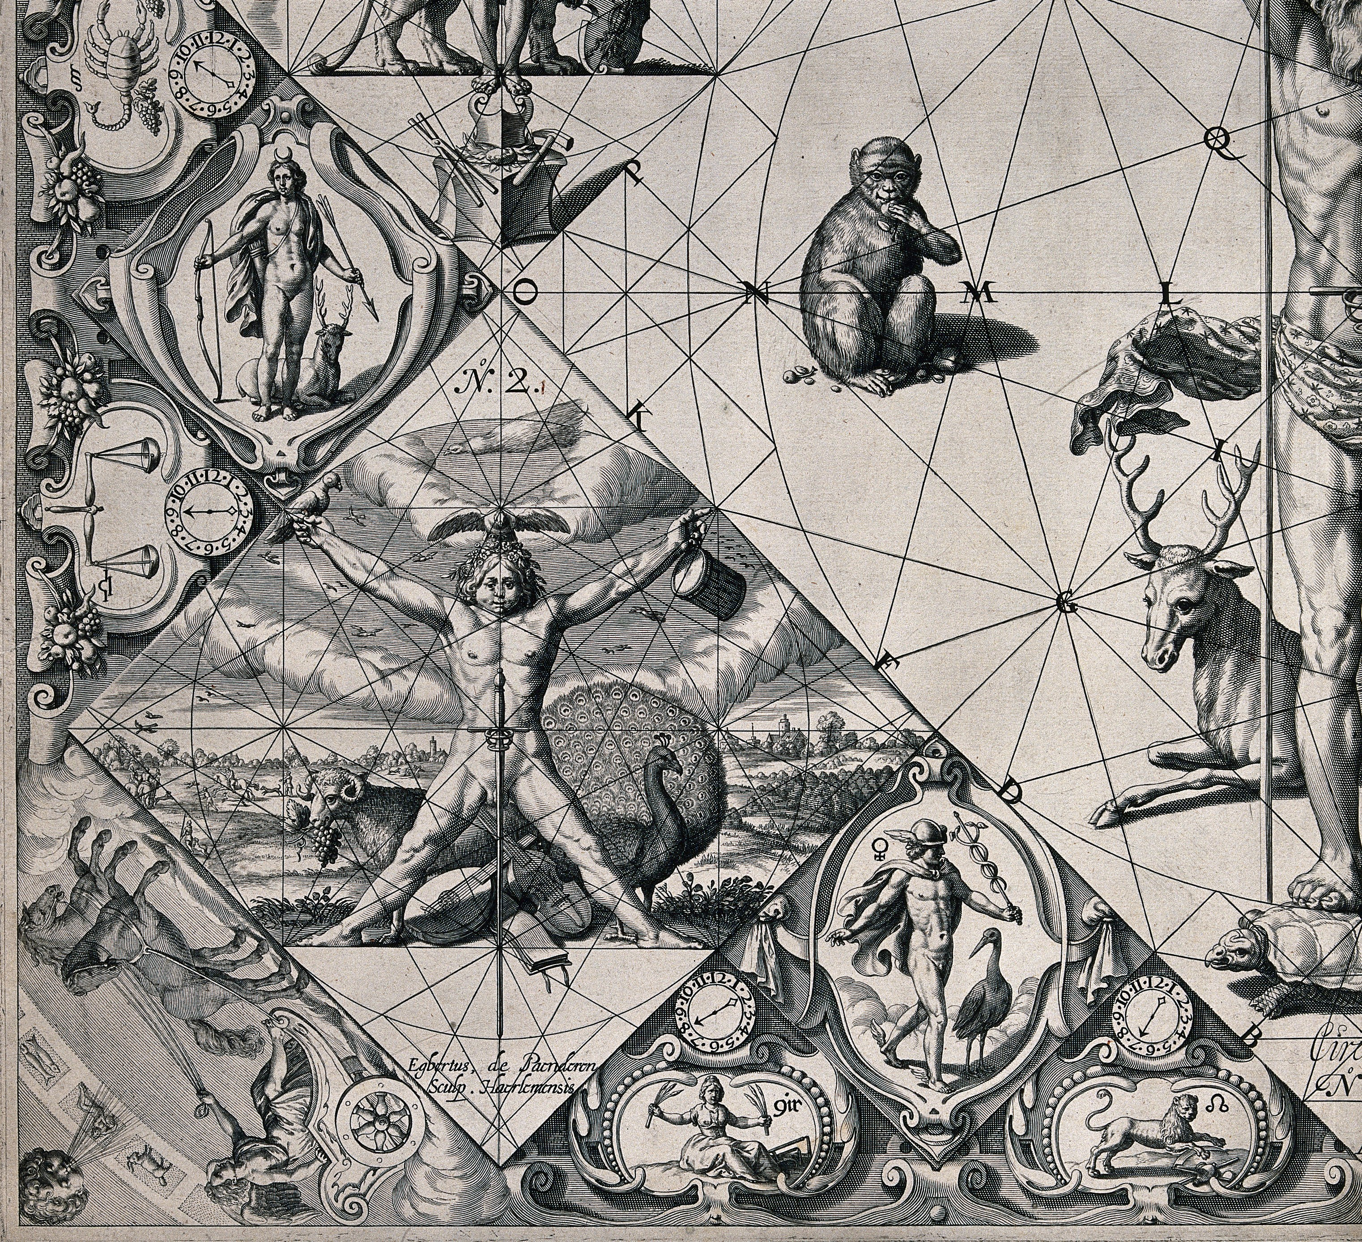

Human proportions established through mythological figures.
Human proportions established through mythological figures. Engraving. Gerard Thibault (ca. 1574–1627).
Catalog URL: https://anatomiesofintelligence.github.io/posts/2019-09-24-Human-Myth
Source URL: https://wellcomecollection.org/works/b27p8pgf

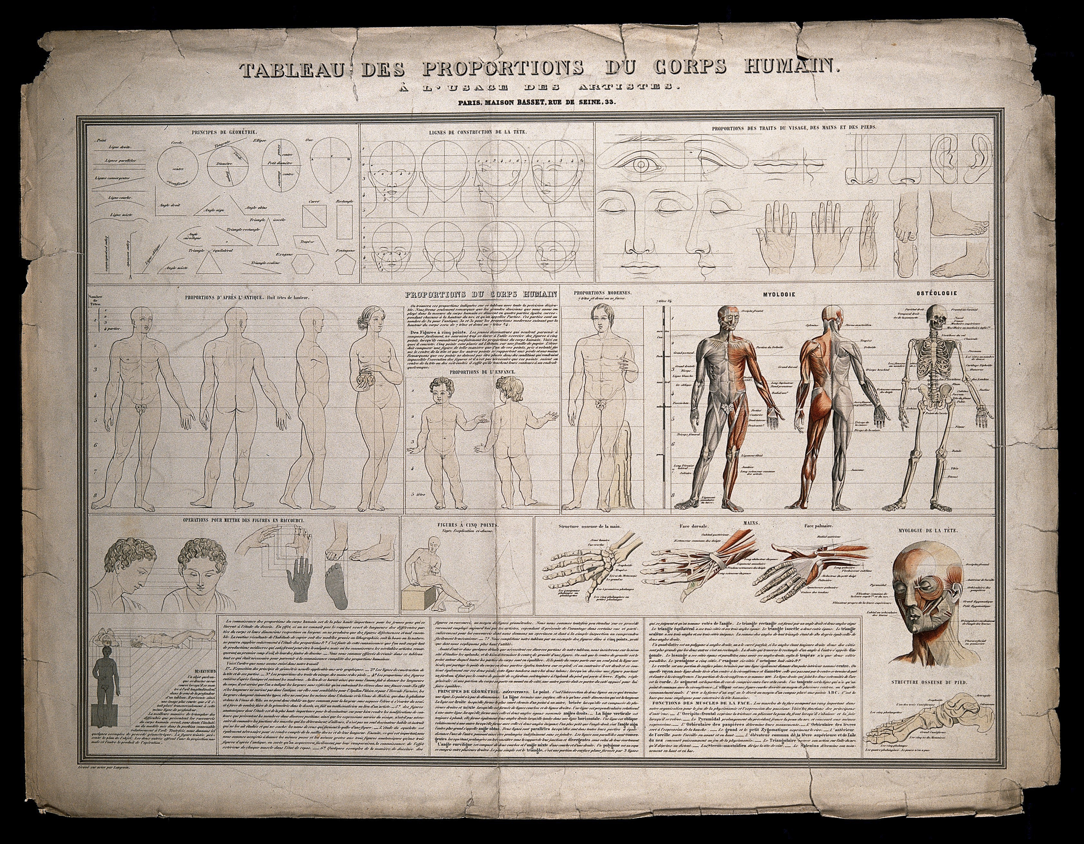

Tableau des proportions du corps humain à l'usage des artists, 1830.
Diagrams, proportional figures, écorchés etc., for use by artists: includes principles of geometry, proportions of the face and body, and coloured illustrations showing the skeleton and musculature. Coloured engraving by Langevin, ca. 1830.
Catalog URL: https://anatomiesofintelligence.github.io/posts/2019-09-24-Diagram-Proportion-Figures
Source URL: https://wellcomecollection.org/works/twc3c6gw

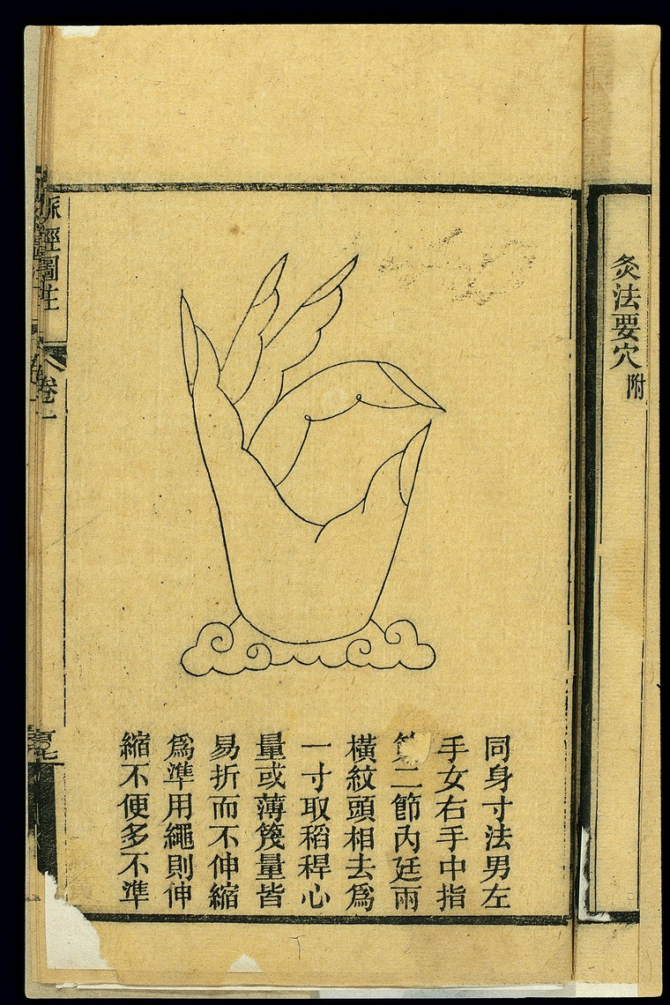

Proportional Body Measurement - Maijing Tuzhu - Middle Finger.
Illustration from Maijing Tuzhu (Canon of the Pulse, illustrated and annotated), author unknown, published in 1901 (27th year of the Guangxu reign period of the Qing dynasty).
Catalogue Source: https://anatomiesofintelligence.github.io/posts/2019-09-24-Body-Measurement-Maijing-Middle-Finger
Source URL: https://wellcomecollection.org/works/skd8xsg7
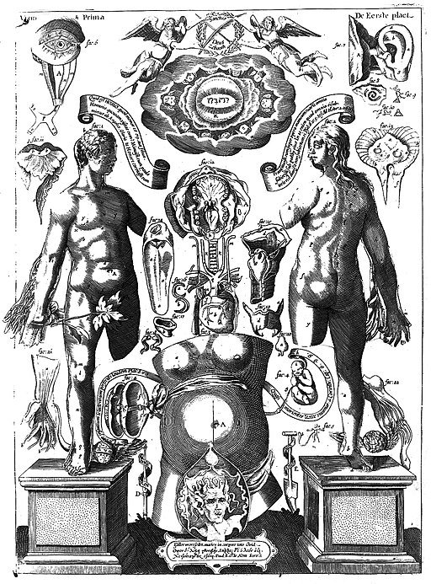

Pinax Mircocosmographicus.
Pinax Microcosmographicus, in quo certissimum Anatomiae compendium variis aere incisis visionibus proponitur. by REMMELIN, JOHANN (JOHANNES REMMELINUS - J. RÜMELIN 1583-1632)
Catalogue Source: https://anatomiesofintelligence.github.io/posts/2019-09-2-Mircocosmographicus
Source URL: https://wellcomecollection.org/works/kun523kp

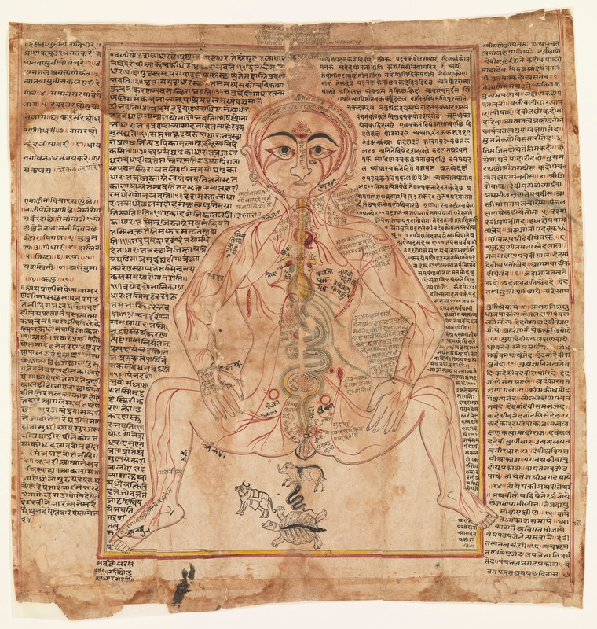

Mystical body of tantric meditation, flow of the life force.
Text surrounding the image is a mixture of Sanskrit and Old Gujarati and describes the mystical body of tantric meditation and the flow of the life force, prana, throughout the body. The image of the body is very similar to the Tashrih-i Mansur style of anatomy drawing.
Catalogue Source: https://anatomiesofintelligence.github.io/posts/2019-09-2-Mystical-Body
Source URL: https://wellcomecollection.org/works/qfufjhkx

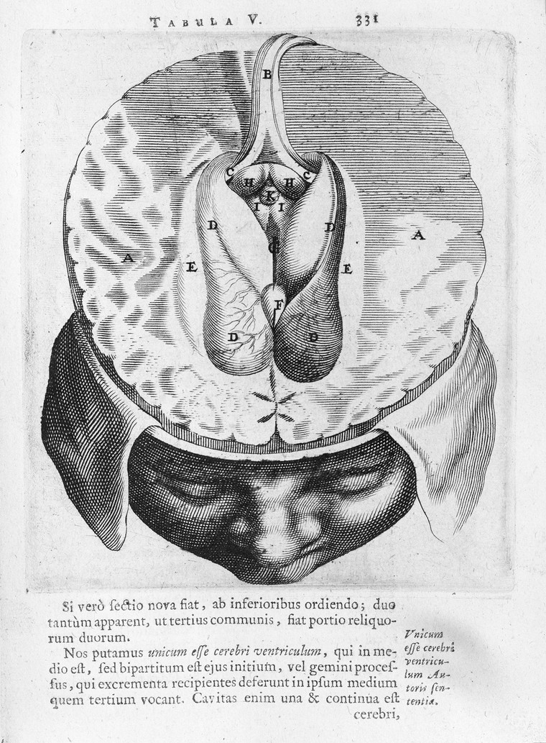

Horizontal section through brain.
Horizontal section through brain. Thomas Bartholin (1616-1680)
Catalogue Source: https://anatomiesofintelligence.github.io/posts/2019-09-2-Horizontal-section-brain
Source URL: https://wellcomecollection.org/works/hs5kx45w?wellcomeImagesUrl=/indexplus/image/L0002492.html

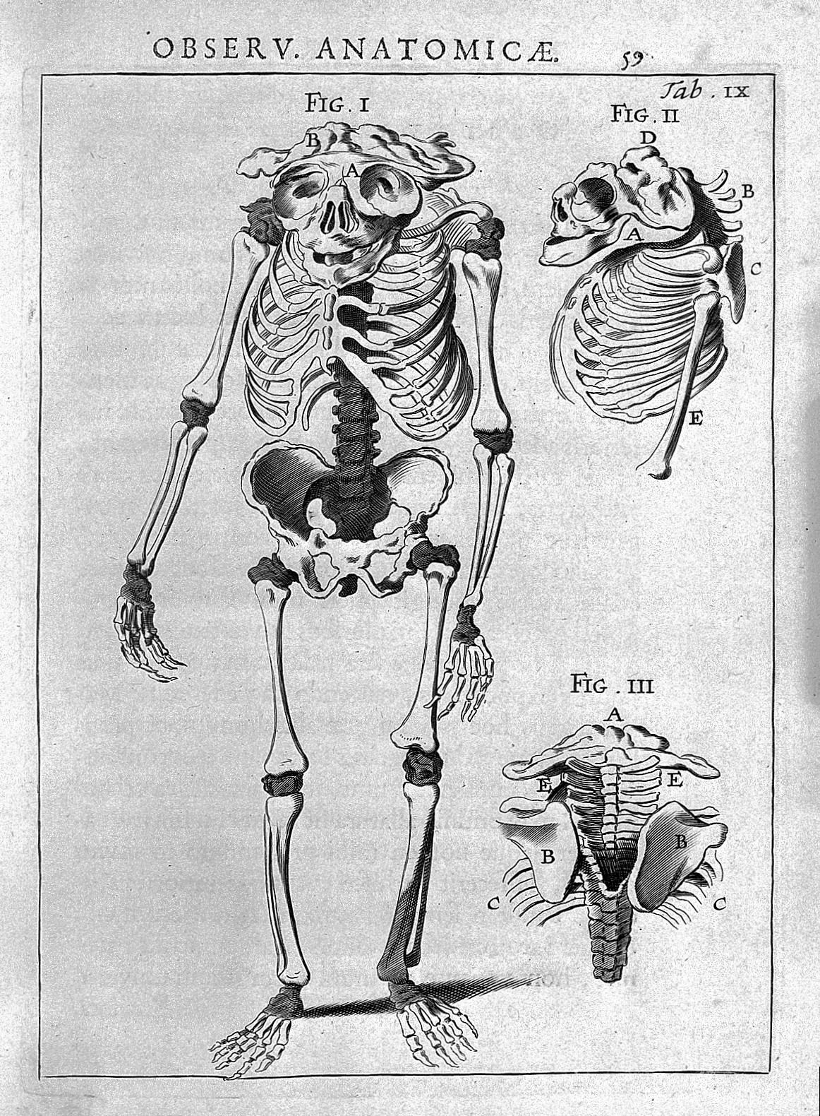

Encephalitis, in Specilegium anatomicum.
Encephalitis, in Specilegium anatomicum. Rare Books Keywords: Anatomy; Nervous System; Thomas Kerckring 1640-1693
Catalogue Source: https://anatomiesofintelligence.github.io/posts/2019-09-2-Encephalitis-Specilegium-Anatomicum
Source URL: https://wellcomecollection.org/works/d5vcdk4u?wellcomeImagesUrl=/indexplus/image/L0005443.html
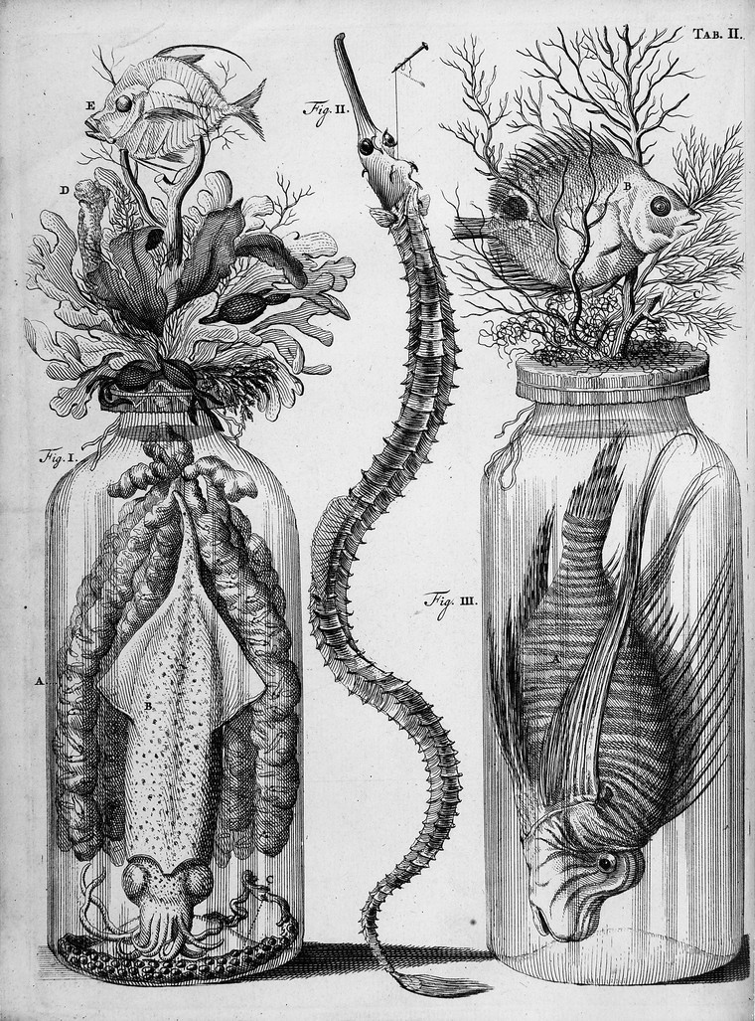

Thesaurus botanical preparations.
Botanical and zoological preparations including the Loligo with eggs. Thesaurus animalium primus Frederik Ruysch Published: 1710.
Catalogue URL: https://anatomiesofintelligence.github.io/posts/2019-12-6-botanical_preparations
Source URL: https://wellcomecollection.org/works/ncecu4v2

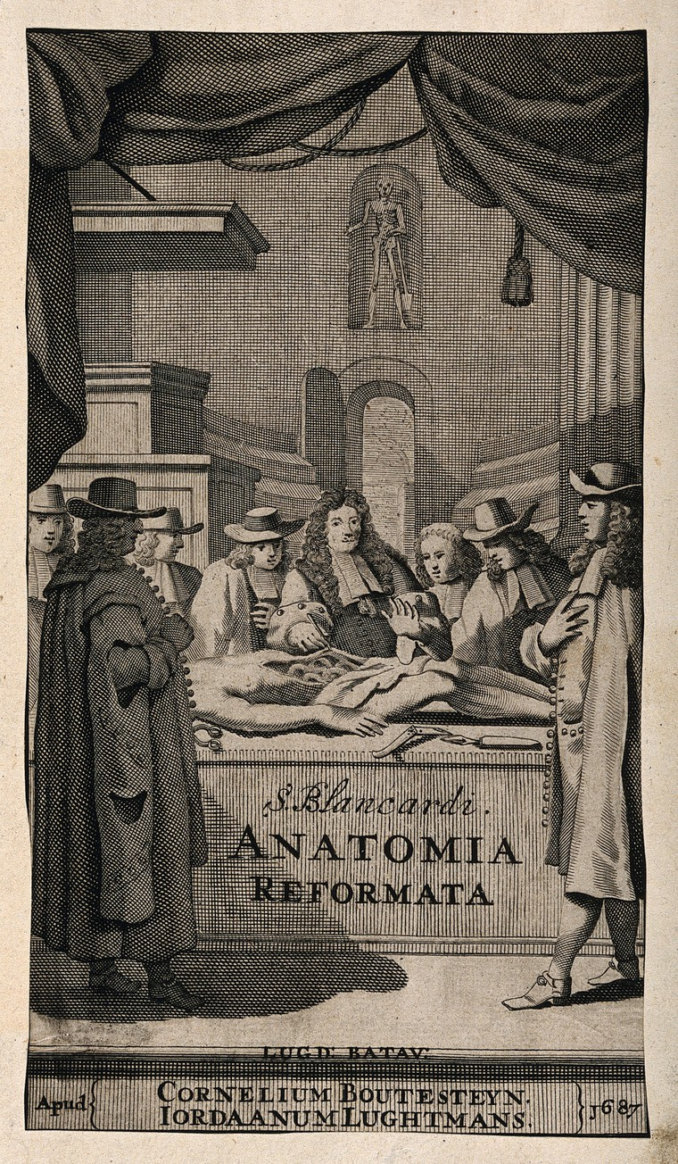

The Dutch anatomist Steven Blankaart (1650-1704) performing a dissection in an anatomy theatre, with seven observers. Engraving, 1687.
The Dutch anatomist S. Blankaart, surrounded by seven observers, retracts the skin of the cadaver he is dissecting to reveal the intestines. Directly behind him is a door leading out of the anatomy theatre and above this, in a niche, is a skeleton holding a spade. Among the surgical instruments lying next to the corpse is a pair of glasses, on the left. Blankaart is similar in features and dress to his engraved portrait at the age of thirty-six (see this catalogue no. 1159), which faces the engraved title page in the Leiden 1687 edition.
Catalogue URL: https://anatomiesofintelligence.github.io/posts/2019-12-6-dissection-anatomical-spectators
Source URL: https://wellcomecollection.org/works/pc3bsnqr
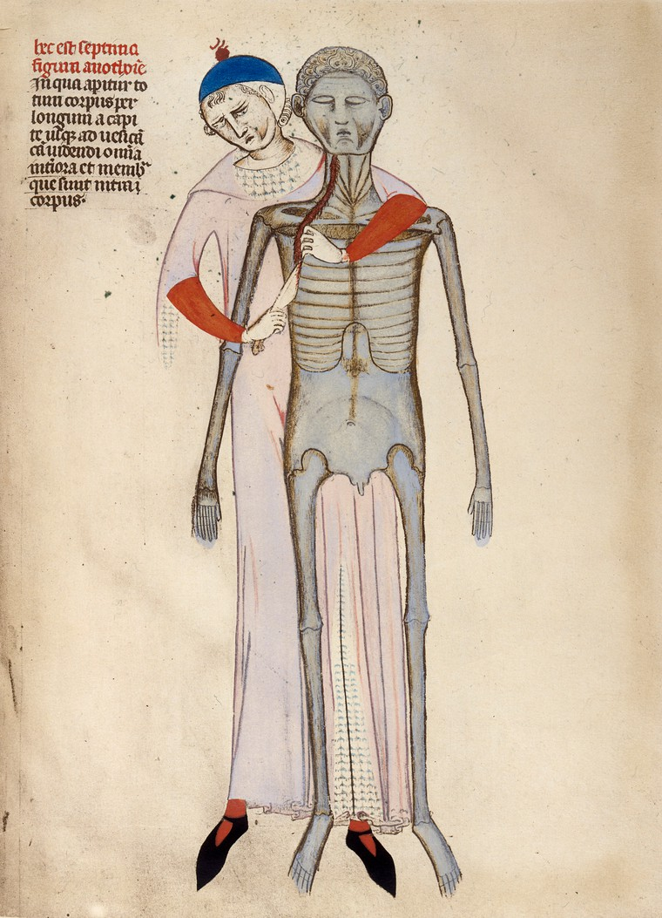

Dissection.
Dissection of a male cadaver, 14th century.
Catalogue URL: https://anatomiesofintelligence.github.io/posts/2019-12-6-dissection
Source URL: https://wellcomecollection.org/works/pjfw5hkc

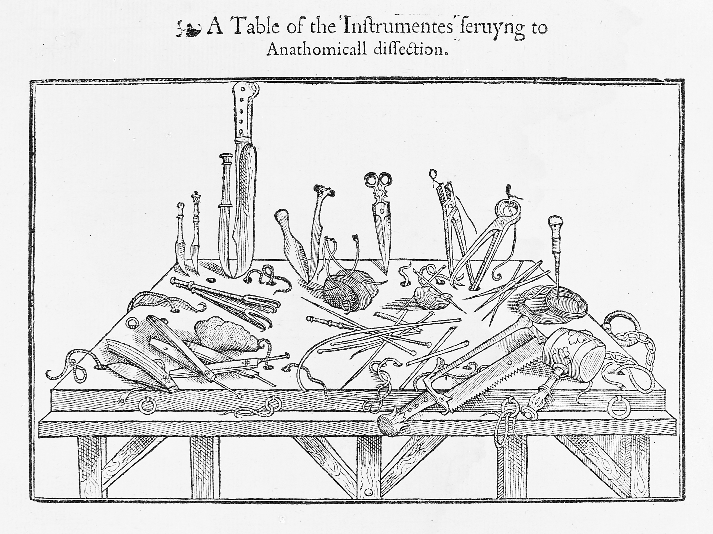

Woodcut, instruments for dissection.
Instruments for dissection, after Vesalius' Fabrica 1543.
Catalogue URL: https://anatomiesofintelligence.github.io/posts/2019-12-6-instruments-for-dissection
Source URL: https://wellcomecollection.org/works/brs86dya

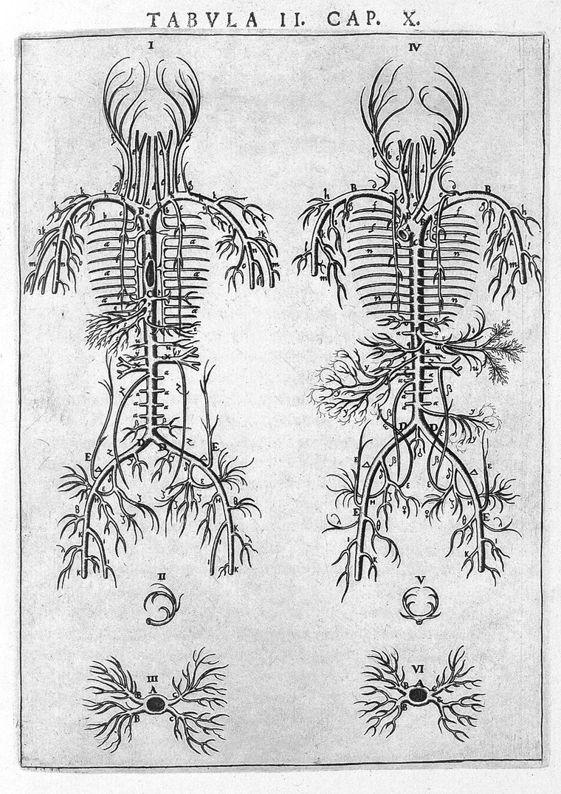

Nerve networks in the body.
Nerve networks, Vesling 'Syntagma', 1647.
Catalogue URL: https://anatomiesofintelligence.github.io/posts/2019-12-6-nerve_networks
Source URL: https://wellcomecollection.org/works/pqqf4r78
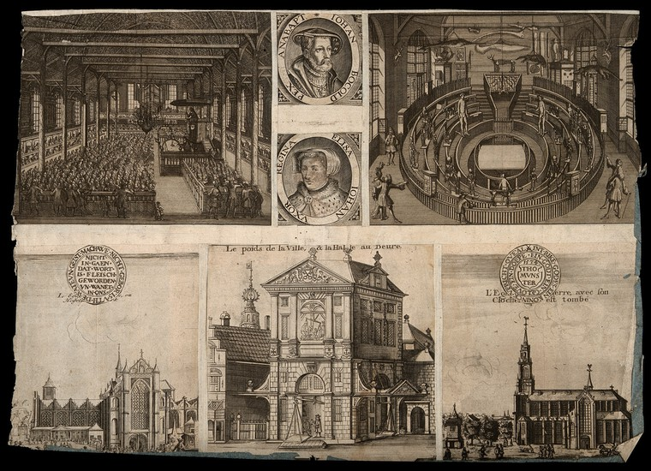

Leiden, the Netherlands, the anatomy theatre, interior of a church, town weighing establishment and portraits.
Top center, portraits of the Anabaptist leader Jan Beukelszoon ('Iohan Bocold rex Anabapt') and one of his wives ('Elisa Johan[nis] uxor regina'). Line engraving.
Catalogue URL: https://anatomiesofintelligence.github.io/posts/2019-12-6-theatre_church
Source URL: https://wellcomecollection.org/works/cmwuk5rg

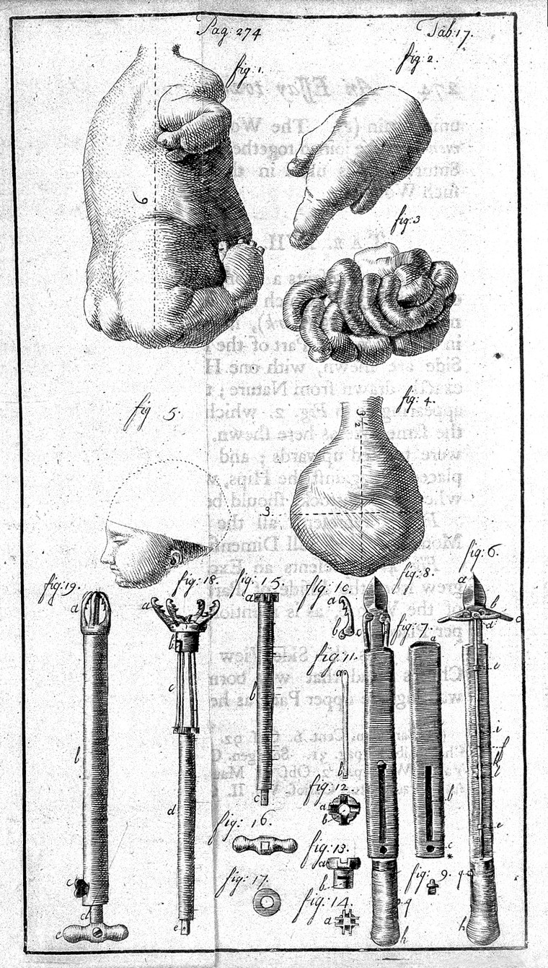

Parts of a monster and instruments.
Catalogue URL: https://anatomiesofintelligence.github.io/posts/2019-12-6-monster_instruments
Source URL: https://wellcomecollection.org/works/sgggvfas

