**Task: Run Existing Docker Image as a Container**

Run a new Container with name "welcome1"

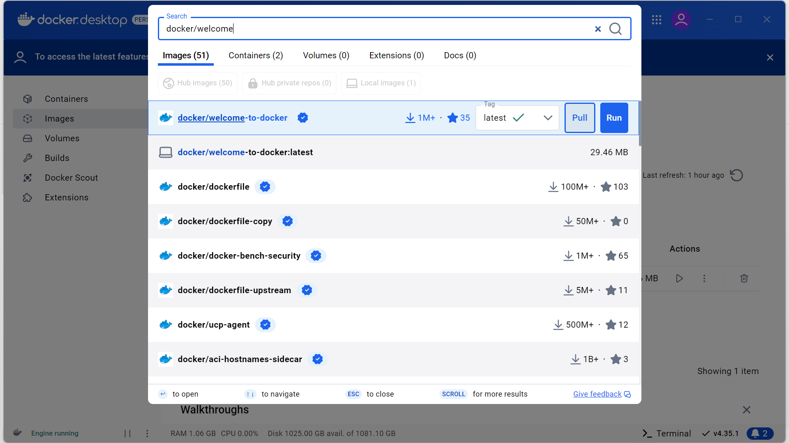

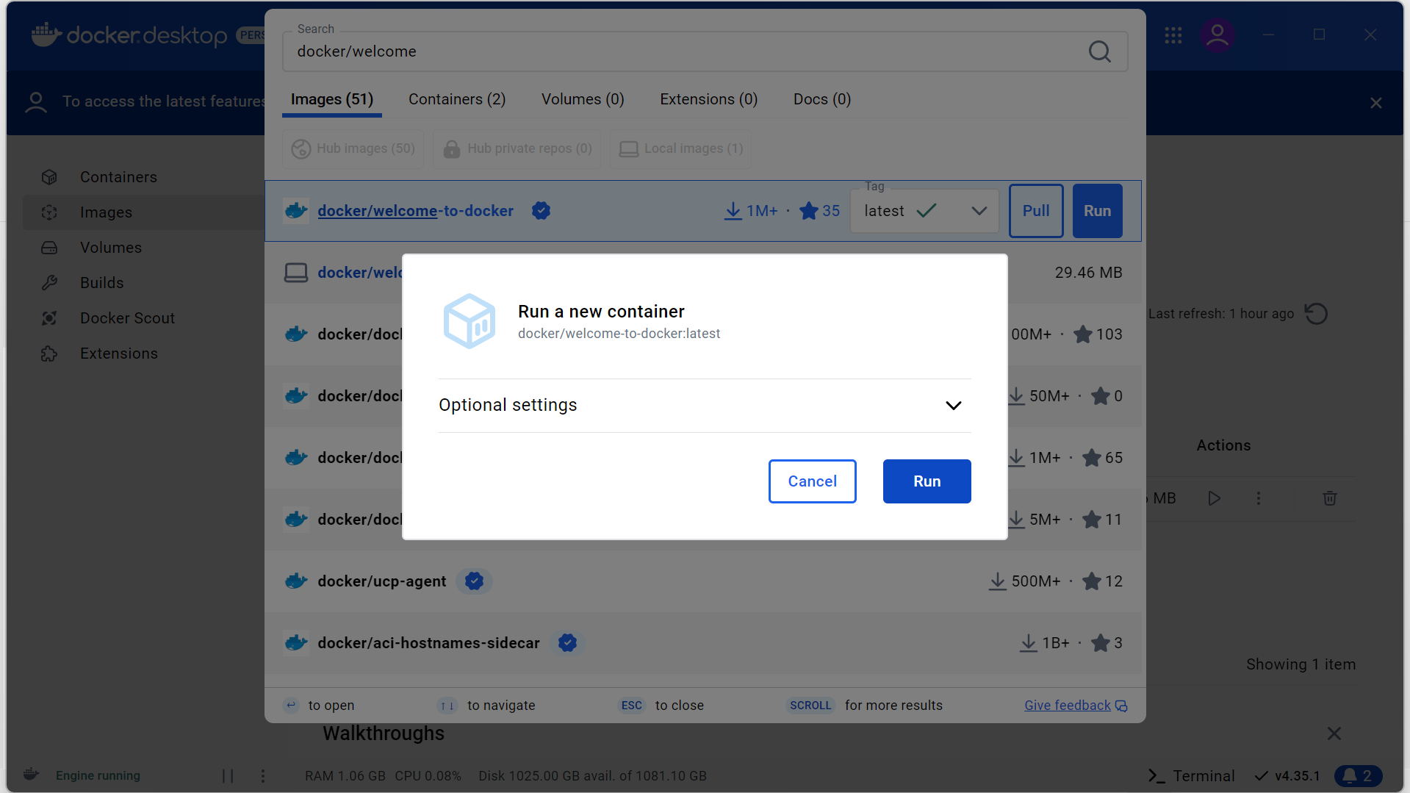

Run a new Container with name "welcome1"

Input this code into a Docker terminal

* docker run -d -p 8080:80name welcome1 docker/welcome-to-docker

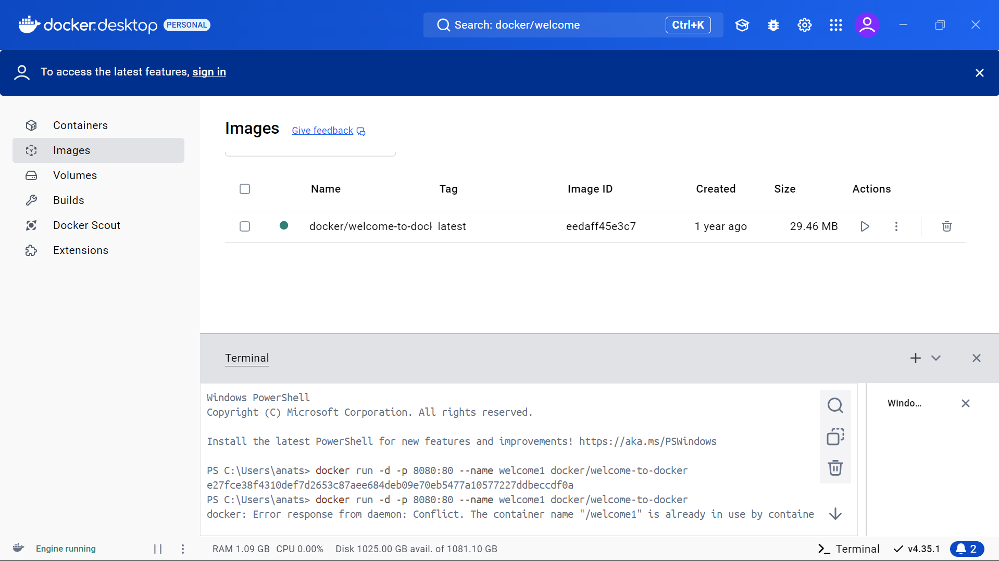

Open URL <http://localhost:8080>, and the result looks like :



See logs of running "welcome1" container

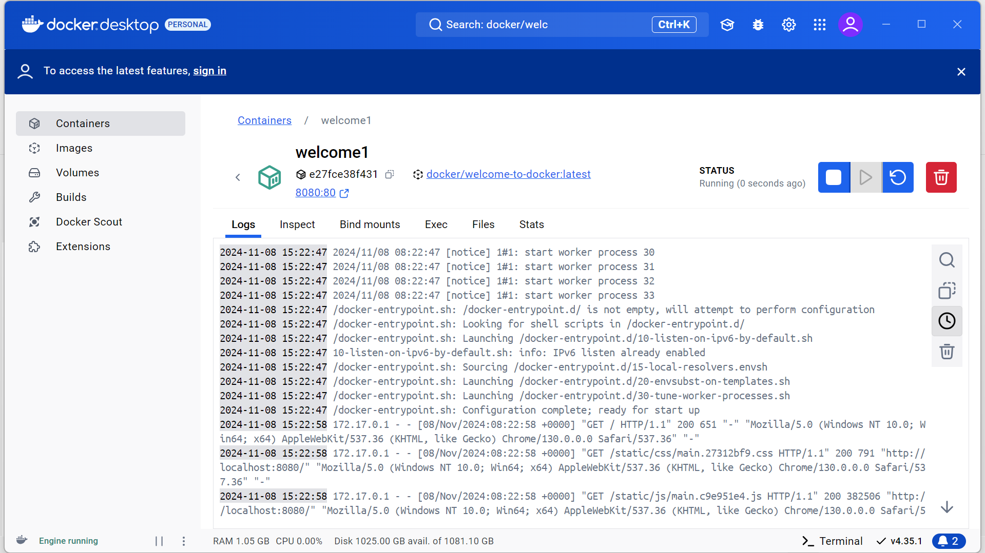

To run a command inside the "welcome1" container, execute:

* docker exec welcome1 cat /usr/share/nginx/html/index.html

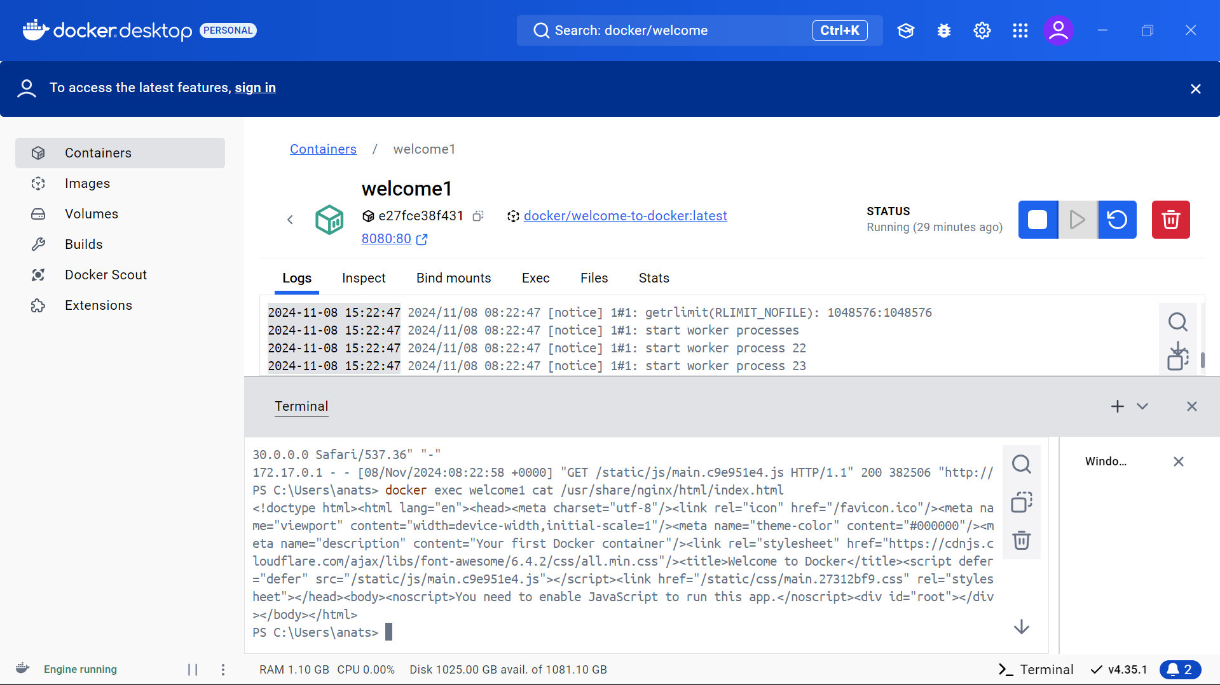

Stop the "welcome1" container by running => docker stop welcome1

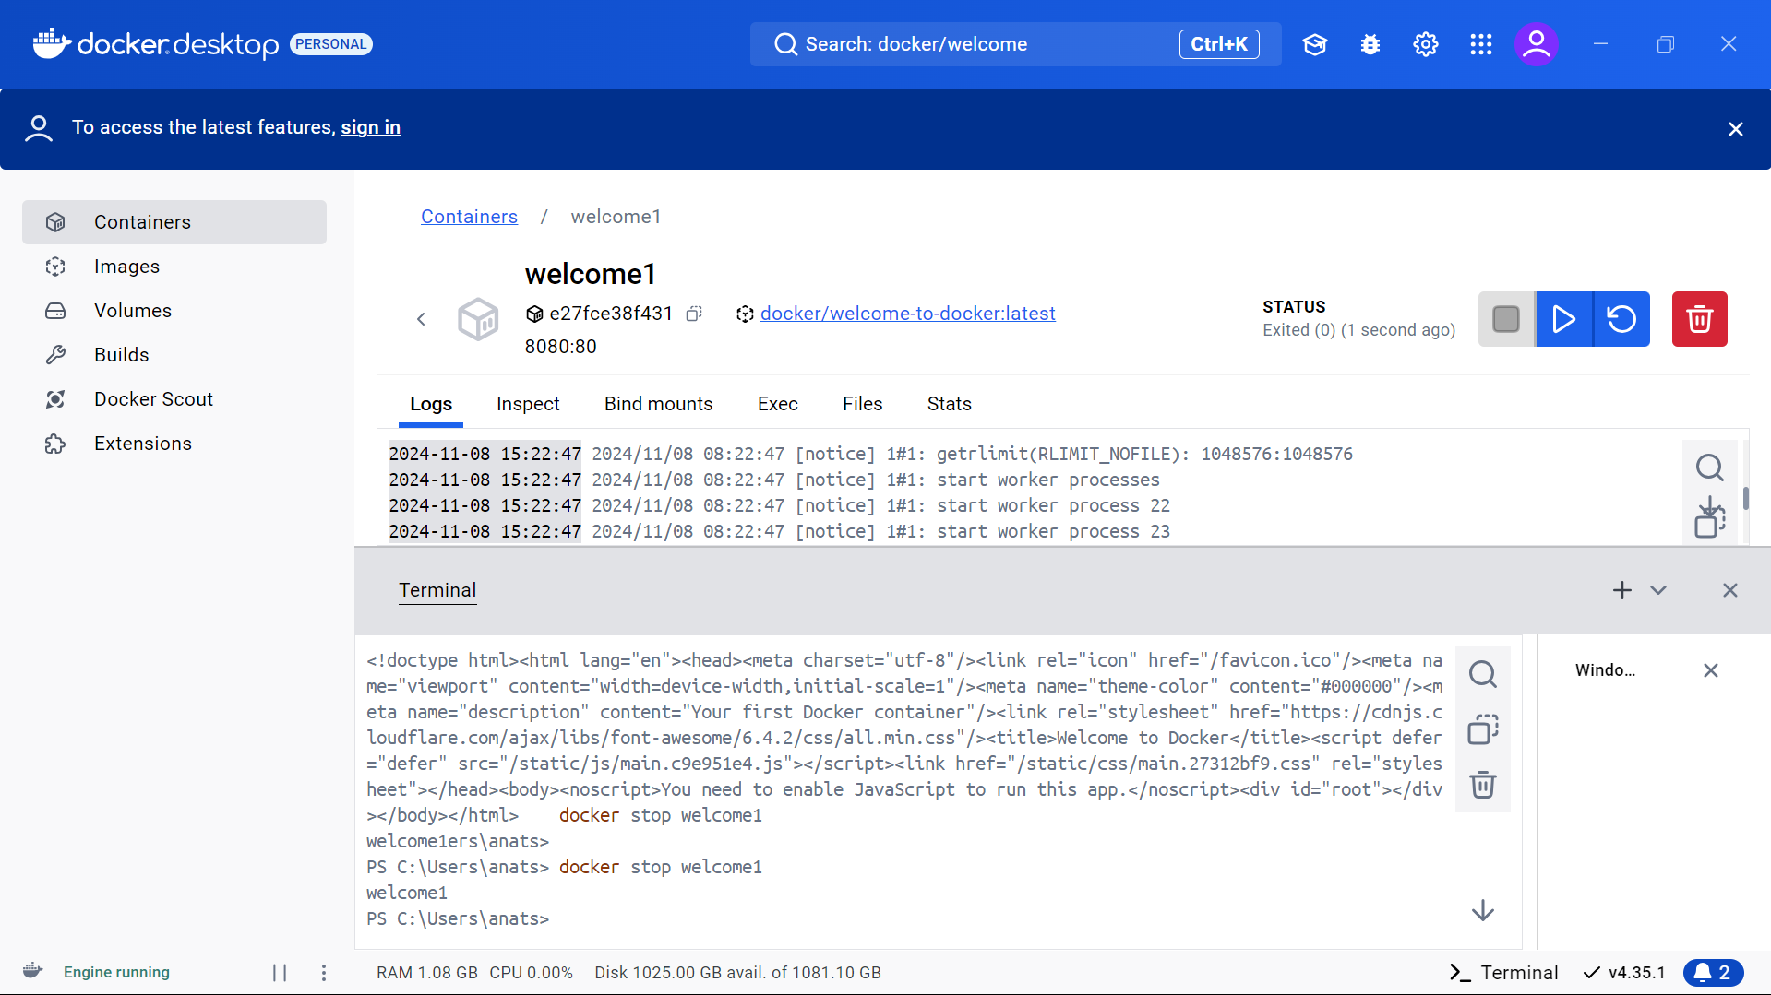

The latest logs:

