**Homework #7: Car Tracking**

# Acknowledgements

# Problem 1

## Problem 1a

After removing non-ancestors of query or evidence, converting to a factor graph, and conditioning on / removing the evidence variable $D_{2}=1$, we are left with the following factor graph:

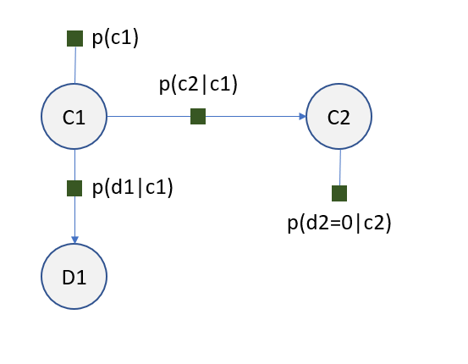

Eliminating $D_{1}$ requires defining a new factor $f\left(c_{1}\right)=Σ_{d_{1}}p\left(d_{1} | c_{1}\right)$. In turn, eliminating $C_{1}$ requires definition of a second new factor $g\left(c_{2}\right)=Σ_{c_{1}}f\left(c_{1}\right)p\left(c_{1}\right)p(c_{2}|c_{1})$. Taking the product of the remaining new factors about the remaining variable $C_{2}$ yields the generalized posterior probability distribution with respect to $C_{2}$:

$$P\left(C_{2}=c_{2}| D_{2}=0\right)∝g\left(c_{2}\right)p\left(d_{2}=0 | c_{2}\right)$$

$$=Σ_{c_{1}}\left[Σ_{d_{1}}p\left(d_{1} | c_{1}\right)\right]p\left(c_{1}\right)p(c_{2}|c_{1}) p\left(d_{2}=0 | c_{2}\right)$$

Now, by substitution we have

$$P\left(C_{2}=1 | D_{2}=0\right)=Σ_{c_{1}}\left[Σ_{d_{1}}p\left(d_{1} | c_{1}\right)\right]p\left(c_{1}\right)p\left(c_{2}=1 | c_{1}\right)p\left(d_{2}=0 | c_{2}=1\right)$$

Noting that $p\left(d_{2}=0 | c_{2}=1\right)=η$ and $Σ_{d_{1}}p\left(d_{1} | c_{1}\right)=1$, we have

$$=ηΣ_{c_{1}}p\left(c_{1}\right)p\left(c_{2}=1 | c_{1}\right)$$

$$=η[\left(0.5*\left(ϵ\right)\right)+\left(0.5*\left(1-ϵ\right))\right]=0.5η$$

## Problem 2b

After performing the same steps as in the previous problem (removing non-ancestors, transforming into a factor graph, and conditioning on the evidence variables), we are left with the following factor graph:

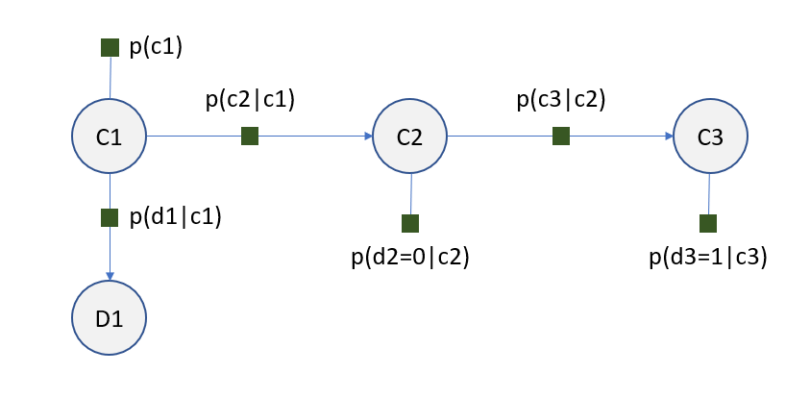

In order to eliminate $C_{3}$, we must define a new factor $h\left(c_{2}\right)=Σ_{c_{3}}p\left(d_{3}=1 | c_{3}\right)p(c_{3}|c_{2})$. Since the conditional value of $D_{2}$ is the same as in the previous problem and the two pieces of the factor graph area independent about $C_{2}$, we can express the solution here in terms of the original solution:

$$P\left(C_{2}=c_{2} | D_{2}=0, D_{3}=1\right)=P\left(C_{2}=c_{2} | D_{2}=0\right)∙h\left(c_{2}\right)$$

$$∴P\left(C_{2}=1 | D_{2}=0, D_{3}=1\right)=0.5η\left[Σ_{c_{3}}p\left(d_{3}=1 | c_{3}\right)p\left(c_{3} | c_{2}=1\right)\right]$$

$$=0.5η\left[ηϵ+\left(1-η\right)\left(1-ϵ\right)\right]$$

## Problem 1c

### 1c(i)

Supposing that we have $ϵ=0.1, η=0.2$, by substitution into the respective expressions we arrive at

$$P\left(C_{2}=1 | D_{2}=0\right)=0.5\left(0.2\right)=0.1$$

$$P\left(C_{2}=1 | D_{2}=0, D_{3}=1\right)=0.5\left(0.2\right)\left[\left(0.2\right)\left(0.1\right)+\left(0.8\right)\left(0.9\right)\right]=0.1\left[0.02+0.72\right]=0.074$$

### 1c(ii)

The above shows that the additional evidentiary observation $D_{3}=1$ lowers the calculated probability. This makes sense intuitively, since the D variables represent the sensor readings for each of the given locations $t∈\left\{1,2,3\right\}$. Therefore, it follows that a situation in which the sensor detects the car at position 3 but not at position 2 ($D_{3}=1, D_{2}=0$) makes it less likely that the car is actually at position 2, as compared to the situation where all we know is that the car is not picking up the car’s location at position 2 ($D_{2}=1$). In other words, the positive reading at position 3 gives our network more evidence against the conclusion that the car is at position 2.

### 1c(iii)

Equating both sides yields

$$0.5η=0.5η\left[ηϵ+\left(1-η\right)\left(1-ϵ\right)\right]$$

Cancelling and setting $η=0.2$ yields

$$1=\left[0.2ϵ+0.8\left(1-ϵ\right)\right]$$

From the above we see that the only real solution for this equality lies at $ϵ=-\frac{1}{3}$, which means there is no actual value of $ϵ$ that allows the two expressions to equate. This is because the observation creates an informational disparity that cannot be fixed by the movement of the car alone. On the other hand, inspection of the above shows that the two probabilities ARE equated by setting $η=0$, which makes intuitive sense – if the sensor is never wrong, then we deterministically know the probability of the car being position 2 based solely on what the sensor at position 2 says.