**Homework #7: Car Tracking**

# Acknowledgements

# Problem 1

## Problem 1a

After removing non-ancestors of query or evidence, converting to a factor graph, and conditioning on / removing the evidence variable $D_{2}=0$, we are left with the following factor graph:

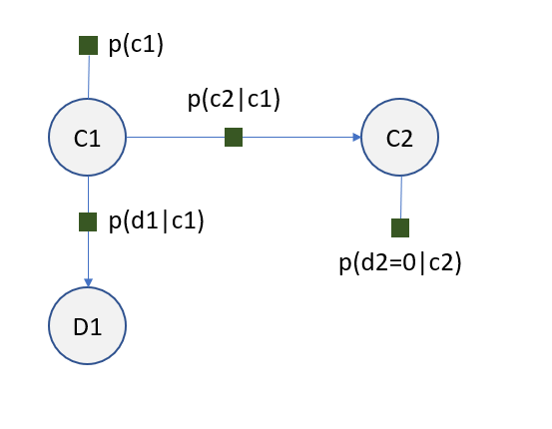

Eliminating $D_{1}$ requires defining a new factor $f\left(c_{1}\right)=Σ_{d_{1}}p\left(d_{1} | c_{1}\right)$. In turn, eliminating $C_{1}$ requires definition of a second new factor $g\left(c_{2}\right)=Σ_{c_{1}}f\left(c_{1}\right)p\left(c_{1}\right)p(c_{2}|c_{1})$. Taking the product of the remaining new factors about the remaining variable $C_{2}$ yields the generalized posterior probability distribution with respect to $C_{2}$:

$$P\left(C_{2}=c_{2}| D_{2}=0\right)∝g\left(c_{2}\right)p\left(d_{2}=0 | c_{2}\right)$$

$$=Σ_{c_{1}}\left[Σ_{d_{1}}p\left(d_{1} | c_{1}\right)\right]p\left(c_{1}\right)p\left(c_{2} | c_{1}\right)p\left(d_{2}=0 | c_{2}\right)$$

Noting that $Σ_{d_{1}}p\left(d_{1} | c_{1}\right)=1$ and that $p(c_{1})$ is a constant, we can simplify to

$$=0.5Σ_{c_{1}}p\left(c_{2} | c_{1}\right)p\left(d_{2}=0 | c_{2}\right)$$

$$∴P\left(C_{2}=c_{2}| D_{2}=0\right)∝\left\{\begin{aligned}0.5(\left(1-ϵ\right)\left(1-η\right)+ϵ(1-η)) if C_{2}=0 \\ 0.5\left(ηϵ+η\left(1-ϵ\right)\right) if C_{2}=1\end{aligned}\right.$$

Therefore, by substitution and normalization we have

$$P\left(C_{2}=1 | D_{2}=0\right)=\frac{0.5\left(ηϵ+η\left(1-ϵ\right)\right)}{\left[0.5\left(\left(1-ϵ\right)\left(1-η\right)+ϵ\left(1-η\right)\right)+ 0.5\left(ηϵ+η\left(1-ϵ\right)\right)\right]}$$

$$=\frac{η}{\left(1-η\right)+η}=η$$

The above makes intuitive sense – at time step 2, the probability of the car being in position 1 given that the sensor reads position 0 is simply equal to the probability that the sensor gives an erroneous reading.

## Problem 1b

After performing the same steps as in the previous problem (removing non-ancestors, transforming into a factor graph, and conditioning on the evidence variables), we are left with the following factor graph:

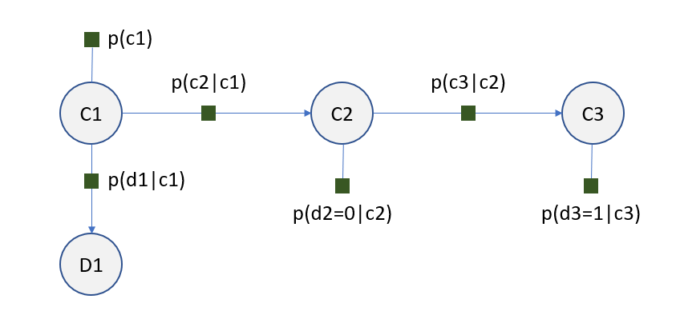

In order to eliminate $C_{3}$, we must define a new factor $h\left(c_{2}\right)=Σ_{c_{3}}p\left(d_{3}=1 | c_{3}\right)p(c_{3}|c_{2})$. Since the conditional value of $D_{2}$ is the same as in the previous problem and the two pieces of the factor graph are independent about $C_{2}$, we can express the solution here in terms of the original solution:

$$P\left(C_{2}=c_{2} | D_{2}=0, D_{3}=1\right)∝P\left(C_{2}=c_{2} | D_{2}=0\right)∙h\left(c_{2}\right)$$

$$=0.5Σ_{c_{1}}p\left(c_{2} | c_{1}\right)p\left(d_{2}=0 | c_{2}\right)Σ_{c_{3}}p\left(d_{3}=1 | c_{3}\right)p(c_{3}|c_{2})$$

$$∴P\left(C_{2}=c_{2}| D_{2}=0, D_{3}=1\right)∝\left\{\begin{aligned}0.5(1-η)(η\left(1-ϵ\right)+\left(1-η\right)ϵ) if C_{2}=0 \\ 0.5η(ηϵ+(1-η)(1-ϵ)) if C_{2}=1\end{aligned}\right.$$

So by substituting and normalizing we have

$$P\left(C_{2}=1| D_{2}=0, D_{3}=1\right)=\frac{η\left(ηϵ+\left(1-η\right)\left(1-ϵ\right)\right)}{\left(1-η\right)\left(η\left(1-ϵ\right)+\left(1-η\right)ϵ\right)+η\left(ηϵ+\left(1-η\right)\left(1-ϵ\right)\right)}$$

## Problem 1c

### 1c(i)

Supposing that we have $ϵ=0.1, η=0.2$, by substitution into the respective expressions we arrive at

$$P\left(C_{2}=1 | D_{2}=0\right)=0.2$$

$$P\left(C_{2}=1 | D_{2}=0, D_{3}=1\right)=0.4157$$

### 1c(ii)

The above shows that the additional evidence increases the probability of the car’s position at time step 2. This makes sense when we consider the relative values of $η, ϵ$. We see that the probability of the car moving is very low, and actually less likely than the sensor having an erroneous reading. Therefore, the additional evidence about $D_{3}$ actually strengthens our inference about the car’s position at time step 2.

### 1c(iii)

Equating both expressions yields

$$η=\frac{η\left(ηϵ+\left(1-η\right)\left(1-ϵ\right)\right)}{\left(1-η\right)\left(η\left(1-ϵ\right)+\left(1-η\right)ϵ\right)+η\left(ηϵ+\left(1-η\right)\left(1-ϵ\right)\right)}$$

$$1=\frac{\left(ηϵ+\left(1-η\right)\left(1-ϵ\right)\right)}{\left(1-η\right)\left(η\left(1-ϵ\right)+\left(1-η\right)ϵ\right)+η\left(ηϵ+\left(1-η\right)\left(1-ϵ\right)\right)}$$

Inspection of the above shows that $ϵ=0.5$ **is a solution for the above equality, i.e. the two probabilities are equal at this value.**

Recall that $P\left(C_{2}=1 | D_{2}=0\right)$ has the sensor at the second position as evidence, while the second one $P\left(C_{2}=1 | D_{2}=0, D_{3}=1\right)$ has sensors at time steps 2 and 3 as evidence. However, because the probability of staying and moving are equal at $ϵ=0.5$, having the additional sensor output for time step 3 as evidence provides no additional useful information about the car’s position (since it’s just as likely to stay as it is to move), and as a result the probability is unchanged.

# Problem 5

## Problem 5a

Applying Bayes’ rule, we know that

$$P\left(C_{11},C_{12} | E_{1}\right)=\frac{P\left(E_{1} | C_{11},C_{12}\right)P(C_{11},C_{12})}{P(E_{1})}$$

By simply looking at proportionality and noting that the two cars move independently, we can directly substitute the local conditional probabilities

$$P\left(C_{11},C_{12} | E_{1}\right)∝P\left(E_{1} | C_{11},C_{12}\right)p\left(c_{11}\right)p(c_{12})$$

In order to determine the remaining probability, we note that the conditional probability is given by the Gaussian distribution function, so that we have

## Problem 5b

Practically, $p(c_{1i})$ being the same for all $i$ ( $p\left(c_{11}\right)=p\left(c_{12}\right)=…=p\left(c_{1}\right)$ means that the local conditional probability is the same for all cars at the first time step. Applying Bayes’ Rule, we have

$$P\left(C_{11},C_{12}…C_{1K} | E_{1}\right)=\frac{P\left(E_{1} | C_{11},C_{12}…C_{1K}\right)P(C_{11},C_{12}…C_{1K})}{P(E_{1})}$$

$$∴P\left(C_{11},C_{12}…C_{1K} | E_{1}\right)∝P\left(E_{1} | C_{11},C_{12}…C_{1K}\right)p\left(c_{11}\right)p\left(c_{12}\right)…p\left(c_{1K}\right)=P\left(E_{1} | C_{11},C_{12}…C_{1K}\right)p{\left(c_{1}\right)}^{K}$$

## Problem 5c