**Homework #7: Car Tracking**

# Problem 1

## Problem 1a

After removing non-ancestors of query or evidence, converting to a factor graph, and conditioning on / removing the evidence variable $D_{2}=0$, we are left with the following factor graph:

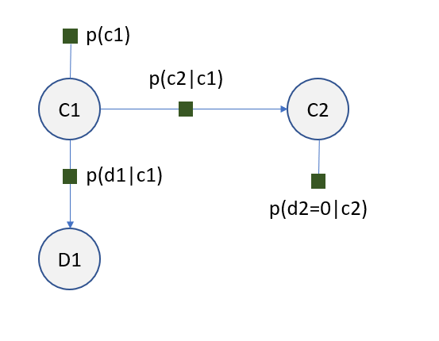

Eliminating $D_{1}$ requires defining a new factor $f\left(c_{1}\right)=Σ_{d_{1}}p\left(d_{1} | c_{1}\right)$. In turn, eliminating $C_{1}$ requires definition of a second new factor $g\left(c_{2}\right)=Σ_{c_{1}}f\left(c_{1}\right)p\left(c_{1}\right)p(c_{2}|c_{1})$. Taking the product of the remaining new factors about the remaining variable $C_{2}$ yields the generalized posterior probability distribution with respect to $C_{2}$:

$$P\left(C_{2}=c_{2}| D_{2}=0\right)∝g\left(c_{2}\right)p\left(d_{2}=0 | c_{2}\right)$$

$$=Σ_{c_{1}}\left[Σ_{d_{1}}p\left(d_{1} | c_{1}\right)\right]p\left(c_{1}\right)p\left(c_{2} | c_{1}\right)p\left(d_{2}=0 | c_{2}\right)$$

Noting that $Σ_{d_{1}}p\left(d_{1} | c_{1}\right)=1$ and that $p(c_{1})$ is a constant, we can simplify to

$$=0.5Σ_{c_{1}}p\left(c_{2} | c_{1}\right)p\left(d_{2}=0 | c_{2}\right)$$

$$∴P\left(C_{2}=c_{2}| D_{2}=0\right)∝\left\{\begin{aligned}0.5(\left(1-ϵ\right)\left(1-η\right)+ϵ(1-η)) if C_{2}=0 \\ 0.5\left(ηϵ+η\left(1-ϵ\right)\right) if C_{2}=1\end{aligned}\right.$$

Therefore, by substitution and normalization we have

$$P\left(C_{2}=1 | D_{2}=0\right)=\frac{0.5\left(ηϵ+η\left(1-ϵ\right)\right)}{\left[0.5\left(\left(1-ϵ\right)\left(1-η\right)+ϵ\left(1-η\right)\right)+ 0.5\left(ηϵ+η\left(1-ϵ\right)\right)\right]}$$

$$=\frac{η}{\left(1-η\right)+η}=η$$

The above makes intuitive sense – at time step 2, the probability of the car being in position 1 given that the sensor reads position 0 is simply equal to the probability that the sensor gives an erroneous reading.

## Problem 1b

After performing the same steps as in the previous problem (removing non-ancestors, transforming into a factor graph, and conditioning on the evidence variables), we are left with the following factor graph:

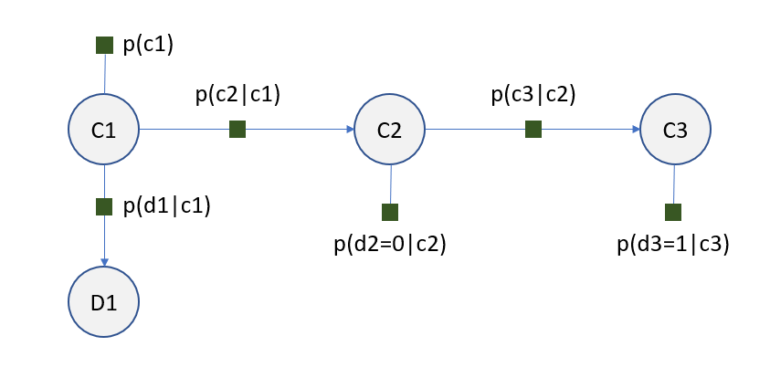

In order to eliminate $C_{3}$, we must define a new factor $h\left(c_{2}\right)=Σ_{c_{3}}p\left(d_{3}=1 | c_{3}\right)p(c_{3}|c_{2})$. Since the conditional value of $D_{2}$ is the same as in the previous problem and the two pieces of the factor graph are independent about $C_{2}$, we can express the solution here in terms of the original solution:

$$P\left(C_{2}=c_{2} | D_{2}=0, D_{3}=1\right)∝P\left(C_{2}=c_{2} | D_{2}=0\right)∙h\left(c_{2}\right)$$

$$=0.5Σ_{c_{1}}p\left(c_{2} | c_{1}\right)p\left(d_{2}=0 | c_{2}\right)Σ_{c_{3}}p\left(d_{3}=1 | c_{3}\right)p(c_{3}|c_{2})$$

$$∴P\left(C_{2}=c_{2}| D_{2}=0, D_{3}=1\right)∝\left\{\begin{aligned}0.5(1-η)(η\left(1-ϵ\right)+\left(1-η\right)ϵ) if C_{2}=0 \\ 0.5η(ηϵ+(1-η)(1-ϵ)) if C_{2}=1\end{aligned}\right.$$

So by substituting and normalizing we have

$$P\left(C_{2}=1| D_{2}=0, D_{3}=1\right)=\frac{η\left(ηϵ+\left(1-η\right)\left(1-ϵ\right)\right)}{\left(1-η\right)\left(η\left(1-ϵ\right)+\left(1-η\right)ϵ\right)+η\left(ηϵ+\left(1-η\right)\left(1-ϵ\right)\right)}$$

## Problem 1c

### 1c(i)

Supposing that we have $ϵ=0.1, η=0.2$, by substitution into the respective expressions we arrive at

$$P\left(C_{2}=1 | D_{2}=0\right)=0.2$$

$$P\left(C_{2}=1 | D_{2}=0, D_{3}=1\right)=0.4157$$

### 1c(ii)

The above shows that the additional evidence increases the probability of the car’s position at time step 2. This makes sense when we consider the relative values of $η, ϵ$. We see that the probability of the car moving is very low, and actually less likely than the sensor having an erroneous reading. Therefore, the additional evidence about $D_{3}$ actually strengthens our inference about the car’s position at time step 2.

### 1c(iii)

Equating both expressions yields

$$η=\frac{η\left(ηϵ+\left(1-η\right)\left(1-ϵ\right)\right)}{\left(1-η\right)\left(η\left(1-ϵ\right)+\left(1-η\right)ϵ\right)+η\left(ηϵ+\left(1-η\right)\left(1-ϵ\right)\right)}$$

$$1=\frac{\left(ηϵ+\left(1-η\right)\left(1-ϵ\right)\right)}{\left(1-η\right)\left(η\left(1-ϵ\right)+\left(1-η\right)ϵ\right)+η\left(ηϵ+\left(1-η\right)\left(1-ϵ\right)\right)}$$

Inspection of the above shows that $ϵ=0.5$ **is a solution for the above equality, i.e. the two probabilities are equal at this value.**

Recall that $P\left(C_{2}=1 | D_{2}=0\right)$ has the sensor at the second position as evidence, while the second one $P\left(C_{2}=1 | D_{2}=0, D_{3}=1\right)$ has sensors at time steps 2 and 3 as evidence. However, because the probability of staying and moving are equal at $ϵ=0.5$, having the additional sensor output for time step 3 as evidence provides no additional useful information about the car’s position (since it’s just as likely to stay as it is to move), and as a result the probability is unchanged.

# Problem 5

## Problem 5a

By applying Bayes’ rule on the case of K=1, we know from the hint in the problem statement that

$$P\left(E_{1} | C_{11}\right)=p_{N}\left(e_{11};\left|a_{1}-c_{11}\right|;σ^{2}\right)$$

In order to express the distribution, we must consider all of the different ways in which the readings $E_{1}=\{e_{11},e_{12}\}$ can map to the locations of the cars $c_{11},c_{12}$. We know that for the case of K=2 there are 2!=4 possible mappings, which are $\left\{e_{11}:c_{11}, e_{11}:c_{12}, e_{21}:c_{11}, e_{21}:c_{12}\right\}$. Each of these possible combinations must be accounted for by sampling from the Gaussian distribution.

By applying Bayes’ rule for the case where K=2 and noting the independence of movement of the two cars, we have

$$P\left(C_{11},C_{12} | E_{1}\right)∝p\left(c_{11}\right)p\left(c_{12}\right)P(E_{1}|C_{11},C_{12})$$

By substituting in the relevant Gaussian probabilities, we have

$$P\left(C_{11},C_{12} | E_{1}\right)∝p\left(c_{11}\right)p\left(c_{12}\right)p_{N}\left(e_{11};\left|a_{1}-c_{11}\right|;σ^{2}\right)p_{N}\left(e_{11};\left|a_{1}-c_{12}\right|;σ^{2}\right)p_{N}\left(e_{12};\left|a_{1}-c_{11}\right|;σ^{2}\right)p_{N}\left(e_{12};\left|a_{1}-c_{12}\right|;σ^{2}\right)$$

## Problem 5b

Practically, $p(c_{1i})$ being the same for all $i$ means that the local conditional probability is the same for all cars at the first time step. This means that each of the readings obtained from the sensors is assigned to any of the K cars with equal probability. **Therefore, there are K possible assignments of the readings to cars $c_{11}…c_{1K}$ which will maximize the probability, since each of the different configurations of assignments will have the exact same probability scheme for assigning readings to cars.**

## Problem 5c

For the posterior distribution of the positions of all the cars conditioned on all of the sensor readings, **the tree-width is equal to $K$ after conditioning on the readings.** In this factor graph, there are factors among each of the cars in every time-step, as well as transition factors between any given car across successive time-steps. Since there are $K$ cars to consider, this means that the maximum number of variables that can exist in the Markov blanket of an eliminated variable is $K.$

## Problem 5d

In order to account for the shift, we can define an auxiliary shift variable which tells us by how much the readings have been shifted:

$$S_{t},s_{t}=\left\{0,1,2…\right\}$$

This means that now, the position of a given car $c_{t}$ is determined both by the probability of a given reading mapping to it, as well as the probability of the readings shifting by a given amount, i.e. $\{e_{1},s_{1}\}$. This results in a factor graph with a new set of factors $\{s_{1}, s_{2}…s_{T}\}$.