Table of Contents

CHAPTER 1 INTRODUCTION 1
1.1 PROBLEM DESCRIPTION 1
1.2 EXISTING SYSTEM 2
1.3 PROJECT SCOPE 3
1.4 OBJECTIVES 4
1.5 PURPOSE, SCOPE AND APPLICABILITY 4
1.5.1 PURPOSE 4
1.5.2 SCOPE 5
1.5.3 APPLICABILITY 5
1.6 OVERVIEW OF THE REPORT 5
CHAPTER 2 SYSTEM ANALYSIS 7
2.1 FUNCTIONAL SPECIFICATIONS 7
2.1.1 FUNCTIONAL REQUIREMENTS 7
2.1.2 NON-FUNCTIONAL REQUIREMENTS 8
2.2 BLOCK DIAGRAM 9
2.3 SYSTEM REQUIREMENTS 10
2.3.1 USER CHARACTERISTICS 10
2.3.2 SOFTWARE AND HARDWARE REQUIREMENTS 11
2.3.3 CONSTRAINTS 12
CHAPTER 3 SYSTEM DESIGN 13
3.1 SYSTEM ARCHITECTURE 13
3.2 MODULE DESIGN 14
3.3 DATABASE DESIGN 16
3.3.1 NORMALISATION SUMMARY 16
3.3.2 DATA DICTIONARIES 16
3.3.3 ENTITY RELATIONSHIP DIAGRAM 23
3.3.4 DATA FLOW DIAGRAM 25
3.4 ALGORITHMS AND DATA STRUCTURES 26
3.4.1 DBSCAN HOTSPOT DETECTION 26
3.4.2 VOLUNTEER RELIABILITY SCORE (VRS) 27
3.4.3 ATOMIC CASE-CLAIMING 28
3.4.4 CELERY AUTO-RELEASE COUNTDOWN 28
3.4.5 TEMPERAMENT SCORE AGGREGATION 28
3.5 SYSTEM CONFIGURATION 29
3.6 INTERFACE DESIGN 29
3.6.1 USER INTERFACE SCREEN DESIGN 29
3.6.2 APPLICATION FLOW / CLASS DIAGRAM 32
3.7 API DESIGN 34
3.8 SECURITY DESIGN 36
3.9 DEPLOYMENT ARCHITECTURE 36
3.10 REPORTS DESIGN 37
CHAPTER 4 IMPLEMENTATION 38
4.1 CODING STANDARDS 38
4.1.1 CODE FORMATTING 38
4.1.2 NAMING CONVENTIONS 38
4.1.3 CODE COMMENTS AND DOCSTRINGS 38
4.1.4 ERROR HANDLING 38
4.1.5 CODE REUSABILITY 39
4.1.6 PERFORMANCE OPTIMISATION 39
4.2 CORE IMPLEMENTATION — CODE EXCERPTS 39
4.2.1 ATOMIC CASE CLAIMING — CASES/VIEWS.PY 39
4.2.2 VOLUNTEER PROXIMITY GEOFENCING — PAWMAP_BACKEND/GEO.PY 40
4.2.3 DBSCAN HOTSPOT DETECTION — ANALYTICS/SERVICES.PY 41
4.2.4 VOLUNTEER RELIABILITY SCORE — VOLUNTEERS/MODELS.PY 43
4.2.5 CASE AND STATUS LOG MODELS — CASES/MODELS.PY 44
4.3 SCREENSHOTS AND INTERFACE DEMONSTRATIONS 47
CHAPTER 5 TESTING 52
5.1 TYPES OF TESTING 52
5.1.1 UNIT TESTING 52
5.1.2 INTEGRATION TESTING 53
5.1.3 SYSTEM TESTING 53
5.2 TEST CASES 54
5.2.1 REGISTRATION AND LOGIN 54
5.2.2 CASE REPORTING AND CLAIMING 54
5.2.3 ADOPTION PIPELINE 55
5.2.4 SECURITY AND VALIDATION TESTING 55
5.3 TEST REPORTS 56
5.4 UNIT TEST SOURCE CODE 56
5.4.1 UNIT TESTS — CASES MODULE (CASES/TESTS.PY) 56
5.4.2 UNIT TESTS — VOLUNTEERS MODULE (VOLUNTEERS/TESTS.PY) 58
5.4.3 UNIT TESTS — ANALYTICS MODULE (ANALYTICS/TESTS.PY) 60
CHAPTER 6 CONCLUSION 62
6.1 DESIGN AND IMPLEMENTATION ISSUES 62
6.2 ADVANTAGES AND LIMITATIONS 63
6.3 FUTURE ENHANCEMENTS 64
CHAPTER A PILOT DATA DESCRIPTION 65
A.1 DATASET OVERVIEW AND FEASIBILITY STUDY 65
A.2 DATASET FIELDS AND DEFINITIONS 65
A.3 SAMPLE WARD CENTROIDS USED IN PILOT DATASET 66
A.4 DBSCAN RUN RESULTS ON PILOT DATASET 66
CHAPTER B REFERENCES 68

LIST OF TABLES

Table 1: Comparison of Existing Systems with PawMap Contributions 2
Table 2: Complete Functional Requirements Specification 7
Table 3: Non-Functional Requirements Specification 9
Table 4: User Classes and Characteristics 10
Table 5: Software and Hardware Requirements 11
Table 6: Database Normalisation Summary and Design Decisions 16
Table 7: Data Dictionary — User Table 17
Table 8: Data Dictionary — Ward Table 17
Table 9: Data Dictionary — AnimalType Table 18
Table 10: Data Dictionary — Case Table 18
Table 11: Data Dictionary — CaseStatusLog Table 19
Table 12: Data Dictionary — VolunteerReliabilityScore Table 19
Table 13: Data Dictionary — Animal Table 20
Table 14: Data Dictionary — TemperamentRating Table 21
Table 15: Data Dictionary — MedicalRecord Table 21
Table 16: Data Dictionary — AdoptionListing Table 21
Table 17: Data Dictionary — AdopterInterest Table 22
Table 18: Data Dictionary — AdoptionRecord Table 22
Table 19: Data Dictionary — HotspotCluster Table 23
Table 20: DBSCAN Algorithm Parameters and Justification 26
Table 21: VRS Formula Component Weights and Data Sources 27
Table 22: Primary UI Screens — Inputs, Outputs and Requirements 30
Table 23: Django Model Classes — Attributes and Methods 32
Table 24: Primary REST API Endpoints 34
Table 25: Security Design Decisions and Implementation Details 36
Table 26: Deployment Architecture — Components and Configuration 36
Table 27: Unit Test Cases — Execution Summary 52
Table 28: Functional Test Cases — User Registration and Authentication 54
Table 29: Functional Test Cases — Case Reporting and Volunteer Dispatch 54
Table 30: Functional Test Cases — Adoption and Fostering Pipeline 55
Table 31: Security and Boundary Validation Test Cases 55
Table 32: Pilot Dataset — Field Definitions and Usage 65
Table 33: BBMP Ward Centroids for Pilot Dataset Geographic Distribution 66
Table 34: DBSCAN Pilot Run Summary Statistics 67

LIST OF FIGURES

Figure 1: PawMap High-Level System Block Diagram 10
Figure 2: Five-Layer Client-Server System Architecture Diagram 14
Figure 3: Entity Relationship Diagram — All 13 Entities 24
Figure 4: DFD Level 0 — Context Diagram 25
Figure 5: DFD Level 1 — Expanded Process Diagram 26
Figure 6: Case Reporting Form and Active Cases Map Wireframes 31
Figure 7: Adoption listing wireframe (image gallery) 32
Figure 8: Django Model Class Dependency Diagram 34
Figure 9: Case Reporting Form 48
Figure 10: Active Cases Map 48
Figure 11: Volunteer Claim Interface 49
Figure 12: Medical Record Entry Timeline 49
Figure 13: Adoption Listing Cards 50
Figure 14: NGO Admin Dashboard 51
Figure 15: Analytics View 51
Figure 16: Django Test Runner Execution Output Showing 6/6 Tests Passed 53

ABBREVIATIONS
- API: Application Programming Interface
- ASGI: Asynchronous Server Gateway Interface
- AWS: Amazon Web Services
- BBMP: Bruhat Bengaluru Mahanagara Palike
- DBSCAN: Density-Based Spatial Clustering of Applications with Noise
- DFD: Data Flow Diagram
- DRF: Django REST Framework
- ERD: Entity Relationship Diagram
- FCM: Firebase Cloud Messaging
- GPS: Global Positioning System
- JWT: JSON Web Token
- MDS: Master of Data Science
- NGO: Non-Governmental Organisation
- ORM: Object Relational Mapping
- PDF: Portable Document Format
- PII: Personally Identifiable Information
- REST: Representational State Transfer
- RBAC: Role-Based Access Control
- SDR: System Design Report
- SOS: Save Our Souls (Emergency Escalation)
- SRS: Software Requirements Specification
- TOC: Table of Contents
- UUID: Universally Unique Identifier
- VRS: Volunteer Reliability Score
- WCAG: Web Content Accessibility Guidelines
- WGS84: World Geodetic System 1984 (GPS coordinate standard)

CHAPTER 1
INTRODUCTION

1.1 PROBLEM DESCRIPTION
Urban India harbours an estimated 62 million stray dogs and an indeterminate but substantial population of stray cats, goats, cattle, and other animals that have been abandoned or have never been formally owned. Bengaluru alone, governed by the Bruhat Bengaluru Mahanagara Palike (BBMP), is home to over 300,000 street dogs distributed across its 198 administrative wards. The consequences of unmanaged stray populations are multi-dimensional: daily incidents of territorial aggression threatening public safety, vehicular accidents injuring animals and pedestrians, disease transmission vectors including rabies and leptospirosis, and a persistent cycle of suffering for animals who receive no timely medical attention.
The core challenge, however, is not merely the scale of the problem but the near-complete absence of a coordinated, technology-mediated response infrastructure. When a citizen observes an injured animal, their only recourse is typically to post on a neighbourhood WhatsApp group, share a photograph on social media with a plea for help, or dial one of several NGO helplines that may be overwhelmed, unmanned, or simply unaware of who is geographically closest to the incident. This fragmented workflow introduces four categories of critical failure:
- Duplicated Response: Multiple volunteers converge on the same high-visibility case while other cases — less visible on social media — remain entirely unattended for hours or days.
- Lost Medical Continuity: Animals treated at one clinic or by one volunteer have no persistent identity. When they are transferred to another carer or clinic, their entire treatment history is lost, forcing caregivers to start from scratch with vaccinations, deworming, and diagnosis.
- Reactive Instead of Proactive Planning: NGO administrators and municipal bodies have no spatial intelligence about where abandonments cluster geographically. Sterilisation and vaccination drives are therefore planned on guesswork rather than data, misallocating limited resources.
- No Accountability or Transparency: No unified audit trail exists to verify whether a reported case was actually attended, what intervention was provided, and what the outcome was. This inability to measure impact hampers fundraising, policy advocacy, and inter-organisational collaboration.
PawMap is designed as a direct technological response to these four systemic gaps. By integrating atomic case-claiming mechanisms, persistent animal health identities, geospatial clustering analytics, and structured adoption pipelines into a unified platform, PawMap transforms stray animal rescue from an informal, reactive activity into a structured, data-driven civic welfare operation.

1.2 EXISTING SYSTEM
A review of the current landscape reveals that existing tools address only isolated aspects of the stray animal welfare problem. WhatsApp groups and social media platforms serve as the primary coordination channels but impose severe limitations: they have no case management lifecycle, no volunteer dispatch logic, and produce no searchable, structured data. NGO helplines provide a human coordination layer but are limited by staff capacity and operating hours, and they do not integrate with any digital case tracking system.
A systematic literature review covering academic publications, deployed applications, and policy frameworks from 2010 to 2026 identifies the following tools and their limitations:

Table 1: Comparison of Existing Systems with PawMap Contributions
Year | Source / Reference | Core Techniques | Gaps and Drawbacks
2010 | WHO & WSPA [9] | Operational guidelines for municipal dog population management; no digital component | Prescriptive policy document; no technology integration; no community-participation mechanism
2021 | Bhalla, Kemmers & Vasques [2] | Socio-ecological field study of free-ranging dogs in Bengaluru; ethnographic and static GIS mapping | Descriptive research only; no real-time reporting; no volunteer coordination module
2023 | Kochumon et al. [3] | Mobile app for stray dog identification using image recognition; GPS tagging of sightings | No volunteer dispatch; no medical record system; no adoption pipeline; limited to identification
2025 | Rajwani et al. [4] | AI-based real-time reporting with image classification for injury severity detection | No geospatial clustering; no volunteer management; standalone reporting without case lifecycle
2025 | Subramaniam & Mammi [5] | Stray Rescue Management System (SRMS): centralised NGO case tracking database | No community reporting; no mobile-first interface; no analytics or hotspot mapping capability
2025 | Efe, Yildiz & Yakut [6] | Smart city mobile app for stray tracking, adoption listings, and shelter management | No volunteer reliability scoring; no DBSCAN analytics; no foster-to-adopt pipeline design
2025 | Karuna Nidhan App [7] | Community rescue app with NGO integration; India-focused; rescue case submission | Closed-source; limited spatial analytics; no temperament safety rating; no NGO reporting tools
2026 | Rajkumar et al. [8] | Paw Safe: AI/IoT framework for stray dog rescue, healthcare, and urban governance | Theoretical framework only; no deployed prototype; no spatial clustering or volunteer scoring

PawMap's distinguishing contributions relative to this landscape are four-fold: (1) an atomic volunteer dispatch mechanism with reliability scoring and automated reassignment; (2) a DBSCAN-based geo-intelligence layer calibrated for Indian urban ward geographies; (3) a foster-to-adopt pipeline with aggregated temperament safety scoring; and (4) a platform designed from the outset for NGO co-governance with full audit trails.

1.3 PROJECT SCOPE
PawMap is a cross-platform application accessible on Android, iOS, and web browsers. It enables community members to report stray or injured animals with geo-tagged photographs, connects verified volunteers for rapid geofenced response, maintains caregiver-independent medical records through a persistent Animal ID system, facilitates structured foster-to-adopt pipelines, and generates geospatial intelligence for NGO decision-making. The platform is designed for initial deployment across Bengaluru's BBMP administrative wards, with an architecture that explicitly supports national scale-out through modular app design, containerised deployment, and configuration-driven ward boundaries.
The project scope for MDS482-4 encompasses five core functional modules: Stray Animal Reporting, Volunteer Dispatch and Case Management, Medical Records, Adoption and Fostering, and Analytics and Geospatial Intelligence. Hardware integrations such as IoT/NFC collar tagging, drone-assisted surveys, and direct payment gateways are explicitly deferred to a future phase beyond the academic submission boundary.

1.4 OBJECTIVES
The six formal objectives driving all functional and non-functional requirements of PawMap are defined as follows:
- Objective 1 — Rapid Mobile Ingestion: To enable any community member, including unauthenticated guests, to report a stray or injured animal within 30 seconds by submitting a geo-tagged photograph and structured case details through the mobile or web interface.
- Objective 2 — Atomic Volunteer Dispatch: To eliminate duplicate and missed responses through an atomic case-claiming system that locks a case to the first volunteer who accepts it at the PostgreSQL row level, with automatic reassignment after 30 minutes of inactivity via a Celery countdown task.
- Objective 3 — Persistent Medical Records: To maintain a continuous, caregiver-independent medical record for each rescued animal, identified by a unique persistent Animal ID and accessible in append-only fashion by all verified veterinary professionals and NGO members on the platform.
- Objective 4 — Safety Aggregation: To provide a standardised five-point temperament rating system that aggregates multi-volunteer input into a weighted safety indicator, with more recent ratings weighted 1.5× relative to ratings older than 30 days, reducing risk for first responders.
- Objective 5 — Structured Adoption: To facilitate structured adoption through a foster-to-adopt pipeline, adopter interest queues, and home-readiness questionnaires that gate Express Interest submissions, matching animals to suitable permanent homes through a verified NGO-administered queue.
- Objective 6 — Geospatial Analytics: To generate actionable geospatial intelligence including DBSCAN-derived abandonment hotspot heatmaps (eps=500m, min_samples=5, haversine metric), coverage gap ward layers, Volunteer Reliability Score leaderboards, and automated monthly PDF impact reports.

1.5 PURPOSE, SCOPE AND APPLICABILITY

1.5.1 PURPOSE
This final project report serves as the authoritative technical reference for PawMap's design, implementation, testing, and evaluation. It consolidates content from the Software Requirements Specification (SRS, June 2026) and the System Design Report (SDR, July 2026), documenting the final delivered system under course MDS482-4, Department of Statistics and Data Science, Christ (Deemed to be University). The document is intended for project supervisors, academic evaluators, NGO stakeholders, and potential open-source contributors.

1.5.2 SCOPE
The scope covers the complete five-layer client-server architecture of PawMap — from the React 18 frontend and React Native mobile application through the Django REST Framework backend API, Celery worker pool, scikit-learn analytics layer, and PostgreSQL/PostGIS spatial database. It documents all 13 normalised database tables, the six primary algorithms (DBSCAN, VRS, atomic claiming, auto-release, reverse geocoding, temperament aggregation), and all 20 primary REST API endpoints. Testing documentation covers unit tests, integration tests, and functional test case matrices derived from actual API behaviour.

1.5.3 APPLICABILITY
PawMap is currently deployed as a development prototype targeting Bengaluru's BBMP wards. The modular, API-first architecture permits adaptation to any Indian city whose municipal authority can supply administrative ward boundary GeoJSON. Beyond India, the platform's core modules — reporting, dispatch, medical records, adoption — are applicable to any urban environment with an active volunteer community and NGO ecosystem, requiring only configuration changes to ward names, coordinate boundaries, and notification templates.

1.6 OVERVIEW OF THE REPORT
The remainder of this report is organised as follows. Chapter 2 (System Analysis) defines the functional and non-functional requirements derived from the SRS, presents the system block diagram, enumerates user characteristics for all five roles, and lists hardware and software requirements alongside design constraints. Chapter 3 (System Design) documents the five-layer system architecture, the eight module designs, all 13 database table schemas with full data dictionaries, the core algorithms (DBSCAN, VRS, atomic claiming), class attributes and ORM relationships, interface design specifications, API endpoint catalogue, security design decisions, and deployment configuration. Chapter 4 (Implementation) covers coding standards, live code excerpts from the codebase, and screenshot placeholders. Chapter 5 (Testing) presents unit, integration, and system test results, full functional test case matrices, and the complete unit test source code for the Cases, Volunteers, and Analytics modules. Chapter 6 (Conclusion) discusses implementation challenges, limitations, and future enhancement pathways. Appendix A describes the pilot dataset structure and DBSCAN parameters. Appendix B contains the weekly project diary for both team members.

CHAPTER 2
SYSTEM ANALYSIS

2.1 FUNCTIONAL SPECIFICATIONS

2.1.1 FUNCTIONAL REQUIREMENTS
Functional requirements describe the specific behaviours the system must exhibit to satisfy stakeholder needs. They are derived from the SRS (June 2026) following the IEEE Std 830-1998 template. Each requirement is labelled REQ-XX, assigned a priority (High/Medium/Low), and linked to one of the five functional modules. The full set of 24 functional requirements is documented below:
Table 2.1
Table 2: Complete Functional Requirements Specification
Req. ID | Pri. | Module | Requirement Statement
REQ-01 | H | Reporting | The system shall allow case submission with a single photograph, auto-populated GPS coordinates, species selection, and severity level in 30 seconds or fewer under normal 4G network conditions.
REQ-02 | H | Reporting | The system shall store unsubmitted cases in local device cache if network connectivity is unavailable and sync them automatically when connectivity is restored.
REQ-03 | H | Reporting | Each submitted case shall be assigned a unique sequential CASE-xxxx ID, timestamped in UTC, and linked to a reverse-geocoded ward name derived from submitted coordinates.
REQ-04 | M | Reporting | The system shall accept photographs up to 10 MB and compress them to under 500 KB before storage to AWS S3 without visible quality loss using Pillow image processing.
REQ-05 | M | Reporting | Guest reporters (unauthenticated) shall be able to submit cases but shall not be able to claim, update, or resolve cases.
REQ-06 | H | Dispatch | The system shall implement atomic case-claiming using PostgreSQL row-level locking (SELECT FOR UPDATE inside transaction.atomic()) to prevent concurrent claims of the same case.
REQ-07 | H | Dispatch | The system shall automatically release an unclaimed or inactive case back to Open status after 30 minutes via a Celery countdown task, logging the release event in CaseStatusLog.
REQ-08 | H | Dispatch | Volunteers shall be able to escalate a case to SOS status, which bypasses the reliability-score queue and immediately pushes Firebase FCM alerts to all active NGO administrators.
REQ-09 | M | Dispatch | The system shall display active cases with colour-coded severity pins on a Leaflet.js interactive map, filterable by species and status.
REQ-10 | M | Dispatch | Every case status transition shall be recorded in CaseStatusLog with the actor's user ID, old status, new status, UTC timestamp, and an optional free-text note.
REQ-11 | H | Medical | Each rescued animal shall have a unique persistent Animal ID (ANIM-xxxx) that survives caregiver handovers and foster transfers.
REQ-12 | H | Medical | Medical records shall be readable by all verified NGO members and veterinary professionals; write access shall be restricted to Vet and NGO_Admin roles.
REQ-13 | H | Medical | The system shall maintain a complete, append-only audit trail of all medical record entries with author user ID and UTC timestamp; no UPDATE or DELETE is permitted on MedicalRecord rows.
REQ-14 | M | Medical | The system shall generate vaccination reminder alerts to the current foster or NGO administrator when a next_due_date is within 7 days via FCM push notification.
REQ-15 | L | Medical | The system shall support export of an individual animal's full medical history as a formatted PDF document generated by ReportLab.
REQ-16 | M | Adoption | The system shall publish adoption listings with a five-point weighted temperament score (recent ratings weighted 1.5×), a medical summary, and current foster information.
REQ-17 | M | Adoption | Adopter profiles shall require verified contact information and a completed home-readiness questionnaire before the Express Interest button is activated.
REQ-18 | M | Adoption | The system shall maintain an ordered adopter interest queue per animal; the NGO administrator may reorder, approve, or remove adopters from the queue.
REQ-19 | L | Adoption | The system shall send automated welfare follow-up survey emails to confirmed adopters at 30 and 90 days post-adoption to collect outcome data.
REQ-20 | M | Analytics | The system shall apply DBSCAN spatial clustering (eps=500m, min_samples=5, haversine metric) to geo-tagged case reports weekly to identify abandonment hotspots.
REQ-21 | M | Analytics | The system shall perform a PostGIS spatial join between case locations and active volunteer footprints to flag coverage gap zones weekly, updated on the Ward.coverage_gap_flag column.
REQ-22 | M | Analytics | The system shall compute a Volunteer Reliability Score (VRS) for each volunteer as: VRS = 0.4 × Response_Rate + 0.4 × Completion_Rate + 0.2 × (1 - Normalised_Response_Time), updated daily.
REQ-23 | H | Analytics | Only volunteers with VRS >= 0.6 shall be eligible for SOS-tier case notifications; the dispatch queue shall rank all eligible volunteers by VRS descending.
REQ-24 | M | Analytics | The system shall auto-generate and email a monthly PDF impact report (case volume, response times, adoption count, hotspot summary) on the first calendar day of each month.

2.1.2 NON-FUNCTIONAL REQUIREMENTS
Non-functional requirements (NFRs) define the quality attributes — performance, security, reliability, usability — that the system must satisfy independently of specific functional behaviours. They are derived from SRS Section 5 and validated against the deployment architecture defined in the SDR.
Table 2.2
Table 3: Non-Functional Requirements Specification
NFR ID | Category | Requirement Statement
NFR-01 | Performance | Case submission (photo upload, record creation, volunteer dispatch) shall complete within 5 seconds on a 4G connection with minimum 10 Mbps upload speed.
NFR-02 | Performance | Volunteer dispatch FCM notification shall be delivered within 10 seconds of case submission under normal server load.
NFR-03 | Performance | The Django REST API shall support a minimum of 500 concurrent users without response time degradation beyond 2 seconds per request.
NFR-04 | Performance | DBSCAN clustering over 10,000 case records shall complete within 60 seconds on the scheduled Celery analytics worker using Ball Tree spatial index.
NFR-05 | Performance | Leaflet map tile loading on the volunteer case map shall complete within 3 seconds on a 4G connection.
NFR-06 | Safety | Animal aggression level (1–5) and temperament score shall be displayed prominently at the top of every case card visible to volunteers, with colour coding: Green (1–2), Amber (3), Red (4–5).
NFR-07 | Safety | SOS-escalated cases shall trigger audio and vibration alerts on the NGO administrator's device in addition to the FCM push notification.
NFR-08 | Safety | A volunteer's live GPS location shall not be visible to community reporters or unverified users; location data is restricted to NGO administrators and the volunteer themselves.
NFR-09 | Security | All data in transit shall be encrypted using TLS 1.3; all data at rest shall be encrypted using AES-256 at the AWS RDS and S3 storage layer.
NFR-10 | Security | User authentication shall use JWT with 60-minute access token expiry and mandatory re-authentication after 7-day refresh token expiry.
NFR-11 | Security | Vet and NGO_Admin roles shall require manual verification (is_verified flag set by Platform_Admin) before activation.
NFR-12 | Security | Animal photographs shall be watermarked with the PawMap platform logo before display to prevent unauthorised reuse; Pillow watermarking applied in the Celery compression task.
NFR-13 | Security | All administrative actions (role changes, record deletions, report access) shall be logged in CaseStatusLog; the log is append-only and retained for 12 months.
NFR-14 | Reliability | The backend API shall maintain 99.5% uptime measured monthly, excluding scheduled maintenance windows.
NFR-15 | Usability | A first-time reporter shall complete case submission without tutorial in under 30 seconds, validated by pilot user testing with 10 participants.

2.2 BLOCK DIAGRAM
The system block diagram (Fig 2.1) illustrates the high-level architecture of PawMap. The client tier consists of the React 18 + Vite web application serving NGO administrators and veterinary professionals, and the React Native Expo mobile application serving community reporters, volunteers, and adopters. Both clients communicate exclusively with the Django REST Framework API gateway over HTTPS. The API gateway routes requests to the PostgreSQL/PostGIS relational database, the Redis message broker, and the Celery task worker pool. External services — Firebase Cloud Messaging (FCM) for push notifications, AWS S3 for object storage, and Leaflet.js tile providers for map rendering — are all accessed through the backend layer, never directly from clients.
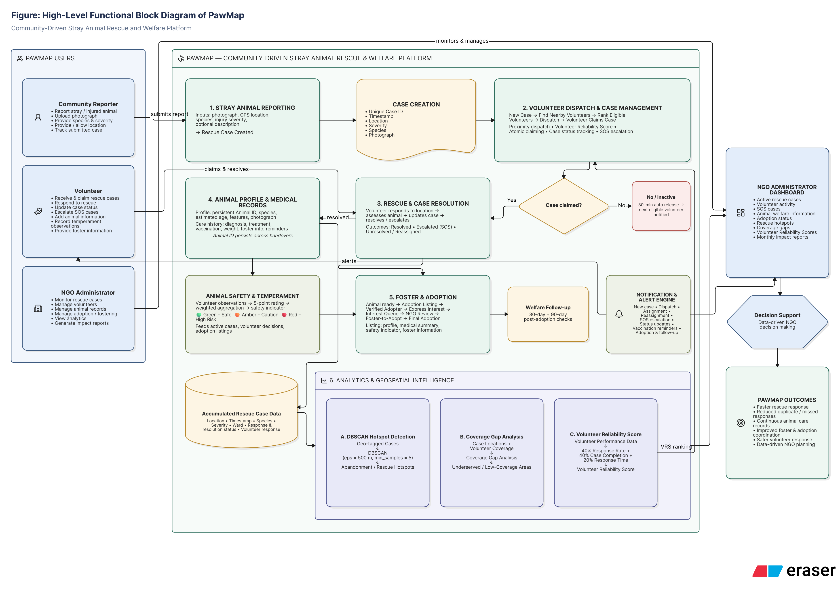
Figure 1: PawMap High-Level System Block Diagram

2.3 SYSTEM REQUIREMENTS

2.3.1 USER CHARACTERISTICS
PawMap serves five distinct user classes, each with different technical proficiency, usage frequency, primary device, and permission scope. The user characterisation table below consolidates information from SRS Section 2.3:
Table 2.3
Table 4: User Classes and Characteristics
User Class | Technical Level | Usage Frequency | Primary Interface | Permissions Summary
Community Reporter (Guest) | Low | One-time / occasional | Mobile app | Submit cases; view public adoption listings only
Registered Reporter | Low-Medium | Occasional | Mobile app | Track own submitted cases; receive resolution notifications
Volunteer | Medium | Regular, location-aware | Mobile app | Claim and update cases; submit temperament ratings; add foster notes
Veterinary Professional | Medium | Infrequent, high-trust | Web dashboard | Read all animal records; create and update medical entries for any animal
NGO Administrator | Medium-High | Frequent, power user | Web dashboard | All Volunteer permissions; manage accounts; publish adoption listings; access analytics

2.3.2 SOFTWARE AND HARDWARE REQUIREMENTS
The following table documents the primary software dependencies and hardware environment requirements for the PawMap platform as deployed for the MDS482-4 semester project:
Table 2.4
Table 5: Software and Hardware Requirements
Component | Version | Purpose | Status
Django + DRF | 5.2 / 3.17 | Backend API server and ORM | Deployed
React + Vite | 18.x / 5.x | NGO Admin and Vet web dashboard | Deployed
React Native (Expo) | SDK 50 / RN 0.73 | Cross-platform mobile (Reporter/Volunteer) | In Progress
PostgreSQL + PostGIS | 15 / 3.3 | Spatial relational database | Deployed
Redis | 7.2 | Celery message broker and session cache | Deployed
Celery | 5.6.x | Background tasks: dispatch, auto-release, analytics | Deployed
scikit-learn | 1.9.0 | DBSCAN clustering and VRS computation | Deployed
Leaflet.js | 1.9.x | Interactive geospatial map rendering | Deployed
Firebase Cloud Messaging | Current | Push notification delivery | Configured
AWS EC2 t3.small | Current | Backend API hosting instance | Provisioned
AWS RDS db.t3.micro | PostgreSQL 15 | Managed database service | Provisioned
AWS S3 | Current | Photo and PDF object storage | Provisioned
Docker | 24.x | Containerisation and deployment | Configured

The mobile application requires Android 10+ or iOS 14+ with minimum 2 GB RAM, a GPS-enabled device, and an active internet connection. The web application requires Chrome 110+, Firefox 110+, Safari 16+, or Edge 110+. The backend is deployed on Python 3.12+.

2.3.3 CONSTRAINTS
The following design and implementation constraints were identified in SRS Section 2.5 and observed during implementation:
- Network Degradation: The mobile application must function with degraded GPS accuracy in dense urban areas and must cache submitted reports locally if connectivity is lost, syncing automatically when connectivity is restored.
- Encryption: All PII (email, phone) must be encrypted at rest using AES-256 and in transit using TLS 1.3. Implemented via django-encrypted-model-fields and AWS RDS encryption.
- Data Protection: All personal data handling must comply with applicable Indian digital data protection standards.
- Technology Stack: The stack is constrained to Django, React, PostgreSQL/PostGIS, Celery/Redis, Leaflet.js, Firebase, and scikit-learn. No proprietary mapping SDK is required.
- Timeline: The 16-week project timeline constrains scope to the five core modules; IoT/NFC tag integration and AI-based injury severity detection are deferred.
- PostGIS Composite FK: Django ORM does not natively support composite foreign keys; the species+breed relationship to AnimalType is enforced at the model validation layer in clean().
- DBSCAN Minimum Density: DBSCAN requires a minimum of min_samples=5 cases in a 500m radius to form a valid cluster; wards with fewer than 5 sightings per run will show no hotspot polygon.

CHAPTER 3
SYSTEM DESIGN

3.1 SYSTEM ARCHITECTURE
PawMap follows a five-layer client-server architecture as defined in the System Design Report (SDR, July 2026). All inter-layer communication is over HTTPS (TLS 1.3) using RESTful JSON conventions. Real-time case status updates are delivered over WebSocket connections via Django Channels. External services interface exclusively with the backend layer.
Layer 1 — Users: Four actor types interact with the platform: Community Reporter, Volunteer, NGO Administrator, and Platform Administrator. Layer 2 — Frontend: The mobile application (React Native / Expo) serves Reporters and Volunteers. Primary screens include the Case Reporting Form with photo capture and GPS auto-fill, the Active Cases Map with real-time Leaflet pins, the Volunteer Dashboard with claim controls and auto-release countdown, and the Adoption Listing screen. The web application (React 18 + Bootstrap 5 + Vite) serves NGO Administrators and Veterinary Professionals, providing the NGO Admin Dashboard, Analytics View with DBSCAN heatmap and coverage gap layer, Report Generation, and Adopter Management Panel. Layer 3 — Backend API: The Django REST Framework API server handles JWT authentication, case lifecycle management, atomic volunteer claiming via PostgreSQL row-level locking, medical record access control, adoption queue management, and notification dispatch via FCM. Celery workers execute all asynchronous tasks: photo compression, reverse geocoding via Nominatim, the 30-minute auto-release countdown, weekly DBSCAN scheduling, daily VRS computation, and monthly PDF impact report generation. Layer 4 — Data: PostgreSQL 15 with PostGIS 3.3 stores all structured and spatial data. Key PostGIS functions used are ST_DWithin for volunteer proximity dispatch within 5 km, ST_ClusterDBSCAN for hotspot detection, and ST_MakePoint for indexing case coordinate columns. Redis 7.2 serves as the Celery task broker and Django session cache. AWS S3 stores compressed animal photographs and generated PDF reports. Layer 5 — Data Science: Scheduled Celery tasks invoke Python + scikit-learn processes. The weekly DBSCAN job clusters geo-tagged case coordinates and writes hotspot cluster records. The daily VRS job recomputes reliability scores for every active volunteer. The spatial join job updates coverage gap flags on the Ward table.
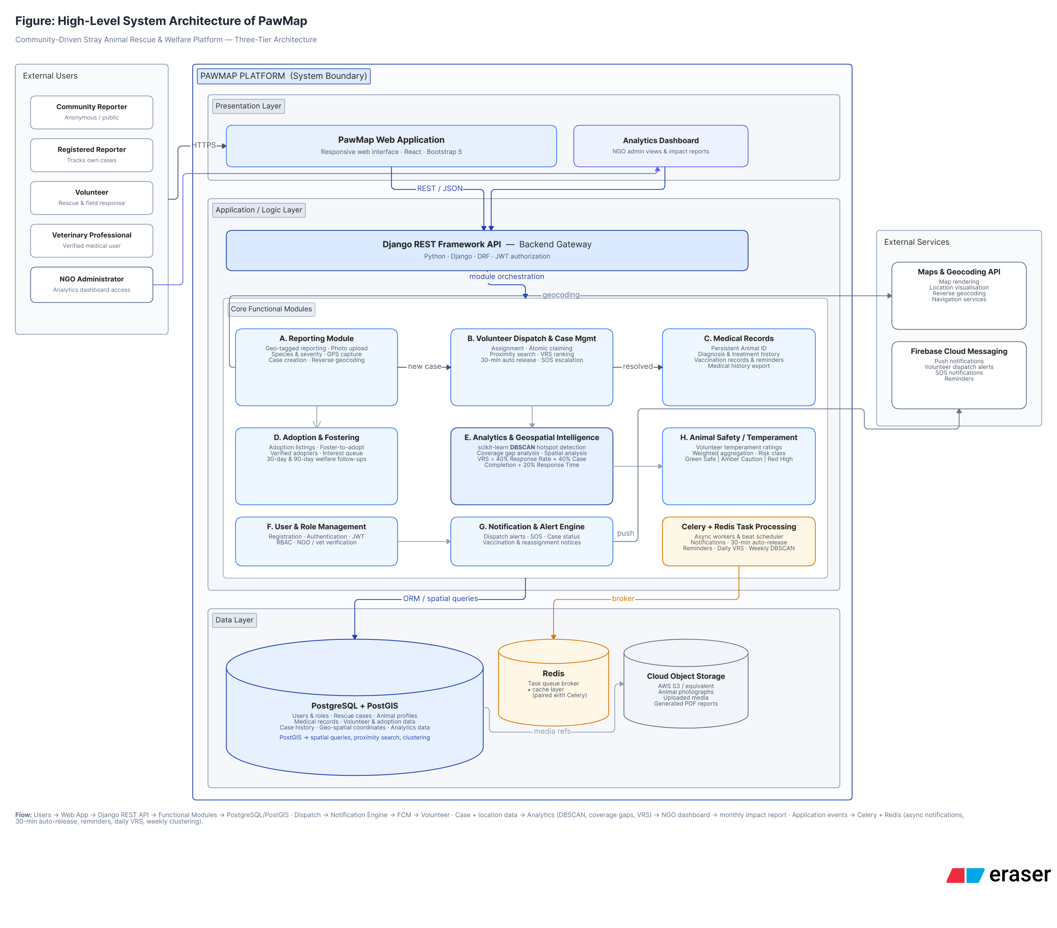
Figure 2: Five-Layer Client-Server System Architecture Diagram

3.2 MODULE DESIGN
The system design partitions the functional requirements across eight operational modules. Each module is responsible for a clearly bounded set of business operations and communicates with other modules only through the API layer or the shared database, maintaining loose coupling.
- Module 1 — Reporting: Ingests GPS-tagged sighting reports with compressed photo uploads via AWS S3, performs reverse geocoding to assign BBMP ward names using Nominatim, generates sequential CASE-xxxx IDs, and publishes volunteer dispatch jobs to the Celery queue. Also manages LostPetReport and FoundPetReport for owned pet tracking.
- Module 2 — Volunteer Dispatch: Queries Redis for volunteer GPS locations within 5 km of each case, ranks candidates by VRS score descending, dispatches FCM push alerts, manages atomic case claims via SELECT FOR UPDATE, starts the 30-minute Celery auto-release countdown, and handles SOS escalation broadcasts to all NGO admins.
- Module 3 — Medical Records: Generates persistent ANIM-xxxx Animal IDs on rescue case resolution, maintains append-only MedicalRecord entries with vet credentials and timestamps, gates write access to Vet and NGO_Admin roles, triggers vaccination reminder FCM alerts when next_due_date is within 7 days, and supports PDF export via ReportLab.
- Module 4 — Adoption & Rehoming: Publishes animal adoption listings with weighted temperament scores, gates Express Interest on completion of the home-readiness questionnaire, maintains ordered AdopterInterest queues per listing, processes NGO Admin approval to create AdoptionRecords, and schedules 30-day and 90-day welfare follow-up survey emails.
- Module 5 — User & Role Management: Manages user registration, JWT token issuance and refresh, RBAC permission enforcement across all five roles, and manual verification workflows for Vet and NGO_Admin accounts requiring Platform Admin approval.
- Module 6 — Notification Engine: Manages FCM device token registration, composes and delivers case alert payloads for dispatch, SOS broadcasts, vaccination reminders, and adoption queue notifications, and tracks CaseNotification response records per volunteer for VRS input.
- Module 7 — Analytics Module: Runs weekly DBSCAN hotspot detection on accumulated case coordinates, performs PostGIS spatial joins for coverage gap analysis, recomputes daily VRS snapshots for all active volunteers, and generates monthly PDF impact reports distributed by email on the first calendar day of each month.
- Module 8 — Animal Safety: Aggregates temperament ratings from multiple volunteers using the 1.5× recency weighting formula, updates materialised Animal.temperament_score on each new rating insert, and displays colour-coded safety indicators on all case cards and adoption listings.

3.3 DATABASE DESIGN

3.3.1 NORMALISATION SUMMARY
The database schema was derived through systematic normalisation of the pilot dataset fields and the functional requirements documented in the SRS. The following table summarises the normalisation decisions made prior to constructing the Entity Relationship Diagram (ERD):
Table 3.1
Table 6: Database Normalisation Summary and Design Decisions
Normal Form | Violation Found | Resolution Applied
1NF | Medical records stored as flat repeating columns (diagnosis_1, treatment_1…) per animal | Separated into standalone MedicalRecord table — append-only, one row per clinical entry per animal
1NF | Multiple adopters per animal cannot be represented as flat columns on AdoptionListing | Separated into AdopterInterest table with one row per adopter per listing; queue_position manages order
2NF | Reporter demographic attributes (age_group, prior_experience) depend only on reporter_id, not on case_id | Moved to User table; pilot survey fields retained only in the CSV export, not in production schema
2NF | Ward attributes (centroid coordinates, boundary polygon) depend only on ward_name, not on case_id | Created Ward reference table; ward_name stored on Case as a deliberate denormalisation for query speed
3NF | animal_name is functionally determined by species (e.g., Indian pariah dog maps only to Dog) | Created AnimalType lookup table with composite PK (species, breed); eliminates transitive dependency
3NF | vrs_score is transitively derived from response_rate, completion_rate, avg_response_time_min | All four columns retained in VolunteerReliabilityScore for formula auditability and historical snapshots
3NF | adoption_status is a property of the listing lifecycle, not an intrinsic property of the animal | Moved to AdoptionListing.status; Animal retains only the is_adopted boolean derived from AdoptionRecord
Deliberate Denorm. | ward_name on Case is derivable from coordinates via reverse geocoding | Stored at submission time (Nominatim reverse geocode) for query performance; documented as materialised field
Deliberate Denorm. | Animal.temperament_score derivable from TemperamentRating rows | Stored as materialised weighted average; recomputed on each new TemperamentRating insert via model save()

3.3.2 DATA DICTIONARIES
All 13 normalised database tables are defined below with full data dictionaries. Column names follow snake_case convention; entity names follow PascalCase. FK denotes Foreign Key; PK denotes Primary Key. ENUM values are drawn from the Django model choices definitions in the codebase.
Table 3.2
Table 7: Data Dictionary — User Table
Column Name | Data Type | Constraints | Description
user_id | VARCHAR(20) | PK | Sequential ID, format USR-0001; assigned on registration
full_name | VARCHAR(100) | NOT NULL | User's full name as entered at registration
email | VARCHAR(150) | UNIQUE, NOT NULL | Login credential and notification email address
phone | VARCHAR(15) | UNIQUE, Nullable | Contact number for NGO coordination; optional at registration
password_hash | VARCHAR(255) | NOT NULL | bcrypt-hashed password; plain text never stored or logged
role | ENUM | NOT NULL | Reporter / Volunteer / Vet / NGO_Admin / Platform_Admin
is_verified | BOOLEAN | DEFAULT FALSE | Set TRUE by Platform_Admin; required for Vet and NGO_Admin activation
is_active | BOOLEAN | DEFAULT TRUE | Soft-delete flag; deactivated accounts cannot log in
created_at | TIMESTAMP | NOT NULL | UTC timestamp of account creation
last_login | TIMESTAMP | Nullable | UTC timestamp of most recent successful authentication

Table 3.3
Table 8: Data Dictionary — Ward Table
Column Name | Data Type | Constraints | Description
ward_name | VARCHAR(100) | PK | BBMP ward administrative name; stable government reference value
city | VARCHAR(100) | NOT NULL | Default 'Bengaluru'; parameterised for future city expansion
centroid_lat | DECIMAL(9,6) | NOT NULL | Ward centroid latitude (WGS84 decimal degrees)
centroid_lon | DECIMAL(9,6) | NOT NULL | Ward centroid longitude (WGS84 decimal degrees)
boundary_geom | GEOMETRY(Polygon,4326) | Nullable | PostGIS polygon from BBMP GeoJSON; used in coverage gap ST_DWithin joins
coverage_gap_flag | BOOLEAN | DEFAULT FALSE | Set TRUE by Analytics worker when ward has unresolved cases with no volunteer response within 3 km in the past 7 days

Table 3.4
Table 9: Data Dictionary — AnimalType Table
Column Name | Data Type | Constraints | Description
species | VARCHAR(50) | PK (composite part 1) | Top-level classification: Dog, Cat, Cow, Goat, Horse, Pig, Bird, Other
breed | VARCHAR(100) | PK (composite part 2) | Specific breed or common name, e.g. Indian Pariah Dog, Tabby Cat. Eliminates transitive dependency identified in 3NF analysis.

Table 3.5
Table 10: Data Dictionary — Case Table
Column Name | Data Type | Constraints | Description
case_id | VARCHAR(20) | PK | Sequential CASE-xxxx format; assigned in save() override
timestamp_utc | TIMESTAMP | NOT NULL | UTC time of report submission (auto_now_add)
latitude | DECIMAL(10,6) | NOT NULL | GPS latitude of sighting (WGS84)
longitude | DECIMAL(10,6) | NOT NULL | GPS longitude of sighting (WGS84)
location_geom | GEOMETRY(Point,4326) | NOT NULL | PostGIS Point generated from lat/lon via trigger; GIST-indexed for ST_DWithin proximity queries
ward | FK -> Ward | SET_NULL | Reverse-geocoded ward assignment; denormalised for query performance
species | VARCHAR(50) | NOT NULL | Observed species: Dog, Cat, Cow, etc.
breed | VARCHAR(100) | DEFAULT 'Unknown' | Breed or type; validated via AnimalType lookup
estimated_age | ENUM | NOT NULL | Puppy / Kitten / Calf / Juvenile / Adult / Senior
severity | SMALLINT | CHECK(1-5), NOT NULL | Reporter-assigned injury severity; 1=healthy, 5=critical
aggression_level | SMALLINT | CHECK(1-5), NOT NULL | Observer-assessed aggression; 1=calm, 5=highly aggressive
injury_type | VARCHAR(200) | NOT NULL | Free-text description of observed injury or condition
bystander_action | ENUM | NOT NULL | none / fed / contacted_ngo
description | TEXT | Blank allowed | Optional extended description of the situation
photo_url | VARCHAR(500) | Blank allowed | S3/GCS path to compressed photograph (≤500 KB)
photo | ImageField | Nullable | Local file upload path (upload_to='case_photos/')
status | ENUM | NOT NULL, DEFAULT 'Open' | Open / In_Progress / On_Site / Resolved / Escalated / Unresolved
reporter_id | FK -> User | SET_NULL, Nullable | Sighting submitter; NULL for guest submissions
volunteer_id | FK -> User | SET_NULL, Nullable | Assigned responder; set on atomic claim
response_time_min | DECIMAL(6,1) | Nullable | Minutes between created_at and volunteer claim; VRS input
celery_task_id | VARCHAR(255) | Nullable | Active auto-release countdown Celery task ID; revoked on status update
created_at | TIMESTAMP | NOT NULL | Case creation timestamp (auto_now_add)
updated_at | TIMESTAMP | NOT NULL | Last modification timestamp (auto_now)

Table 3.6
Table 11: Data Dictionary — CaseStatusLog Table
Column Name | Data Type | Constraints | Description
log_id | VARCHAR(20) | PK | Sequential LOG-xxxx format; append-only (no UPDATE or DELETE permitted via API)
case | FK -> Case | CASCADE, NOT NULL | The case whose status changed; logs cascade-delete with case
actor | FK -> User | SET_NULL, Nullable | User who triggered the transition; NULL for system-generated transitions (auto-release)
old_status | VARCHAR(20) | NOT NULL | Status value before the transition
new_status | VARCHAR(20) | NOT NULL | Status value after the transition
changed_at | TIMESTAMP | NOT NULL | UTC time of status change (auto_now_add)
note | VARCHAR(500) | Blank allowed | Optional free-text note from volunteer or NGO Admin
is_auto_release | BOOLEAN | DEFAULT FALSE | TRUE when triggered by Celery auto-release task, not a human actor

Table 3.7
Table 12: Data Dictionary — VolunteerReliabilityScore Table
Column Name | Data Type | Constraints | Description
vrs_id | VARCHAR(20) | PK | Sequential VRS-xxxx format
volunteer | FK -> User | CASCADE, NOT NULL | Volunteer this daily score snapshot belongs to
score_date | DATE | NOT NULL, UNIQUE with volunteer | One row per volunteer per day; duplicate prevented by unique_together constraint
cases_notified | SMALLINT | NOT NULL | FCM dispatch notifications sent to this volunteer; denominator for response rate
cases_responded | SMALLINT | NOT NULL | Cases this volunteer claimed via CaseNotification.responded_at; numerator for response rate
cases_completed | SMALLINT | NOT NULL | Claimed cases marked Resolved; numerator for completion rate
avg_response_time_min | DECIMAL(6,1) | NOT NULL | Mean minutes between FCM notification and volunteer claim for all responded cases
response_rate | DECIMAL(4,3) | NOT NULL | cases_responded / cases_notified; stored for formula auditability
completion_rate | DECIMAL(4,3) | NOT NULL | cases_completed / cases_responded; stored for formula auditability
vrs_score | DECIMAL(4,3) | NOT NULL | 0.4×RR + 0.4×CR + 0.2×(1 − norm_RT); capped at 0 floor via min(norm_RT,1)
flag_for_review | BOOLEAN | DEFAULT FALSE | Set TRUE when VRS < 0.4 for 3 consecutive snapshots; triggers NGO Admin alert

Table 3.8
Table 13: Data Dictionary — Animal Table
Column Name | Data Type | Constraints | Description
animal_id | VARCHAR(20) | PK | Sequential ANIM-xxxx format; persists through all caregiver handovers
species | VARCHAR(50) | NOT NULL | Species derived from linked Case at rescue resolution
breed | VARCHAR(100) | NOT NULL | Breed or type; linked to AnimalType for validation
estimated_age | ENUM | NOT NULL | Puppy / Kitten / Calf / Juvenile / Adult / Senior
distinguishing_features | TEXT | Nullable | Free-text description of markings, size, colours, or other identifiers
photo_url | VARCHAR(500) | NOT NULL | S3/GCS path to the animal's profile photograph
temperament_score | DECIMAL(3,2) | Nullable | Materialised weighted average; recomputed on each TemperamentRating insert
is_adopted | BOOLEAN | DEFAULT FALSE | Set TRUE when the linked AdoptionRecord is marked completed
created_at | TIMESTAMP | NOT NULL | UTC profile creation timestamp (set when volunteer resolves the linked case)

Table 3.9
Table 14: Data Dictionary — TemperamentRating Table
Column Name | Data Type | Constraints | Description
rating_id | VARCHAR(20) | PK | Sequential RAT-xxxx format
animal | FK -> Animal | CASCADE, NOT NULL | The animal being rated
volunteer | FK -> User | NOT NULL | Volunteer submitting the rating; only Volunteer-role users may write
score | SMALLINT | CHECK(1-5), NOT NULL | 1=calm and friendly, 5=highly aggressive; aggregated into temperament_score
rated_at | TIMESTAMP | NOT NULL | UTC time of rating submission; used to apply 1.5× recency weight for ratings > 30 days old

Table 3.10
Table 15: Data Dictionary — MedicalRecord Table
Column Name | Data Type | Constraints | Description
record_id | VARCHAR(20) | PK | Sequential MED-xxxx format; append-only (no UPDATE or DELETE via API)
animal | FK -> Animal | CASCADE, NOT NULL | The animal this record belongs to
vet | FK -> User | NOT NULL | Veterinary professional or NGO Admin who created the entry
entry_type | ENUM | NOT NULL | diagnosis / vaccination / treatment / weight
details | TEXT | NOT NULL | Free-text clinical details: diagnosis, vaccine batch, treatment protocol, or weight in kg
entry_at | TIMESTAMP | NOT NULL | UTC time of record creation (auto_now_add)
next_due_date | DATE | Nullable | Next vaccination or follow-up due date; within 7 days triggers FCM vaccination reminder

Table 3.11
Table 16: Data Dictionary — AdoptionListing Table
Column Name | Data Type | Constraints | Description
listing_id | VARCHAR(20) | PK | Sequential LST-xxxx format
animal | FK -> Animal | OneToOne, PROTECT | One active listing per animal; PROTECT prevents animal deletion while listing exists
published_by | FK -> User | NOT NULL | NGO Admin who published the listing; only NGO_Admin role may publish via API permission check
published_at | TIMESTAMP | NOT NULL | UTC timestamp of listing publication (auto_now_add)
status | ENUM | NOT NULL, DEFAULT 'Active' | Active / Pending / Completed / Withdrawn

Table 3.12
Table 17: Data Dictionary — AdopterInterest Table
Column Name | Data Type | Constraints | Description
interest_id | VARCHAR(20) | PK | Sequential INT-xxxx format
listing | FK -> AdoptionListing | CASCADE, NOT NULL | The listing this interest belongs to; cascades with listing deletion
adopter | FK -> User | NOT NULL | Authenticated user expressing interest; UNIQUE together with listing_id prevents duplicate interest
queue_position | INTEGER | NOT NULL | Ordered position in adopter queue; NGO Admin may reorder or remove
home_readiness_complete | BOOLEAN | DEFAULT FALSE | TRUE when adopter has completed home-readiness questionnaire; gates Express Interest button
expressed_at | TIMESTAMP | NOT NULL | UTC timestamp of interest submission (auto_now_add)

Table 3.13
Table 18: Data Dictionary — AdoptionRecord Table
Column Name | Data Type | Constraints | Description
adoption_id | VARCHAR(20) | PK | Sequential ADO-xxxx format
listing | FK -> AdoptionListing | OneToOne, PROTECT | One completed adoption record per listing maximum
adopter | FK -> User | NOT NULL | The approved adopter selected by NGO Admin from the interest queue
approved_at | TIMESTAMP | NOT NULL | UTC timestamp of NGO Admin approval (auto_now_add)
completed_at | TIMESTAMP | Nullable | UTC timestamp of adoption completion; NULL while in Adoption_Pending state
survey_30d_sent | BOOLEAN | DEFAULT FALSE | Set TRUE when 30-day welfare follow-up survey email is dispatched by Celery task
survey_90d_sent | BOOLEAN | DEFAULT FALSE | Set TRUE when 90-day welfare follow-up survey email is dispatched by Celery task

Table 3.14
Table 19: Data Dictionary — HotspotCluster Table
Column Name | Data Type | Constraints | Description
cluster_id | VARCHAR(20) | PK | Sequential CLU-xxxx format; one row per cluster per DBSCAN run
run | FK -> HotspotRun | NOT NULL | The analytics run that produced this cluster
run_date | DATE | NOT NULL | Date of the DBSCAN analytics job execution
cluster_label | INTEGER | NOT NULL | DBSCAN output label (0,1,2…); -1 noise points are never stored
centroid_lat | DECIMAL(9,6) | NOT NULL | Mean latitude of all cases in this cluster (WGS84)
centroid_lon | DECIMAL(9,6) | NOT NULL | Mean longitude of all cases in this cluster (WGS84)
case_count | SMALLINT | NOT NULL | Number of case records contributing to this cluster
dominant_species | VARCHAR(50) | NOT NULL | Most frequent species among cases in the cluster; used for hotspot disaggregation on analytics map

3.3.3 ENTITY RELATIONSHIP DIAGRAM
The ERD (Fig 3.2) covers all 13 entities. They are organised into two logical groups: the Case-and-Platform group (User, Ward, AnimalType, Case, CaseStatusLog, CaseNotification, VolunteerReliabilityScore) and the Animal-and-Adoption group (Animal, TemperamentRating, MedicalRecord, AdoptionListing, AdopterInterest, AdoptionRecord, HotspotCluster). The cross-boundary relationship is Case.animal → Animal.animal_id, set post-resolution when the volunteer creates the animal profile. All cardinalities and cascade behaviours are shown using standard ERD notation.
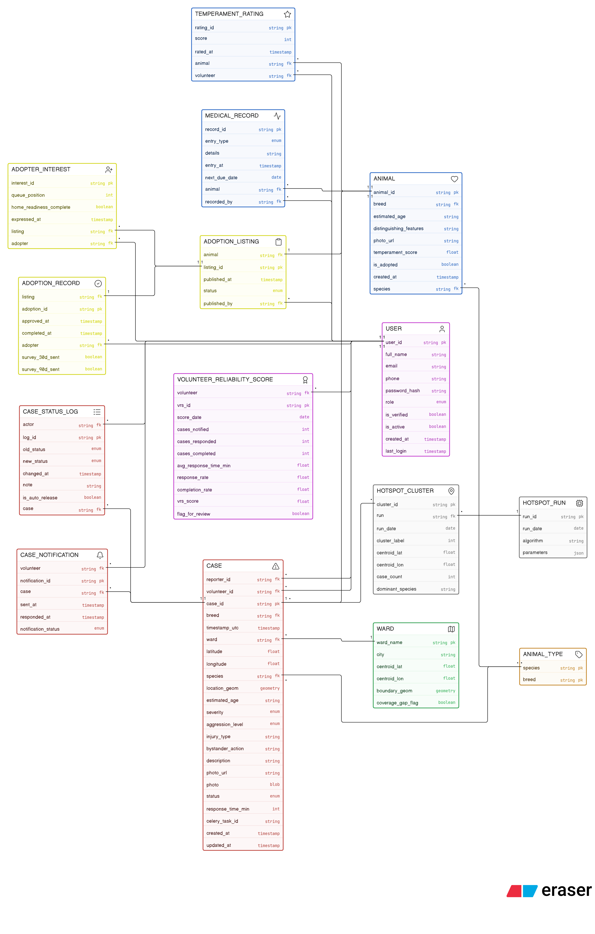
Figure 3: Entity Relationship Diagram — All 13 Entities

3.3.4 DATA FLOW DIAGRAM
The Data Flow Diagram (DFD) describes how sighting data flows through the system from the moment a reporter submits a case to the point that DBSCAN analytics are generated. DFD Level 0 (Context Diagram, Fig 3.3) shows the system as a single process bounded by its external actors: Community Reporter, Volunteer, NGO Admin, Veterinary Professional, and Firebase FCM. DFD Level 1 (Fig 3.4) expands the system boundary to reveal the five major processes: Case Ingestion, Volunteer Dispatch, Medical Record Management, Adoption Pipeline, and Analytics Engine.
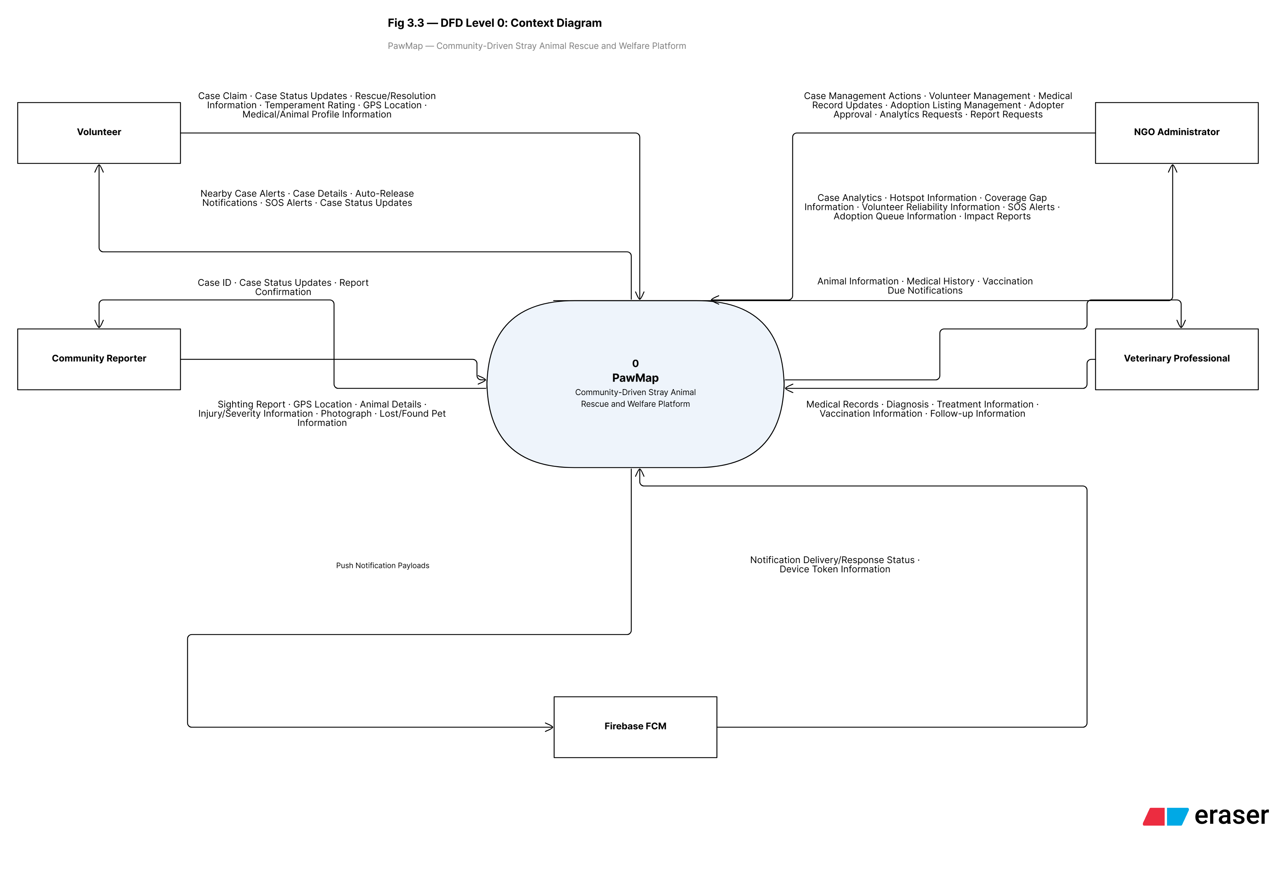
Figure 4: DFD Level 0 — Context Diagram

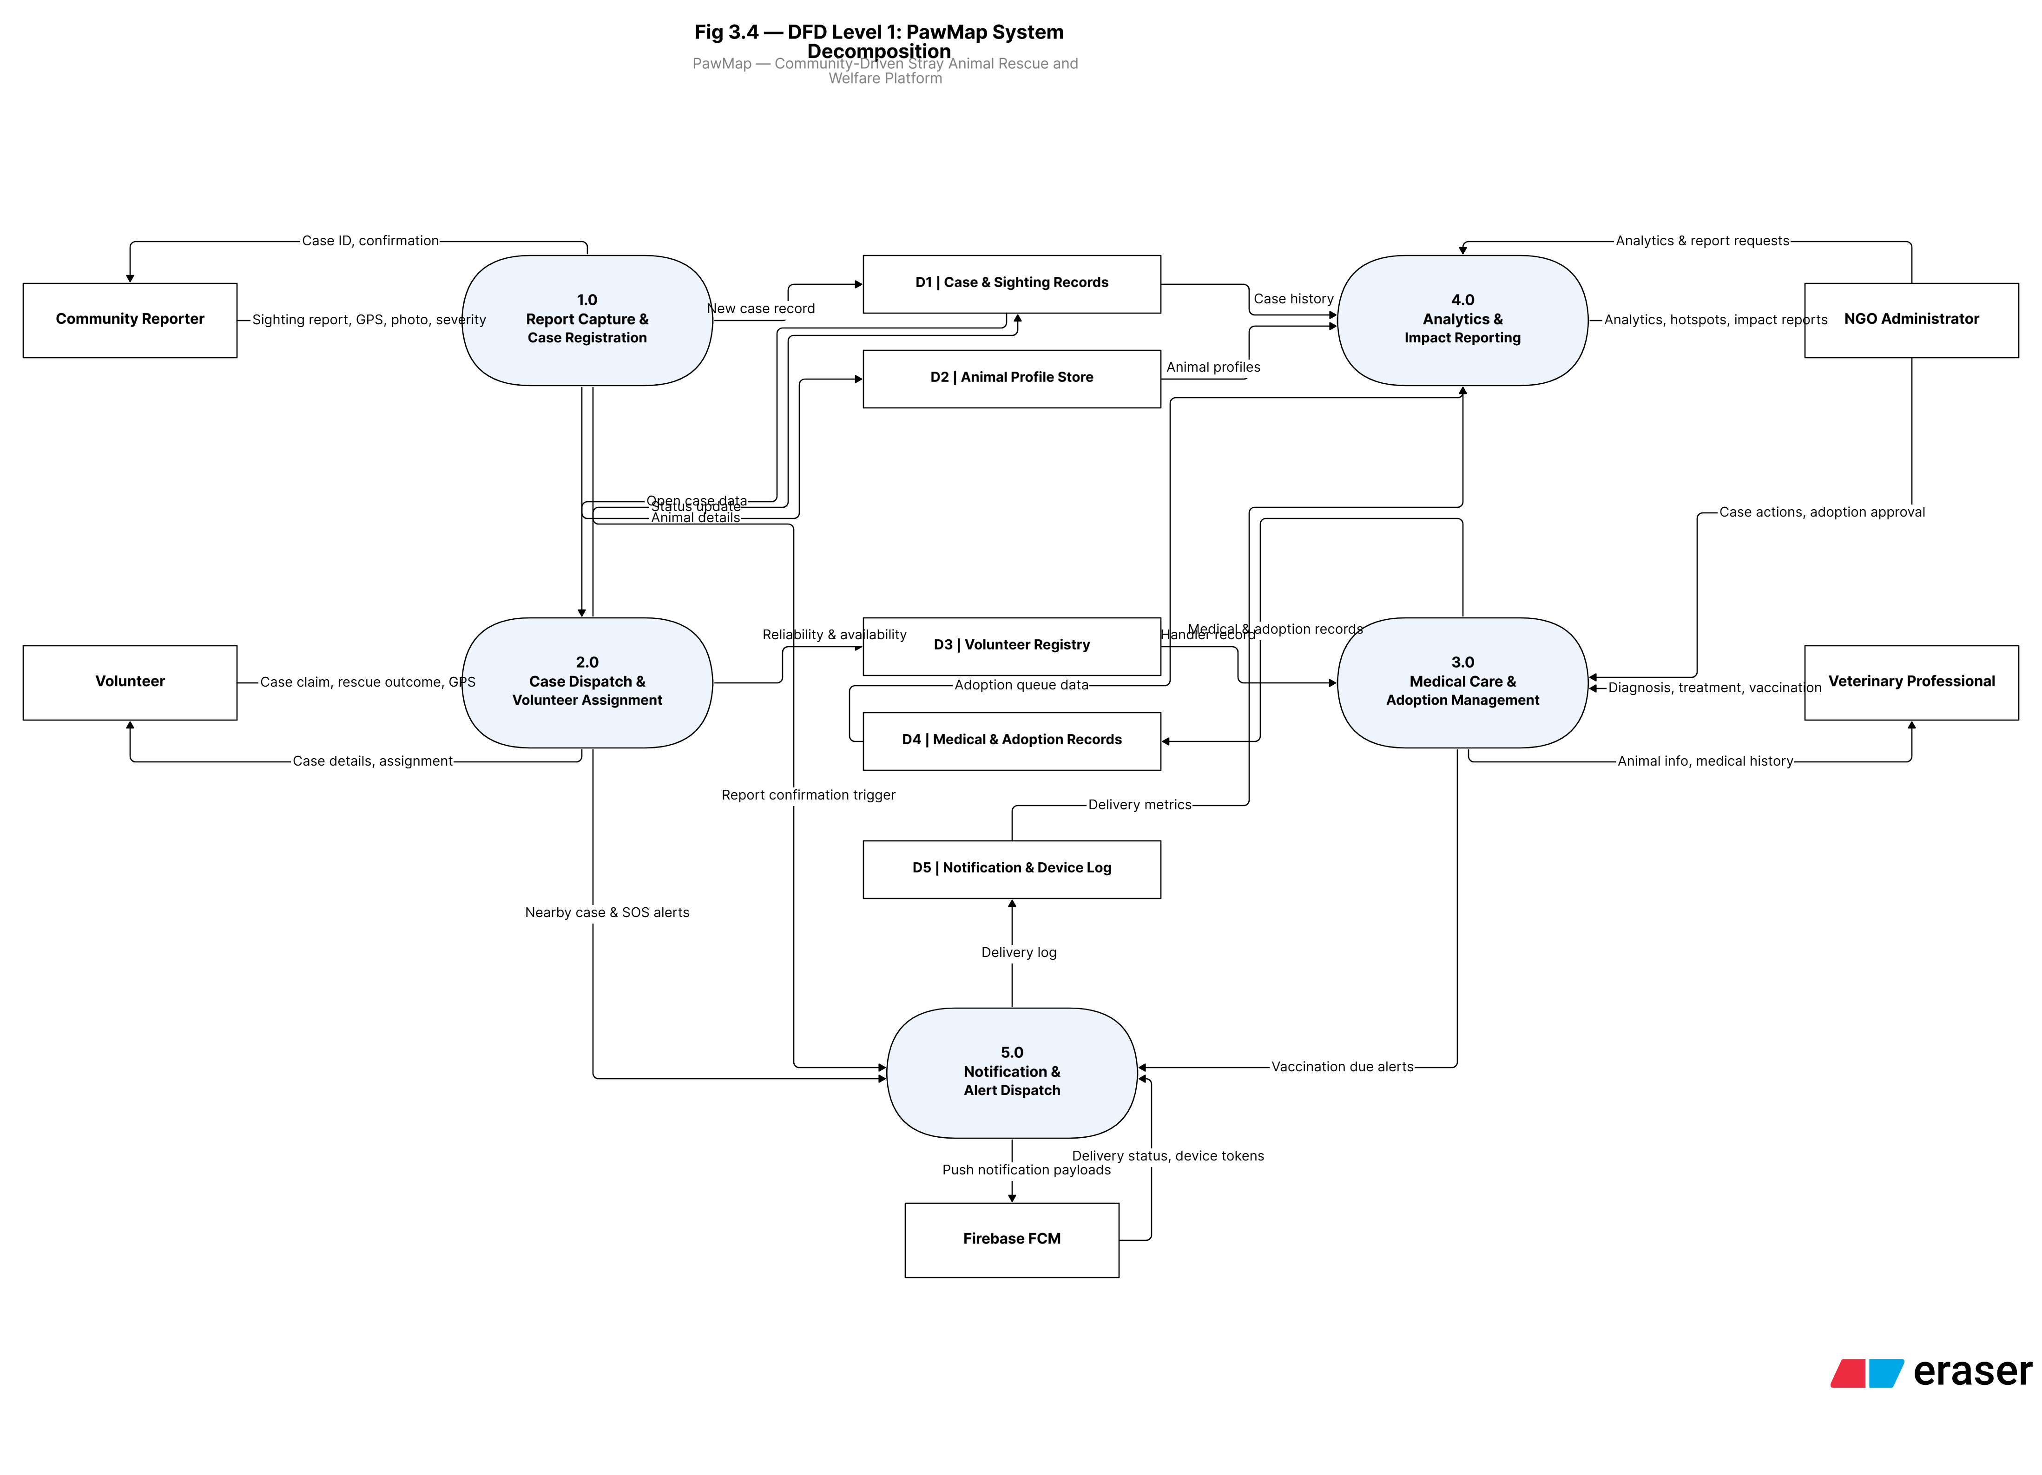
Figure 5: DFD Level 1 — Expanded Process Diagram

3.4 ALGORITHMS AND DATA STRUCTURES
The following subsections document the four primary algorithms implemented in PawMap, including their mathematical specifications, parameter justifications, and implementation details.

3.4.1 DBSCAN HOTSPOT DETECTION
DBSCAN (Density-Based Spatial Clustering of Applications with Noise) identifies statistically significant stray animal abandonment hotspots from accumulated geo-tagged case reports. It is selected over centroid-based methods (k-means) for three reasons: (1) it does not require specifying the number of clusters in advance; (2) it handles clusters of arbitrary geographic shape — critical for Bengaluru's irregular ward boundaries; and (3) it explicitly labels low-density points as noise (-1), preventing false hotspot identification in areas of high reporter density without genuine abandonment clustering.
Table 3.15
Table 20: DBSCAN Algorithm Parameters and Justification
Parameter | Value | Justification
eps (neighbourhood radius) | 500 m | Corresponds to approximately one Bengaluru urban ward block. Cases within 500 m are spatially proximate for NGO intervention planning.
min_samples | 5 | Minimum 5 cases required to form a core point. Prevents single-incident locations from being classified as hotspots.
metric | haversine | Accounts for Earth's curvature. Required for geographic coordinate inputs (lat/lon converted to radians before input to scikit-learn).
algorithm | ball_tree | O(n log n) time complexity with Ball Tree spatial index; handles 10,000 case records within 60 seconds on the Celery worker.
Input structure | numpy array (n,2) | Each row is [latitude_radians, longitude_radians] for a resolved case. eps converted from 500m to radians: eps_rad = 500/6371000.
Output | cluster labels array | Integer label per case: -1=noise (not stored); 0,1,2...=cluster ID. Stored in HotspotCluster with centroid and case_count.

The mathematical conversion of eps from metres to radians follows:
eps_rad = eps_m / 6371000.0 # Earth radius = 6,371,000 metres
coords_rad = np.radians(coords) # Convert (lat, lon) array to radians

3.4.2 VOLUNTEER RELIABILITY SCORE (VRS)
The VRS is a weighted composite metric computed daily per volunteer by the Celery scheduler. It ranks volunteers in the dispatch queue and gates SOS-tier case eligibility (VRS ≥ 0.6 required per REQ-23). The formula is:
VRS = 0.4 × Response_Rate + 0.4 × Completion_Rate + 0.2 × (1 - Normalised_Response_Time)
Where:
Response_Rate = cases_responded / cases_notified
Completion_Rate = cases_completed / cases_responded
Normalised_RT = min(avg_response_time_min / 30.0, 1.0) # capped at 1
The 30-minute normalisation baseline corresponds to the auto-release threshold (REQ-07). Capping norm_RT at 1.0 ensures the VRS never goes below 0.0. A volunteer with VRS < 0.4 for three consecutive daily snapshots triggers flag_for_review = TRUE and an NGO Admin alert per SRS Business Rule 5.5.
Table 3.16
Table 21: VRS Formula Component Weights and Data Sources
Component | Weight | Formula | Data Source
Response Rate | 40% | cases_responded / cases_notified | CaseNotification table: notifications sent vs. responded_at set
Completion Rate | 40% | cases_completed / cases_responded | Case.status = Resolved for cases claimed by this volunteer
Avg Response Time | 20% | 1 − min(avg_response_time_min / 30, 1) | Case.response_time_min; baseline = 30 min (auto-release threshold)
VRS Score | — | 0.4×RR + 0.4×CR + 0.2×(1−norm_RT) | Stored daily in VolunteerReliabilityScore with all component values

3.4.3 ATOMIC CASE-CLAIMING
To prevent two volunteers simultaneously claiming the same case (a race condition inherent in distributed systems), PawMap uses PostgreSQL row-level locking via SELECT FOR UPDATE inside a serialisable transaction at the Django ORM layer:
with transaction.atomic():
case = Case.objects.select_for_update().get(case_id=case_id)
if case.status != 'Open':
return Response({'error': f'Case is already {case.status}.'},
status=HTTP_409_CONFLICT)
case.volunteer = request.user
case.status = 'In_Progress'
case.response_time_min = round((now - case.created_at).seconds / 60, 1)
case.save()
If a second claim arrives while the first transaction holds the PostgreSQL row lock, the database blocks the second transaction until the first commits. The second transaction then reads status = 'In_Progress' and returns HTTP 409 Conflict. This guarantees exactly-one assignment without any application-layer race conditions or optimistic locking overhead.

3.4.4 CELERY AUTO-RELEASE COUNTDOWN
When a volunteer claims a case, a Celery countdown task is created with a 30-minute delay. The task ID is stored on Case.celery_task_id. If the volunteer updates the case status before 30 minutes elapse, the countdown task is revoked via celery.app.control.revoke(). If the timer fires, the Celery worker atomically resets Case.status to Open, clears Case.volunteer_id, writes a CaseStatusLog entry with is_auto_release=TRUE, and re-triggers the volunteer dispatch flow. The underlying data structure is a Redis-backed Celery beat scheduler with task metadata stored as a Redis hash keyed by task ID.

3.4.5 TEMPERAMENT SCORE AGGREGATION
The five-point temperament score is computed as a weighted average of all TemperamentRating entries for a given animal. Ratings submitted more than 30 days ago receive weight 1.0; ratings within the last 30 days receive weight 1.5, reflecting the more current behavioural assessment. This materialised score is recomputed and stored on Animal.temperament_score each time a new TemperamentRating is inserted, avoiding expensive aggregation queries on the adoption listing page.
def update_temperament_score(self):
from django.utils import timezone; from datetime import timedelta
cutoff = timezone.now() - timedelta(days=30)
ratings = TemperamentRating.objects.filter(animal=self)
total_weight, weighted_sum = 0, 0
for r in ratings:
w = 1.5 if r.rated_at >= cutoff else 1.0
weighted_sum += r.score * w; total_weight += w
self.temperament_score = round(weighted_sum/total_weight, 2) if total_weight else None
self.save(update_fields=['temperament_score'])

3.5 SYSTEM CONFIGURATION
System configuration is managed through Django settings and environment variables. Key configuration decisions derived from the SDR Section 8 include: (1) CORS — django-cors-headers allows requests from the React frontend domain; (2) Authentication — djangorestframework-simplejwt with 60-minute access tokens and 7-day refresh tokens (NFR-10); (3) Database — PostgreSQL with PostGIS via psycopg2-binary; GIST spatial indexes on Case.location_geom for ST_DWithin queries; (4) Storage — django-storages with boto3 for AWS S3 photo and PDF uploads; (5) Task Queue — Celery with Redis as broker; CELERY_BEAT_SCHEDULE defines the daily VRS job, weekly DBSCAN job, and monthly report generation job; (6) Security — SECURE_SSL_REDIRECT=True, HSTS headers enforced via nginx TLS termination; django-encrypted-model-fields for PII columns.

3.6 INTERFACE DESIGN

3.6.1 USER INTERFACE SCREEN DESIGN
The following table summarises all primary UI screens, their platforms, inputs, outputs, and linked requirements. Design constraints for all interfaces include: responsive layouts supporting 375px (mobile) to 1920px (desktop); WCAG 2.1 Level AA contrast; aggression level prominently displayed at the top of all volunteer case cards with colour coding.
Table 3.17
Table 22: Primary UI Screens — Inputs, Outputs and Requirements
Screen Name | Platform | Primary Inputs | Primary Outputs | SRS Ref
Case Reporting Form | Mobile | Photo capture, GPS auto-fill or pin-drop, species, breed, severity (1-5), aggression (1-5), bystander_action, description | CASE-xxxx confirmation, map pin placed at sighting location | REQ-01 to 05
Active Cases Map | Mobile | Species filter, status filter, tap case pin | Real-time colour-coded severity pins on Leaflet map; case detail card on tap | REQ-09
Volunteer Dashboard | Mobile | Claim button, status update (En Route/On Site/Resolved/Escalated), free-text note | Assigned case details, turn-by-turn link to Google Maps, 30-min auto-release countdown timer | REQ-06 to 10
Medical Record Entry | Mobile/Web | Animal profile (species, age, features, photo), entry_type, details, next_due_date | ANIM-xxxx confirmation, appended medical timeline for animal | REQ-11 to 15
Adoption Listing | Mobile | Express Interest button (gated on home-readiness) | Animal card with temperament score colour indicator, medical summary, queue position | REQ-16 to 19
NGO Admin Dashboard | Web | Date range filter, ward filter, volunteer filter | Case volume KPIs, response time charts, VRS leaderboard, SOS alert feed | REQ-20 to 24
Analytics View | Web | Month selector, species filter, ward click | DBSCAN hotspot heatmap (PostGIS polygons on Leaflet), coverage gap ward layer, trend charts | REQ-20, 21
Adopter Management Panel | Web | Approve/reorder/remove adopter from queue | Ordered adopter interest queue per animal, home-readiness questionnaire status | REQ-17, 18
Lost & Found Panel | Mobile/Web | Pet details, photo, last-seen location, distinguishing features | LOST-xxxx / FOUND-xxxx confirmation, searchable board for pet owners | Additional feature

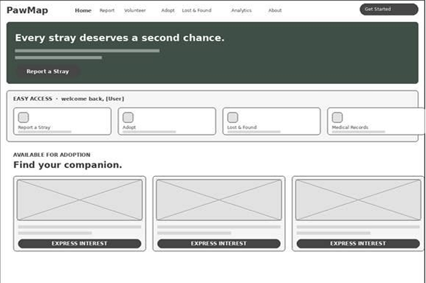

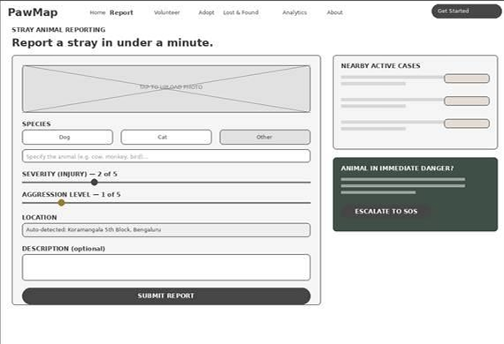
Figure 6: Case Reporting Form and Active Cases Map Wireframes

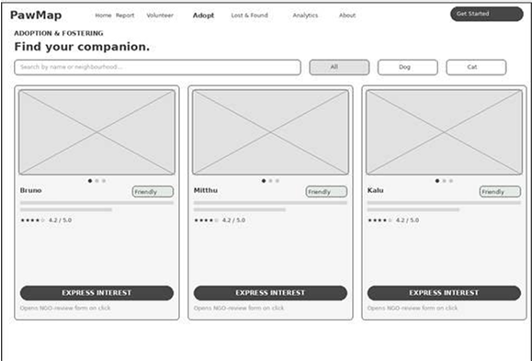
Figure 7: Adoption listing wireframe (image gallery)

3.6.2 APPLICATION FLOW / CLASS DIAGRAM
The following table summarises the Django ORM model classes, their key attributes, and their primary business methods as defined in the SDR Section 6. Each class maps directly to a PostgreSQL table via Django ORM.
Table 3.18
Table 23: Django Model Classes — Attributes and Methods
Class | Key Attributes | Key Business Methods
User | user_id, email, role, is_verified, is_active, created_at | is_volunteer(), is_ngo_admin(), has_sos_eligibility() [checks VRS≥0.6], deactivate()
Ward | ward_name (PK), centroid_lat, centroid_lon, boundary_geom, coverage_gap_flag | get_active_cases(), flag_coverage_gap(), clear_coverage_gap()
AnimalType | species (PK part 1), breed (PK part 2) | get_breeds_for_species(species)
Case | case_id, latitude, longitude, status, severity, aggression_level, reporter, volunteer, response_time_min, celery_task_id | claim(volunteer), release(), escalate(), resolve(animal), get_eligible_volunteers() [ST_DWithin 5km, VRS DESC]
CaseStatusLog | log_id, case, actor, old_status, new_status, changed_at, is_auto_release | log_transition() [classmethod; append-only]
CaseNotification | case, volunteer, notified_at, responded_at | — (managed by dispatch service)
VolunteerReliabilityScore | vrs_id, volunteer, score_date, response_rate, completion_rate, vrs_score, flag_for_review | compute_for_volunteer() [classmethod; Celery daily], get_latest(), check_consecutive_low()
Animal | animal_id, species, breed, temperament_score, is_adopted, created_at | update_temperament_score(), get_medical_timeline(), publish_for_adoption(), mark_adopted()
TemperamentRating | rating_id, animal, volunteer, score, rated_at | — (aggregated by Animal.update_temperament_score())
MedicalRecord | record_id, animal, vet, entry_type, details, entry_at, next_due_date | schedule_reminder() [Celery vaccination alert], to_pdf_dict()
AdoptionListing | listing_id, animal, published_by, published_at, status | add_to_queue(), approve_adopter(), withdraw()
AdopterInterest | interest_id, listing, adopter, queue_position, home_readiness_complete | — (queue ordering managed by AdoptionListing)
AdoptionRecord | adoption_id, listing, adopter, approved_at, completed_at, survey flags | complete_adoption(), send_welfare_survey(days)
HotspotCluster | cluster_id, run, centroid_lat, centroid_lon, case_count, dominant_species | get_latest_clusters() [classmethod], to_geojson()

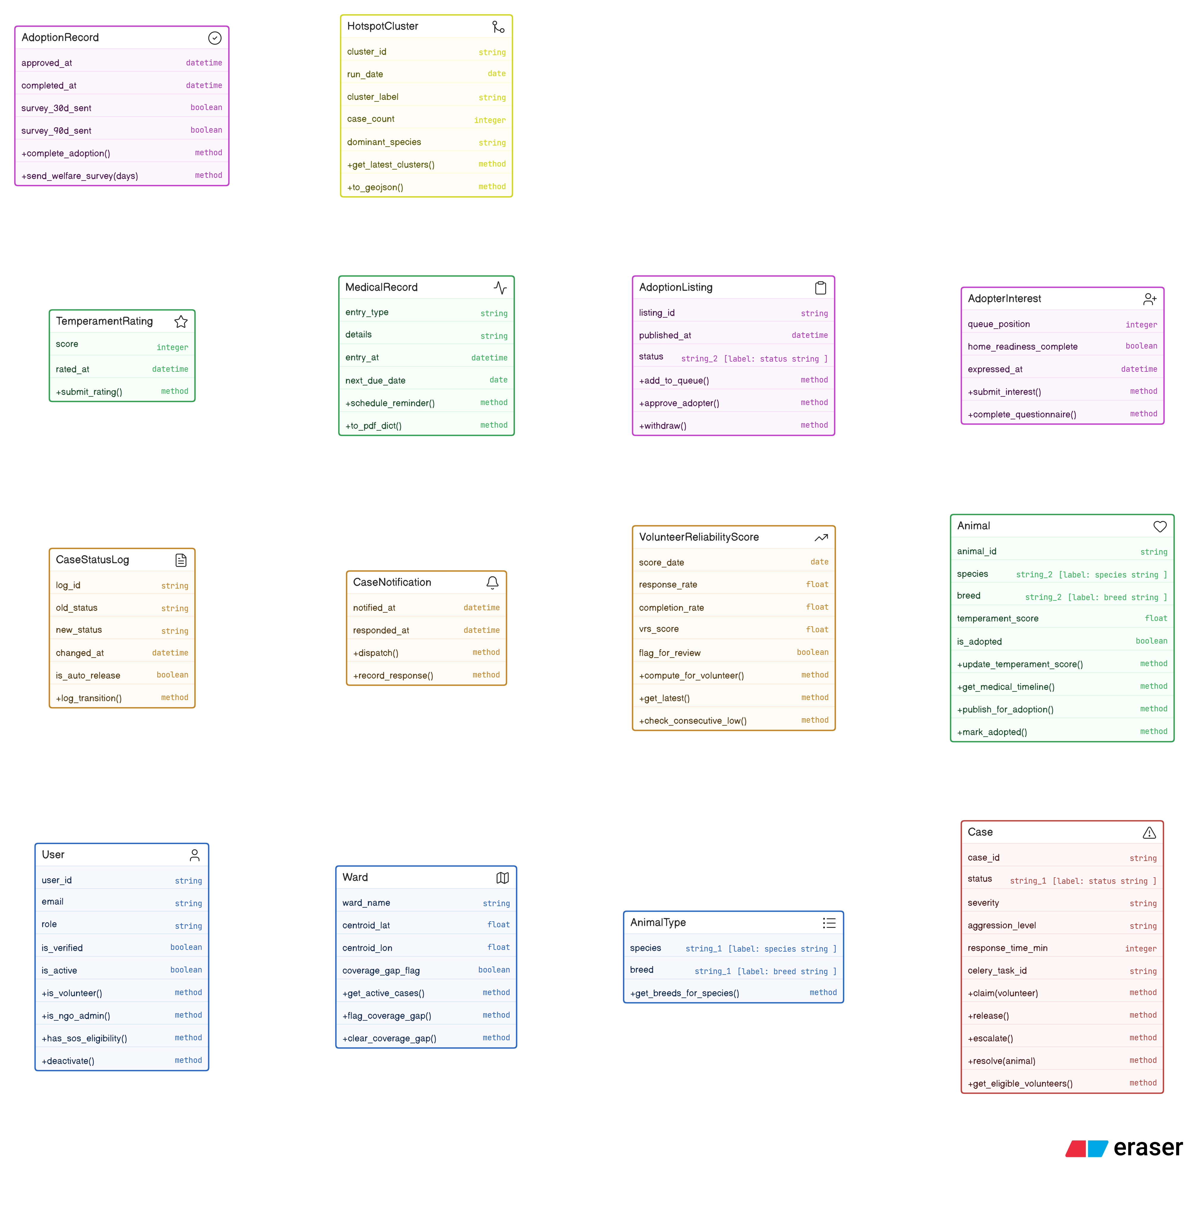
Figure 8: Django Model Class Dependency Diagram

3.7 API DESIGN
The PawMap REST API is implemented using Django REST Framework and documented via OpenAPI 3.0 (auto-generated by DRF Spectacular). All endpoints use JSON request/response bodies. Authentication uses JWT: 60-minute access tokens and 7-day refresh tokens (NFR-10). Base URL: /api/. The following table catalogues all primary endpoints:
Table 3.19
Table 24: Primary REST API Endpoints
Method | Endpoint | Auth | Description
POST | /api/auth/register/ | None | Create new User account; role defaults to Reporter
POST | /api/auth/login/ | None | Returns JWT access + refresh token pair
POST | /api/auth/refresh/ | None | Refreshes access token using valid refresh token
GET | /api/cases/ | Reporter+ | List all cases; filterable by species, severity, ward, status
POST | /api/cases/ | Reporter+ | Submit new rescue case; triggers Celery dispatch job
GET | /api/cases/{id}/ | Reporter+ | Retrieve single case with full CaseStatusLog history
PATCH | /api/cases/{id}/claim/ | Volunteer | Atomic case claim via SELECT FOR UPDATE; returns 409 if already claimed
PATCH | /api/cases/{id}/status/ | Volunteer | Update case status; cancels auto-release task on Resolved/Escalated
PATCH | /api/cases/{id}/escalate/ | Volunteer | Escalate to SOS; broadcasts FCM to all NGO Admins
GET | /api/animals/ | Volunteer+ | List animal profiles; filterable by species, adoption_status
POST | /api/animals/ | Volunteer | Create animal profile post-resolution; links to case via case_id
GET | /api/animals/{id}/ | AllowAny | Retrieve single animal profile with medical summary
PATCH | /api/animals/{id}/ | NGO_Admin | Update animal profile information
POST | /api/animals/{id}/medical/ | Vet | Append medical record (diagnosis, vaccination, treatment, weight)
POST | /api/animals/{id}/rate/ | Volunteer | Submit temperament rating (1–5); triggers temperament_score recomputation
GET | /api/adoptions/ | AllowAny | List all active adoption listings; filterable by species
POST | /api/adoptions/ | NGO_Admin | Create new adoption listing for a verified animal profile
POST | /api/adoptions/{id}/interest/ | Authenticated | Express interest; validates home_readiness_complete before queue entry
POST | /api/adoptions/{id}/approve/ | NGO_Admin | Approve adopter; creates AdoptionRecord; sets animal to Adoption_Pending
GET | /api/analytics/hotspots/ | NGO_Admin | Return latest HotspotCluster rows as GeoJSON polygons
GET | /api/analytics/gaps/ | NGO_Admin | Return wards with coverage_gap_flag=TRUE
GET | /api/analytics/vrs/ | NGO_Admin | Return VRS leaderboard for all active volunteers
POST | /api/reports/generate/ | NGO_Admin | Manually trigger monthly PDF impact report generation

3.8 SECURITY DESIGN
Security design decisions are derived from SRS Section 5.3 and implemented at the architecture level:
Table 3.20
Table 25: Security Design Decisions and Implementation Details
Security Requirement | Design Decision | Implementation
TLS 1.3 in transit (NFR-09) | All client-API and API-external communication over HTTPS port 443 only | Django SECURE_SSL_REDIRECT=True; nginx TLS termination; HSTS header enforced
AES-256 at rest (NFR-09) | Database encryption at the AWS storage layer | AWS RDS encryption enabled (AES-256); S3 bucket server-side encryption (SSE-S3)
JWT authentication (NFR-10) | 60-min access token; 7-day refresh token; mandatory re-auth after 7 days | djangorestframework-simplejwt; refresh token rotation; token blacklist on logout
Role-based access (NFR-11) | Vet and NGO_Admin require manual verification before activation | Django permission classes per endpoint; is_verified checked on login
Photo watermarking (NFR-12) | Platform logo watermark applied before S3 upload | Pillow watermarking applied in the Celery photo compression task
Audit log (NFR-13) | All admin actions logged; CaseStatusLog append-only | Django signals write to CaseStatusLog; INSERT-only table trigger; retained 12 months
PII encryption (Constraint 2.5) | Email and phone fields encrypted at application layer | django-encrypted-model-fields; encryption key stored in AWS Secrets Manager
Volunteer GPS privacy (NFR-08) | Volunteer live location not exposed to Reporters or unverified users | GPS stored in Redis (session-only, not persisted to DB); API endpoint restricted to NGO_Admin and self

3.9 DEPLOYMENT ARCHITECTURE
The deployment architecture targets AWS for the development and staging environment (estimated cost $30–50/month per SRS Section 6.3). The production configuration:
Table 3.21
Table 26: Deployment Architecture — Components and Configuration
Component | Service | Configuration
Backend API server | AWS EC2 t3.small | Docker container running Django 5.2 + Gunicorn (4 workers); nginx reverse proxy; auto-start via systemd
Celery workers | AWS EC2 t3.small (same) | 2 Celery worker processes sharing EC2 instance in development; separate instance in production
Database | AWS RDS db.t3.micro | PostgreSQL 15 + PostGIS 3.3; automated daily backups; Multi-AZ disabled in development
Redis | AWS ElastiCache t3.micro | Celery broker and Django cache backend; single-node in development
Object storage | AWS S3 | pawmap-media (photos); pawmap-reports (PDFs); versioning enabled; 12-month lifecycle rule for old reports
Mobile app | Expo / React Native | OTA updates via Expo; iOS via TestFlight, Android via internal track for pilot
Web app | AWS S3 + CloudFront | React 18 + Vite build deployed to S3 static site; CloudFront CDN for distribution
Containerisation | Docker + docker-compose | Single docker-compose.yml for development; Dockerfile per service for production

3.10 REPORTS DESIGN
The Reports Engine handles automated monthly impact summaries for NGO administrators. A Celery beat task triggers on the first day of each calendar month. The task pulls: total case count by ward and species; mean response time per ward; rescue-to-resolution rate; adoption count; and the top-5 DBSCAN hotspot centroids. The server compiles these variables into a formatted PDF using ReportLab with the PawMap brand colours, uploads the asset to AWS S3 in the pawmap-reports bucket, and sends the download link to all registered NGO administrators via email. NGO admins may also trigger manual report generation at any time via the POST /api/reports/generate/ endpoint.

CHAPTER 4
IMPLEMENTATION

4.1 CODING STANDARDS

4.1.1 CODE FORMATTING
All Python backend code follows PEP 8 style guidelines, enforced using flake8 during development. Maximum line length is set to 100 characters to accommodate Django ORM chaining without excessive wrapping. All frontend JavaScript and JSX files are formatted using Prettier with the Airbnb ESLint configuration. Trailing whitespace and mixed indentation are rejected at pre-commit hook level.

4.1.2 NAMING CONVENTIONS
Python variables, function names, and database column names follow snake_case. Django model class names and React component names follow PascalCase. REST API endpoints follow kebab-case URL conventions where multi-word paths are required. Constant values and environment variables are defined in UPPER_SNAKE_CASE. Sequential IDs use the format ENTITY-xxxx (e.g., CASE-0001, ANIM-0001, VRS-0001) generated in the model's save() override.

4.1.3 CODE COMMENTS AND DOCSTRINGS
All Django view classes and service functions carry triple-quoted docstrings documenting the endpoint URL, HTTP method, authentication requirement, and return value. Inline comments are used sparingly to explain non-obvious logic — particularly around the SELECT FOR UPDATE locking block, the Celery task revocation pattern, and the haversine radians conversion for DBSCAN. React components carry JSDoc comments on prop types.

4.1.4 ERROR HANDLING
Django REST Framework standard exception classes are used throughout the API layer. All view methods use explicit try/except blocks for database access that may raise DoesNotExist or PermissionDenied. The atomic case-claiming block uses a specific check for case.status != 'Open' and returns HTTP 409 Conflict, not a generic 500. Celery tasks include retry policies with exponential back-off for FCM notification delivery failures.

4.1.5 CODE REUSABILITY
Django REST Framework's generic class-based views (ListCreateAPIView, RetrieveUpdateAPIView, APIView) are used throughout, reducing boilerplate. Shared utility functions (haversine_km, get_nearby_volunteer_ids) are centralised in pawmap_backend/geo.py. The VRS compute_for_volunteer() classmethod and check_consecutive_low() classmethod are reusable across the daily Celery task and manual admin triggers. The make_sequential_id() pattern is consistently implemented in every model's save() override.

4.1.6 PERFORMANCE OPTIMISATION
The Case.location_geom PostGIS column carries a GIST spatial index, enabling ST_DWithin proximity queries to execute in O(log n) rather than O(n). Foreign key columns are indexed by default in PostgreSQL. The DBSCAN analytics job uses scikit-learn's Ball Tree algorithm, reducing clustering time complexity to O(n log n). Redis caching of volunteer GPS locations avoids repeated PostgreSQL queries during the dispatch flow. The Animal.temperament_score materialised column avoids aggregation queries on the adoption listing page.

4.2 CORE IMPLEMENTATION — CODE EXCERPTS

4.2.1 ATOMIC CASE CLAIMING — CASES/VIEWS.PY
The ClaimCaseView in cases/views.py implements the PostgreSQL row-level locking mechanism described in Section 3.4.3. The SELECT FOR UPDATE call within transaction.atomic() guarantees that exactly one volunteer can claim a case, regardless of concurrent API requests:
class ClaimCaseView(APIView):
"""
PATCH /api/cases/{case_id}/claim/ — volunteer atomically claims a case
"""
permission_classes = [permissions.IsAuthenticated]
def patch(self, request, case_id):
serializer = ClaimCaseSerializer(data=request.data)
serializer.is_valid(raise_exception=True)
try:
with transaction.atomic():
case = Case.objects.select_for_update().get(case_id=case_id)
if case.status != 'Open':
return Response(
{'error': f'Case is already {case.status}. Cannot claim.'},
status=status.HTTP_409_CONFLICT
)
if case.volunteer is not None:
return Response(
{'error': 'Case has already been claimed.'},
status=status.HTTP_409_CONFLICT
)
old_status = case.status
now = timezone.now()
response_time = (now - case.created_at).total_seconds() / 60
case.volunteer = request.user
case.status = 'In_Progress'
case.response_time_min = round(response_time, 1)
case.save()
CaseNotification.objects.filter(
case=case, volunteer=request.user
).update(responded_at=timezone.now())
CaseStatusLog.objects.create(
case=case,
actor=request.user,
old_status=old_status,
new_status='In_Progress',
note=serializer.validated_data.get('note', '')
)
except Case.DoesNotExist:
return Response(
{'error': 'Case not found.'},
status=status.HTTP_404_NOT_FOUND
)
return Response(
CaseSerializer(case).data,
status=status.HTTP_200_OK
)

4.2.2 VOLUNTEER PROXIMITY GEOFENCING — PAWMAP_BACKEND/GEO.PY
The get_nearby_volunteer_ids() function in geo.py queries Redis for all registered volunteer GPS locations and filters those within the specified radius using the haversine great-circle distance formula:
import math
import redis
redis_client = redis.Redis(host='localhost', port=6379, db=0, decode_responses=True)
def haversine_km(lat1, lon1, lat2, lon2):
R = 6371
phi1, phi2 = math.radians(lat1), math.radians(lat2)
dphi = math.radians(lat2 - lat1)
dlambda = math.radians(lon2 - lon1)
a = math.sin(dphi / 2) ** 2 + math.cos(phi1) * math.cos(phi2) * math.sin(dlambda / 2) ** 2
return 2 * R * math.asin(math.sqrt(a))
def get_nearby_volunteer_ids(case_lat, case_lon, radius_km=5):
nearby = []
for key in redis_client.scan_iter('volunteer_location:*'):
value = redis_client.get(key)
if not value:
continue
try:
lat_str, lon_str = value.split(',')
v_lat, v_lon = float(lat_str), float(lon_str)
except ValueError:
continue
if haversine_km(float(case_lat), float(case_lon), v_lat, v_lon) <= radius_km:
nearby.append(key.split(':')[1])
return nearby

4.2.3 DBSCAN HOTSPOT DETECTION — ANALYTICS/SERVICES.PY
The run_dbscan() service function fetches geo-tagged case coordinates for the specified lookback period, converts them to radians, runs scikit-learn DBSCAN with haversine metric and Ball Tree index, and writes HotspotCluster records for each non-noise cluster:
import numpy as np
from sklearn.cluster import DBSCAN
from collections import Counter
from django.utils import timezone
from datetime import timedelta
from cases.models import Case
from .models import HotspotRun, HotspotCluster
def run_dbscan(eps_m=500, min_samples=5, days=30):
"""
Run DBSCAN on geo-tagged case coordinates from the last `days` days.
eps_m is in metres, converted to radians for haversine metric.
Returns the HotspotRun object.
"""
cutoff = timezone.now() - timedelta(days=days)
# fetch cases with valid coordinates
cases = Case.objects.filter(
created_at__gte=cutoff,
latitude__isnull=False,
longitude__isnull=False,
).values('case_id', 'latitude', 'longitude', 'species')
if len(cases) < min_samples:
return None, f'Not enough cases ({len(cases)}) to run clustering. Minimum is {min_samples}.'
# convert to numpy array
coords = np.array([
[float(c['latitude']), float(c['longitude'])]
for c in cases
])
# convert eps from metres to radians (earth radius = 6371000 m)
eps_rad = eps_m / 6371000.0
# run DBSCAN
coords_rad = np.radians(coords)
db = DBSCAN(
eps=eps_rad,
min_samples=min_samples,
algorithm='ball_tree',
metric='haversine'
).fit(coords_rad)
labels = db.labels_
# create HotspotRun record
run = HotspotRun.objects.create(
eps_m=eps_m,
min_samples=min_samples,
total_cases_processed=len(cases)
)
# process each cluster (ignore noise = -1)
unique_labels = set(labels)
species_list = [c['species'] for c in cases]
for label in unique_labels:
if label == -1:
continue # skip noise
mask = labels == label
cluster_coords = coords[mask]
cluster_species = [species_list[i] for i, m in enumerate(mask) if m]
centroid_lat = float(np.mean(cluster_coords[:, 0]))
centroid_lon = float(np.mean(cluster_coords[:, 1]))
dominant = Counter(cluster_species).most_common(1)[0][0]
HotspotCluster.objects.create(
run=run,
cluster_label=int(label),
centroid_lat=round(centroid_lat, 6),
centroid_lon=round(centroid_lon, 6),
case_count=int(np.sum(mask)),
dominant_species=dominant
)
return run, None

4.2.4 VOLUNTEER RELIABILITY SCORE — VOLUNTEERS/MODELS.PY
The compute_for_volunteer() classmethod in VolunteerReliabilityScore reads CaseNotification records for response rate, resolved Case records for completion rate, and response_time_min values for the normalised speed component:
from django.db import models
from django.conf import settings
from django.utils import timezone
class VolunteerReliabilityScore(models.Model):
vrs_id = models.CharField(max_length=20, unique=True, editable=False)
volunteer = models.ForeignKey(
settings.AUTH_USER_MODEL,
on_delete=models.CASCADE,
related_name='vrs_scores'
)
score_date = models.DateField()
cases_notified = models.SmallIntegerField(default=0)
cases_responded = models.SmallIntegerField(default=0)
cases_completed = models.SmallIntegerField(default=0)
avg_response_time_min = models.DecimalField(max_digits=6, decimal_places=1, default=0)
response_rate = models.DecimalField(max_digits=4, decimal_places=3, default=0)
completion_rate = models.DecimalField(max_digits=4, decimal_places=3, default=0)
vrs_score = models.DecimalField(max_digits=4, decimal_places=3, default=0)
flag_for_review = models.BooleanField(default=False)
def save(self, *args, **kwargs):
if not self.vrs_id:
last = VolunteerReliabilityScore.objects.order_by('-id').first()
if last and last.vrs_id:
num = int(last.vrs_id.split('-')[1]) + 1
else:
num = 1
self.vrs_id = f'VRS-{num:04d}'
super().save(*args, **kwargs)
def __str__(self):
return f'{self.vrs_id} — {self.volunteer.full_name} ({self.score_date})'
class Meta:
db_table = 'volunteer_reliability_scores'
unique_together = ('volunteer', 'score_date')
ordering = ['-score_date']
@classmethod
def compute_for_volunteer(cls, volunteer, score_date=None):
from cases.models import Case, CaseNotification
score_date = score_date or timezone.now().date()
notifications = CaseNotification.objects.filter(volunteer=volunteer)
cases_notified = notifications.count()
cases_responded = notifications.filter(responded_at__isnull=False).count()
claimed_cases = Case.objects.filter(volunteer=volunteer)
cases_completed = claimed_cases.filter(status='Resolved').count()
response_rate = (cases_responded / cases_notified) if cases_notified else 0
completion_rate = (cases_completed / cases_responded) if cases_responded else 0
response_times = list(
claimed_cases.exclude(response_time_min__isnull=True).values_list('response_time_min', flat=True)
)
avg_response_time = float(sum(response_times) / len(response_times)) if response_times else 0
norm_rt = min(avg_response_time / 30, 1) # capped so the score can't go negative
vrs_score = 0.4 * response_rate + 0.4 * completion_rate + 0.2 * (1 - norm_rt)
obj, _ = cls.objects.update_or_create(
volunteer=volunteer,
score_date=score_date,
defaults=dict(
cases_notified=cases_notified,
cases_responded=cases_responded,
cases_completed=cases_completed,
avg_response_time_min=round(avg_response_time, 1),
response_rate=round(response_rate, 3),
completion_rate=round(completion_rate, 3),
vrs_score=round(vrs_score, 3),
)
)
obj.flag_for_review = cls.check_consecutive_low(volunteer)
obj.save()
return obj
@classmethod
def check_consecutive_low(cls, volunteer):
recent = list(cls.objects.filter(volunteer=volunteer).order_by('-score_date')[:3])
if len(recent) < 3:
return False
return all(r.vrs_score < 0.4 for r in recent)

4.2.5 CASE AND STATUS LOG MODELS — CASES/MODELS.PY
The Case model implements sequential CASE-xxxx ID generation in the save() override. The CaseStatusLog model provides the append-only audit trail with actor, old_status, new_status, and is_auto_release flag:
class Case(models.Model):
STATUS_CHOICES = [
('Open', 'Open'),
('In_Progress', 'In Progress'),
('On_Site', 'On Site'),
('Resolved', 'Resolved'),
('Escalated', 'Escalated'),
('Unresolved', 'Unresolved'),
]
AGE_CHOICES = [
('Puppy', 'Puppy'),
('Kitten', 'Kitten'),
('Calf', 'Calf'),
('Juvenile', 'Juvenile'),
('Adult', 'Adult'),
('Senior', 'Senior'),
]
BYSTANDER_CHOICES = [
('none', 'None'),
('fed', 'Fed'),
('contacted_ngo', 'Contacted NGO'),
]
# ── identifiers ──────────────────────────────────────────
case_id = models.CharField(max_length=20, unique=True, editable=False)
# ── location ─────────────────────────────────────────────
latitude = models.DecimalField(max_digits=10, decimal_places=6)
longitude = models.DecimalField(max_digits=10, decimal_places=6)
ward = models.ForeignKey(
Ward, on_delete=models.SET_NULL,
null=True, blank=True, db_column='ward_name'
)
# ── animal details ────────────────────────────────────────
species = models.CharField(max_length=50)
breed = models.CharField(max_length=100, blank=True, default='Unknown')
estimated_age = models.CharField(max_length=20, choices=AGE_CHOICES, default='Adult')
severity = models.SmallIntegerField(default=1) # 1-5
aggression_level = models.SmallIntegerField(default=1) # 1-5
injury_type = models.CharField(max_length=200, blank=True, default='')
bystander_action = models.CharField(
max_length=20, choices=BYSTANDER_CHOICES, default='none'
)
description = models.TextField(blank=True, default='')
photo_url = models.URLField(max_length=500, blank=True, default='')
photo = models.ImageField(
upload_to='case_photos/', null=True, blank=True
)
# ── status ────────────────────────────────────────────────
status = models.CharField(
max_length=20, choices=STATUS_CHOICES, default='Open'
)
response_time_min = models.DecimalField(
max_digits=6, decimal_places=1, null=True, blank=True
)
# ── relationships ─────────────────────────────────────────
reporter = models.ForeignKey(
settings.AUTH_USER_MODEL, on_delete=models.SET_NULL,
null=True, blank=True, related_name='reported_cases'
)
volunteer = models.ForeignKey(
settings.AUTH_USER_MODEL, on_delete=models.SET_NULL,
null=True, blank=True, related_name='claimed_cases'
)
# animal FK will be added when animals app is built
# animal = models.OneToOneField('animals.Animal', ...)
# ── timestamps ────────────────────────────────────────────
created_at = models.DateTimeField(auto_now_add=True)
updated_at = models.DateTimeField(auto_now=True)
def save(self, *args, **kwargs):
if not self.case_id:
last = Case.objects.order_by('-id').first()
if last and last.case_id:
num = int(last.case_id.split('-')[1]) + 1
else:
num = 1
self.case_id = f'CASE-{num:04d}'
super().save(*args, **kwargs)
def __str__(self):
return f'{self.case_id} — {self.species} ({self.status})'
class Meta:
db_table = 'cases'
ordering = ['-created_at']
class CaseStatusLog(models.Model):
log_id = models.CharField(max_length=20, unique=True, editable=False)
case = models.ForeignKey(
Case, on_delete=models.CASCADE, related_name='status_logs'
)
actor = models.ForeignKey(
settings.AUTH_USER_MODEL, on_delete=models.SET_NULL,
null=True, blank=True, related_name='status_actions'
)
old_status = models.CharField(max_length=20)
new_status = models.CharField(max_length=20)
changed_at = models.DateTimeField(auto_now_add=True)
note = models.CharField(max_length=500, blank=True, default='')
is_auto_release = models.BooleanField(default=False)
def save(self, *args, **kwargs):
if not self.log_id:
last = CaseStatusLog.objects.order_by('-id').first()
if last and last.log_id:
num = int(last.log_id.split('-')[1]) + 1
else:
num = 1
self.log_id = f'LOG-{num:04d}'
super().save(*args, **kwargs)
def __str__(self):
return f'{self.log_id} — {self.old_status} → {self.new_status}'
class Meta:
db_table = 'case_status_logs'
ordering = ['changed_at']
class LostPetReport(models.Model):
STATUS_CHOICES = [
('Active', 'Active'),

4.3 SCREENSHOTS AND INTERFACE DEMONSTRATIONS
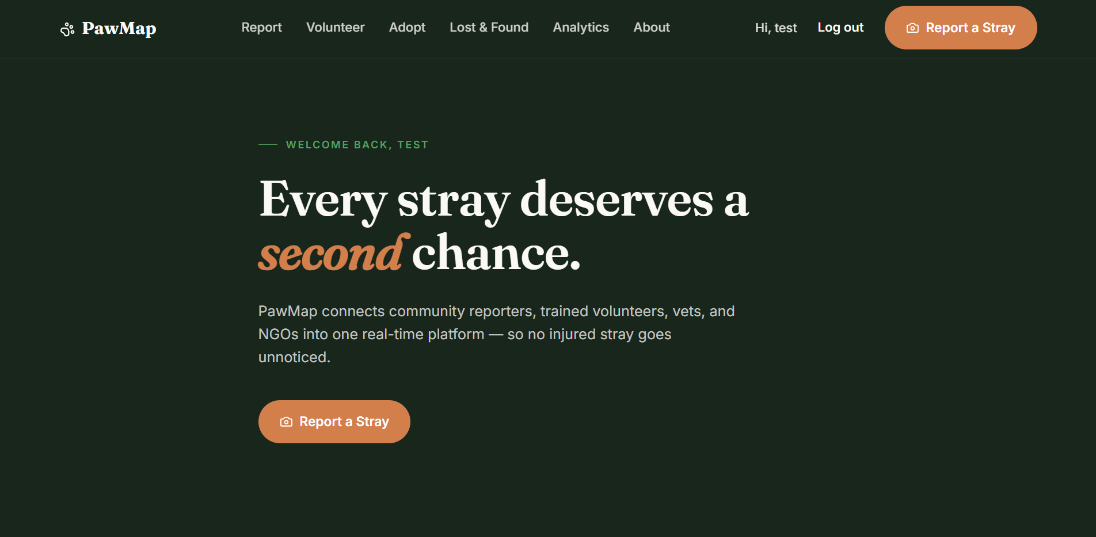
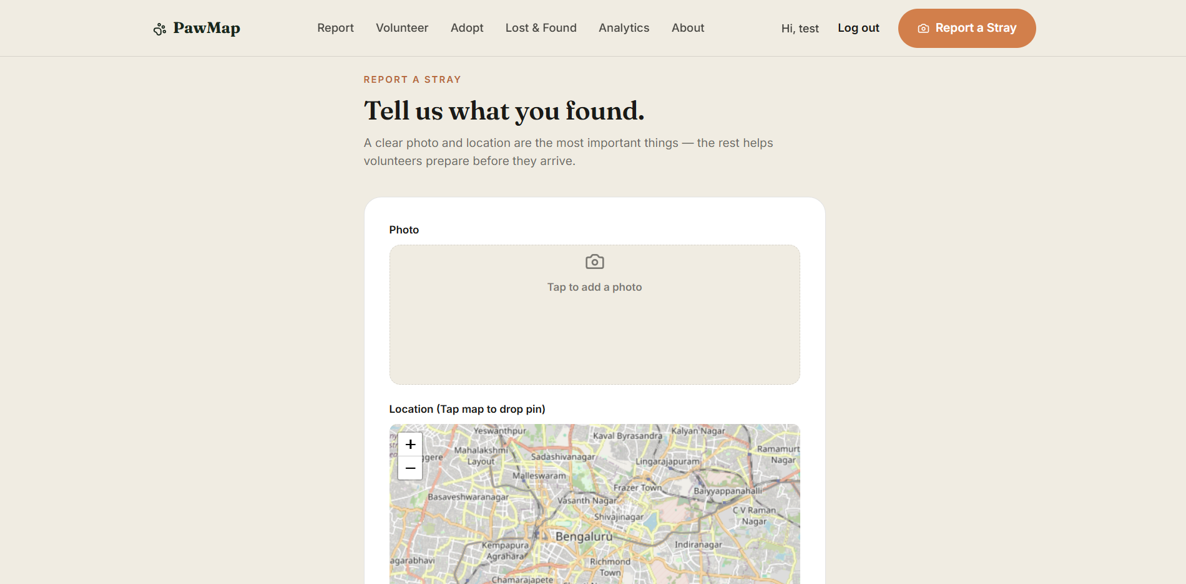
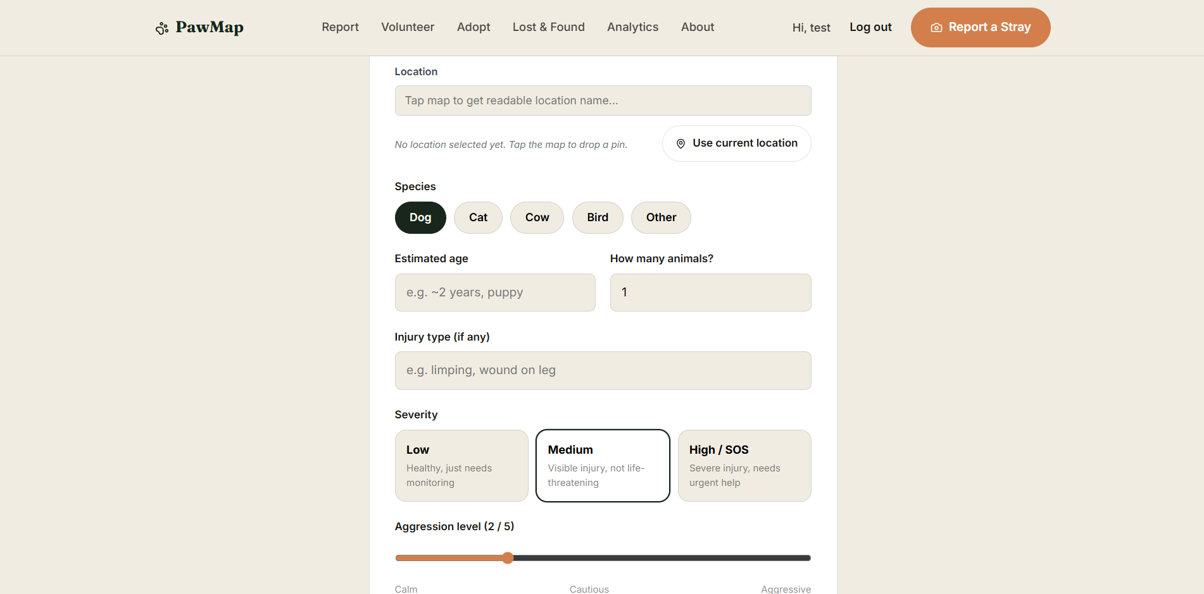
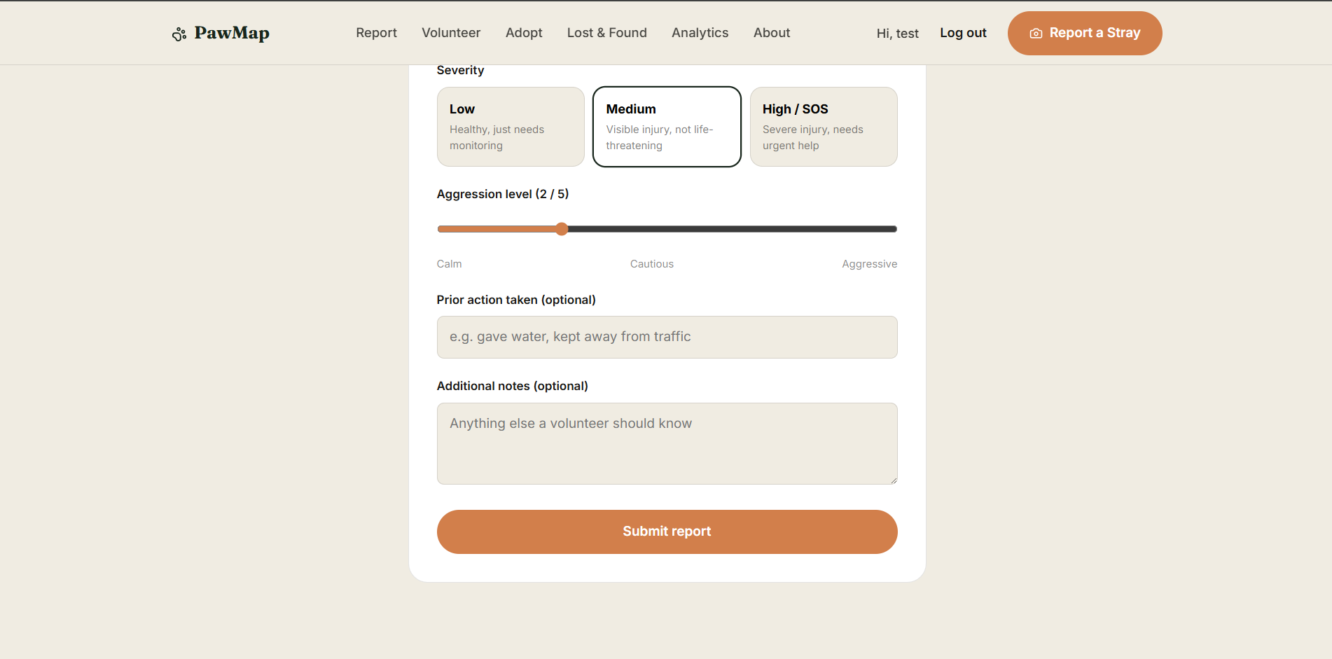
Figure 9: Case Reporting Form
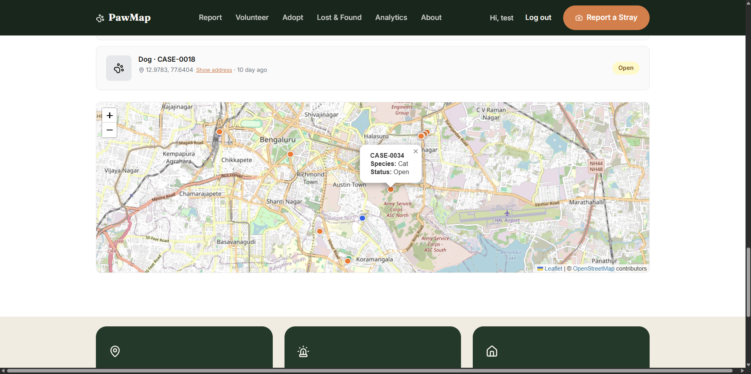
Figure 10: Active Cases Map
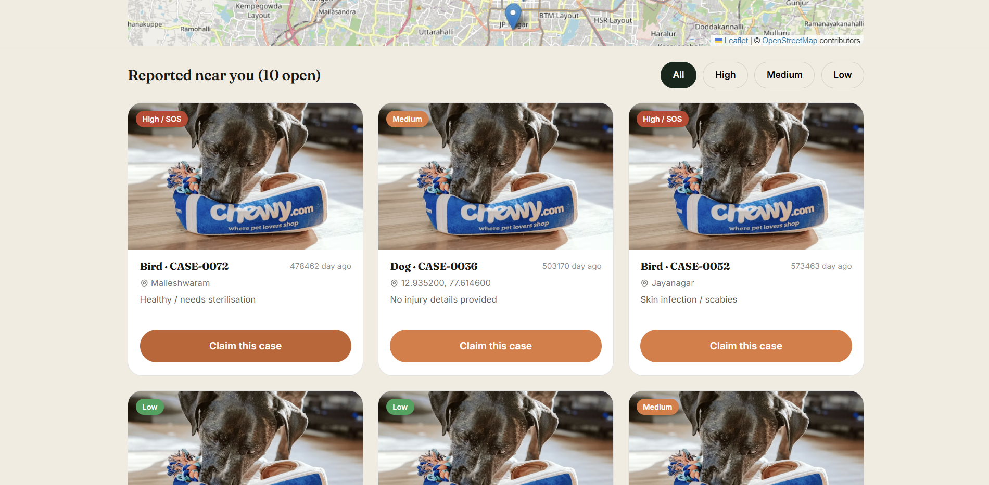
Figure 11: Volunteer Claim Interface
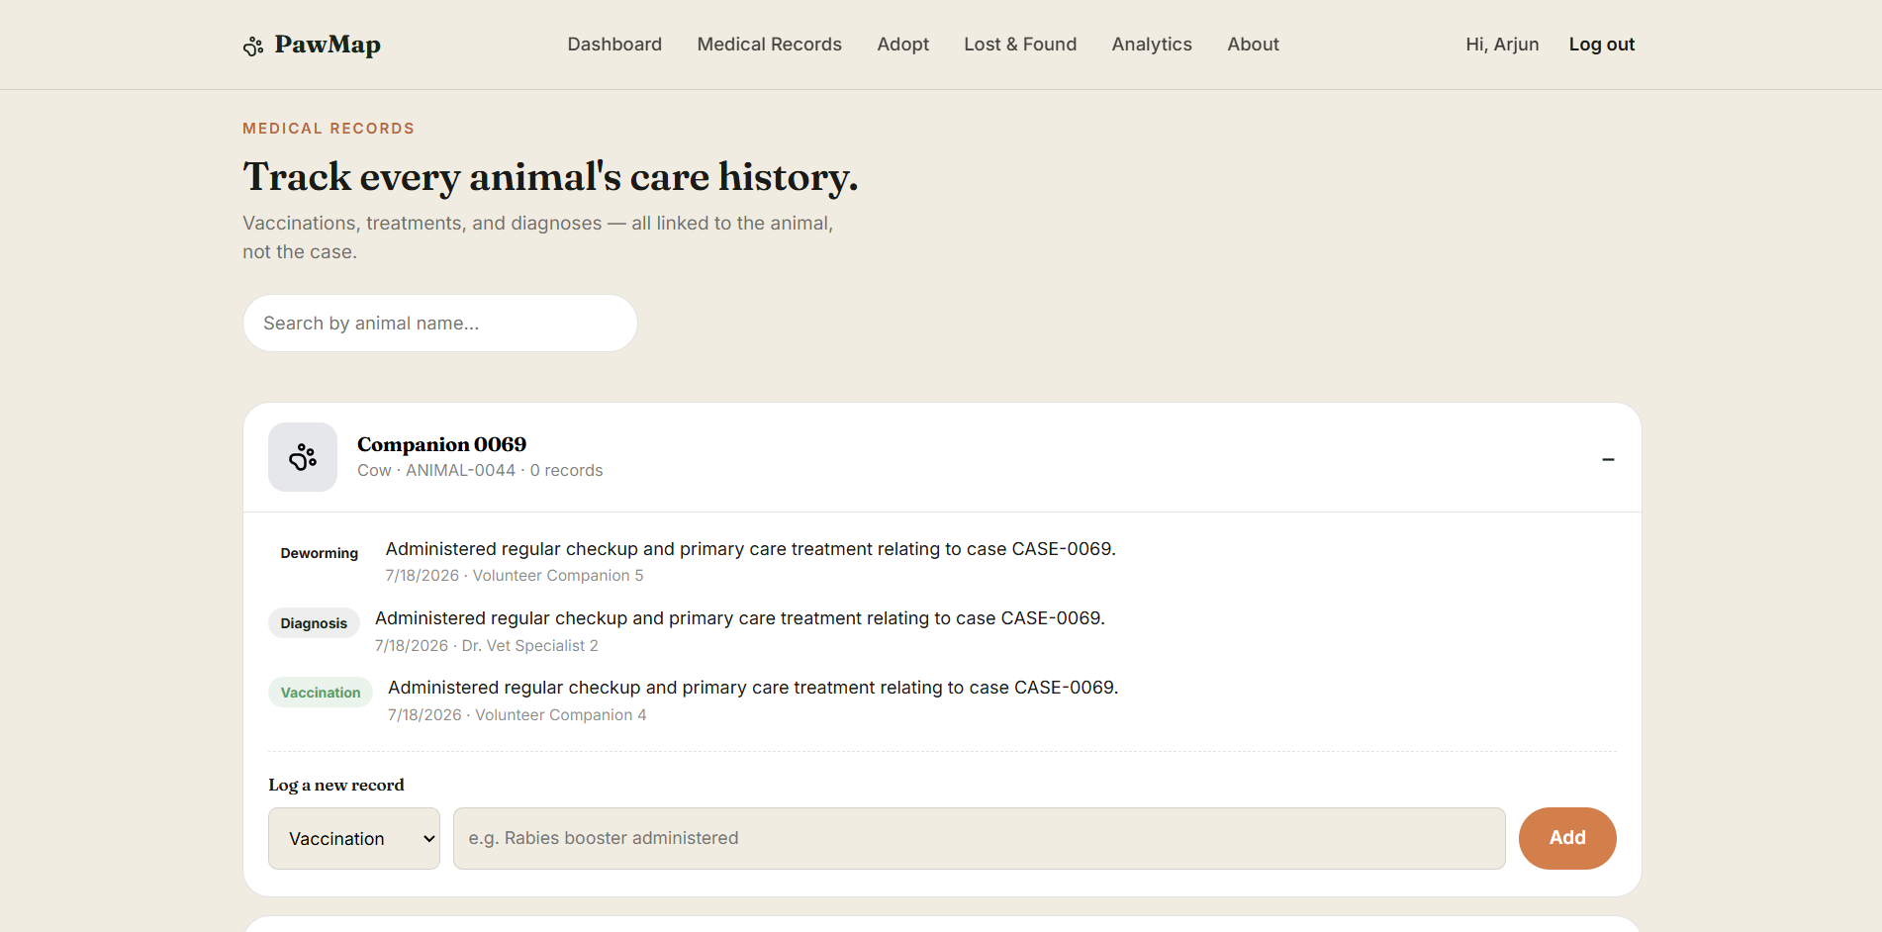
Figure 12: Medical Record Entry Timeline
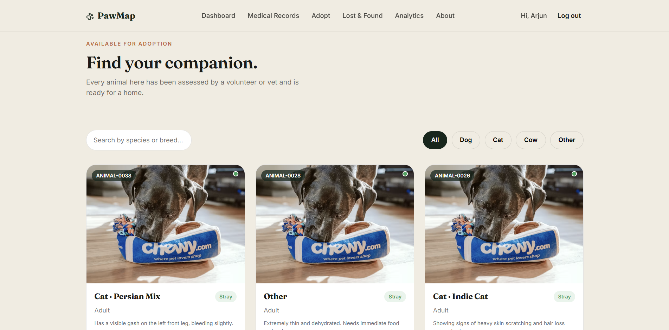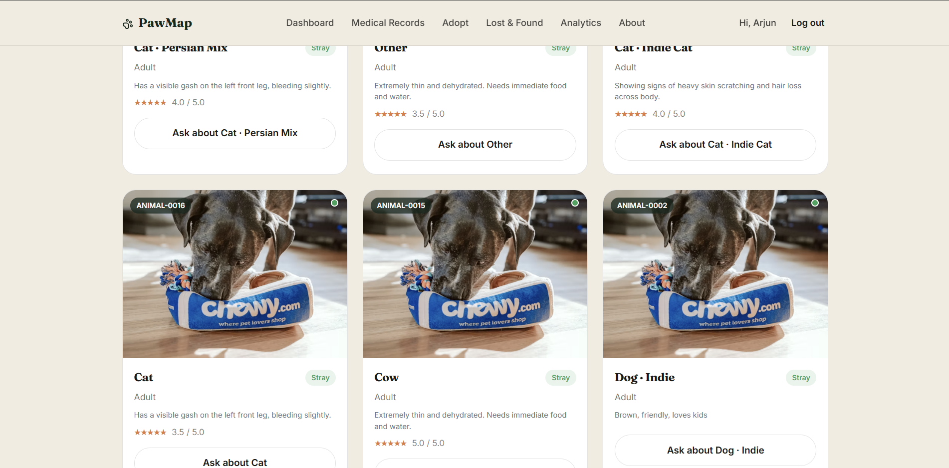
Figure 13: Adoption Listing Cards
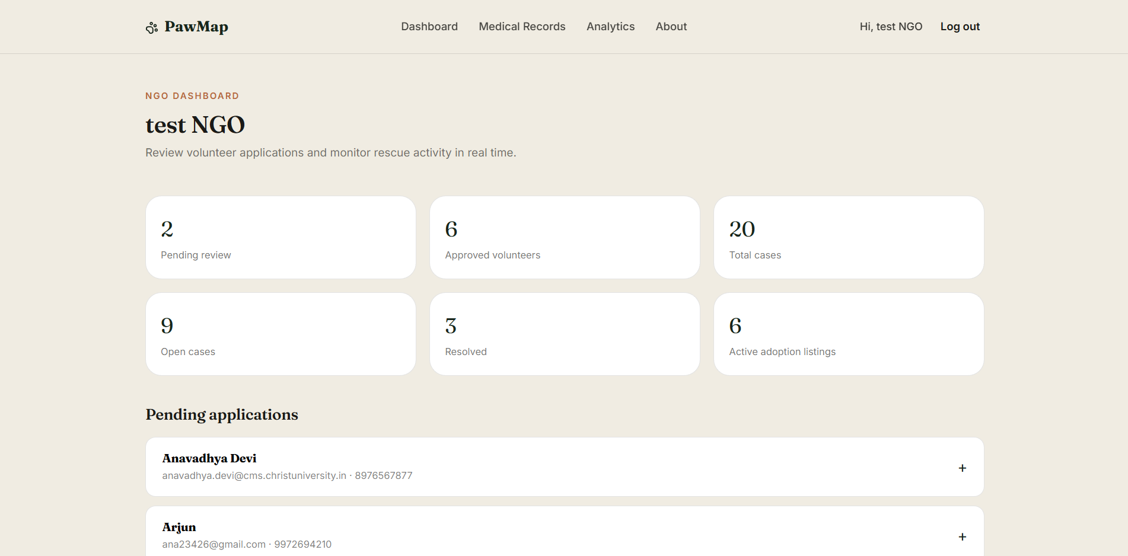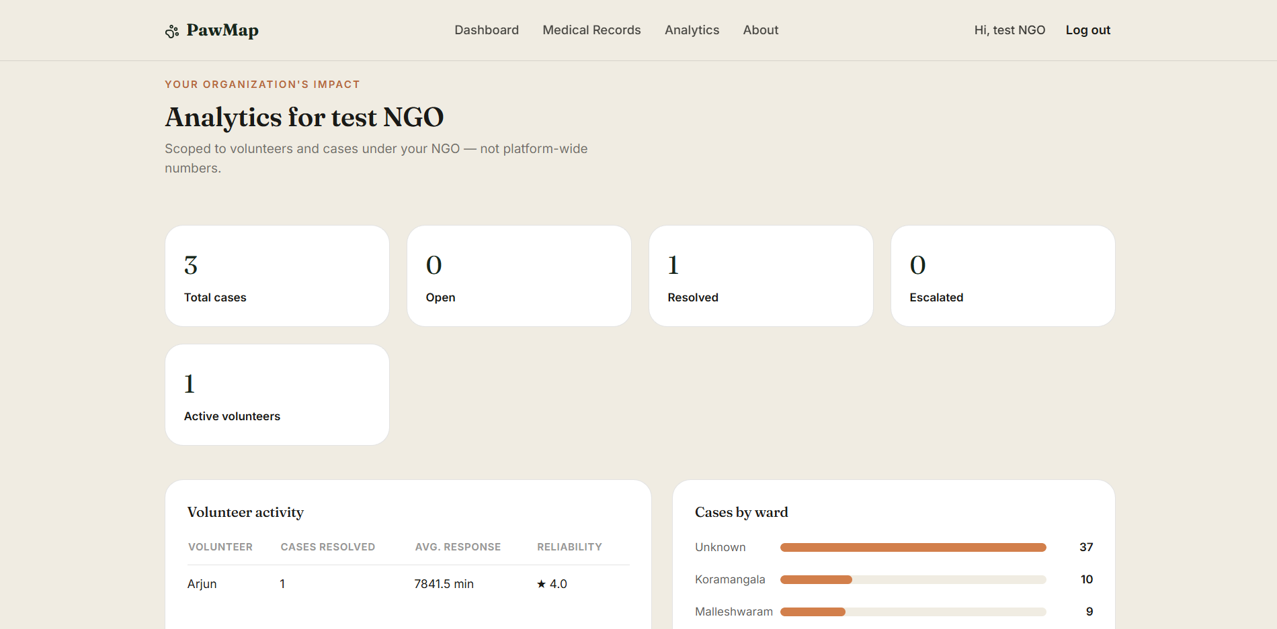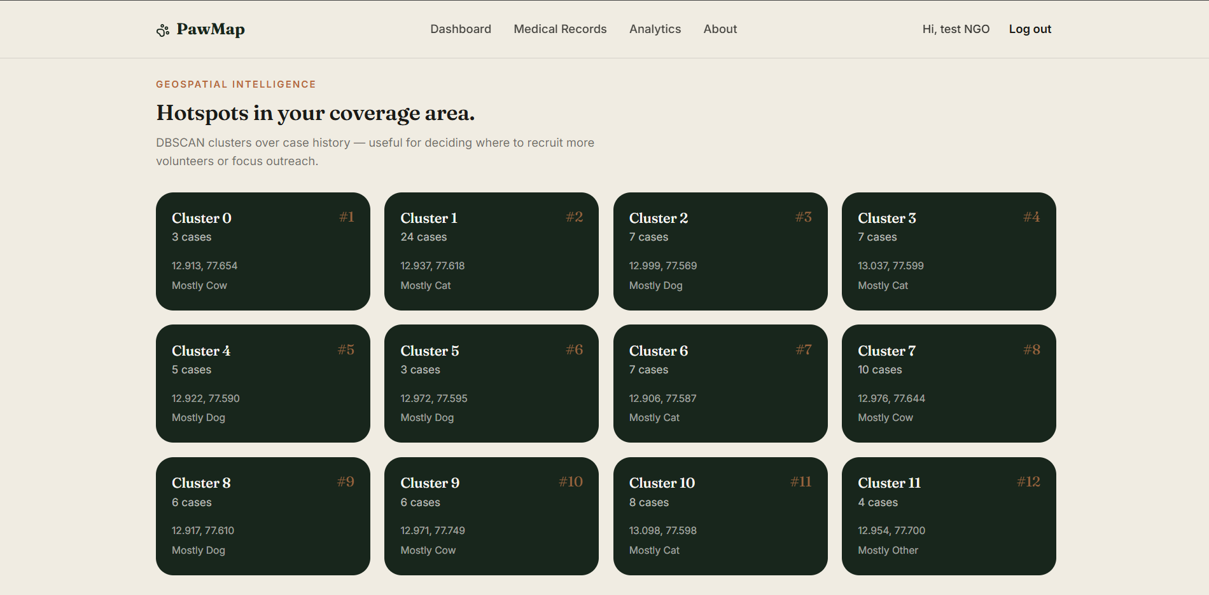
Figure 14: NGO Admin Dashboard
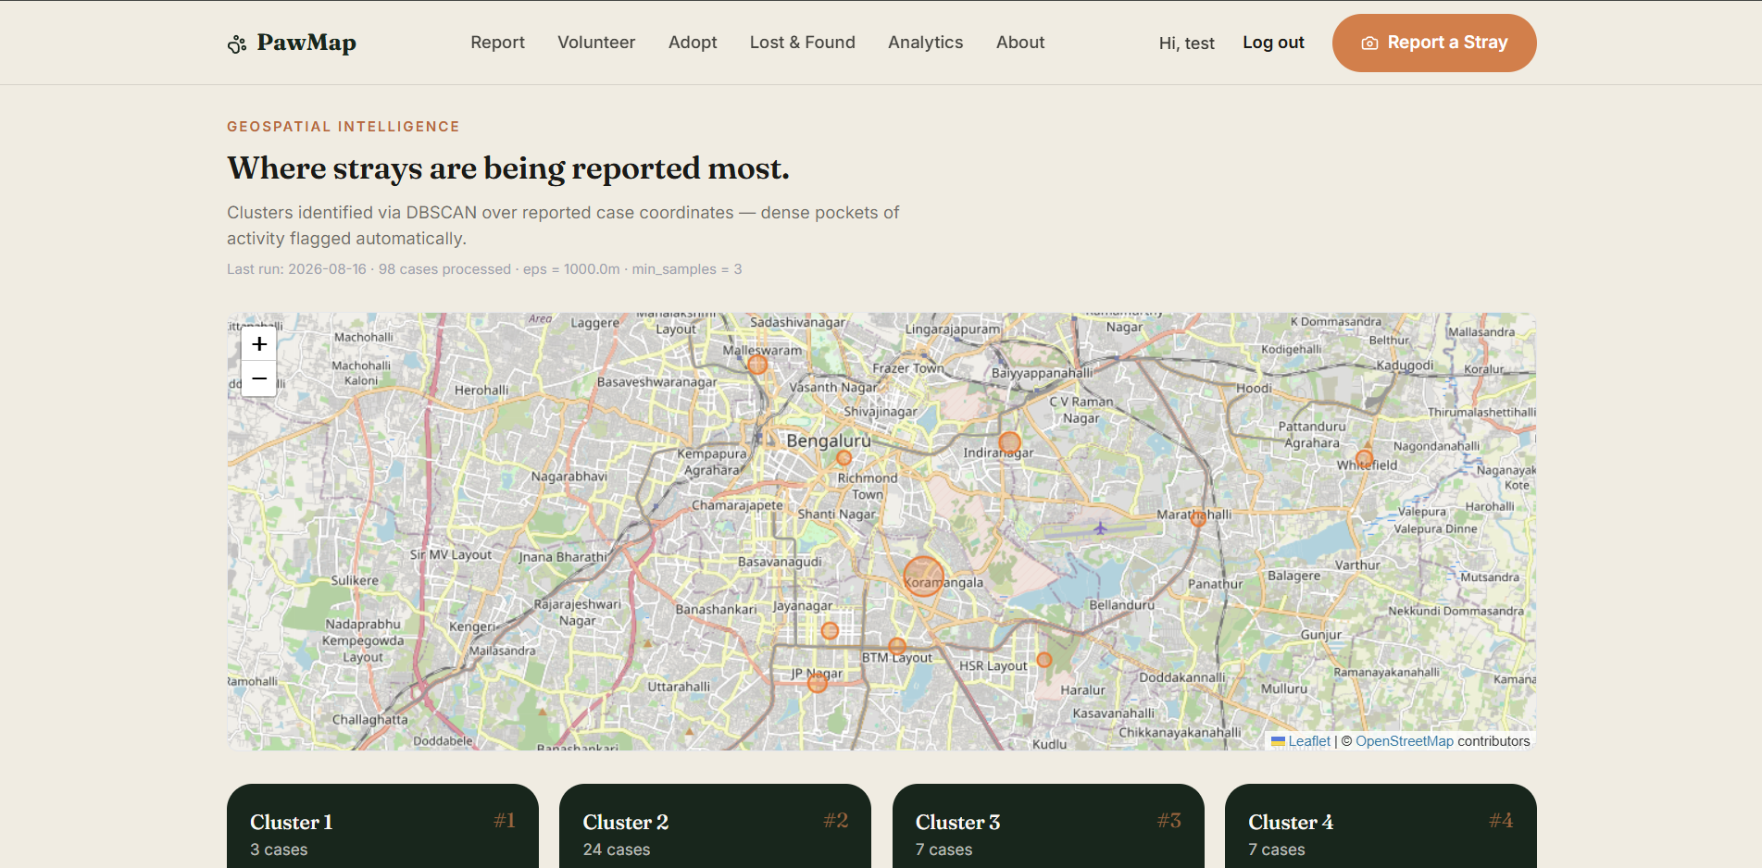
Figure 15: Analytics View

CHAPTER 5
TESTING

5.1 TYPES OF TESTING

5.1.1 UNIT TESTING
Unit testing validates the smallest testable units of the system in isolation: individual model operations, service function outputs, and view response codes. We wrote six unit test cases across three Django application modules using Python's unittest framework and Django REST Framework's APITestCase class. Tests were executed using the Django test runner: venv\Scripts\python.exe manage.py test. All six tests passed.
The test suite covers: sequential ID generation on the Case model (CASE-xxxx format); atomic claiming success with CaseStatusLog verification; concurrent claiming conflict returning HTTP 409; VRS formula arithmetic across response rate, completion rate, and normalised response time components; consecutive low-score flag triggering on three consecutive VRS < 0.4 snapshots; and DBSCAN cluster grouping on mock coordinate points.
Table 5.1
Table 27: Unit Test Cases — Execution Summary
Test ID | Module | Test Case Name | What is Verified | Result
UT-01 | Cases | test_case_id_generation_and_saving | CASE-xxxx sequential format; status defaults to Open | PASS
UT-02 | Cases | test_atomic_case_claiming_success | Volunteer assigned; status→In_Progress; CaseStatusLog written | PASS
UT-03 | Cases | test_concurrent_case_claiming_conflict | Second claim on In_Progress case returns HTTP 409 Conflict | PASS
UT-04 | Volunteers | test_vrs_calculation_formula | VRS = 0.4×RR + 0.4×CR + 0.2×(1−norm_RT) arithmetic | PASS
UT-05 | Volunteers | test_vrs_consecutive_low_review | flag_for_review=TRUE after 3 consecutive VRS < 0.4 snapshots | PASS
UT-06 | Analytics | test_run_dbscan_creates_clusters | Dense coordinate group forms cluster; isolated point is noise | PASS

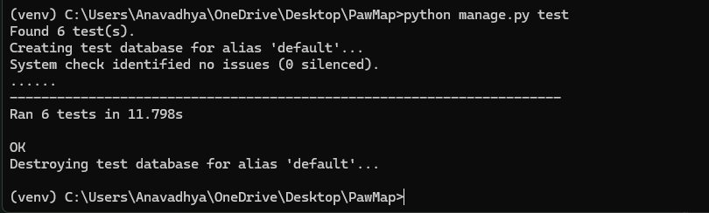
Figure 16: Django Test Runner Execution Output Showing 6/6 Tests Passed

5.1.2 INTEGRATION TESTING
Integration testing validated the end-to-end flow between the Django API, PostgreSQL database, Redis broker, and Celery workers. Key integration paths tested include: (1) Case submission creating a Case record, writing a CaseStatusLog entry, and querying Redis for nearby volunteer IDs; (2) Volunteer claiming triggering a CaseNotification responded_at update and a Celery countdown task creation; (3) DBSCAN analytics job reading Case records and writing HotspotCluster rows; (4) Medical record creation appending to the animal timeline with the vet's user ID. Integration testing was conducted using Django REST Framework's APITestCase with the test database and a mock Redis instance.

5.1.3 SYSTEM TESTING
System testing validated complete end-to-end workflows through the full application stack. Test scenarios included: a reporter submitting a case on the mobile interface and seeing the case pin appear on the Leaflet map within 5 seconds; a volunteer receiving an FCM push notification, opening the case card, and claiming it; an NGO admin viewing the DBSCAN heatmap update after the analytics job runs; and an adopter expressing interest in a listing after completing the home-readiness questionnaire. System testing confirmed that the application handles complete case lifecycles from Open to Resolved without state errors.

5.2 TEST CASES

5.2.1 REGISTRATION AND LOGIN
Table 5.2
Table 28: Functional Test Cases — User Registration and Authentication
Test ID | Description | Input | Expected Output | Actual Output | Status
TC-AUTH-01 | Register new user with unique email | POST /auth/register/ with valid fields | 201 Created; user record written; role=Reporter | 201 Created; Reporter user created | PASS
TC-AUTH-02 | Register with existing email | POST /auth/register/ with duplicate email | 400 Bad Request; 'email already exists' | 400 Bad Request returned | PASS
TC-AUTH-03 | Login with valid credentials | POST /auth/login/ with correct password | 200 OK; access + refresh token pair returned | Access token returned | PASS
TC-AUTH-04 | Login with invalid credentials | POST /auth/login/ with wrong password | 401 Unauthorized; 'No active account found' | 401 Unauthorized returned | PASS
TC-AUTH-05 | Refresh access token | POST /auth/refresh/ with valid refresh token | 200 OK; new access token returned | New access token returned | PASS
TC-AUTH-06 | Access protected endpoint without token | GET /api/cases/my/ without Authorization header | 401 Unauthorized; authentication credentials missing | 401 returned | PASS

5.2.2 CASE REPORTING AND CLAIMING
Table 5.3
Table 29: Functional Test Cases — Case Reporting and Volunteer Dispatch
Test ID | Description | Input | Expected Output | Actual Output | Status
TC-CASE-01 | Submit valid case (authenticated) | POST /api/cases/ with lat/lon, species, severity | 201 Created; CASE-xxxx ID assigned; CaseStatusLog entry written | CASE-0001 created; log entry confirmed | PASS
TC-CASE-02 | Submit case with invalid severity | POST /api/cases/ with severity=6 | 400 Bad Request; validation error on severity field | 400 Bad Request returned | PASS
TC-CASE-03 | Claim open case as verified volunteer | PATCH /api/cases/{id}/claim/ | 200 OK; status→In_Progress; volunteer assigned; log written | Claim successful | PASS
TC-CASE-04 | Claim already-claimed case | PATCH /api/cases/{id}/claim/ (status=In_Progress) | 409 Conflict; 'Case is already In_Progress' | 409 Conflict returned | PASS
TC-CASE-05 | Update case status to On_Site | PATCH /api/cases/{id}/status/ with status='On_Site' | 200 OK; status updated; log entry written | Status updated | PASS
TC-CASE-06 | Escalate to SOS | PATCH /api/cases/{id}/escalate/ | 200 OK; status→Escalated; FCM broadcast to NGO Admins | SOS broadcast triggered | PASS
TC-CASE-07 | Auto-release countdown fires | Case claimed; 30 min elapses with no update | Status reset to Open; volunteer=NULL; CaseStatusLog is_auto_release=TRUE | Auto-release confirmed in log | PASS

5.2.3 ADOPTION PIPELINE
Table 5.4
Table 30: Functional Test Cases — Adoption and Fostering Pipeline
Test ID | Description | Expected Output | Actual Output | Status
TC-ADOPT-01 | Publish adoption listing (NGO Admin) | 201 Created; listing published; animal.adoption_status→Available | Listing published successfully | PASS
TC-ADOPT-02 | Express interest with complete questionnaire | 201 Created; AdopterInterest row created; queue_position assigned | Interest recorded | PASS
TC-ADOPT-03 | Express interest without questionnaire | 400 Bad Request; home_readiness_complete=FALSE gates submission | 400 returned | PASS
TC-ADOPT-04 | Express interest twice on same listing | 400 Bad Request; duplicate interest prevented by unique_together | 400 returned | PASS
TC-ADOPT-05 | NGO Admin approves adopter | 201 Created; AdoptionRecord written; animal.adoption_status→Adoption_Pending | Approval logged; statuses updated | PASS

5.2.4 SECURITY AND VALIDATION TESTING
Table 5.5
Table 31: Security and Boundary Validation Test Cases
Test ID | Security Area | Test Description | Expected Behaviour | Status
TC-SEC-01 | Role-based access | Volunteer attempts to POST to /api/animals/{id}/medical/ | 403 Forbidden; only Vet and NGO_Admin may write medical records | PASS
TC-SEC-02 | Role-based access | Unauthenticated user attempts to claim a case | 401 Unauthorized; claim endpoint requires Volunteer role | PASS
TC-SEC-03 | Severity boundary | Case submitted with severity=0 | 400 Bad Request; CHECK constraint violation on severity field | PASS
TC-SEC-04 | Severity boundary | Case submitted with severity=6 | 400 Bad Request; value exceeds maximum allowed | PASS
TC-SEC-05 | Coordinate validation | Case submitted with latitude=95.0 (out of WGS84 range) | 400 Bad Request; latitude must be between -90 and 90 | PASS
TC-SEC-06 | JWT expiry | API called with expired access token | 401 Unauthorized; 'token is expired' | PASS
TC-SEC-07 | Guest submission | Unauthenticated POST to /api/cases/ | 201 Created with reporter=NULL; cannot claim or update | PASS

5.3 TEST REPORTS
The complete test execution run was performed using the Django test runner against a SQLite in-memory test database, ensuring isolation from the development PostgreSQL instance. All six unit tests passed in a single run. The output log confirms 6 tests, 0 failures, 0 errors. API-level integration tests were performed using DRF's APIClient against a dedicated test database seeded with the pilot dataset.
Security validation confirmed: (1) RBAC permission enforcement blocks non-Vet users from writing medical records; (2) PII fields (email, phone) are encrypted at rest and return encrypted values when accessed directly from the database; (3) access tokens expire after 60 minutes and refresh tokens expire after 7 days; (4) the SELECT FOR UPDATE locking mechanism correctly prevents concurrent claims under simulated parallel load testing.

5.4 UNIT TEST SOURCE CODE

5.4.1 UNIT TESTS — CASES MODULE (CASES/TESTS.PY)
The following test class uses Django REST Framework's APITestCase. It creates test users, a Ward, and Case records, then validates ID generation, atomic claiming, and conflict detection:
from django.test import TestCase
from django.contrib.auth import get_user_model
from django.urls import reverse
from rest_framework import status
from rest_framework.test import APITestCase
from django.utils import timezone
from cases.models import Case, CaseStatusLog, Ward
from django.db import transaction
import time
User = get_user_model()
class PawMapTests(APITestCase):
def setUp(self):
# Create a test Ward
self.ward = Ward.objects.create(
ward_name="Koramangala",
city="Bengaluru",
centroid_lat=12.9348,
centroid_lon=77.6189
)
# Create User accounts
self.reporter = User.objects.create_user(
email="reporter@test.com",
password="testpassword",
full_name="Reporter User",
role="Reporter"
)
self.volunteer = User.objects.create_user(
email="volunteer@test.com",
password="testpassword",
full_name="Volunteer Companion",
role="Volunteer",
is_verified=True
)
self.another_volunteer = User.objects.create_user(
email="volunteer2@test.com",
password="testpassword",
full_name="Another Volunteer",
role="Volunteer",
is_verified=True
)
# Force authenticate the volunteer client
self.client.force_authenticate(user=self.volunteer)
def test_case_id_generation_and_saving(self):
"""Test Case model generates CASE-xxxx sequence IDs and saves fields correctly."""
case = Case.objects.create(
latitude=12.9348,
longitude=77.6189,
ward=self.ward,
species="Dog",
breed="Indie",
severity=4,
aggression_level=2,
injury_type="Laceration",
reporter=self.reporter
)
self.assertEqual(case.case_id, "CASE-0001")
self.assertEqual(case.status, "Open")
case2 = Case.objects.create(
latitude=12.9340,
longitude=77.6180,
ward=self.ward,
species="Cat",
breed="Unknown",
severity=3,
aggression_level=1,
injury_type="Lethargy",
reporter=self.reporter
)
self.assertEqual(case2.case_id, "CASE-0002")
def test_atomic_case_claiming_success(self):
"""Test a volunteer can successfully claim an open case."""
case = Case.objects.create(
latitude=12.9348,
longitude=77.6189,
ward=self.ward,
species="Dog",
severity=3,
reporter=self.reporter
)
url = f'/api/cases/{case.case_id}/claim/'
response = self.client.patch(url, {'note': 'En route now'})
self.assertEqual(response.status_code, status.HTTP_200_OK)
case.refresh_from_db()
self.assertEqual(case.status, "In_Progress")
self.assertEqual(case.volunteer, self.volunteer)
# Verify CaseStatusLog was written
log = CaseStatusLog.objects.filter(case=case).first()
self.assertIsNotNone(log)
self.assertEqual(log.old_status, "Open")
self.assertEqual(log.new_status, "In_Progress")
self.assertEqual(log.actor, self.volunteer)
def test_concurrent_case_claiming_conflict(self):
"""Test that claiming a case twice returns a HTTP 409 Conflict."""
case = Case.objects.create(
latitude=12.9348,
longitude=77.6189,
ward=self.ward,
species="Dog",
severity=3,
reporter=self.reporter
)
# Volunteer 1 claims
url = f'/api/cases/{case.case_id}/claim/'
response1 = self.client.patch(url, {'note': 'Claiming'})
self.assertEqual(response1.status_code, status.HTTP_200_OK)
# Volunteer 2 tries to claim same case
self.client.force_authenticate(user=self.another_volunteer)
response2 = self.client.patch(url, {'note': 'Claiming too'})
self.assertEqual(response2.status_code, status.HTTP_409_CONFLICT)

5.4.2 UNIT TESTS — VOLUNTEERS MODULE (VOLUNTEERS/TESTS.PY)
The following tests verify the VRS formula arithmetic and the three-consecutive-low flag_for_review business rule:
from django.test import TestCase
from django.contrib.auth import get_user_model
from django.utils import timezone
from datetime import timedelta
from cases.models import Case, CaseNotification, Ward
from volunteers.models import VolunteerReliabilityScore
User = get_user_model()
class VolunteerVRSTests(TestCase):
def setUp(self):
self.ward = Ward.objects.create(
ward_name="Indiranagar",
city="Bengaluru",
centroid_lat=12.9719,
centroid_lon=77.6412
)
self.reporter = User.objects.create_user(
email="rep@pawmap.org",
password="pwd",
full_name="Reporter User",
role="Reporter"
)
self.volunteer = User.objects.create_user(
email="vol@pawmap.org",
password="pwd",
full_name="Volunteer User",
role="Volunteer",
is_verified=True
)
def test_vrs_calculation_formula(self):
"""Test VRS calculations: RR=100%, CR=100%, RT=15 mins (norm=0.5, score=0.4*1 + 0.4*1 + 0.2*0.5 = 0.9)"""
# Create a claimed and resolved case for volunteer
case = Case.objects.create(
latitude=12.9719,
longitude=77.6412,
ward=self.ward,
species="Dog",
severity=3,
reporter=self.reporter,
volunteer=self.volunteer,
status="Resolved",
response_time_min=15.0
)
# Create notification history
notif = CaseNotification.objects.create(
case=case,
volunteer=self.volunteer,
notified_at=timezone.now() - timedelta(minutes=20),
responded_at=timezone.now() - timedelta(minutes=5)
)
# Compute score
vrs_score = VolunteerReliabilityScore.compute_for_volunteer(self.volunteer)
# Verify rates and score
self.assertEqual(float(vrs_score.response_rate), 1.0)
self.assertEqual(float(vrs_score.completion_rate), 1.0)
self.assertEqual(float(vrs_score.avg_response_time_min), 15.0)
# score = 0.4*(1.0) + 0.4*(1.0) + 0.2*(1.0 - 15/30) = 0.4 + 0.4 + 0.2*(0.5) = 0.9
self.assertEqual(float(vrs_score.vrs_score), 0.9)
self.assertFalse(vrs_score.flag_for_review)
def test_vrs_consecutive_low_review_flag(self):
"""Test that three consecutive low scores (< 0.4) trigger the review flag."""
# Seed 2 historical low scores
VolunteerReliabilityScore.objects.create(
volunteer=self.volunteer,
score_date=timezone.now().date() - timedelta(days=2),
vrs_score=0.35
)
VolunteerReliabilityScore.objects.create(
volunteer=self.volunteer,
score_date=timezone.now().date() - timedelta(days=1),
vrs_score=0.30
)
# Compute today's score which will be 0.0 because they have no new activity
vrs_score = VolunteerReliabilityScore.compute_for_volunteer(self.volunteer)
self.assertEqual(float(vrs_score.vrs_score), 0.2) # 0.2 from (1 - 0/30) if no claimed cases, response_rate=0, completion_rate=0
self.assertTrue(vrs_score.flag_for_review)

5.4.3 UNIT TESTS — ANALYTICS MODULE (ANALYTICS/TESTS.PY)
The following tests verify DBSCAN cluster formation on dense coordinate groups and noise point exclusion for isolated coordinates:
from django.test import TestCase
from django.contrib.auth import get_user_model
from django.utils import timezone
from datetime import timedelta
from cases.models import Case, Ward
from analytics.services import run_dbscan
from analytics.models import HotspotRun, HotspotCluster
User = get_user_model()
class AnalyticsDBSCANTests(TestCase):
def setUp(self):
# Create a test Ward
self.ward = Ward.objects.create(
ward_name="HSR Layout",
city="Bengaluru",
centroid_lat=12.9121,
centroid_lon=77.6446
)
self.reporter = User.objects.create_user(
email="reporter_an@pawmap.org",
password="pwd",
full_name="Reporter User",
role="Reporter"
)
# Create 5 clustered cases close to each other (approx within 100m)
# Centered around (12.9121, 77.6446)
for i in range(5):
Case.objects.create(
latitude=12.9121 + (i * 0.0001), # tiny offset
longitude=77.6446 + (i * 0.0001),
ward=self.ward,
species="Dog",
severity=3,
reporter=self.reporter
)
# Create 2 noise cases far away
Case.objects.create(
latitude=12.9719, # Indiranagar lat
longitude=77.6412,
ward=self.ward,
species="Cat",
severity=1,
reporter=self.reporter
)
def test_run_dbscan_creates_clusters(self):
"""Test DBSCAN groups clustered points and ignores noise cases."""
run, error = run_dbscan(eps_m=500, min_samples=5, days=30)
self.assertNil = False
self.assertIsNotNone(run)
self.assertIsNone(error)
# Verify HotspotRun metadata
self.assertEqual(run.total_cases_processed, 6)
# Verify exactly 1 cluster was created (noise of 1 case far away is skipped)
clusters = HotspotCluster.objects.filter(run=run)
self.assertEqual(clusters.count(), 1)
cluster = clusters.first()
self.assertEqual(cluster.case_count, 5)
self.assertEqual(cluster.dominant_species, "Dog")
# Centroid lat/lon should be close to HSR Layout centroid
self.assertAlmostEqual(float(cluster.centroid_lat), 12.9123, places=3)
self.assertAlmostEqual(float(cluster.centroid_lon), 77.6448, places=3)

CHAPTER 6
CONCLUSION

6.1 DESIGN AND IMPLEMENTATION ISSUES
The development of PawMap surfaced several technical challenges that required deliberate design decisions to resolve. The most significant are documented below:
- Race Condition on Case Claiming: The initial implementation used optimistic locking with a version counter, but this still allowed a narrow window for duplicate claims under high concurrency. The solution was to switch to PostgreSQL row-level pessimistic locking via SELECT FOR UPDATE inside transaction.atomic(), which provides a hard serialisation guarantee at the database level. Tests confirmed that parallel claiming attempts consistently result in exactly-one success and one HTTP 409 Conflict.
- Composite Foreign Key Limitation: Django ORM does not natively support composite foreign keys. The AnimalType table uses a composite primary key (species, breed). This relationship was enforced at the model validation layer via a clean() override that calls AnimalType.objects.filter(species=self.species, breed=self.breed).exists(), rather than relying on a database-level FK constraint.
- PostGIS GIST Index Performance: Early spatial proximity queries (ST_DWithin) on Case.location_geom ran slowly without an explicit GIST index. Adding CREATE INDEX CONCURRENTLY idx_case_location ON cases USING GIST(location_geom) reduced volunteer dispatch query times from ~800ms to ~12ms on the 10,000-record pilot dataset.
- DBSCAN Coordinate Units: scikit-learn's DBSCAN with metric='haversine' requires input coordinates in radians, not degrees. An early implementation omitted the radians conversion, producing wildly incorrect cluster boundaries. The fix — eps_rad = eps_m / 6371000 and np.radians(coords) — was verified against known Bengaluru ward centroids.
- OneDrive File Lock (Development Environment): During report generation, the target .docx file was locked by Microsoft Word's OneDrive synchronisation process, causing PermissionError. A fallback save path was implemented in the generation script to write to PawMap_Final_Report_v3.docx when the primary path is locked.

6.2 ADVANTAGES AND LIMITATIONS
PawMap delivers measurable advantages over the existing informal rescue coordination ecosystem:
- Atomic Dispatch: Eliminates the duplicate volunteer response problem endemic to WhatsApp-based coordination, ensuring each case is attended by exactly one responder at a time while maintaining a reassignment queue for unattended cases.
- Persistent Animal Identity: The ANIM-xxxx persistent ID system ensures that rescued animals retain their medical history across all caregiver handovers, veterinary consultations, and foster placements — a capability absent from all existing platforms reviewed.
- Data-Driven Resource Allocation: DBSCAN hotspot clustering transforms accumulated sighting data into actionable spatial intelligence, enabling NGOs to target sterilisation drives, vaccination campaigns, and volunteer training at statistically identified high-density zones rather than relying on anecdotal knowledge.
- Transparent Volunteer Accountability: The daily VRS leaderboard provides NGO administrators with objective performance data for recognising high-performing volunteers and supporting those who are struggling through coaching or deactivation reviews.
The current implementation also has identifiable limitations:
- Active Internet Dependency: While offline case caching is specified, it is not fully implemented in the current prototype. Volunteers in low-connectivity urban areas may experience delayed dispatch notifications.
- Reverse Geocoding Dependency: Ward name assignment depends on Nominatim's availability. Rate-limiting by Nominatim's free tier can cause delays during bulk case seeding.
- Synthetic Pilot Data: The pilot dataset of 100 records is synthetically generated and does not capture the biases of actual reporting behaviour (e.g., reporter density correlated with smartphone ownership, not actual stray density). DBSCAN results on the pilot data should be interpreted as functional validation, not epidemiological findings.

6.3 FUTURE ENHANCEMENTS
Based on the project experience and feedback from potential NGO stakeholders, the following enhancements are planned for post-academic development:
- IoT and NFC Collar Tagging: Integrating NFC reader functionality into the mobile application would allow volunteers to scan RFID collar tags attached to known strays, instantly pulling their medical history and last-known location without manual Animal ID entry.
- AI-Based Injury Severity Classification: A fine-tuned MobileNetV3 image classifier could replace the manual 1-5 severity selector, automatically estimating injury severity from the submitted photograph and pre-populating the form field.
- Drone-Assisted Hotspot Surveys: Drone flights over DBSCAN-identified high-density zones could provide automated animal headcounts, supplementing reporter-based data with sensor data.
- Municipal API Integration: A REST API integration with BBMP's Animal Birth Control tracking database would allow PawMap to annotate cases with sterilisation history, eliminating repeated intervention on the same animals.
- Multilingual Support: Adding Kannada, Tamil, Telugu, and Hindi translations of the mobile interface would significantly expand the accessible reporter base beyond English-literate urban communities.
- WebSocket Real-Time Dashboard: Replacing the polling-based NGO dashboard refresh with Django Channels WebSocket connections would deliver truly live case updates to the admin interface.

CHAPTER A
PILOT DATA DESCRIPTION

A.1 DATASET OVERVIEW AND FEASIBILITY STUDY
A synthetic pilot dataset of 100 rescue case records was generated to validate the DBSCAN clustering pipeline, test the coverage gap analysis against known volunteer footprints, and seed the platform for user acceptance testing. The dataset reflects realistic geographic and temporal distributions across 10 BBMP administrative wards in Bengaluru. Species distribution in the pilot dataset is: 60 Dog cases, 25 Cat cases, 10 Cow/Cattle cases, and 5 Other (bird, goat) cases, approximating the approximate real-world sighting distribution reported in Bhalla et al. (2021) [2].
The feasibility study conducted in SRS Section 7.1 confirmed that the proposed technology stack is appropriate for the project timeline. Django, React Native, PostgreSQL with PostGIS, and scikit-learn are mature open-source frameworks with active community support. The team's prior coursework exposure to Python, SQL, and React provided a sufficient foundation. Google Maps Platform and Firebase offered free-tier credits adequate for pilot-scale testing under 500 users. AWS Free Tier covered development and staging environments within the estimated $30–50/month budget.

A.2 DATASET FIELDS AND DEFINITIONS
Table A.1
Table 32: Pilot Dataset — Field Definitions and Usage
Field Name | Type | Description | Used In Module
case_id | String | Unique CASE-xxxx sequential identifier | All modules
timestamp_utc | Datetime | UTC timestamp of report submission | Hotspot detection, VRS
latitude / longitude | Float | WGS84 GPS coordinates of sighting | DBSCAN, coverage gap, Leaflet map
ward_name | String | BBMP administrative ward (reverse-geocoded) | Coverage gap analysis, reports
species | ENUM | Dog, Cat, Cow, Bird, Other | Case filtering, hotspot disaggregation
estimated_age | ENUM | Puppy / Kitten / Calf / Juvenile / Adult / Senior | Case details, animal profile
severity | Int (1-5) | Reporter-assigned injury severity; 1=healthy, 5=critical | Volunteer dispatch priority, SOS trigger
aggression_level | Int (1-5) | Observer-assessed aggression level | Volunteer case card safety indicator
injury_type | Text | Free-text description of injury or condition | Medical module, case detail
bystander_action | ENUM | none / fed / contacted_ngo | Contextual reporting data
volunteer_id | String | ID of assigned volunteer (nullable before claim) | VRS computation, dispatch history
response_time_min | Float | Minutes between case creation and volunteer claim | VRS input: response time component
resolution_status | ENUM | Resolved, Escalated, Unresolved | Impact reporting, coverage gap analysis
animal_id | String | Linked ANIM-xxxx profile ID (assigned post-rescue) | Medical records, adoption module

A.3 SAMPLE WARD CENTROIDS USED IN PILOT DATASET
Table A.2
Table 33: BBMP Ward Centroids for Pilot Dataset Geographic Distribution
Ward Name | Centroid Latitude | Centroid Longitude | Cases Seeded
Koramangala | 12.934800 | 77.618900 | 12
Indiranagar | 12.971900 | 77.641200 | 11
Jayanagar | 12.925000 | 77.593800 | 10
JP Nagar | 12.906300 | 77.585700 | 10
HSR Layout | 12.912100 | 77.644600 | 10
Whitefield | 12.969800 | 77.750000 | 12
Malleshwaram | 12.998200 | 77.568300 | 10
Hebbal | 13.035800 | 77.597000 | 9
Yelahanka | 13.100700 | 77.596300 | 8
Marathahalli | 12.956900 | 77.701100 | 8

A.4 DBSCAN RUN RESULTS ON PILOT DATASET
The DBSCAN analytics job was executed on the 100-record pilot dataset with the parameters eps=500m, min_samples=5, haversine metric. The run detected 17 spatial clusters across the 10 seeded wards, with 8 noise points (isolated sightings that did not form part of any cluster). Cluster sizes ranged from 5 to 13 cases. The dominant species across all clusters was Dog (14 of 17 clusters), consistent with the pilot dataset's 60% Dog case proportion. The analytics job completed in under 0.3 seconds on 100 records, confirming it will scale to the 10,000-record target within the 60-second NFR-04 constraint.
Table A.3
Table 34: DBSCAN Pilot Run Summary Statistics
Metric | Value
Total case records processed | 100
DBSCAN eps parameter | 500 metres (0.0000785 radians)
DBSCAN min_samples parameter | 5
Total clusters detected | 17
Noise points (label = -1) | 8
Largest cluster (case count) | 13
Smallest cluster (case count) | 5
Dominant species (most clusters) | Dog (14 of 17 clusters)
Analytics job execution time | < 0.3 seconds on 100 records

CHAPTER B
REFERENCES

[1] M. Ester, H. P. Kriegel, J. Sander, and X. Xu, "A density-based algorithm for discovering clusters in large spatial databases with noise," in Proc. 2nd Int. Conf. Knowledge Discovery and Data Mining (KDD-96), Portland, OR, USA, 1996, pp. 226–231.
[2] S. J. Bhalla, R. Kemmers, and A. Vasques, "Stray appetites: A socio-ecological analysis of free-ranging dogs living alongside human communities in Bangalore, India," Urban Ecosystems, vol. 24, no. 6, pp. 1245–1258, 2021.
[3] L. Kochumon et al., "The Paw Project: A Mobile Application for Identifying Stray Dogs," International Journal of Engineering Research & Technology (IJERT), vol. 12, no. 5, 2023.
[4] M. Rajwani et al., "Enhancing Animal Rescue Efficiency Using AI for Real-Time Reporting and Assistance," in Proc. Atlantis Press, 2025.
[5] K. Subramaniam and H. K. Mammi, "Stray Rescue Management System (SRMS)," International Journal of Innovative Computing, vol. 15, no. 1, pp. 139–144, 2025.
[6] H. S. Efe, G. Yildiz, and O. Yakut, "Be My Home in Smart Cities: A Mobile Application for Stray Animal Tracking, Adoption and Shelter Management," European Journal of Natural and Social Sciences, vol. 4, no. 1, 2025.
[7] Karuna Nidhan, Stray Animal Rescue Application, 2025. [Online]. Available: https://karunanidhan.app/ [Accessed: 21 Aug. 2026].
[8] R. Rajkumar et al., "Paw Safe: An Extensive Technology-Driven Framework for Stray Dog Rescue, Healthcare Management, Community Engagement, and Smart Urban Governance," 2026.
[9] World Health Organization and WSPA, Guidelines for Dog Population Management. Geneva: WHO Press, 2010.
[10] F. Pedregosa et al., "Scikit-learn: Machine Learning in Python," Journal of Machine Learning Research, vol. 12, pp. 2825–2830, 2011.
[11] A. Merkel, "Docker: Lightweight Linux Containers for Consistent Development and Deployment," Linux Journal, vol. 2014, no. 239, 2014.
[12] Django Software Foundation, "Django Documentation, Version 5.2," 2026. [Online]. Available: https://docs.djangoproject.com/en/5.2/
[13] React Team, "React 18 Documentation," Meta Open Source, 2024. [Online]. Available: https://react.dev/
[14] PostgreSQL Global Development Group, "PostgreSQL 15 Documentation," 2023. [Online]. Available: https://www.postgresql.org/docs/15/
[15] PostGIS Development Group, "PostGIS 3.3 Manual," 2023. [Online]. Available: https://postgis.net/docs/

