ICONOCRACIA-CV

Visual cohort architecture

STATUS  Proposal |  | OWNER  Ana Vitória Vanzin Mendes |  | UPDATED  August 14, 2026

Author | Ana Vitória Vanzin Mendes
Review | Course instructors and team — to be confirmed
Documents | 2026-08-12 freeze; integrated dossier; codebook
Scope | From the cataloguing freeze to an audited visual cohort and the semester CBIR system.

1. Abstract
ICONOCRACIA-CV transforms the ICONOCRACIA cataloguing freeze into a visual cohort suitable for content-based image retrieval. The system compares classical descriptors, pretrained CNN embeddings, and, optionally, a vision transformer over the same audited gallery. Its output is a computational atlas of visual neighborhoods with metrics, error analysis, and human historical-iconographic interpretation.
The release fixes 335 canonical records and 286 coding-ledger entries, but contains zero image binaries. It also includes 106 all-zero vectors and 159 records with fragile or provisional provenance. The architecture separates metadata integrity, media materialization, label eligibility, and experimental readiness through gates G0–G3; it does not propose training a large CNN from scratch.

2. Goals and non-goals
Goals | Non-goals
Build a verifiable visual cohort from the 335 records. | Treat 335 records as 335 trainable images.
Compare HOG/color, a pretrained CNN, and a transformer on one gallery. | Design or fully train a large original neural network.
Produce reproducible top-k retrieval with distance and provenance. | Claim that distance proves historical influence or iconological understanding.
Use auxiliary supervision only after G2 and G3. | Use false zeros or a composite score as evidentiary truth.

3. Background and problem statement
The current freeze is internally consistent as a metadata snapshot: all 335 records pass schema validation, and the separate ledger has 286 entries. This does not make it a self-contained visual dataset. Cataloguing URLs do not guarantee a valid image, correspondence with the described object, or permission to redistribute it.
The ten indicators are formally present in all 335 records, but their substantive validity varies: 106 vectors are all zero, and 159 provenance records remain under audit. The architectural principle is closed failure: package validation alone never authorizes claims about media, labels, or machine-learning readiness.

4. Proposed architecture

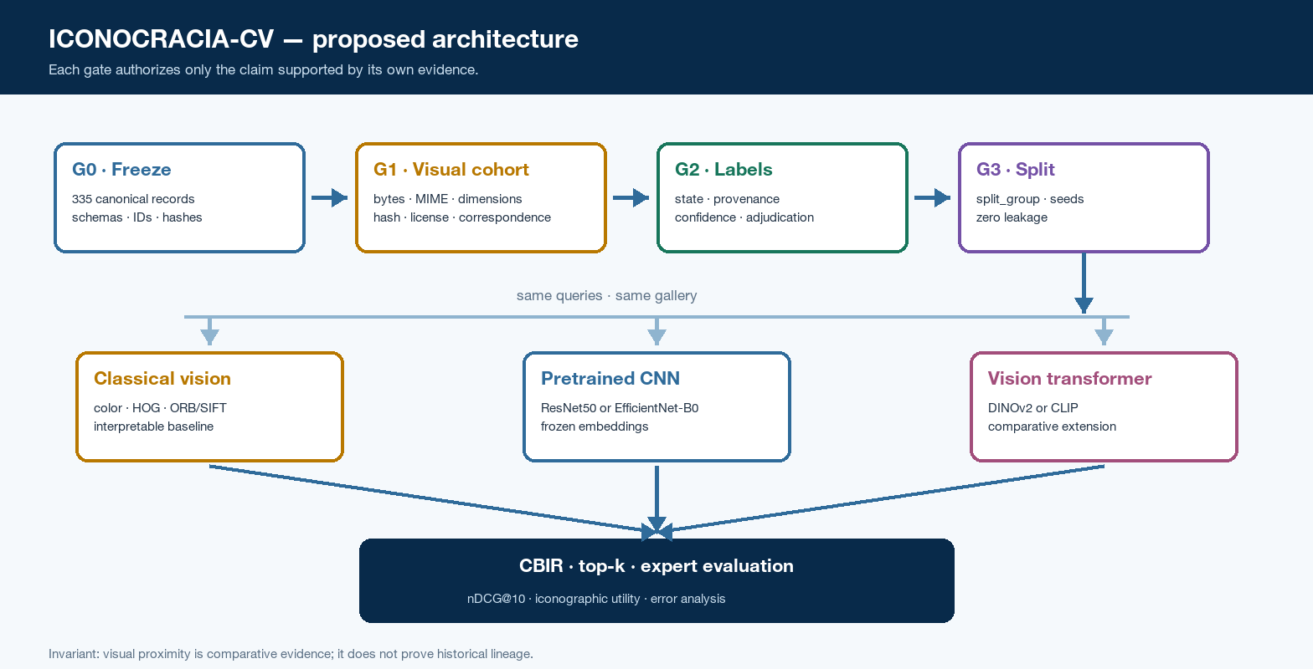
Figure 1. Proposed ICONOCRACIA-CV architecture and evidence gates.

Core components

Component | Responsibility | Storage | Failure
Freeze registry | Fixes release, IDs, schemas, counts, and hashes. | records.jsonl + manifest | Closed failure; G0 does not pass.
Cohort builder | Validates bytes, MIME, dimensions, correspondence, and license. | vision-v1 + cache | Excludes item; does not promote G1.
Label auditor | Records state, provenance, confidence, and adjudication. | ledger + provenance | Marks ineligible; never assumes zero.
Indexer | Produces descriptors and embeddings from versioned configuration. | features + hashes | Invalidates run; no hidden fallback.
Evaluator | Computes top-k, metrics, and expert error analysis. | rankings + judgments | Reports partial output and blocks conclusion.

5. Request lifecycle
- Execution receives an image or record_id, the release, the manifest, and the requested representation.
- The record is resolved against the immutable freeze; unknown or ambiguous IDs terminate execution.
- The system confirms G1 and verifies that the binary hash matches the visual manifest.
- The image is decoded and processed with the versioned preprocessing of the selected representation.
- The selected extractor produces the query feature or embedding.
- The query is compared only with the gallery and groups authorized by the G3 split.
- The output records top-k, IDs, distances, metadata, versions, and caveats; human review stays separate.

6. Data and interface contracts

Primary data contract

Field | Type | Required | Description
record_id | string | Yes | Stable canonical identifier for the object.
freeze_release | string | Yes | Immutable tag from which the record was derived.
media_ref | object | Yes | Binary source, license, and redistribution conditions.
image_sha256 | hex string | Yes | Exact identity of the validated bytes.
split_group | string | Yes | Indivisible group for duplicates, views, or series.
label_state | object | Conditional | Values, state, provenance, and adjudication.
representation_spec | object | Yes | Extractor, weights, preprocessing, version, and hash.

Contract guarantees

- record_id is unique within an immutable freeze_release.
- An eligible image has validated bytes and image_sha256; an isolated URL does not satisfy the contract.
- Supervised labels are exposed only after G2; a zero without provenance never becomes a negative.
- Manifest, split, representation, and seed fix the experiment; they do not prove historical causality.
The versioned contract and immutable release are published at
Hugging Face — ICONOCRACIA-CV-2026-08-12

7. Consistency, idempotency, and replay

Media identity is based on byte hashes, not URLs. Each run fixes the release, manifest, split, extractor, weights, preprocessing, and seed. Artifact divergence causes closed failure; legitimate changes create a new version without overwriting the previous freeze.
Scenario | Expected behavior | Reason
Same bytes reingested | Does not create a new unit; associates an alias with the group. | image_sha256 makes ingestion idempotent.
URL returns new bytes | Fails or creates an explicit version; never overwrites the freeze. | A URL is not content identity.
Duplicate or series reclassified | Creates a new manifest and split_group. | Previous splits remain reconstructible.
Replay artifact differs | Stops execution and reports the mismatched hash. | Prevents silent result reconstruction.

8. Security and privacy

- Do not redistribute binaries without explicit rights; the metadata license does not transfer to the images.
- Keep tokens, credentials, and local paths out of manifests, ZIP archives, logs, and reports.
- Treat downloads as untrusted: validate MIME type, decoding, dimensions, and correspondence.
- Verify hashes for data, weights, and artifacts before ingestion or replay.
- Publish only permitted artifacts; provide a reconstructible manifest for restricted images.

9. Operational readiness
Signal | SLO or alert | Owner | Gate
Freeze integrity | 335/335 valid; hashes and remote identity confirmed. | Freeze QA | G0 · required
Eligible media | 100% decodable; zero HTML accepted as an image. | Media QA | G1 · required
Supervised labels | 100% with state and provenance; zero false zeros. | Label QA | G2 · conditional
Leak-free separation | Zero split_group crossing the datasets. | ML curator | G3 · required
Reproducibility | 100% of results linked to versions and hashes. | ML/CV + domain | Post-G3
Current state: G0 approved; G1 failed because image binaries are absent; G2 not demonstrated; G3 does not yet exist. Promotion follows only the highest approved gate.

10. Alternatives considered

Alternative | Why consider it | Why not select it
Deep CNN from scratch | Exercises end-to-end training and neural architecture. | Small cohort; high overfitting risk.
Classification as core task | Directly links images and indicators. | Deferred until provenance, classes, and split pass G2–G3.
JSON release as visual dataset | Simple and already published. | Passes G0 but contains zero image binaries.
Web application or API first | Supports demonstration and sharing. | Diverts effort from manifest, evaluation, and reproducibility.

11. Open questions
- Is similarity retrieval accepted by the instructors as the primary task?
- Does a linear head over a pretrained extractor satisfy the checkpoint requirement?
- May the final ZIP omit restricted images and reconstruct them from the manifest?
- What hardware will be available through VLAB@UFSC for the experiments?

12. Decision and next steps
Adopt the ICONOCRACIA-CV-2026-08-12 tag as the semester universe and build a vision-v1 cohort through explicit promotion across G0, G1, G2, and G3. Model comparison begins only after the grouped split; every result remains linked to the hashes and versions that produced it.
Milestone | Deliverable | Exit criterion
M1 | Consolidated G0: tag, hashes, schemas, and crosswalk. | Immutable tag and 335/335 valid records.
M2 | G1 / vision-v1: bytes, MIME, license, and hashes. | Every eligible item linked to validated bytes.
M3 | G2–G3: labels, groups, splits, and data card. | Zero false zeros supervised and zero leakage.
M4 | HOG, CNN, extension, evaluation, and deliverables. | Same gallery, reconstructible results, documented errors.

Visual dataset means a G1–G3 cohort; the G0 freeze remains metadata-only.

