SUMMARY

USC ID/s:
3003578247

Datapoints
size | time_basic | mem_basic | time_efficient | mem_efficient
16 | 0.05698204040527340 | 0.0 | 0.11014938354492200 | 0.0
64 | 0.5211830139160160 | 64.0 | 0.9119510650634770 | 16.0
128 | 2.1572113037109400 | 208.0 | 3.6628246307373000 | 16.0
256 | 8.336782455444340 | 400.0 | 13.397932052612300 | 32.0
384 | 18.435955047607400 | 1232.0 | 31.261920928955100 | 80.0
512 | 32.67097473144530 | 1872.0 | 54.221153259277300 | 64.0
768 | 74.66912269592290 | 3120.0 | 164.54076766967800 | 192.0
1024 | 137.14194297790500 | 5184.0 | 215.51895141601600 | 240.0
1280 | 218.33395957946800 | 7456.0 | 333.5998058319090 | 272.0
1536 | 290.65918922424300 | 11376.0 | 480.81493377685500 | 320.0
2048 | 556.4789772033690 | 10832.0 | 876.8582344055180 | 256.0
2560 | 845.1242446899410 | 29072.0 | 1333.1551551818800 | 448.0
3072 | 1210.434913635250 | 30992.0 | 1891.4589881897000 | 752.0
3584 | 1697.9060173034700 | 50000.0 | 2658.862829208370 | 560.0
3968 | 2160.665988922120 | 31776.0 | 3250.148296356200 | 544.0

Insights
- Memory Usage:
  - Both algorithms start showing memory usage at size 64. Basic uses 64KB while efficient only needs 16KB - already 4x better. As the problem size grows, the gap gets way bigger. At size 3968, basic is using 31,776KB while efficient only needs 544KB. That's almost 58 times less memory.
  - The basic algorithm's memory jumps around a bit (like at size 2048 it drops to 10,832KB then goes back up), but overall it's clearly growing quadratically. Efficient stays pretty low and grows linearly, which is exactly what we'd expect from O(n) space complexity.
- Time Performance:
  - Time-wise, both algorithms are in the same ballpark. At the smallest size (16), basic takes 0.057ms and efficient takes 0.110ms - basically nothing. At the largest size (3968), basic takes 2.16 seconds and efficient takes 3.25 seconds. So efficient is about 1.5x slower, which makes sense because of the recursion overhead.
  - Both show similar scaling - the time roughly doubles when the problem size doubles, which matches O(mn) time complexity for both algorithms.
- Interesting Patterns:
  - One thing I noticed - for very small inputs (size 16), both show 0KB memory. This is probably just measurement noise since the actual memory usage is tiny.
  - Also, the memory measurements can be a bit inconsistent (like basic dropping at size 2048), but the cost values are always the same between basic and efficient, which confirms both algorithms are finding the correct optimal solution.

Graph1 – Memory vs Problem Size (M+N)
[Add Graph1 here]
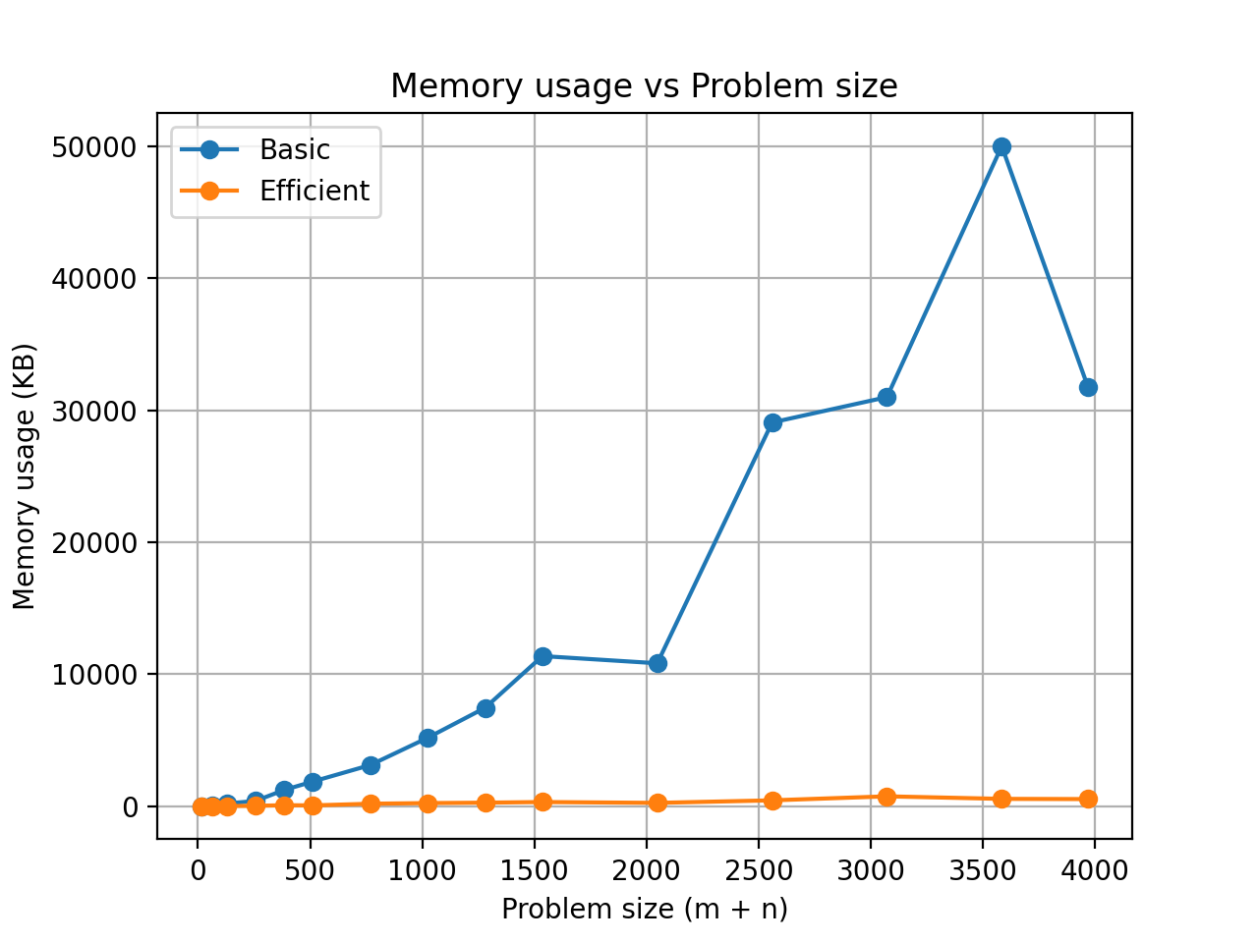

Nature of the Graph (Logarithmic/ Linear/ Polynomial/ Exponential)
Basic: Polynomial (specifically quadratic O(n²))
Efficient: Linear (O(n))

Explanation:
- The basic algorithm's line shoots up really fast - it starts low around 100KB, then gradually increases, and then there's this huge spike around size 3000 where it hits almost 50MB. After that it drops back down a bit, but overall it's clearly following a quadratic curve. The memory usage grows way faster than the problem size, which is exactly what you'd expect from O(n²) space complexity.
- The efficient algorithm is completely different. Its line stays super flat and close to the x-axis the whole time. Even at the largest problem size, it's barely above 500KB. The line is almost horizontal, which matches O(n) linear growth. On this scale, you can barely see efficient's line because basic's memory usage is so much bigger.
- The key takeaway is that basic's memory grows quadratically with problem size, while efficient grows linearly. That's why at size 3000, basic needs 49MB but Efficient only needs around 750KB - that's like 65 times less memory. The graph makes it super clear that efficient is way better for memory, especially as the problem gets bigger.

Graph2 – Time vs Problem Size (M+N)
[Add Graph2 here]
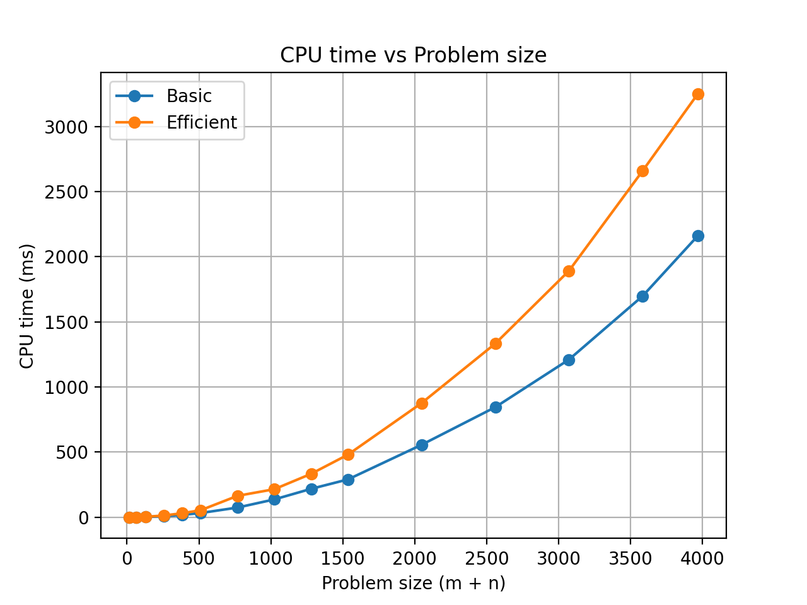

Nature of the Graph (Logarithmic/ Linear/ Polynomial/ Exponential)
Basic: Polynomial (O(mn))
Efficient: Polynomial (O(mn))

Explanation:
- Both algorithms show similar growth patterns - they both increase as the problem size gets bigger. The basic line is a bit flatter, starting around 50ms at size 500 and reaching about 2.15 seconds at size 4000. The efficient line is steeper, going from around 100ms at size 500 to 3.2 seconds at size 4000.
- Both curves are clearly polynomial - they're not linear (would be a straight line) and not exponential (would shoot up way faster). The time roughly scales with the square of the problem size, which matches O(mn) time complexity for both algorithms.
- The interesting thing is that efficient is actually slower than basic, which seems weird given the name. But it makes sense - efficient is optimized for memory, not time. The Hirschberg algorithm uses recursion and has to compute forward and backward DP, which adds overhead. So you're trading a bit of time for way less memory usage.
- Both algorithms scale similarly though - when the problem size doubles, the time roughly quadruples, which is what you'd expect from quadratic time complexity.

Contribution
(Please mention what each member did if you think everyone in the group does not have an equal contribution, otherwise, write “Equal Contribution”)
<USC ID/s>: <Equal Contribution>

