**Digital Medicine**

Anay Tripathi [170911298]

**Digital Medicine Project**

Submitted by,

Anay Tripathi

170911298

**Contents**

1) Projecting National and State Level Population 2

2) The Male to Female Gender Ratio. 4

3) Predicted Life Expectancy. 8

4) Changing age Composition 11

5) Impact of the longevity of the Indian population 11

6) Key areas/sectors for investment- 11

# Projecting National and State Level Population

In Accordance to the cohort-component methodology, the population is projected using assumptions for fertility, mortality, life expectance and sex ratio at birth.

The following link consists of the Indian population data. The dataset consists of the National and State population numbers for the year 1900. The data is in the frequency of 10 years as the census is conducted every 10 year (the last census was conducted in 2011). The dataset also consists of the predicted of the nation and a few states, for the years 2016, 2021, 2031 and 2041.



The predictions are made using Polynomial regression and the aforementioned indicators. Python programming language is used. Supporting libraries Pandas, Matplotlib and Scikit-Learn are used.



On Running the script, it outputs three line graphs for each state namely:

* Ground state - The data used as input for the model i.e data points from year 1900 to 2011.
* Test predicted - The values predicted by the model for the years present in the dataset.
* Future predicted – The values predicted by the model for the future years, that are not present in the dataset.

The script runs for each state and the entire population.

The predictions for total population and for 6 states are illustrated below.

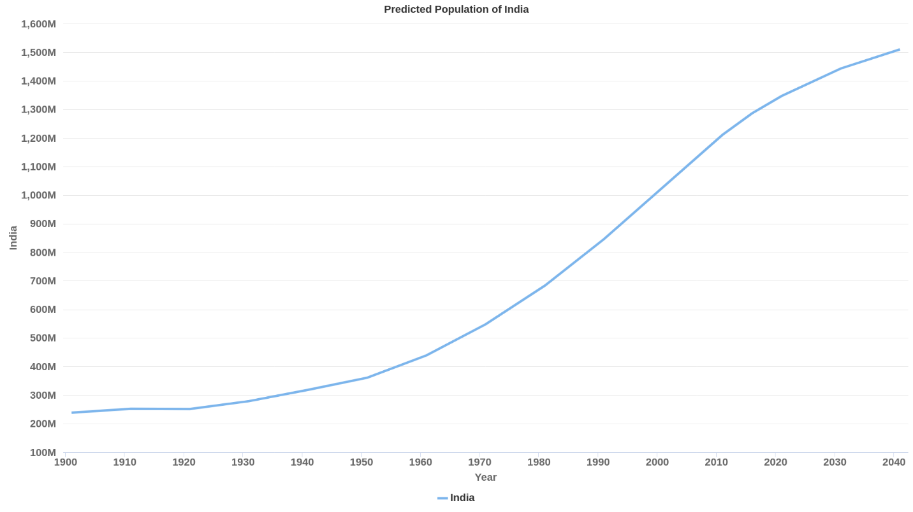

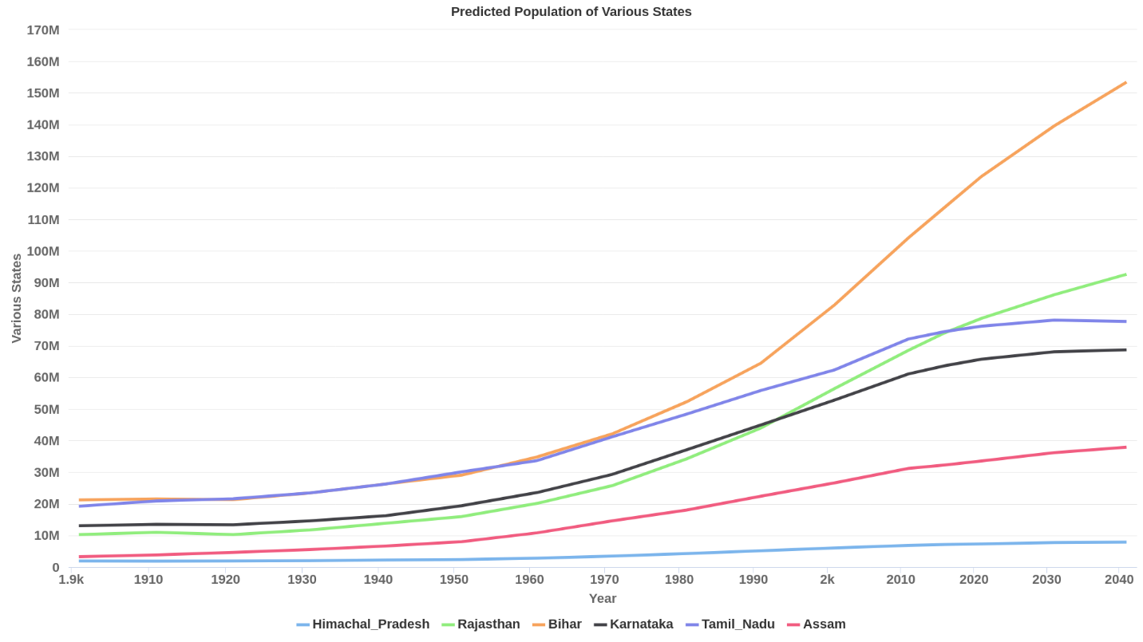

# The Male to Female Gender Ratio.

The data for number of females per 1000 males is linked below for Census data from 1950 onwards.



From the above data the following time series graphs for different states are plotted.

The states are divided into Norther, Central, Eastern and Southern. The national figures for each year is plotted in black in each figure and is used as a reference in drawing the following conclusions.

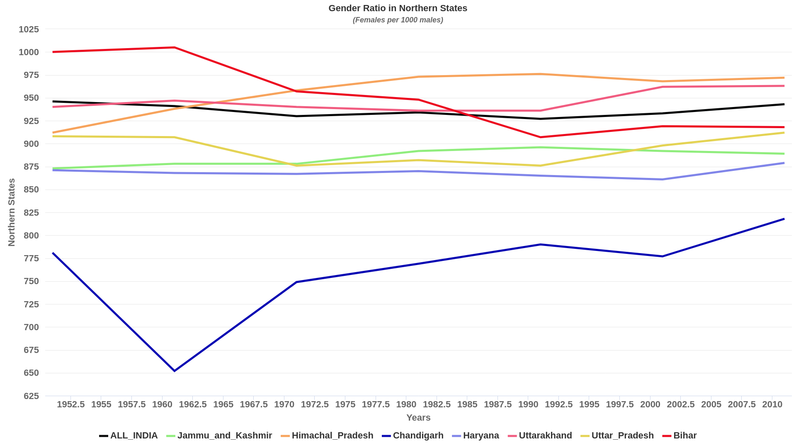

Amongst the Northern States,

* Uttarakhand and Himachal Pradesh (current highest ratio in North India) maintain a gender ratio almost same as the national figures.
* Jammu and Kashmir, Uttar Pradesh and Haryana have maintained a ratio just below the national figures i.e. between 875 to 930 females per 1000 male.
* Bihar had a positive ratio i.e. over 1000 females per 1000 males till 1961, which was well above the national average. Since then the ratio has had a downward trend, finally coming below the national average in 1984 and has maintained itself in the low 900 women per 1000 men since then.
* Chandigarh has by far the worst gender ratio in North India, well below the national average and crossed 800 female per 1000 males for the first time in 2008.

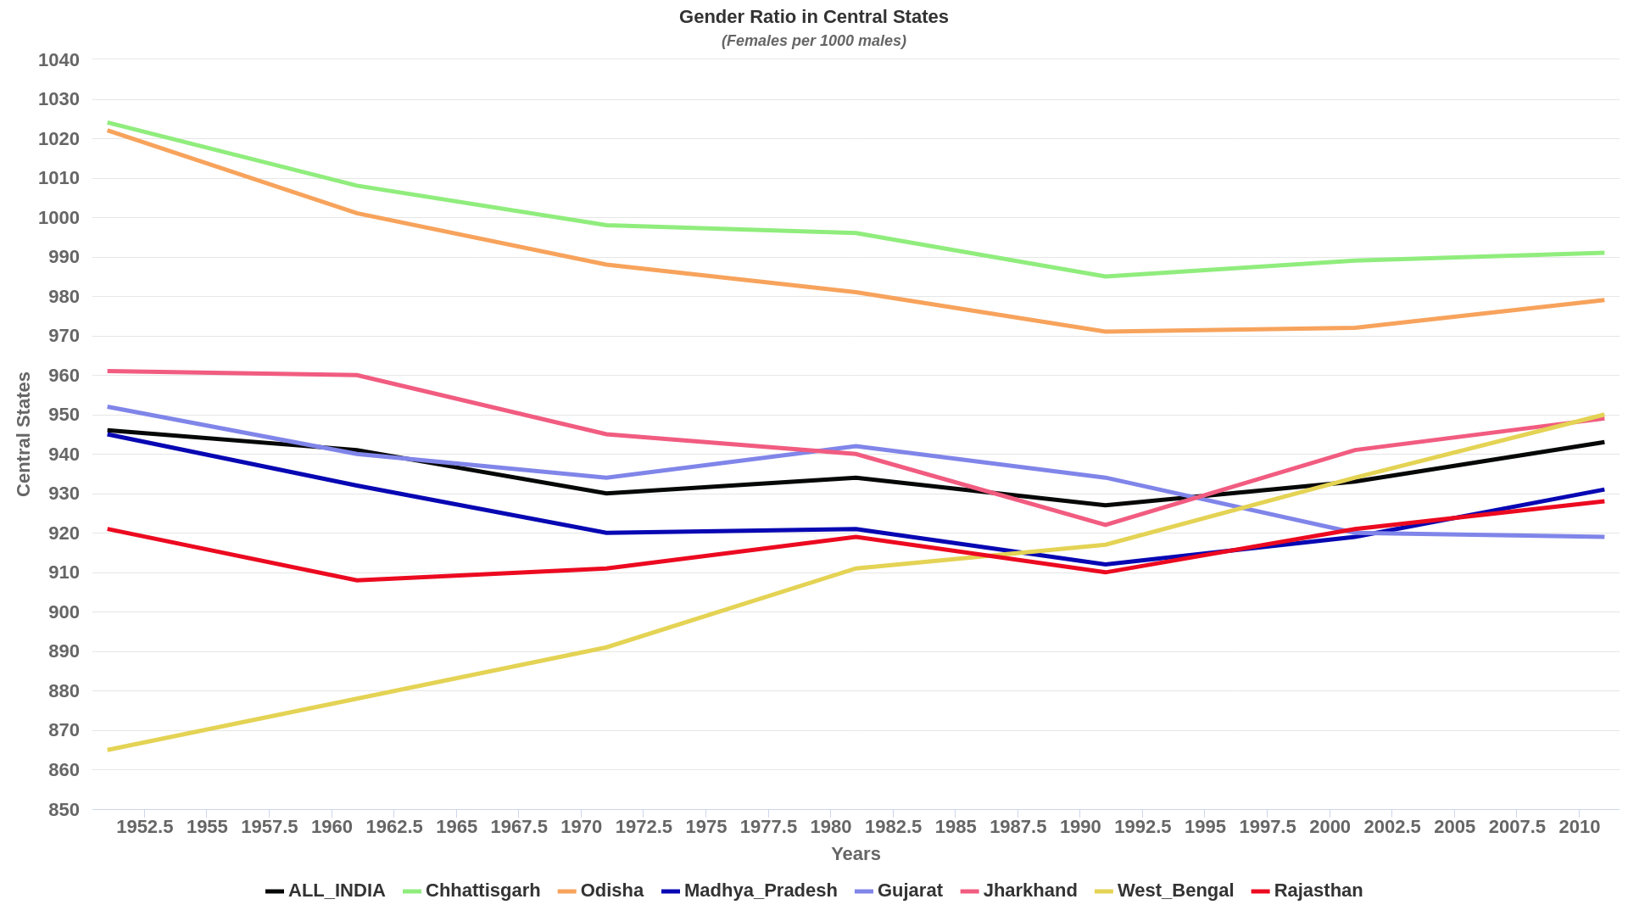

The Central Indian state figure for gender ratio seem to be converging with the national average.

* Chhattisgarh and Odisha have the highest number of females per 1000 males.

They still maintain almost a 1:1 ratio.

* Gender ratio in West Bengal were very poor in the 1950s, but a significant positive trend in the number brought it above the national average in 2001.

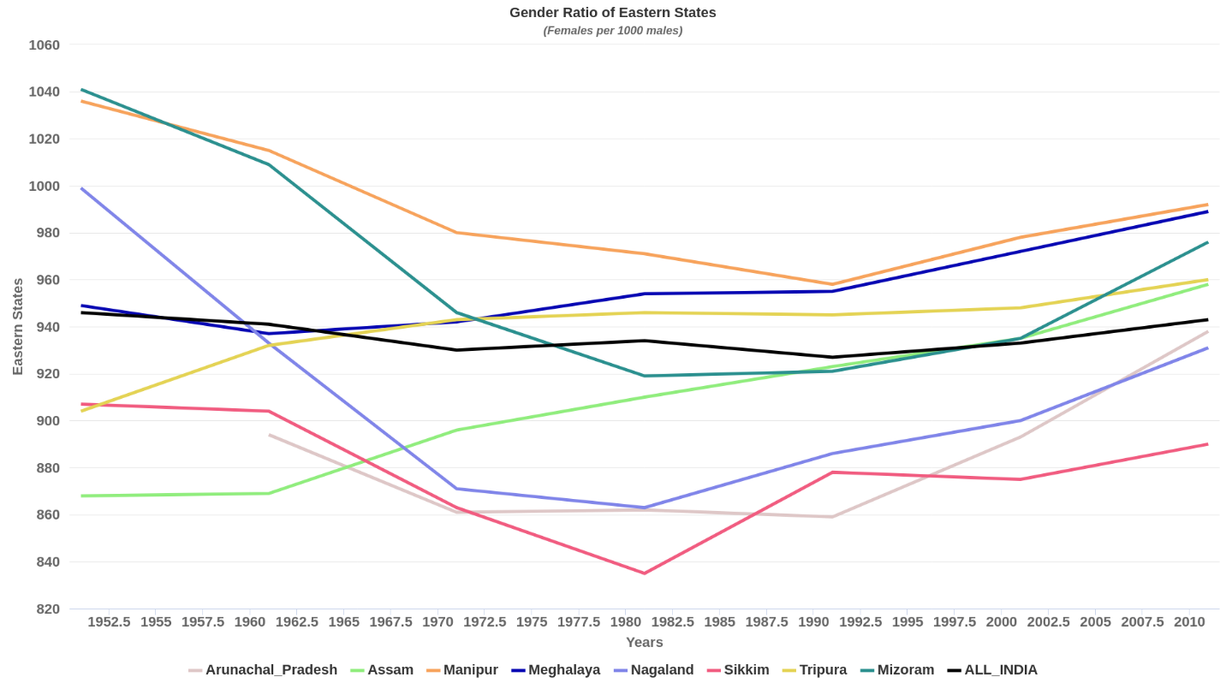

Amongst the Six sisters,

* Manipur has the highest gender ratio, and Meghalaya has similar figures since 1991.
* Several states in this region have a gender ratio below the national average including Sikkim, Arunachal Pradesh, Nagaland and Mizoram. However Mizoram crossed the National average in the early 2000.

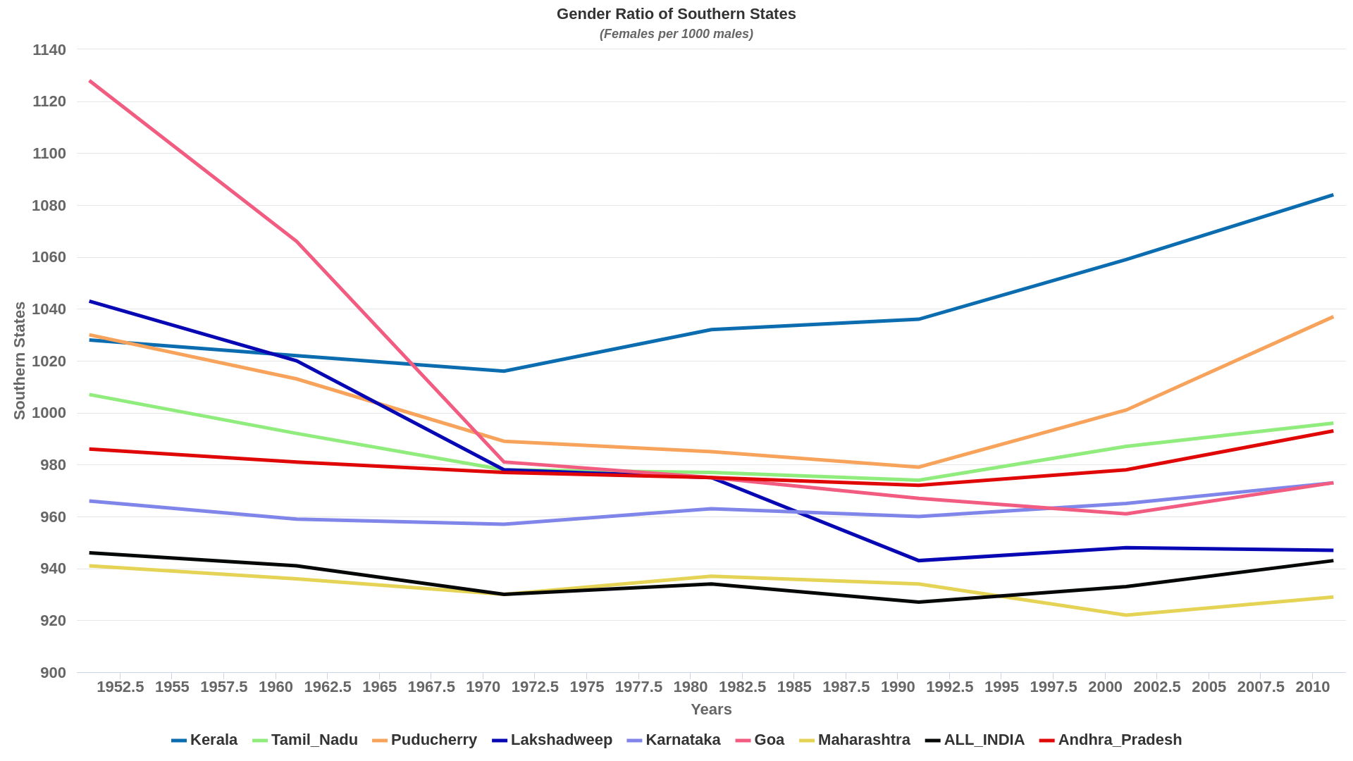

The southern States of India boast the best gender ratios when compared to the national average. All the states have a higher number of females per 1000 males.

Kerala has the highest Ratio in the country with around 1084 females per males in 2010.

The National average over the last 60 years has been 936.29 females per 1000 males.

18 of the 36 states in India have average above the national average.

# Predicted Life Expectancy.

The Life expectancy in the country and per state is as mentioned in the dataset.



The following python script predicts the life expectancy upto the year 2026.



On plotting the life expectancy of the various states along with the future predictions as outputted by the polynomial regression model, we can draw the following conclusions.

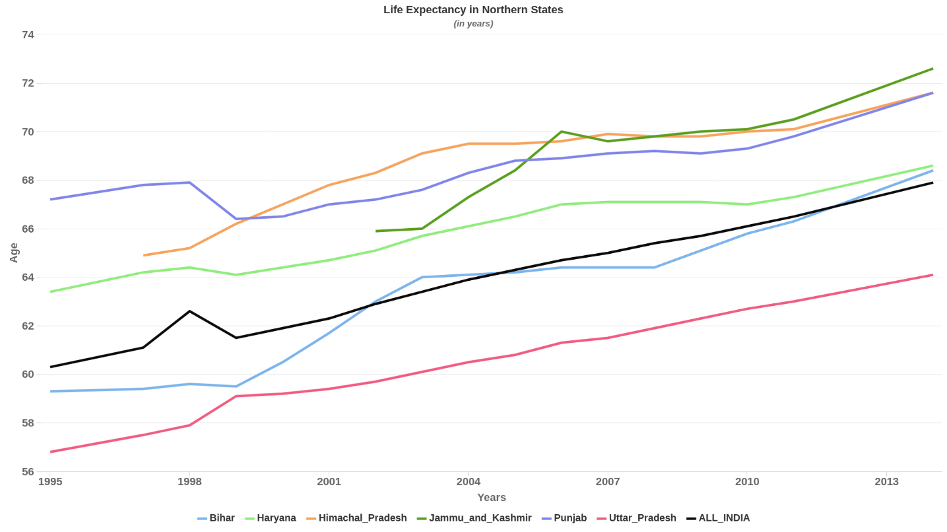

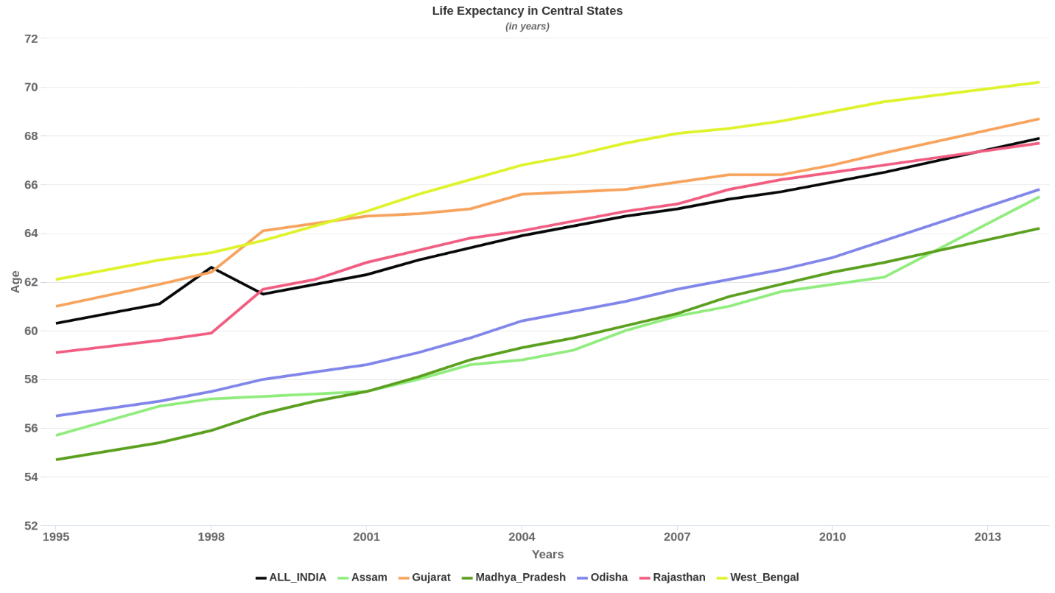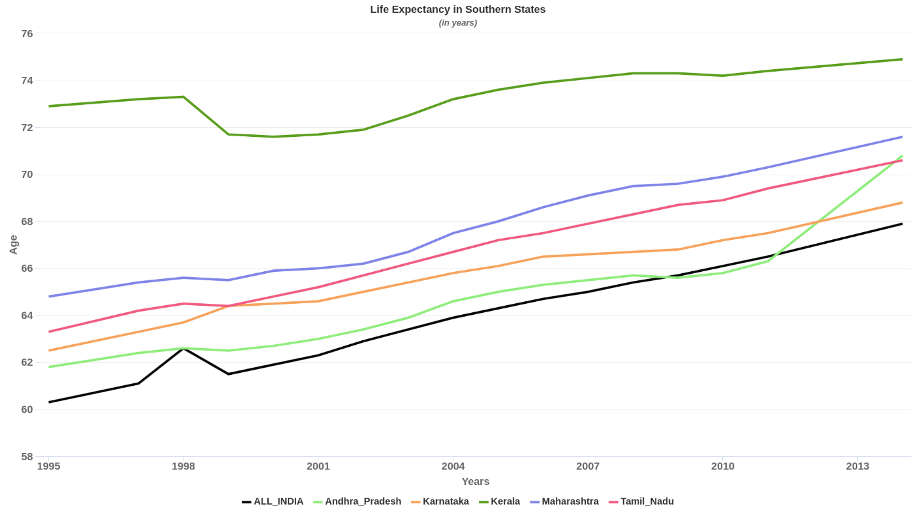

Uttar Pradesh is predicted to continue to have the lowest life expectancy amongst the northern states.

Bihar despite being slightly below the national average till 2010, will have an average life expectancy above here on.

Remaining Northern states will continue to have life expectancy above the national average.

Amongst the Central states,

West Bengal and Gujarat are expected to have life expectancy above the national average.

Rajasthan, despite having a life expectancy slightly above the national average since 1998, is expected to fall below the national average.

Remaining states will continue to have life expectancy below the national average life expectancy.

The trend of Southern states having good demographic indicators continues.

Kerala has the highest life expectancy in the country and is estimated to be around 75.5 in 2016.

Andhra Pradesh is expected to have a sudden jump as seen in the above graph.

# Changing age Composition

The following datasets provide the age composition of the Indian population. The population is divided into 3 categories:

* 0-19 Years
* 20-59 Years
* 60 and above.

 

# Impact of the longevity of the Indian population

## Health Sector and the behaviour of potential healthcare seekers.

As a result of an increased life expectancy and economic growth, there is an expected **rise in demand for healthcare** by potential healthcare seekers that can broadly be divided in to 2 main categories-

1. Low income group seeking affordable healthcare mostly provided by public sector health organizations.
2. Middle and high income group seeking good quality healthcare (mostly private).

## Surge in per capita energy requirements of the Indian demographic.

There exists a positive correlation between life expectancies and per capita energy requirements evident from the case in developed countries (though there is no direct or obvious causation). Therefore, it is reasonable to **expect a surge in overall and per capita energy demand by Indians as life expectancy increases** which will require an entirely different investment strategy.

## Rise in working age population.

With reference to the data collected and future estimations, it is discernible that **the rise in working age population** in India will result in a need for growth in sustainable employment opportunities over the next two decades.

# Key areas/sectors for investment-

On the basis of the aforementioned impact points of the longevity of the Indian population and other demographic indicators, the following investment solutions can be proposed-

## In the healthcare sector-

### Health Insurance-

In 2018, the Indian government launched a flagship scheme that aims to provide free health coverage at the secondary and tertiary level to its bottom 40% poor and vulnerable population called **Ayushman Bharat Yojana. Further investment in health insurance schemes/services** like these would contribute to limited healthcare services expenses in times of need for the masses especially the lower income group and also improve the range of medical issues covered, accessibility and availability of health insurance throughout the country.

### Investment in public-private partnerships for hospitals-

Since hospitals and health systems are the most capital intensive organizations in the healthcare system with a low return on capital, there is a requirement for a **scalable investment model** that caters to the two income demographics mentioned above through an efficient system that **provides healthcare services in a cost effective manner** to meet the **projected rise in demand for healthcare.**

In a hospital that works on public-private partnership model, a well-to-do patient subsidizes the treatment of the patient who cannot afford treatment by paying a price above the breakeven point and the hospital lowers its costs through economies of scale.

## In the energy sector-

**Investment in R&D** to incorporate cost effective, clean and renewable energy alternatives into manufacturing industries, automotive industries, businesses and the commercial sector will put India on a path of a more sustainable, climate friendly development, will mitigate the health risks associated with the more primitive forms of energy production (for example-the coal industry) and usage while also serving the purpose of **meeting the energy demands of India’s growing population.**

## Sustainable employment generation for the rising working age population-

Economic stimulus and investment in **large scale infrastructural projects and schemes**, as well as investment in **creating a network** of small scale business/industries, startups and other entrepreneurial ventures especially in rural areas and providing them **access to participate in the national market via a platform** (either e-commerce, physical markets or other forms of internet businesses). Prior to these investments however, investments in programmes, schemes or organizations that would work towards **making internet connections ubiquitous in every Indian household** across the nation is necessary to facilitate the above goals.