BU7141 — Data Management & Data Visualization

Group Project: Subscriptions
A Guide to Finding Real Data Sources for Your KPIs

If you haven't worked in or around a subscription business before, it can be genuinely hard to know where to even start looking for data. This guide points you toward reliable places to look, along with sample entities and attributes around the KPIs discussed during class (Acquisition, Engagement, Retention, Monetization, Satisfaction)
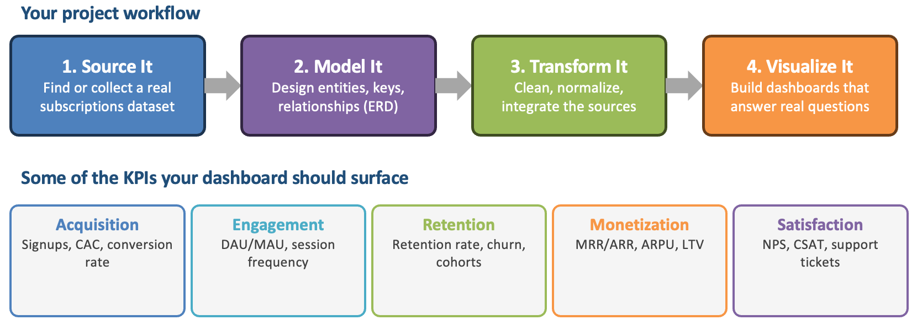
Two ground rules apply to everything below:
1. Your data sources must be real and validated. Not invented, and not fabricated by an AI tool in place of an actual dataset. You need to be able to say where each source came from.
2. Transforming the data is your job, not a blocker. Expect to clean, normalize, and reshape whatever you find so it fits the entity model you design — that's the point of the exercise, not a sign you picked the wrong source.
Note for your project: you do not need to find every entity with every attribute listed here. Focus on selected KPIs based on the data sources you can find and the output you want to deliver in your written assignment and during your presentation.

Before You Use a Source: A Validation Checklist
Run every candidate dataset through these questions before you build anything on top of it.
- Can you name the original publisher or collector? (“a company,” “a regulator,” “an academic study” — not just “found online”)
- Does the source's own documentation say whether the data is real, anonymized, or synthetic? Any of these is fine to use — what matters is that you say so accurately in your submission.
- Is there a stated collection date, period, or “accessed on” timestamp? Subscription numbers age quickly.
- Can you sanity-check at least one figure against an independent source — does a churn rate or price roughly match what else is publicly known about that industry or company?
- Have you recorded the source in your submission — URL, publisher, and the date you retrieved it?

Core Subscription Entities at a Glance
Here are some examples on typical entities that are related to the subscription business. This list is not exhaustive but will guide you to understand if the data sources are applicable.
These entities recur across every KPI category below. Most groups will start here and add, split, or rename entities once their chosen data source is in hand.
Entity | What It Represents | Example Key Attributes
Customer | The subscriber account itself | customer_id (PK), signup_date, country, status
AcquisitionChannel | Where a customer came from | channel_id (PK), channel_name, channel_type, campaign_cost
Plan | A sellable subscription tier | plan_id (PK), plan_name, billing_cycle, list_price, currency
Subscription | One customer's instance of a plan over time | subscription_id (PK), customer_id (FK), plan_id (FK), start_date, end_date, status
Payment | A billing transaction against a subscription | payment_id (PK), subscription_id (FK), amount, payment_date, payment_status
Session | One login / usage session | session_id (PK), customer_id (FK), session_start, session_end, device_type
UsageEvent | A single in-product action | event_id (PK), session_id (FK), customer_id (FK), event_type, feature_name, event_timestamp
SupportTicket | A customer service interaction | ticket_id (PK), customer_id (FK), created_date, resolved_date, category, resolution_time_hours
SurveyResponse | An NPS / CSAT survey reply | response_id (PK), customer_id (FK), survey_type, score, response_date

Acquisition
KPIs: Signups, CAC, conversion rate • Entities involved: Customer, AcquisitionChannel
Attribute | Type | What It Captures
Customer.customer_id | Integer / UUID | Unique subscriber identifier
Customer.signup_date | Date | When the account was created — the basis for counting signups in a period
Customer.acquisition_channel_id | FK → AcquisitionChannel | Which channel gets credit for the signup
AcquisitionChannel.channel_name | Text | e.g. “Paid Social”, “Organic Search”, “Referral”
AcquisitionChannel.campaign_cost | Decimal | Spend attributable to that channel in a period
How you'd calculate it: Signups = COUNT(Customer) grouped by signup_date period. CAC = SUM(campaign_cost) ÷ COUNT(new customers attributed to that channel) over the same period. Conversion rate needs a funnel concept — if your group wants to model the pre-signup journey, add a Lead entity (lead_id, source, created_date, converted_customer_id); otherwise treat conversion rate as coming from outside your schema (e.g. web analytics), which is itself a useful discussion about where an ERD's boundary should sit.

Engagement
KPIs: DAU / MAU, session frequency, feature adoption • Entities involved: Session, UsageEvent, Customer
Attribute | Type | What It Captures
Session.session_id | UUID | Unique session identifier
Session.customer_id | FK → Customer | Who had the session
Session.session_start / session_end | Datetime | Used to compute duration and to bucket activity by day
UsageEvent.event_type | Text | e.g. “login”, “feature_used”, “content_viewed”
UsageEvent.feature_name | Text | Which feature was touched — needed for feature adoption
UsageEvent.event_timestamp | Datetime | When the action happened
How you'd calculate it: DAU = COUNT(DISTINCT customer_id) with a Session or UsageEvent on a given day; MAU = the same over a trailing 30 days. The DAU/MAU ratio is the classic “stickiness” metric. Session frequency = sessions per customer per week. Feature adoption = % of active customers with at least one UsageEvent where feature_name = X in the period.

Retention
KPIs: Retention rate, churn rate, cohort trends • Entities involved: Subscription, Customer
Attribute | Type | What It Captures
Subscription.start_date / end_date | Date | Defines the active window for that subscription
Subscription.status | Text | active / cancelled / paused
Subscription.cancellation_reason | Text | Optional, but useful for churn analysis
Customer.signup_date | Date | Used to assign each customer to a signup cohort (e.g. signup month)
How you'd calculate it: Churn rate (period) = cancellations in the period ÷ subscriptions active at the start of the period. Retention rate = 1 − churn rate. Cohort trend = group customers by signup_month, then for each following month measure what % of that cohort still has an active subscription — the classic “cohort retention curve”, and a good candidate for a pivoted, visualized table.

Monetization
KPIs: MRR / ARR, ARPU, LTV • Entities involved: Payment, Subscription, Plan
Attribute | Type | What It Captures
Payment.amount | Decimal | What was actually charged
Payment.payment_date | Date | When the charge occurred
Payment.payment_status | Text | success / failed / refunded — only successful payments should count as revenue
Plan.list_price / billing_cycle | Decimal / Text | Used to normalize revenue to a monthly figure (e.g. divide an annual price by 12)
How you'd calculate it: MRR = sum of each active subscription's monthly-normalized revenue. ARR = MRR × 12. ARPU = total revenue in a period ÷ count of active customers in that period. A simple LTV = ARPU × average customer lifespan in months — and that lifespan figure comes straight out of the Retention entities above, a good moment to show students how KPI categories share underlying data.

Satisfaction
KPIs: NPS, CSAT, support tickets • Entities involved: SurveyResponse, SupportTicket
Attribute | Type | What It Captures
SurveyResponse.survey_type | Text | “NPS” or “CSAT”
SurveyResponse.score | Integer | 0–10 for NPS, 1–5 for CSAT
SurveyResponse.response_date | Date | When the response was collected
SupportTicket.category | Text | e.g. billing, bug, feature request
SupportTicket.created_date / resolved_date | Date | Used to compute resolution_time_hours
SupportTicket.resolution_time_hours | Decimal | How long the ticket took to close
How you'd calculate it: NPS = %Promoters (score 9–10) − %Detractors (score 0–6) among NPS responses. CSAT = average CSAT score, or the % of responses at or above a “satisfied” threshold. Ticket volume and average resolution time are common leading indicators of satisfaction even before a formal survey response exists.

Where to Look, for data sources
Governmental and non-governmental organizations globally have started sharing public data through open data repositories. This is not an exhaustive list, there are also other repositories like Kaggle
Data.gov | Official repository for US federal government agencies
Data.census.gov | Main platform to access US Census Bureau data
Eurostat | Statistical office of the European Union
Federal Reserve Economic Research | For US and international data
Global Open Data Index | By the Open Knowledge Foundation
Google Dataset Search | Search engine for datasets
Harvard Dataverse | Open to all researchers from any discipline
Humanitarian Data Exchange | By the UN Office for the Coordination of Humanitarian Affairs
IPUMS | Integrated Public Use Microdata Series, world’s largest individual-level population database
openAfrica | Largest volunteer-driven open data repository on the African continent
Open Data Inception | Map-oriented global directory
Open Data Network | Directory by Socrata, primary of US state and municipal open data platforms
UNdata | United Nations Data
World Bank Open Data | Global collection of economic development data
World Inequality Database | Global data on income and wealth inequality
Worldometer | Independent organization collecting world statistics

Remember
- Your sources must be real and validated — not invented, and not generated by an AI tool standing in for an actual dataset. If you're unsure whether something is real, that's a question to bring to class, not to guess past.
- Real data will not arrive shaped like your ERD. Mismatched date formats, missing values, inconsistent category codes, and duplicate records are normal — cleaning and normalizing them into your model is the assignment, not an obstacle to it.
- Combining two or three sources that were never designed to fit together (e.g. a churn dataset for Subscription + a company's real pricing page for Plan + a published NPS benchmark for Satisfaction) is expected, and mirrors how this kind of project actually gets built in industry.

