BCG DevOps GenAI POC
Autonomous DevOps Agent with AI-Powered Code Analysis

Version: 1.0
Date: December 2024
Project: BCG DevOps GenAI Proof of Concept

Table of Contents
1. Executive Summary
2. System Architecture Overview
3. Core Components
4. API Endpoints
5. Autonomous DevOps Agent Workflow
6. CI/CD Pipeline Integration
7. Security Features
8. Technology Stack
9. Deployment Guide
10. Usage Examples

1. Executive Summary
The BCG DevOps GenAI POC is an innovative proof-of-concept that demonstrates the power of integrating Generative AI into DevOps workflows. This solution leverages Amazon Bedrock's Nova Pro model to create an autonomous DevOps agent capable of:
- Analyzing code repositories for patterns, issues, and improvements
- Generating production-ready code based on natural language requirements
- Performing comprehensive security scans using Trivy and Bandit
- Automatically fixing identified vulnerabilities with AI-generated patches
- Creating pull requests with detailed descriptions and change summaries
- Providing an interactive chat interface for DevOps assistance
- Running complete DevOps pipelines autonomously

This solution significantly reduces manual intervention in DevOps workflows, accelerates development cycles, and ensures consistent security practices across all code changes.

2. System Architecture Overview
The system follows a serverless architecture pattern, leveraging AWS services for scalability, reliability, and cost-efficiency.

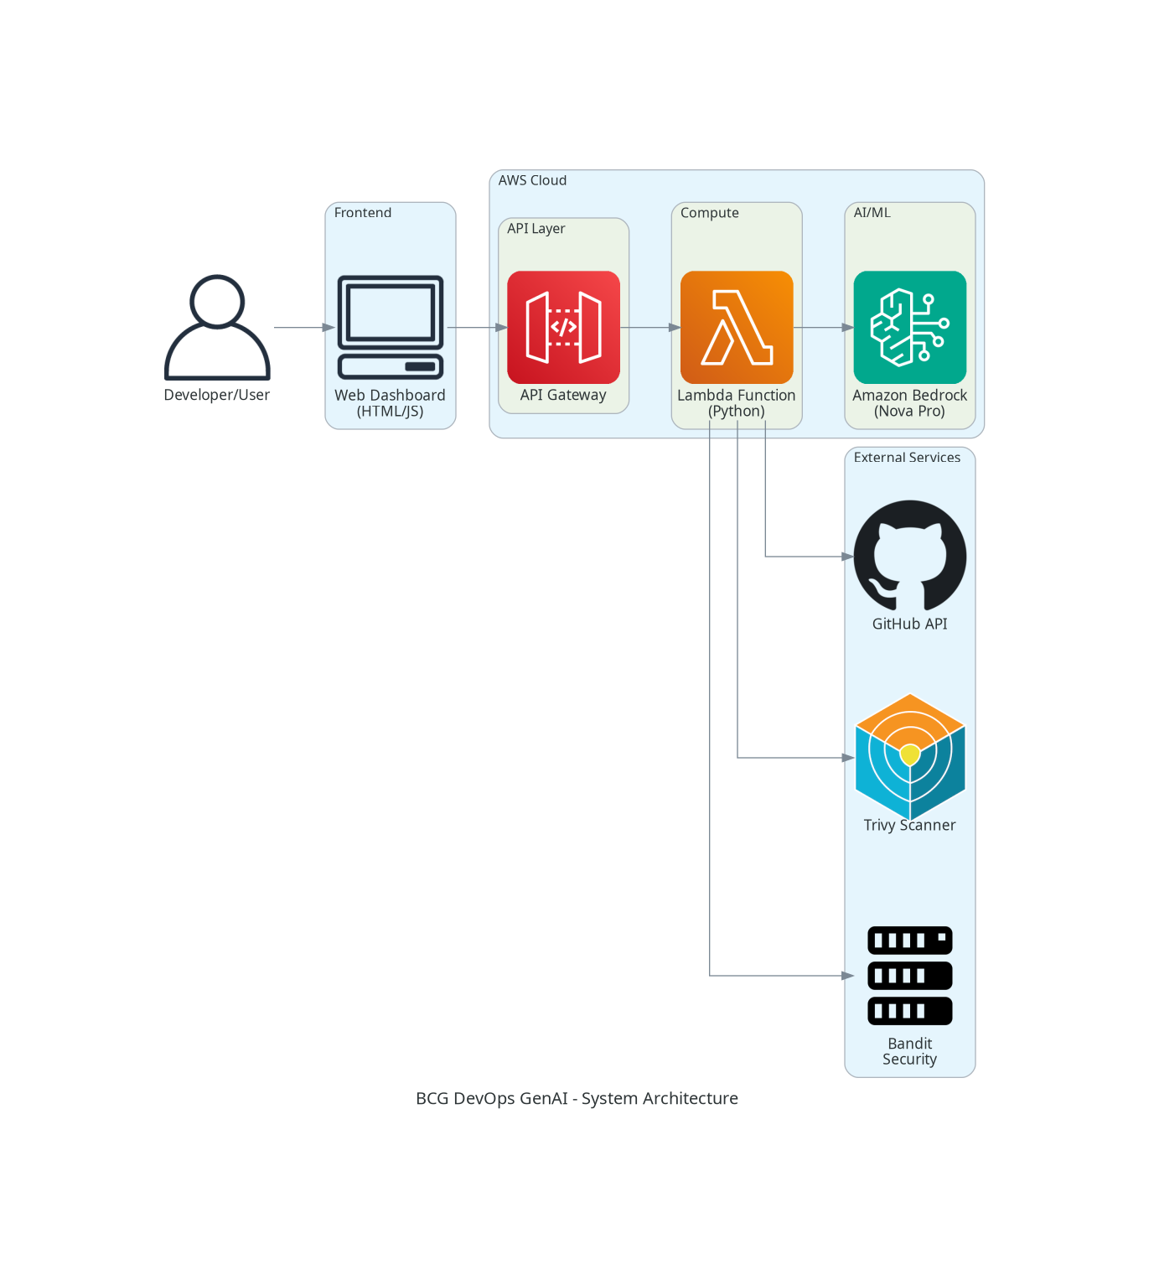
Figure 1: System Architecture Overview

Architecture Components:
Frontend (Web Dashboard): A responsive HTML/JavaScript single-page application that provides an intuitive interface for interacting with the DevOps agent.
API Gateway: AWS API Gateway serves as the entry point, handling REST API requests, authentication, and rate limiting.
Lambda Function: A Python-based serverless function (5,000+ lines) that processes all requests and orchestrates the DevOps workflows.
Amazon Bedrock: Provides the AI backbone using the Nova Pro model for code analysis, generation, and natural language understanding.
GitHub Integration: Direct API integration for repository operations, PR creation, and code management.
Security Tools: Integration with Trivy and Bandit for comprehensive security scanning.

3. Core Components

3.1 Lambda Function (index.py)
The Lambda function is the heart of the system, containing over 5,000 lines of Python code that handles all DevOps operations. Key modules include:
Module | Description
Request Handler | Routes incoming API requests to appropriate handlers
Repository Analyzer | Clones and analyzes GitHub repositories
Code Generator | Uses AI to generate code based on requirements
Security Scanner | Integrates with Trivy and Bandit for vulnerability detection
Auto-Fixer | Generates AI-powered fixes for identified issues
PR Creator | Creates well-documented pull requests on GitHub
Chat Handler | Provides conversational AI interface for DevOps queries
Autonomous Agent | Orchestrates complete DevOps workflows automatically

3.2 AI Integration (Amazon Bedrock)
The system uses Amazon Bedrock's Nova Pro model (amazon.nova-pro-v1:0) for all AI operations. Key AI capabilities include:
- Natural language understanding for parsing user requirements
- Code analysis and pattern recognition
- Vulnerability assessment and prioritization
- Code generation following best practices
- Automated fix generation for security issues
- Contextual conversation for DevOps assistance

3.3 Frontend Dashboard
The frontend is a single HTML file with embedded CSS and JavaScript, providing:
- Repository analysis interface with real-time results
- Code generation with syntax highlighting
- Security scan visualization with severity indicators
- Interactive chat interface for AI assistance
- Pipeline execution controls and monitoring
- Pull request creation and tracking

4. API Endpoints
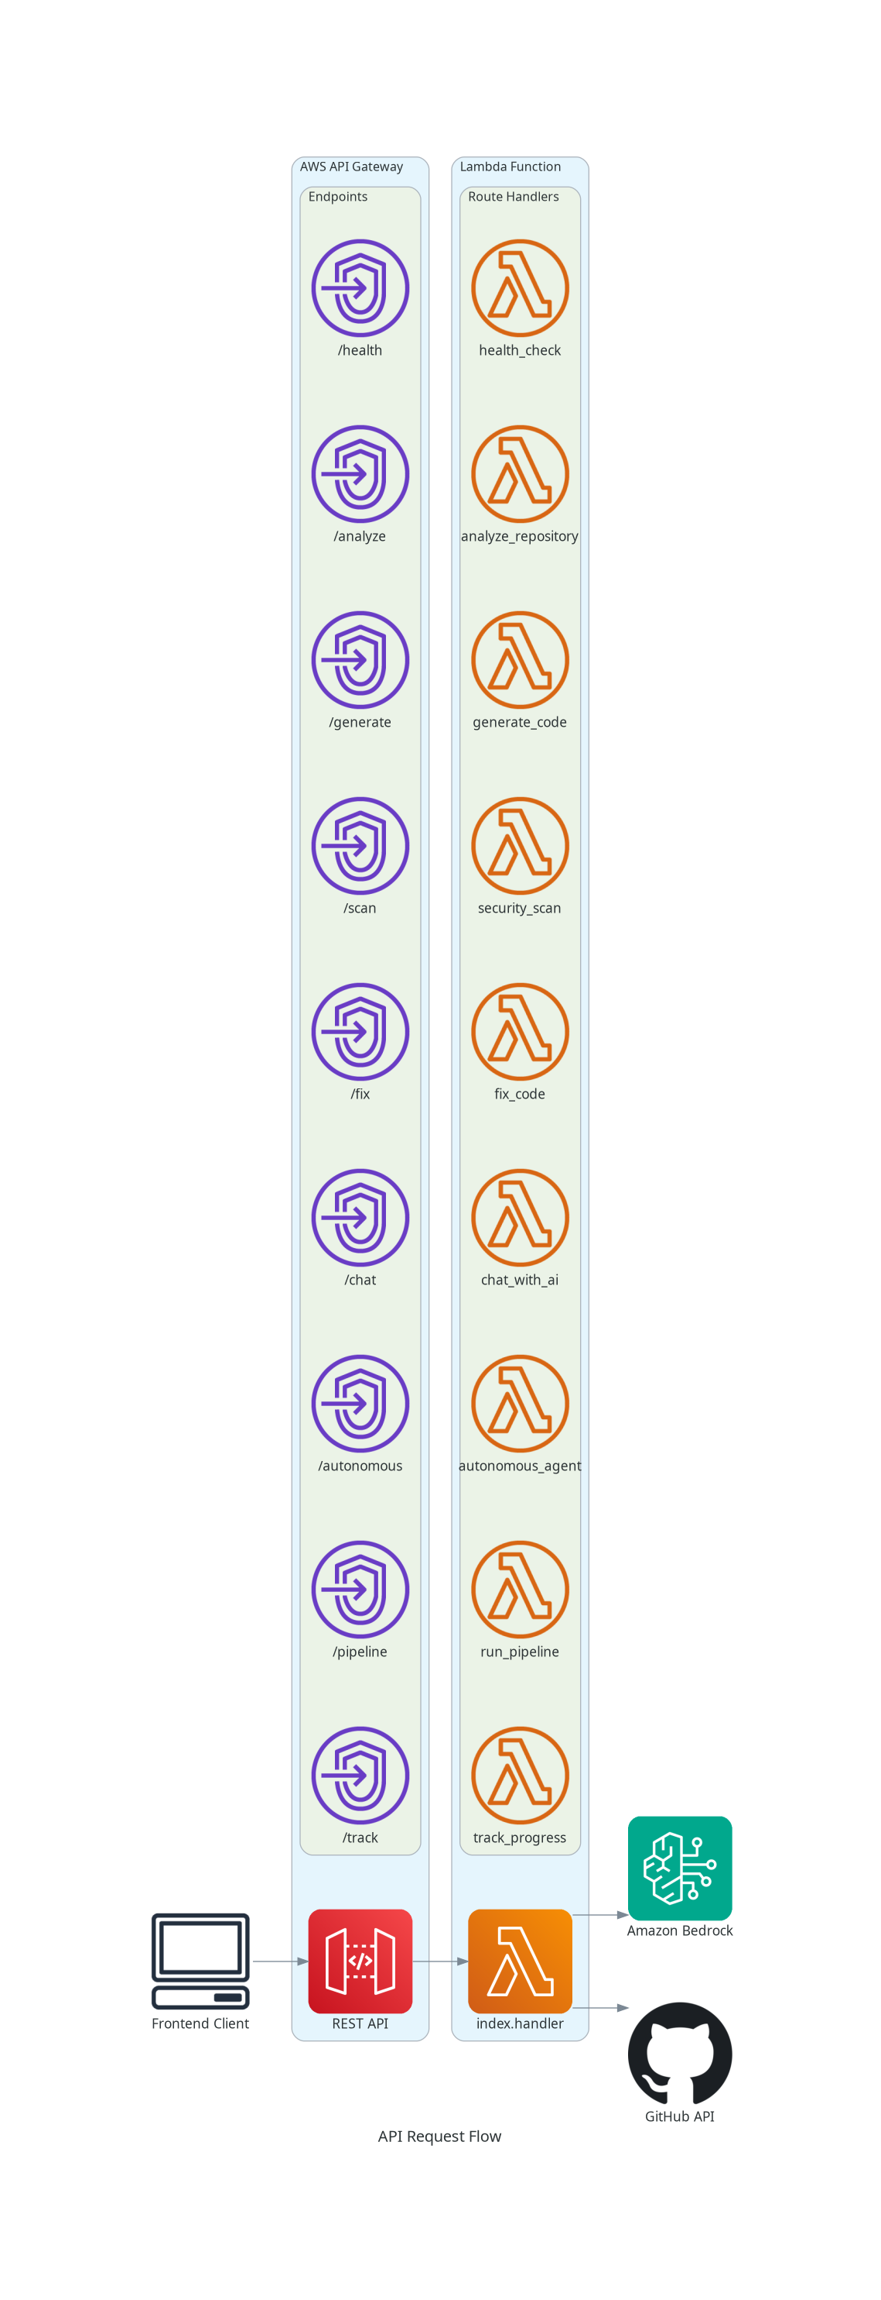
Figure 2: API Request Flow

Base URL: https://4dyb4z9kgk.execute-api.us-east-1.amazonaws.com/prod

Endpoint | Purpose | Description
GET /health | Health check endpoint | Returns system status and version
POST /analyze | Repository analysis | Analyzes a GitHub repository for structure, languages, and patterns
POST /generate | Code generation | Generates code based on natural language requirements
POST /scan | Security scanning | Performs security scan using Trivy and Bandit
POST /fix | Auto-fix vulnerabilities | Generates AI-powered fixes for security issues
POST /chat | AI chat interface | Interactive conversation for DevOps assistance
POST /autonomous | Autonomous agent | Runs complete DevOps workflow automatically
POST /pipeline | Pipeline execution | Executes a complete CI/CD pipeline
POST /track | Progress tracking | Tracks progress of ongoing operations

5. Autonomous DevOps Agent Workflow
The autonomous agent is the flagship feature of this POC, demonstrating how AI can orchestrate complete DevOps workflows without human intervention.

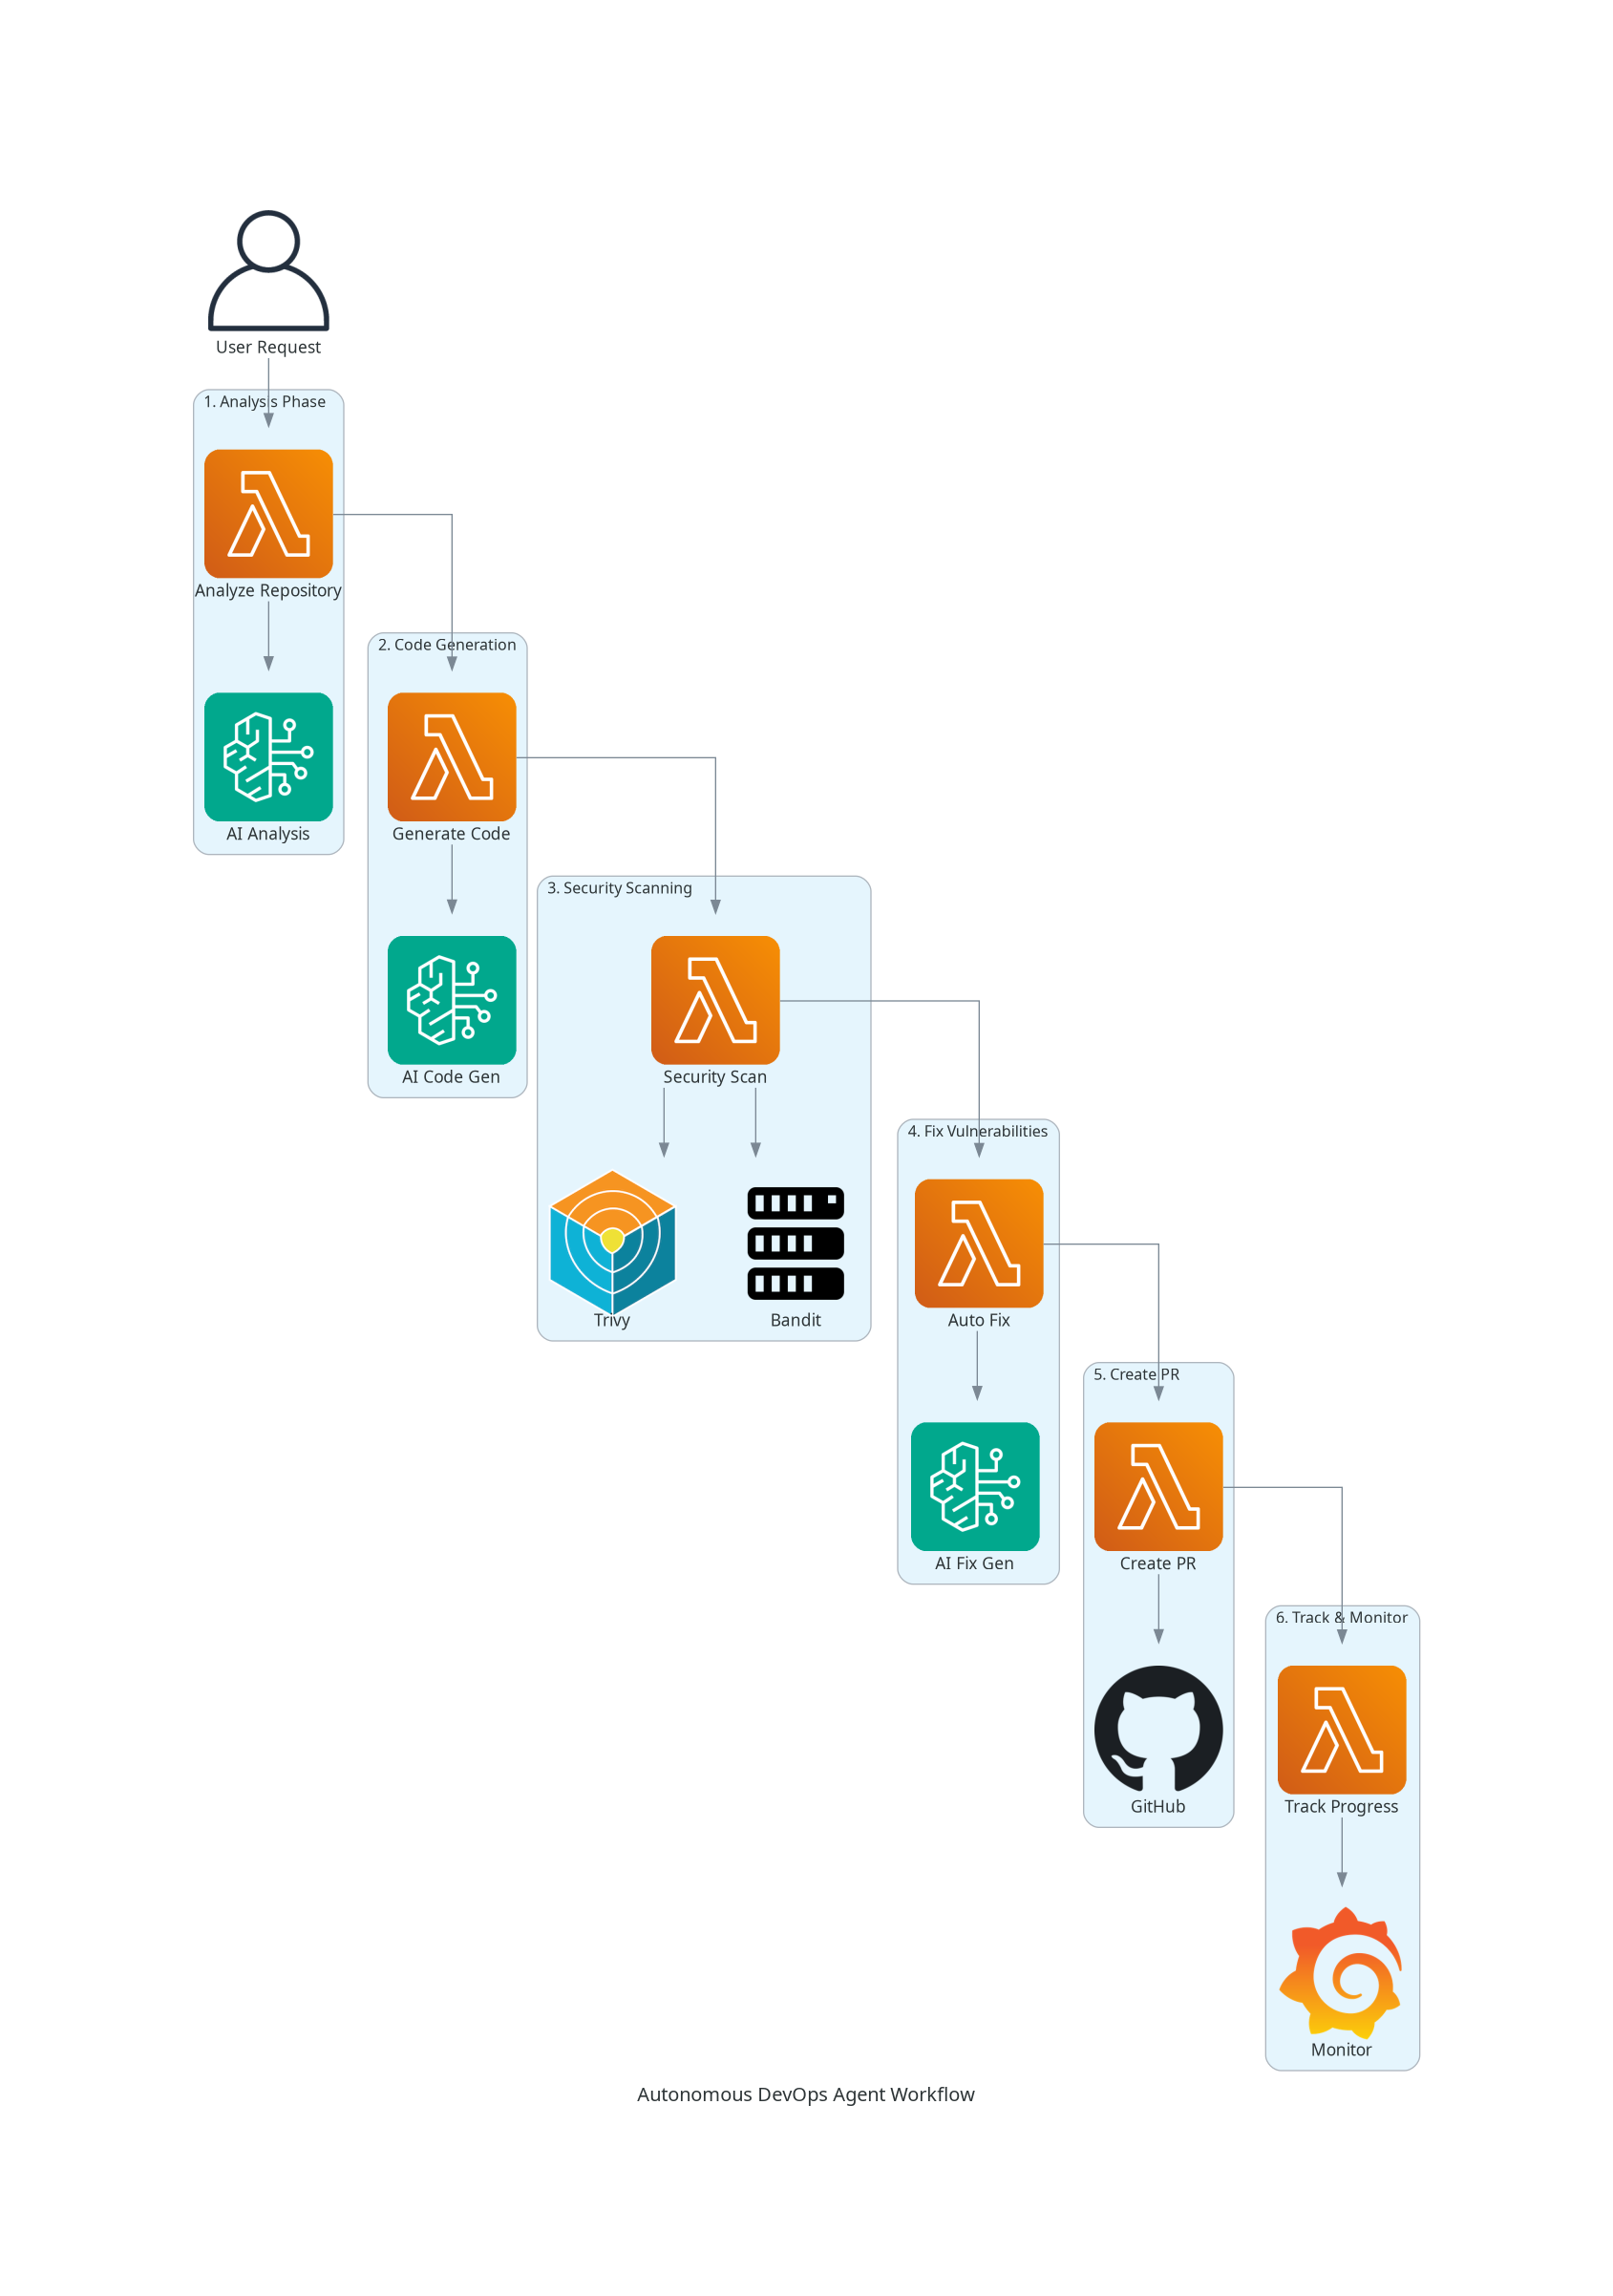
Figure 3: Autonomous Agent Workflow

Workflow Steps:

Step 1: Repository Analysis
The agent clones the target repository and performs comprehensive analysis including:
- Language detection and file structure mapping
- Dependency analysis
- Code pattern identification
- AI-powered code review

Step 2: Code Generation
Based on user requirements or identified needs, the agent:
- Generates new code following project conventions
- Creates necessary configuration files
- Adds appropriate documentation

Step 3: Security Scanning
The agent runs comprehensive security scans:
- Trivy for container and dependency vulnerabilities
- Bandit for Python security issues
- Custom pattern matching for common security anti-patterns

Step 4: Vulnerability Fixing
For each identified vulnerability:
- AI analyzes the root cause
- Generates appropriate fix
- Validates the fix doesn't break existing functionality

Step 5: Pull Request Creation
The agent creates a pull request with:
- Detailed description of changes
- List of fixed vulnerabilities
- Before/after comparisons
- Automated labels and reviewers

Step 6: Tracking & Monitoring
The agent provides:
- Real-time progress updates
- Detailed logs of all operations
- Summary reports of completed actions

6. CI/CD Pipeline Integration
The system integrates seamlessly with GitHub Actions to provide automated CI/CD pipelines.

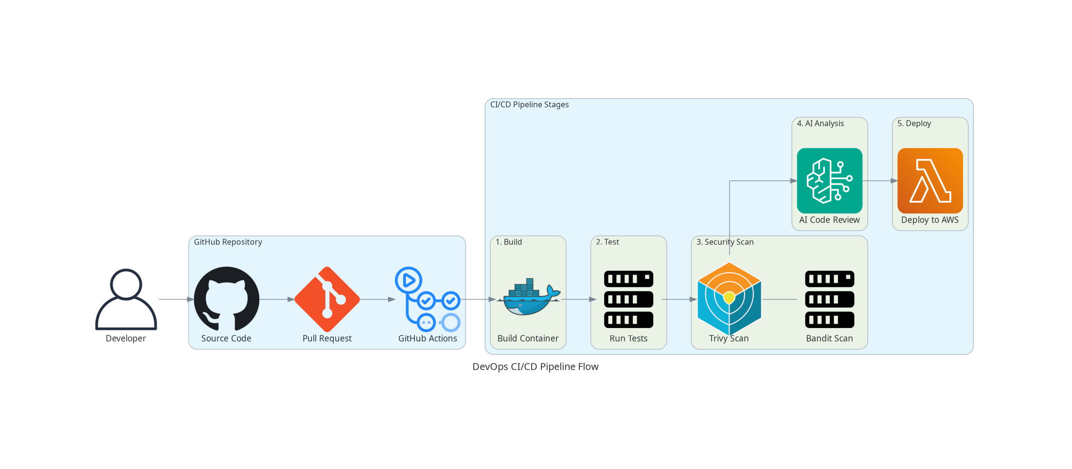
Figure 4: CI/CD Pipeline Flow

Pipeline Stages:
Build: Compiles code and creates container images
Test: Runs unit tests, integration tests, and code quality checks
Security Scan: Performs Trivy and Bandit security scans
AI Analysis: Uses Bedrock to analyze code changes and provide recommendations
Deploy: Deploys to AWS infrastructure using Lambda and API Gateway

7. Security Features

7.1 Trivy Integration
Trivy is a comprehensive vulnerability scanner that checks for:
- Container image vulnerabilities
- Filesystem vulnerabilities
- Git repository issues
- Kubernetes misconfigurations
- Infrastructure as Code (IaC) issues

7.2 Bandit Integration
Bandit is a Python security linter that identifies:
- Hardcoded passwords and secrets
- SQL injection vulnerabilities
- Command injection risks
- Insecure cryptographic practices
- Dangerous function usage

7.3 AI-Powered Security Analysis
Beyond traditional scanning, the AI provides:
- Context-aware vulnerability assessment
- Risk prioritization based on business impact
- Intelligent fix recommendations
- Security best practice suggestions

8. Technology Stack

Cloud Platform
- AWS Lambda
- AWS API Gateway
- Amazon Bedrock
- AWS CloudWatch

AI/ML
- Amazon Nova Pro (v1:0)
- Natural Language Processing
- Code Generation Models

Programming Languages
- Python 3.12
- JavaScript (ES6+)
- HTML5/CSS3

Security Tools
- Trivy
- Bandit
- Custom Security Scanners

Version Control
- Git
- GitHub API
- GitHub Actions

Frontend
- Vanilla JavaScript
- CSS Grid/Flexbox
- Fetch API

9. Deployment Guide

9.1 Prerequisites
- AWS Account with appropriate permissions
- GitHub account and personal access token
- Python 3.12 or later
- AWS CLI configured with credentials

9.2 Lambda Deployment
Deploy the Lambda function with the following configuration:
Setting | Value
Runtime | Python 3.12
Memory | 256 MB
Timeout | 300 seconds (5 minutes)
Handler | index.handler
Required Files | index.py, opensource_tools.py

9.3 Environment Variables
Variable | Description
GITHUB_TOKEN | GitHub personal access token
AWS_REGION | AWS region (e.g., us-east-1)
BEDROCK_MODEL_ID | amazon.nova-pro-v1:0

10. Usage Examples

10.1 Analyzing a Repository
Request:
POST /analyze
{
"repo_url": "https://github.com/owner/repo",
"branch": "main"
}

10.2 Generating Code
Request:
POST /generate
{
"requirement": "Create a Python function to validate email addresses",
"language": "python"
}

10.3 Running Security Scan
Request:
POST /scan
{
"repo_url": "https://github.com/owner/repo",
"scan_type": "full"
}

10.4 Running Autonomous Agent
Request:
POST /autonomous
{
"repo_url": "https://github.com/owner/repo",
"task": "Analyze repository, fix security issues, and create PR",
"create_pr": true
}

Conclusion
The BCG DevOps GenAI POC demonstrates the transformative potential of integrating Generative AI into DevOps workflows. By automating code analysis, security scanning, vulnerability fixing, and pull request creation, this solution significantly reduces manual effort while improving code quality and security posture.

Key benefits include:
- Reduced time from code commit to production deployment
- Consistent security practices across all code changes
- AI-powered insights for better code quality
- Automated documentation and change tracking
- Seamless integration with existing GitHub workflows

This POC serves as a foundation for building more sophisticated AI-powered DevOps solutions that can adapt to specific organizational needs and workflows.

