How much of the stem must a terrestrial laser scanner see? Diameter error as a function of circumferential coverage, and what it means for scan design
Angel Nayaª
ª Independent Researcher, Berlin, Germany
Corresponding author: Angel Naya, Berlin, Germany. E-mail: angel.naya@posteo.de

Abstract
Stem diameters at breast height (DBH) are derived from terrestrial laser scanning (TLS) data by fitting circles or cylinders to stem points, but occlusion leaves each stem partly hidden. Algorithms apply coverage rules — 3DFin accepts a diameter only if at least 9 of 16 angular sectors (202.5°) contain points — yet the required coverage has not been quantified. We combined a Monte Carlo experiment (six estimators, seven perturbations), HELIOS++ simulations of three stands (400–1200 stems ha⁻¹) with geometrically computed visible arc, a stand with branches at breast height, and two open real datasets. For round stems without outliers, 45–180° of visible arc gave a DBH root mean square error (RMSE) ≤ 2 cm; non-circularity raised this to 157.5–202.5° for 40 cm stems; with outliers, only robust estimators reached it. In simulated stands 82 % of stems were within 2 cm at 180–225° and over 90 % beyond 225°; the 3DFin rule corresponds to a median of 190°. Branches in the breast-height band made least-squares fits fail at any coverage, whereas random sample consensus (RANSAC) fitting was unaffected. On 458 real stems Kasa fitting needed 225° for 80 % within 2 cm; with surrounding points left in, only RANSAC approached this. Running 3DFin on twelve real plots with partial coverage, 88 % of accepted diameters were within 2 cm, but about half the stems received a diameter with four to six spread scan positions. Coverage thresholds must be stated per estimator and segmentation quality, rejected stems must be reported, and scan positions should be spread rather than added.
Keywords: Terrestrial laser scanning; Diameter at breast height; Occlusion; Circle fitting; Virtual laser scanning; Scan design

1. Introduction
Terrestrial laser scanning (TLS) was introduced to forestry in the early 2000s for basic tree measurements such as height and diameter and has since become a tool for detailed three-dimensional assessment of forest structure (Calders et al., 2020). In forest inventories, TLS records plot-level point clouds with millimetre detail from which attributes such as stem position and diameter at breast height (DBH) can be derived automatically and repeatedly (Liang et al., 2016). An international benchmark of 18 algorithms applied to identical TLS data showed large differences in accuracy between methods and forest conditions (Liang et al., 2018), and the operational use of TLS in national forest inventories is still being evaluated (Holvoet et al., 2025).
The main limitation of static TLS is occlusion. Stems, branches and understorey hide parts of the plot from each scan position, so that the share of a stem’s circumference that reaches the scanner depends on stand density, the diameter distribution and the placement of the scanner (Abegg et al., 2017). In a comparison across a wide range of forest types and structures, no tree was scanned around its whole cross-section at 1.3 m in single-scan mode and 42 % of the trees in multi-scan mode (Bauwens et al., 2016). The proportion of detected trees decreases with distance from the scanner, following the decrease of visible area (Olofsson et al., 2014), and single-scan data yield markedly fewer detected stems than multi-scan data, particularly in dense, multi-layered stands (Liang et al., 2018). Scan protocols therefore trade coverage against field time; for plot-scale structural modelling, a 10 m × 10 m scan grid has been recommended at a cost of several field days per hectare (Wilkes et al., 2017).
Mobile laser scanning (MLS), from vehicles, backpacks or hand-held personal laser scanners (PLS), records the stand along a continuous trajectory and thereby reduces occlusion (Bauwens et al., 2016; Bienert et al., 2018). A hand-held scanner recorded the full cross-section of 91 % of the trees in the comparison mentioned above (Bauwens et al., 2016), PLS detected more trees than TLS on inventory plots (Gollob et al., 2020c), and hand-held scanning shortened survey time considerably compared with static scanning and conventional fieldwork (Ryding et al., 2015). Since the first demonstrations of personal laser scanning in forests (Liang et al., 2014), backpack, hand-held and under-canopy drone systems have been compared for field reference data (Hyyppä et al., 2020), low-cost devices have been tested as TLS alternatives (Mokroš et al., 2021), and hand-held PLS has been reviewed with a view to operational inventories (Balenović et al., 2021). Mobile systems do not, however, remove the question of coverage. Their coverage is governed by the trajectory, and the density of walking lines affected single-tree estimates from hand-held scanning (Del Perugia et al., 2019). Simulations of hand-held trajectories in complex natural forests showed that occlusion by the surrounding vegetation reduces the point density on stems, lowers detection and increases DBH errors, which makes trajectory design a question of coverage as well (Kuželka, 2025). In all ground-based point clouds, the diameter of a stem is estimated from the part of its circumference that was recorded.
The diameter fitted to a partial arc is poorly constrained. Algebraic circle fits are biased towards small radii on short, noisy arcs (Kåsa, 1976; Al-Sharadqah and Chernov, 2009; Chernov, 2010), and both the scan mode and the circle-fitting method affect stem detection and diameter estimates (Pueschel et al., 2013). Robust approaches such as random sample consensus (RANSAC) reduce the influence of noise (Olofsson et al., 2014). Processing software reacts with coverage rules. 3DFin (Laino et al., 2024) divides the stem cross-section into 16 angular sectors and accepts a diameter only if at least nine sectors contain points, i.e. 202.5° of the circumference, while FORTLS (Molina-Valero et al., 2022) corrects stand-level estimates for occlusion in single-scan inventories.
Previous work has addressed coverage mainly in terms of visibility and detection. Abegg et al. (2017) ray-traced 2740 virtual plots derived from the Swiss national forest inventory and showed that visibility depends on stem number, dominant diameter and the scale of the diameter distribution, and that evenly distributed scan positions give the best visibility; they did not estimate diameters. Gollob et al. (2019) and Ritter et al. (2020) related scanner position layout and plot size to detection rate and diameter accuracy on real inventory plots. Li et al. (2021) introduced the cumulative degree of ring closure (CDRC), the union of the angular sectors of a stem circle that are visible from the scan positions, to optimise scan positions in simulated forests, and noted that accurate DBH estimation requires a CDRC above about 200°. That statement rests on one least-squares estimator, idealised segmentation and simulated stems. How the required coverage depends on the estimator, on non-circular stems and on outliers from branches and understorey, whether it holds for real bark and field-measured DBH, and how it relates to the sector rules used in inventory software has, to our knowledge, not been quantified.
This study therefore asks: (i) how does the DBH error of common estimators depend on the visible arc, and how is this modified by non-circular stems, outliers, branches and registration offsets; (ii) does a sector-based rule such as that of 3DFin correspond to a meaningful coverage threshold, and what does it cost in completeness; and (iii) which scan designs achieve the required coverage in stands of different density? We combine three levels of evidence: a Monte Carlo experiment in which coverage, cross-section shape, outliers and registration errors are controlled; virtual laser scanning of three simulated stands and of one stand with branches at breast height with HELIOS++ (Winiwarter et al., 2022), in which the visible arc of every stem is known geometrically; and two open real datasets, including a run of 3DFin itself on twelve real plots with simulated partial coverage.

2. Methods

2.1 Estimators
All estimators operate on the points $\left(x_{i},y_{i}\right)$, $i=1,…,N$, of one stem in the band 1.05–1.55 m above ground (the cylinder fit uses 1.0–1.6 m); the height coordinate is ignored except by the cylinder fit. The DBH is reported as twice the fitted radius. Six estimators that are common in TLS processing or represent distinct statistical principles were compared.
Kasa fit. The algebraic circle fit of Kåsa (1976) writes the circle as $x^{2}+y^{2}+Dx+Ey+F=0$ and minimises the algebraic residuals
$$\min_{D,E,F}\sum_{i=1}^{N}{{\left(x_{i}^{2}+y_{i}^{2}+Dx_{i}+Ey_{i}+F\right)}^{2}}, \left(1\right)$$
which is a linear least-squares problem with centre $\left(a,b\right)=\left(−D/2,−E/2\right)$ and radius $r=\sqrt{a^{2}+b^{2}−F}$. It is fast and needs no start value, but its implicit weighting of the residuals biases the radius towards small values when the points cover only a short, noisy arc (Al-Sharadqah and Chernov, 2009; Chernov, 2010).
Geometric fit. The geometric fit minimises the orthogonal distances of the points to the circle,
$$\min_{a,b,r}\sum_{i=1}^{N}{{\left(\sqrt{{\left(x_{i}−a\right)}^{2}+{\left(y_{i}−b\right)}^{2}}−r\right)}^{2}}, \left(2\right)$$
solved iteratively from the Kasa solution with the centre bounded to ±0.3 m around the start and the radius to 4–75 cm; a solution on a bound is treated as a failure.
RANSAC. Circle hypotheses are formed from three randomly drawn points (400 iterations), and points within 12 mm of a hypothesis count as inliers (Fischler and Bolles, 1981). A hypothesis is admitted only if its inliers span at least 90° around its centre, which prevents small circles through dense clusters of points on a short arc from winning; the final estimate is a Kasa fit to the inliers of the best admitted hypothesis.
Cylinder fit. The axis direction is optimised (Nelder–Mead, tilt limited to 15°) so that the circle fitted in the plane normal to the axis has minimal residual spread; this removes the elliptical distortion that a tilted stem produces in a horizontal slice. A solution at the tilt limit is treated as a failure.
Huber-robust fit. The geometric objective (2) is replaced by the Huber loss of the orthogonal residuals $e_{i}$,
$$ρ\left(e\right)=\left\{\begin{matrix}e^{2}/2, & \left|e\right|≤c \\ c \left(\left|e\right|−c/2\right), & \left|e\right|>c\end{matrix}\right. \left(3\right)$$
with $c=1$ cm, so that residuals larger than the scale enter linearly instead of quadratically; start values and bounds as for the geometric fit.
Hough transform. The circle Hough transform of scikit-image (hough_circle with normalised accumulators; van der Walt et al., 2014) is applied to a binary raster of the points, coarse-to-fine: first on a 1 cm raster over radii of 4–75 cm, with the accumulator extended beyond the image so that centres of short arcs may lie outside the point extent, then on a 2.5 mm raster within ±1.5 cm of the coarse radius. The strongest accumulator cell is taken.
No parameter of any estimator was tuned to the data. Implementations: dbh_methods.py and arc_error_mc_real.py (Naya, 2026; see Data availability). For comparison with inventory software, the 3DFin acceptance rule is evaluated as the number of occupied 22.5° sectors around the stem centre in a 10 cm slice at 1.3 m.

2.2 Monte Carlo experiment
A stem of DBH 20 or 40 cm is observed on one contiguous arc θ ∈ {45, 67.5, …, 360°} with N = 200 or 1000 points uniformly distributed over the arc and a 0.6 m height band, radial Gaussian noise σ = 5 mm (2 and 10 mm in the ideal case). Seven scenarios: ideal; non-circular (elliptical cross-section, axis ratio U(0.85, 1), random orientation; true DBH = perimeter/π, tape definition); 5 % / 15 % outliers (points 2–30 cm outside the surface, as from twigs, foliage or understorey in front of the stem); 5 / 10 mm registration offset (the second half of arcs > 90° shifted, mimicking a second scan position); combined (non-circular + 5 % outliers + 5 mm offset). 100 replicates per cell (300 for the ideal grid). As a reference for the best achievable precision, the Cramér–Rao lower bound for the radius is computed for the ideal model. With the residual derivatives $g_{i}=\left(−cosφ_{i},−sinφ_{i},−1\right)$ with respect to $\left(a,b,r\right)$ at the point angles $φ_{i}$ spread uniformly over the arc, the Fisher information is
$$J=σ^{−2}\sum_{i=1}^{N}{g_{i}^{T}}g_{i}, SD\left(\hat{r}\right)≥\sqrt{{\left(J^{−1}\right)}_{33}}. \left(4\right)$$
The bound grows rapidly as the arc shortens, because the centre and the radius become nearly interchangeable on a short arc. Code: scripts/arc_error_mc.py, scripts/arc_error_mc_real.py.

2.3 HELIOS++ simulation
Three 40 × 40 m core plots with a 10 m buffer were generated (scripts/paperC_scene.py): S1a 400 stems ha⁻¹ (DBH drawn from 38 ± 11 cm), S1b 800 ha⁻¹ (30 ± 9 cm), S1c 1200 ha⁻¹ (24 ± 7 cm); random positions with a minimum gap of 10 cm. Stems are 4 m elliptical cylinders (axis ratio U(0.85, 1), 32 segments, rings every 0.25 m with ±3 mm bark roughness); crowns were omitted because only the breast-height cross-section is analysed. Scans were simulated with HELIOS++ 2.2.2 (Winiwarter et al., 2022) using the RIEGL VZ-400 model (5 mm range accuracy, 0.3 mrad divergence), tripod height 1.5 m, 0.06° angular resolution, vertical field −30° to +5°. Each scene has a pool of 40 positions (5 × 5 grid at 8 m spacing plus 15 random); each position is simulated once and the configurations are assembled offline: n ∈ {1, 2, 3, 4, 6, 9} positions as (a) a spread grid subset (greedy max–min from the centre), (b) 10 random draws from the pool, (c) the n positions closest to the plot centre (“clustered”). Stem points are assigned by the HELIOS object identifier, i.e. segmentation is perfect, isolating coverage and fitting from detection.
The stems of S1a–S1c carry no branches. To test the effect of branches at breast height, a fourth scene S1b-B repeats S1b with identical stems, positions and scan pool and adds branches as thin tapered cylinders (Poisson(6) per stem, attachment height 0.5–3.0 m, inclination −10° to +50°, length 0.3–2.0 m, base diameter 1.5–5 cm). Branches belong to the stem object, so their points enter the stem point set as they would after a real stem segmentation; in the core plot 88 % of the stems have at least one branch crossing the 1.05–1.55 m band (median 2).
Occupied-sector counts and fine angular bins both depend on point density. As a density-independent measure of coverage we therefore compute the geometrically visible arc: for 360 points on the true elliptical perimeter at 1.3 m, a point counts as visible from a position if it faces it (cosine of incidence > 0.1) and the line of sight does not intersect another stem; the union over the positions of a configuration gives the visible arc (scripts/paperC_eval.py). Formally, with $v_{k}\left(ψ\right)∈\{0,1\}$ indicating whether the perimeter point at angle $ψ$ is visible from position $k$, the visible arc of a configuration $K$ is
$$θ_{vis}=\frac{{360}^{∘}}{360}\sum_{j=1}^{360}{\max_{k∈K}}v_{k}\left(ψ_{j}\right). \left(5\right)$$
This is the CDRC of Li et al. (2021), here evaluated on the true elliptical perimeter.

2.4 Real point clouds
Two open datasets were used. SegmentedForests (Laino et al., 2026; MIT licence) provides TLS point clouds of 14 plots with point-wise semantic labels; 12 plots were used (plot 08 was omitted because of its size, plot 09 could not be downloaded). Stem points (class 3) at 1.0–1.6 m above ground were clustered into stems, and 458 stems with at least 330° observed coverage (1° bins) and at least 300 points served as references. As no field DBH is available, the reference DBH of each stem is the median of the Kasa, geometric, RANSAC and cylinder estimates on all of its points (at least three valid). LAUT (Gollob et al., 2020a, b; CC BY 4.0) contains TLS scans (Faro Focus3D X330) of 17 Austrian inventory plots with field-measured DBH (1 908 trees, median 15.6 cm) and tree positions. Here all points within DBH/2 + 25 cm of the field position were taken as the stem’s points, i.e. without any segmentation; field positions and fitted centres agree to 6 cm (median). Breast-height bands were extracted with ext_band.py.
In both datasets, coverage was reduced artificially for well-covered stems by retaining one contiguous arc at random orientation (12 arcs from 45° to 360° for SegmentedForests; 7 arcs from 90° to 360° for the 460 LAUT trees with at least 330° observed coverage; 5 repetitions each), and the six estimators were applied to the retained points. For SegmentedForests this was done with the stem points only and, in a second variant, with all non-stem points within 30 cm of the stem surface added, as from branches and understorey.

2.5 3DFin on real plots with reduced coverage
To test the complete pipeline rather than isolated circle fits, 3DFin 0.6.0 (Laino et al., 2024) was run on the complete SegmentedForests plot clouds (12 plots, 2 cm voxel thinning) with the dataset authors’ 3DFin settings (paperC_3dfin_real.py). The run on the full multi-scan cloud defines the reference: stems with an accepted DBH. Reduced coverage was then produced by virtual scan positions (1, 2, 3, 4 and 6 positions spread on a grid by greedy max–min, and 4 clustered near the plot centre) and a stem-occlusion model: a point is kept if it lies on the facing side of its own stem and the line of sight from at least one position does not cross another stem (all full-cloud detections act as occluders). Branches and foliage do not occlude in this model, so coverage is, if anything, overestimated in 3DFin’s favour. 3DFin was rerun with the same settings on each reduced cloud; per reference stem we record the geometric visible arc (as in Section 2.3), detection (a 3DFin stem within 0.5 m), acceptance (non-zero DBH) and the DBH difference to the full-coverage 3DFin value.

2.6 Metrics
For each estimator and class of visible arc, the error of a DBH estimate is $e=\hat{DBH}−{DBH}_{ref}$, where the reference is the true perimeter-based DBH in the simulations, the full-coverage estimate on SegmentedForests and the field measurement on LAUT. Bias and root mean square error (RMSE) are computed over all successful estimates,
$$bias=\frac{1}{n}∑e_{j}, RMSE=\sqrt{\frac{1}{n}∑e_{j}^{2}}, \left(6\right)$$
and the failure rate is the share of cases in which an estimator returned no value. The share of stems within ±2 cm counts failures as outside, so that an estimator cannot improve its score by refusing difficult stems. The 2 cm level corresponds to the DBH accuracy of 1–2 cm that the international TLS benchmark found achievable (Liang et al., 2018).
In the Monte Carlo experiment, a coverage threshold is the smallest arc from which RMSE ≤ 2 cm, |bias| ≤ 1 cm and failure ≤ 10 % hold for all larger arcs. For the share within 2 cm we additionally report the smallest arc class from which at least 80 % of the stems are within 2 cm. Because the same stem appears in many scan configurations and arc reductions, cases are not independent; 95 % confidence intervals for the shares and for the 80 % point were therefore obtained by a cluster bootstrap that resamples stems with replacement and keeps all cases of a drawn stem together (B = 300; scripts/paperC_bootstrap.py).

3. Results

3.1 Monte Carlo
Under the ideal model all least-squares estimators approach the Cramér–Rao bound for arcs ≥ 135°. On short arcs the Kasa, RANSAC and cylinder fits are biased low (DBH 40 cm, N = 200: −2.4 cm at 90°, −7.1 cm at 67.5°), whereas the geometric fit stays unbiased (RMSE 0.8 cm at 90°); coverage thresholds of the least-squares and RANSAC fits are 45–135° at σ ≤ 5 mm and up to 180° at σ = 10 mm, depending on estimator and N (Fig. 1a); Hough needs 180–225°.
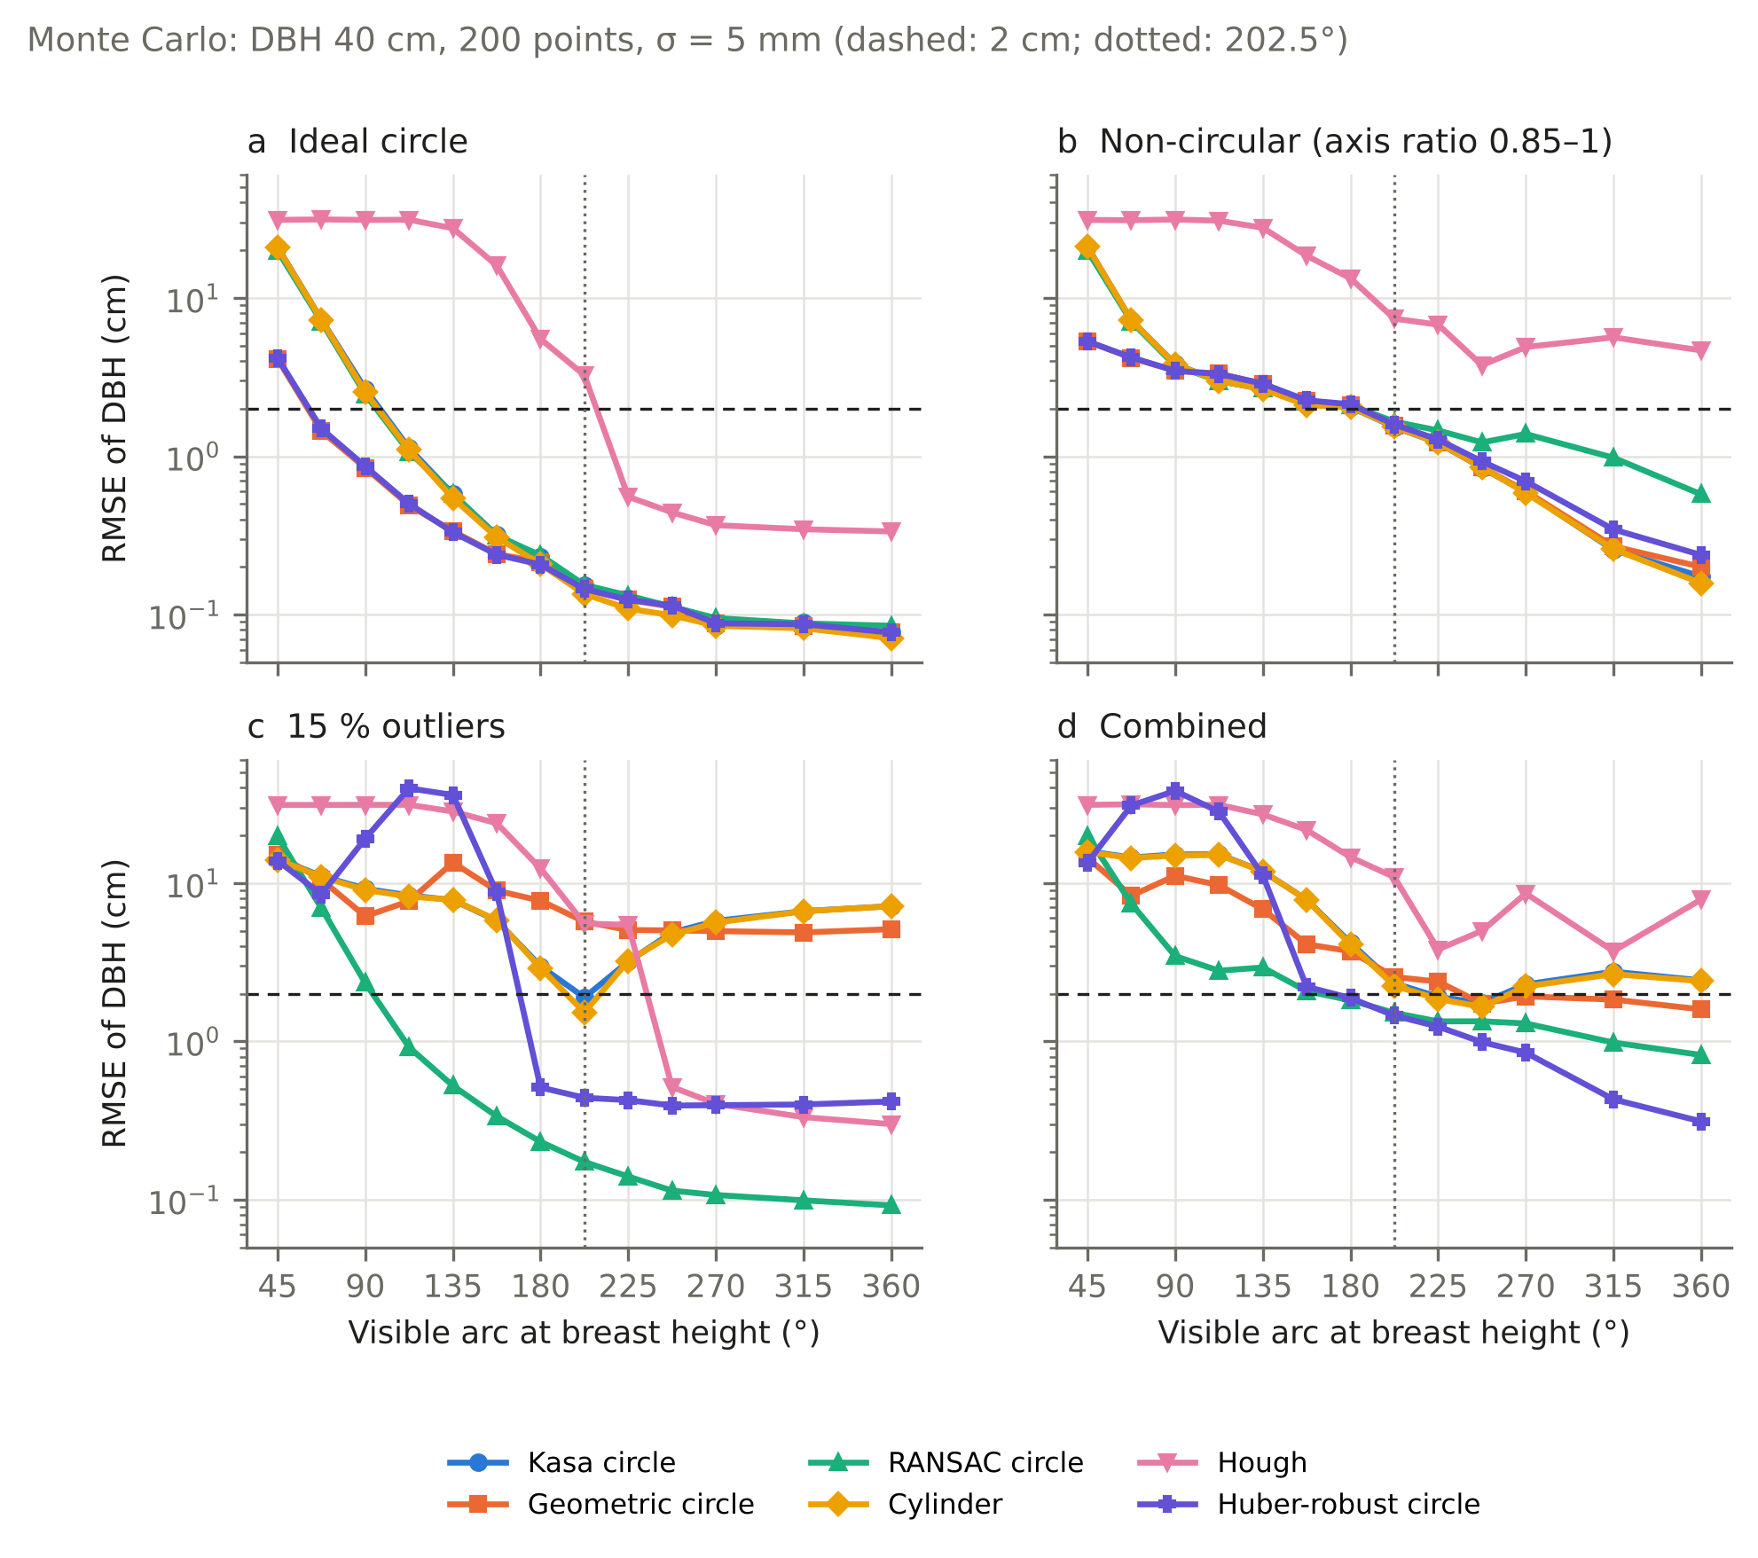
Figure 1. Monte Carlo experiment: RMSE of DBH versus visible arc for six estimators (DBH 40 cm, 200 points, σ = 5 mm). (a) ideal circle, (b) non-circular cross-section (axis ratio 0.85–1), (c) 15 % outliers, (d) combined perturbations. Dashed line: 2 cm; dotted line: 202.5° (3DFin sector rule).
Non-circularity shifts the thresholds of the least-squares, RANSAC and Huber fits to 157.5–202.5° for DBH 40 cm and to 90–135° for DBH 20 cm: a partial view of an ellipse yields a systematically wrong circle, an error that grows with diameter (Fig. 1b). Registration offsets of 5–10 mm set an RMSE floor of 0.2–0.5 cm at full coverage but barely change thresholds.
Table 1 summarises the coverage thresholds of all estimators and scenarios. Outliers dominate everything else (Fig. 1c). With 5–15 % outliers, Kasa, geometric and cylinder fits never meet the threshold, even at 360° (RMSE 1.6–8.6 cm). RANSAC meets it from 112.5–135°, the Huber-robust fit only from 135–270° (it fails on short arcs because its Kasa starting value is already biased), Hough from 180–247.5°. Hough tolerates outliers but not non-circularity: for DBH 40 cm it never meets the threshold on elliptical stems (RMSE at full coverage 4.7 cm with 200 points, 2.0 cm with 1000), and below 135° it fails in 29–100 % of cases. In the combined scenario only RANSAC (135–180°) and the Huber fit (180–225°) reach the threshold for both diameters; Hough only for DBH 20 cm (202.5°).
Scenario | Kasa | Geometric | RANSAC | Cylinder | Huber | Hough
Ideal | 112.5–135 | 45–67.5 | 112.5–135 | 112.5–135 | 45–67.5 | 180–225
Non-circular | 135–202.5 | 90–202.5 | 135–202.5 | 135–202.5 | 90–202.5 | 202.5*
5 % outliers | never | never | 112.5–135 | never | 135–270 | 180–225
15 % outliers | never | never | 112.5–135 | never | 157.5–270 | 202.5–247.5
5 mm offset | 135 | 45–67.5 | 112.5–135 | 135 | 45–67.5 | 180–202.5
10 mm offset | 135 | 45–67.5 | 112.5–135 | 135 | 45–67.5 | 180–360
Combined | never | never | 135–180 | never | 180–225 | 202.5*
Table 1. Coverage thresholds (°) in the Monte Carlo experiment: smallest arc from which RMSE ≤ 2 cm, |bias| ≤ 1 cm and failure ≤ 10 % hold for all larger arcs, at σ = 5 mm. Ranges span DBH 20 and 40 cm and N = 200 and 1000 points. “never”: threshold not reached at any arc up to 360°; *: reached only for DBH 20 cm.

3.2 HELIOS++: error versus visible arc
Pooled over the three stands (26 712 cases; 56, 130 and 185 core stems), the RMSE of Kasa, cylinder and RANSAC falls from 9–17 cm below 90° to 1.6–1.7 cm at 180–225° and 0.5–0.8 cm beyond 315°; Hough remains worst throughout (13.7 cm at 180–225°, 2.1 cm beyond 315°; Fig. 2a). The share of stems within 2 cm rises from 45–46 % at 90–135° (RANSAC 56 %) to 82 % at 180–225°, 93 % at 225–270° and 98–99 % beyond 270° for the Kasa and cylinder fits; RANSAC stays slightly lower beyond 225° (89–94 %) (Fig. 2b). Thicker stems need more coverage: at 180–225° RMSE is 2.0 cm in S1a (mean DBH 37 cm) versus 1.5–1.7 cm in S1b and S1c, consistent with the non-circularity effect in the Monte Carlo experiment (Section 3.1). A single scan position sees at most 172° of a stem (median 164°).
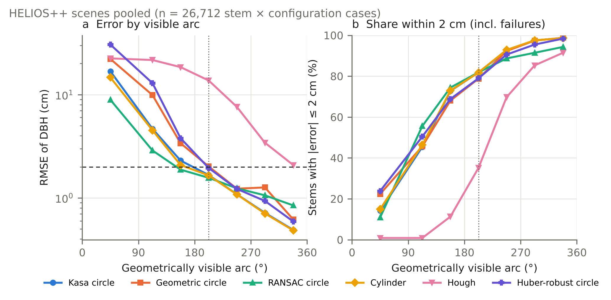
Figure 2. HELIOS++ simulations, three stands pooled (26 712 stem × configuration cases). (a) RMSE of DBH and (b) share of stems within ±2 cm (failures counted as outside) versus geometrically visible arc.
With the same stems and scan positions as S1b but branches crossing the breast-height band (S1b-B), the least-squares fits collapse: at 225–270° visible arc only 11 % (Kasa), 10 % (geometric), 9 % (cylinder) and 26 % (Huber) of stems are within 2 cm, and at most 19–43 % beyond 270°; the median error above 180° is +15 to +42 cm because branch points pull the circle outwards. RANSAC is practically unaffected (71 %, 79 % and 89 % at 135–180°, 180–225° and 225–270°, versus 73 %, 80 % and 90 % without branches). Hough degrades (43 % instead of 70 % at 225–270°; Fig. 3).
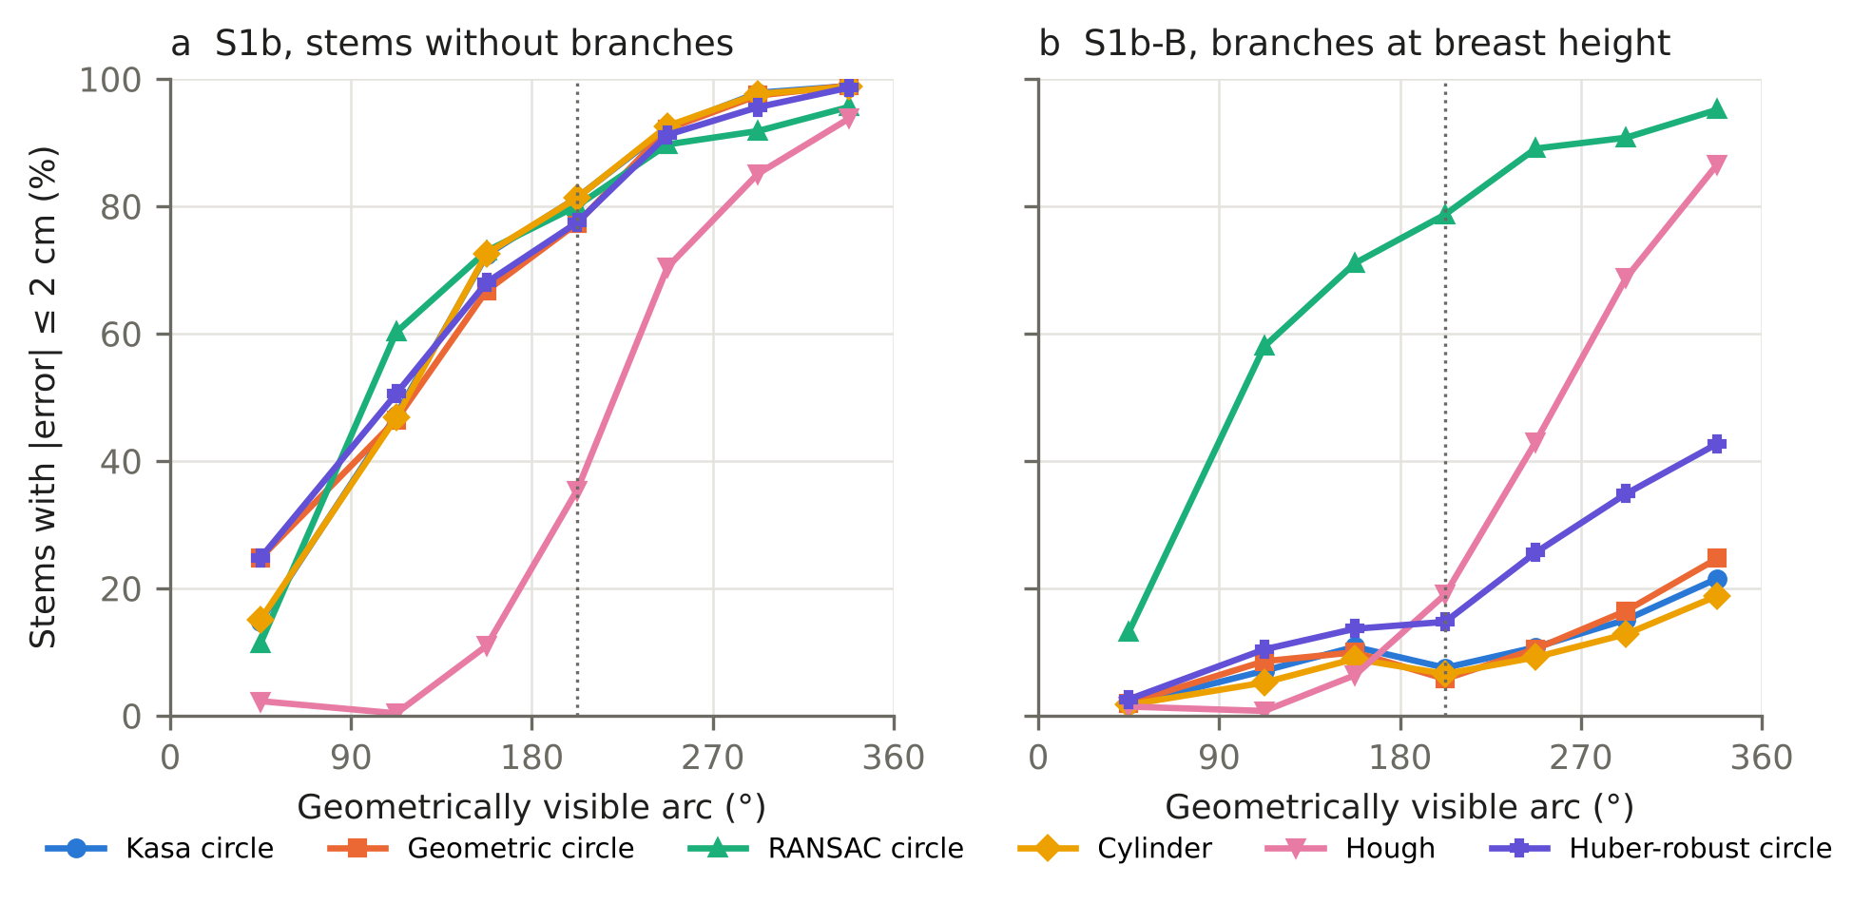
Figure 3. Effect of branches at breast height: share of stems within ±2 cm versus geometrically visible arc in (a) stand S1b and (b) the same stand with branches crossing the 1.05–1.55 m band (S1b-B); stem and branch points are segmented together, as after a real stem segmentation. Dotted line: 202.5°.
Table 2 lists the 80 % points for all datasets. The cluster bootstrap places the 80 % point of the Kasa, cylinder and RANSAC fits in the 180–225° class for the pooled HELIOS stands (95 % CI: 180–225° to 225–270°), of the geometric and Huber fits one class higher, and of Hough in the 270–315° class. With branches, RANSAC reaches 80 % in the 225–270° class (CI 180–225° to 225–270°), Hough only beyond 315°, and the least-squares and Huber fits never.
Dataset | Kasa | Geometric | RANSAC | Cylinder | Huber | Hough
HELIOS, three stands (371 stems) | 180–225 (180–225 to 225–270) | 225–270 (180–225 to 225–270) | 180–225 (180–225 to 225–270) | 180–225 (180–225 to 225–270) | 225–270 (180–225 to 225–270) | 270–315 (270–315)
HELIOS, branches (130 stems) | – | – | 225–270 (180–225 to 225–270) | – | – | 315–360 (315–360)
SegmentedForests, stem points (458 stems) | 225 (225–270) | 270 (270–315) | 315 (315) | 270 (270) | 315 (270–315) | –
SegmentedForests, with surroundings (458 stems) | – | – | 360 (315–360) | – | – | –
LAUT, field DBH (460 trees) | – | – | – | – | – | –
Table 2. Smallest visible arc (°) from which at least 80 % of the stems are within ±2 cm, with 95 % cluster-bootstrap confidence interval in brackets. HELIOS values are classes of geometrically visible arc; real-data values are retained arcs. “–”: 80 % not reached at any arc.

3.3 Stem diameter, distance and point density
In the pooled HELIOS stands (371 core stems: 78 below 20 cm DBH, 164 of 20–30 cm, 93 of 30–40 cm and 36 of 40 cm or more), larger stems needed more visible arc for the same accuracy. At 180–225°, 89 % of the stems below 20 cm were within 2 cm with the Kasa fit, compared with 85 %, 75 % and 70 % in the three larger classes, and the RMSE rose from 1.2 cm to 1.6, 1.8 and 2.3 cm. At 225–270° the shares were 94 %, 96 %, 91 % and 80 %, and beyond 270° all classes reached at least 93 %. The dependence on diameter follows from the non-circularity of the simulated cross-sections: the same relative deviation from a circle produces a larger absolute error on a thick stem, as in the Monte Carlo experiment (Section 3.1), where non-circularity raised the thresholds for 40 cm stems far more than for 20 cm stems (Table 1).
The visible arc decreased with the distance between a stem and the nearest scan position of a configuration: its median was 284° for stems closer than 5 m, 259° at 5–10 m, 210° at 10–15 m and 168° beyond 15 m. The number of points in the 10 cm slice at breast height fell even more steeply, from a median of 1 903 to 604, 215 and 51 points. At a given visible arc, however, accuracy hardly depended on distance or point count. At 180–225°, 87 %, 83 %, 81 % and 79 % of the stems were within 2 cm in the four distance classes, and the share varied only between 80 % and 83 % across point counts from fewer than 50 to more than 500. Once a few dozen points are available, the error is therefore controlled by the visible arc rather than by point density or range.

3.4 Sector rule and scan design
The 3DFin rule of ≥ 9/16 sectors corresponds to a median geometric arc of 190° at exactly nine sectors (Fig. 4); 7.2 % of accepted stems have less than 180° visible. Used as an acceptance filter, the rule separates stems with 92 % (Kasa) of estimates within 2 cm from those with 53 % — it sits close to the arc at which errors become small in these simulations.
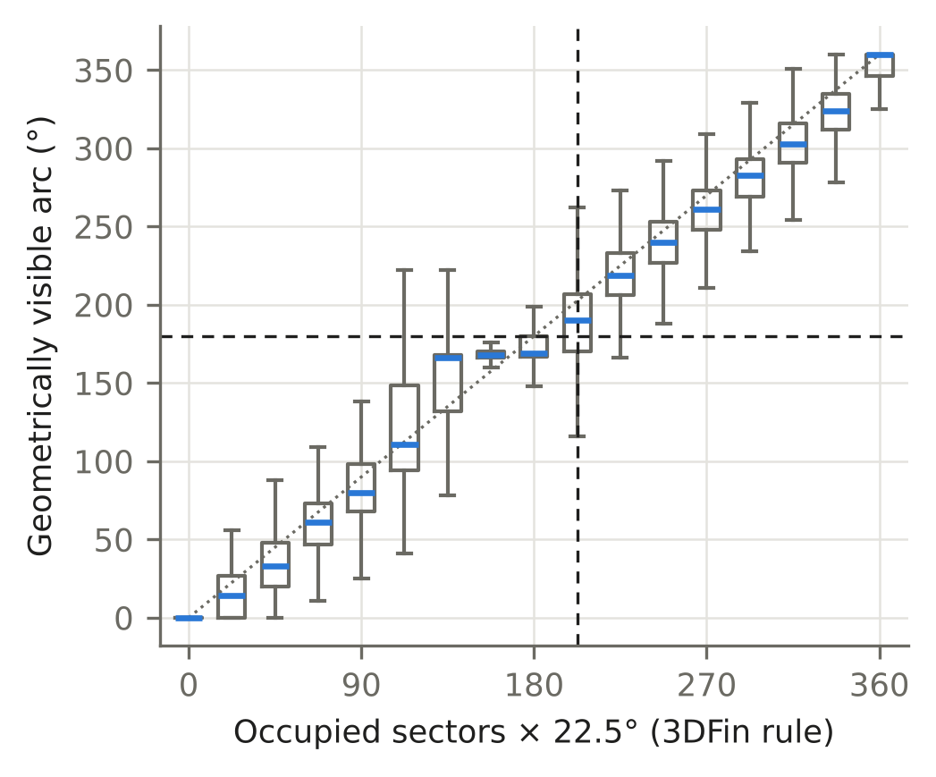
Figure 4. Occupied 22.5° sectors (3DFin rule) versus geometrically visible arc in the HELIOS++ simulations; boxes show quartiles, whiskers 1.5 IQR. Dashed lines: 202.5° sector rule and 180° visible arc.
Coverage depends more on the spread than on the number of positions (Fig. 5). Four grid positions bring 89 %, 82 % and 80 % of stems above 180° in the three stands; six bring 96–98 %. Four positions clustered near the centre reach 89 %, 71 % and 56 %, i.e. the penalty of clustering grows with stand density. Random placement performs close to the grid.
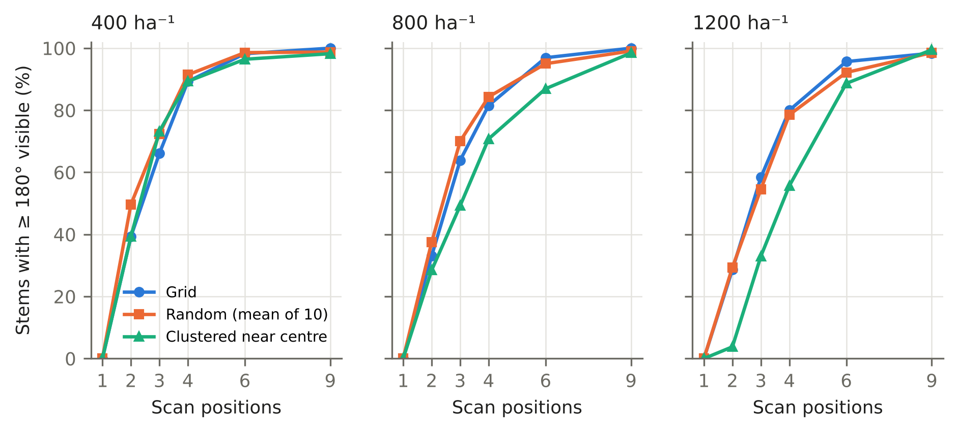
Figure 5. Share of stems with ≥ 180° visible arc versus number of scan positions for grid, random (mean of 10 draws) and clustered placement in stands of 400, 800 and 1200 stems ha⁻¹.

3.5 Real point clouds
The real multi-scan clouds themselves do not guarantee full coverage. Of the 1 908 LAUT trees, the observed coverage around the fitted centre (5° classes) had a median of 265°; 82 % of the trees were covered on at least 180° and 24 % on at least 330°, so that only about a quarter of the trees could serve for the arc reduction.
With stem points only (SegmentedForests, Fig. 6a), the Kasa fit reaches 56 % of stems within 2 cm at 180°, 72 % at 202.5°, 82 % at 225° and 91 % at 270°; its RMSE falls from 6.1 cm at 135° to 2.9 cm at 202.5° and 1.5 cm at 270°, with a negative bias on short arcs (−4.4 cm at 135°, −1.0 cm at 202.5°) as predicted by the Monte Carlo experiment. On these thinner stems (median DBH 16 cm), real bark shifts the 80 % point from about 180° (HELIOS) to about 225°. RANSAC with a 12 mm inlier tolerance is weaker on clean real stems (87 % at 360°), because rough bark excludes valid points. Hough reaches only 58 % even at 360°.
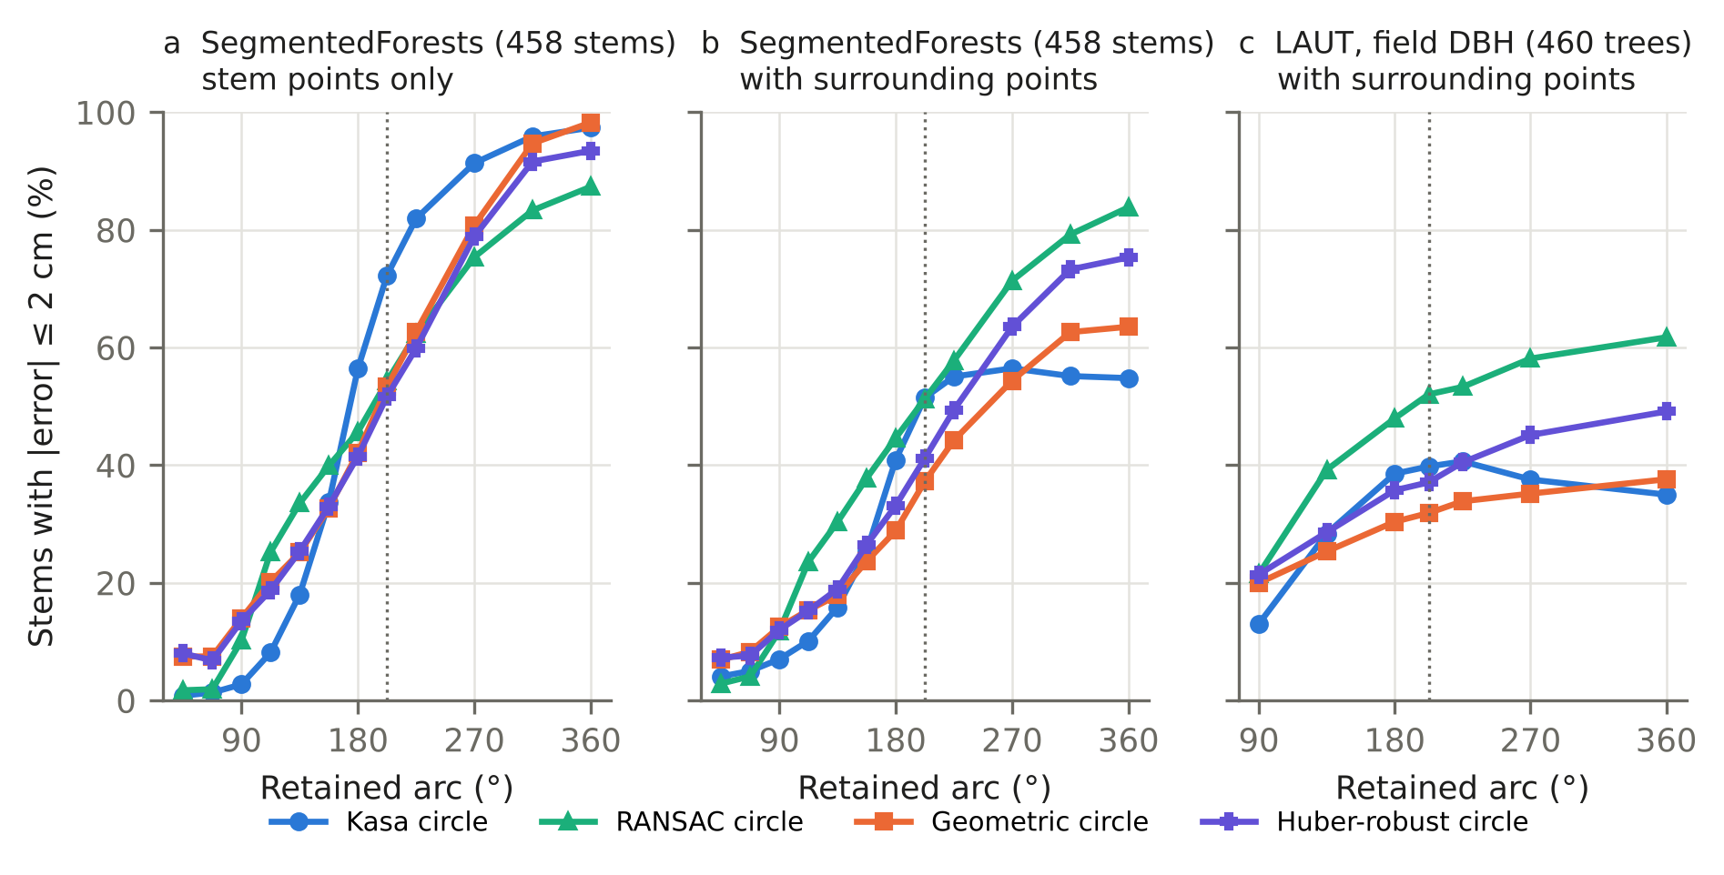
Figure 6. Real point clouds, share of stems within ±2 cm versus retained arc. (a) SegmentedForests, stem points only (458 stems, reference: fit on full coverage); (b) the same stems with surrounding points within 30 cm; (c) LAUT, 460 well-covered trees against field DBH, with surrounding points within 25 cm.
When branches, understorey and unlabelled points within 30 cm (SegmentedForests) or 25 cm (LAUT) remain (Fig. 6b, c), the least-squares fits saturate: at full coverage only 55 % (Kasa) and 64 % (geometric) of SegmentedForests stems are within 2 cm, and 35–38 % of LAUT trees against field DBH. RANSAC rises with coverage to 84 % (SegmentedForests) and 62 % (LAUT) and is the best estimator from about 112° on, reproducing the outlier scenario of the Monte Carlo experiment (Section 3.1) on real data. The lower LAUT values include field-measurement error and the absence of any segmentation. Bootstrap 80 % points (95 % CI) on SegmentedForests: Kasa 225° (225–270°), cylinder 270° (270°), geometric 270° (270–315°), RANSAC and Huber 315° (270–315° for Huber); with surrounding points only RANSAC at 360° (315–360°); on LAUT no estimator reaches 80 % at any arc.

3.6 3DFin on real plots with reduced coverage
The full-cloud runs gave 296 reference stems in 12 plots (median DBH 23.6 cm). Under reduced coverage 3DFin still detects most stems (66 % with one position, 83–96 % with two to six), but accepts a DBH for far fewer: 10 % with one position, 24 %, 36 %, 49 % and 54 % with two, three, four and six spread positions, and 36 % with four clustered positions, which behave like three spread ones (Fig. 7). The median visible arc of the reference stems was 166° with one position, 168° with two, 209° with three, 247° with four and 283° with six spread positions, and the share of stems with at least 180° rose from 0 % to 43 %, 68 %, 80 % and 93 %; four clustered positions gave a median of 193° and 75 % of stems above 180°. By visible arc, acceptance rises from 16 % at 135–180° and 36 % at 180–225° to 52–56 % at 225–315° and 76 % beyond 315°. The accepted diameters are accurate: 88 % lie within 2 cm of the full-coverage value (66 % at 135–180°, 78 % at 180–225°, 95 % at 225–270°, ≥ 96 % beyond), and 14 % of the accepted diameters come from stems with less than 180° visible. On real plots the sector rule thus acts as intended — it filters poorly covered stems — but at the price of completeness: with four spread positions half of the reference stems receive no DBH.
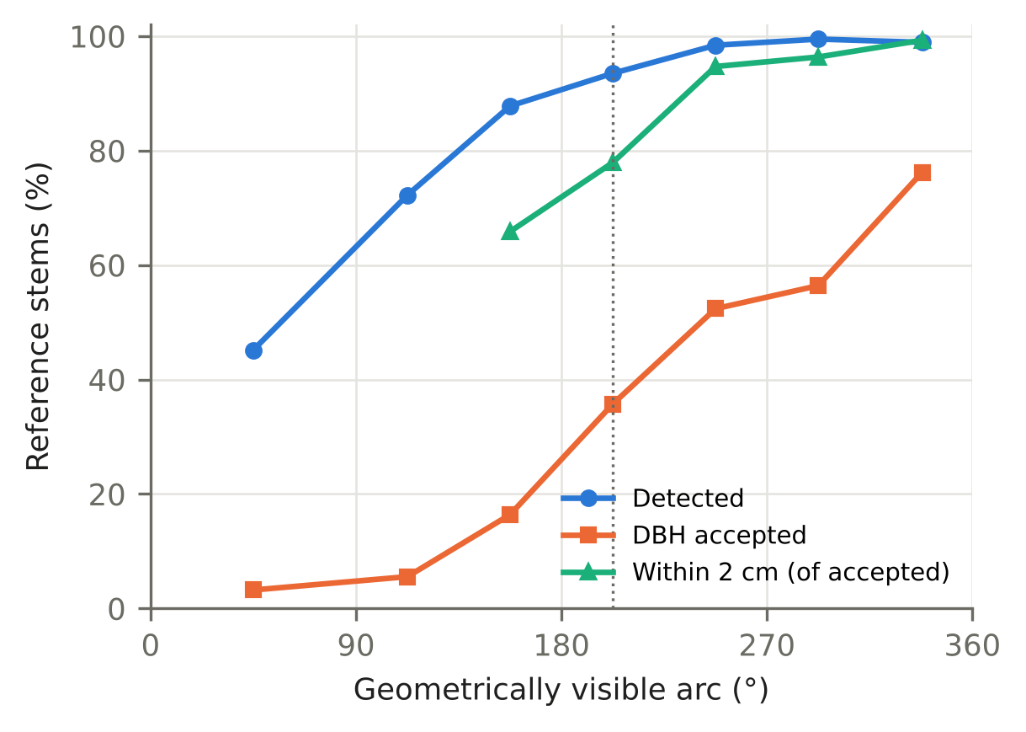
Figure 7. 3DFin on twelve SegmentedForests plots with simulated reduced coverage (1–6 virtual scan positions): share of the 296 reference stems detected and with an accepted DBH, and share of accepted diameters within ±2 cm of the full-coverage 3DFin value, by geometrically visible arc (classes with fewer than ten accepted diameters omitted). Dotted line: 202.5°.

4. Discussion
The coverage needed for a reliable DBH is not a single number. Under ideal conditions least-squares circle fits reached an RMSE of 2 cm with less than half of the circumference visible, whereas non-circular cross-sections raised the requirement to 160–200° for 40 cm stems, and outliers prevented least-squares fits from reaching it at any coverage (Fig. 1). The threshold is therefore a property of the estimator and of the expected cross-section rather than of the point cloud alone. For least-squares fits of clean stem points, the simulations confirm the guideline of Li et al. (2021) that a CDRC of about 200° is required: 82 % of the simulated stems were within 2 cm at 180–225° of visible arc. On real stems with rough bark and a median DBH of 16 cm, however, the 80 % point shifted to 225°, with a bootstrap interval reaching 270°. The negative bias of the Kasa fit on short real arcs (−4.4 cm at 135°, −1.0 cm at 202.5°) matches the short-arc bias of algebraic fits in the Monte Carlo experiment (Section 3.1) and is in line with the negative DBH bias that Bauwens et al. (2016) found for all scanning approaches and attributed to bark roughness and non-circular cross-sections.
The required coverage also grows with stem diameter. In the simulated stands, stems of 40 cm or more reached the 80 % level only beyond 270°, whereas stems below 20 cm reached it at 135–180° (Section 3.3). A rule expressed as a fixed angle is therefore stricter than necessary for thin stems and too lenient for thick ones, at least where cross-sections deviate from a circle. In absolute terms the effect is plausible: the same relative non-circularity displaces the fitted circle by more centimetres on a thick stem. Inventories that emphasise large trees, for example for volume or biomass, should therefore aim at more coverage than a single angular rule suggests, or use estimators that model the cross-section shape.
Segmentation proved more decisive than coverage. When branch points entered the breast-height band in the simulation (Fig. 3), or when the surrounding points were left in the real data (Fig. 6b, c), least-squares fits failed at any coverage, because a few points outside the stem surface pull the fitted circle outwards. RANSAC with an arc constraint kept its accuracy under the same conditions, so that the outlier scenarios of the Monte Carlo experiment were reproduced in simulated and real stands. This agrees with earlier findings that the circle-fitting method affects diameter estimates from TLS (Pueschel et al., 2013) and that RANSAC reduces the influence of noise (Olofsson et al., 2014). The price of robustness was a lower ceiling on clean real stems, where the 12 mm inlier tolerance excluded valid points on rough bark (87 % within 2 cm at full coverage). A coverage rule is therefore meaningful only together with a statement of how stem points were separated from branches and understorey and which estimator was applied to them.
The simulations also separate two quantities that are usually confounded in field data: the visible arc and the point density. Both decrease with distance from the scanner, and Olofsson et al. (2014) reported that the proportion of detected trees decreased with distance following the decrease of visible area. For the diameter error, the present results point to the arc as the controlling factor. At a given visible arc, the share of stems within 2 cm changed by only a few percentage points between stems closer than 5 m and stems beyond 15 m, and between fewer than 50 and more than 500 points in the breast-height slice, whereas it changed by tens of percentage points between arc classes. Point density matters for detection and for the stability of the fit on very sparse stems, but once a few dozen points describe the visible arc, adding points does not compensate for missing circumference. Scan planning should therefore target the angular coverage of stems rather than point density alone.
On real plots, the sector rule of 3DFin acted as intended. Accepted diameters were within 2 cm of the full-coverage value for 78 % of the stems at 180–225° and 95 % at 225–270°, close to the behaviour of least-squares fits in the simulations, and in the simulated stands the rule separated stems with 92 % from those with 53 % of estimates within 2 cm. With a median of 190° geometric arc at exactly nine occupied sectors, the rule sits close to the coverage at which errors become small. The cost is completeness: with four or six spread positions about half of the reference stems received no diameter, and a quarter of the stems with more than 315° visible were still rejected. Unless the rejected stems are measured otherwise or imputed, inventories that rely on such rules should report the share of stems without DBH, and scan designs should aim at more coverage than the nominal 202.5°.
The accuracies obtained here are of the same order as those reported for ground-based laser scanning. For hand-held mobile scanning, Bauwens et al. (2016) found a DBH bias of −0.08 cm and an RMSE of 1.11 cm, with the full cross-section scanned for 91 % of the trees, and Ryding et al. (2015) an RMSE of 1.5 cm relative to a concurrent TLS survey. With an early personal laser scanning system the RMSE was 5.06 cm (Liang et al., 2014), and for TLS plots Olofsson et al. (2014) reported a relative RMSE of 14 % within 10 m of the scanner. The simulated RMSE of 1.6–1.7 cm at 180–225° and 0.5–0.8 cm beyond 315° is at the favourable end of this range, as expected for perfect segmentation and modest bark roughness; the real SegmentedForests stems, with an RMSE of 2.9 cm at 202.5° and 1.5 cm at 270° for the Kasa fit, are closer to field conditions. The comparison supports the interpretation that much of the spread between studies reflects how much of each stem was seen and how stem points were isolated, not only the sensor.
Spreading scan positions mattered more than adding them. Four grid positions brought 80–89 % of the simulated stems above 180° of visible arc, whereas four positions clustered near the plot centre reached only 56 % in the densest stand, about as many as three grid positions (58 %); six grid positions brought 96–98 % of the stems above 180°. This agrees with Abegg et al. (2017), who found evenly distributed scan positions to give the best visibility, and with the use of regular scan grids for plot-scale structural modelling (Wilkes et al., 2017). A single position never saw more than 172° of a stem in the simulations, so single-scan TLS cannot meet a 180–200° criterion for any stem, consistent with the absence of fully scanned trees in single-scan data reported by Bauwens et al. (2016). As a tentative recommendation for stands of 400–1200 stems ha⁻¹, a spread grid of four to six positions per 0.16 ha (25–38 positions per hectare) brought 80–98 % of the stems above 180°; stand-specific simulation can refine this.
It may be argued that occlusion becomes less relevant as mobile and personal laser scanning improve and as static scanners become faster. Hand-held scanning recorded the full cross-section of most trees in one comparison (Bauwens et al., 2016), and PLS detected more trees than TLS on inventory plots (Gollob et al., 2020c). Faster static scanners allow more positions per plot, and the present results show that the benefit of additional positions depends strongly on their arrangement. The coverage question does not disappear with mobile systems, however. Their coverage is governed by the trajectory instead of fixed positions, and the density of walking lines affected single-tree estimates from hand-held scanning (Del Perugia et al., 2019). Kuželka (2025) used simulation to design hand-held trajectories in complex natural forests and found that occlusion reduced stem point density and detection and increased DBH errors. The present study is complementary: it addresses static scan positions, the choice of estimator and the acceptance rules of processing software, and expresses coverage as a geometric visible arc that can equally be computed along a trajectory. Mobile workflows also fit stems from partial arcs; one workflow, for example, detects stem arcs and matches them iteratively to cope with drift of the simultaneous localization and mapping (SLAM) trajectory (Hyyppä et al., 2020). The visible arc used here describes the geometry between sensor and stem, not the sensor type, so the thresholds apply to any ground-based point cloud once the recorded arc of each stem is known. Static TLS also remains in use where its accuracy and repeatability are needed, including tests in national forest inventories (Holvoet et al., 2025).
Several practical recommendations follow. First, the estimator should be chosen with the segmentation in mind: least-squares fits are adequate, and on short arcs the geometric fit preferable, only for clean stem points, whereas point sets that may contain branches or understorey call for a robust, arc-constrained estimator such as RANSAC. Second, coverage should be planned and reported as the visible arc per stem, which can be estimated from stem positions and scan positions before or after scanning, rather than as point density or number of positions. Third, for least-squares fits of well-segmented stems, about 200–225° of visible arc should be the target, more for thick or irregular stems. Fourth, scan positions should be spread over the plot; in the simulated stands, four to six positions on a grid brought most stems above 180°, while clustering near the centre lost a large part of that benefit in dense stands. Fifth, inventories that apply acceptance rules should report the share of rejected stems, because the accepted diameters alone can give a misleading impression of completeness.
Several limitations apply. In the HELIOS++ scenes, segmentation was perfect, crowns were absent, branches were represented in one scene only and as simple cylinders, the terrain was flat, a single scanner model was used, and outliers and registration offsets were idealised; range-dependent incidence effects and beam divergence were simulated but not varied systematically. Mobile trajectories were not simulated. Hough was run with scikit-image defaults; other accumulator normalisations or smoothing may behave differently, but no parameter was tuned for any estimator. On SegmentedForests the reference DBH is itself a fit to well-covered points, not a field measurement, and the 3DFin experiment simulated reduced coverage by removing points from a multi-scan cloud with a stem-only occlusion model; real single-position scans differ in point density and range effects, and the reference there is the full-coverage result of 3DFin itself.
Future work should extend the geometric analysis to mobile trajectories, so that walking or flight paths can be planned with the same coverage targets, and to scenes with crowns, sloped terrain and realistic branch and understorey structure. Field campaigns with measured stem perimeters and recorded scan positions would allow the visible-arc thresholds to be tested directly against tape measurements.

5. Conclusions
This study quantified how the error of DBH estimates from ground-based laser scanning depends on the visible part of the stem circumference, using controlled simulations, virtual laser scanning and open real data. Coverage rules for TLS diameters should be reported per estimator and per segmentation quality. With clean stem points, least-squares fits need about 180° (simulation) to 225° (real bark) of visible arc for most stems to be within 2 cm, and 3DFin’s 202.5° sector rule sits in this range. Without clean segmentation, no amount of coverage rescues least-squares fits; robust estimators such as RANSAC with an arc constraint are then the main lever. Scan positions should be spread rather than clustered, especially in dense stands. Coverage rules such as 3DFin’s keep the accepted diameters accurate but leave many stems without a DBH; the share of rejected stems belongs in every TLS inventory report. Because the error is controlled by the visible arc rather than by point density, and because thick stems need more coverage than thin ones, scan planning for TLS as well as for mobile systems should be based on the expected visible arc of the stems that matter most for the inventory.

CRediT authorship contribution statement
Angel Naya: Conceptualization, Methodology, Software, Formal analysis, Investigation, Data curation, Visualization, Writing – original draft, Writing – review & editing.

Declaration of competing interest
The author declares no known competing financial interests or personal relationships that could have appeared to influence the work reported in this paper.

Declaration of generative AI and AI-assisted technologies in the manuscript preparation process
During the preparation of this work the author used Claude (Anthropic) in order to assist with programming, data analysis and drafting of the text. After using this tool, the author reviewed and edited the content as needed and takes full responsibility for the content of the published article.

Data availability
All result tables underlying the figures and numbers are included in the Zenodo archive (Naya, 2026); simulated scenes are reproducible from the scripts and seeds. The real point clouds are third-party open data and are not redistributed: SegmentedForests (Laino et al., 2026; MIT), LAUT (Gollob et al., 2020b; CC BY 4.0). All scripts used for this study (Monte Carlo, HELIOS++ scenes and evaluation, real-data analyses, 3DFin experiment, bootstrap and figures) are archived on Zenodo (https://doi.org/10.5281/zenodo.23911186; GPL-3.0-or-later). Third-party software: HELIOS++ 2.2.2 (conda-forge), 3DFin 0.6.0 with dendromatics 0.7.0, scikit-image 0.26, NumPy, SciPy, pandas.

Funding
This research did not receive any specific grant from funding agencies in the public, commercial, or not-for-profit sectors.

Acknowledgements
The author thanks the creators of the open datasets SegmentedForests and LAUT for publishing their data under open licences, and the developers of HELIOS++, 3DFin and scikit-image.

References
- Abegg, M., Kükenbrink, D., Zell, J., Schaepman, M.E., Morsdorf, F., 2017. Terrestrial laser scanning for forest inventories—tree diameter distribution and scanner location impact on occlusion. Forests 8 (6), 184. https://doi.org/10.3390/f8060184
- Al-Sharadqah, A., Chernov, N., 2009. Error analysis for circle fitting algorithms. Electronic Journal of Statistics 3, 886–911. https://doi.org/10.1214/09-EJS419
- Balenović, I., Liang, X., Jurjević, L., Hyyppä, J., Seletković, A., Kukko, A., 2021. Hand-held personal laser scanning: current status and perspectives for forest inventory application. Croatian Journal of Forest Engineering 42 (1), 165–183. https://doi.org/10.5552/crojfe.2021.858
- Bauwens, S., Bartholomeus, H., Calders, K., Lejeune, P., 2016. Forest inventory with terrestrial LiDAR: a comparison of static and hand-held mobile laser scanning. Forests 7 (6), 127. https://doi.org/10.3390/f7060127
- Bienert, A., Georgi, L., Kunz, M., Maas, H.-G., von Oheimb, G., 2018. Comparison and combination of mobile and terrestrial laser scanning for natural forest inventories. Forests 9 (7), 395. https://doi.org/10.3390/f9070395
- Calders, K., Adams, J., Armston, J., Bartholomeus, H., Bauwens, S., Bentley, L.P., et al., 2020. Terrestrial laser scanning in forest ecology: expanding the horizon. Remote Sensing of Environment 251, 112102. https://doi.org/10.1016/j.rse.2020.112102
- Chernov, N., 2010. Circular and Linear Regression: Fitting Circles and Lines by Least Squares. CRC Press.
- Del Perugia, B., Giannetti, F., Chirici, G., Travaglini, D., 2019. Influence of scan density on the estimation of single-tree attributes by hand-held mobile laser scanning. Forests 10 (3), 277. https://doi.org/10.3390/f10030277
- Fischler, M.A., Bolles, R.C., 1981. Random sample consensus: a paradigm for model fitting with applications to image analysis and automated cartography. Communications of the ACM 24 (6), 381–395.
- Gollob, C., Ritter, T., Nothdurft, A., 2020a. Comparison of 3D point clouds obtained by terrestrial laser scanning and personal laser scanning on forest inventory sample plots. Data 5 (4), 103. https://doi.org/10.3390/data5040103
- [dataset] Gollob, C., Ritter, T., Nothdurft, A., 2020b. LAUT – Terrestrial and personal laser scanner data from Austrian forest inventory plots. Zenodo. https://doi.org/10.5281/zenodo.3698956
- Gollob, C., Ritter, T., Nothdurft, A., 2020c. Forest inventory with long range and high-speed personal laser scanning (PLS) and simultaneous localization and mapping (SLAM) technology. Remote Sensing 12 (9), 1509. https://doi.org/10.3390/rs12091509
- Gollob, C., Ritter, T., Wassermann, C., Nothdurft, A., 2019. Influence of scanner position and plot size on the accuracy of tree detection and diameter estimation using terrestrial laser scanning on forest inventory plots. Remote Sensing 11 (13), 1602. https://doi.org/10.3390/rs11131602
- Holvoet, J., Eichhorn, M.P., Giannetti, F., Kükenbrink, D., Liang, X., Mokroš, M., et al., 2025. Terrestrial and mobile laser scanning for national forest inventories: from theory to implementation. Remote Sensing of Environment 329, 114947. https://doi.org/10.1016/j.rse.2025.114947
- Hyyppä, E., Yu, X., Kaartinen, H., Hakala, T., Kukko, A., Vastaranta, M., Hyyppä, J., 2020. Comparison of backpack, handheld, under-canopy UAV, and above-canopy UAV laser scanning for field reference data collection in boreal forests. Remote Sensing 12 (20), 3327. https://doi.org/10.3390/rs12203327
- Kuželka, K., 2025. Trajectory design for handheld mobile laser scanning in complex natural forests: a simulation approach. ISPRS Journal of Photogrammetry and Remote Sensing 230, 524–546. https://doi.org/10.1016/j.isprsjprs.2025.09.025
- Kåsa, I., 1976. A circle fitting procedure and its error analysis. IEEE Transactions on Instrumentation and Measurement IM-25 (1), 8–14. https://doi.org/10.1109/TIM.1976.6312298
- Laino, D., Cabo, C., Ordóñez, C., Bolanos, R., Janvier, R., Giulioni, F., Herrmann, M., Hudak, A., Parsons, R., Santín, C., 2026. SegmentedForests: a labelled dataset of terrestrial LiDAR point clouds for semantic segmentation of forests. Forestry 99 (2). https://doi.org/10.1093/forestry/cpaf062
- Laino, D., Cabo, C., Prendes, C., Janvier, R., Ordóñez, C., Nikonovas, T., Doerr, S., Santín, C., 2024. 3DFin: a software for automated 3D forest inventories from terrestrial point clouds. Forestry 97 (4), 479–496. https://doi.org/10.1093/forestry/cpae020
- Li, L., Mu, X., Soma, M., Wan, P., Qi, J., Hu, R., Zhang, W., Tong, Y., Yan, G., 2021. An iterative-mode scan design of terrestrial laser scanning in forests for minimizing occlusion effects. IEEE Transactions on Geoscience and Remote Sensing 59 (4), 3547–3566. https://doi.org/10.1109/TGRS.2020.3018643
- Liang, X., Hyyppä, J., Kaartinen, H., et al., 2018. International benchmarking of terrestrial laser scanning approaches for forest inventories. ISPRS Journal of Photogrammetry and Remote Sensing 144, 137–179. https://doi.org/10.1016/j.isprsjprs.2018.06.021
- Liang, X., Kankare, V., Hyyppä, J., Wang, Y., Kukko, A., Haggrén, H., et al., 2016. Terrestrial laser scanning in forest inventories. ISPRS Journal of Photogrammetry and Remote Sensing 115, 63–77. https://doi.org/10.1016/j.isprsjprs.2016.01.006
- Liang, X., Kukko, A., Kaartinen, H., Hyyppä, J., Yu, X., Jaakkola, A., Wang, Y., 2014. Possibilities of a personal laser scanning system for forest mapping and ecosystem services. Sensors 14 (1), 1228–1248. https://doi.org/10.3390/s140101228
- Mokroš, M., Mikita, T., Singh, A., Tomaštík, J., Chudá, J., Wężyk, P., et al., 2021. Novel low-cost mobile mapping systems for forest inventories as terrestrial laser scanning alternatives. International Journal of Applied Earth Observation and Geoinformation 104, 102512. https://doi.org/10.1016/j.jag.2021.102512
- Molina-Valero, J.A., Martínez-Calvo, A., Ginzo Villamayor, M.J., Novo Pérez, M.A., Álvarez-González, J.G., Montes, F., Pérez-Cruzado, C., 2022. Operationalizing the use of TLS in forest inventories: the R package FORTLS. Environmental Modelling & Software 150, 105337. https://doi.org/10.1016/j.envsoft.2022.105337
- [dataset] Naya, A., 2026. Code and results for: “How much of the stem must a terrestrial laser scanner see?” Zenodo, v1. https://doi.org/10.5281/zenodo.23911186
- Olofsson, K., Holmgren, J., Olsson, H., 2014. Tree stem and height measurements using terrestrial laser scanning and the RANSAC algorithm. Remote Sensing 6 (5), 4323–4344. https://doi.org/10.3390/rs6054323
- Pueschel, P., Newnham, G., Rock, G., Udelhoven, T., Werner, W., Hill, J., 2013. The influence of scan mode and circle fitting on tree stem detection, stem diameter and volume extraction from terrestrial laser scans. ISPRS Journal of Photogrammetry and Remote Sensing 77, 44–56. https://doi.org/10.1016/j.isprsjprs.2012.12.001
- Ritter, T., Gollob, C., Nothdurft, A., 2020. Towards an optimization of sample plot size and scanner position layout for terrestrial laser scanning in multi-scan mode. Forests 11 (10), 1099. https://doi.org/10.3390/f11101099
- Ryding, J., Williams, E., Smith, M.J., Eichhorn, M.P., 2015. Assessing handheld mobile laser scanners for forest surveys. Remote Sensing 7 (1), 1095–1111. https://doi.org/10.3390/rs70101095
- Wilkes, P., Lau, A., Disney, M., Calders, K., Burt, A., Gonzalez de Tanago, J., et al., 2017. Data acquisition considerations for terrestrial laser scanning of forest plots. Remote Sensing of Environment 196, 140–153. https://doi.org/10.1016/j.rse.2017.04.030
- Winiwarter, L., Esmorís Pena, A.M., Weiser, H., Anders, K., Martínez Sánchez, J., Searle, M., Höfle, B., 2022. Virtual laser scanning with HELIOS++: a novel take on ray tracing-based simulation of topographic full-waveform 3D laser scanning. Remote Sensing of Environment 269, 112772. https://doi.org/10.1016/j.rse.2021.112772
- van der Walt, S., Schönberger, J.L., Nunez-Iglesias, J., Boulogne, F., Warner, J.D., Yager, N., Gouillart, E., Yu, T., the scikit-image contributors, 2014. scikit-image: image processing in Python. PeerJ 2, e453. https://doi.org/10.7717/peerj.453

Abbreviations: CDRC, cumulative degree of ring closure; DBH, diameter at breast height; MLS, mobile laser scanning; PLS, personal laser scanning; RANSAC, random sample consensus; RMSE, root mean square error; SLAM, simultaneous localization and mapping; TLS, terrestrial laser scanning.

