KiCAD Workshop
Date: 13th August 2025
Time: 11:15 AM to 4:00 PM
Venue: Seminar Hall, A Wing, Don Bosco Institute of Technology, Kurla, Mumbai - 400070
Speakers: Prem Singh
Number of Participants: 52
Number of Boys: 15
Number of Girls: 37
Objective: The KiCAD Workshop was organized with the primary aim of introducing students to PCB (Printed Circuit Board) design using KiCAD software, a widely used open-source EDA tool. The objectives included:
- Familiarizing students with the KiCAD interface and its various modules.
- Teaching the fundamentals of schematic design, component libraries, and footprint assignment.
- Demonstrating the process of PCB layout creation, routing, and design rule checks.
- Providing hands-on exposure to generating Gerber files for fabrication.
- Motivating students to independently design and fabricate their own electronic circuits.

Outcome: • Students successfully created a schematic diagram and PCB layout for a simple electronic circuit.
• Participants understood the importance of design rules and constraints in PCB development.
• Several students expressed interest in using KiCAD for their mini-projects and academic work.

• The workshop enhanced design skills and introduced participants to industry-standard workflows.
• Encouraged collaboration and peer learning among participants.

Description:
- The KiCAD Workshop, held on 13th August 2025, began with a welcome address by the IEEE faculty in-charge, who emphasized the importance of PCB design knowledge for aspiring engineers.
- The session was divided into two major parts:
- Introduction to KiCAD and Schematic Capture:
- Participants were guided through the KiCAD interface, focusing on the schematic editor.
- Basics of creating circuits, symbol libraries, and electrical rules checks were explained.
- Hands-on practice was given for designing a small amplifier circuit schematic.
- PCB Layout Design and Fabrication Workflow:
- The trainers explained footprint assignment and demonstrated how to import schematics into the PCB layout editor.
- Students learned about routing techniques, via placement, ground planes, and optimization of PCB area.
- Important aspects of Design Rule Check (DRC) were highlighted to ensure manufacturability.
- The session concluded with Gerber file generation, explaining how these files are used for fabrication.
- To enrich the session, the trainers also showcased examples of student-designed PCBs and explained practical considerations in real-world electronic product design.
- The workshop ended with an interactive Q&A session, where students clarified doubts regarding advanced features of KiCAD and professional PCB design practices.

Summary of session:
- Introduction to KiCAD software modules and interface.
- Hands-on practice in schematic design.
- PCB layout design and routing demonstration.

- Explanation of design rules, DRC, and Gerber file generation.
- Q&A and discussion on applications in projects and industry.

Photos of the Event:
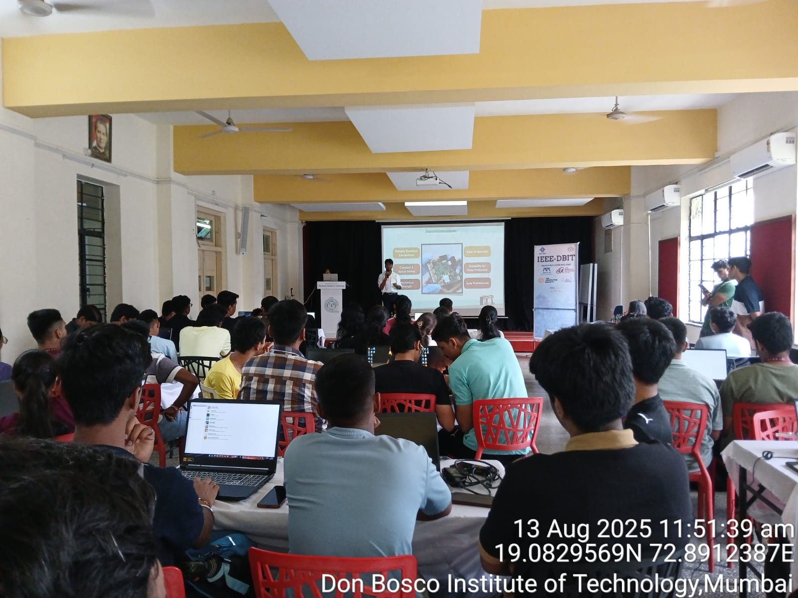
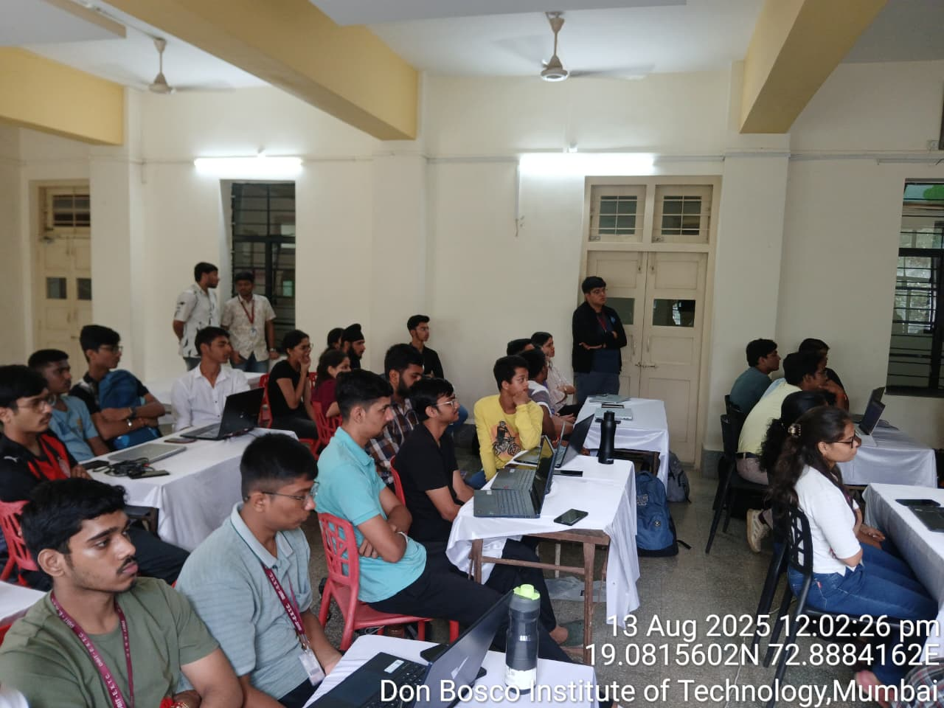

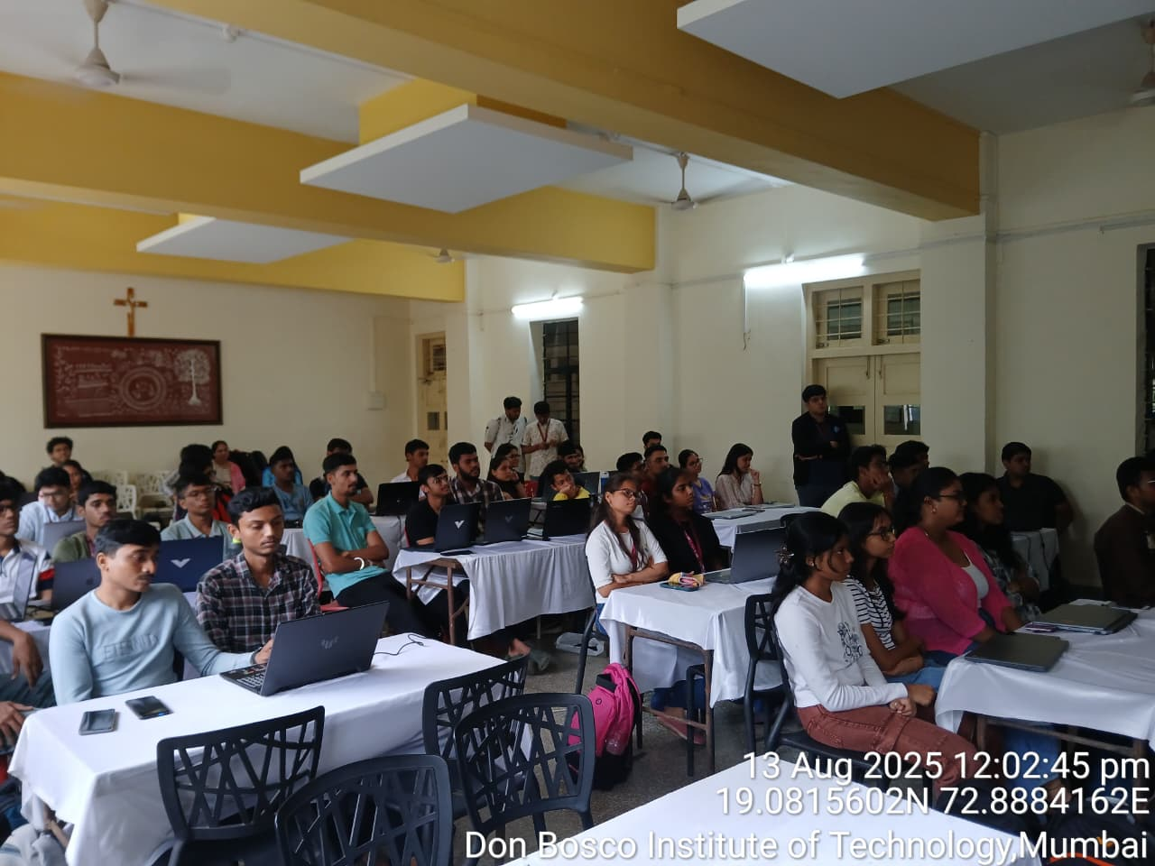
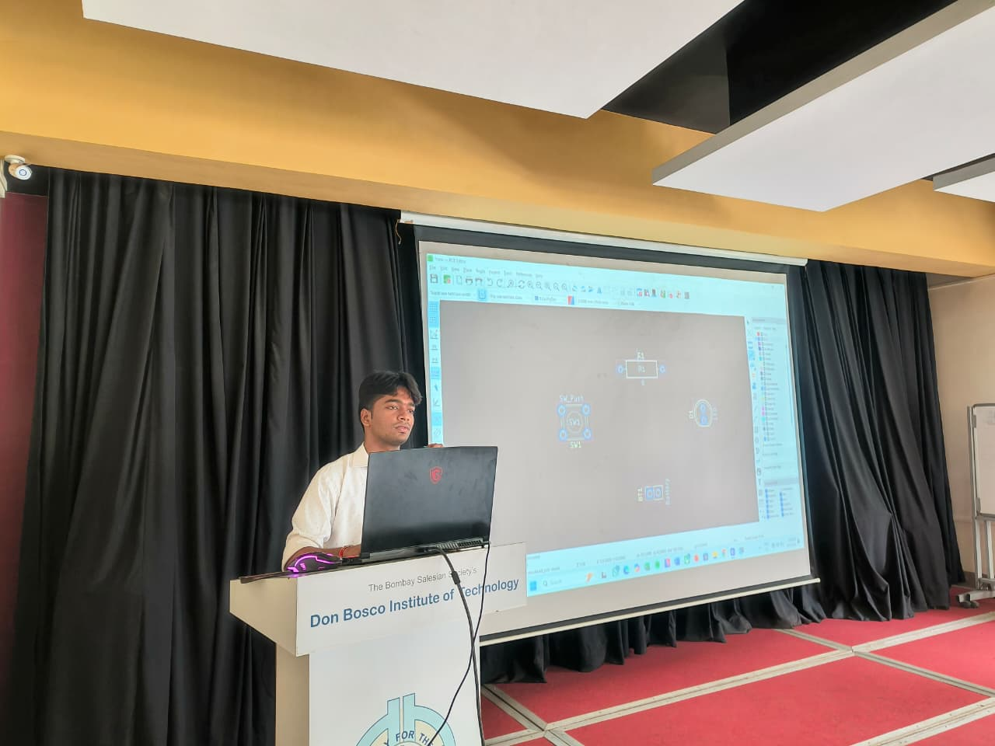

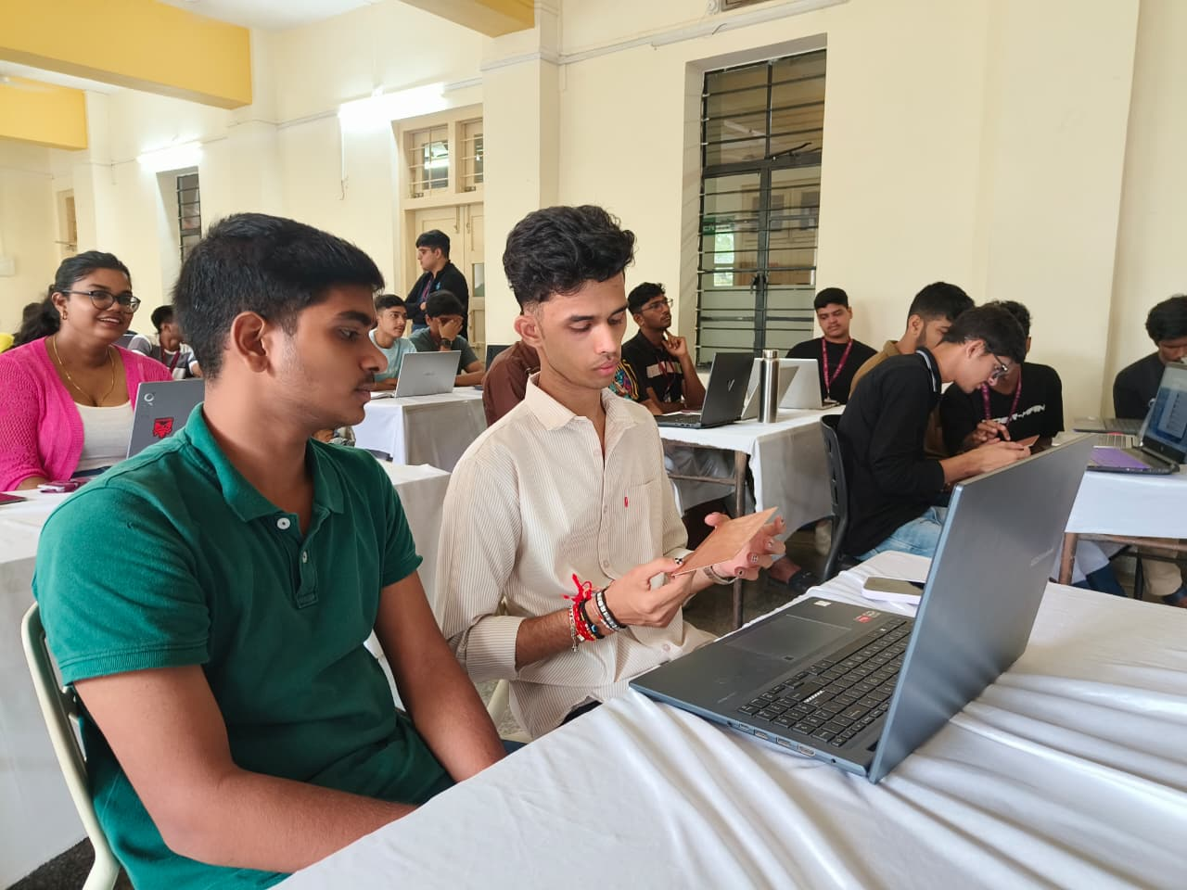

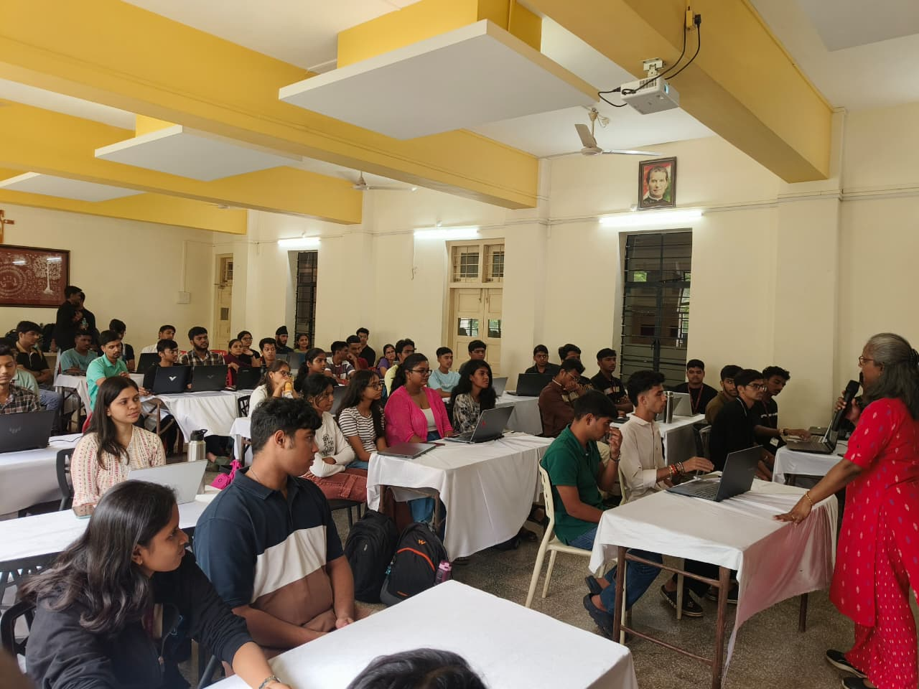

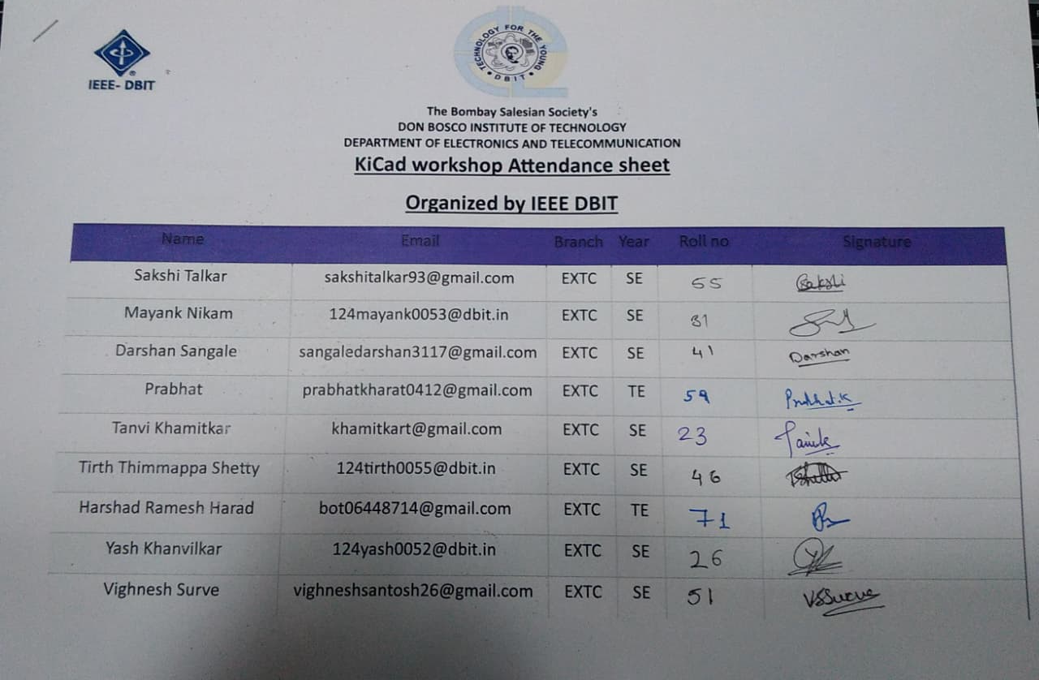
Social Media Links:

Website-https://ieee.dbit.in/?fbclid=PAY2xjawJVnYZleHRuA2FlbQIxMQABpvVoqE33E2wKVxqPSlimOFc1-8Aj9UZ3sC1UGsmGbVVubLOAxkbS-wUZRQ_aem_vgeXwR8_YQ7up3f8DDCMrA

Participants:

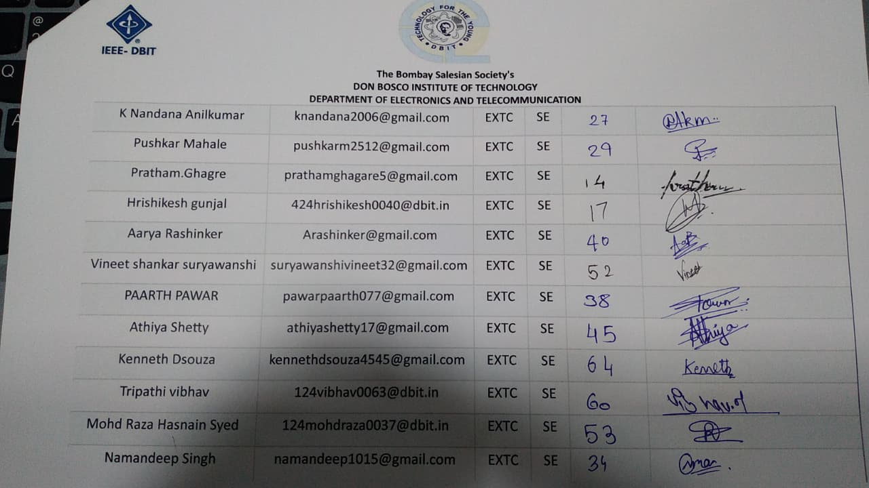
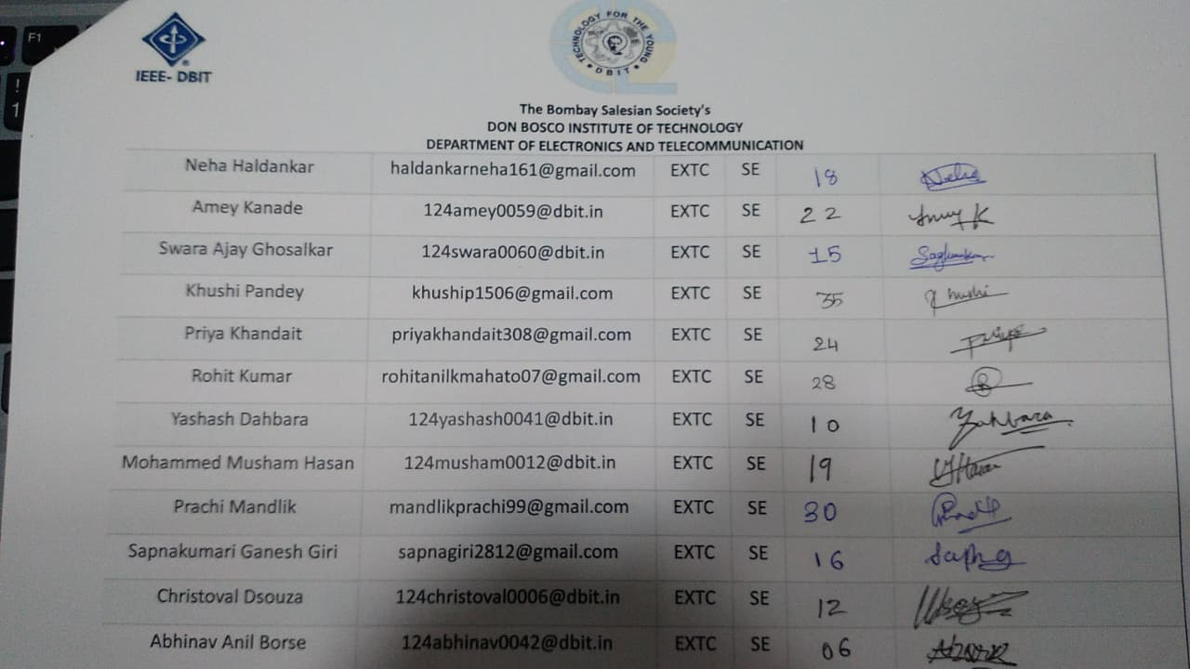
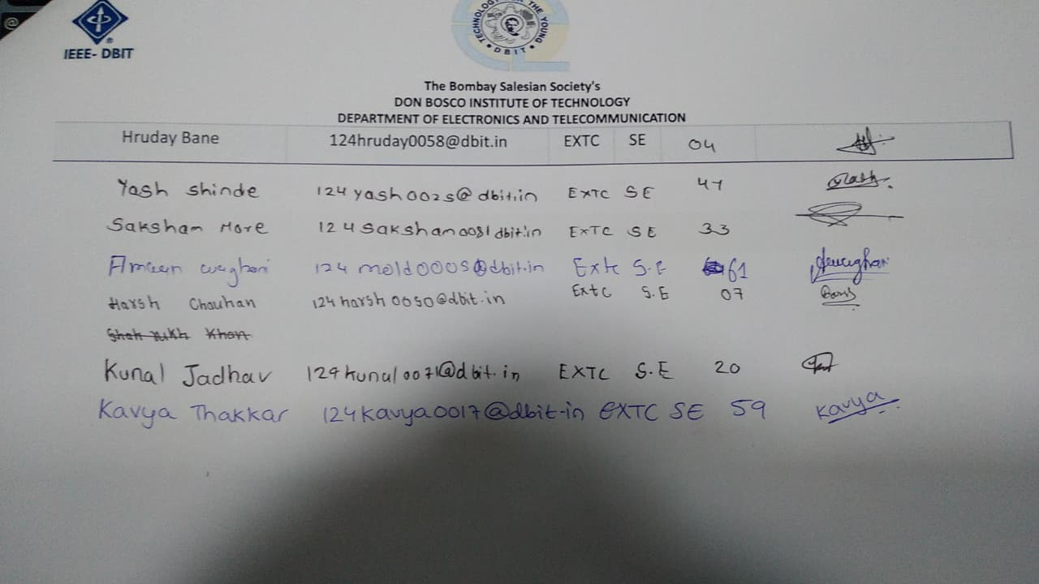
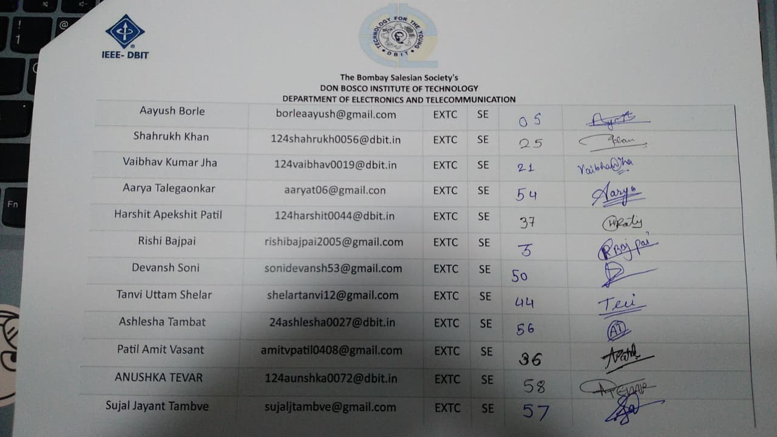

Feedback:
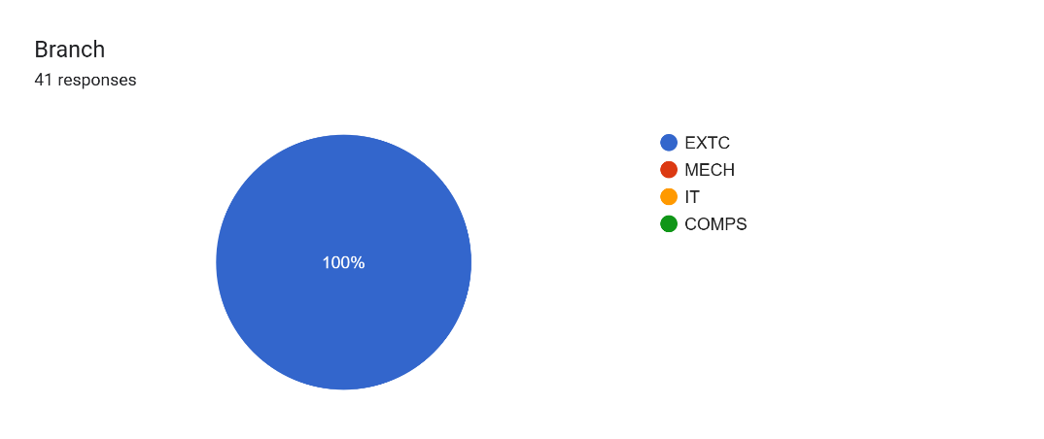
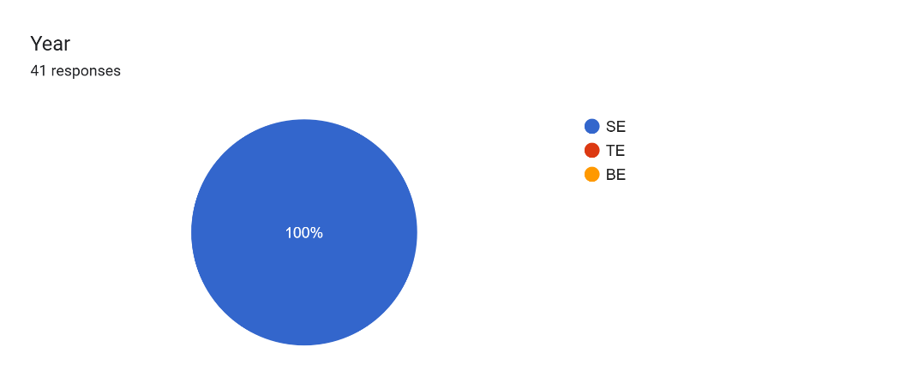
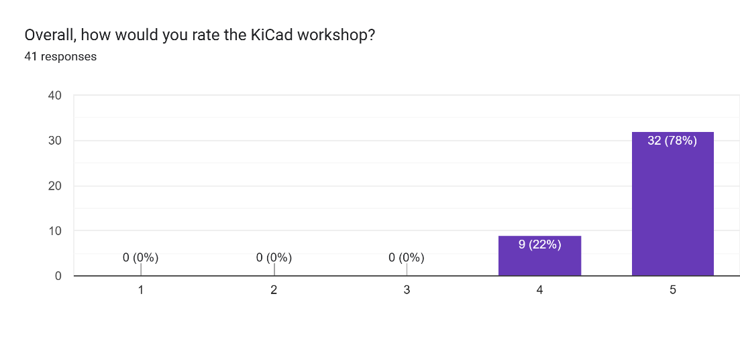

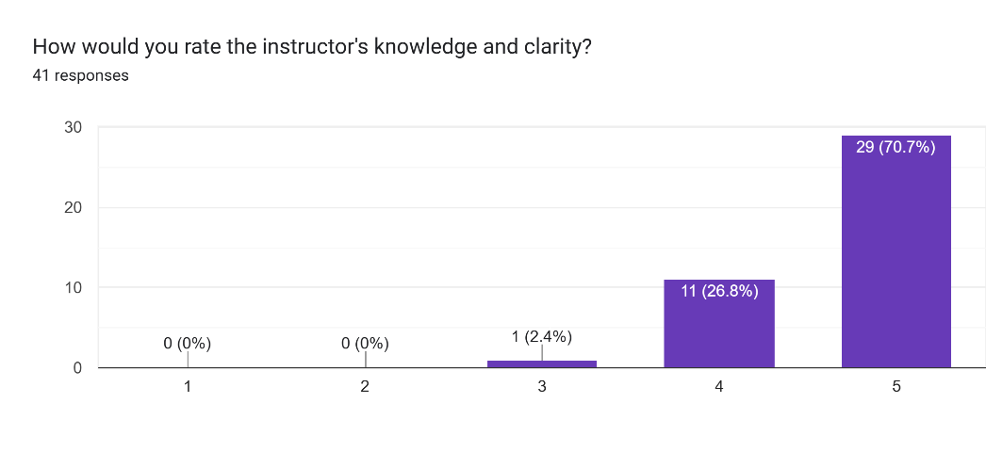
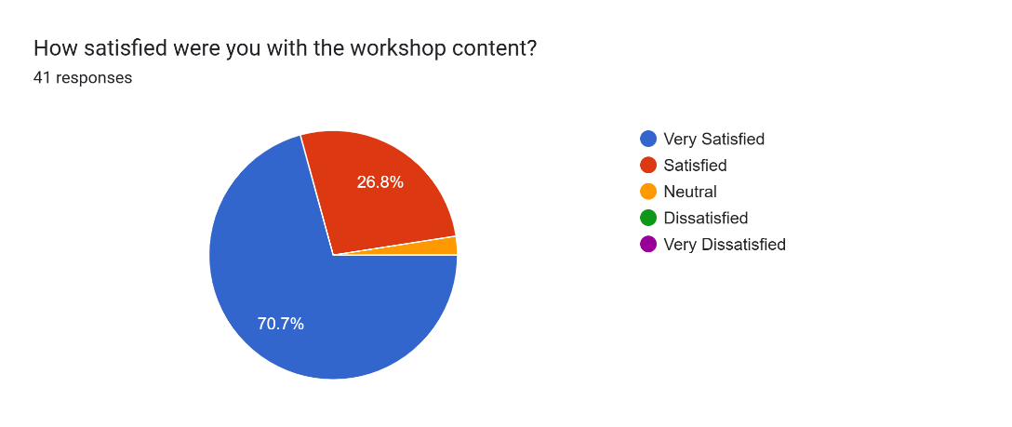
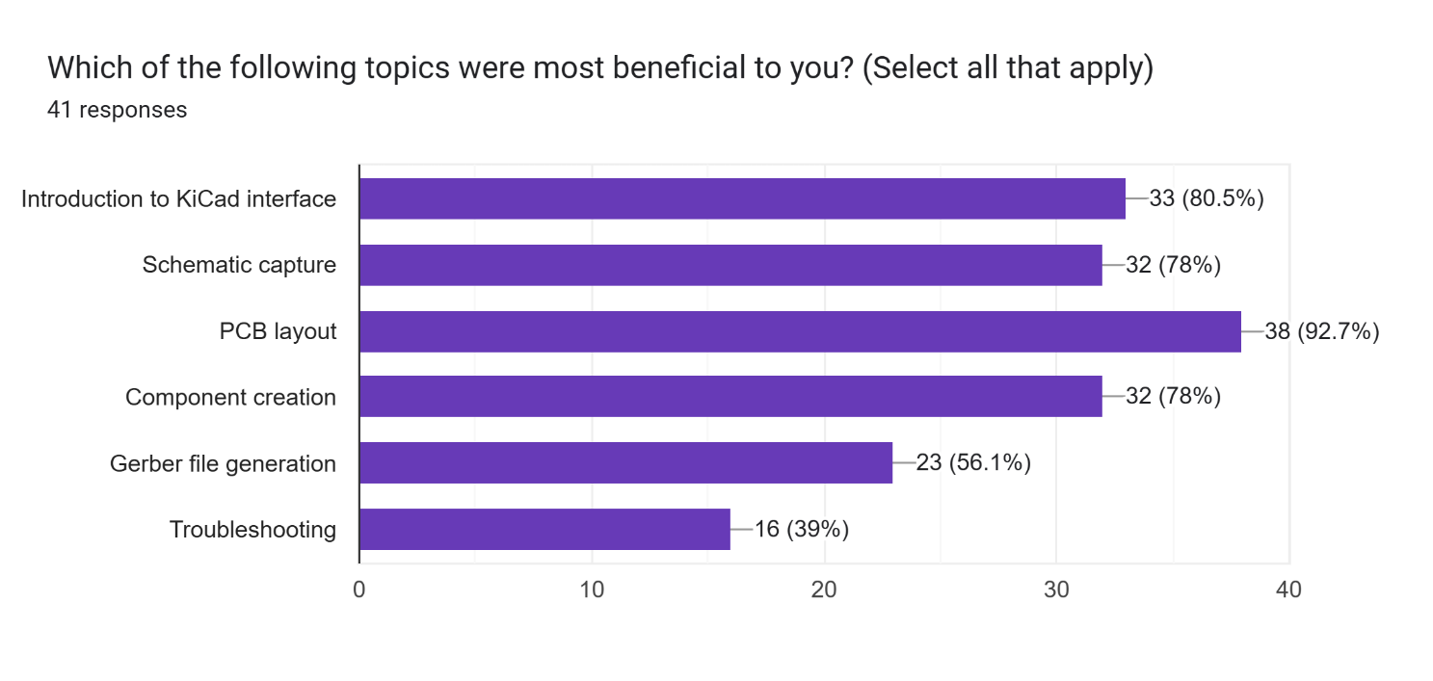

Comments:
- What improvements or changes would you suggest for future workshops?
- Better time management
- Sir was great
- Hands-on experience
- It was a very good workshop
- Speaker should've spoken a bit louder
- No suggestion
- It should be better to more go on hands on
- Very nice

Conclusion:
The KiCAD Workshop organized by IEEE-DBIT Student Branch successfully introduced participants to the fundamentals of PCB design. Through practical demonstrations and hands-on activities, students learned essential skills in schematic capture, PCB layout, and file preparation for fabrication. The event motivated participants to apply these skills in their upcoming projects and enhanced their readiness for industry-level design challenges.
Report Prepared by: IEEE DBIT Reporting Team
Name of the Student: Dhruv Tare
Post of the student: Reporting Head
Name of the Student: Pritika Mediboina
Post of the Student: Joint Reporting Head

