Revolutionizing Inventory Management: An IoT-based Approach

Gayatri Jagnade Mam, Akshay Paithankar , Suraj Pathan ,Ghanshyam Pandey , Omkar Deshmane , Harsh Mule , Devashish Padgan

a Department of Chemical Engineering , Vishwakarma Institute of Technology , Pune 411037

|  |  |  |  |
| --- | --- | --- | --- |
|  |  |  | ABSTRACT |
|  |  |  | By fusing IoT technology with load cells and NodeMCU modules, the IoT-based Inventory Management System utilising Load Cell and NodeMCU project aims to automate inventory management procedures. Users may remotely check inventory levels via the system's web-based application, and they can sign up to get notifications when inventory levels drop below a certain threshold. The hardware consists of a load cell sensor for weighing the inventory and a NodeMCU module for wirelessly transmitting weight data to a cloud server. The cloud server processes and saves the data, giving the web application access to real-time inventory status. Users of the online application may examine inventory levels, establish alarm levels, and get notifications when inventory levels drop below the predetermined level. The method has a number of advantages, including a decrease in human labour, the elimination of inventory counting mistakes, and an increase in the accuracy of inventory tracking. The project is perfect for small to medium-sized enterprises who need to manage their inventories effectively because of its low-cost technology and simplicity of usage. The project is a fantastic learning opportunity for students and hobbyists interested in IoT technology because its implementation calls for a basic understanding of electronics and programming. To accommodate the requirements of bigger organisations or specialised inventory management applications, the project may also be adjusted and scaled. The Load Cell and NodeMCU-based IoT-based Inventory Management System is a dependable and effective inventory management system that provides real-time inventory tracking, lowers labour costs, eliminates mistakes, and improves inventory accuracy. The project's inexpensive hardware and simplicity of use make it a great option for small to medium-sized enterprises as well as a worthwhile educational experience for students and hobbyists.  **KEYWORDS**: Internet of things (IOT),Node MCU , Flask , Plotly ,Load cell. |
|  |  |  |  |

# INTRODUCTION

# A crucial task for firms is inventory management, which is keeping track of, ordering, and replenishing goods inventories to keep up with demand from customers. Inventory management may be time-consuming and laborious, especially for companies that deal with a lot of different items. The systems for managing inventories have, however, undergone a substantial revolution with the advent of technology, becoming more precise, efficient, and economical. The Internet of Things is one such technology that has grown significantly in popularity in recent years.

# Objects (IoT).The Internet of Things is a system of interconnected gadgets and sensors that communicate and share information with one another online. IoT technology has completely changed how organizations run by making it possible to gather and analyze data that was previously inaccessible or difficult to get. Businesses have benefited greatly from the adoption of IoT technology in inventory management, including real-time tracking, enhanced accuracy, lower labor costs, and increased productivity. An initiative that makes use of IoT technology to automate inventory management procedures is the IoT-based Inventory Management System employing Load Cell and NodeMCU. The main goal of the project is to develop an inventory management system that enables users to track inventory levels remotely and get alerts when levels drop below a certain threshold. By combining load cells and NodeMCU modules with IoT technology, the project achieves this goal. In industrial settings, load cells are frequently used to gauge the mass of big objects or containers. A few grammes to many tones of weight may be measured with great accuracy using load cells. Since load cells can be used to precisely measure the weight of objects, they are a great option for inventory management systems.

# Small, inexpensive, and simple to use NodeMCU modules are Wi-Fi capable microcontrollers that can be programmed using the Arduino environment. NodeMCU modules are well-liked by developers and hobbyists since they are simple to programme and call for little hardware. NodeMCU modules are a great option for internet of things (IoT) applications since they can easily share data with other devices and sensors thanks to their Wi-Fi connectivity. The Load Cell and NodeMCU-based IoT-based Inventory Management System enables customers to remotely monitor inventory levels by combining load cells and NodeMCU modules. The project's hardware architecture consists of load cell sensors that weigh the goods and NodeMCU modules that use the Wi-Fi network to transmit the weight data to a cloud server. The data is stored and processed on the cloud server, which gives a web application access to real-time inventory status. Users of the online application may examine inventory levels, establish alarm levels, and get notifications when inventory levels drop below the predetermined level. Users may view real-time inventory levels using the web application's user-friendly interface, making it simple to decide when to resupply goods. Businesses who need to efficiently manage their inventory may take advantage of a number of advantages provided by the IoT-based Inventory Management System employing Load Cell and NodeMCU. The system minimizes mistakes in inventory counting, enhances accuracy in inventory monitoring, and lowers manual labor by automating inventory management procedures. Businesses looking to implement IoT-based inventory management systems without incurring major expenditures will find the system to be a great option due to the system's low-cost hardware and simplicity of use. Basic understanding of electronics and programming are needed to create the Load Cell and NodeMCU-based IoT-based Inventory Management System. The project is appropriate for bigger companies or specialized inventory management applications because to its modular architecture and scalability. The project's execution offers IoT technology enthusiasts and students a fantastic learning opportunity. An innovative approach to inventory management that makes use of IoT technology to automate inventory management procedures is the IoT-based Inventory Management System employing Load Cell and NodeMCU. It provides real-time inventories.

# COMPONENTS REQUIRED

* NodeMCU - 1
* Load Cell - 1
* HX711 Load Cell Amplifier Module
* 128*64 OLED Display
* Connecting Wires
* MDF, Cardboard, Foam Sheet - for Enclosure
* 7.4-volt li-ion Battery

# METHODOLOGY

**Hardware:**

The project weighs the goods using a load cell and a HX711 amplifier module.

The microcontroller and Wi-Fi module are both implemented on the NodeMCU board, a development board based on the ESP8266.

The HX711 amplifier module is linked to the NodeMCU board, and the load cell is attached to the amplifier module.

The NodeMCU board is connected to the LED, which shows the inventory status.

**1] Circuitry System**

The D1 and D2 pins on the board, which are the I2C pins of the NodeMCU, are used here to connect the OLED display. We then connected NodeMCU to the loadcell. The four wires on a loadcell are red, black, green, and white. In the HX711 board, we wired up the following colors: red to E+, black to E-, white to A+, and green to A-, Doubt, and clock, which we linked to D5 and D6, respectively. The OLED display and amplifier's grounds were then connected to NodeMCU ground. Since the NodeMCU lacks 5 volt pins and both the OLED and the load cell amplifier require 5 volts, we must utilize a 5 volt regulator in the circuit.

**2] The Circuitry's Encloser was Made**

Due to its robustness, a PVC sheet was used to build an enclosure to house the circuitry and inventory for a scale. The PVC board was then cut into a 20 x 20 cm square and three 20 x 5 cm rectangles. Then, using hot glue, these parts were put together to form a small box. To offer more storage, the top of the scale was made out of an old cardboard box. To allow for bending, it's crucial to leave room between the ground and the load cell. Plastic spacers were inserted between the load cell and the top of the enclosure, and screw nuts were added between the load cell and the base.

**3] Setting up ThingSpeak Account** ThingSpeak is an open-source IoT analytics platform that enables real-time data aggregation, visualization, and analysis in the cloud. Using web services like Twitter and ThingHTTP, you can send alerts and instantly visualize live data while controlling your equipment. You can also transmit data to ThingSpeak from your devices.

We established a new interface by clicking on channels after signing up on thinkspeak.com. We set up two channels, "total weight" and "number of pieces left," to gather data from the esp. In order to upload data to the ThingSpeak cloud, API keys were then duplicated. Then, for the two

fields, we made two widgets.

**4] Configuring IFTTT to Send Automatic Email Notifications**

An IFTTT account was created to send an email when a stock threshold was achieved. After choosing the webhooks service and specifying the name of the event, the email message and body were customized. The user's event name was substituted for the event name when the webhooks service was linked to the email service. The channel ID and notification box were then added after pasting the URL into Things peak’s ThingHTTP. With the server setup now complete, work on the NodeMCU code could start.

**5] Arduino Code for Automatic Inventory Monitoring and Management**

The Arduino IDE was used to programme the NodeMCU board. By accessing the preferences menu under the file menu and installing the ESP Board package from the board manager, it was added. Included were necessary libraries including Wire, Adafruit GFX, SSD1306, ESP8266WiFi, HX711, and EEPROM. Pins were assigned for the modules and OLED display properties were defined. By uploading the calibration code and adding a known weight to the balance, calibration was carried out. In EEPROM, the calibration value was stored. In the setup step, the API key, SSID, and password were configured. After entering the display's I2C address, the load cell, EEPROM, and Wi-Fi were all activated. The display was set up to display the values once the data from the load cell was read and stored. The weight of each piece was divided by the total weight to determine how many pieces were still in the inventory. After that, the board was assembled and uploaded.

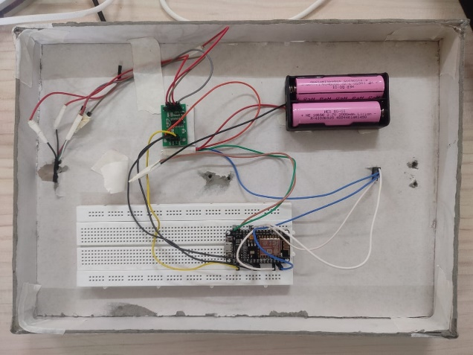

**LITERATURE REVIEW**

VMI is being adopted by the industrial sector to improve supply chain effectiveness in the digital economy. The difficulties in acquiring inventory data and integrating it into the IoT can be solved by an integrated Hub VMI system and RFID system. This leads to better inventory control, cost and time savings, quicker customer service, and higher system efficiency. [1]

Systems for tracking warehouse inventory make use of RFID technology to wirelessly communicate precise product information and position data to a central computer. A main server run on a Raspberry Pi may easily monitor and verify products thanks to the Internet of Things architecture. This affordable, user-friendly solution makes it possible to track warehouse products effectively. [2]

Because of the booming IT industry and the popularity of smart devices, the Internet of Things (IoT) is developing quickly. Small businesses often do not use IoT for inventory management, despite the fact that large corporations frequently do. Researchers created an inventory management system using a Raspberry Pi, an Arduino, a color sensor to identify different sorts of merchandise, and a MySQL database to test it on a small business. The technology showed promise for improving inventory control for small businesses. [3]

In order to increase record accuracy, this study suggests an intelligent inventory management strategy that uses a Bayesian approximation of physical inventory levels. The instrument updates a probability distribution on inventory levels, allowing for efficient audits and replenishments while lowering expenses related to incorrect data. The suggested audit strategy works better than conventional procedures, according to simulation data. [4]

In the healthcare industry, efficient inventory management is crucial for lowering costs, raising service standards, and conserving resources. In this industry, many techniques for modelling and evaluating inventory systems have been created by researchers and practitioners. This study offers recommendations for additional research along with an integrated research methodology, critical analysis of current approaches, and solution strategies. [5]

This study examines inventory distribution in fast-fashion retail networks in collaboration with Zara. The study predicts item sales at a single retailer during a replenishment period using a stochastic model. To determine shop shipment numbers that maximize total predicted sales while taking inventory availability and other limitations into account, a mixed-integer programed is designed. The technique was followed by Zara, and as a consequence, sales increased by 3-4% while transshipments decreased.[6]

**RESULTS AND DISSCUSION**

The NodeMCU was used to send the data to the web server through the Wi-Fi network after the load cell was used to determine the weight of the inventory items. The weight of the inventory items may be accurately measured by the system, sent, and afterwards monitored remotely through a web-based interface. Using an IoT-based inventory management system can have a number of advantages, including enhanced accuracy, decreased manual labour, and real-time monitoring. The system can deliver precise and trustworthy data that can be utilised to optimise inventory management procedures by measuring the weight of inventory items using a load cell. The NodeMCU offers an inexpensive and simple-to-use platform for data transmission over a Wi-Fi network, making it perfect for Internet of Things (IoT)-based applications. The system can give a user-friendly and accessible interface for inventory managers to view inventory levels and make educated decisions by employing a web-based interface to monitor and manage inventory.

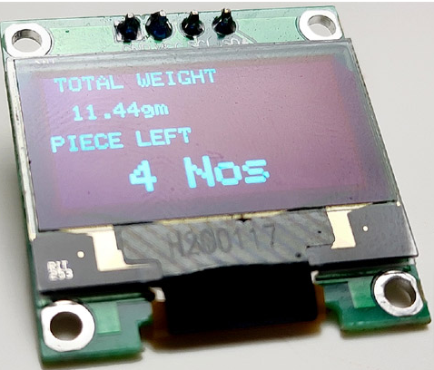

**CONCLUSION**

This project suggests an Internet of Things-based inventory management system that continually monitors and tracks product weight using a load cell and NodeMCU. The system provides a scalable, reasonably priced inventory management solution that may be applied in diverse settings. The recommended solution has the potential to greatly improve inventory management for firms and offers benefits including real-time monitoring, decreased stockout risk, and cheaper inventory carrying costs. Notwithstanding the implementation's difficulties, the benefits of improved inventory management and cost reductions justify the expense.

**FUTURE SCOPE**

A potential solution to the issues with traditional inventory management methods is a NodeMCU and load cell-based Internet of Things-based inventory management system. It may be investigated to do more research and development in a variety of areas to enhance the system's usability and functionality.

One potential area for future development is the introduction of additional sensors and technologies, such as temperature and humidity sensors for perishable goods, to provide more comprehensive data on inventory levels.

**REFERENCE**

1.Fang, X., & Chen, H. C. (2022). Using vendor management inventory system for goods inventory management in IoT manufacturing. Enterprise Information Systems, 16(7), 1885743.

2.Tejesh, B. S. S., & Neeraja, S. J. A. E. J. (2018). Warehouse inventory management system using IoT and open source framework. Alexandria Engineering Journal, 57(4), 3817-3823.

3.Choi, E. S., Kang, M. S., Jung, Y. G., & Paik, J. K. (2017). Implementation of IoT-based Automatic Inventory Management System. International Journal of Advanced Culture Technology, 5(1), 70-75.

4.DeHoratius, N., Mersereau, A. J., & Schrage, L. (2008). Retail inventory management when records are inaccurate. Manufacturing & Service Operations Management, 10(2), 257-277.

5.Saha, E., & Ray, P. K. (2019). Modeling and analysis of inventory management systems in healthcare: A review and reflections. Computers & Industrial Engineering, 137, 106051.

6.Caro, F., & Gallien, J. (2010). Inventory management of a fast-fashion retail network. Operations Research, 58(2), 257-273.

7.Rezwan, S., Ahmed, W., Mahia, M. A., & Islam, M. R. (2018). IoT based smart inventory management system for kitchen using weight sensors, LDR, LED, Arduino Mega and NodeMCU (ESP8266) Wi-Fi module with website and app. In 2018 Fourth International Conference on Advances in Computing, Communication & Automation (ICACCA) (pp. 1-6). IEEE.

8.Xie and Sarathchandra (2015) conducted an empirical study of an automated inventory management system using a Bayesian inference algorithm.

9.Li and Kuo (2008) developed an inventory management system for automobile spare parts in a central warehouse.

10.Gaur, Kesavan, and Raman (2014) discussed the importance of managing retail inventory and proposed solutions for effective management.

11.Kobbacy and Liang (1999) proposed the development of an intelligent inventory management system.

12.Payne et al. (2020) developed a chemical management system (CMS) to assist with inventory management.

13.Park and Yoo (2012) developed a heuristic for inventory management in smart vending machine systems.

14.Atieh et al. (2016) proposed the use of an automated warehouse management system to improve inventory management system processes.

15.Tan and Karabati (2013) proposed a retail inventory management approach based on dynamic demand substitution.

16.Lancioni and Howard (1978) discussed various inventory management techniques.

17.Eckert (2007) explored the effects of inventory management on customer satisfaction.

18.Lei et al. (2021) analyzed the dynamics and fractional-order approximate entropy of nonlinear inventory management systems.

19.Samuel (2012) investigated the performance of supermarkets in western Kenya with the implementation of an inventory management automation system.

20.Razi and Tarn (2003) proposed an applied model for improving inventory management in ERP systems.