**The Maximum Profit System.**

In short: it allows you to get bigger gains in a shorter amount of time… by identifying when a stock is starting and ending a growth period.

It does not use earnings per share, PE ratios, analyst estimates, anything like that.

The Maximum Profit System uses two unique indicators. These two indicators aren’t widely known. There aren’t found on a balance sheet… an income statement… or in a company’s SEC filings. Taken by themselves they have proven to deliver great results for investors.

The first indicator is called ***relative strength***. If you’ve never heard of relative strength before, you are not alone. Most people haven’t. Another name for it is momentum investing. Here is how it works…

Simply put, relative strength tells you how fast a company’s share price s moving upward. We compare the past six months performance of a stock to the entire market. If, over the past six months, a stock has outperformed 70% of all other stocks on the market, then it passes the relative strength test → The stock is performing strongly relative to its peers. Studies have consistently shown that stocks that are currently performing well and likely to continue doing so in the future.

When a stock shows a high relative strength rating, it means the company has entered a growth window and has a high probability of delivering market-beating gains in the near future. The great thing about relative strength is that you don’t have to try to catch a falling knife. Instead of trying to guess when a falling stock will rebound, you focus on stocks that are already moving in the right direction. Furthermore, once a stock starts to flatten or fall, its relative strength falls too – signaling that it’s time to sell.

*Note by Dima: some may argue that since S&P 500 is moving and moving upward, there are always some stocks which rise. That is true, BUT we are focusing on stocks that rise CONTINUOUSLY. Of course there are shares, which go up and down every month, and many of them may grow positively and outperform the market. But the winners may change every month – the outperforming stocks shoot up and come down, therefore its is fairly hard to find stocks outperforming the entire S&P 500 and moreover 70% or more of its peers.*

The formula for calculation of return is simple:

$\frac{Pe−Pb}{Pb}$

Where Pe – price at the end of a period

Pb – price at the beginning of a period

The obvious question is: what is the period? The period should be a month1, for example it would be convenient to take 28th of each month (we certainly cannot take 6 months as our period straight away since some stocks may be quite volatile – we are looking for CONSISTENT returns2). So lets say stock X was traded at the price Pb=50$ dollars on the 28th of August and its price went up to Pe=60$ by 28th of September. Then the return would be (60-50/50)*100%=20%. It is that simple. The hard part is – we have to compare it to each single company in the entire NYSE, which has approximately 3500 companies. we compute returns for all 3500 companies and then arrange them in the normal distribution and then take companies in the highest 30% of the curve (that is we take companies, which are on the right end of the curve)3. If we want to make things simpler, we can arrange all the returns from lowest to highest and then take highest 30%. Or use percentiles – take companies in the top 25th percentile, the idea is the same – outline top winners. We do it for each month and look for companies, which have persistently been at the right end of the curve. Another possible way is to narrow down the sample size: that is to take company from S&P 500 and compare it with companies from the index. However in that case it would be harder to find company with the criteria we want.

Relative strength is what’s called a technical indicator. It determines whether or

not a stock is a “buy” based strictly on its price movements over the past six

months. But it turns out you can add another level of safety and growth by

adding a fundamental indicator… an indicator that tells you that you’re investing

in a good, fundamentally sound company. It is related to ***cash flow***. Most people

use earnings to analyze a company they look at things like the PE ratio, earnings

per share, earnings estimates and the like. The problem is – earnings can be

manipulated (think of Enron). Cash flow is different – it is not an accounting

measure that you can create out of thin air. Cash low measures the actual amount

of money coming into the business. Not “paper profits”, or some future income

stream that may or may not pan out. Cash flow is the money business uses to buy

new factories, pour into research and development or deliver back to its

investors via dividends. And if a company is increasing its cash flow t a rapid clip,

it’s not likely to go belly up any time soon. To pass the test, a company has to be

***growing its cash flow***. The same way a company’s share price must be

outperforming 70% of its peers; its cash flow must be doing the same thing. Same rules apply for calculations as described by the relative strength, the only difference in the formula being – we replace price P with CF – cash flow.

By combining these two indicators – ***relative strength and cash flow growth***– we are able to better now when stock is entering and leaving a growth period. First. Rising cash flow growth tells us the company has been bringing in more and more money. So we know it’s a good, fundamentally - sound business. Second, relative strength tells us that the market is starting to catch on. The share price is gaining momentum, entering a possible breakout phase. That’s how this system has been able to deliver bigger gains in the shorter amount of time. It can catch stocks during their growth periods.

Bottom line: figuring conservatively, history suggests the Maximum Profit system could give you bigger gains in a shorter amount of time.

Where to find data:

1. Prices are available on Yahoo Finance.
2. Cash Flow might be available on Yahoo Finance, but we are looking for Operating Cash Flow. This can be found in the “Key Statistics” section – the second parameter from the bottom in this section.

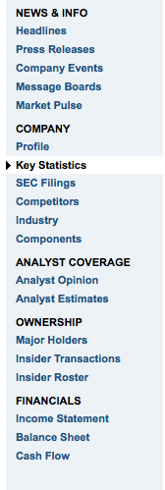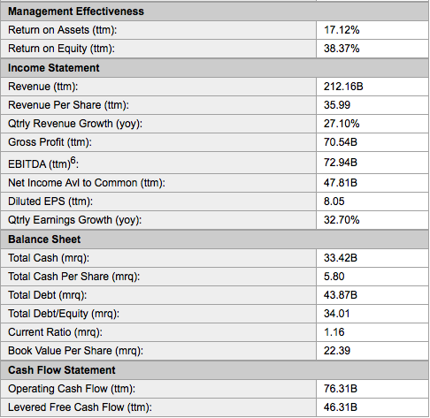

1 This is just best way in my opinion, but if you want you can choose 2 months or 3 months

2 The 6 months period may be used, although when stocks are chosen we should check their graphs to ensure that these are not volatile.

3 Different methods can be used depending on the availability of data and efficiency. The way involving normal distribution involves less calculations and therefore is quicker and more efficient although can be less precise.