Report for Advanced Databases Project

ITI, SD, Intake 43

Ahmed Negmeldin Abdeltawwab

Hagar Mustafa Mahmoud

Hafsa Ebrahim Baddor

Khaled Ayman Taha

Mohaned Saudi Raady

Contents

1. GitHub Repository 2

2. ERD 2

1. DB Diagram 3

2. Reports 4

a. First Report: Students Information by Department ID 4

b. Second Report: Student Grades by Student ID 4

c. Third Report: Current Courses and Number of Registered Students by Instructor ID 5

d. Fourth Report: Course Topics by Course ID 5

e. Fifth Report: Display Exam by Exam ID 6

f. Sixth Report: Student Answers by Exam ID and Student ID 7

3. Stored Procedures 8

# GitHub Repository

<https://github.com/anazhmetdin/ITI_Exams_DB>

# ERD

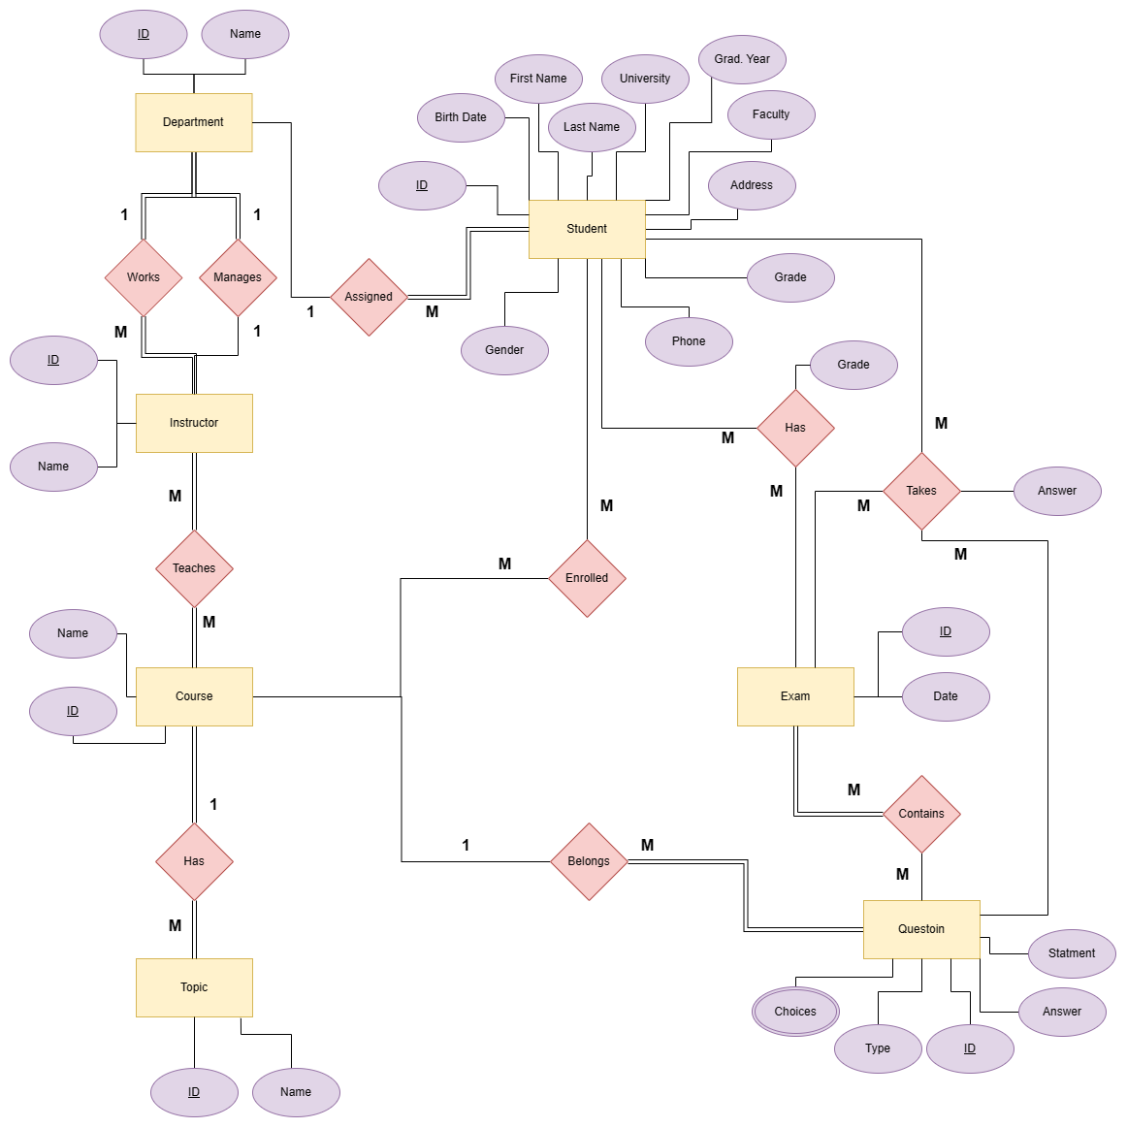

# DB Diagram

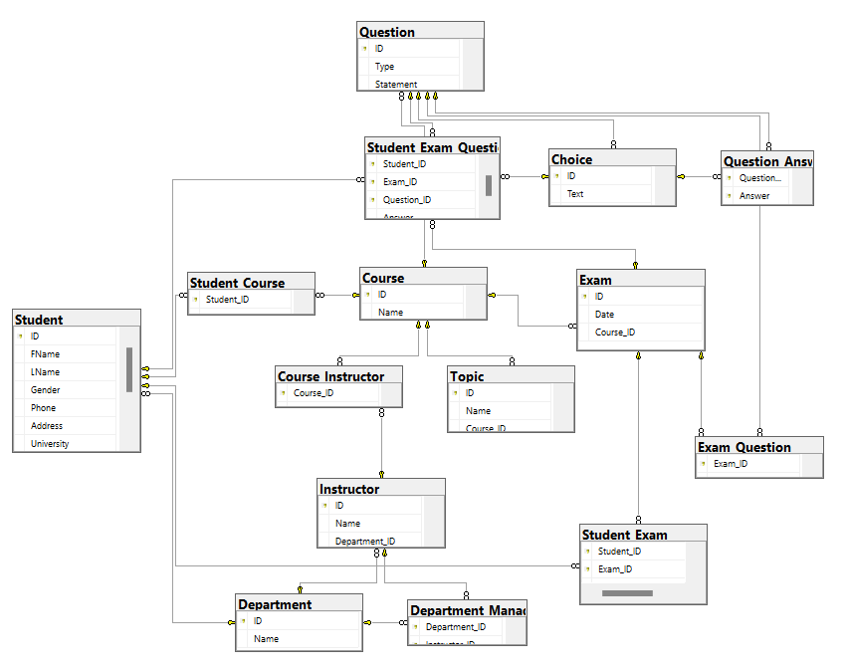

# Reports

All reports are generated by MS Report Builder

## First Report: Students Information by Department ID

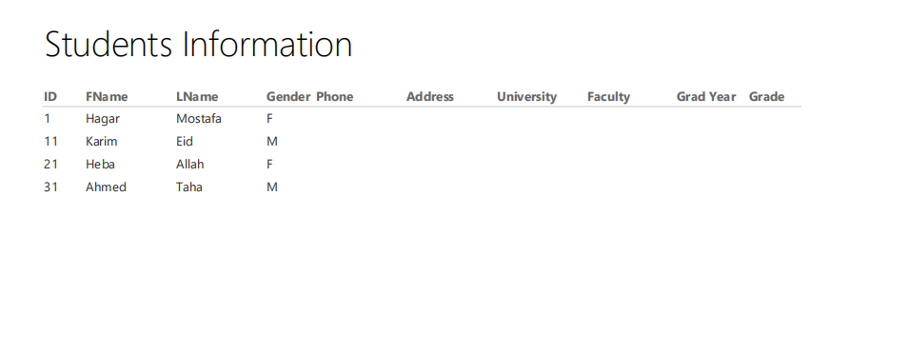

The corresponding stored procedure: Std_Info_Dep

## Second Report: Student Grades by Student ID

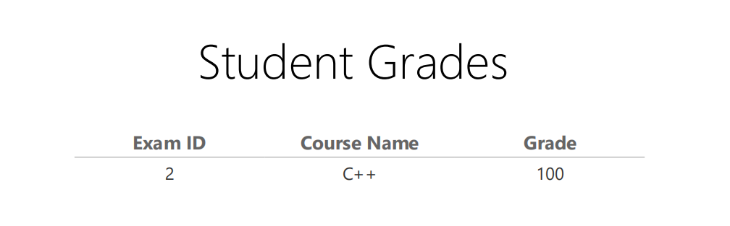

The corresponding stored procedure: stdGrades

## Third Report: Current Courses and Number of Registered Students by Instructor ID

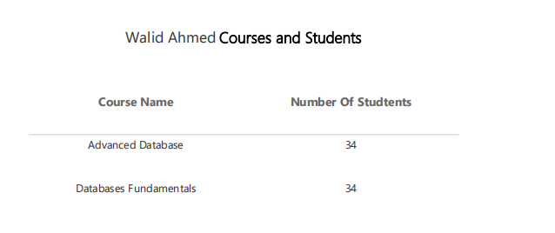

The corresponding stored procedure: ReturnInstructorCourseStudents

## Fourth Report: Course Topics by Course ID

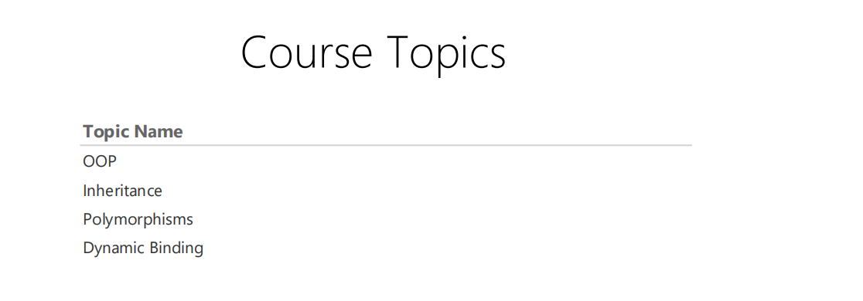

The corresponding stored procedure: GetCourseTopics

## Fifth Report: Display Exam by Exam ID

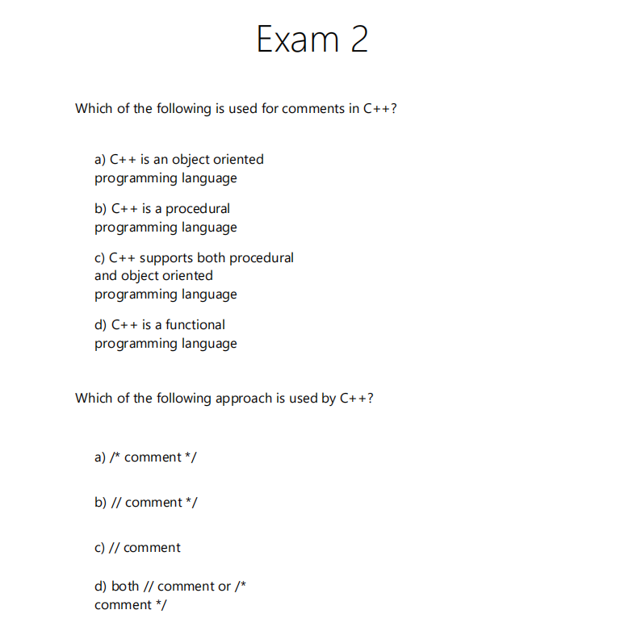

The corresponding stored procedure: exam_ques_choices

## Sixth Report: Student Answers by Exam ID and Student ID

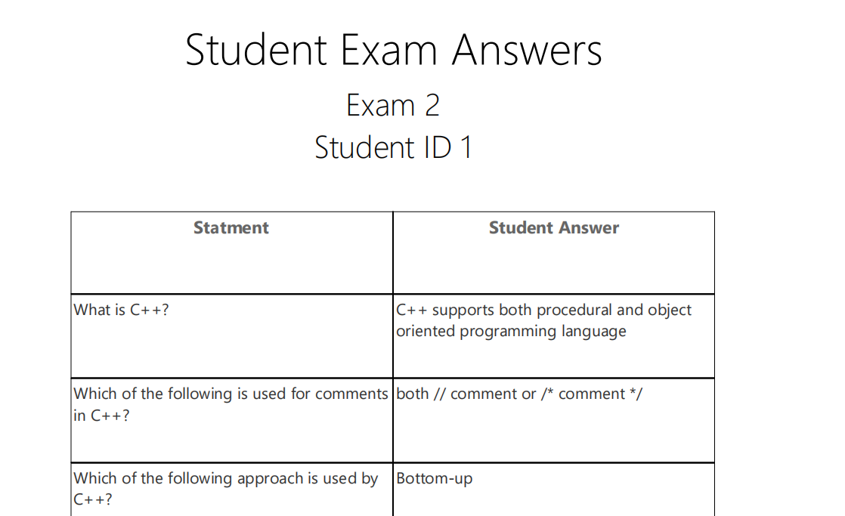

The corresponding stored procedure: Report6

# Stored Procedures

|  |  |  |  |  |  |  |
| --- | --- | --- | --- | --- | --- | --- |
| **Proc ID** | **Procedure Name** | **Param ID** | **Parameter Name** | **Param Data type** | **Param Size in Bytes** | **Is Param Out** |
| 1 | CorrectExam | 1 | @eid | int | 4 | False |
|  | CorrectExam | 2 | @sid | int | 4 | False |
| 2 | DeleteAnswer | 1 | @qid | int | 4 | False |
|  | DeleteAnswer | 2 | @force | bit | 1 | False |
| 3 | DeleteChoices | 1 | @qid | int | 4 | False |
|  | DeleteChoices | 2 | @force | bit | 1 | False |
| 4 | DeleteCourse | 1 | @id | int | 4 | False |
|  | DeleteCourse | 2 | @cName | varchar | 30 | False |
| 5 | DeleteCourseInstructor | 1 | @cID | int | 4 | False |
|  | DeleteCourseInstructor | 2 | @insID | int | 4 | False |
| 6 | DeleteDepartment | 1 | @id | int | 4 | False |
|  | DeleteDepartment | 2 | @name | varchar | 32 | False |
|  | DeleteDepartment | 3 | @all | bit | 1 | False |
| 7 | DeleteDeptMngr | 1 | @MngrID | int | 4 | False |
|  | DeleteDeptMngr | 2 | @DeptID | int | 4 | False |
| 8 | DeleteExam | 1 | @id | int | 4 | False |
|  | DeleteExam | 2 | @date | date | 3 | False |
|  | DeleteExam | 3 | @all | bit | 1 | False |
| 9 | DeleteExamQ | 1 | @QID | int | 4 | False |
|  | DeleteExamQ | 2 | @ExamID | int | 4 | False |
| 10 | DeleteQuestion | 1 | @qid | int | 4 | False |
|  | DeleteQuestion | 2 | @force | bit | 1 | False |
| 11 | DeleteStdCourse | 1 | @StdID | int | 4 | False |
|  | DeleteStdCourse | 2 | @CrsID | int | 4 | False |
| 12 | DeleteStudentExam | 1 | @id | int | 4 | False |
|  | DeleteStudentExam | 2 | @name | varchar | 32 | False |
|  | DeleteStudentExam | 3 | @all | bit | 1 | False |
| 13 | DeleteStudentExamQuestionAnswer | 1 | @studentID | int | 4 | False |
|  | DeleteStudentExamQuestionAnswer | 2 | @examID | int | 4 | False |
|  | DeleteStudentExamQuestionAnswer | 3 | @questionID | int | 4 | False |
|  | DeleteStudentExamQuestionAnswer | 4 | @answer | int | 4 | False |
|  | DeleteStudentExamQuestionAnswer | 5 | @all | bit | 1 | False |
| 14 | DeleteTopic | 1 | @id | int | 4 | False |
|  | DeleteTopic | 2 | @tName | varchar | 30 | False |
| 15 | exam_ques_choices | 1 | @exam_id | int | 4 | False |
| 16 | ExamAnswer | 1 | @eID | int | 4 | False |
|  | ExamAnswer | 2 | @sID | int | 4 | False |
|  | ExamAnswer | 3 | @c1 | int | 4 | False |
|  | ExamAnswer | 4 | @c2 | int | 4 | False |
|  | ExamAnswer | 5 | @c3 | int | 4 | False |
|  | ExamAnswer | 6 | @c4 | int | 4 | False |
|  | ExamAnswer | 7 | @c5 | int | 4 | False |
|  | ExamAnswer | 8 | @c6 | int | 4 | False |
|  | ExamAnswer | 9 | @c7 | int | 4 | False |
|  | ExamAnswer | 10 | @c8 | int | 4 | False |
|  | ExamAnswer | 11 | @c9 | int | 4 | False |
|  | ExamAnswer | 12 | @c10 | int | 4 | False |
| 17 | GenerateExam | 1 | @courseName | varchar | 128 | False |
|  | GenerateExam | 2 | @MCQCount | int | 4 | False |
|  | GenerateExam | 3 | @MTFCount | int | 4 | False |
|  | GenerateExam | 4 | @exam_ID | int | 4 | True |
|  | GenerateExam | 5 | @date | date | 3 | False |
| 18 | GetCourseTopics | 1 | @cid | int | 4 | False |
| 19 | InsertChoice | 1 | @qid | int | 4 | False |
|  | InsertChoice | 2 | @c | varchar | 5000 | False |
|  | InsertCourse | 1 | @cName | varchar | 16 | False |
|  | InsertCourse | 2 | @id | int | 4 | True |
| 20 | InsertCourseInstructor | 1 | @cID | int | 4 | False |
|  | InsertCourseInstructor | 2 | @insID | int | 4 | False |
| 21 | InsertDepartment | 1 | @id | int | 4 | False |
|  | InsertDepartment | 2 | @name | varchar | 32 | False |
| 22 | InsertDeptMngr | 1 | @MngrID | int | 4 | False |
|  | InsertDeptMngr | 2 | @DeptID | int | 4 | False |
| 23 | InsertExam | 1 | @date | date | 3 | False |
|  | InsertExam | 2 | @id | int | 4 | True |
|  | InsertExam | 3 | @courseId | int | 4 | False |
| 24 | InsertExamAnswerChoice | 1 | @eID | int | 4 | False |
|  | InsertExamAnswerChoice | 2 | @sID | int | 4 | False |
|  | InsertExamAnswerChoice | 3 | @ch | int | 4 | False |
| 25 | InsertExamQ | 1 | @QID | int | 4 | False |
|  | InsertExamQ | 2 | @ExamID | int | 4 | False |
| 26 | InsertInstructor | 1 | @id | int | 4 | False |
|  | InsertInstructor | 2 | @name | varchar | 32 | False |
|  | InsertInstructor | 3 | @dep_id | int | 4 | False |
| 27 | InsertQuestion | 1 | @type | varchar | 3 | False |
|  | InsertQuestion | 2 | @statment | varchar | -1 | False |
|  | InsertQuestion | 3 | @cid | int | 4 | False |
|  | InsertQuestion | 4 | @id | int | 4 | True |
| 28 | InsertQuestionAnswer | 1 | @qid | int | 4 | False |
|  | InsertQuestionAnswer | 2 | @aid | int | 4 | False |
| 29 | InsertQuestionWithChoices | 1 | @type | varchar | 3 | False |
|  | InsertQuestionWithChoices | 2 | @statment | varchar | -1 | False |
|  | InsertQuestionWithChoices | 3 | @cid | int | 4 | False |
|  | InsertQuestionWithChoices | 4 | @answer | int | 4 | False |
|  | InsertQuestionWithChoices | 5 | @c1 | varchar | 5000 | False |
|  | InsertQuestionWithChoices | 6 | @c2 | varchar | 5000 | False |
|  | InsertQuestionWithChoices | 7 | @c3 | varchar | 5000 | False |
|  | InsertQuestionWithChoices | 8 | @c4 | varchar | 5000 | False |
| 30 | InsertStdCourse | 1 | @StdID | int | 4 | False |
|  | InsertStdCourse | 2 | @CrsID | int | 4 | False |
| 31 | InsertStudent | 1 | @studentID | int | 4 | False |
|  | InsertStudent | 2 | @fname | varchar | 16 | False |
|  | InsertStudent | 3 | @lname | varchar | 16 | False |
|  | InsertStudent | 4 | @gender | varchar | 1 | False |
|  | InsertStudent | 5 | @phone | varchar | 13 | False |
|  | InsertStudent | 6 | @address | varchar | 256 | False |
|  | InsertStudent | 7 | @university | varchar | 128 | False |
|  | InsertStudent | 8 | @faculty | varchar | 128 | False |
|  | InsertStudent | 9 | @gradyear | int | 4 | False |
|  | InsertStudent | 10 | @grade | varchar | 2 | False |
|  | InsertStudent | 11 | @dep_id | int | 4 | False |
| 31 | InsertStudentExam | 1 | @studentID | int | 4 | False |
|  | InsertStudentExam | 2 | @examID | int | 4 | False |
|  | InsertStudentExam | 3 | @Grade | float | 8 | False |
| 32 | InsertStudentExamQuestionAnswer | 1 | @studentID | int | 4 | False |
|  | InsertStudentExamQuestionAnswer | 2 | @examID | int | 4 | False |
|  | InsertStudentExamQuestionAnswer | 3 | @questionID | int | 4 | False |
|  | InsertStudentExamQuestionAnswer | 4 | @answer | int | 4 | False |
| 33 | InsertTopic | 1 | @tName | varchar | 16 | False |
|  | InsertTopic | 2 | @id | int | 4 | True |
| 34 | Report6 | 1 | @stdID | int | 4 | False |
|  | Report6 | 2 | @examID | int | 4 | False |
| 35 | ReturnInstructorCourseStudents | 1 | @insID | int | 4 | False |
| 36 | SelectChoices | 1 | @qid | int | 4 | False |
|  | SelectCourse | 1 | @id | int | 4 | False |
|  | SelectCourse | 2 | @cName | varchar | 30 | False |
| 37 | SelectCourseInstructor | 1 | @cID | int | 4 | False |
|  | SelectCourseInstructor | 2 | @insID | int | 4 | False |
| 38 | SelectDepartment | 1 | @id | int | 4 | False |
|  | SelectDepartment | 2 | @name | varchar | 32 | False |
| 39 | SelectDeptMngr | 1 | @MngrID | int | 4 | False |
|  | SelectDeptMngr | 2 | @DeptID | int | 4 | False |
| 40 | SelectExam | 1 | @id | int | 4 | False |
|  | SelectExam | 2 | @dateStart | date | 3 | False |
|  | SelectExam | 3 | @dateEnd | date | 3 | False |
| 41 | SelectInstructor | 1 | @id | int | 4 | False |
|  | SelectInstructor | 2 | @name | varchar | 32 | False |
|  | SelectInstructor | 3 | @dep_id | int | 4 | False |
| 42 | SelectQuestionAnswer | 1 | @qid | int | 4 | False |
| 43 | SelectStdCourses | 1 | @StdID | int | 4 | False |
|  | SelectStdCourses | 2 | @CrsID | int | 4 | False |
| 44 | SelectStudent | 1 | @studentID | int | 4 | False |
|  | SelectStudent | 2 | @fname | varchar | 16 | False |
|  | SelectStudent | 3 | @lname | varchar | 16 | False |
|  | SelectStudent | 4 | @gender | varchar | 1 | False |
|  | SelectStudent | 5 | @phone | varchar | 13 | False |
|  | SelectStudent | 6 | @address | varchar | 256 | False |
|  | SelectStudent | 7 | @university | varchar | 128 | False |
|  | SelectStudent | 8 | @faculty | varchar | 128 | False |
|  | SelectStudent | 9 | @gradyear | int | 4 | False |
|  | SelectStudent | 10 | @grade | varchar | 2 | False |
|  | SelectStudent | 11 | @dep_id | int | 4 | False |
| 45 | SelectStudentExam | 1 | @studentID | int | 4 | False |
|  | SelectStudentExam | 2 | @examID | int | 4 | False |
|  | SelectStudentExam | 3 | @minGrade | float | 8 | False |
|  | SelectStudentExam | 4 | @maxGrade | float | 8 | False |
| 46 | SelectStudentExamQuestionAnswer | 1 | @studentID | int | 4 | False |
|  | SelectStudentExamQuestionAnswer | 2 | @examID | int | 4 | False |
|  | SelectStudentExamQuestionAnswer | 3 | @questionID | int | 4 | False |
|  | SelectStudentExamQuestionAnswer | 4 | @answer | int | 4 | False |
| 47 | SelectTopic | 1 | @id | int | 4 | False |
|  | SelectTopic | 2 | @tName | varchar | 30 | False |
| 48 | stdGrades | 1 | @StdID | int | 4 | False |
| 49 | UpdateChoice | 1 | @cid | int | 4 | False |
|  | UpdateChoice | 2 | @text | varchar | 5000 | False |
|  | UpdateCourse | 1 | @id | int | 4 | False |
|  | UpdateCourse | 2 | @oldName | varchar | 30 | False |
|  | UpdateCourse | 3 | @newName | varchar | 30 | False |
| 50 | UpdateCourseInstructor | 1 | @insID | int | 4 | False |
|  | UpdateCourseInstructor | 2 | @cID | int | 4 | False |
| 51 | UpdateDepartment | 1 | @id | int | 4 | False |
|  | UpdateDepartment | 2 | @name | varchar | 32 | False |
|  | UpdateDepartment | 3 | @all | bit | 1 | False |
| 52 | UpdateDeptMngr | 1 | @MngrID | int | 4 | False |
|  | UpdateDeptMngr | 2 | @DeptID | int | 4 | False |
|  | UpdateDeptMngr | 3 | @all | bit | 1 | False |
| 53 | UpdateExam | 1 | @id | int | 4 | False |
|  | UpdateExam | 2 | @date | date | 3 | False |
|  | UpdateExam | 3 | @all | bit | 1 | False |
| 54 | UpdateInstuctor | 1 | @id | int | 4 | False |
|  | UpdateInstuctor | 2 | @name | varchar | 32 | False |
|  | UpdateInstuctor | 3 | @dep_id | int | 4 | False |
|  | UpdateInstuctor | 4 | @all | bit | 1 | False |
|  | UpdateQuestion | 1 | @qid | int | 4 | False |
|  | UpdateQuestion | 2 | @statment | varchar | -1 | False |
|  | UpdateQuestion | 3 | @cid | int | 4 | False |
| 55 | UpdateQuestionAnswer | 1 | @qid | int | 4 | False |
|  | UpdateQuestionAnswer | 2 | @ans | int | 4 | False |
| 56 | UpdateStudentExam | 1 | @studentID | int | 4 | False |
|  | UpdateStudentExam | 2 | @examID | int | 4 | False |
|  | UpdateStudentExam | 3 | @minGrade | float | 8 | False |
|  | UpdateStudentExam | 4 | @maxGrade | float | 8 | False |
|  | UpdateStudentExam | 5 | @Grade | float | 8 | False |
|  | UpdateStudentExam | 6 | @all | bit | 1 | False |
| 57 | UpdateStudentExamQuestionAnswer | 1 | @studentID | int | 4 | False |
|  | UpdateStudentExamQuestionAnswer | 2 | @examID | int | 4 | False |
|  | UpdateStudentExamQuestionAnswer | 3 | @questionID | int | 4 | False |
|  | UpdateStudentExamQuestionAnswer | 4 | @answer | int | 4 | False |
|  | UpdateStudentExamQuestionAnswer | 5 | @all | bit | 1 | False |
| 58 | UpdateTopic | 1 | @id | int | 4 | False |
|  | UpdateTopic | 2 | @oldName | varchar | 30 | False |