Docker
🧠 1. Hypervisor
If you meant Hypervisor, here's what it is:
- A hypervisor is a software or hardware platform that allows multiple virtual machines (VMs) to run on a single physical machine.
- It manages and allocates hardware resources to each virtual machine.
Day 1: Docker Tutorial for Beginners: What It Solves & How to Install Docker – 19th Apr 2025
Docker is a platform used to develop, ship, and run applications in a consistent environment called containers.

🚢 What is Docker?
- Docker is an open-source tool that allows you to package an application along with all its dependencies, libraries, and configurations into a container.
- A container is a lightweight, standalone, executable package of software that includes everything needed to run it.
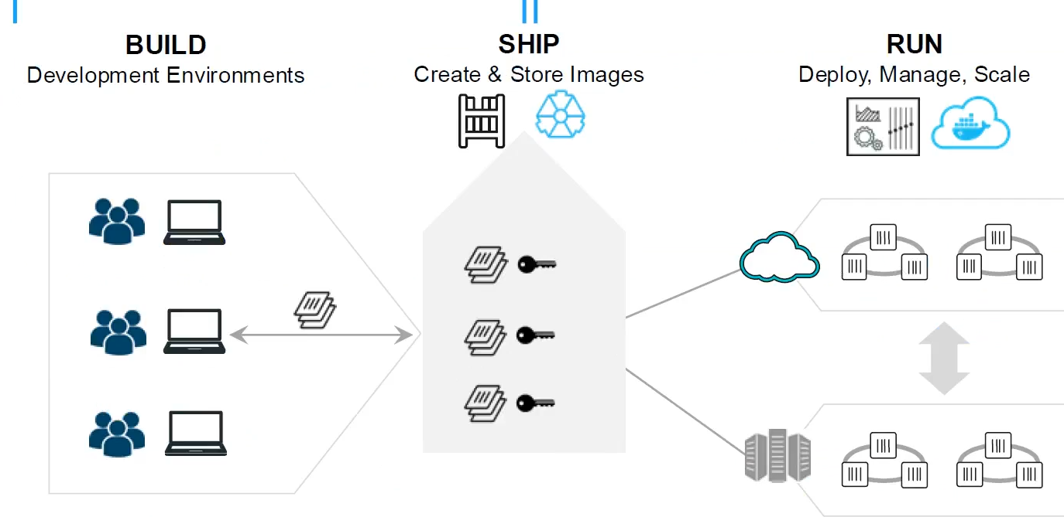
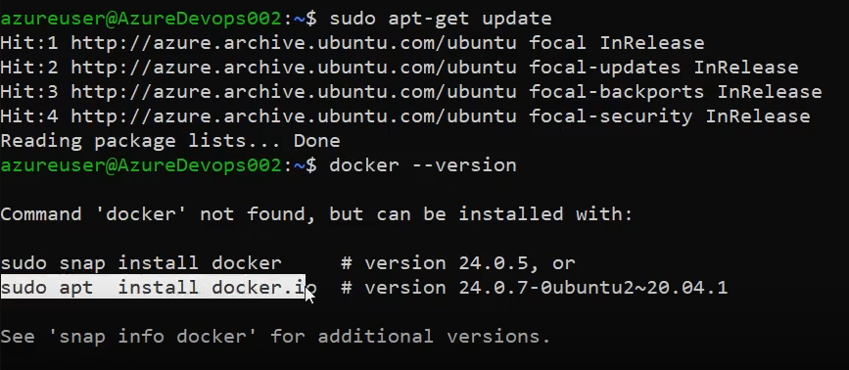
>docker –version
>sudo chmod 777 /var/run/docker.sock
>docker images
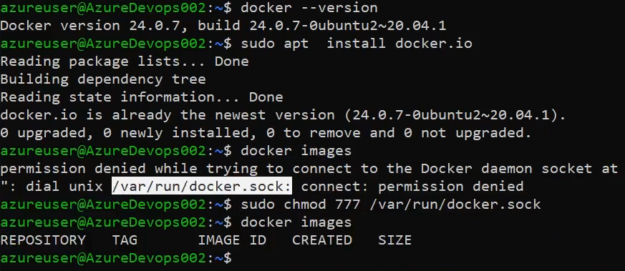
In Docker Hub, already public and private images are available, Just search and pull into that:
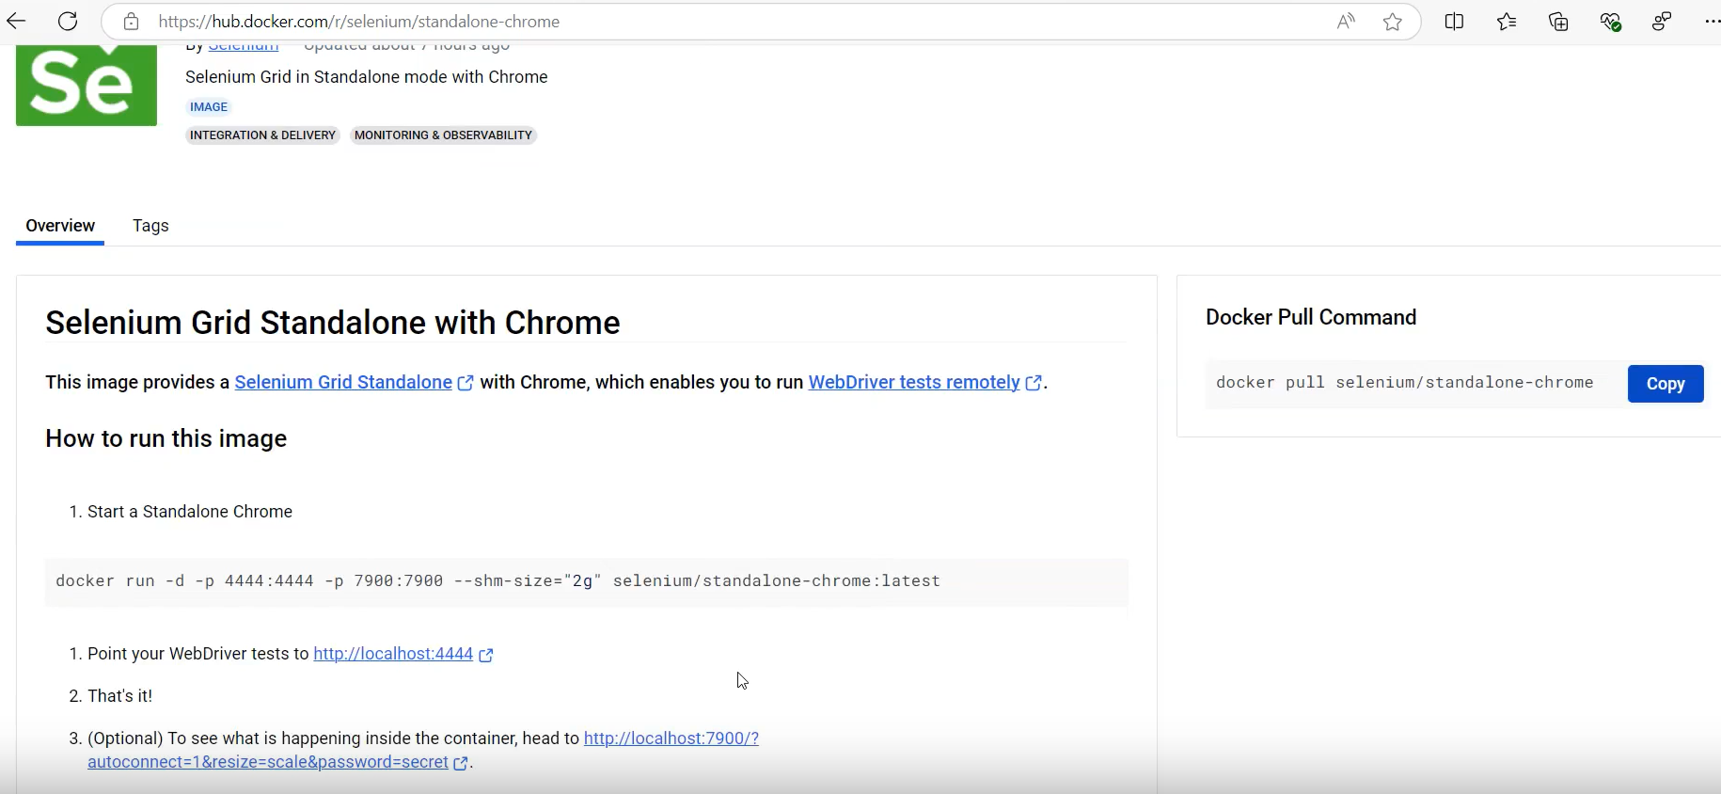

Latest means, It always pull/download latest version.
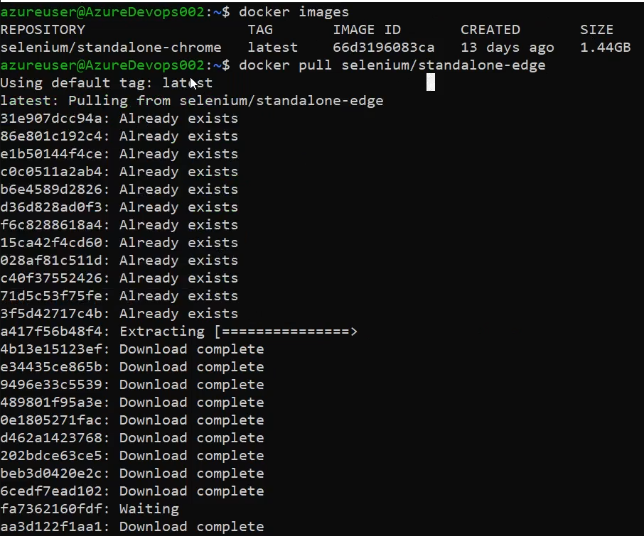
If you want specific version, click on Tag section and select appropriate version:
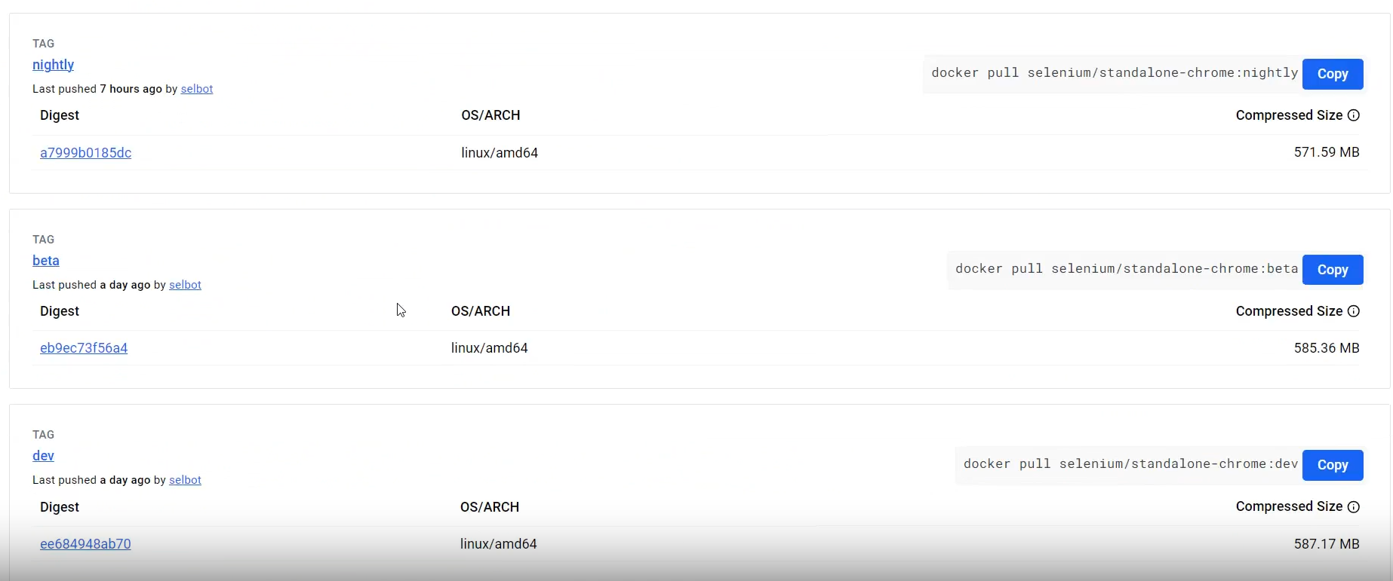
>docker images
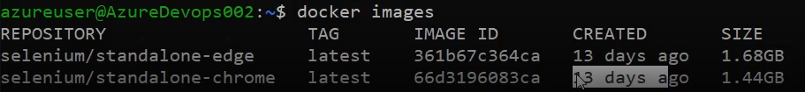
How to run Selenium Grid Standalone with Chrome:
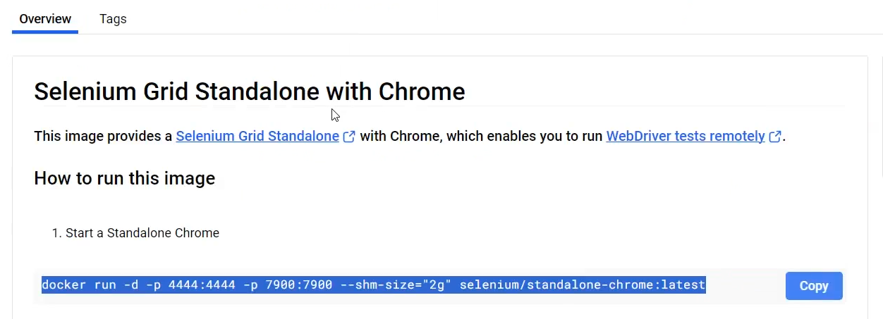
>docker run -d -p 4444:4444 -p 7900:7900 --shm-size="2g" selenium/standalone-chrome:latest
docker - command start with docker
run – create and start a container
-d – deattached mode, run in background
-p – port
4444:4444 – External : Internal
--shm-size
selenium/standalone-chrome:latest – Image Name

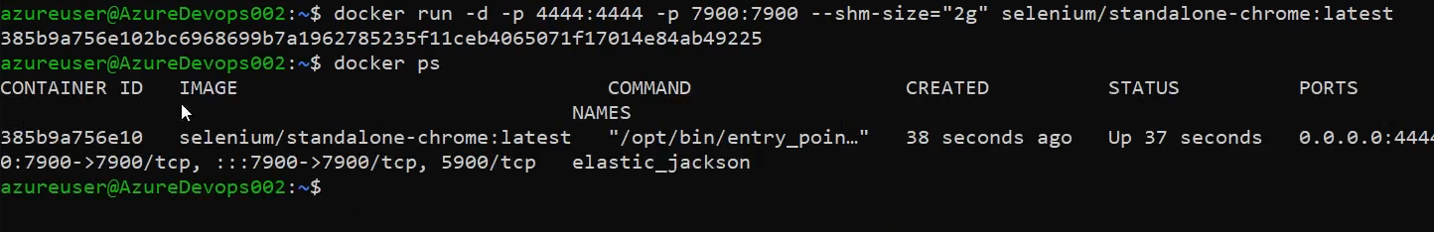
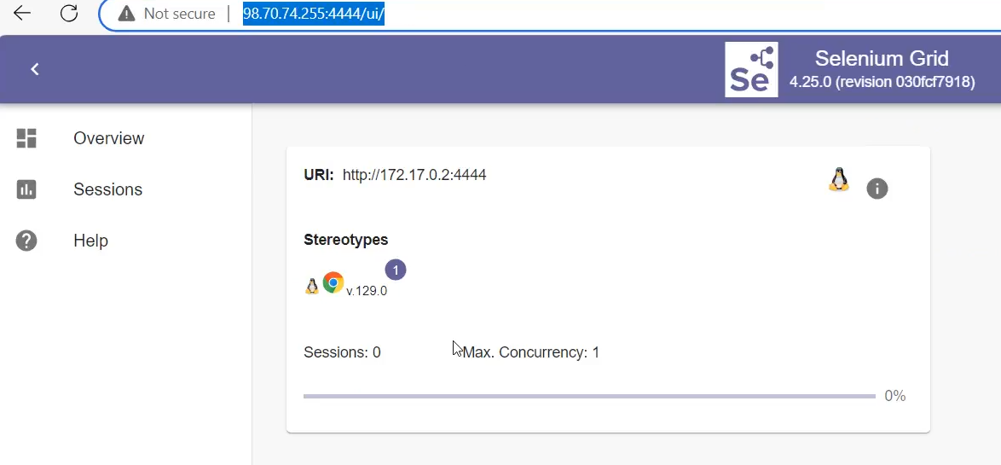
>docker run -d -p 4445:4444 -p 7901:7900 --shm-size="2g" selenium/standalone-edge:latest
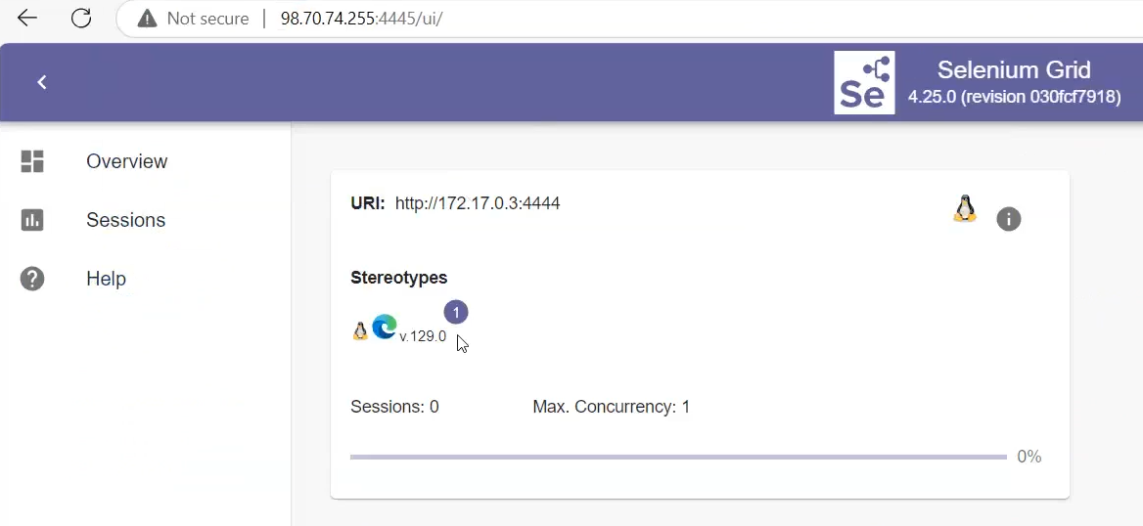

To know the list of port and usage:
https://en.wikipedia.org/wiki/List_of_TCP_and_UDP_port_numbers
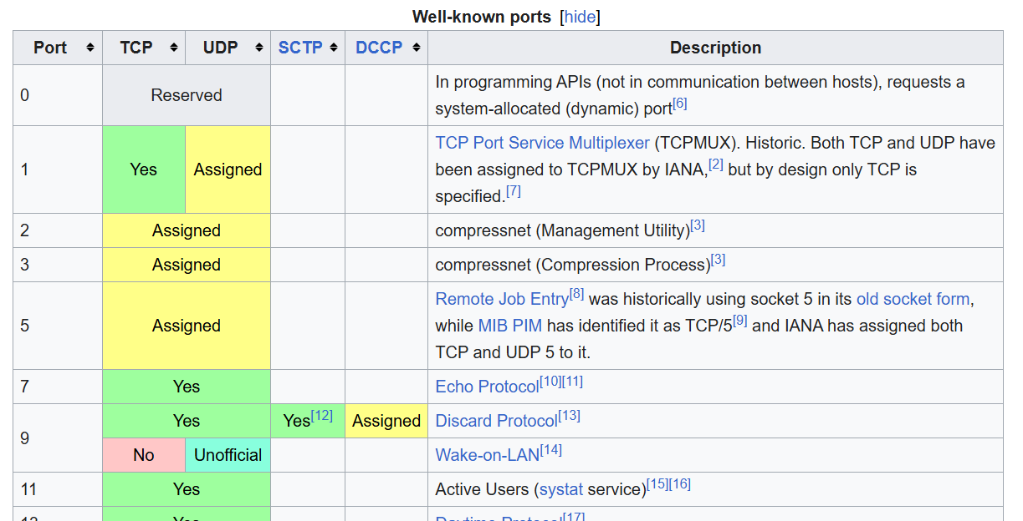
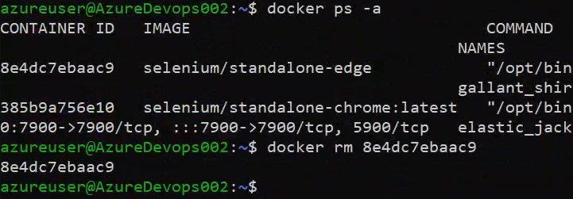
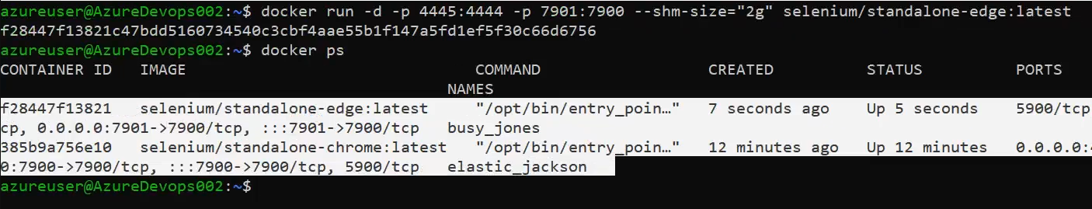

🤔 Why Do We Use Docker?
- Consistency Across Environments
  - "It works on my machine" problem? Gone!
  - Same container runs on dev, test, or production without issues.
- Faster Setup and Deployment
  - You can spin up environments in seconds using Docker images.
- Isolation
  - Each container runs separately, so one app doesn’t affect another.
- Portability
  - Containers can run on any platform that supports Docker (Windows, Linux, macOS, cloud, etc.).
- Efficient Resource Usage
  - Unlike virtual machines, Docker shares the host OS kernel, making containers lightweight and fast.
- Version Control
  - Docker images can be versioned and rolled back if needed.

🚀 Example Use Cases:
- Running web servers like Nginx or Apache
- Deploying microservices
- Automating CI/CD pipelines
- Hosting databases or message queues
- Testing in isolated environments

Difference b/w Docket and Ansible:
Docker and Ansible are both powerful DevOps tools, but they serve different purposes. Let’s break it down:

🐳 Docker vs 🛠️ Ansible
Feature | Docker | Ansible
🔧 Type | Containerization platform | Configuration management & automation tool
🎯 Purpose | Package and run apps in isolated containers | Automate provisioning, configuration, and app deployment
📦 What it does | Creates lightweight, portable environments (containers) | Installs software, configures systems, manages infrastructure
🏃‍♂️ Run-time environment | Creates and manages containers | Connects to servers (via SSH) and applies changes
📁 Language | Uses Dockerfile to build images | Uses YAML in Playbooks to define tasks
🔁 State | Docker is imperative (you define step-by-step instructions) | Ansible is declarative (you define the desired state)
👥 Typical use | Run apps consistently across environments | Set up servers, install packages, deploy apps, etc.
🌐 Dependency | Needs Docker Engine installed | Needs Python + SSH access on target machines

📌 In Simple Terms:
- Docker: Think of it as a box 📦 that holds your app and everything it needs to run.
- Ansible: Think of it as a remote assistant 🤖 that sets up and configures your servers.

🔗 Can They Work Together? https://hub.docker.com/
Absolutely! 💥
- You can use Ansible to install Docker and then deploy Docker containers across servers.
- Together, they make a strong DevOps combo.

What is chmod and chown?
Sure! Here's a simple explanation of chmod and chown in Linux, including their purpose:

🔐 – Change File Permissions
Purpose:
Used to change the permissions (who can read, write, or execute) for a file or directory.
Syntax:
chmod [permissions] [file or directory name]
Types of permissions:
- r – read -- 4
- w – write -- 2
- x – execute -- 1
Who:
- u – user (owner)
- g – group
- o – others
- a – all
Examples:
- Add execute permission to the owner:
chmod u+x script.sh
- Make a file readable and writable by everyone:
chmod a+rw file.txt
- Numeric way:
chmod 755 file.sh
  - 7 = read + write + execute (owner)
  - 5 = read + execute (group and others)

👤 chown – Change File Ownership
Purpose:
Used to change the owner and/or group of a file or directory.
Syntax:
chown [new_owner][:new_group] [file or directory]
Examples:
- Change owner of a file:
chown alice file.txt
- Change owner and group:
chown alice:devteam file.txt
- Change ownership recursively for a directory:
chown -R alice:devteam /project-folder

Day 1: Docker Tutorial for Beginners: What It Solves & How to Install Docker – 19th Apr 2025
>sudo su
root>yum install docker
root>docker --version
root>systemctl start docker
root> docker images
root > docker ps
root>docker ps -a
https://hub.docker.com/
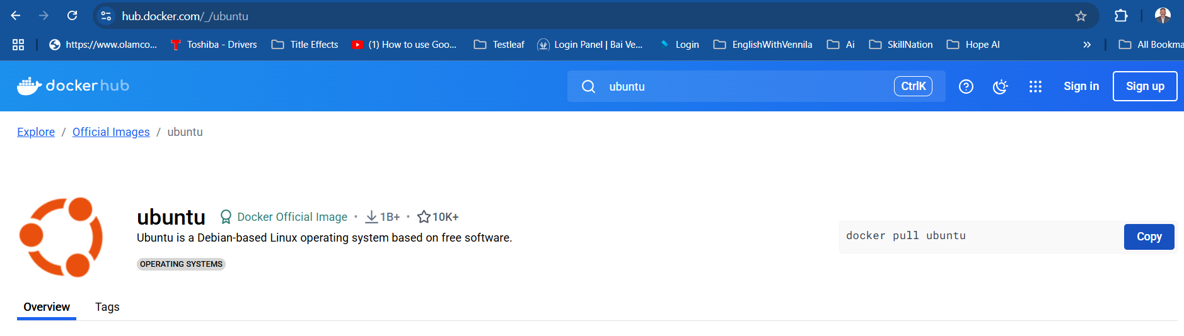
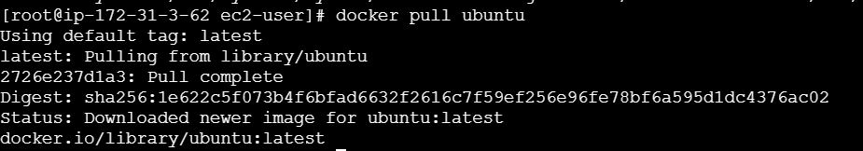
>docker run -it ubuntu // it means Interative Terminal, It will create a container with random name. But if you a custom for the container use the below command:
>docker run ---name anbuMachine -it ubuntu // with custom name container
>cat /etc/os-release
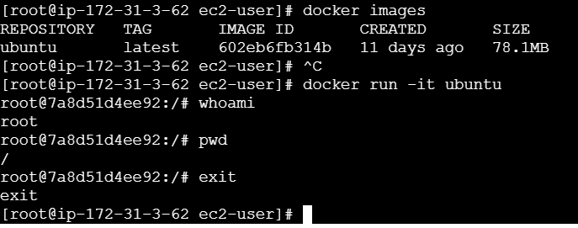

Day 2: Docker Basics for Beginners | Top Docker Commands You MUST Know! – 20th Apr 2025
🐳 What is a Docker Image?
✅ Definition:
A Docker image is like a blueprint or template. It contains everything needed to run a program:
- The code
- Libraries
- Dependencies
- Configuration files
It’s read-only and used to create containers.

🔧 Example:
Think of a cake recipe. That’s your image.
If you have an nginx image, it includes:
- The nginx web server
- All required files to run nginx

📦 What is a Docker Container?
✅ Definition:
A Docker container is a running instance of a Docker image.
It’s like actually baking the cake using the recipe.
You can run, stop, delete, or restart a container.
- Containers are isolated and can run multiple at the same time.
- They are temporary but can be saved if needed.

⚙️ Example:
Using the nginx image (recipe), you start a container (bake a cake). Now you can serve content through it.

📊 Analogy Table
Term | Think of it as... | Key Characteristics
Docker Image | A blueprint or recipe | Read-only, used to create containers
Docker Container | A running machine | A live, working unit based on the image

🔁 Relationship
- You pull or build a Docker image.
- Then you run a container from that image.
# Pulling an image
docker pull nginx
#View all Images
docker images
# Running a container from that image
docker run --name myweb -d nginx
You said:
explain this in detailed :docker run --name myweb -d nginx
ChatGPT said:
Absolutely! Let's break down this Docker command in detail:

🔸 Full Command:
docker run --name myweb -d nginx
This command is used to create and run a Docker container based on the nginx image.

🧱 Word-by-Word Breakdown
Part of Command | Meaning
docker | You're using the Docker command-line tool
run | Tells Docker to create and start a new container
--name myweb | Gives your container a custom name: myweb
-d | Runs the container in detached mode (in the background)
nginx | The image you’re using to create the container (nginx web server)

🧠 What Happens Behind the Scenes:
- Docker checks if the nginx image is already on your machine.
  - If not, it downloads (pulls) it from Docker Hub.
- It creates a new container from the image.
- It starts the container.
- The container runs in the background (thanks to -d).
- The container is named myweb, so you can easily reference it later.

✅ Example Use Case:
You're building a website or testing something. You want to quickly run an nginx server:
docker run --name myweb -d nginx
Now you have a live web server running on nginx inside a Docker container — no manual server setup needed!

🧪 You can now:
- See it running:
  - docker ps
- Access its logs:
  - docker logs myweb
- Stop it:
  - docker stop myweb
- Remove it:
  - docker rm myweb

⚠️ Notes:
- -d (detached mode) is useful when you don’t want your terminal to be blocked.
- You can add ports with -p, like -p 8080:80 to access nginx on your browser.
🔹 docker ps -a
- What it does:
Lists all containers on your system — both running and stopped (exited) ones.
- Breakdown:
  - ps = process status (like ps in Linux).
  - -a = all containers (not just the running ones).
- Useful when:
You want to see containers that have stopped, crashed, or exited.
- Example output:
mathematica
CopyEdit
CONTAINER ID IMAGE COMMAND STATUS NAMES
abc123 nginx "/start.sh" Exited (0) 2 hours ago my_nginx
def456 ubuntu "bash" Up 5 minutes my_ubuntu

🔹 docker images
- What it does:
Lists all Docker images available on your local machine.
- Useful when:
You want to see what base images (like Ubuntu, Nginx, Node, etc.) are available to create containers from.
- Example output:
REPOSITORY TAG IMAGE ID CREATED SIZE
nginx latest abc123 3 days ago 133MB
ubuntu 20.04 def456 2 weeks ago 72.9MB

Summary Table
Command | Shows what? | Includes stopped? | Purpose
docker ps | Only running containers | ❌ No | See what’s running now
docker ps -a | All containers (running + stopped) | ✅ Yes | Full history of containers
docker images | All images on your system | Not about containers | See base images available
To know the list of group:
>cat /etc/group
To know the list of users:
>cat /etc/passwd
To know the user on the specific group:
>lid -g docker // docker is a group name and root user have access to all groups by default.

Add user to the group:
>gpasswd -a ec2-user docker // Once we added an user to the group, we have to restart the system, then only it will reflect.
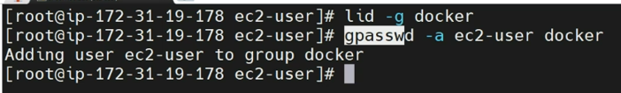
Before restart:
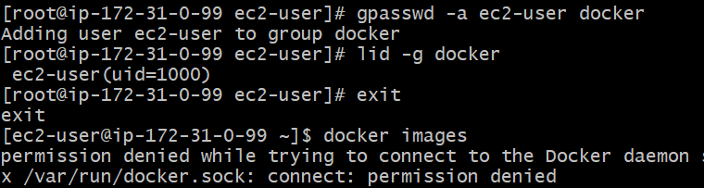
How to restart: >sudo reboot
Using reboot with force > sudo reboot -f
After restart:
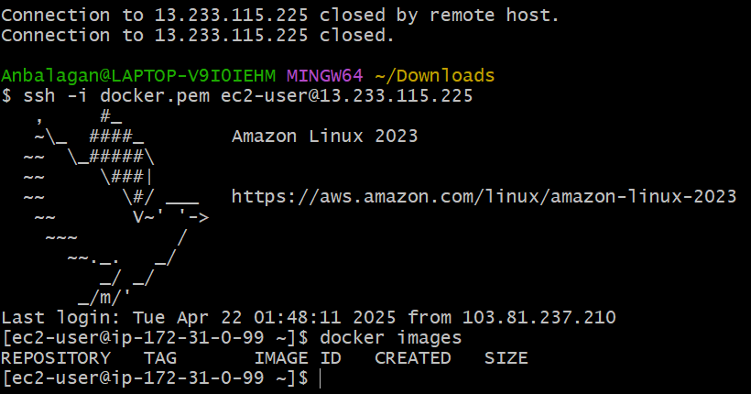
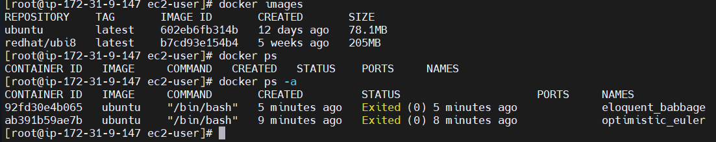
⚠️ Key Differences:
Feature | docker start | docker exec
Container State | Used on stopped containers | Used on running containers
Purpose | To start the container | To run a command inside a container
Creates Process? | Starts the container's main process | Runs additional command inside
Interactive? | Not typically | Can be interactive with -it
🧠 Summary:
Task | Correct Command
Start Docker Engine | sudo systemctl start docker
Start a stopped container | docker start <container-name>

To start the container:
>docker start <container ID> OR <container name>
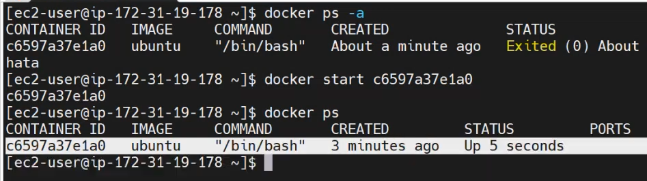
To execute/run the container:
>docker exec -it <containerName or ID> /bin/bash
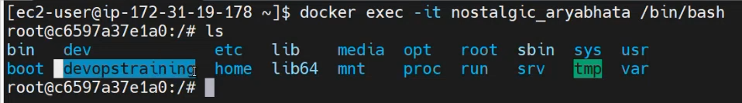
>docker images
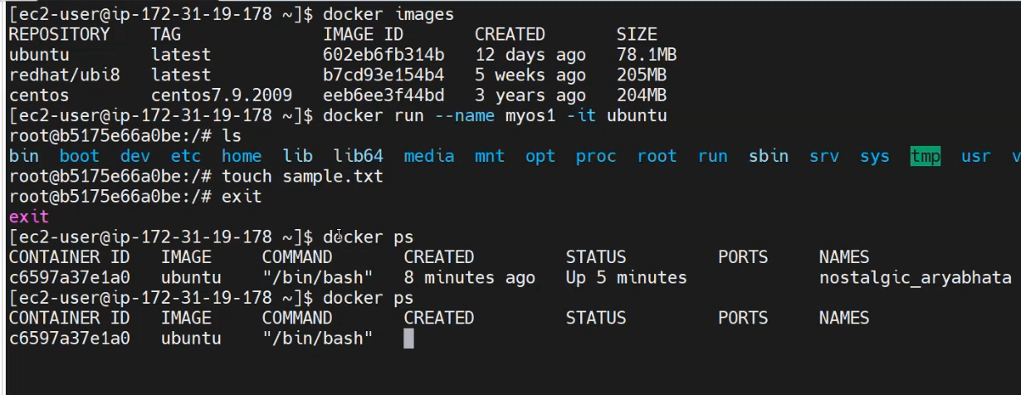
>docker ps
>docker ps -a
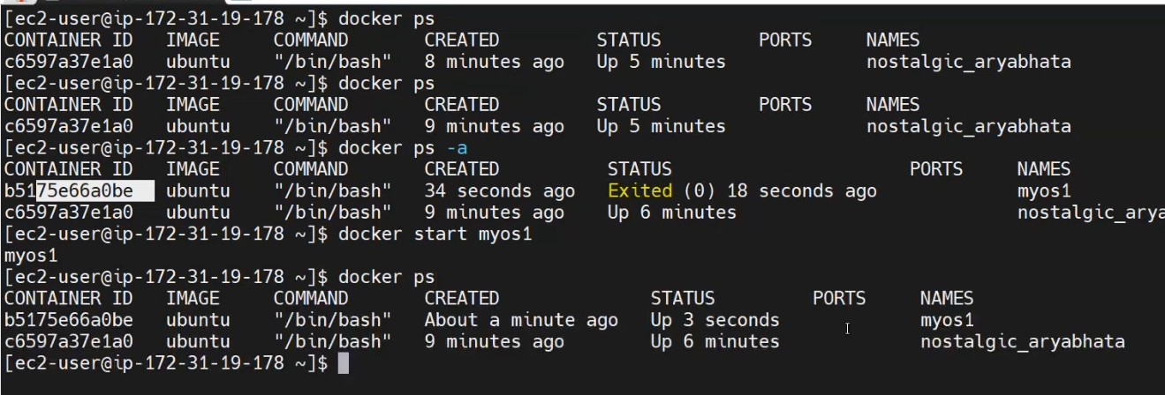

To stop the container:
>docker stop <container id> OR <container name>
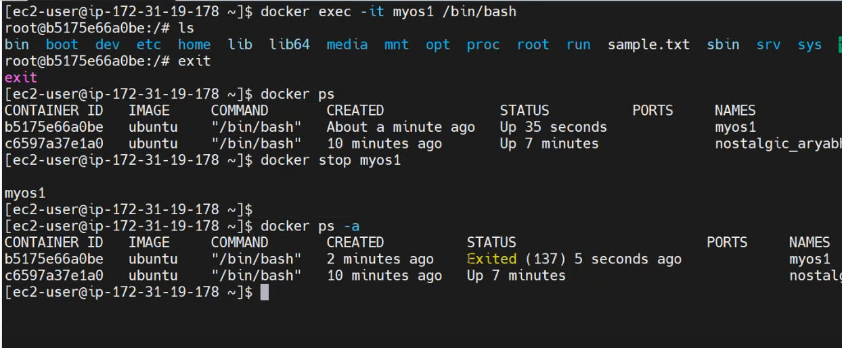
>docker inspect // To know the container details…
To remove docker container, Before removing the container, first we need to STOP the container and then remove.
>docker rm <container Id> OR <containerName>
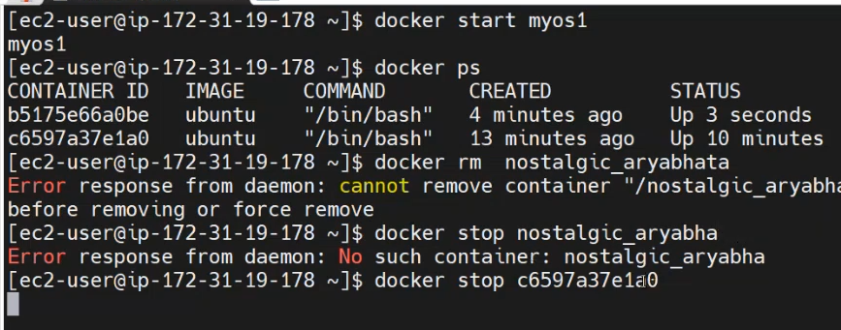

🧹 Remove a Specific Docker Image
To delete an image by its name or ID:​
docker rmi <image_name_or_id>
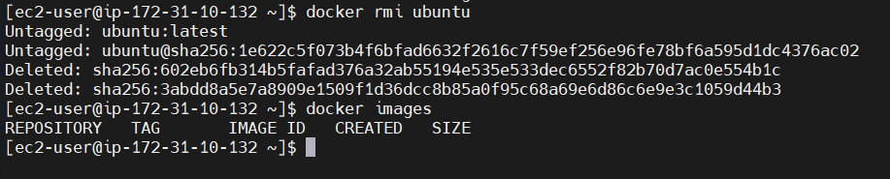

For example:​
docker rmi nginx:latest
If the image is used by any containers (even stopped ones), you'll need to remove those containers first or force the deletion.​
⚠️ Force Delete an Image
To forcefully remove an image, bypassing checks for existing containers:​Stack Overflow+5GeeksforGeeks+5Learn R, Python & Data Science Online+5
docker rmi -f <image_name_or_id>
This is useful when the image is associated with containers that you haven't removed yet.​

🧼 Remove All Docker Images
To delete all images from your system:​
docker rmi $(docker images -q)
This command lists all image IDs and removes them.​

🧹 Remove Dangling (Untagged) Images
Dangling images are layers that are no longer tagged and are not referenced by any container. To remove them:​Warp+5Stack Overflow+5Learn R, Python & Data Science Online+5
docker image prune
To remove all unused images (not just dangling ones):​BlueVPS+7Stack Overflow+7Stack Overflow+7
docker image prune -a
This cleans up images not associated with any container.​

🧩 Remove an Image by Digest
If an image was pulled by digest and has no tag, you can remove it using its digest:​Docker Documentation
docker rmi <image_name>@<digest>
For example:​
docker rmi localhost:5000/test/busybox@sha256:cbbf2f9a99b47fc460d422812b6a5adff7dfee951d8fa2e4a98caa0382cfbdbf
This command un-tags and removes the image associated with the specified digest. ​

Note: Before deleting images, ensure that they are not being used by any running containers to avoid unintended disruptions.

Day 3: Essential Docker Commands for Beginners | Part 2 - Learn Docker Basics – 21th Apr 2025
>Mostly recall concept of the previous class…
Day 4: Using Maven and Tomcat with Docker: Why and How – 22th Apr 2025
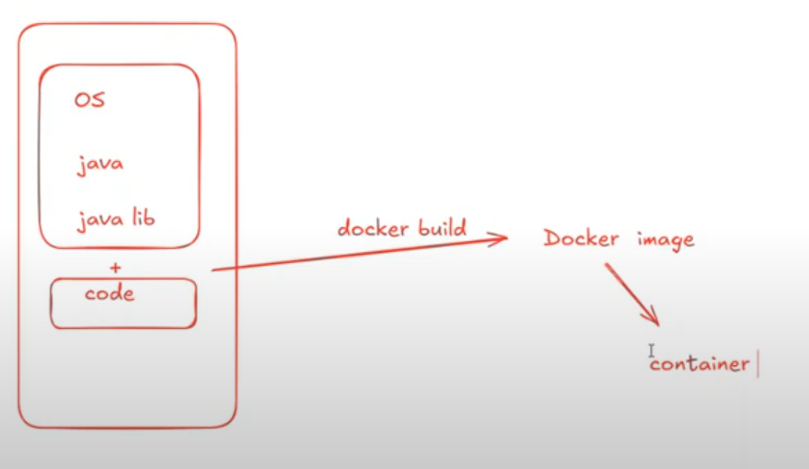
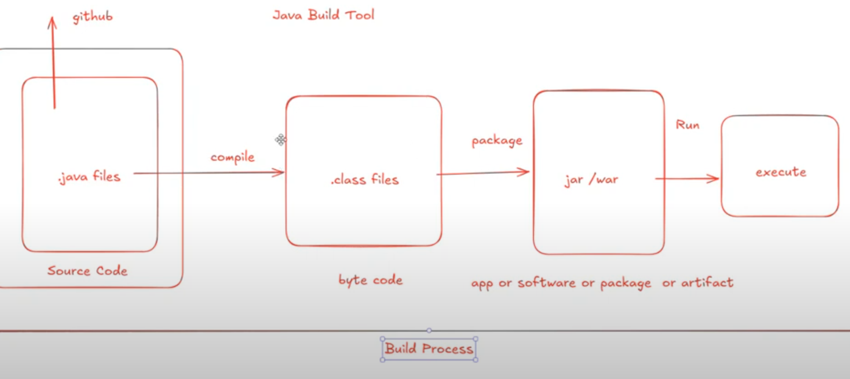
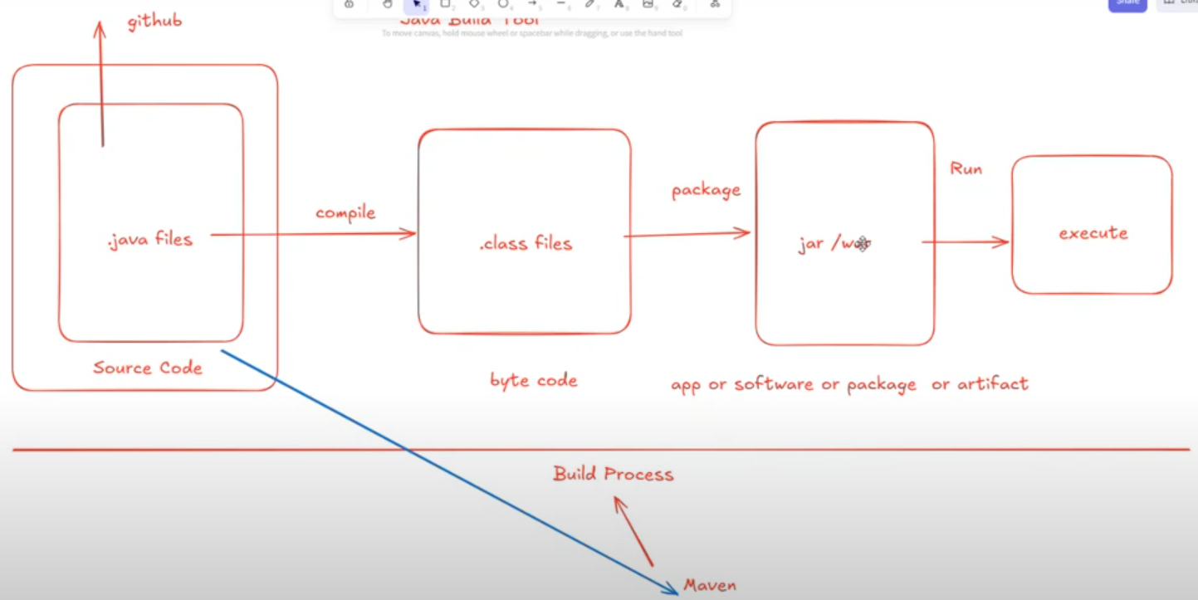
Two types of Application:
- Standlone > download and use it. (Eg. Notepad, VS Code, Browser etc…). They use jar file.
- Web > Create a virtual/physical server and run the code. Access through browser/online. They use war file.
jar > java archive
war > web archive
If we use both standlaone and web application, then we use ear file (Enterprise archive)

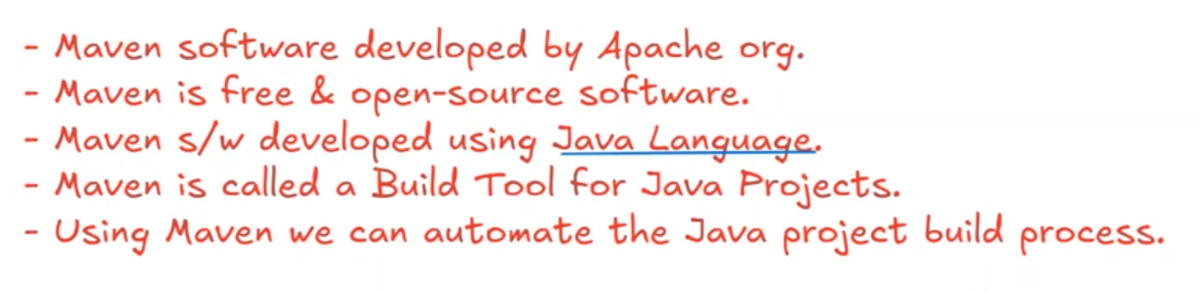
Javascript related project, we use npm (Node Package Manager) to build code. It stores all javascript related library. Using npm, we can install any javascript libraries.
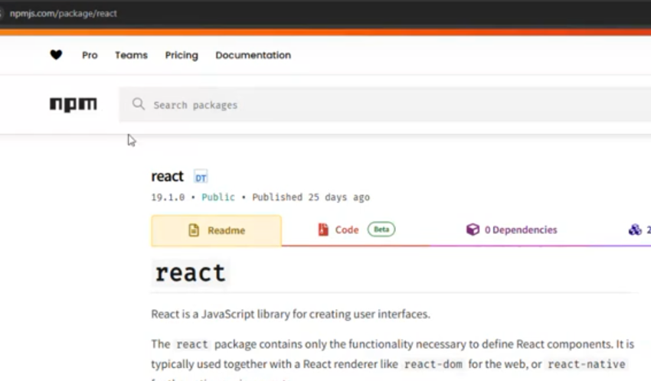
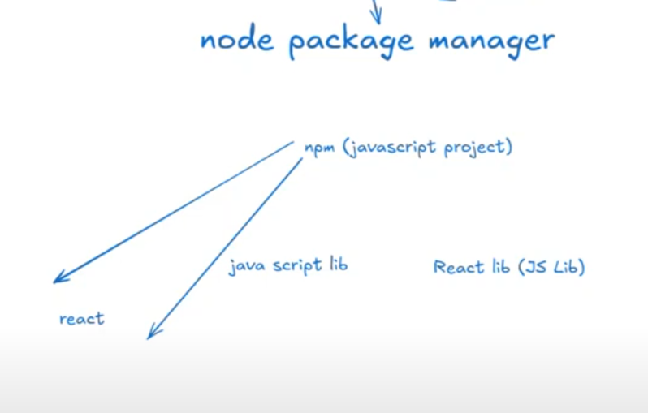
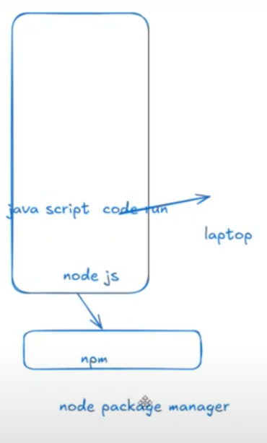
Day 5: Using Maven and Tomcat with Docker: Why and How – 24th Apr 2025
We can download java from oracle or Amazon java
https://aws.amazon.com/corretto/?filtered-posts.sort-by=item.additionalFields.createdDate&filtered-posts.sort-order=desc
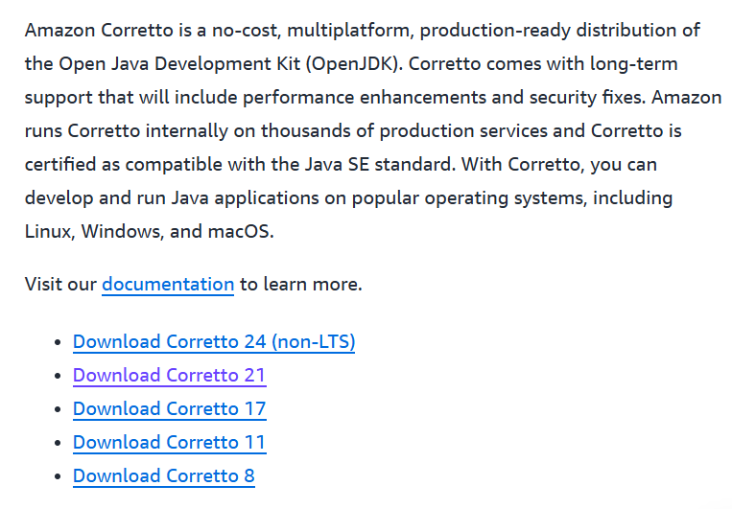
https://www.oracle.com/in/java/technologies/downloads/
IMPORTANT:
1.Install java 17 OR 21 OR any and Maven in C driver under program files.
2.Go to environment variable, then under System Variable, Click New > set a path of JAVA_HOME, MAVEN_HOME
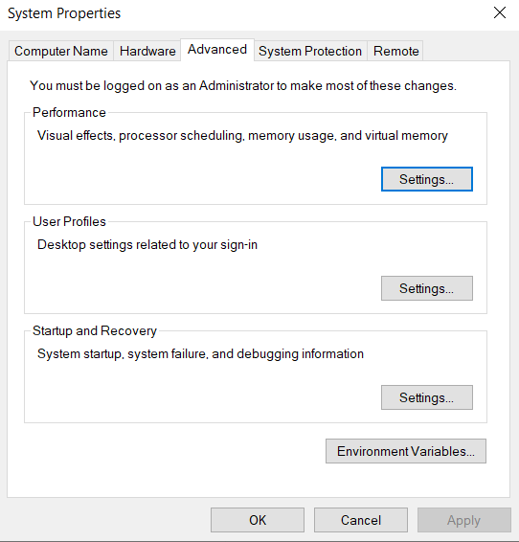
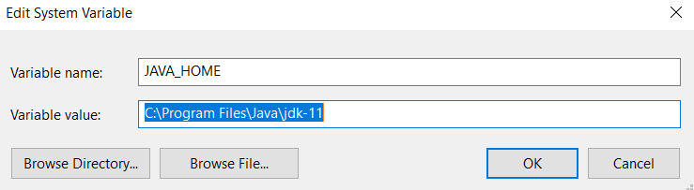
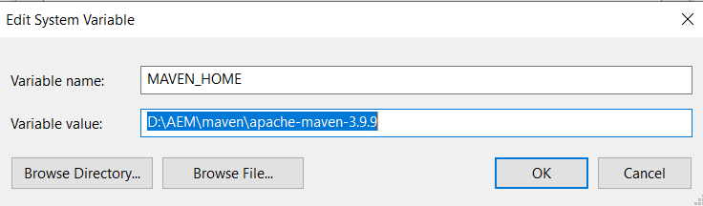

Select & Edit Path:
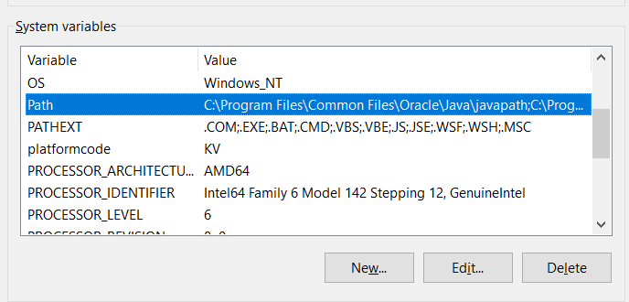
Add below 2:
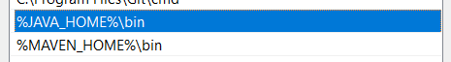

Maven archetype will create a structure of the java project:
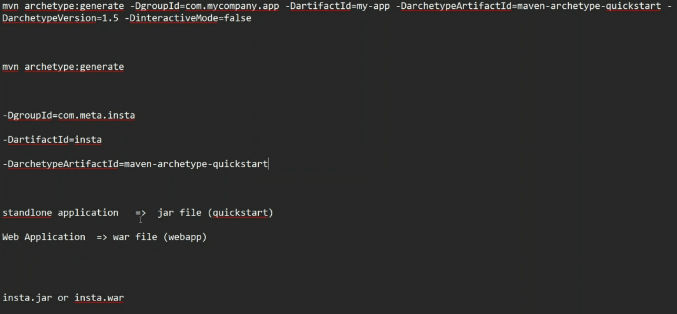

POM: Project Object Model
Maven Goals > User to perform project build process
Go to the specific JAVA folder that should have pom file, then cmd
Command:
>mvn compile // compile all the java files and create a class files.
When we compile, the target folder will be created.
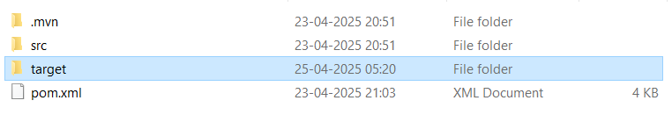
>mvn test // It will compile + test
>mvn package //It will compile+test+package i.e jar or war file
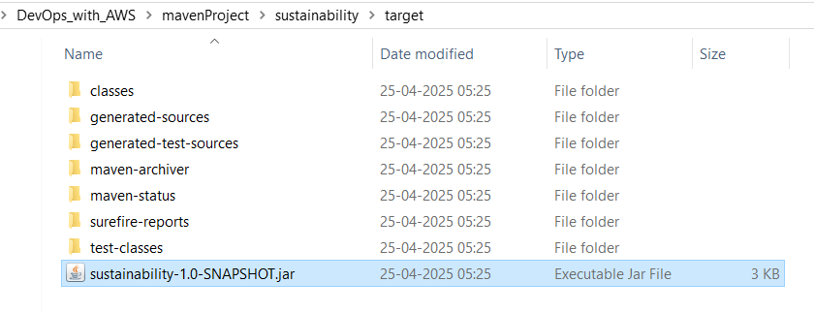
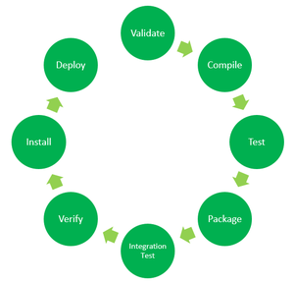
https://www.geeksforgeeks.org/maven-build-phases-and-basic-maven-commands/?utm_source=chatgpt.com
- Validate: This step validates if the project structure is correct. For example – It checks if all the dependencies have been downloaded and are available in the local repository.
- Compile: It compiles the source code, converts the .java files to .class, and stores the classes in the target/classes folder.
- Test: It runs unit tests for the project.
- Package: This step packages the compiled code in a distributable format like JAR or WAR.
- Integration test: It runs the integration tests for the project.
- Verify: This step runs checks to verify that the project is valid and meets the quality standards.
- Install: This step installs the packaged code to the local Maven repository.
- Deploy: It copies the packaged code to the remote repository for sharing it with other developers.
These build phases are executed sequentially by default when you run a Maven build.
In a Maven project, the build process begins with the Validate phase, where Maven validates the project structure. It ensures to Maven standards that the required plugins are available. Next, in the Compile phase, Maven compiles the Java source code into bytecode. Following compilation, the Test phase executes unit tests to validate the code’s functionality. Once tests pass, the Package phase bundles the compiled code, resources, and dependencies into a distributable format, like a JAR or WAR file. Finally, in the Install phase, Maven installs the packaged artifact into the local Maven repository and makes it available for other projects.
Maven Commands
With a simple command-line interface, Maven manages project dependencies, compiles source code, runs tests, and packages applications. Some basic Maven commands includes:
- mvn clean: Cleans the project and removes all files generated by the previous build.
- mvn compile: Compiles source code of the project.
- mvn test-compile: Compiles the test source code.
- mvn test: Runs tests for the project.
- mvn package: Creates JAR or WAR file for the project to convert it into a distributable format.
- mvn install: Deploys the packaged JAR/ WAR file to the local repository.
- mvn site: generate the project documentation.
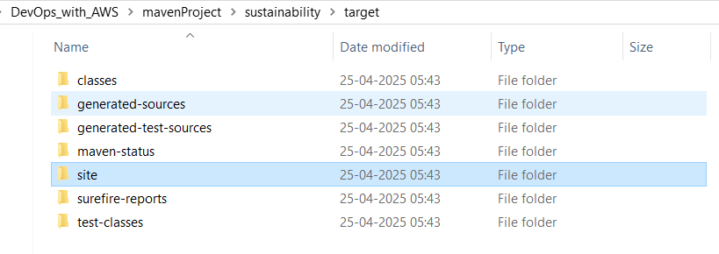
- mvn validate: validate the project’s POM and configuration.
- mvn idea:idea: generate project files for IntelliJ IDEA or Eclipse.
- mvn release:perform: Performs a release build.
- mvn deploy: Copies the packaged JAR/ WAR file to the remote repository after compiling, running tests and building the project.
- mvn archetype:generate: This command is used to generate a new project from an archetype, which is a template for a project. This command is typically used to create new projects based on a specific pattern or structure.
- mvn dependency:tree: This command is used to display the dependencies of the project in a tree format. This command is typically used to understand the dependencies of the project and troubleshoot any issues.
ChatGPT:
1. mvn clean
- Purpose: Removes the target/ directory, which contains all files generated by the previous build.
- Usage: Ensures that the next build starts from a clean state, preventing issues caused by outdated or stale files.
- Example:​Itexus+3GeeksforGeeks+3Automation Panda+3Itexus+1Stack Overflow+1
mvn clean
- Note: It's a good practice to run this command before building your project to avoid potential conflicts from previous builds. ​

2. mvn compile
- Purpose: Compiles the project's main source code located in src/main/java.
- Usage: Processes the source code and outputs the compiled .class files into the target/classes directory.
- Example:​ComputingForGeeks
mvn compile
- Note: This command does not compile test source code. ​DEV Community

3. mvn test
- Purpose: Runs the unit tests for the project.
- Usage: Compiles the test source code located in src/test/java and executes the tests using a testing framework like JUnit or TestNG.
- Example:​GeeksforGeeks+5GeeksforGeeks+5MonoVM+5
mvn test
- Note: This command includes the compile phase before running the tests. ​Automation Panda+1Marco Behler+1

4. mvn package
- Purpose: Packages the compiled code into a distributable format, such as a JAR or WAR file.
- Usage: Executes all necessary phases, including compiling the code, running tests, and packaging the application.
- Example:​GeeksforGeeks+3MonoVM+3GeeksforGeeks+3Soham Kamani+2Stack Overflow+2Marco Behler+2
mvn package
- Note: The output artifact is placed in the target/ directory. ​Automation Panda

Common Combined Usage
Developers often combine these commands to perform multiple actions in sequence. For example:​
mvn clean package
This command cleans the project and then compiles, tests, and packages it. ​GeeksforGeeks

Day 6: Maven Webapp Project Explained | POM File, Local Repo & Remote Repo | Guide for Beginners – 26th Apr 2025
what is the command mvn install and mvn package? explain in detail? when we use?
🗒️ Answer
1. mvn package
- This command compiles the source code, runs the tests, and then packages the project into a distributable format like a .jar or .war file [2], [6].
- It stops after creating the package inside the target/ folder.
- Use case:
  - When you just want a packaged file to deploy or share.
  - Example: Creating a JAR to run manually on your machine or send to others.

2. mvn install
- This command does everything mvn package does (compile, test, package), plus it installs the resulting .jar or .war into your local Maven repository (typically at ~/.m2/repository) [1], [2], [5], [6].
- Use case:
  - When your project will be used as a dependency in another local project.
  - Example: After developing a library, installing it so other projects can find it without uploading to a central server.

🔔 Quick Summary:
Command | Does What | When to Use
mvn package | Compile + Test + Create package (JAR/WAR) | Need distributable file
mvn install | package + Install to local repo | Need the project available for other local Maven builds
🌐 Sources
- stackoverflow.com - What does mvn install in maven exactly do
- geeksforgeeks.org - Maven Commands and Options
- maven.apache.org - Maven in 5 Minutes
- marcobehler.com - mvn clean install - a short guide to Maven
- dev.to - Difference between mvn install and mvn package
- geeksforgeeks.org - Maven Build Phases and Basic Maven Commands

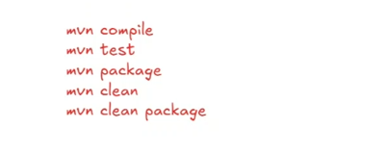
https://maven.apache.org/guides/getting-started/maven-in-five-minutes.html

When we use “webapp”, It will create a web application (war)
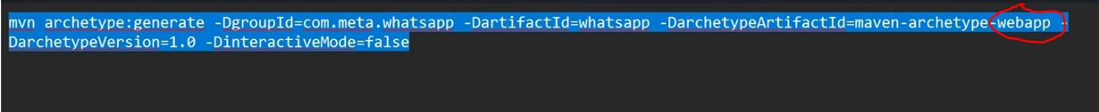
Once the project structure is created, go to folder and then run the mavn command:
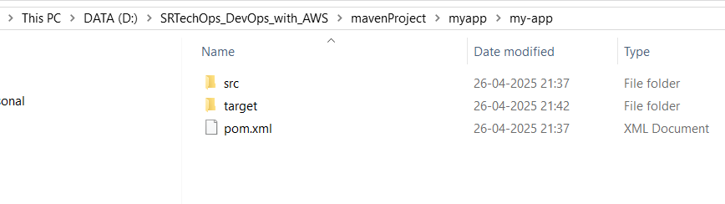
>cd my-app
my-app>mvn package
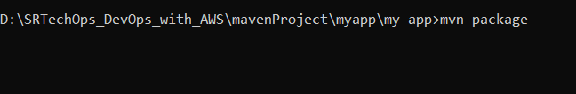

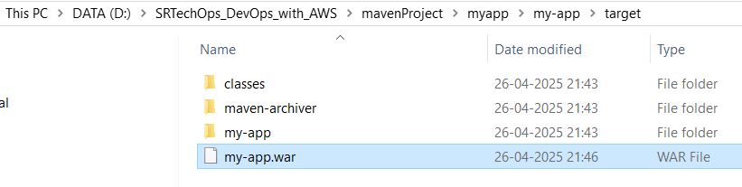
>mvn install
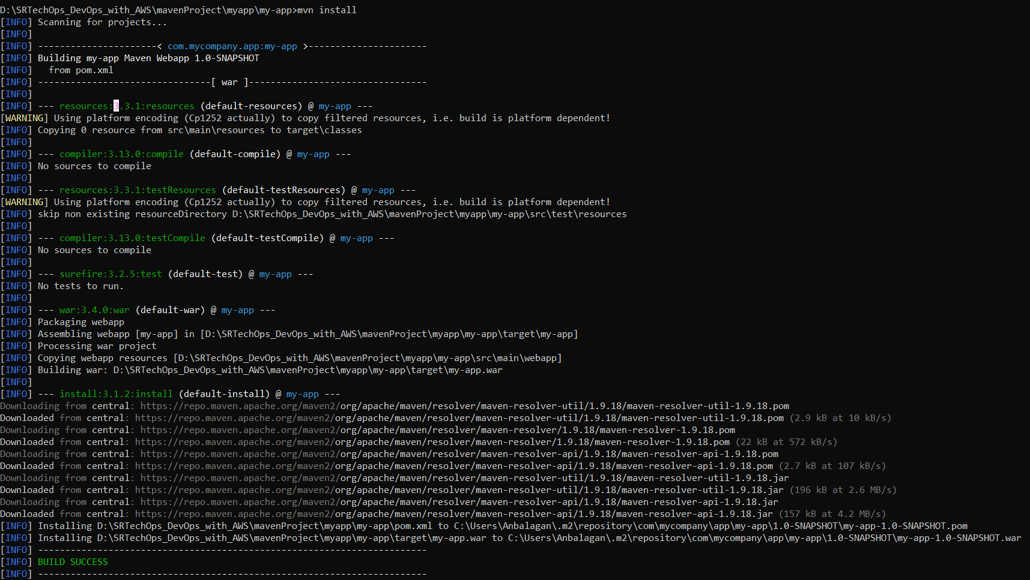
Creating a Project
You need somewhere for your project to reside. Create a directory somewhere and start a shell in that directory. On your command line, execute the following Maven goal:
mvn archetype:generate -DgroupId=com.mycompany.app -DartifactId=my-app -DarchetypeArtifactId=maven-archetype-quickstart -DarchetypeVersion=1.5 -DinteractiveMode=false
If you have just installed Maven, it may take a while on the first run. This is because Maven is downloading the most recent artifacts (plugin jars and other files) into your local repository. You may also need to execute the command a couple of times before it succeeds. This is because the remote server may time out before your downloads are complete. Don't worry, there are ways to fix that.
You will notice that the generate goal created a directory with the same name given as the artifactId. Change into that directory.
cd my-app
Under this directory you will notice the following standard project structure.
my-app
|-- pom.xml
`-- src
|-- main
| `-- java
| `-- com
| `-- mycompany
| `-- app
| `-- App.java
`-- test
`-- java
`-- com
`-- mycompany
`-- app
`-- AppTest.java
The src/main/java directory contains the project source code, the src/test/java directory contains the test source, and the pom.xml file is the project's Project Object Model, or POM.
The POM
The pom.xml file is the core of a project's configuration in Maven. It is a single configuration file that contains the majority of information required to build a project in just the way you want. The POM is huge and can be daunting in its complexity, but it is not necessary to understand all of the intricacies just yet to use it effectively. This project's POM should look like this:
- <project xmlns="http://maven.apache.org/POM/4.0.0" xmlns:xsi="http://www.w3.org/2001/XMLSchema-instance"
- xsi:schemaLocation="http://maven.apache.org/POM/4.0.0 http://maven.apache.org/xsd/maven-4.0.0.xsd">
- <modelVersion>4.0.0</modelVersion>

- <groupId>com.mycompany.app</groupId>
- <artifactId>my-app</artifactId>
- <version>1.0-SNAPSHOT</version>

- <name>my-app</name>
- <!-- FIXME change it to the project's website -->
- <url>http://www.example.com</url>

- <properties>
- <project.build.sourceEncoding>UTF-8</project.build.sourceEncoding>
- <maven.compiler.release>17</maven.compiler.release>
- </properties>

- <dependencyManagement>
- <dependencies>
- <dependency>
- <groupId>org.junit</groupId>
- <artifactId>junit-bom</artifactId>
- <version>5.11.0</version>
- <type>pom</type>
- <scope>import</scope>
- </dependency>
- </dependencies>
- </dependencyManagement>

- <dependencies>
- <dependency>
- <groupId>org.junit.jupiter</groupId>
- <artifactId>junit-jupiter-api</artifactId>
- <scope>test</scope>
- </dependency>
- <!-- Optionally: parameterized tests support -->
- <dependency>
- <groupId>org.junit.jupiter</groupId>
- <artifactId>junit-jupiter-params</artifactId>
- <scope>test</scope>
- </dependency>
- </dependencies>

- <build>
- <pluginManagement><!-- lock down plugins versions to avoid using Maven defaults (may be moved to parent pom) -->
- ... lots of helpful plugins
- </pluginManagement>
- </build>
- </project>
What did I just do?
You executed the Maven goal archetype:generate, and passed in various parameters to that goal. The prefix archetype is the plugin that provides the goal. If you are familiar with Ant, you may conceive of this as similar to a task. This archetype:generate goal created a simple project based upon a maven-archetype-quickstart archetype. Suffice it to say for now that a plugin is a collection of goals with a general common purpose. For example the jboss-maven-plugin, whose purpose is "deal with various jboss items".
Build the Project
mvn package
The command line will print out various actions, and end with the following:
...
[INFO] ------------------------------------------------------------------------
[INFO] BUILD SUCCESS
[INFO] ------------------------------------------------------------------------
[INFO] Total time: 2.953 s
[INFO] Finished at: 2019-11-24T13:05:10+01:00
[INFO] ------------------------------------------------------------------------
Unlike the first command executed (archetype:generate), the second is simply a single word - package. Rather than a goal, this is a phase. A phase is a step in the build lifecycle, which is an ordered sequence of phases. When a phase is given, Maven executes every phase in the sequence up to and including the one defined. For example, if you execute the compile phase, the phases that actually get executed are:
- validate
- generate-sources
- process-sources
- generate-resources
- process-resources
- compile
You may test the newly compiled and packaged JAR with the following command:
java -cp target/my-app-1.0-SNAPSHOT.jar com.mycompany.app.App
Which will print the quintessential:
Hello World!
Java 9 or later
By default your version of Maven might use an old version of the maven-compiler-plugin that is not compatible with Java 9 or later versions. To target Java 9 or later, you should at least use version 3.6.0 of the maven-compiler-plugin and set the maven.compiler.release property to the Java release you are targetting (e.g. 9, 10, 11, 12, etc.).
In the following example, we have configured our Maven project to use version 3.8.1 of maven-compiler-plugin and target Java 11:
- <properties>
- <maven.compiler.release>11</maven.compiler.release>
- </properties>

- <build>
- <pluginManagement>
- <plugins>
- <plugin>
- <groupId>org.apache.maven.plugins</groupId>
- <artifactId>maven-compiler-plugin</artifactId>
- <version>3.8.1</version>
- </plugin>
- </plugins>
- </pluginManagement>
- </build>
To learn more about javac's --release option, see JEP 247.

Running Maven Tools
Maven Phases
Although hardly a comprehensive list, these are the most common default lifecycle phases executed.
- validate: validate the project is correct and all necessary information is available
- compile: compile the source code of the project
- test: test the compiled source code using a suitable unit testing framework. These tests should not require the code be packaged or deployed
- package: take the compiled code and package it in its distributable format, such as a JAR.
- integration-test: process and deploy the package if necessary into an environment where integration tests can be run
- verify: run any checks to verify the package is valid and meets quality criteria
- install: install the package into the local repository, for use as a dependency in other projects locally
- deploy: done in an integration or release environment, copies the final package to the remote repository for sharing with other developers and projects.
There are two other Maven lifecycles of note beyond the default list above. They are
- clean: cleans up artifacts created by prior builds
- site: generates site documentation for this project
Phases are actually mapped to underlying goals. The specific goals executed per phase is dependant upon the packaging type of the project. For example, package executes jar:jar if the project type is a JAR, and war:war if the project type is - you guessed it - a WAR.

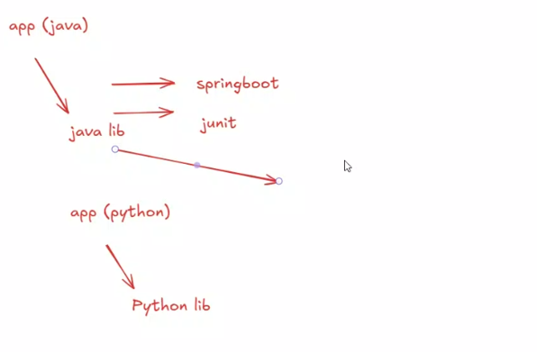
In POM file:
https://mvnrepository.com/
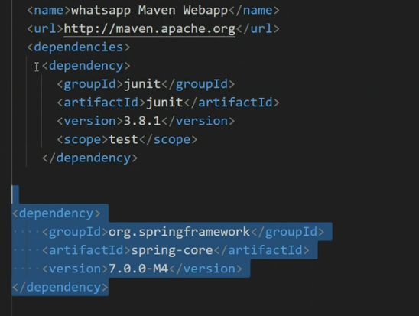

>mvn package
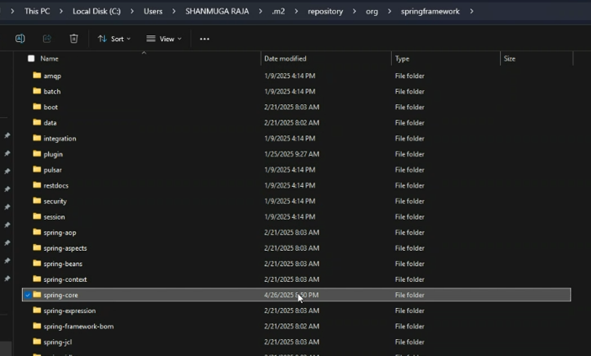

Day 7: Maven Installation in Linux – 29th Apr 2025
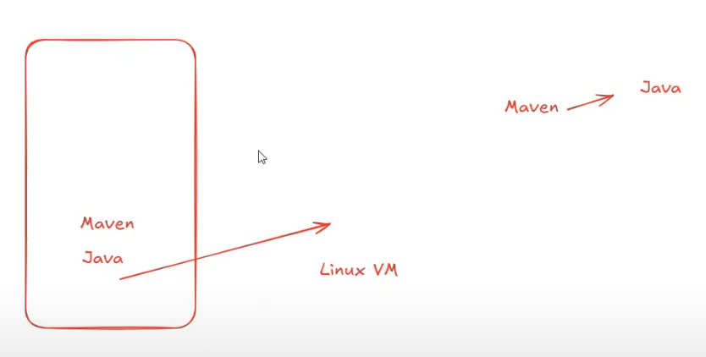
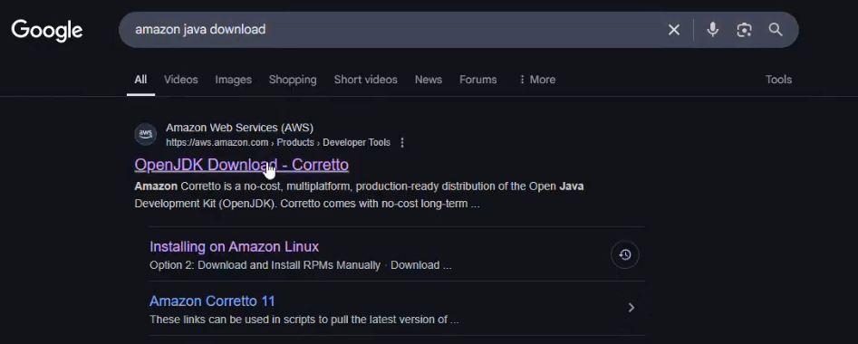
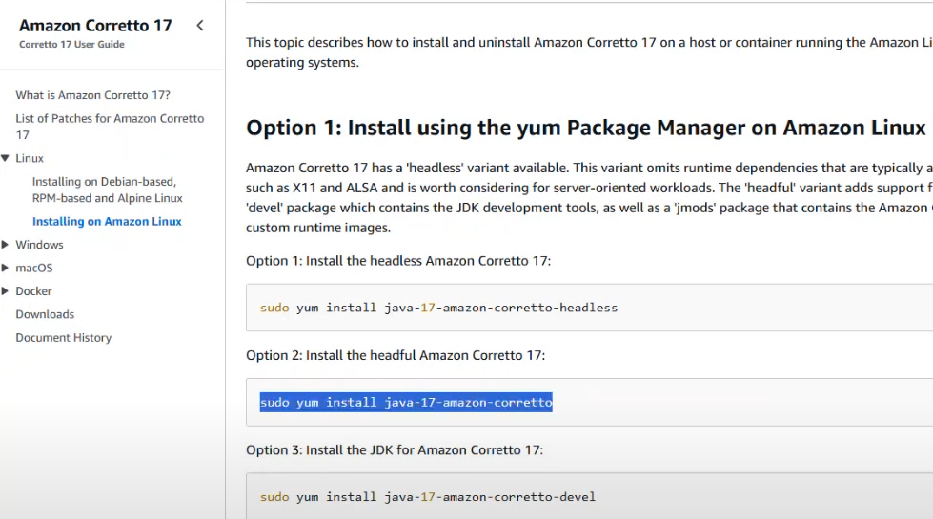
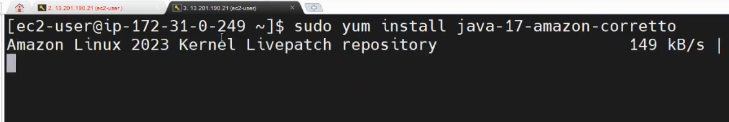
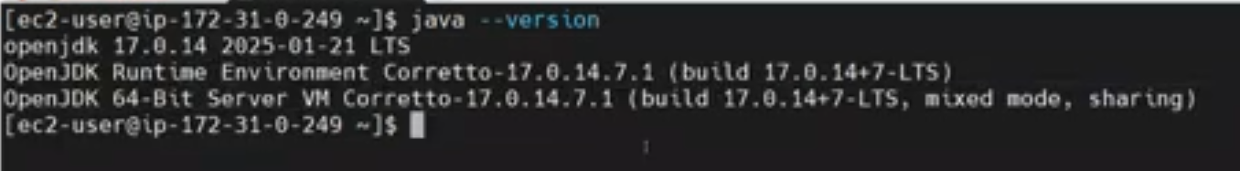
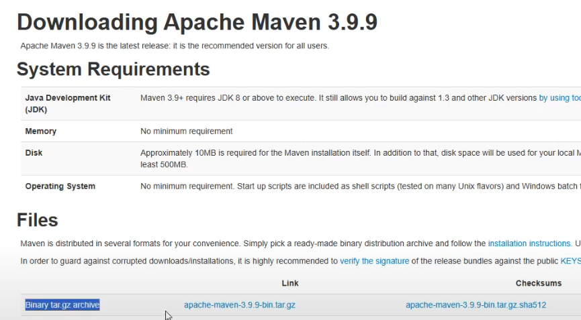

Usually user download and store the softwares in “opt” directory. Only root user has an ownership of the directory.
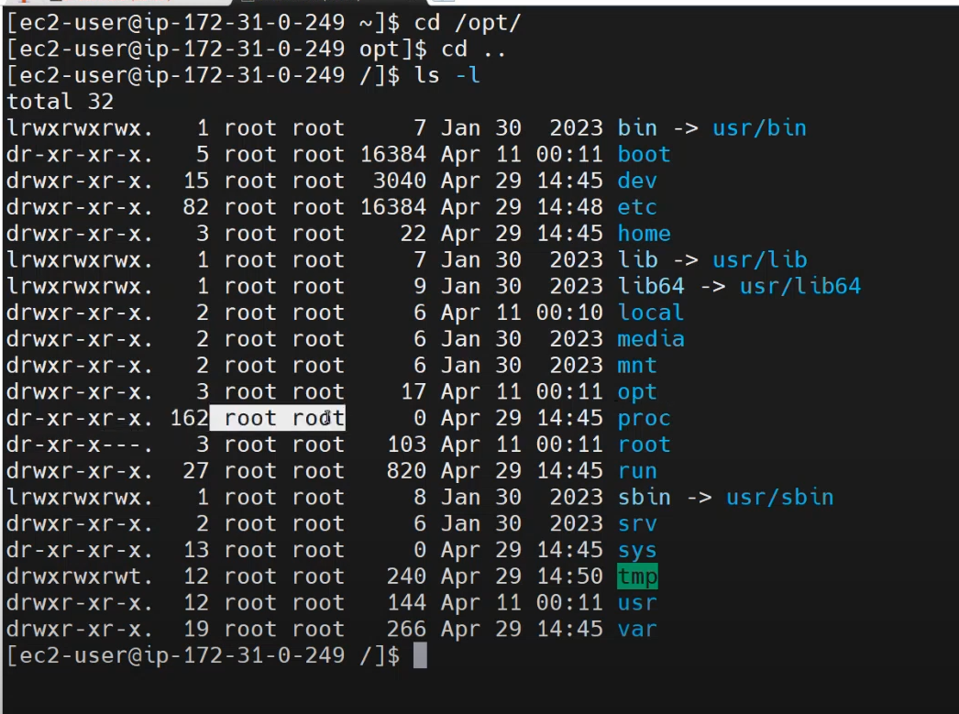
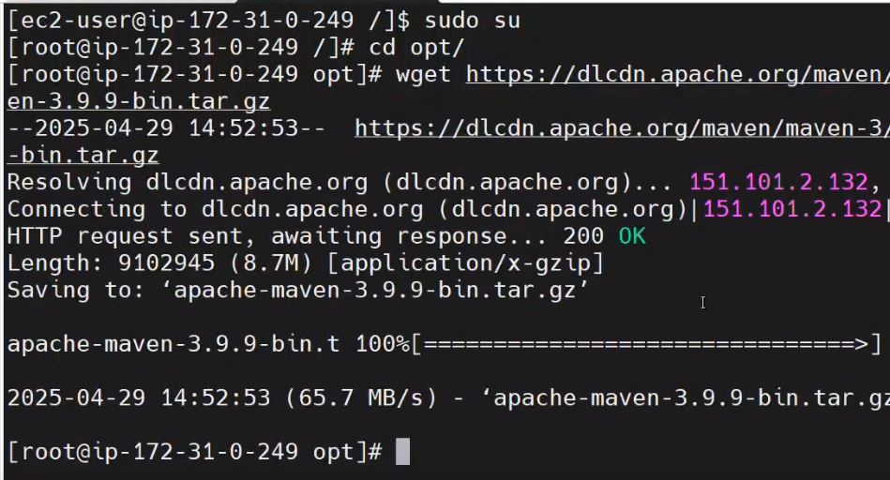

Unzip the tar file:
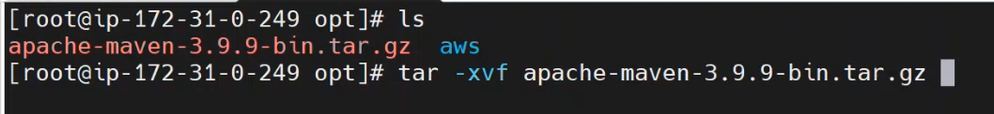
Delete the downloaded tar once we unzipped:
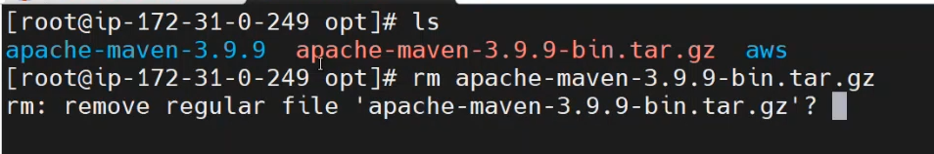
Rename the maven as we wish:
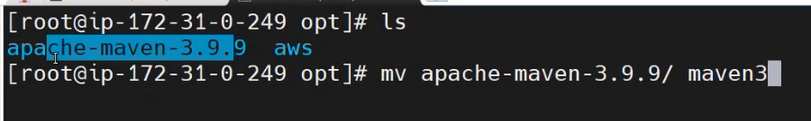
We need to set a maven path, that’s why we couldn’t get the maven version:
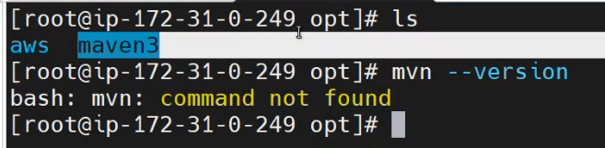
This is the maven path and maven bin path:
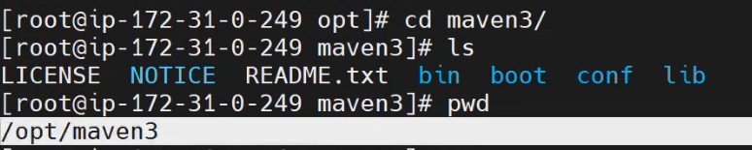
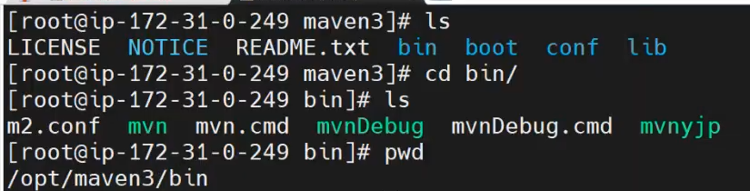
In Windows, we go to environment variables to set the mavan path. In Linux, we “bashrc”
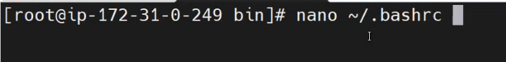
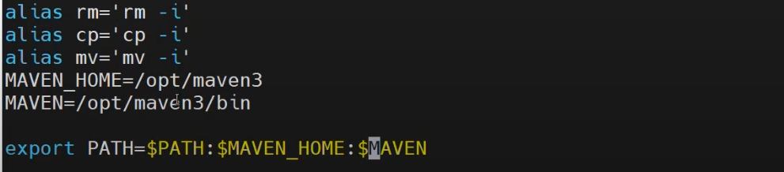
Aftering adding the path, we need to activate:
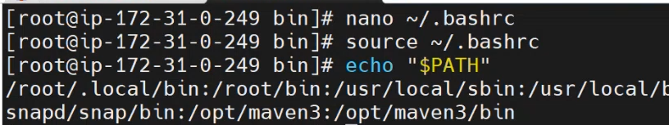
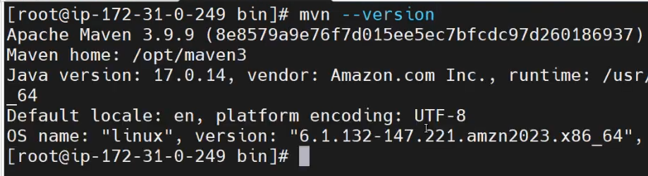

Create a maven project:
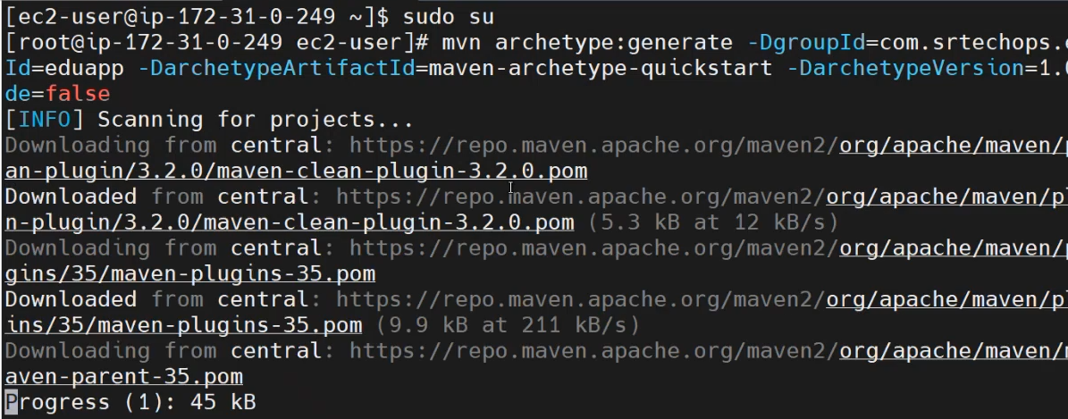
Go to the project directory and build the package using > mvn package
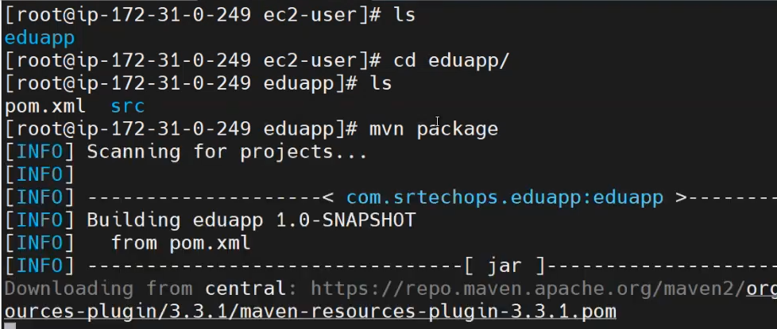
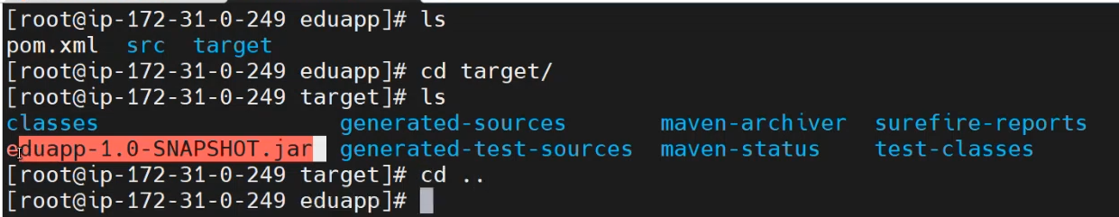
If you want to change the ownership of the “opt” directory to ec2-user. But no need to change the ownership.
We have separate “bashrc” file for Root and ec2-user.
>chown -R ec2-user:ec2-user opt/
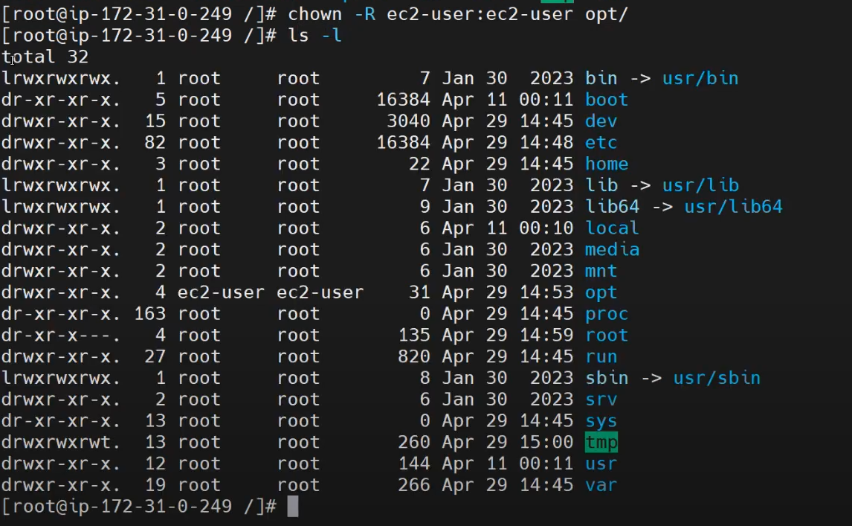
If you want to set the maven path for the ec2-user, there is separate file “bashrc” for ec2-user. Before we set it path root user > bashrc. Now, we are going to set mavan path in “bashrc” file as a ec2-user:
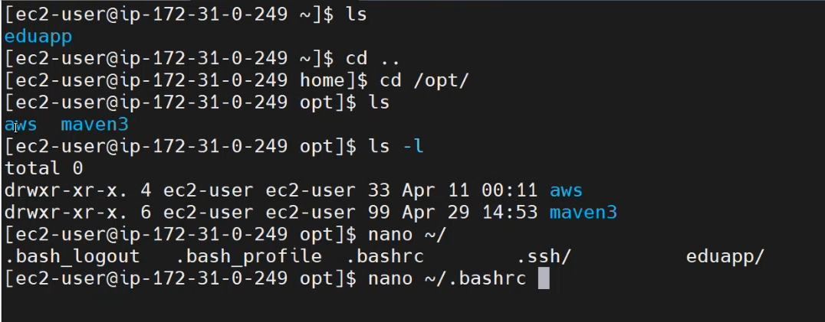

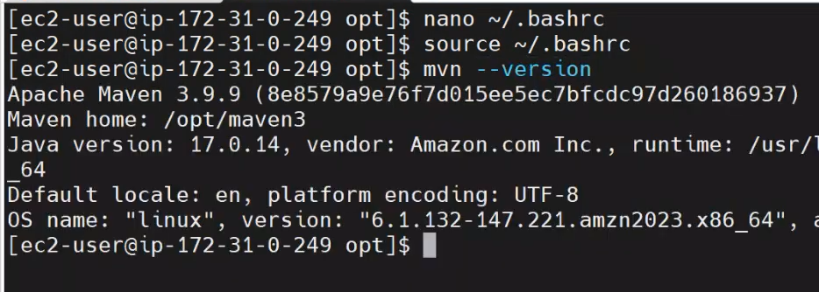
Create a maven project:
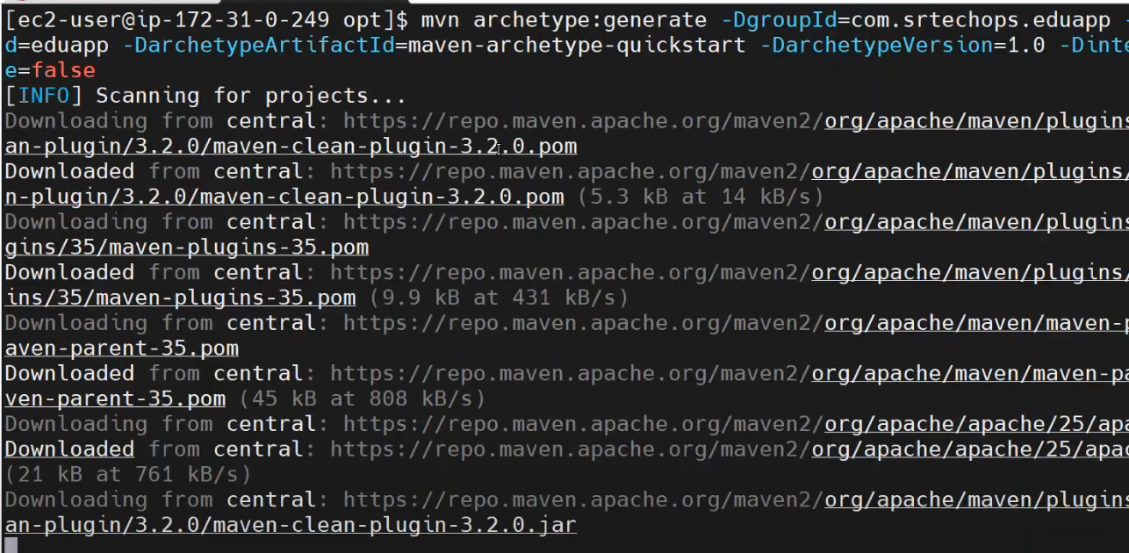
STEPS:
    - Install Java from Amazon
    - Install Maven using tar file
    - Set maven path in bashrc file and activate
    - Build the maven project

