Linux with GenAI

Day 1 - Introduction to Linux with GenAI 🤖 | Boost Your Productivity with AI-Powered
https://www.youtube.com/watch?v=Q8n7cYzgw6s&list=PL7iDpp0KYTgEAIpjLF10bnN-nDzLPBOGo&index=1
Linux and Generative AI (GenAI) together can revolutionize how you work, automate tasks, and boost productivity. In this tutorial, we’ll explore how AI-powered tools can enhance your Linux experience by automating commands, optimizing workflows, and providing intelligent assistance.

Day 2 - Terminal-GPT: Unlocking & Automating Linux Potential with Gen AI
https://www.youtube.com/watch?v=PqEukpp8VBY&list=PL7iDpp0KYTgEAIpjLF10bnN-nDzLPBOGo&index=2
Discover Terminal-GPT, an AI-powered assistant designed to enhance Linux productivity and automation. In this tutorial, we’ll explore how Generative AI (GenAI) can simplify command execution, scripting, and troubleshooting within the Linux terminal.
📌 What You Will Learn: ✅ What is Terminal-GPT? – Understand how this AI-powered tool works in a Linux environment. ✅ AI-Powered Command Suggestions – Use GenAI to generate and correct Linux commands in real time. ✅ Automating Linux Tasks with AI – Learn how AI-driven automation can simplify file management, backups, and system monitoring. ✅ AI for Troubleshooting – Use Terminal-GPT to debug scripts, analyze errors, and find quick fixes. ✅ Smart Bash Scripting – Generate optimized Bash scripts using AI assistance. ✅ Boost Productivity in Linux – Leverage AI to enhance efficiency, reduce manual effort, and streamline workflows.

1.Shell GPT // It uses Open AI API
2. TGPT (Terminal GPT)
LLM > Phind // Phind Model without API key we use.
https://github.com/aandrew-me/tgpt

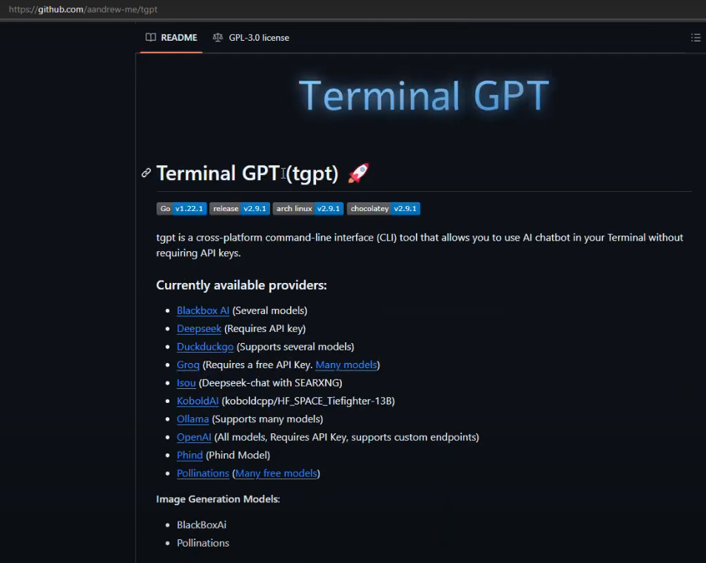
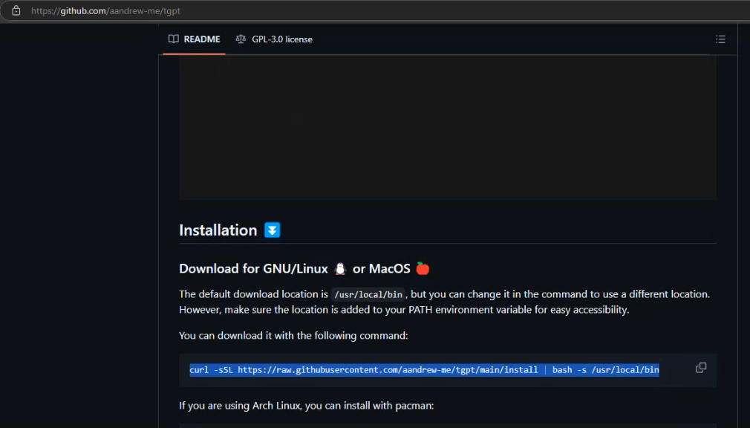
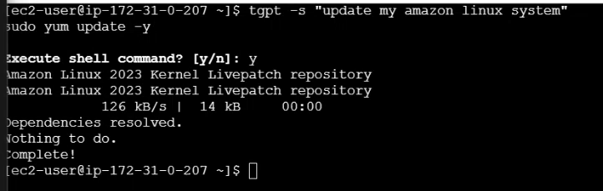

Aichat:
