Ansible

Day 1 - Why and where Ansible used | Step-by-step Installation Guide
Day 2 - Master Ansible Ad-Hoc Commands in Minutes
Day 3 - Host a Static Website with Ansible Ad-Hoc Commands | Ansible Tutorial
Day 4 - Ansible Tutorial: How to Set Up Apache Web Server Using Ansible Playbook
Day 5 - Understanding Ansible Architecture: Key Components and How It Works | Ansible Tutorial
Day 6 - Ansible Vault Tutorial: Secure Your Sensitive Data in Playbooks - Step-by-Step Guide
Day 7 – Ansible Tags and Playbook Variables
Day 8 – Inventory Groups & Runtime Variables Explained | Dynamic Configuration in Ansible

Are you new to Ansible and wondering why it's such a powerful tool in DevOps and IT automation?
🤔 In this tutorial, we'll explore the use cases of Ansible and walk through a step-by-step installation guide to get you started.
📌 What You Will Learn: ✅ Why Use Ansible? – Understand how Ansible simplifies configuration management, application deployment, and automation. ✅ Where is Ansible Used? – Learn about real-world use cases in cloud computing, DevOps, system administration, and infrastructure automation. ✅ How Ansible Works? – Understand its agentless architecture and key components like playbooks, modules, and inventory. ✅ Step-by-Step Installation Guide ✅ Hands-on Demo – Running a simple Ansible playbook to automate tasks.

Day 1 - Why and where Ansible used | Step-by-step Installation Guide
https://www.youtube.com/watch?v=_B3e054PjNg
Ansible is an open-source automation tool that plays a pivotal role in DevOps by facilitating configuration management, application deployment, and task automation across IT environments. Its simplicity and efficiency make it a preferred choice for orchestrating complex workflows and ensuring consistent system configurations.​
Key Features of Ansible in DevOps:
- Agentless Architecture: Ansible operates without the need for installing agents on managed nodes, simplifying maintenance and reducing overhead. ​
- Declarative Language: Utilizing YAML for its playbooks, Ansible allows users to define the desired state of systems in an easy-to-read format. ​
- Idempotency: Ansible ensures that repeated executions produce the same results without unintended side effects, maintaining system stability. ​
Ansible Architecture:
Ansible's architecture is designed for simplicity and scalability, comprising several key components:​TecAdmin
- Control Node: This is the central machine where Ansible is installed. It manages the execution of playbooks and controls the entire automation process. ​TecAdmin
- Managed Nodes: These are the target systems that Ansible manages. Communication between the control node and managed nodes typically occurs over SSH for Unix-based systems or WinRM for Windows systems. ​GeeksforGeeks
- Inventory: An inventory file lists all managed nodes, organizing them into groups and defining variables for each system. This file informs the control node about the hosts to manage. ​Canarys
- Modules: Ansible uses modules to perform tasks on managed nodes. These are small programs that execute specific actions, such as installing packages or managing services. Modules can be executed independently or within playbooks. ​
- Plugins: Plugins extend Ansible's functionality, handling tasks like logging, caching, and connecting to inventory sources. They are integral to customizing and enhancing Ansible's capabilities. ​
- Playbooks: Playbooks are YAML files that define a series of tasks to be executed on managed nodes. They allow for the orchestration of multiple tasks, ensuring complex operations are performed in a specified order. ​
- APIs: Ansible provides APIs that facilitate integration with various cloud services and applications, enabling dynamic inventory management and interaction with external systems. ​Educba
Ansible Architecture Diagram:
To visualize Ansible's architecture, consider the following diagram:​
​
​Ansible Architecture Diagram​
This diagram illustrates the interaction between the control node, managed nodes, inventory, modules, plugins, playbooks, and APIs, highlighting the streamlined communication and execution flow within Ansible's architecture. ​tutorialsinhand.com
Benefits of Using Ansible in DevOps:
- Simplified Automation: Ansible's straightforward syntax and agentless operation reduce the complexity of automating IT tasks.​DEV Community
- Scalability: It efficiently manages a vast number of nodes, making it suitable for both small and large-scale environments.​
- Flexibility: Ansible supports a wide range of modules and plugins, allowing customization to meet diverse automation needs.​
- Community Support: Being open-source, Ansible benefits from a robust community that contributes modules, plugins, and best practices.​
Incorporating Ansible into DevOps practices enhances operational efficiency, reduces manual errors, and accelerates deployment cycles, thereby fostering a more agile and reliable IT infrastructure.
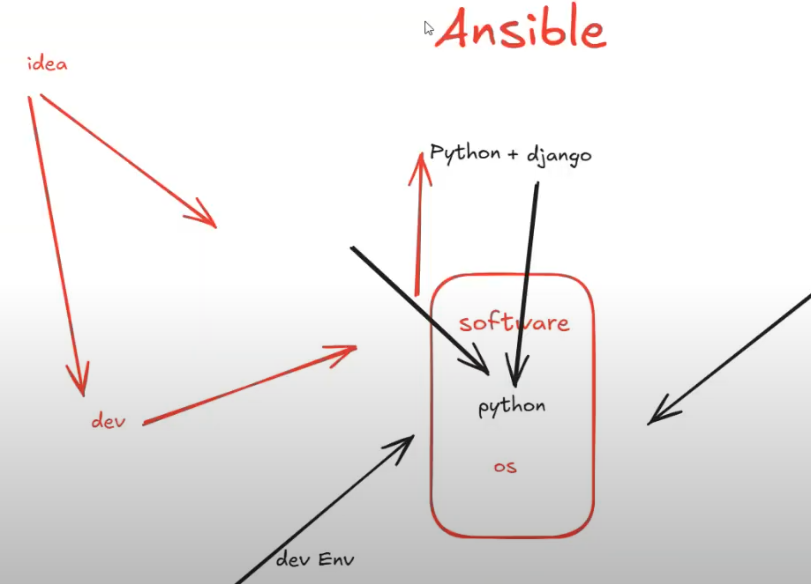
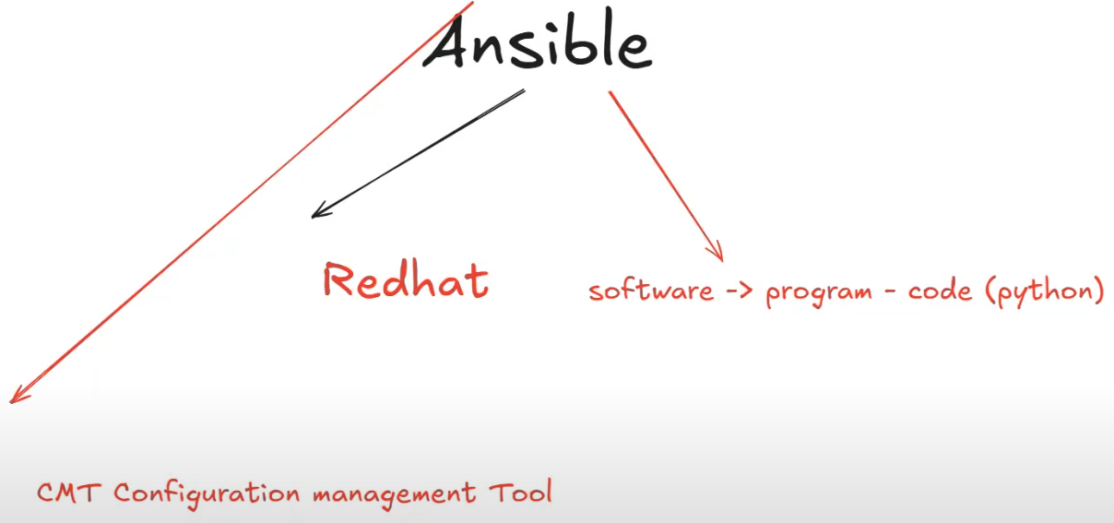
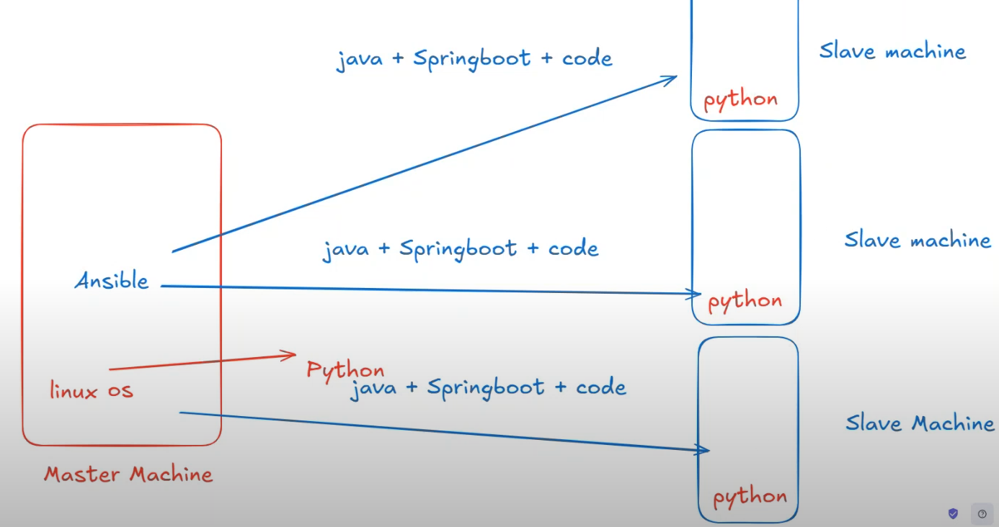
Install Putty:
https://www.chiark.greenend.org.uk/~sgtatham/putty/latest.html
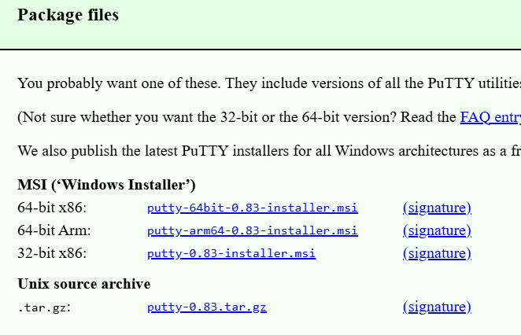
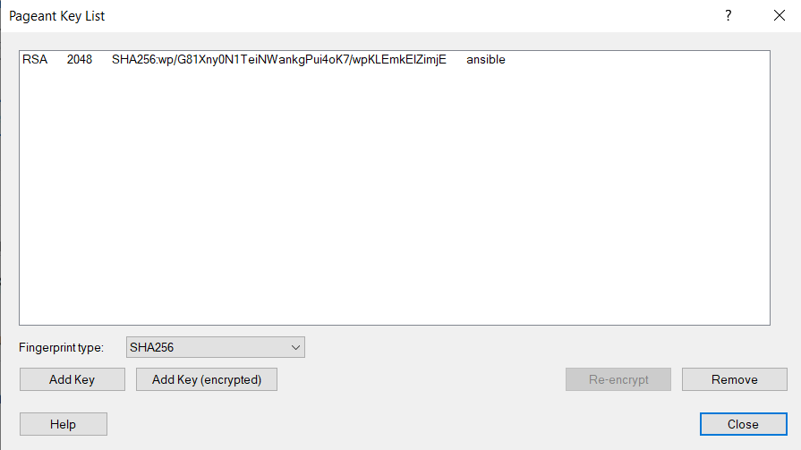
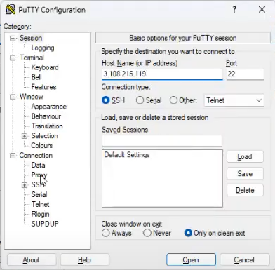

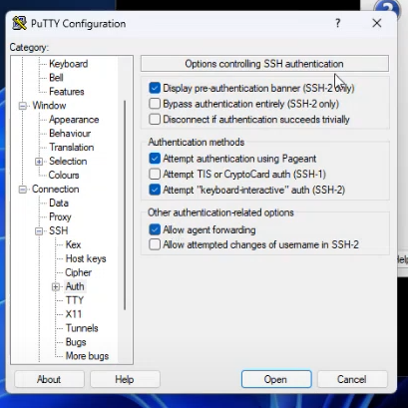
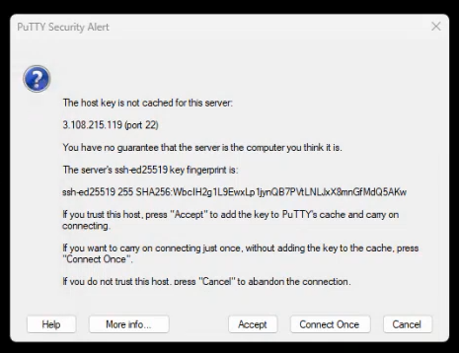
By default, Python 3 will available on linux machine.
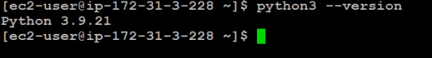

We need to install ansible.
>sudo yum install ansible
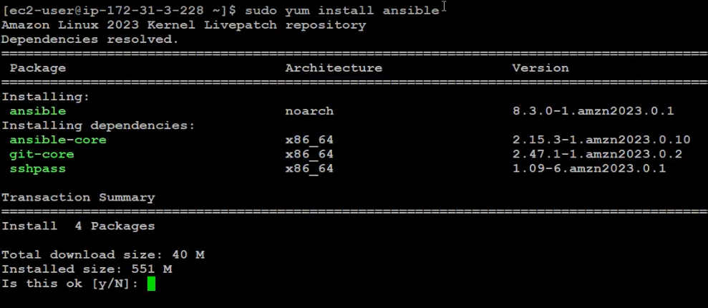
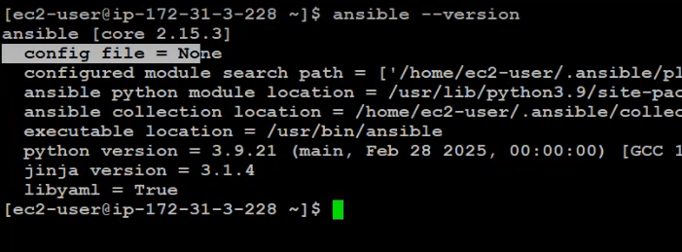

https://gist.github.com/wbcurry/f38bc6d8d1ee4a70ee2c
https://gist.githubusercontent.com/wbcurry/f38bc6d8d1ee4a70ee2c/raw/fa07b224edfe73a854bf7e5aa5952e9d7cc400b6/.ansible.cfg
>wget <URL>
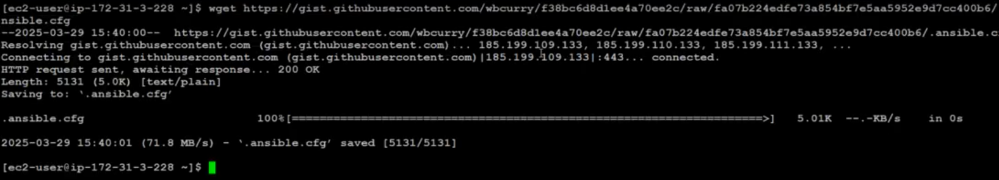
>ls -la
>mv .ansible.cfg ansible.cfg // make the file as a normal file instead of hidden file
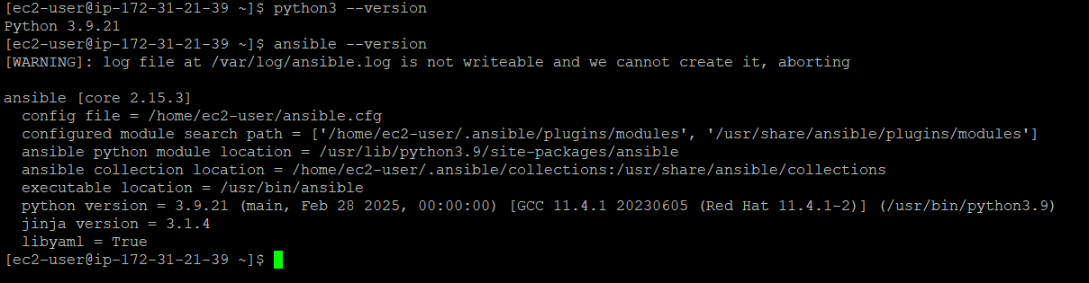
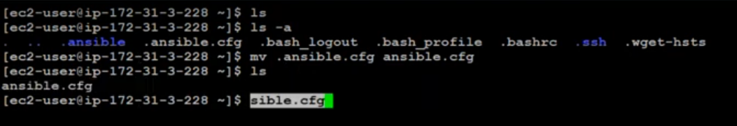
Create host file: // Inventory file
>nano host
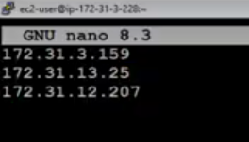
Check the Slave machines are reponding/working fine using ping module:
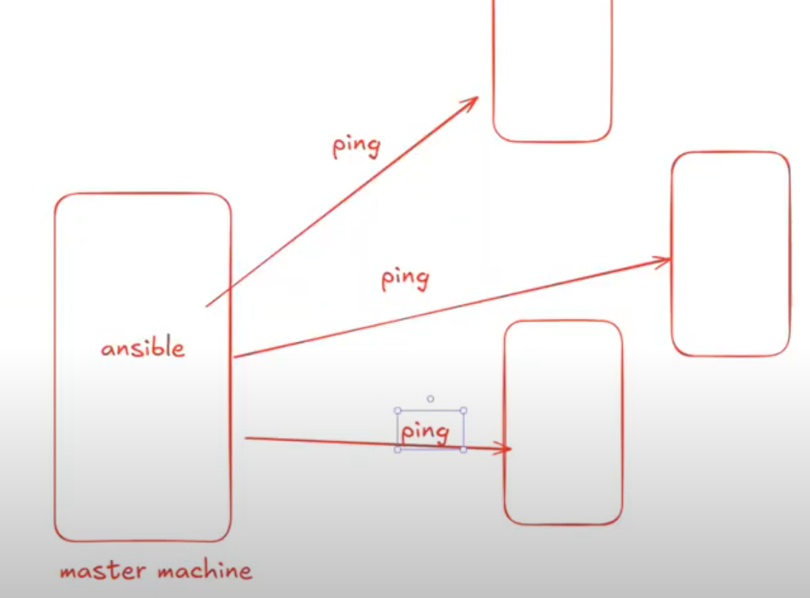
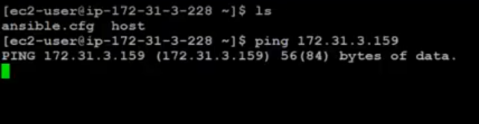
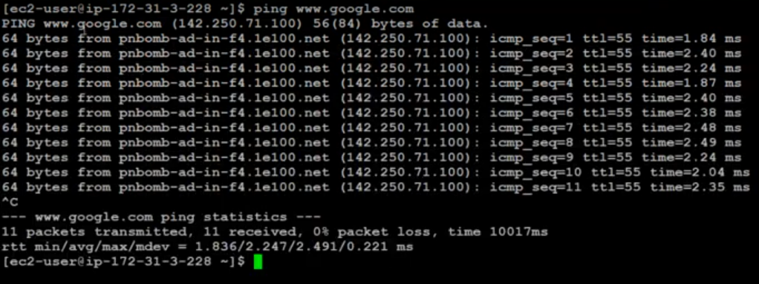
>ansible all -i host -m ping

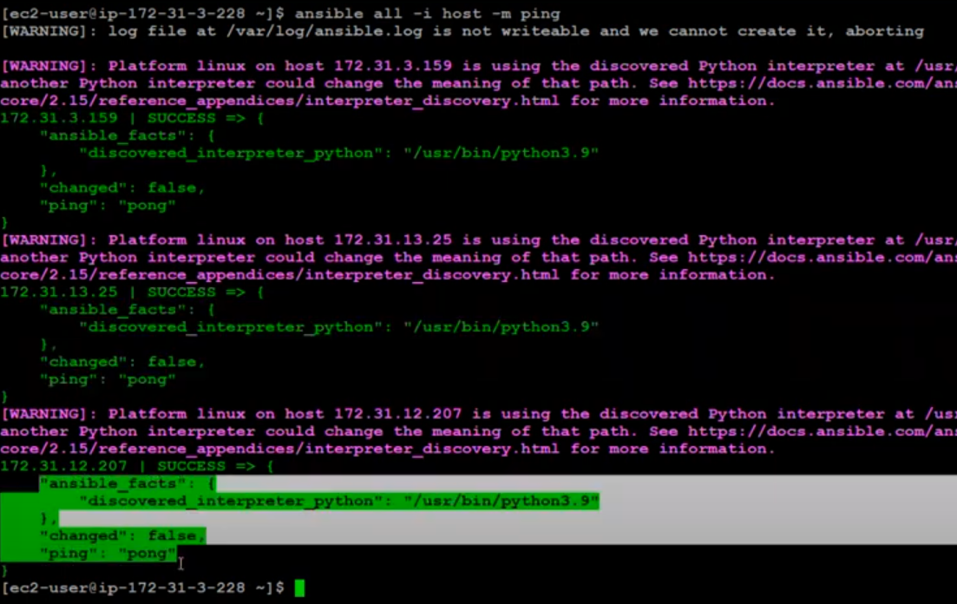
We need to enable ICMP to work ping command.
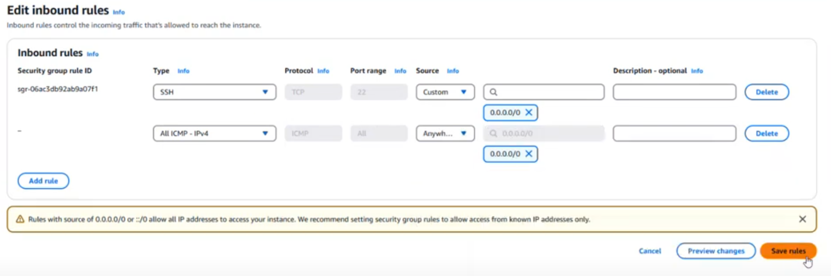
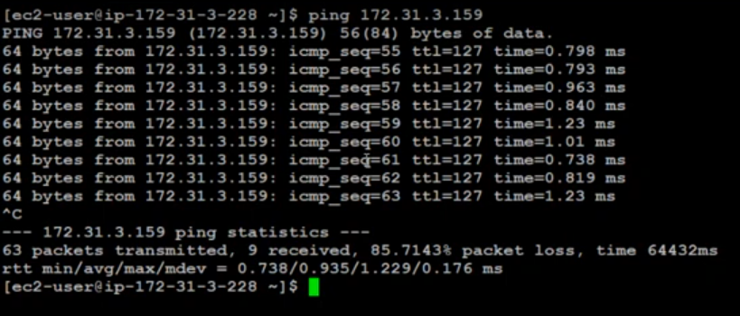

Day 2 - Master Ansible Ad-Hoc Commands in Minutes
https://www.youtube.com/watch?v=ey4y6TZQx8o&t=9s
Want to execute quick, one-time tasks without writing a playbook?
🤔 Ansible ad-hoc commands are the perfect way to manage servers instantly with just a single command! 🚀
📌 What You Will Learn:
✅ What are Ansible Ad-Hoc Commands? – When and why to use them. ✅ Running Simple Ad-Hoc Commands – Executing basic tasks like checking uptime, disk space, and active users. ✅ Managing Remote Servers – Running ad-hoc commands on multiple nodes. ✅ Using Ansible Modules with Ad-Hoc Commands – File management, user management, package installation, and more. ✅ Real-World Examples – Quick automation tasks without writing a playbook.

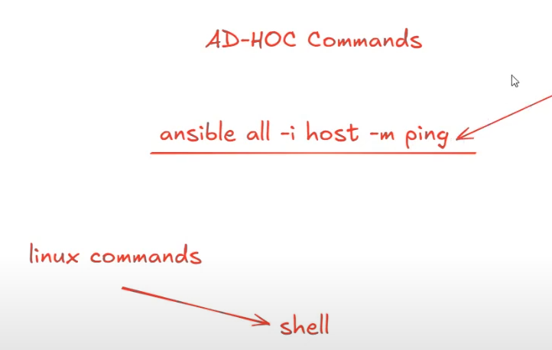

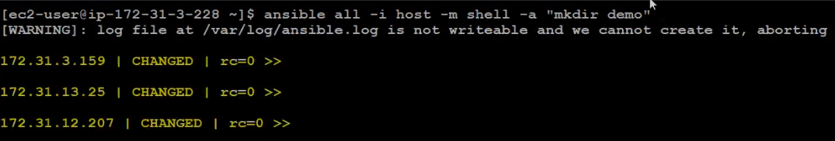
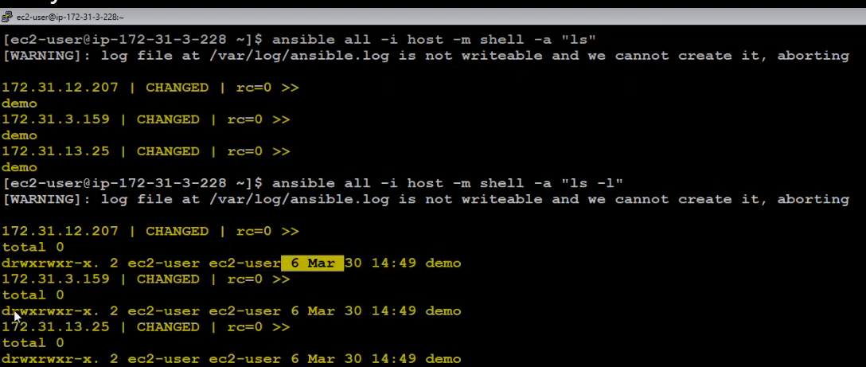
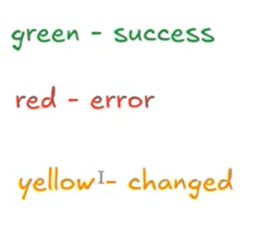
>ansible all -i host -m ping
If you want to run shell command use shell module:
>ansible all -i host -m shell -a “mkdir demo”
>ansible all -i host -m shell -a “ls la”
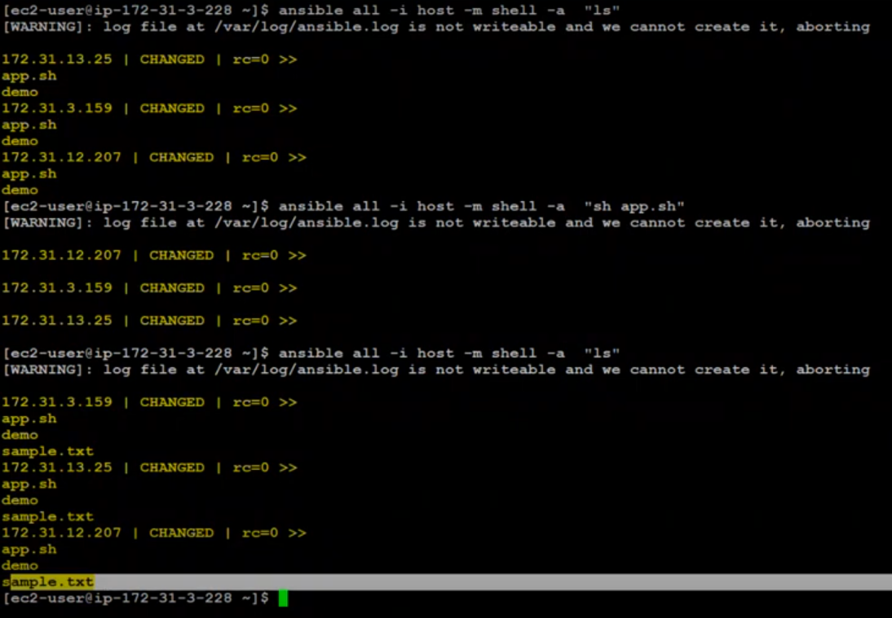
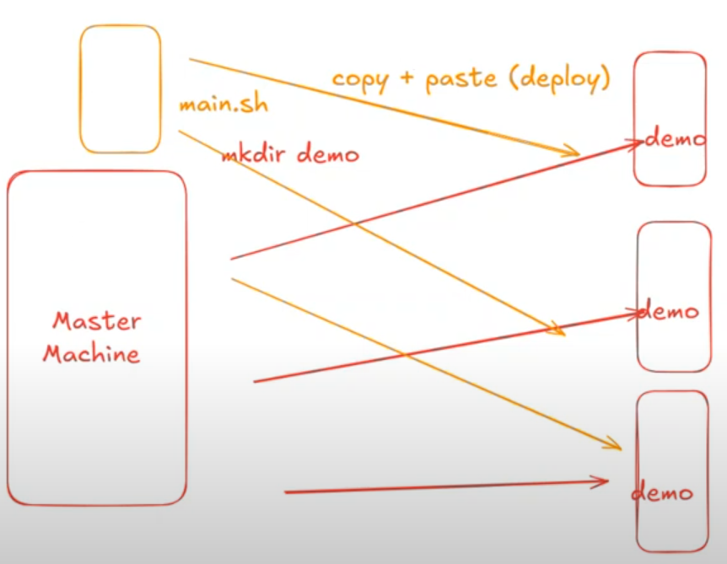

For Copy & Paste, Use copy module:
>ansible all -i host -m copy -a “src=main.sh dest=.”
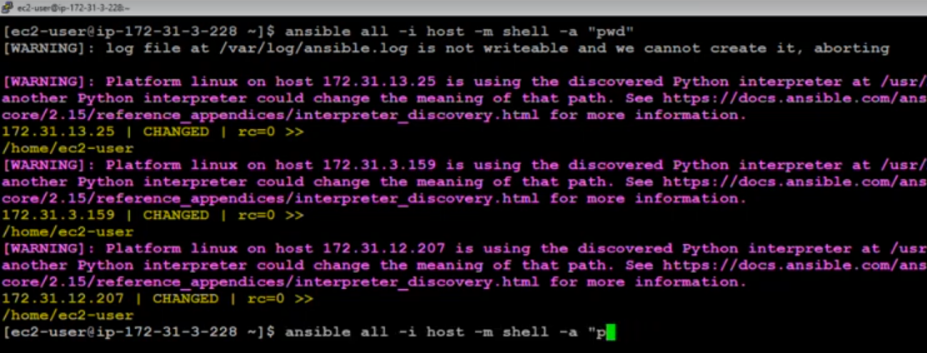
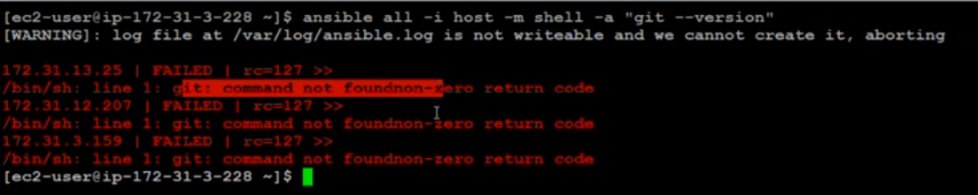
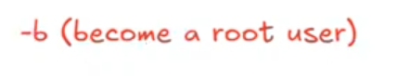
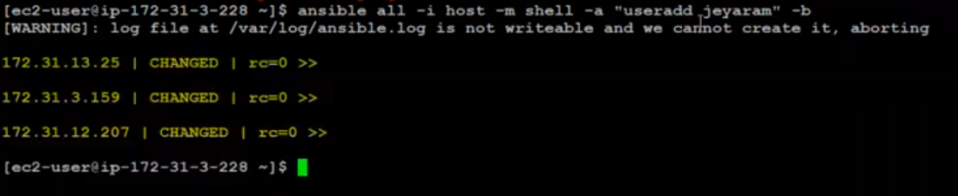

Day 3 - Host a Static Website with Ansible Ad-Hoc Commands | Ansible Tutorial
https://www.youtube.com/watch?v=1dNXp6S1dSM&list=PL7iDpp0KYTgFGlYGY765gTtAtCnRVi4E_&index=3
Looking to deploy a static website quickly using Ansible ad-hoc commands?
🤔 In this tutorial, we’ll walk you through a fast and efficient way to set up a web server and host a static website using Ansible—without writing a playbook! 🚀
📌 What You Will Learn: ✅ Setting Up a Web Server with Ansible – Install & configure Apache/Nginx using ad-hoc commands. ✅ Deploying a Static Website – Copying website files to the server with Ansible. ✅ Managing Web Services – Start, stop, and enable the web server on boot using Ansible commands. ✅ Real-World Use Cases – When to use ad-hoc commands vs. playbooks for web deployment.

We can install ansible in 2 ways:
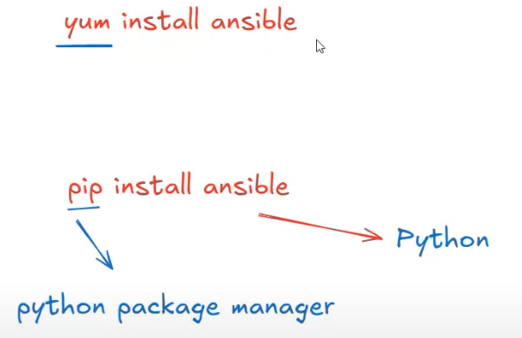

First, we have to install pip, and then we use pip command to install ansible.
>sudo yum install python3-pip
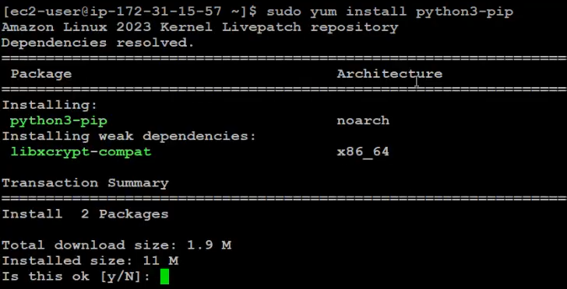
Check the pip3 has installed or not:
>pip3 --version
Now, Install ansible using pip…
>pip install ansible
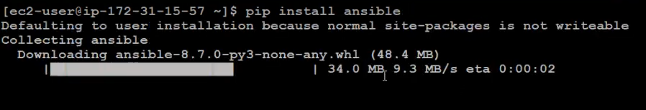
Once ansible installed, then the machine as called MASTER machine. We have to create 2 files on the ansible machine.
- Configuration file // download it from github
- Inventory file // create nano host and add slave machines IP
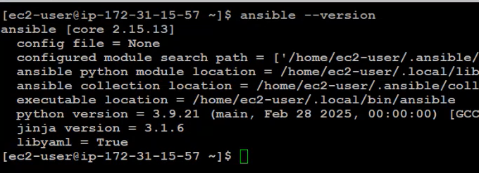
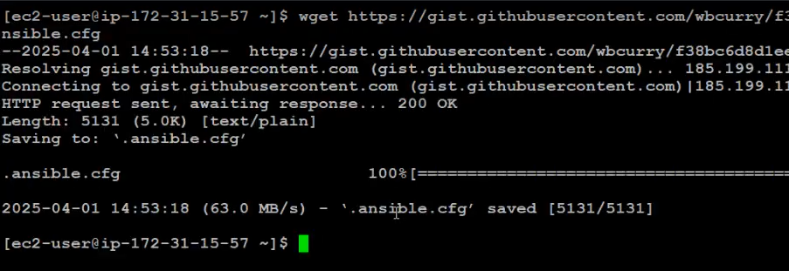
We can install package/software in 2 ways:
1. Using Shell module

2. Using Package module


To install Git:
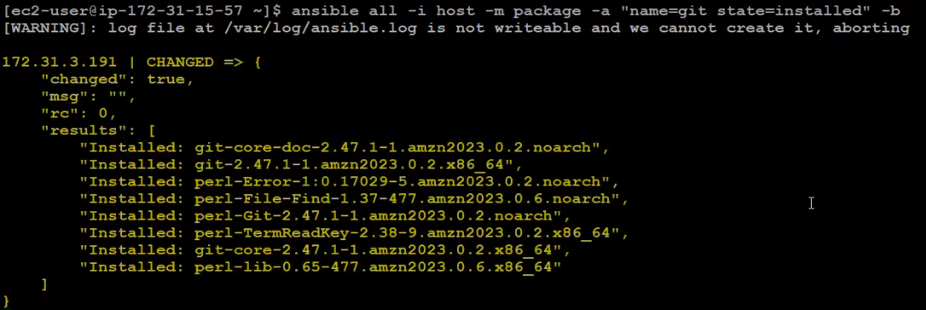
To check Git version:
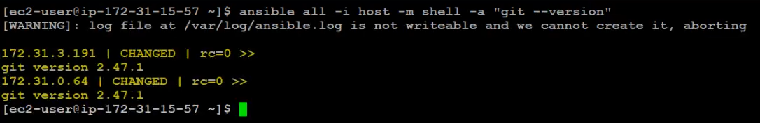
To remove Git:
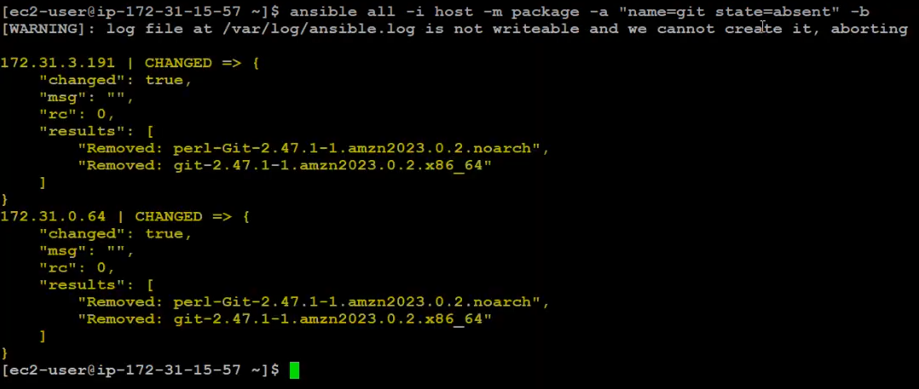
Force to remove git software: autoremove should be used alone or with state=absent
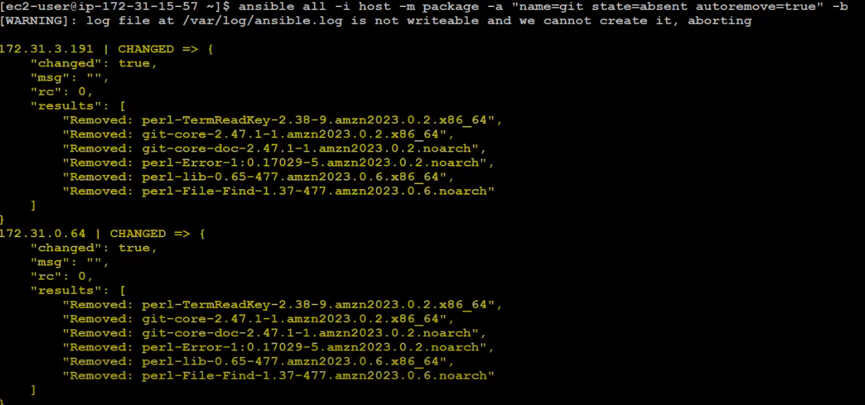
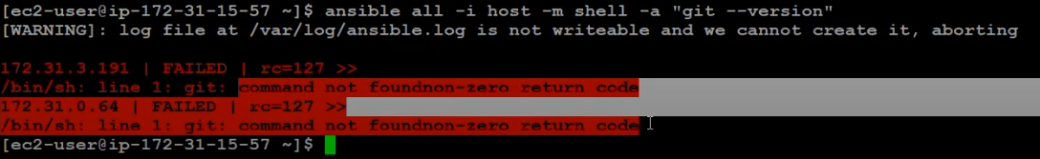
Small Project:

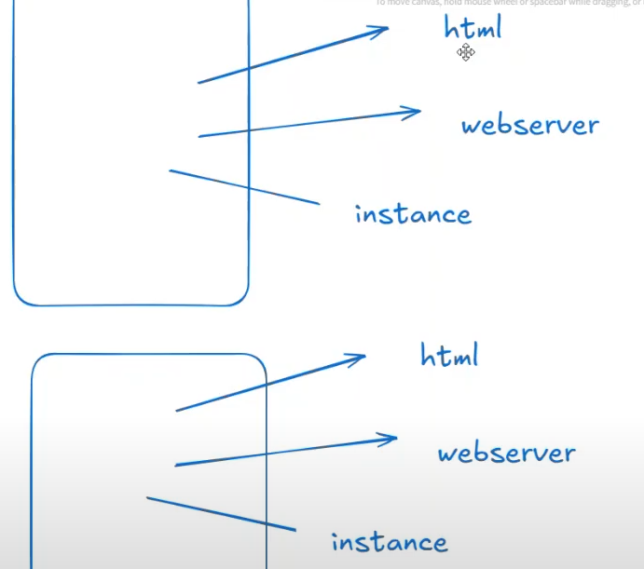


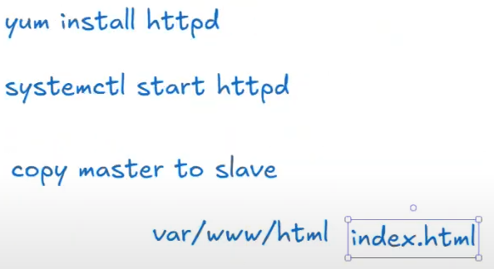
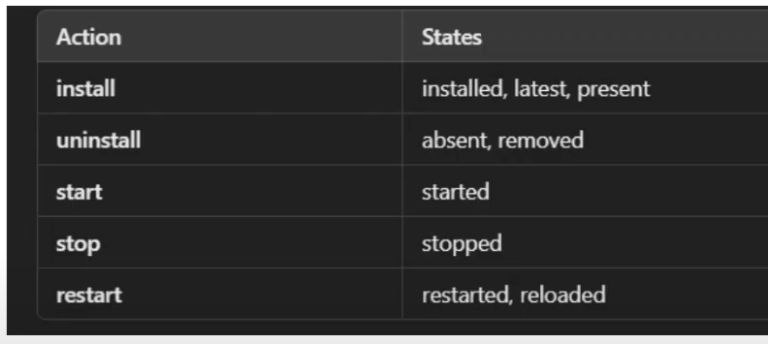
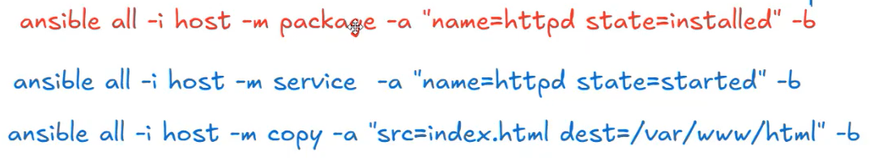
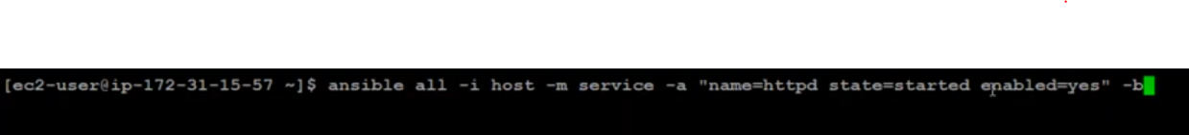

Day 4 - Ansible Tutorial: How to Set Up Apache Web Server Using Ansible Playbook
https://www.youtube.com/watch?v=xEjI2FgmA24
Want to automate Apache Web Server deployment using Ansible Playbook?
🚀 In this tutorial, we'll walk you through writing and executing an Ansible playbook to install and configure Apache (HTTPD/Nginx) on a remote server effortlessly!
📌 What You Will Learn:
✅ What is an Ansible Playbook? – Understand YAML-based automation scripts.
✅ Install Apache Web Server – Use Ansible to install and configure Apache/HTTPD on Linux servers.
✅ Deploy a Web Page Automatically – Copy an index.html file to the web server.
✅ Manage Services – Start, stop, and enable Apache on boot with Ansible.
✅ Real-World Use Cases – How Ansible playbooks simplify server configuration.

If you are going to use pip package manager to install ansible, first you install pip using below:
>sudo yum install python3-pip
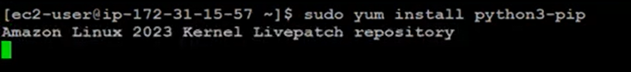

Ansible utilizes YAML (YAML Ain't Markup Language) as the foundation for its playbooks and configuration files due to its readability and simplicity. YAML's straightforward syntax allows users to define complex configurations in a human-readable format, making it ideal for automation tasks. ​GitHub+1The world's open source leader+1
Key Features of YAML in Ansible:
- Human-Readable Syntax: YAML's clean and minimalistic structure emphasizes data over syntax, reducing the need for extensive punctuation. This design enhances clarity and ease of understanding. ​
- Data Serialization: YAML efficiently represents data structures like mappings (dictionaries), sequences (lists), and scalars (strings, integers). This versatility allows for the expression of complex configurations in a straightforward manner. ​Red Hat Developer
- Integration with Ansible: Ansible playbooks, inventories, and variable files are written in YAML. This consistency ensures that configurations are both human-readable and machine-parsable, facilitating automation processes. ​
Basic YAML Constructs in Ansible:
- Mappings (Dictionaries): Represent key-value pairs.​
package: nginx
state: present
In this example, package and state are keys with their respective values.​
- Sequences (Lists): Denoted by a dash (-) followed by a space, representing a list of items.​GitHub
packages:
- nginx
- mysql
- php
Here, packages is a list containing three items.​Red Hat Learning
- Scalars: Individual values like strings, integers, or booleans.​
timeout: 30
debug: true
timeout is an integer scalar, and debug is a boolean scalar.​
Structure of an Ansible Playbook:
An Ansible playbook is a YAML file that defines a series of plays. Each play specifies a set of tasks to be executed on a group of hosts. ​Ansible Documentation+5GitHub+5Coddy Reference+5

- name: Install and start Nginx
hosts: webservers
become: yes
tasks:
- name: Install Nginx
ansible.builtin.yum:
name: nginx
state: present

- name: Start Nginx service
ansible.builtin.service:
name: nginx
state: started
In this playbook:
- name provides a description of the play.​
- hosts specifies the target group of machines.​
- become: yes indicates that tasks should be executed with elevated privileges.​
- Under tasks, two tasks are defined: one to install Nginx and another to start its service.​
Best Practices for Writing YAML in Ansible:
- Consistent Indentation: YAML relies on indentation to denote structure. It's essential to use consistent spaces (commonly two spaces per level) and avoid tabs to prevent syntax errors. ​
- Use of --- and ...: While optional, starting a YAML file with --- and ending with ... can clearly denote the beginning and end of a document, enhancing readability. ​TutorialsPoint+1TutorialsPoint+1
- Commenting: Use the # symbol to add comments, providing context or explanations for specific sections.​
# Install Nginx package
- name: Install Nginx
ansible.builtin.yum:
name: nginx
state: present
- Avoid Trailing Spaces: Trailing spaces can lead to parsing errors. Ensure lines end cleanly without extraneous spaces.​
- Use Descriptive Names: Clearly describe plays and tasks using the name attribute to make playbooks self-explanatory.​
Common Pitfalls and How to Avoid Them:
- Incorrect Indentation: Since YAML is indentation-sensitive, inconsistent indentation can cause errors. Always use spaces (not tabs) and maintain uniform indentation levels.​DEV Community
- Misplaced Colons: Ensure that colons in key-value pairs are followed by a space. For example, key: value, not key:value.​
- Unquoted Strings: While YAML allows unquoted strings, it's a good practice to quote strings, especially those that can be interpreted as booleans or numbers, to prevent unintended behavior.​
By adhering to these guidelines and understanding YAML's structure, users can effectively harness Ansible's capabilities to automate and manage complex IT environments.
Create a folder and open it on “VS Code” editor and create a YAML file.
Go extension and Install called “Ansible”
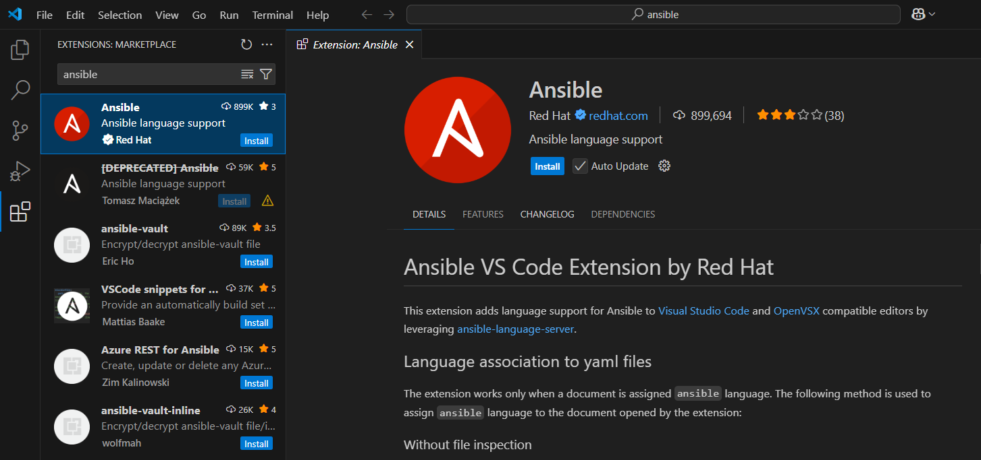
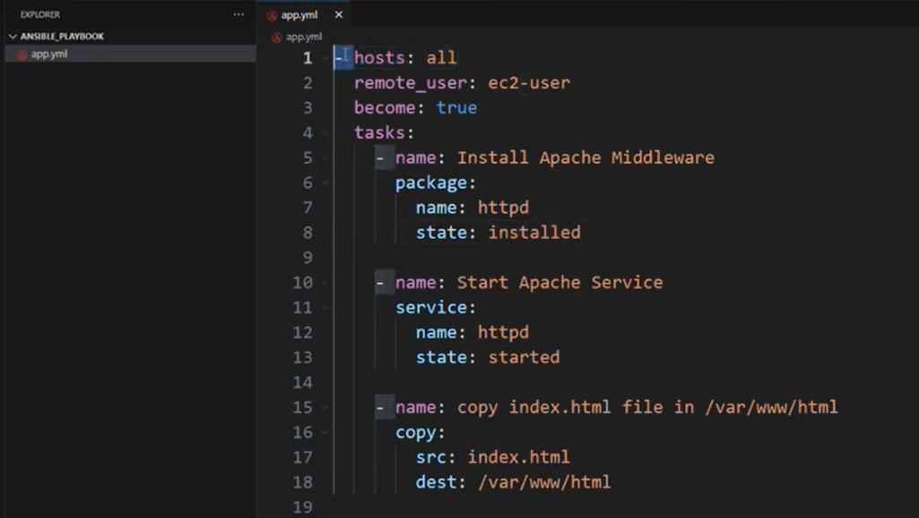
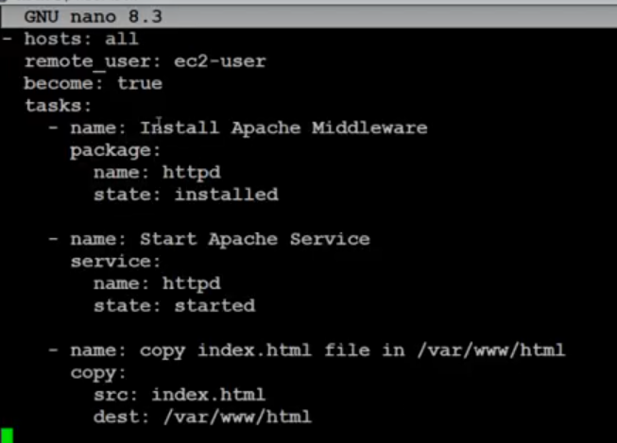
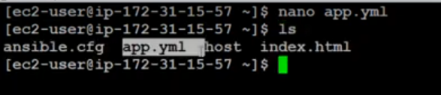
>ansible-playbook -i host app.yml
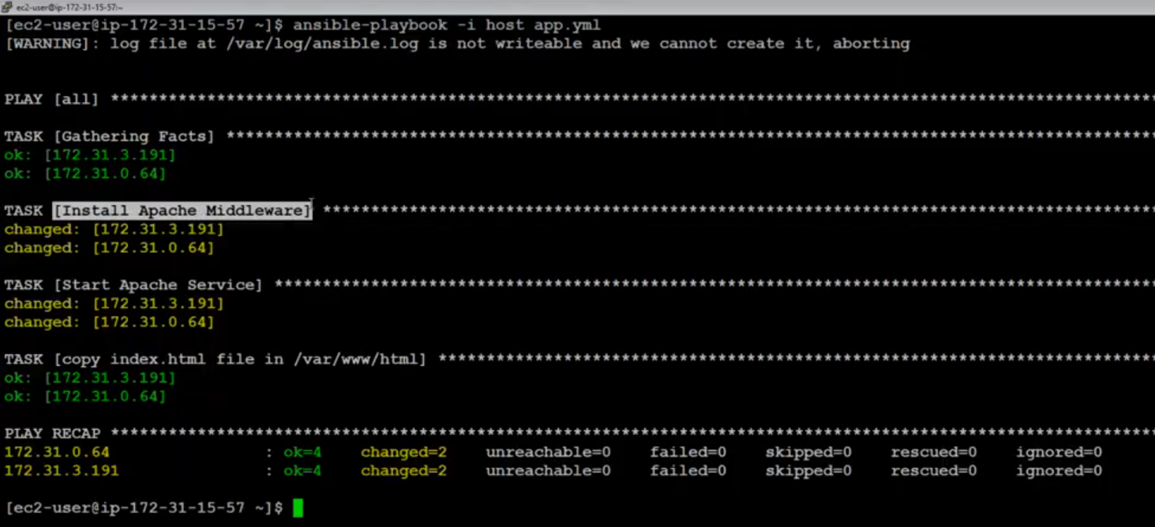

Step 1: Open the File in Nano
nano filename.txt

Step 2: Select Multiple Lines
- Move the cursor to the starting line of the text you want to delete.
- Press Ctrl + ^ (Control + caret) to start marking (this sets the selection anchor).
- Use the arrow keys to highlight the lines or text block you want to delete.

Step 3: Delete the Selected Lines
- Press Ctrl + K to cut/delete the selected lines (they are removed and stored in Nano's clipboard buffer).

Step 4: Save or Discard Changes
- Save: Press Ctrl + O to save the file.
- Exit: Press Ctrl + X to exit Nano.

Additional Tips:
- Delete a Single Line: Press Ctrl + K without marking text to delete the entire line where the cursor is.
- Delete Multiple Non-Consecutive Lines:
  - Use Ctrl + K repeatedly to delete one line at a time (no selection needed).
- Undo Deletion:
  - Nano does not natively support undo. To recover accidentally deleted lines, exit without saving (Ctrl + X → N).

Example Workflow:
- Open a file: nano example.txt
- Move to line 5.
- Press Ctrl + ^ to start marking.
- Use the down arrow to highlight lines 5–10.
- Press Ctrl + K to delete the selected lines.
- Save with Ctrl + O and exit with Ctrl + X.

Key Shortcuts:
Action | Shortcut
Start Marking | Ctrl + ^
Cut/Delete | Ctrl + K
Save | Ctrl + O
Exit | Ctrl + X

The Nano editor does not natively support "undo" in most versions, but there are workarounds depending on your setup. Here’s how to handle it:

1. Use Nano’s Experimental Undo (Version 5.0+)
If you’re using Nano 5.0 or later, undo is available but disabled by default. To enable it:
- Open or create the Nano config file:
nano ~/.nanorc
- Add this line to enable undo:
set undo
- Save (Ctrl + O) and exit (Ctrl + X).
- Now, use Alt + U to undo changes in Nano.

2. Workarounds for Older Nano Versions
If your Nano lacks undo, try these methods:
A. Use the Clipboard
- Before deleting: Mark text with Ctrl + ^ (select), then copy with Alt + ^ (instead of cutting with Ctrl + K).
- If you accidentally delete, paste the clipboard back with Ctrl + U.
B. Save Frequently & Revert
- Save a backup before risky edits (Ctrl + O → save as filename.backup).
- If you make a mistake:
  - Exit without saving (Ctrl + X → N).
  - Reopen the original file.
C. Use External Tools
- Use git to version-control your files. Revert changes with git checkout -- filename.txt.
- Use meld or diff to compare versions.

3. Switch to an Editor with Undo
For frequent undo needs, consider these alternatives:
- Vim: Press u to undo.
- Emacs: Press Ctrl + / or Ctrl + _ to undo.
- Micro: Modern terminal editor with Ctrl + Z for undo.

Summary
Method | Command/Action
Enable Nano Undo (v5.0+) | set undo in ~/.nanorc → Alt + U
Copy-Paste Workaround | Alt + ^ (copy) → Ctrl + U (paste)
Exit Without Saving | Ctrl + X → N
Use Git | git checkout -- filename.txt
Let me know if you need help setting up alternatives! 🛠️

Day 5 - Understanding Ansible Architecture: Key Components and How It Works | Ansible Tutorial
How to use SHELL command in playbook yaml file.
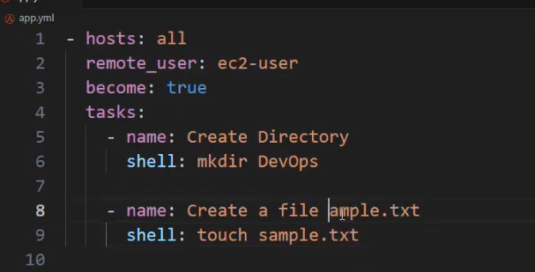

When we install “ansible” using YUM, ansible folder will be created under
/etc/ansible
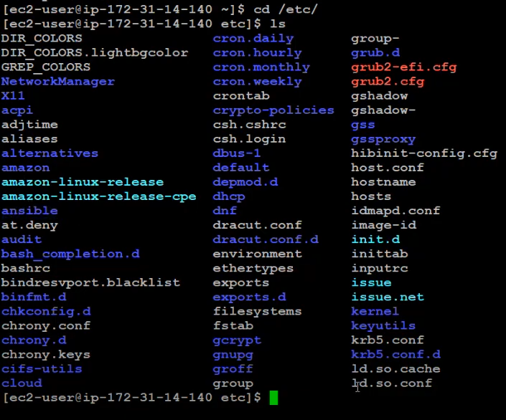
Save configuration file inside the ansible folder to easy maintainance ansible related files.
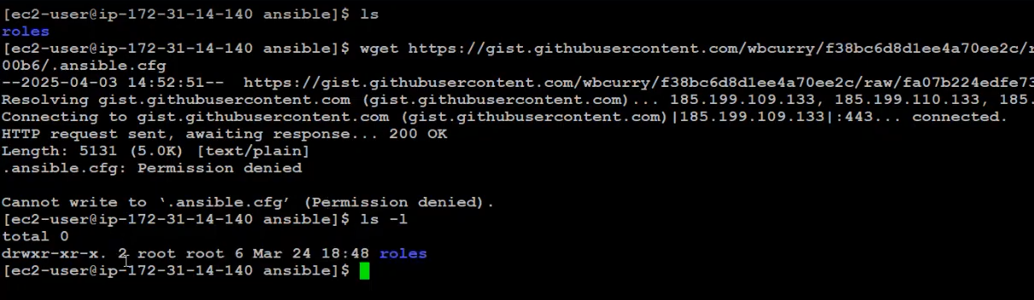

Only root user has a permission to the /etc folder and inside it NOT the ec2-user.
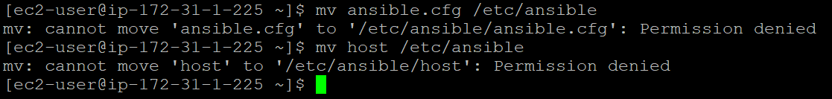
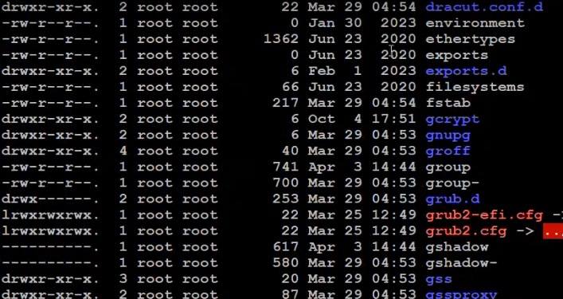
So, change the owner of the ansible folder to ec2-user.
-R means appling permission inside the ansible folder(Parent+child folder) as well. Now changing the user owner and group owner.
>sudo chown -R ec2-user:ec2-user ansible
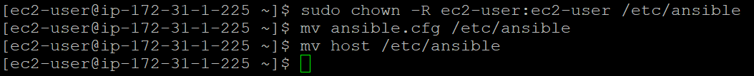
Now, the download configuration file will work:
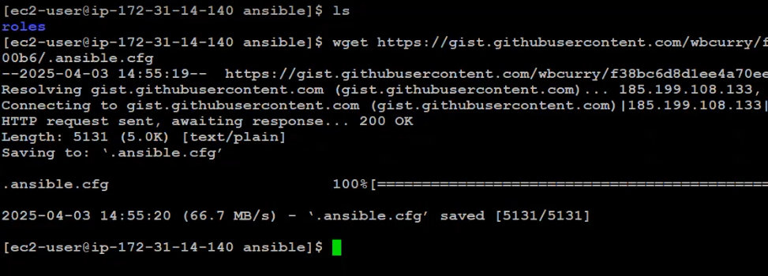
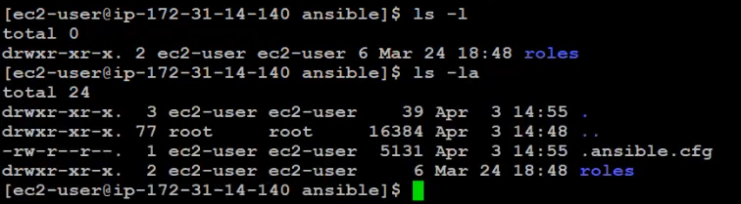
>ansible all -i host -m ping
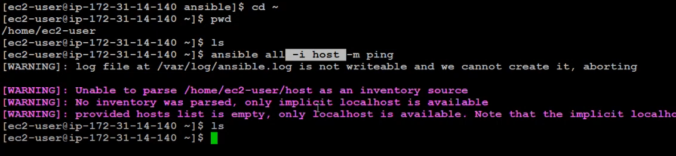
If you want to run ansible command anywhere, update the host file path on the ansible.cfg.
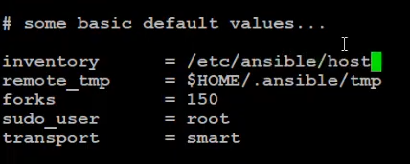
Also, no need to use or include “-i host” on the command hereafter.
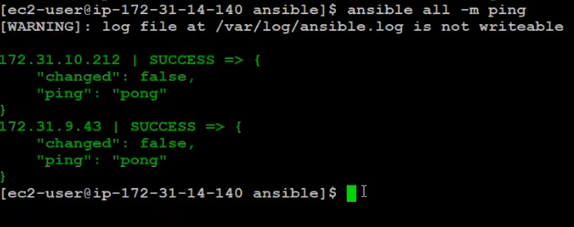
Create a playbook directory > app.yml
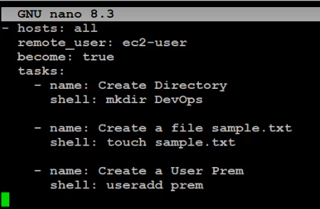
>ansible-playbook app.yml
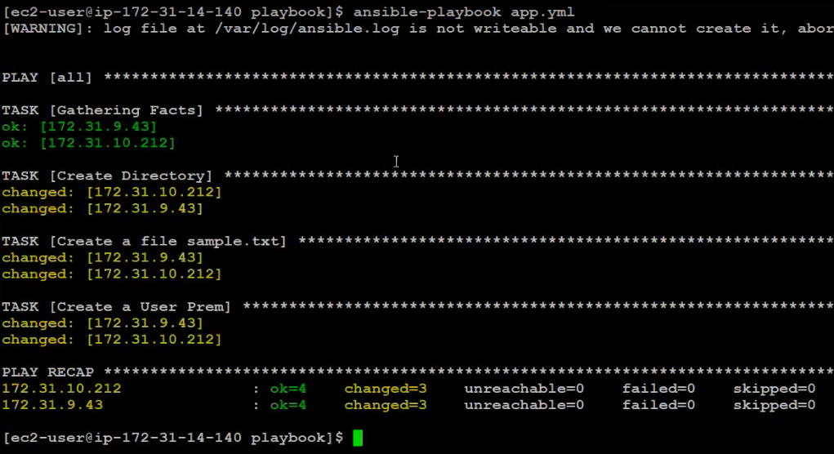
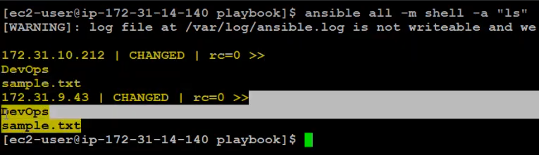

Ansible is agentless. It means doesn’t require any software to be installed on the target machines/managed nodes. It connects over SSH to configure and manage systems.
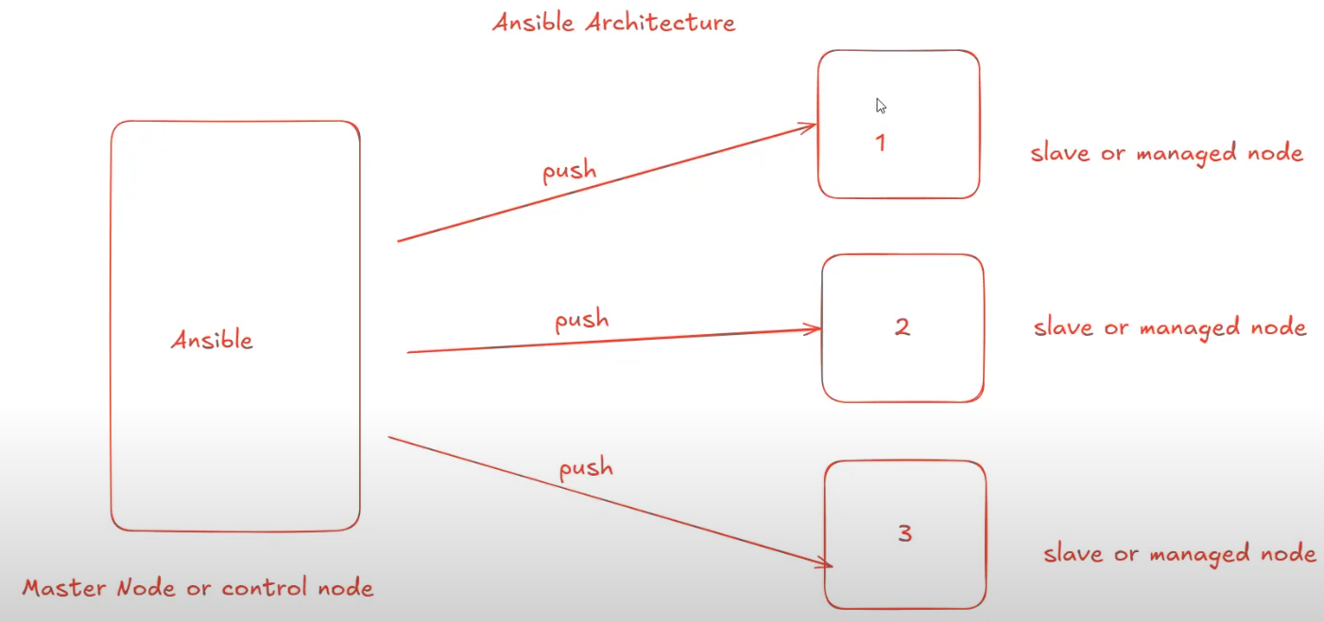
How to check playbook yaml file syntax are correct:
>ansible-playbook --syntax-check app.yml
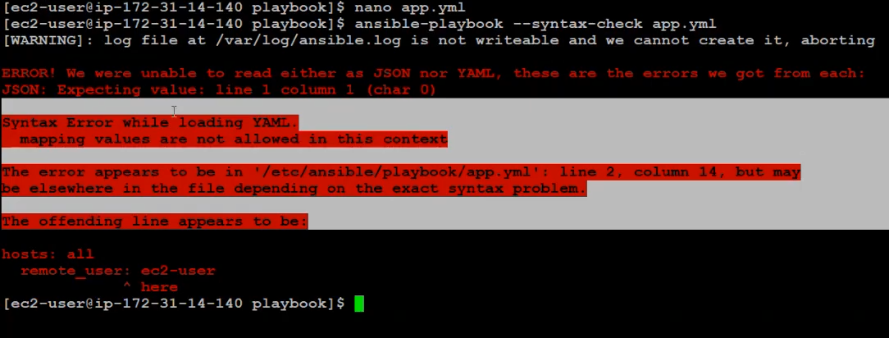
How to check number of hosts mentioned on the playbook:
>ansible-playbook --list-hosts app.yml
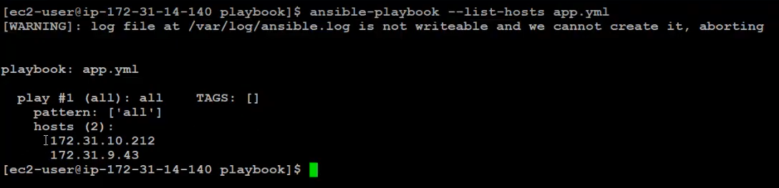
If you want to execute the task step-by-step OR one-by-one with your confirmation:
>ansible-playbook --step app.yml
If you press “y”, will perform task one-by-one/step-by-step:
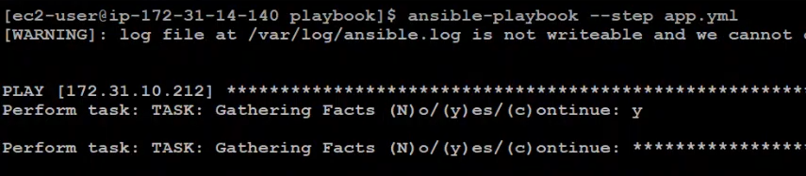
If you press “c”, will perform all the task:
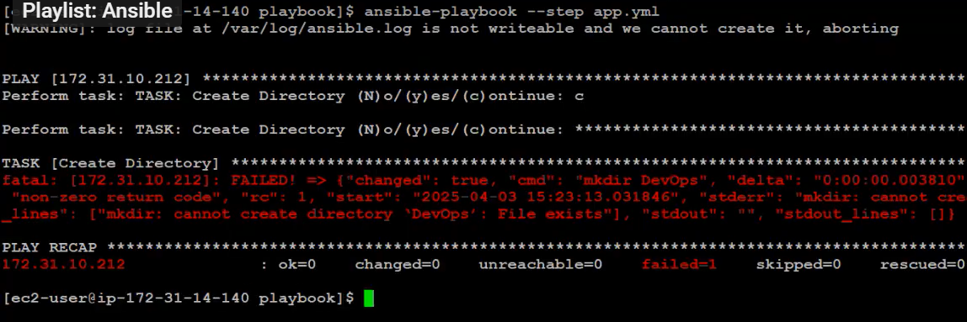
To know the process of the playbook file:
>ansible-playbook --check app.yml
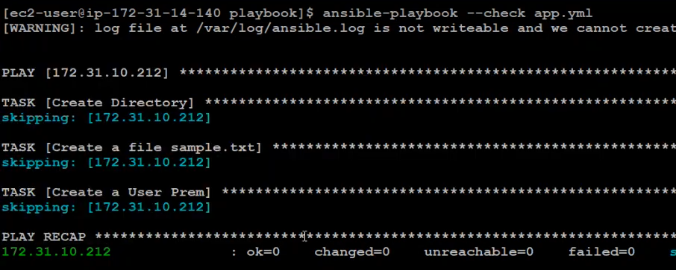

Day 6 - Ansible Vault Tutorial: Secure Your Sensitive Data in Playbooks - Step-by-Step Guide
​Encryption and decryption are fundamental processes in the field of cryptography, essential for securing digital communication and data. They ensure that sensitive information remains confidential and accessible only to authorized parties.
​Ansible Vault is a feature within Ansible that allows users to encrypt sensitive information, such as passwords, keys, and other confidential data, ensuring that this information is not exposed in plaintext within Ansible projects.
This encryption capability is crucial for maintaining security and confidentiality in automated IT environments.
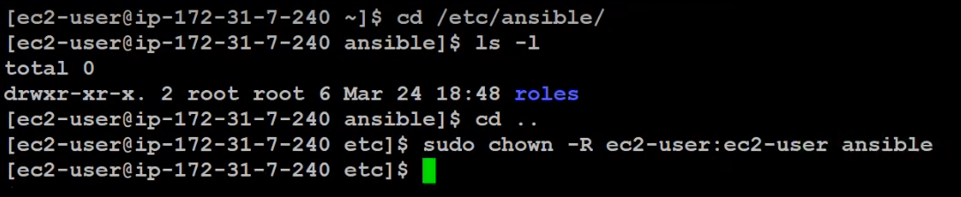
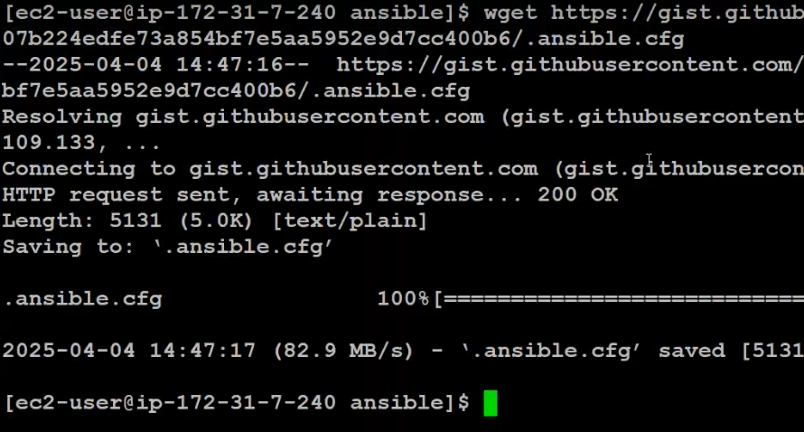
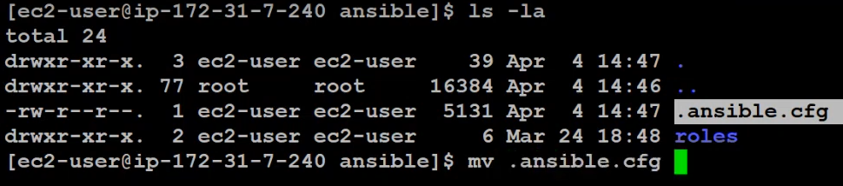
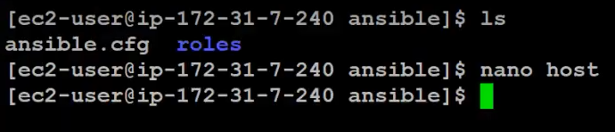
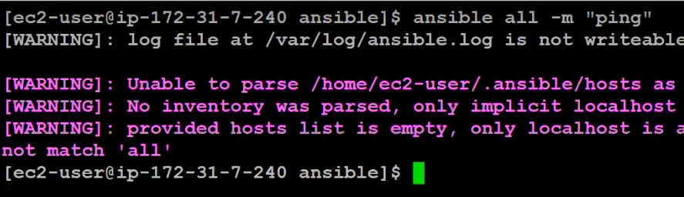
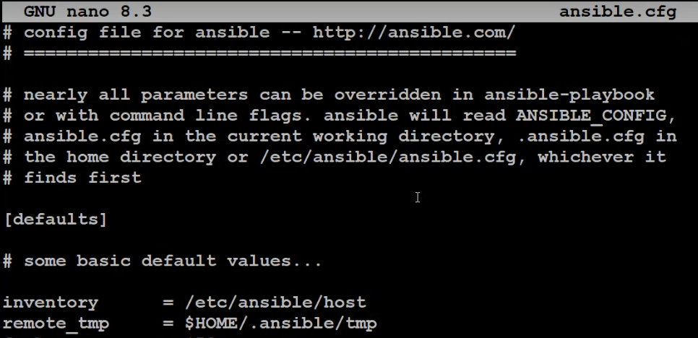
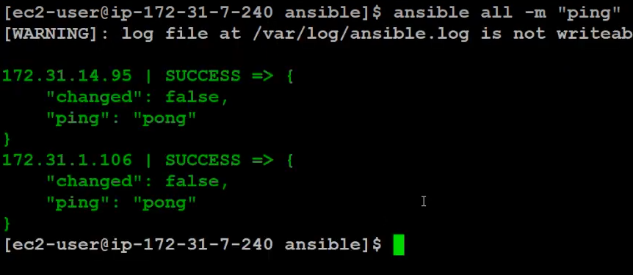

Encrypt the file:
>ansible-vault encrypt app.yml
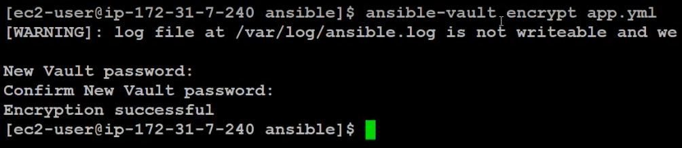
>cat app.yml
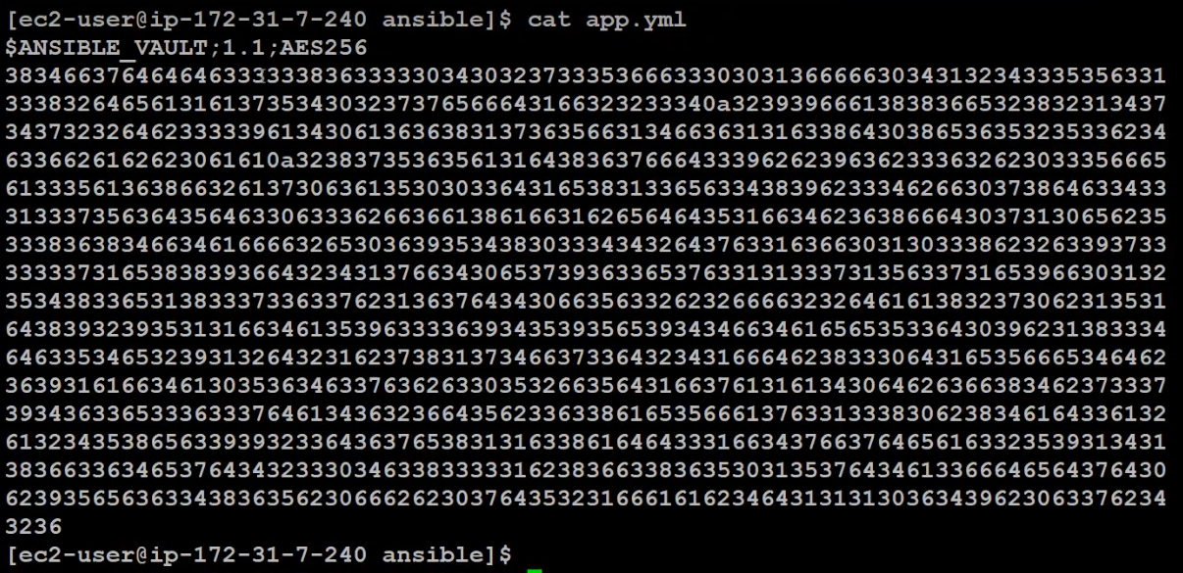
How to run/execute the playbook file after encryption:
>ansible-playbook app.yml --ask-vault-pass
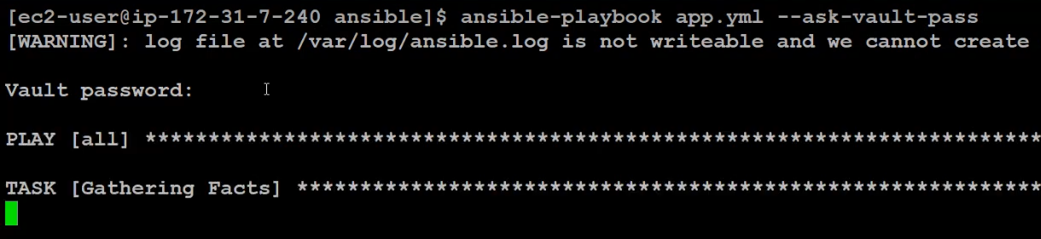
How to view encrypted file:
>ansible-vault view app.yml
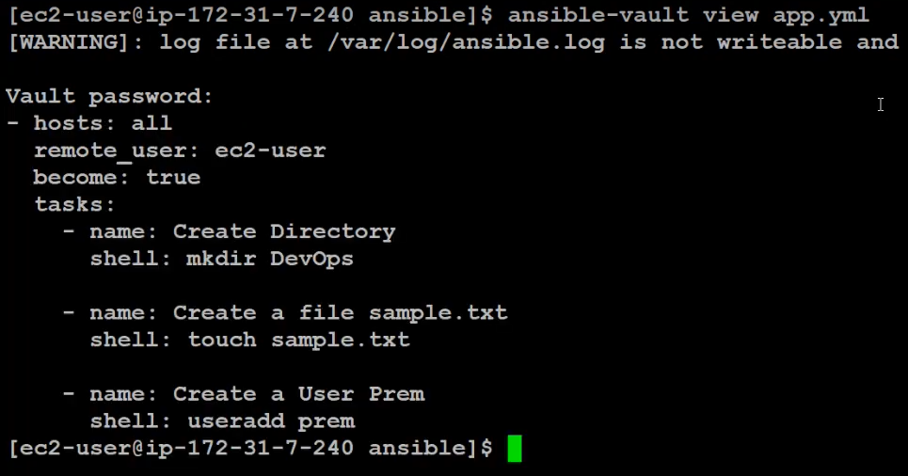

How to edit encrypted file:
>ansible-vault edit app.yml
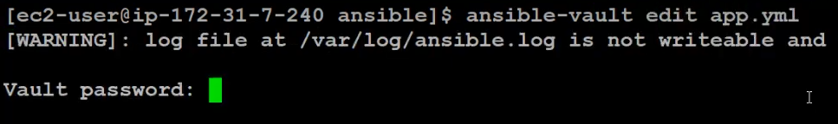
OR
>ansible-vault edit app.yml --vault-password-file=playbook
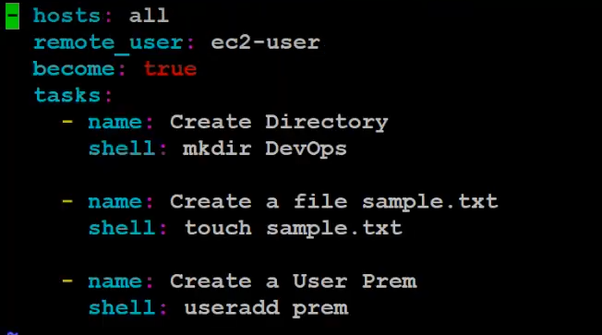
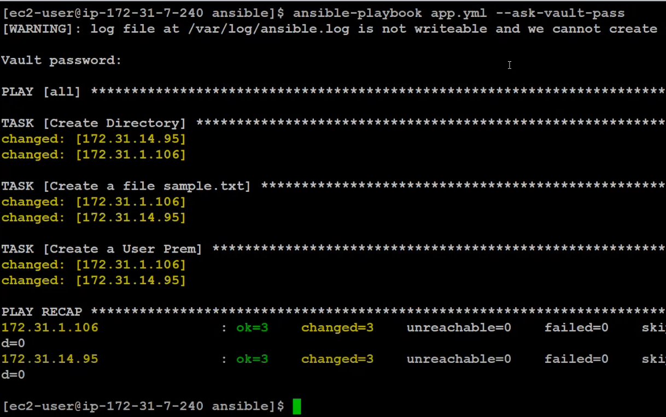
How to change encrypted key/password:
>ansible-valut rekey app.yml
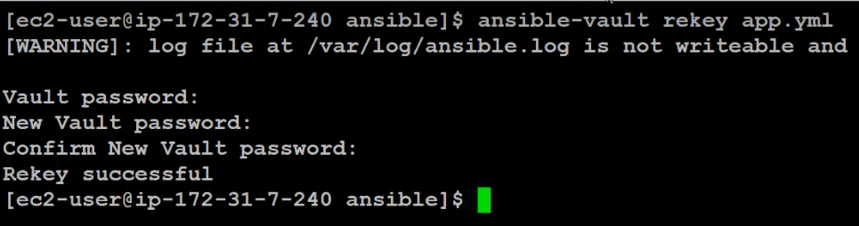
How to decrypt the file:
>ansible-vault decrypt app.yml
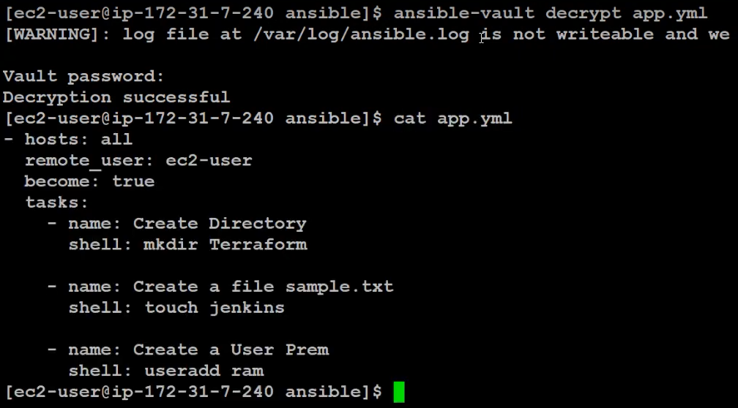

Instead of entering the key/password, We can store the password/key in a file and encrypt the file and use the file as a password.
>nano playbookpasskey
Apply encrption to the file:
>ansible-vault encrypt app.yml
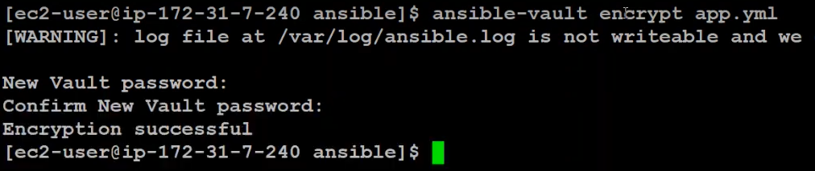
Instead of --ask-vault-password, use --valut-password-file to execute the playbook:
>ansible-playbook app.yml --valut-password-file=playbookpasskey
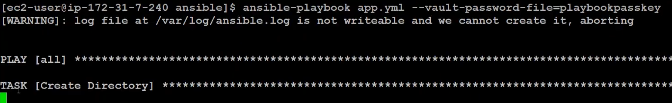

Day 7 – Ansible Tags and Playbook Variables
https://www.youtube.com/watch?v=OvgZPyjmrW8&list=PL7iDpp0KYTgFGlYGY765gTtAtCnRVi4E_&index=8
Ansible Tags:
🔖 What are Ansible Tags?
Ansible tags are labels you can assign to tasks, roles, or plays in your playbooks so you can control which parts of the playbook get executed when you run it.
They are super useful when:
- You want to run only specific tasks.
- You want to skip some tasks during testing.
- Your playbook is long and has multiple purposes (like installing, configuring, restarting).

🧱 Basic Syntax
You add a tags attribute to your tasks or roles.
- name: Install nginx
apt:
name: nginx
state: present
tags:
- install
You can add multiple tags:
- name: Configure nginx
template:
src: nginx.conf.j2
dest: /etc/nginx/nginx.conf
tags:
- configure
- nginx

▶️ How to Use Tags When Running a Playbook
To run only tasks with a certain tag, use:
ansible-playbook playbook.yml --tags "install"
To skip tasks with a certain tag, use:
ansible-playbook playbook.yml --skip-tags "configure"
You can also combine multiple tags:
ansible-playbook playbook.yml --tags "install,restart"

📦 Using Tags in Roles
You can tag an entire role like this:
- hosts: webservers
roles:
- role: nginx
tags:
- web
- nginx

✅ Example Use Case
Imagine your playbook has tasks to:
- Install software
- Configure it
- Restart service

You can tag them like this:
- name: Install packages
apt: ...
tags: install

- name: Copy config file
template: ...
tags: config

- name: Restart service
service: ...
tags: restart
Then you can run only one part like:
ansible-playbook site.yml --tags "config"

🧠 Summary
Feature | Description
--tags | Runs only tasks with those tags
--skip-tags | Skips tasks with those tags
Tag location | Can be used on tasks, plays, or roles
Multiple tags | Add more than one tag per task/role

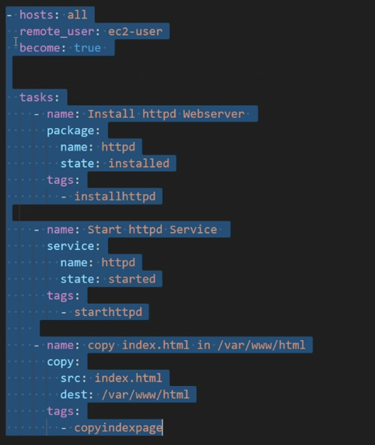
>ansible-playbook app.yml --list-tags
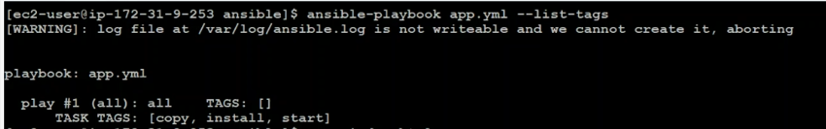
>ansible-playbook app.yml --tags copy
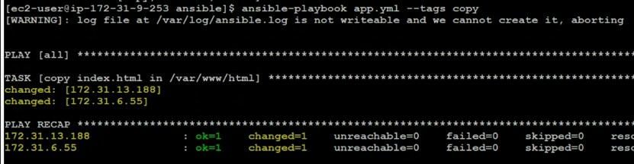
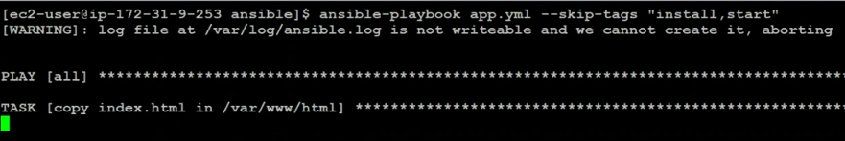

1. Missing --- at the top of the YAML file
While optional, it's a good practice and sometimes required by linters or certain parsers:
2. File indentation or whitespace issues
YAML is very sensitive to spaces. Make sure you're using 2 spaces per indent, not tabs or mixed spaces.
3. File Encoding or Hidden Characters
If you copy-pasted into nano, sometimes weird hidden characters might sneak in. Try running:
cat -A cmd.yml
And check if you see any unusual characters (like ^M, \t, etc.).
CODE:

---
- name: Sample playbook for file management
hosts: all
remote_user: ec2-user
become: true

tasks:
- name: Create a Directory called cloud
shell: mkdir -p cloud
tags:
- create_dir

- name: Create an Empty file called cloud.txt
shell: touch cloud.txt
tags:
- create_file

- name: List the files
shell: ls -la
tags:
- list_files

Key Rules:
- tags: should be under the same indentation level as shell:, name:, etc.

Playbook Variables:
🧠 What are Playbook Variables?
Variables in Ansible allow you to make your playbooks dynamic and reusable.
Instead of hardcoding values (like IPs, usernames, paths), you use variables to:
- Set different values for different hosts or environments
- Avoid repeating the same value in multiple places
- Make configuration and management easier

📦 Where Can You Define Variables in a Playbook?
Here are the common ways to define variables in a playbook:

1. Inline in the Playbook (under vars)
- name: Install nginx
hosts: webservers
vars:
package_name: nginx
tasks:
- name: Install web package
apt:
name: "{{ package_name }}"
state: present

2. Using vars_files (External YAML files)
- name: Setup webserver
hosts: webservers
vars_files:
- vars/web_vars.yml
web_vars.yml:
package_name: nginx

3. Using host_vars or group_vars (Based on inventory)
- group_vars/webservers.yml
- host_vars/server1.yml
You just place these files in your project structure, and Ansible automatically loads them.

4. Using set_fact (Inside tasks)
- name: Set a custom fact
set_fact:
my_service: apache2

5. Using extra_vars (Command line)
ansible-playbook playbook.yml --extra-vars "package_name=nginx"

🧪 How to Use Variables in Tasks
You use the Jinja2 template syntax with double curly braces {{ variable_name }}:
- name: Create a config file
template:
src: "{{ config_template }}"
dest: "/etc/myapp/{{ config_file }}"

📝 Example Playbook with Variables
- name: Install and start web service
hosts: webservers
vars:
package_name: nginx
service_name: nginx
tasks:
- name: Install the package
apt:
name: "{{ package_name }}"
state: present

- name: Start the service
service:
name: "{{ service_name }}"
state: started

🧠 Summary
Place to Define |  | Description
vars |  | Inside the playbook
vars_files |  | External YAML files
host_vars/group_vars |  | Host or group specific vars
set_fact |  | Define variables during playbook execution
extra-vars |  | Command line overrides

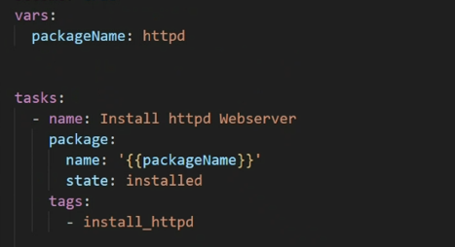
💡 Bonus Tips:
- Use state: present for package modules if you're not sure the system supports installed (though it's usually okay).
- Make sure index.html is present in the same directory where you're running the playbook (or give full path in src:).

Day 8 – Inventory Groups & Runtime Variables Explained | Dynamic Configuration in Ansible
https://www.youtube.com/watch?v=qQbrK9_IdJ0&list=PL7iDpp0KYTgFGlYGY765gTtAtCnRVi4E_&index=9
🔹 Inventory Groups in Ansible
An Inventory in Ansible is a file (usually hosts file) where you define the systems (nodes) you want to manage.
✅ What are Inventory Groups?
Inventory groups allow you to group hosts logically. This is useful when you want to run certain tasks on a group of servers, like webservers, dbservers, etc.
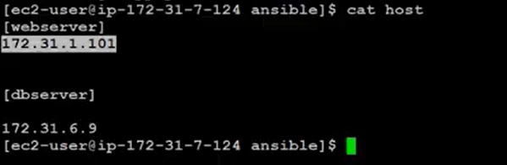
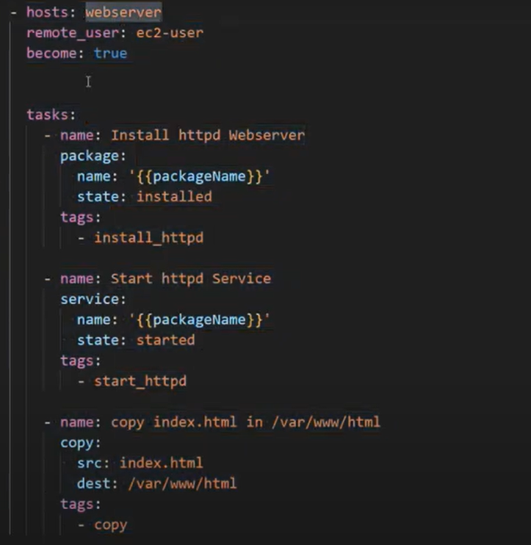
Run time Variable:
>ansible-playbook app.yml --extra-vars packageName=httpd
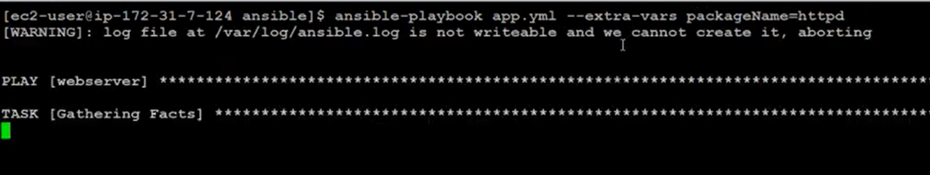
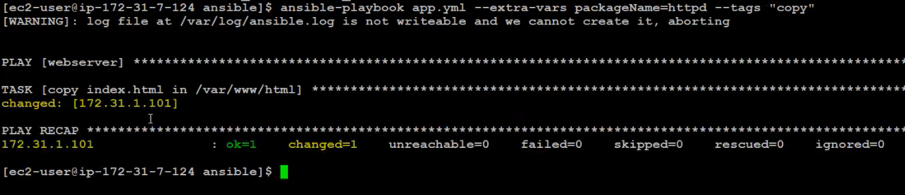
🧾 Example Inventory (hosts) File:
[webservers]
web1.example.com
web2.example.com

[dbservers]
db1.example.com

[allservers:children]
webservers
dbservers
🛠️ How it works:
- webservers group contains two web nodes.
- dbservers group contains one database node.
- allservers is a parent group which includes both webservers and dbservers.

🔹 Runtime Variables in Ansible
Runtime variables are values passed to Ansible at runtime, meaning when you run the playbook.
✅ Ways to define Runtime Variables:
- Using --extra-vars or -e
- Prompting user input using vars_prompt
- Setting facts dynamically using set_fact

💡 Example 1: Passing variables using --extra-vars
Playbook: example.yml
- name: Example Playbook
hosts: all
tasks:
- name: Print the username
debug:
msg: "Hello, {{ username }}!"
Command:
ansible-playbook example.yml -i hosts --extra-vars "username=Elakkiya"
Output:
TASK [Print the username]
ok: [web1.example.com] => {
"msg": "Hello, Elakkiya!"
}

💡 Example 2: Using vars_prompt in a playbook

- name: Prompt example
hosts: localhost
vars_prompt:
- name: "fav_color"
prompt: "What's your favorite color?"
private: no
tasks:
- debug:
msg: "Your favorite color is {{ fav_color }}"
When run, this playbook will prompt the user to enter a color.

🔄 Putting it all together
Let’s say we have a playbook for installing software differently on webservers and dbservers:
- name: Install packages based on group
hosts: all
tasks:
- name: Install Nginx on webservers
apt:
name: nginx
state: present
when: "'webservers' in group_names"

- name: Install MySQL on dbservers
apt:
name: mysql-server
state: present
when: "'dbservers' in group_names"
This checks which group the host belongs to and installs packages accordingly.

