**AEM Forms**

**AEM 6.5 +SP 20 + Forms Extension**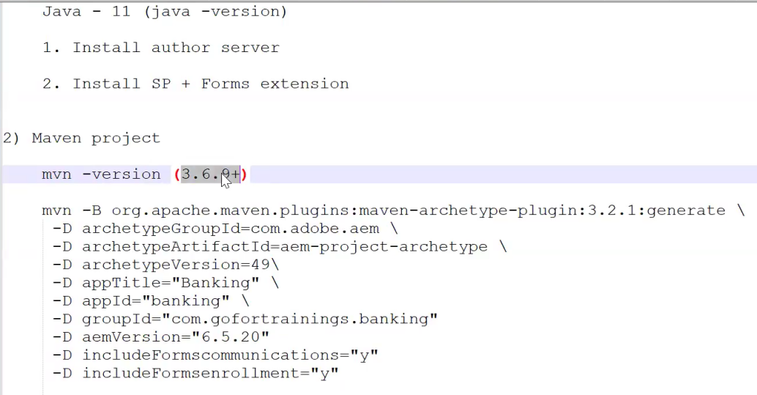

**Recommended way is to create a “install” folder and paste the SP 20 and Forms extension files inside it. And stop the local server and re-start it again. The both will be intalled automatically.**

**AEM As a Cloud + Forms Extension:**



Remove **aem-version** from the archetype command while setup a project in local:

**IMPORTANT MODULE:**

**IMPORTANT COMMENTS:**

**>mvn clean install //** It will compile and generate the below output files in local mentioned directory

mvn means Maven

clean means remove all the existing content package (ZIP) and Bundles (JAR)

install regenerate the new content package(ZIP) and Bundles (JAR)

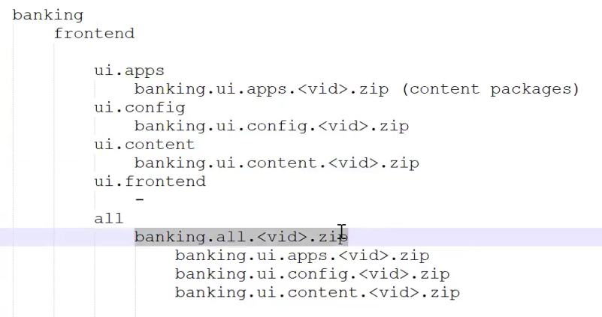

**To verify post deployment > localhost:4502/crx/packmgr**

**To verify post deployment > localhost:4502/system/console**

ui.frontend > It will merge into the ui.apps

**1. mvn clean install -PautoInstallSinglePackage**

**🡪** To deploy entire project into local AEM author server as a single package.

**2. mvn clean install -PautoInstallSinglePackagePublish**

**🡪** To deploy entire project into local AEM publish server as a single package.

**3. mvn clean install -PautoInstallPackage**

**🡪** To deploy entire project into local AEM author server as a single package.

**🡪** Also to deploy separate module into the local AEM author server.

Eg.

* ui.apps > mvn clean install -PautoInstallPackage

**4. mvn clean install -PautoInstallPackagePublish**

**🡪** To deploy entire project into local AEM author server as a single package.

**🡪** Also to deploy separate module into the local AEM author server.

**5. mvn clean install -PautoInstallBundle**

**🡪** To deploy only back-end module into local AEM author server.

Eg>

*core> mvn clean install -PautoInstallBundle*

**Editor:**

For Front-End 🡪 VS Code

For Back-End 🡪 IntelliJ / Eclipse

