**JavaScript Basics**

**Variables:** It’s used to store the value

* Default value of the variable in javascript is **undefined.**

**Constants:** It can’t be changed.

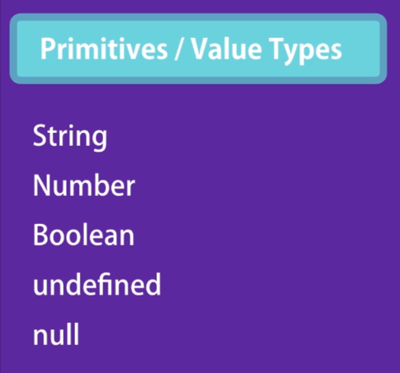

**let firstName; //** If we not declared anything, it will consider as undefined.

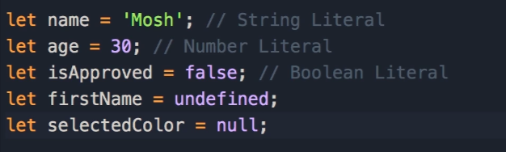

**All types of number like integer, float under number type.**

**To clear console press CTRL+L**

Person is an Object and Object contains key value pair.

**let person={}; // Object literal**

Properties of a Person 🡪name, age, height, weight, color, etc

For Dynamic purpose:

**Purpose of the object to group related variables and functions.**

**Factory Functions:**

* How factory use the products, similar, factory function, use objects.
* We use Camel Notation: oneTwoThree
* If we have objects in different ways, then we go with Factory functions.

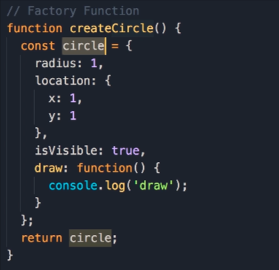

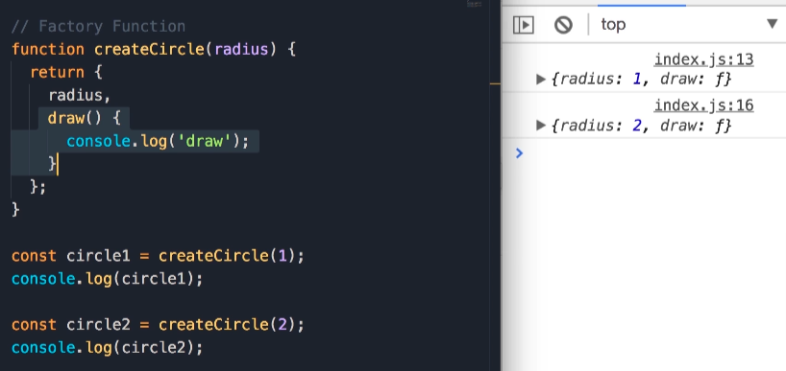

**Constructor Functions:**

* Another pattern to create an Object.
* The job of the function is to construct or create an object.But the naming conversion we use for the constructor function is different.
* We use Pascal Notation: OneTwoThree
* When we use ‘new’ keyword,3 things happen:
  + First create EMPTY object.
  + This set ‘this’ to the empty object.
  + Finally, It returns the object to the function.
* Instead of return object, we use this keyword.
* Developer familiar with this approach as they aware of C sharp and Java.

In above, No need to add return this. Because, explicitly it will happen.

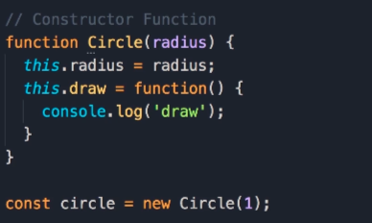

**Dynamic Nature of Objects:**

* We can add or delete member of an object dynamically whether it is property or method/function.
* We have used ‘const’ keyword for an object, however, we modified the object’s member.
* The ‘const’ means, we can’t reassign the variable.
  + circle={}; // *TypeError: Assignment to constant variable.*

Constructor Property:

* Every object in JavaScript is called as Constructor. That reference the object

Array🡪 (Different type of product)

* It’s a data structure that we used to represent set of items.
* We can store different types of elements/variables in the Array. So, object of the array and size of the array in javascript is **dynamic**.

let selectColor=[]; // Array literal

**Function:**

* It’s a fundamental building block in javascript.
* Set of statements to perform a task.
* To calculate a set of values.

function setAddition(); // function is a keyword

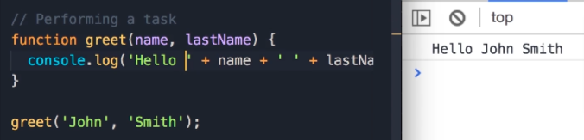

From JVL Code Youtube Channel:

<https://www.youtube.com/watch?v=CyBY6YJOtBY>

1. Global Scope
2. Functional Scope
3. Block Scope

**JavaScript Tutorial for beginners in Tamil | Full Course for Beginners | Basic to Advanced concepts**

https://www.youtube.com/watch?v=toymwoKBtbM

<https://www.youtube.com/watch?v=ZVXmgrXT2MA&list=PLXCfOoPnFIbujsRRd0c2CrYZ9y7PRRoA4>

In var

🡪 Re-declaration is possible

In let

🡪Re-declaration is not possible